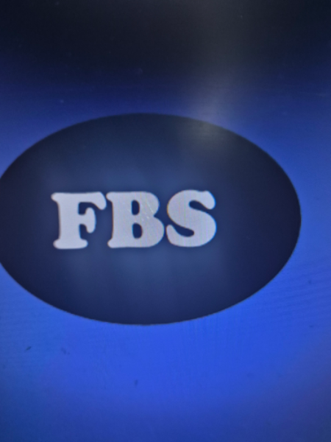
Francis Blackstone Surveyors
Property Valuation Report

Property Address | 54 Gas Lane, Dartford, Dartford, Kent, DA2 5TT
Client Name | Dan Baker
Job Reference | VL1433
Inspection Date | 11 November 2026
Report Generated | 12 November 2026, 11:25 PM

About Inspection

General Details | At the time of inspection, the property was occupied, had fully furnished finishes and was fully carpeted throughout.  The purpose of this valuation is for Market Value.  At the time of my inspection, the weather conditions were dry. It should be noted that certain defects may be more or less apparent depending on the prevailing weather conditions at the time of inspection.  The property is held on a freehold basis. Your legal adviser should confirm the precise terms and any obligations arising from the tenure.  The property is a semi-detached house.  The property is situated on an ex commercial estate.  The property incorporates non-traditional construction including concrete. Your legal adviser should confirm whether a structural certificate or warranty is available.  Based on my professional knowledge of the area, construction methods, and architectural styles, I estimate the property was built circa 1968. This estimate is provided for guidance purposes and should be verified by your legal adviser through title deeds or local authority records where appropriate.

About Property

Accommodation
Floor | Living | Beds | Bath / shower | WC | Kitchen | Utility | Conservatory | Other
Property total | 1 | 3 | 2 | 1 | - | 1 | 1 | 1 Garage

Location & Amenities | The property is situated within an established town area, which is considered to be a desirable location for properties of this type.  The property is conveniently located close to local amenities including schools, shops, and transport links and a designated conservation area.  I noted adverse neighbouring uses in the vicinity of the property, which may have an adverse effect on the value, saleability, or desirability of the property. Further enquiries with the relevant local authority are recommended.
Road | The property fronts onto an adopted highway maintained at public expense and a made-up road.

Outside Property
Roof | The main roof is of pitched construction, covered with natural slate materials, which is a typical covering for a property of this age and construction type. The roof surfaces were inspected from ground level using binoculars where necessary to supplement the visual assessment.  The pitched roof covering is considered satisfactory, commensurate with the age and type of construction. No immediate repair work is considered necessary at this stage. Ongoing routine maintenance should be undertaken to preserve the current condition and prevent deterioration.  Roof ventilation is provided and appears sufficient.
Rainwater Goods | The rainwater goods are of UPVC construction, which is consistent with the original building specification for a property of this age and type.  The rainwater goods are considered satisfactory, commensurate with the age and type of construction. No immediate repair work is considered necessary at this stage. Ongoing routine maintenance should be undertaken to preserve the current condition and prevent deterioration.
Chimney Stacks | The chimney stacks are of brick construction.  The chimney stacks are considered satisfactory, commensurate with the age and type of construction. No immediate repair work is considered necessary at this stage. Ongoing routine maintenance should be undertaken to preserve the current condition and prevent deterioration.
Main Walls | The principal external walls comprise a mixed selection including solid and cavity construction, which is consistent with the original building specification for a property of this age and type.  The external walls are considered satisfactory, commensurate with the age and type of construction. No immediate repair work is considered necessary at this stage. Ongoing routine maintenance should be undertaken to preserve the current condition and prevent deterioration.  The measured wall thickness is approximately 300, which is consistent with the identified construction type.
Floor | The ground floor is of solid concrete construction. The floor coverings were not lifted during the inspection, and the condition of the floor structure could only be assessed from the general feel and level of the floors when walked upon.  The ground floor is considered satisfactory, commensurate with the age and type of construction. No immediate repair work is considered necessary at this stage. Ongoing routine maintenance should be undertaken to preserve the current condition and prevent deterioration.  The upper floors are of suspended timber construction. No significant deflection or unevenness was noted when the floors were walked upon during the inspection.  The upper floors are considered satisfactory, commensurate with the age and type of construction. No immediate repair work is considered necessary at this stage. Ongoing routine maintenance should be undertaken to preserve the current condition and prevent deterioration.
Garage | The property includes a double detached garage, which was inspected as part of this survey.  The garage is considered satisfactory, commensurate with the age and type of construction. No immediate repair work is considered necessary at this stage. Ongoing routine maintenance should be undertaken to preserve the current condition and prevent deterioration.
Outbuildings | The property includes outbuildings comprising Summer house. The outbuildings were inspected as part of this survey where accessible.
Site / Boundaries | The site boundaries are defined by fences, hedges, walls and wire mesh fencing. The boundaries were inspected from within the site and from adjacent public areas where accessible.  The boundaries appear well defined and clearly identifiable on the ground. Your legal adviser should confirm the precise extent of the boundaries from the title deeds.  Trees were noted within root influencing distance of the property. Your legal adviser should confirm whether any Tree Preservation Orders are in place. The proximity of the trees may influence the property's foundations and drainage, and specialist arboricultural advice should be obtained if any works to the trees are proposed.  The site boundaries are considered satisfactory, commensurate with the age and type of construction. No immediate repair work is considered necessary at this stage. Ongoing routine maintenance should be undertaken to preserve the current condition and prevent deterioration.
Drainage | The property is served by mains drainage. The drainage system was not tested as part of this inspection.  The drainage is considered satisfactory, commensurate with the age and type of construction. No immediate repair work is considered necessary at this stage. Ongoing routine maintenance should be undertaken to preserve the current condition and prevent deterioration.

F Inside Property

Roof Space | The roof space was entered and inspected where accessible. The roof structure is of trussed rafter and unlined construction, which is consistent with the original building specification for a property of this age and type.  The inspection of the roof space was limited by stored items restricting access and boarding over the joists, which prevented a full examination of all areas. Concealed defects may exist in those areas that could not be inspected.  The roof space is considered satisfactory, commensurate with the age and type of construction. No immediate repair work is considered necessary at this stage. Ongoing routine maintenance should be undertaken to preserve the current condition and prevent deterioration.
Ceilings | The ceilings are of a mixed selection including plasterboard and lath and plaster construction.  The ceilings are considered satisfactory, commensurate with the age and type of construction. No immediate repair work is considered necessary at this stage. Ongoing routine maintenance should be undertaken to preserve the current condition and prevent deterioration.
Internal Walls | The internal walls and partitions are of a mixed selection including solid and stud partition construction.  The internal walls and partitions are considered satisfactory, commensurate with the age and type of construction. No immediate repair work is considered necessary at this stage. Ongoing routine maintenance should be undertaken to preserve the current condition and prevent deterioration.
Windows | The windows and external joinery are of UPVC frame construction, double glazed. The windows were inspected from both the interior and exterior of the property where accessible.  The windows and external joinery are considered satisfactory, commensurate with the age and type of construction. No immediate repair work is considered necessary at this stage. Ongoing routine maintenance should be undertaken to preserve the current condition and prevent deterioration.
Internal Fittings | The internal fittings include kitchen units and worktops, utility room fittings and bathroom and sanitary fittings. These were visually inspected as part of this survey. No tests were carried out to the plumbing or waste systems.  The internal fittings are considered satisfactory, commensurate with the age and type of construction. No immediate repair work is considered necessary at this stage. Ongoing routine maintenance should be undertaken to preserve the current condition and prevent deterioration.
Damp | Moisture readings were taken with a calibrated electronic moisture meter at representative points to the internal faces of external walls. Elevated moisture levels were detected.  Elevated readings were noted at bathroom. Further investigation by a specialist damp surveyor is recommended to establish the cause, extent, and appropriate remedial treatment for the dampness identified.
Timber Defects | Evidence of beetle infestation was noted during the inspection. This is a potentially serious defect which, if left untreated, may spread and cause significant damage to the building fabric. A specialist timber and damp report is strongly recommended before exchange of contracts to establish the full extent of the defect, the risk of spread, and the cost of remedial treatment.

G Services
Electricity | Where visible, the electrical wiring is modern PVC sheathed cable. Only a limited visual inspection of the electrical installation was possible, as the majority of the wiring is concealed within the building fabric.  The electrical installation appears dated. A current Electrical Installation Condition Report (EICR), carried out by a competent electrician registered with an appropriate Part P scheme, should be obtained to confirm the safety and adequacy of the installation.
Gas Supply | The property is connected to mains gas supply. The gas installation was not tested as part of this inspection. A current Gas Safety Certificate, issued by a Gas Safe registered engineer, should be obtained to confirm the safety and adequacy of the installation.  The gas installation is considered satisfactory, commensurate with the age and type of construction. No immediate repair work is considered necessary at this stage. Ongoing routine maintenance should be undertaken to preserve the current condition and prevent deterioration.
Water Supply | The property is connected to mains water supply. The water supply system was not tested as part of this inspection.  The water supply is considered satisfactory, commensurate with the age and type of construction. No immediate repair work is considered necessary at this stage. Ongoing routine maintenance should be undertaken to preserve the current condition and prevent deterioration.
Hot Water / Central Heating | The hot water and central heating system is fuelled by gas.  Heat is distributed throughout the property by radiators, warm air and storage heaters.  The heating system was not tested as part of this inspection. A current service record should be obtained to confirm the system has been regularly maintained. The boiler and associated system should be serviced annually by a suitably qualified engineer in accordance with the manufacturer's instructions and current regulations.  The heating system is considered satisfactory, commensurate with the age and type of construction. No immediate repair work is considered necessary at this stage. Ongoing routine maintenance should be undertaken to preserve the current condition and prevent deterioration.
Smoke Detectors | Mains-powered smoke detectors were noted to be installed within the property. The detectors should be tested regularly in accordance with the manufacturer's guidelines and replaced in accordance with the recommended service life. Carbon monoxide detectors should also be installed where gas or solid fuel appliances are present.

Restrictions

Limitations
The inspection of the grounds was visual only. Underground services, buried structures, and concealed defects could not be inspected or confirmed as part of this inspection.
No inspection restrictions: There were no unusual restrictions affecting my inspection of the grounds within the apparent ownership of the property.
Restricted access: Access to the rear or external elevations of the property was not available. Consequently, I was unable to inspect or comment on the condition or composition of the rear grounds. Comments are limited to those external areas that were visible and accessible at the time of the inspection.
Overall Condition | Having regard to the age, type, and style of the property, and based upon my thorough inspection, The overall condition of the property is considered good, commensurate with the age and type of construction. No immediate repair work is considered necessary at this stage. Ongoing routine maintenance should be undertaken to preserve the current condition and prevent deterioration.  The following restrictions or matters that may affect the value or use of the property should be noted: building

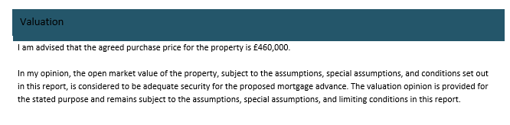

Signatures

Izuka Soligbo (Surveyor) - 12 November 2026

Property Photos


