

SCHOOL OF PURE AND APPLIED SCIENCES.

DEPARTMENT OF COMPUTER AND INFORMATION SCIENCE.

NAME: HUSSEIN IBRAHIM WERAR

REGNO: DIP/IT/1126/2017

UNIT CODE: 030

PROJECT TITTLE: AL RAHMA HOTEL WEBSITE.

I.DECLARATION
I hereby declare that this proposal report is based on my original work except for citations and
Quotations which have been duly acknowledged. I also declare that it has not been previously
And concurrently submitted for any other degree or award at GAU

SIGNATURE: _________________

NAME: ______________________

REG NO: _____________________

DATE: _______________________

II.SUPERVISOR

I hereby certify that this is a true report for the proposal undertaken by the
Above named student under my supervision and that it has been submitted to GAU with my approval.

Signature…………………………………………………….Date…………………………….

III. ACKNOWLEDGEMENTS

I would like to thank everyone who contributed to the successful completion of this proposal. I would like to express my gratitude to my research supervisor, Mr. Mbugua for his invaluable advice, guidance and his enormous patience throughout the development of the project.
In addition, I would also like to express my gratitude to my loving family specially my mum who helped and gave me encouragement. I would also like to thank Mr.Juma who advised me on many areas.

IV. DEDICATION
My special dedication goes to my family for the financial support they gave me throughout my studies.

ABSTRACT

ONLINE FOOD ORDER SYSTEM is a website designed primarily for use in the food delivery industry. This system will allow hotels and restaurants to increase scope of business by reducing the labor cost involved. The system also allows to quickly and easily manage an online menu which customers can browse and use to place orders with just few clicks. Restaurant employees then use these orders through an easy to navigate graphical interface for efficient processing.

Introduction

It is known globally that, in today’s market, it is extremely difficult to start a new small-scale business and live-through the competition from the well-established and settled owners. In fast paced time of today, when everyone is squeezed for time, the majority of people are finicky when it comes to placing a food order. The customers of today are not only attracted because placing an order online is very convenient but also because they have visibility into the items offered, price and extremely simplified navigation for the order.

Implementation
Hardware/Software Interface:
This section lists the minimum hardware and software requirements needed to run the system efficiently.

Hardware Interface:
• Pentium Processor
• 60 MB of free hard-drive space
• 128 MB of RAM

Software Interface:
• Operating System: Windows (Vista/7 or above)
• Web Browser: IE 10 or above, Mozilla FF 31 and above or Google Chrome
• Drivers: Java Runtime Environment
• Integrated Development Environment: Visual Studio Code.

Background and Related Work

Need for a Hotel to have an online Presence.

- A Dedicated Site Will Strengthen Your Brand Identity
Want your restaurant to be thought of as a family eatery with a touch of class? Dream of being the “hip” place for the after work crowd to grab a bite?
Whatever brand identity you wish to create for your establishment, having a designated website will affect the way that customers see your business. Crisp, clean, and well designed web sites will let people that have never eaten at your restaurant know that you are a professional and trustworthy establishment with an eye for quality.
Whatever identity you wish to convey for your business, a web developer and graphic artist can help you design your pages with a brand in mind. And beware: having no website for your restaurant at all may paint you as dated and out of touch, and may cost you customers.
You need a website that is clean, appealing and easy to find. Why? Because a clean website reflects your professionalism in the kitchen, the appealing images create appetite and some basics SEO(Search Engine Optimization) rules guarantee that people can find/ discover you online.
Do not overcrowd your website with a lot of things. Mainly people come to learn a few words about you, check the menu, check pictures, get contact details, and see the info about special offers or events. That’s the focus. That’s what you SEO!

Physical design.

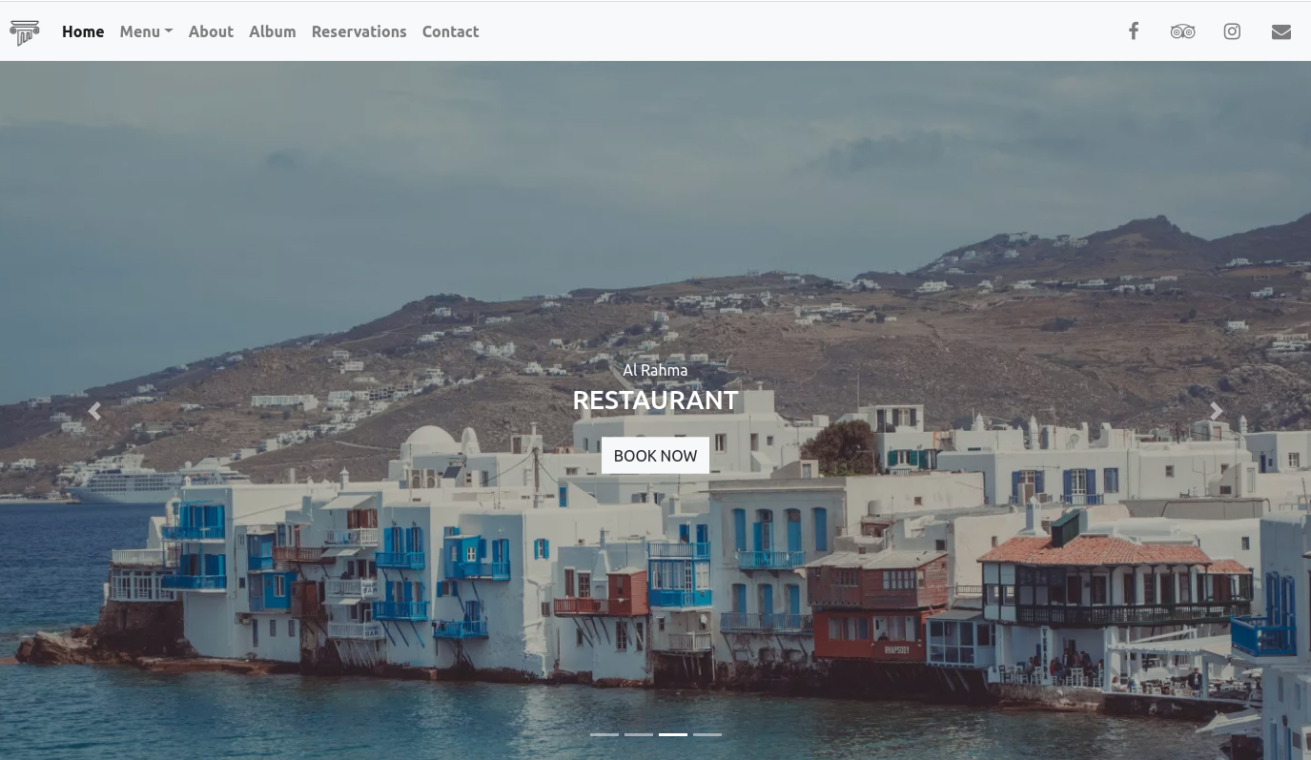
HOME PAGE.

Above figure 1 shows the home page of “AL RAHMA” web based system. This interface contains Home, Album, Reservations , Social Media Pages, and a book Now Button.

Desserts Menu Page.
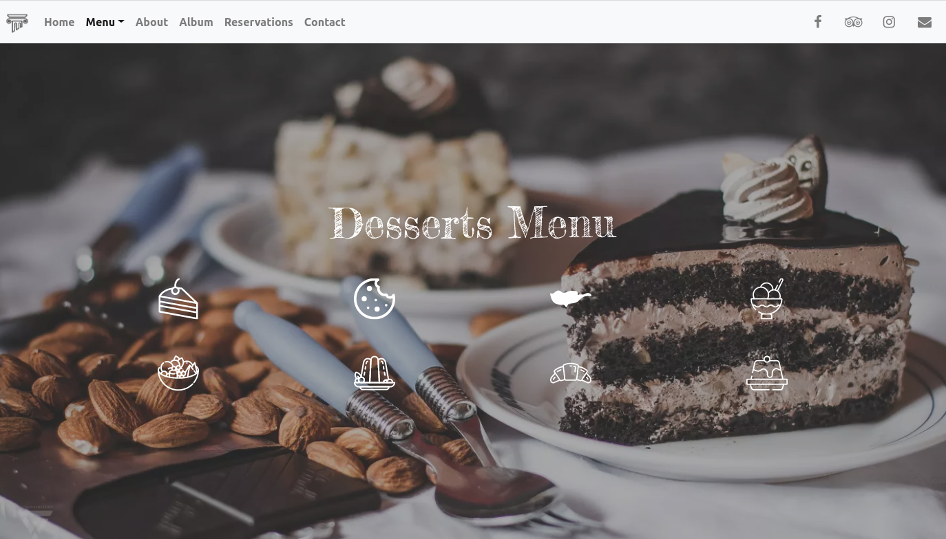
Above figure 2 shows the Desserts page of “AL RAHMA” web based system. This interface contains Home, Album, Reservations , Social Media Pages, and the different types of desserts offered in the said Hotel.

RESERVATIONS PAGE.
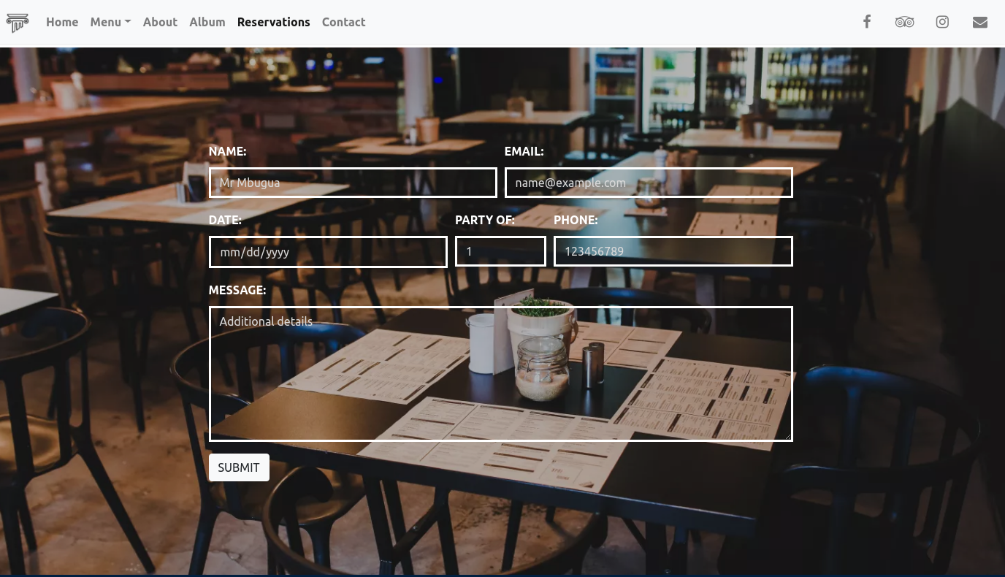
Above figure 3 shows the Reservations page of “AL RAHMA” web based system. This interface contains Home, Album, Reservations , Social Media Pages, and a form to fill when you want a table at the establishment. The form contains
- Name
- Date
- Message
- Email
- Telephone Number
- How Many people you want to dine with...

CONTACT PAGE
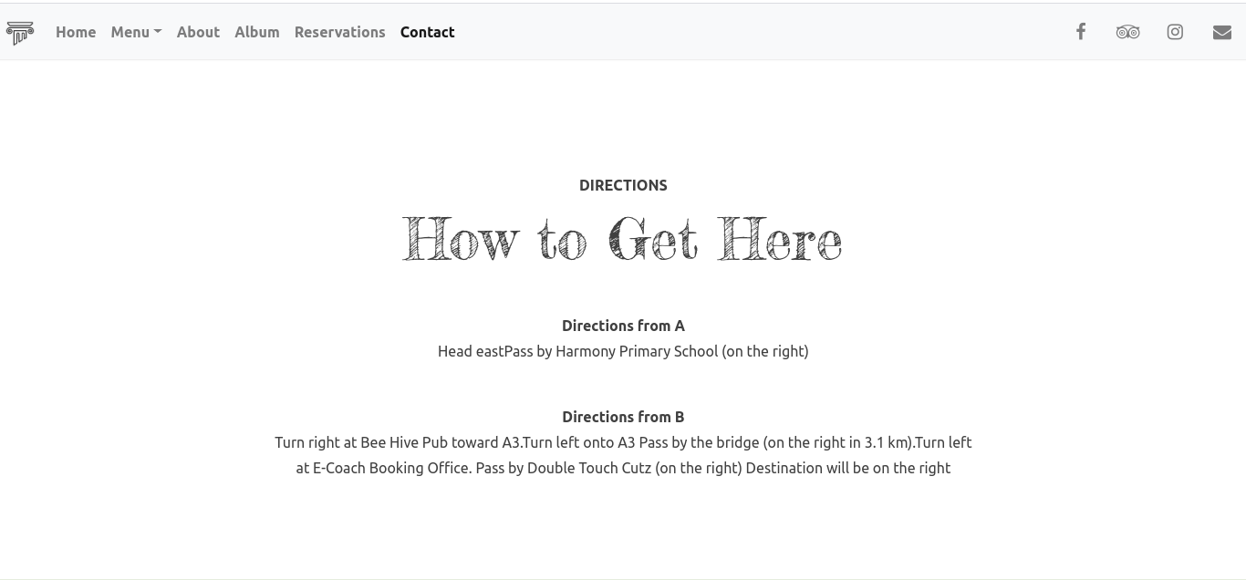
Above figure 4 shows the Reservations page of “AL RAHMA” web based system. This interface contains Home, Album, Reservations , Social Media Pages, and directions to get to the restaurant.

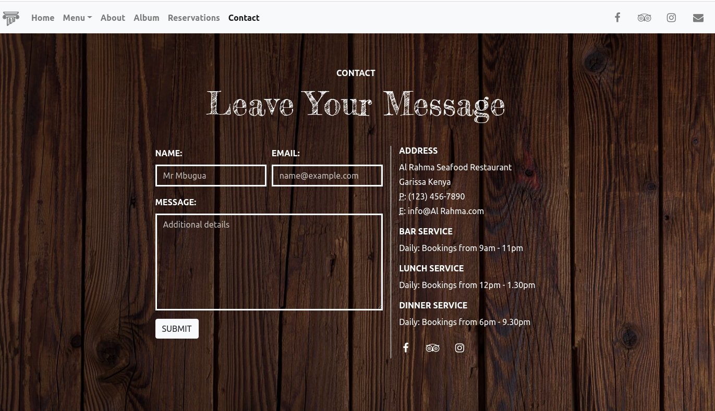
Above figure 5 shows the Contacts page of “AL RAHMA” web based system. This interface contains Home, Album, Reservations , Social Media Pages, details of the restaurant such as
- Address
- Service
- Time of Opening and Closing
- Social Media Pages of the Restaurant

Footer Page
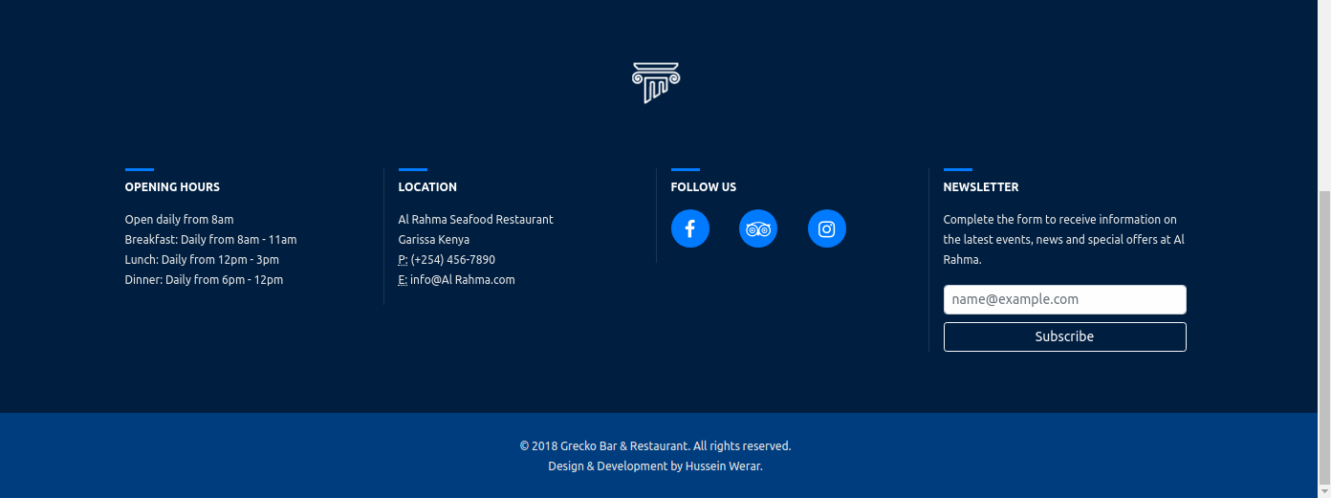
Above figure 6 shows the Footer page of “AL RAHMA” web based system. This interface contains
- Social Media Pages,
- Location
- Newsletter
- Copyright.

Sample Code.
<!doctype html>
<html lang="en">
<head>
<meta charset="utf-8"><meta name="viewport" content="width=device-width,initial-scale=1,shrink-to-fit=no"><title>Al RAHMA Restaurant | Free Bootstrap Website Template</title>
<link rel="manifest" href="manifest.json">
<style>
@charset "UTF-8";.animated{-webkit-animation-duration:1s;animation-duration:1s;-webkit-animation-fill-mode:both;animation-fill-mode:both}
@-webkit-keyframes pulse{from{-webkit-transform:scale3d(1,1,1);transform:scale3d(1,1,1)}50%{-webkit-transform:scale3d(1.05,1.05,1.05);transform:scale3d(1.05,1.05,1.05)}to{-webkit-transform:scale3d(1,1,1);transform:scale3d(1,1,1)}}
@keyframes pulse{from{-webkit-transform:scale3d(1,1,1);transform:scale3d(1,1,1)}50%{-webkit-transform:scale3d(1.05,1.05,1.05);transform:scale3d(1.05,1.05,1.05)}to{-webkit-transform:scale3d(1,1,1);transform:scale3d(1,1,1)}}.pulse{-webkit-animation-name:pulse;animation-name:pulse}@-webkit-keyframes fadeInDown{from{opacity:0;-webkit-transform:translate3d(0,-100%,0);transform:translate3d(0,-100%,0)}to{opacity:1;-webkit-transform:none;transform:none}}@keyframes fadeInDown{from{opacity:0;-webkit-transform:translate3d(0,-100%,0);transform:translate3d(0,-100%,0)}to{opacity:1;-webkit-transform:none;transform:none}}.fadeInDown{-webkit-animation-name:fadeInDown;animation-name:fadeInDown}@-webkit-keyframes fadeInUp{from{opacity:0;-webkit-transform:translate3d(0,100%,0);transform:translate3d(0,100%,0)}to{opacity:1;-webkit-transform:none;transform:none}}@keyframes fadeInUp{from{opacity:0;-webkit-transform:translate3d(0,100%,0);transform:translate3d(0,100%,0)}to{opacity:1;-webkit-transform:none;transform:none}}.fadeInUp{-webkit-animation-name:fadeInUp;animation-name:fadeInUp}:root{--blue:#007bff;--indigo:#6610f2;--purple:#6f42c1;--pink:#e83e8c;--red:#dc3545;--orange:#fd7e14;--yellow:#ffc107;--green:#28a745;--teal:#20c997;--cyan:#17a2b8;--white:#fff;--gray:#6c757d;--gray-dark:#343a40;--primary:#007bff;--secondary:#6c757d;--success:#28a745;--info:#17a2b8;--warning:#ffc107;--danger:#dc3545;--light:#f8f9fa;--dark:#343a40;--breakpoint-xs:0;--breakpoint-sm:576px;--breakpoint-md:768px;--breakpoint-lg:992px;--breakpoint-xl:1200px;--font-family-sans-serif:-apple-system,BlinkMacSystemFont,"Segoe UI",Roboto,"Helvetica Neue",Arial,sans-serif,"Apple Color Emoji","Segoe UI Emoji","Segoe UI Symbol";--font-family-monospace:SFMono-Regular,Menlo,Monaco,Consolas,"Liberation Mono","Courier New",monospace}*,::after,::before{box-sizing:border-box}html{font-family:sans-serif;line-height:1.15;-webkit-text-size-adjust:100%;-ms-text-size-adjust:100%;-ms-overflow-style:scrollbar}footer,header,main,nav{display:block}body{margin:0;font-family:-apple-system,BlinkMacSystemFont,"Segoe UI",Roboto,"Helvetica Neue",Arial,sans-serif,"Apple Color Emoji","Segoe UI Emoji","Segoe UI Symbol";font-size:1rem;font-weight:400;line-height:1.5;color:#212529;text-align:left;background-color:#fff}h1,h4{margin-top:0;margin-bottom:.5rem}p{margin-top:0;margin-bottom:1rem}ol,ul{margin-top:0;margin-bottom:1rem}blockquote{margin:0 0 1rem}a{color:#007bff;text-decoration:none;background-color:transparent;-webkit-text-decoration-skip:objects}img{vertical-align:middle;border-style:none}button{border-radius:0}button{margin:0;font-family:inherit;font-size:inherit;line-height:inherit}button{overflow:visible}button{text-transform:none}button,html [type=button]{-webkit-appearance:button}[type=button]::-moz-focus-inner,button::-moz-focus-inner{padding:0;border-style:none}::-webkit-file-upload-button{font:inherit;-webkit-appearance:button}h1,h4{margin-bottom:.5rem;font-family:inherit;font-weight:500;line-height:1.2;color:inherit}h1{font-size:2.5rem}h4{font-size:1.5rem}.display-2{font-size:5.5rem;font-weight:300;line-height:1.2}.blockquote-footer{display:block;font-size:80%;color:#6c757d}.blockquote-footer::before{content:"\2014 \00A0"}.img-thumbnail{padding:.25rem;background-color:#fff;border:1px solid #dee2e6;border-radius:.25rem;max-width:100%;height:auto}.container{width:100%;padding-right:15px;padding-left:15px;margin-right:auto;margin-left:auto}@media (min-width:576px){.container{max-width:540px}}@media (min-width:768px){.container{max-width:720px}}@media (min-width:992px){.container{max-width:960px}}@media (min-width:1200px){.container{max-width:1140px}}.btn{display:inline-block;font-weight:400;text-align:center;white-space:nowrap;vertical-align:middle;border:1px solid transparent;padding:.375rem .75rem;font-size:1rem;line-height:1.5;border-radius:.25rem}.btn-light{color:#212529;background-color:#f8f9fa;border-color:#f8f9fa}.collapse{display:none}.dropdown{position:relative}.dropdown-toggle::after{display:inline-block;width:0;height:0;margin-left:.255em;vertical-align:.255em;content:"";border-top:.3em solid;border-right:.3em solid transparent;border-bottom:0;border-left:.3em solid transparent}.dropdown-menu{position:absolute;top:100%;left:0;z-index:1000;display:none;float:left;min-width:10rem;padding:.5rem 0;margin:.125rem 0 0;font-size:1rem;color:#212529;text-align:left;list-style:none;background-color:#fff;background-clip:padding-box;border:1px solid rgba(0,0,0,.15);border-radius:.25rem}.dropdown-item{display:block;width:100%;padding:.25rem 1.5rem;clear:both;font-weight:400;color:#212529;text-align:inherit;white-space:nowrap;background-color:transparent;border:0}.nav-link{display:block;padding:.5rem 1rem}.navbar{position:relative;display:-webkit-box;display:-ms-flexbox;display:flex;-ms-flex-wrap:wrap;flex-wrap:wrap;-webkit-box-align:center;-ms-flex-align:center;align-items:center;-webkit-box-pack:justify;-ms-flex-pack:justify;justify-content:space-between;padding:.5rem 1rem}.navbar-brand{display:inline-block;padding-top:.3125rem;padding-bottom:.3125rem;margin-right:1rem;font-size:1.25rem;line-height:inherit;white-space:nowrap}.navbar-nav{display:-webkit-box;display:-ms-flexbox;display:flex;-webkit-box-orient:vertical;-webkit-box-direction:normal;-ms-flex-direction:column;flex-direction:column;padding-left:0;margin-bottom:0;list-style:none}.navbar-nav .nav-link{padding-right:0;padding-left:0}.navbar-nav .dropdown-menu{position:static;float:none}.navbar-collapse{-ms-flex-preferred-size:100%;flex-basis:100%;-webkit-box-flex:1;-ms-flex-positive:1;flex-grow:1;-webkit-box-align:center;-ms-flex-align:center;align-items:center}.navbar-toggler{padding:.25rem .75rem;font-size:1.25rem;line-height:1;background-color:transparent;border:1px solid transparent;border-radius:.25rem}.navbar-toggler-icon{display:inline-block;width:1.5em;height:1.5em;vertical-align:middle;content:"";background:no-repeat center center;background-size:100% 100%}@media (min-width:992px){.navbar-expand-lg{-webkit-box-orient:horizontal;-webkit-box-direction:normal;-ms-flex-flow:row nowrap;flex-flow:row nowrap;-webkit-box-pack:start;-ms-flex-pack:start;justify-content:flex-start}.navbar-expand-lg .navbar-nav{-webkit-box-orient:horizontal;-webkit-box-direction:normal;-ms-flex-direction:row;flex-direction:row}.navbar-expand-lg .navbar-nav .dropdown-menu{position:absolute}.navbar-expand-lg .navbar-nav .nav-link{padding-right:.5rem;padding-left:.5rem}.navbar-expand-lg .navbar-collapse{display:-webkit-box!important;display:-ms-flexbox!important;display:flex!important;-ms-flex-preferred-size:auto;flex-basis:auto}.navbar-expand-lg .navbar-toggler{display:none}}.navbar-light .navbar-brand{color:rgba(0,0,0,.9)}.navbar-light .navbar-nav .nav-link{color:rgba(0,0,0,.5)}.navbar-light .navbar-nav .active>.nav-link{color:rgba(0,0,0,.9)}.navbar-light .navbar-toggler{color:rgba(0,0,0,.5);border-color:rgba(0,0,0,.1)}.navbar-light .navbar-toggler-icon{background-image:url("data:image/svg+xml;charset=utf8,%3Csvg viewBox='0 0 30 30' xmlns='http://www.w3.org/2000/svg'%3E%3Cpath stroke='rgba(0, 0, 0, 0.5)' stroke-width='2' stroke-linecap='round' stroke-miterlimit='10' d='M4 7h22M4 15h22M4 23h22'/%3E%3C/svg%3E")}.carousel{position:relative}.carousel-inner{position:relative;width:100%;overflow:hidden}.carousel-item{position:relative;display:none;-webkit-box-align:center;-ms-flex-align:center;align-items:center;width:100%;-webkit-backface-visibility:hidden;backface-visibility:hidden;-webkit-perspective:1000px;perspective:1000px}.carousel-item.active{display:block}.carousel-control-next,.carousel-control-prev{position:absolute;top:0;bottom:0;display:-webkit-box;display:-ms-flexbox;display:flex;-webkit-box-align:center;-ms-flex-align:center;align-items:center;-webkit-box-pack:center;-ms-flex-pack:center;justify-content:center;width:15%;color:#fff;text-align:center;opacity:.5}.carousel-control-prev{left:0}.carousel-control-next{right:0}.carousel-control-next-icon,.carousel-control-prev-icon{display:inline-block;width:20px;height:20px;background:transparent no-repeat center center;background-size:100% 100%}.carousel-control-prev-icon{background-image:url("data:image/svg+xml;charset=utf8,%3Csvg xmlns='http://www.w3.org/2000/svg' fill='%23fff' viewBox='0 0 8 8'%3E%3Cpath d='M5.25 0l-4 4 4 4 1.5-1.5-2.5-2.5 2.5-2.5-1.5-1.5z'/%3E%3C/svg%3E")}.carousel-control-next-icon{background-image:url("data:image/svg+xml;charset=utf8,%3Csvg xmlns='http://www.w3.org/2000/svg' fill='%23fff' viewBox='0 0 8 8'%3E%3Cpath d='M2.75 0l-1.5 1.5 2.5 2.5-2.5 2.5 1.5 1.5 4-4-4-4z'/%3E%3C/svg%3E")}.carousel-indicators{position:absolute;right:0;bottom:10px;left:0;z-index:15;display:-webkit-box;display:-ms-flexbox;display:flex;-webkit-box-pack:center;-ms-flex-pack:center;justify-content:center;padding-left:0;margin-right:15%;margin-left:15%;list-style:none}.carousel-indicators li{position:relative;-webkit-box-flex:0;-ms-flex:0 1 auto;flex:0 1 auto;width:30px;height:3px;margin-right:3px;margin-left:3px;text-indent:-999px;background-color:rgba(255,255,255,.5)}.carousel-indicators li::before{position:absolute;top:-10px;left:0;display:inline-block;width:100%;height:10px;content:""}.carousel-indicators li::after{position:absolute;bottom:-10px;left:0;display:inline-block;width:100%;height:10px;content:""}.carousel-indicators .active{background-color:#fff}.carousel-caption{position:absolute;right:15%;bottom:20px;left:15%;z-index:10;padding-top:20px;padding-bottom:20px;color:#fff;text-align:center}.bg-light{background-color:#f8f9fa!important}.rounded-circle{border-radius:50%!important}.d-block{display:block!important}.fixed-top{position:fixed;top:0;right:0;left:0;z-index:1030}.sr-only{position:absolute;width:1px;height:1px;padding:0;overflow:hidden;clip:rect(0,0,0,0);white-space:nowrap;-webkit-clip-path:inset(50%);clip-path:inset(50%);border:0}.mb-0{margin-bottom:0!important}.mr-2{margin-right:.5rem!important}.mt-3{margin-top:1rem!important}.mx-auto{margin-right:auto!important}
.ml-auto,.mx-auto{margin-left:auto!important}.text-center{text-align:center!important}@media (min-width:992px){.text-lg-left{text-align:left!important}}html{font-size:1rem}body{font-size:1rem;color:#404040;line-height:1.75;font-family:-apple-system,BlinkMacSystemFont,"Segoe UI",Roboto,Oxygen-Sans,Ubuntu,Cantarell,"Helvetica Neue",sans-serif;font-weight:400;padding-top:62px}a{color:inherit}.back-to-top{display:none;position:fixed;z-index:1;bottom:0;right:0;margin:0 auto;width:40px;height:40px;background-color:#007bff;opacity:.5;text-align:center;line-height:40px}.back-to-top i{color:#fff;font-size:20px}.navbar{box-shadow:0 2px 2px -2px rgba(0,0,0,.2)}.dropdown-item,.nav-link{font-weight:700}.cover .carousel-item>img{min-width:100%;height:calc(100vh - 62px);object-fit:cover}.cover .carousel-caption{bottom:initial;top:50%;transform:translateY(-50%);color:#fff}.cover .carousel-caption>a{border-radius:0}.dark-overlay::after{content:' ';width:100%;height:100%;background:#000;opacity:.3;position:absolute;left:0;top:0}.brand-title{font-family:'Fredericka the Great',cursive;font-size:calc(50px + (120 - 50) * (100vw - 320px)/ (2560 - 320))}.brand-description{font-size:calc(16px + (40 - 16) * (100vw - 320px)/ (2560 - 320))}.homepage-testimonials blockquote{max-width:50em;margin:2.8rem auto 0 auto}.homepage-testimonials blockquote footer{color:#e6e6e6}.homepage-testimonials blockquote footer a{color:#fff;text-decoration:underline}.nav-social{display:inline-block;width:40px;height:40px;line-height:43px}.nav-social i{font-size:20px;color:rgba(0,0,0,.5)}.navbar-brand.animated{animation-duration:2s;animation-iteration-count:infinite}</style><link rel="preload" href="https://cdnjs.cloudflare.com/ajax/libs/font-awesome/4.7.0/css/font-awesome.min.css" as="style" onload="this.onload=null;this.rel='stylesheet'"><noscript><link rel="stylesheet" href="https://cdnjs.cloudflare.com/ajax/libs/font-awesome/4.7.0/css/font-awesome.min.css">
</noscript><link href="https://fonts.googleapis.com/css?family=Fredericka+the+Great" rel="preload" as="style" onload="this.onload=null;this.rel='stylesheet'"><noscript><link href="https://fonts.googleapis.com/css?family=Fredericka+the+Great" rel="stylesheet"></noscript>
<link rel="preload" href="css/purestyles.css" as="style" onload="this.onload=null;this.rel='stylesheet'">
<noscript>
<link rel="stylesheet" href="css/purestyles.css">
</noscript>
<script>
!function(n){"use strict";n.loadCSS||(n.loadCSS=function(){});var o=loadCSS.relpreload={};if(o.support=function(){var e;try{e=n.document.createElement("link").relList.supports("preload")}catch(t){e=!1}return function(){return e}}(),o.bindMediaToggle=function(t){var e=t.media||"all";function a(){t.media=e}t.addEventListener?t.addEventListener("load",a):t.attachEvent&&t.attachEvent("onload",a),setTimeout(function(){t.rel="stylesheet",t.media="only x"}),setTimeout(a,3e3)},o.poly=function(){if(!o.support())for(var t=n.document.getElementsByTagName("link"),e=0;e<t.length;e++){var a=t[e];"preload"!==a.rel||"style"!==a.getAttribute("as")||a.getAttribute("data-loadcss")||(a.setAttribute("data-loadcss",!0),o.bindMediaToggle(a))}},!o.support()){o.poly();var t=n.setInterval(o.poly,500);n.addEventListener?n.addEventListener("load",function(){o.poly(),n.clearInterval(t)}):n.attachEvent&&n.attachEvent("onload",function(){o.poly(),n.clearInterval(t)})}"undefined"!=typeof exports?exports.loadCSS=loadCSS:n.loadCSS=loadCSS}("undefined"!=typeof global?global:this);</script>
</head>
<body id="top">
<header>
<nav class="navbar navbar-expand-lg navbar-light bg-light fixed-top"><a class="navbar-brand animated pulse" href="#">
<img src="media/brand/logo-dark.svg" width="30" height="30" alt="Logo">
</a><button class="navbar-toggler" type="button" data-toggle="collapse" data-target="#navbarNav" aria-controls="navbarNav" aria-expanded="false" aria-label="Toggle navigation"><span class="navbar-toggler-icon"></span></button><div class="collapse navbar-collapse text-center" id="navbarNav"><ul class="navbar-nav"><li class="nav-item active"><a class="nav-link" href="#">Home <span class="sr-only">(current)</span></a>
</li>
<li class="nav-item dropdown"><a class="nav-link dropdown-toggle" href="#" id="navbarDropdown" role="button" data-toggle="dropdown" aria-haspopup="true" aria-expanded="false">Menu</a><div class="dropdown-menu text-center text-lg-left" aria-labelledby="navbarDropdown"><a class="dropdown-item" href="#">Food</a> <a class="dropdown-item" href="pages/desserts.html">Desserts</a> <a class="dropdown-item" href="#">Drinks</a></div></li><li class="nav-item"><a class="nav-link" href="#">About</a></li><li class="nav-item"><a class="nav-link" href="#">Album</a></li><li class="nav-item"><a class="nav-link" href="pages/reservations.html">Reservations</a></li><li class="nav-item"><a class="nav-link" href="#">Contact</a></li></ul><div class="ml-auto"><a class="nav-social mr-2" href="#"><i class="fa fa-facebook" aria-hidden="true"></i></a> <a class="nav-social mr-2" href="#"><i class="fa fa-tripadvisor" aria-hidden="true"></i></a> <a class="nav-social mr-2" href="#"><i class="fa fa-instagram" aria-hidden="true"></i></a> <a class="nav-social" href="#"><i class="fa fa-envelope" aria-hidden="true"></i></a></div></div></nav></header><main><div id="cover" class="cover carousel slide" data-ride="carousel"><ol class="carousel-indicators"><li data-target="#cover" data-slide-to="0" class="active"></li><li data-target="#cover" data-slide-to="1"></li><li data-target="#cover" data-slide-to="2"></li><li data-target="#cover" data-slide-to="3"></li></ol><div class="carousel-inner"><div class="dark-overlay carousel-item active"><img sizes="(max-width: 2560px) 100vw, 2560px" srcset="https://res.cloudinary.com/pictureelement/image/upload/q_auto,f_auto,c_scale,w_320/v1535322021/website-template-3/cover-homepage-1.jpg 320w, https://res.cloudinary.com/pictureelement/image/upload/q_auto,f_auto,c_scale,w_563/v1535322021/website-template-3/cover-homepage-1.jpg 563w, https://res.cloudinary.com/pictureelement/image/upload/q_auto,f_auto,c_scale,w_770/v1535322021/website-template-3/cover-homepage-1.jpg 770w, https://res.cloudinary.com/pictureelement/image/upload/q_auto,f_auto,c_scale,w_956/v1535322021/website-template-3/cover-homepage-1.jpg 956w, https://res.cloudinary.com/pictureelement/image/upload/q_auto,f_auto,c_scale,w_1109/v1535322021/website-template-3/cover-homepage-1.jpg 1109w, https://res.cloudinary.com/pictureelement/image/upload/q_auto,f_auto,c_scale,w_1283/v1535322021/website-template-3/cover-homepage-1.jpg 1283w, https://res.cloudinary.com/pictureelement/image/upload/q_auto,f_auto,c_scale,w_1439/v1535322021/website-template-3/cover-homepage-1.jpg 1439w, https://res.cloudinary.com/pictureelement/image/upload/q_auto,f_auto,c_scale,w_1580/v1535322021/website-template-3/cover-homepage-1.jpg 1580w, https://res.cloudinary.com/pictureelement/image/upload/q_auto,f_auto,c_scale,w_1712/v1535322021/website-template-3/cover-homepage-1.jpg 1712w, https://res.cloudinary.com/pictureelement/image/upload/q_auto,f_auto,c_scale,w_1864/v1535322021/website-template-3/cover-homepage-1.jpg 1864w, https://res.cloudinary.com/pictureelement/image/upload/q_auto,f_auto,c_scale,w_1993/v1535322021/website-template-3/cover-homepage-1.jpg 1993w, https://res.cloudinary.com/pictureelement/image/upload/q_auto,f_auto,c_scale,w_2115/v1535322021/website-template-3/cover-homepage-1.jpg 2115w, https://res.cloudinary.com/pictureelement/image/upload/q_auto,f_auto,c_scale,w_2246/v1535322021/website-template-3/cover-homepage-1.jpg 2246w, https://res.cloudinary.com/pictureelement/image/upload/q_auto,f_auto,c_scale,w_2377/v1535322021/website-template-3/cover-homepage-1.jpg 2377w, https://res.cloudinary.com/pictureelement/image/upload/q_auto,f_auto,c_scale,w_2506/v1535322021/website-template-3/cover-homepage-1.jpg 2506w, https://res.cloudinary.com/pictureelement/image/upload/q_auto,f_auto,c_scale,w_2560/v1535322021/website-template-3/cover-homepage-1.jpg 2560w" src="https://res.cloudinary.com/pictureelement/image/upload/q_auto,f_auto,c_scale,w_2560/v1535322021/website-template-3/cover-homepage-1.jpg" alt="First slide"><div class="carousel-caption"><h1 class="brand-title display-2 animated fadeInDown">Al Rahma</h1><h4 class="brand-description animated fadeInDown"> RESTAURANT</h4><a class="mt-3 btn btn-light animated fadeInUp" href="pages/reservations.html" role="button">BOOK NOW</a></div></div><div class="dark-overlay carousel-item"><img sizes="(max-width: 2560px) 100vw, 2560px" srcset="https://res.cloudinary.com/pictureelement/image/upload/q_auto,f_auto,c_scale,w_320/v1535322195/website-template-3/cover-homepage-2.jpg 320w, https://res.cloudinary.com/pictureelement/image/upload/q_auto,f_auto,c_scale,w_618/v1535322195/website-template-3/cover-homepage-2.jpg 618w, https://res.cloudinary.com/pictureelement/image/upload/q_auto,f_auto,c_scale,w_842/v1535322195/website-template-3/cover-homepage-2.jpg 842w, https://res.cloudinary.com/pictureelement/image/upload/q_auto,f_auto,c_scale,w_1037/v1535322195/website-template-3/cover-homepage-2.jpg 1037w, https://res.cloudinary.com/pictureelement/image/upload/q_auto,f_auto,c_scale,w_1200/v1535322195/website-template-3/cover-homepage-2.jpg 1200w, https://res.cloudinary.com/pictureelement/image/upload/q_auto,f_auto,c_scale,w_1326/v1535322195/website-template-3/cover-homepage-2.jpg 1326w, https://res.cloudinary.com/pictureelement/image/upload/q_auto,f_auto,c_scale,w_1439/v1535322195/website-template-3/cover-homepage-2.jpg 1439w, https://res.cloudinary.com/pictureelement/image/upload/q_auto,f_auto,c_scale,w_1541/v1535322195/website-template-3/cover-homepage-2.jpg 1541w, https://res.cloudinary.com/pictureelement/image/upload/q_auto,f_auto,c_scale,w_1639/v1535322195/website-template-3/cover-homepage-2.jpg 1639w, https://res.cloudinary.com/pictureelement/image/upload/q_auto,f_auto,c_scale,w_1724/v1535322195/website-template-3/cover-homepage-2.jpg 1724w, https://res.cloudinary.com/pictureelement/image/upload/q_auto,f_auto,c_scale,w_1808/v1535322195/website-template-3/cover-homepage-2.jpg 1808w, https://res.cloudinary.com/pictureelement/image/upload/q_auto,f_auto,c_scale,w_1886/v1535322195/website-template-3/cover-homepage-2.jpg 1886w, https://res.cloudinary.com/pictureelement/image/upload/q_auto,f_auto,c_scale,w_1963/v1535322195/website-template-3/cover-homepage-2.jpg 1963w, https://res.cloudinary.com/pictureelement/image/upload/q_auto,f_auto,c_scale,w_2037/v1535322195/website-template-3/cover-homepage-2.jpg 2037w, https://res.cloudinary.com/pictureelement/image/upload/q_auto,f_auto,c_scale,w_2108/v1535322195/website-template-3/cover-homepage-2.jpg 2108w, https://res.cloudinary.com/pictureelement/image/upload/q_auto,f_auto,c_scale,w_2169/v1535322195/website-template-3/cover-homepage-2.jpg 2169w, https://res.cloudinary.com/pictureelement/image/upload/q_auto,f_auto,c_scale,w_2238/v1535322195/website-template-3/cover-homepage-2.jpg 2238w, https://res.cloudinary.com/pictureelement/image/upload/q_auto,f_auto,c_scale,w_2301/v1535322195/website-template-3/cover-homepage-2.jpg 2301w, https://res.cloudinary.com/pictureelement/image/upload/q_auto,f_auto,c_scale,w_2361/v1535322195/website-template-3/cover-homepage-2.jpg 2361w, https://res.cloudinary.com/pictureelement/image/upload/q_auto,f_auto,c_scale,w_2420/v1535322195/website-template-3/cover-homepage-2.jpg 2420w, https://res.cloudinary.com/pictureelement/image/upload/q_auto,f_auto,c_scale,w_2477/v1535322195/website-template-3/cover-homepage-2.jpg 2477w, https://res.cloudinary.com/pictureelement/image/upload/q_auto,f_auto,c_scale,w_2536/v1535322195/website-template-3/cover-homepage-2.jpg 2536w, https://res.cloudinary.com/pictureelement/image/upload/q_auto,f_auto,c_scale,w_2558/v1535322195/website-template-3/cover-homepage-2.jpg 2558w, https://res.cloudinary.com/pictureelement/image/upload/q_auto,f_auto,c_scale,w_2560/v1535322195/website-template-3/cover-homepage-2.jpg 2560w" src="https://res.cloudinary.com/pictureelement/image/upload/q_auto,f_auto,c_scale,w_2560/v1535322195/website-template-3/cover-homepage-2.jpg" alt="Second slide"><div class="carousel-caption"><h1 class="brand-title display-2 animated fadeInDown">Al Rahma</h1><h4 class="brand-description animated fadeInDown">RESTAURANT</h4><a class="mt-3 btn btn-light animated fadeInUp" href="pages/reservations.html" role="button">BOOK NOW</a></div></div><div class="dark-overlay carousel-item"><img sizes="(max-width: 2560px) 100vw, 2560px" srcset="https://res.cloudinary.com/pictureelement/image/upload/q_auto,f_auto,c_scale,w_320/v1535322301/website-template-3/cover-homepage-3.jpg 320w, https://res.cloudinary.com/pictureelement/image/upload/q_auto,f_auto,c_scale,w_525/v1535322301/website-template-3/cover-homepage-3.jpg 525w, https://res.cloudinary.com/pictureelement/image/upload/q_auto,f_auto,c_scale,w_682/v1535322301/website-template-3/cover-homepage-3.jpg 682w, https://res.cloudinary.com/pictureelement/image/upload/q_auto,f_auto,c_scale,w_827/v1535322301/website-template-3/cover-homepage-3.jpg 827w, https://res.cloudinary.com/pictureelement/image/upload/q_auto,f_auto,c_scale,w_945/v1535322301/website-template-3/cover-homepage-3.jpg 945w, https://res.cloudinary.com/pictureelement/image/upload/q_auto,f_auto,c_scale,w_1052/v1535322301/website-template-3/cover-homepage-3.jpg 1052w, https://res.cloudinary.com/pictureelement/image/upload/q_auto,f_auto,c_scale,w_1153/v1535322301/website-template-3/cover-homepage-3.jpg 1153w, https://res.cloudinary.com/pictureelement/image/upload/q_auto,f_auto,c_scale,w_1251/v1535322301/website-template-3/cover-homepage-3.jpg 1251w, https://res.cloudinary.com/pictureelement/image/upload/q_auto,f_auto,c_scale,w_1346/v1535322301/website-template-3/cover-homepage-3.jpg 1346w, https://res.cloudinary.com/pictureelement/image/upload/q_auto,f_auto,c_scale,w_1427/v1535322301/website-template-3/cover-homepage-3.jpg 1427w, https://res.cloudinary.com/pictureelement/image/upload/q_auto,f_auto,c_scale,w_1506/v1535322301/website-template-3/cover-homepage-3.jpg
1506w, https://res.cloudinary.com/pictureelement/image/upload/q_auto,f_auto,c_scale,w_1592/v1535322301/website-template-3/cover-homepage-3.jpg 1592w, https://res.cloudinary.com/pictureelement/image/upload/q_auto,f_auto,c_scale,w_1680/v1535322301/website-template-3/cover-homepage-3.jpg 1680w, https://res.cloudinary.com/pictureelement/image/upload/q_auto,f_auto,c_scale,w_1760/v1535322301/website-template-3/cover-homepage-3.jpg 1760w, https://res.cloudinary.com/pictureelement/image/upload/q_auto,f_auto,c_scale,w_1814/v1535322301/website-template-3/cover-homepage-3.jpg 1814w, https://res.cloudinary.com/pictureelement/image/upload/q_auto,f_auto,c_scale,w_1895/v1535322301/website-template-3/cover-homepage-3.jpg 1895w, https://res.cloudinary.com/pictureelement/image/upload/q_auto,f_auto,c_scale,w_1972/v1535322301/website-template-3/cover-homepage-3.jpg 1972w, https://res.cloudinary.com/pictureelement/image/upload/q_auto,f_auto,c_scale,w_2034/v1535322301/website-template-3/cover-homepage-3.jpg 2034w, https://res.cloudinary.com/pictureelement/image/upload/q_auto,f_auto,c_scale,w_2107/v1535322301/website-template-3/cover-homepage-3.jpg 2107w, https://res.cloudinary.com/pictureelement/image/upload/q_auto,f_auto,c_scale,w_2174/v1535322301/website-template-3/cover-homepage-3.jpg 2174w, https://res.cloudinary.com/pictureelement/image/upload/q_auto,f_auto,c_scale,w_2245/v1535322301/website-template-3/cover-homepage-3.jpg 2245w, https://res.cloudinary.com/pictureelement/image/upload/q_auto,f_auto,c_scale,w_2302/v1535322301/website-template-3/cover-homepage-3.jpg 2302w, https://res.cloudinary.com/pictureelement/image/upload/q_auto,f_auto,c_scale,w_2366/v1535322301/website-template-3/cover-homepage-3.jpg 2366w, https://res.cloudinary.com/pictureelement/image/upload/q_auto,f_auto,c_scale,w_2429/v1535322301/website-template-3/cover-homepage-3.jpg 2429w, https://res.cloudinary.com/pictureelement/image/upload/q_auto,f_auto,c_scale,w_2497/v1535322301/website-template-3/cover-homepage-3.jpg 2497w, https://res.cloudinary.com/pictureelement/image/upload/q_auto,f_auto,c_scale,w_2559/v1535322301/website-template-3/cover-homepage-3.jpg 2559w, https://res.cloudinary.com/pictureelement/image/upload/q_auto,f_auto,c_scale,w_2555/v1535322301/website-template-3/cover-homepage-3.jpg 2555w, https://res.cloudinary.com/pictureelement/image/upload/q_auto,f_auto,c_scale,w_2560/v1535322301/website-template-3/cover-homepage-3.jpg 2560w" src="https://res.cloudinary.com/pictureelement/image/upload/q_auto,f_auto,c_scale,w_2560/v1535322301/website-template-3/cover-homepage-3.jpg" alt="Third slide"><div class="container"><div class="carousel-caption"><h1 class="brand-title display-2 animated fadeInDown"></h1>Al Rahma</h1><h4 class="brand-description animated fadeInDown">RESTAURANT</h4><a class="mt-3 btn btn-light animated fadeInUp" href="pages/reservations.html" role="button">BOOK NOW</a></div></div></div><div class="dark-overlay carousel-item"><img sizes="(max-width: 2560px) 100vw, 2560px" srcset="https://res.cloudinary.com/pictureelement/image/upload/q_auto,f_auto,c_scale,w_320/v1535322386/website-template-3/cover-homepage-4.jpg 320w, https://res.cloudinary.com/pictureelement/image/upload/q_auto,f_auto,c_scale,w_572/v1535322386/website-template-3/cover-homepage-4.jpg 572w, https://res.cloudinary.com/pictureelement/image/upload/q_auto,f_auto,c_scale,w_782/v1535322386/website-template-3/cover-homepage-4.jpg 782w, https://res.cloudinary.com/pictureelement/image/upload/q_auto,f_auto,c_scale,w_969/v1535322386/website-template-3/cover-homepage-4.jpg 969w, https://res.cloudinary.com/pictureelement/image/upload/q_auto,f_auto,c_scale,w_1131/v1535322386/website-template-3/cover-homepage-4.jpg 1131w, https://res.cloudinary.com/pictureelement/image/upload/q_auto,f_auto,c_scale,w_1291/v1535322386/website-template-3/cover-homepage-4.jpg 1291w, https://res.cloudinary.com/pictureelement/image/upload/q_auto,f_auto,c_scale,w_1446/v1535322386/website-template-3/cover-homepage-4.jpg 1446w, https://res.cloudinary.com/pictureelement/image/upload/q_auto,f_auto,c_scale,w_1583/v1535322386/website-template-3/cover-homepage-4.jpg 1583w, https://res.cloudinary.com/pictureelement/image/upload/q_auto,f_auto,c_scale,w_1713/v1535322386/website-template-3/cover-homepage-4.jpg 1713w, https://res.cloudinary.com/pictureelement/image/upload/q_auto,f_auto,c_scale,w_1837/v1535322386/website-template-3/cover-homepage-4.jpg 1837w, https://res.cloudinary.com/pictureelement/image/upload/q_auto,f_auto,c_scale,w_1959/v1535322386/website-template-3/cover-homepage-4.jpg 1959w, https://res.cloudinary.com/pictureelement/image/upload/q_auto,f_auto,c_scale,w_2075/v1535322386/website-template-3/cover-homepage-4.jpg 2075w, https://res.cloudinary.com/pictureelement/image/upload/q_auto,f_auto,c_scale,w_2193/v1535322386/website-template-3/cover-homepage-4.jpg 2193w, https://res.cloudinary.com/pictureelement/image/upload/q_auto,f_auto,c_scale,w_2305/v1535322386/website-template-3/cover-homepage-4.jpg 2305w, https://res.cloudinary.com/pictureelement/image/upload/q_auto,f_auto,c_scale,w_2407/v1535322386/website-template-3/cover-homepage-4.jpg 2407w, https://res.cloudinary.com/pictureelement/image/upload/q_auto,f_auto,c_scale,w_2513/v1535322386/website-template-3/cover-homepage-4.jpg 2513w, https://res.cloudinary.com/pictureelement/image/upload/q_auto,f_auto,c_scale,w_2560/v1535322386/website-template-3/cover-homepage-4.jpg 2560w" src="https://res.cloudinary.com/pictureelement/image/upload/q_auto,f_auto,c_scale,w_2560/v1535322386/website-template-3/cover-homepage-4.jpg" alt="Fourth slide"><div class="container"><div class="carousel-caption"><h1 class="brand-title display-2 animated fadeInDown">Al Rahma</h1><h4 class="brand-description animated fadeInDown">RESTAURANT</h4><a class="mt-3 btn btn-light animated fadeInUp" href="pages/reservations.html" role="button">BOOK NOW</a></div></div></div><a class="carousel-control-prev" href="#cover" role="button" data-slide="prev"><span class="carousel-control-prev-icon" aria-hidden="true"></span> <span class="sr-only">Previous</span> </a><a class="carousel-control-next" href="#cover" role="button" data-slide="next"><span class="carousel-control-next-icon" aria-hidden="true"></span> <span class="sr-only">Next</span></a></div></div><div class="homepage-menu container text-center"><div class="row"><div class="col-md-4 homepage-food"><h3 class="special-title-2">Food</h3><div id="food"><img data-src="https://res.cloudinary.com/pictureelement/image/upload/q_auto,f_auto,c_scale,w_200/v1535882302/website-template-3/homepage-food.jpg" data-srcset="
https://res.cloudinary.com/pictureelement/image/upload/q_auto,f_auto,c_scale,w_200/v1535882302/website-template-3/homepage-food.jpg 1x,
https://res.cloudinary.com/pictureelement/image/upload/q_auto,f_auto,c_scale,w_400/v1535882302/website-template-3/homepage-food.jpg 2x,
https://res.cloudinary.com/pictureelement/image/upload/q_auto,f_auto,c_scale,w_600/v1535882302/website-template-3/homepage-food.jpg 3x" alt="Food Menu" class="rounded-circle lazyload"><p class="homepage-menu-description"></p>Food is a metaphor for existence.</p><a class="btn btn-outline-dark" href="pages/food.html" role="button">VIEW MENU</a></div></div><div class="col-md-4 homepage-desserts"><h3 class="special-title-2">Desserts</h3><div id="desserts"><img data-src="https://res.cloudinary.com/pictureelement/image/upload/q_auto,f_auto,c_scale,w_200/v1535885127/website-template-3/homepage-desserts.jpg" data-srcset="
https://res.cloudinary.com/pictureelement/image/upload/q_auto,f_auto,c_scale,w_200/v1535885127/website-template-3/homepage-desserts.jpg 1x,
https://res.cloudinary.com/pictureelement/image/upload/q_auto,f_auto,c_scale,w_400/v1535885127/website-template-3/homepage-desserts.jpg 2x,
https://res.cloudinary.com/pictureelement/image/upload/q_auto,f_auto,c_scale,w_600/v1535885127/website-template-3/homepage-desserts.jpg 3x" alt="Desserts Menu" class="rounded-circle lazyload"><p class="homepage-menu-description"></p>Whether you crave sweet, savory, decadent or healthy, we have hundreds of top-rated desserts to satisfy your taste buds.<a class="btn btn-outline-dark" href="pages/desserts.html" role="button">VIEW MENU</a></div></div><div class="col-md-4 homepage-drinks"><h3 class="special-title-2">Drinks</h3><div id="drinks"><img data-src="https://res.cloudinary.com/pictureelement/image/upload/q_auto,f_auto,c_scale,w_200/v1535885398/website-template-3/homepage-drinks.jpg" data-srcset="
https://res.cloudinary.com/pictureelement/image/upload/q_auto,f_auto,c_scale,w_200/v1535885398/website-template-3/homepage-drinks.jpg 1x,
https://res.cloudinary.com/pictureelement/image/upload/q_auto,f_auto,c_scale,w_400/v1535885398/website-template-3/homepage-drinks.jpg 2x,
https://res.cloudinary.com/pictureelement/image/upload/q_auto,f_auto,c_scale,w_600/v1535885398/website-template-3/homepage-drinks.jpg 3x" alt="Drinks Menu" class="rounded-circle lazyload"><p class="homepage-menu-description">Banana, strawberry, and dozens more fruit and vegetable smoothies.</p><a class="btn btn-outline-dark" href="pages/drinks.html" role="button">VIEW MENU</a></div></div></div></div><div class="homepage-about-us dark-overlay text-white"><img sizes="(max-width: 2560px) 100vw, 2560px" data-srcset="
https://res.cloudinary.com/pictureelement/image/upload/q_auto,f_auto,c_scale,w_320/v1535893044/website-template-3/homepage-about-us.jpg 320w,
https://res.cloudinary.com/pictureelement/image/upload/q_auto,f_auto,c_scale,w_514/v1535893044/website-template-3/homepage-about-us.jpg 514w,
https://res.cloudinary.com/pictureelement/image/upload/q_auto,f_auto,c_scale,w_674/v1535893044/website-template-3/homepage-about-us.jpg 674w,
https://res.cloudinary.com/pictureelement/image/upload/q_auto,f_auto,c_scale,w_814/v1535893044/website-template-3/homepage-about-us.jpg 814w,
https://res.cloudinary.com/pictureelement/image/upload/q_auto,f_auto,c_scale,w_936/v1535893044/website-template-3/homepage-about-us.jpg 936w,
https://res.cloudinary.com/pictureelement/image/upload/q_auto,f_auto,c_scale,w_1058/v1535893044/website-template-3/homepage-about-us.jpg 1058w,
https://res.cloudinary.com/pictureelement/image/upload/q_auto,f_auto,c_scale,w_1174/v1535893044/website-template-3/homepage-about-us.jpg 1174w,
https://res.cloudinary.com/pictureelement/image/upload/q_auto,f_auto,c_scale,w_1274/v1535893044/website-template-3/homepage-about-us.jpg 1274w,
https://res.cloudinary.com/pictureelement/image/upload/q_auto,f_auto,c_scale,w_1377/v1535893044/website-template-3/homepage-about-us.jpg 1377w,
https://res.cloudinary.com/pictureelement/image/upload/q_auto,f_auto,c_scale,w_1476/v1535893044/website-template-3/homepage-about-us.jpg 1476w,
https://res.cloudinary.com/pictureelement/image/upload/q_auto,f_auto,c_scale,w_1574/v1535893044/website-template-3/homepage-about-us.jpg 1574w,
https://res.cloudinary.com/pictureelement/image/upload/q_auto,f_auto,c_scale,w_1659/v1535893044/website-template-3/homepage-about-us.jpg 1659w,
https://res.cloudinary.com/pictureelement/image/upload/q_auto,f_auto,c_scale,w_1740/v1535893044/website-template-3/homepage-about-us.jpg 1740w,
https://res.cloudinary.com/pictureelement/image/upload/q_auto,f_auto,c_scale,w_1829/v1535893044/website-template-3/homepage-about-us.jpg 1829w,
https://res.cloudinary.com/pictureelement/image/upload/q_auto,f_auto,c_scale,w_1909/v1535893044/website-template-3/homepage-about-us.jpg 1909w,
https://res.cloudinary.com/pictureelement/image/upload/q_auto,f_auto,c_scale,w_1985/v1535893044/website-template-3/homepage-about-us.jpg 1985w,
https://res.cloudinary.com/pictureelement/image/upload/q_auto,f_auto,c_scale,w_2064/v1535893044/website-template-3/homepage-about-us.jpg 2064w,
https://res.cloudinary.com/pictureelement/image/upload/q_auto,f_auto,c_scale,w_2141/v1535893044/website-template-3/homepage-about-us.jpg 2141w,
https://res.cloudinary.com/pictureelement/image/upload/q_auto,f_auto,c_scale,w_2213/v1535893044/website-template-3/homepage-about-us.jpg 2213w,
https://res.cloudinary.com/pictureelement/image/upload/q_auto,f_auto,c_scale,w_2283/v1535893044/website-template-3/homepage-about-us.jpg 2283w,
https://res.cloudinary.com/pictureelement/image/upload/q_auto,f_auto,c_scale,w_2350/v1535893044/website-template-3/homepage-about-us.jpg 2350w,
https://res.cloudinary.com/pictureelement/image/upload/q_auto,f_auto,c_scale,w_2417/v1535893044/website-template-3/homepage-about-us.jpg 2417w,
https://res.cloudinary.com/pictureelement/image/upload/q_auto,f_auto,c_scale,w_2486/v1535893044/website-template-3/homepage-about-us.jpg 2486w,
https://res.cloudinary.com/pictureelement/image/upload/q_auto,f_auto,c_scale,w_2551/v1535893044/website-template-3/homepage-about-us.jpg 2551w,
https://res.cloudinary.com/pictureelement/image/upload/q_auto,f_auto,c_scale,w_2554/v1535893044/website-template-3/homepage-about-us.jpg 2554w,
https://res.cloudinary.com/pictureelement/image/upload/q_auto,f_auto,c_scale,w_2560/v1535893044/website-template-3/homepage-about-us.jpg 2560w" data-src="https://res.cloudinary.com/pictureelement/image/upload/q_auto,f_auto,c_scale,w_2560/v1535893044/website-template-3/homepage-about-us.jpg" alt="" class="homepage-about-us-bg lazyload"><div class="homepage-about-us-caption"><h2 class="special-title-1">ABOUT US</h2><h3 class="special-title-2">Tradition &amp; Passion</h3><div id="about-description"><p class="homepage-about-us-description">Since 2010, Al Rahma Restaurant has been the go-to diner for residents of Garissa, KE. Our diner serves breakfast all day, in addition to wholesome and flavorful dining options for lunch and dinner. From burgers to salads, seafood to pastas, you’ll find all kinds of hearty meals prepared fresh at The Spot Restaurant. Our diner also has a full bakery with delicious baked goods and other treats, including our famous cheesecake. Sounds delicious, right? <br>
Al Rahma Restaurant is open daily from 5 a.m. to 11 p.m. We’re here to serve you the best food around, whenever you’re looking for a great American restaurant in Garissa, KE. </p><a class="btn btn-outline-light" href="pages/about.html" role="button">OUR STORY</a></div></div></div><div class="homepage-special-offers container"><h2 class="special-title-1 text-center">SPECIALS &amp; EVENTS</h2><h3 class="special-title-2 text-center">Hurry Up</h3><div class="row"><div id="card-1" class="col-md-4"><div class="card-1 card box-shadow"><img sizes="(max-width: 1016px) 100vw, 1016px" data-srcset="
https://res.cloudinary.com/pictureelement/image/upload/q_auto,f_auto,c_scale,w_208/v1536003083/website-template-3/homepage-special-offers-1.jpg 208w,
https://res.cloudinary.com/pictureelement/image/upload/q_auto,f_auto,c_scale,w_521/v1536003083/website-template-3/homepage-special-offers-1.jpg 521w,
https://res.cloudinary.com/pictureelement/image/upload/q_auto,f_auto,c_scale,w_747/v1536003083/website-template-3/homepage-special-offers-1.jpg 747w,
https://res.cloudinary.com/pictureelement/image/upload/q_auto,f_auto,c_scale,w_945/v1536003083/website-template-3/homepage-special-offers-1.jpg 945w,
https://res.cloudinary.com/pictureelement/image/upload/q_auto,f_auto,c_scale,w_1016/v1536003083/website-template-3/homepage-special-offers-1.jpg 1016w" data-src="https://res.cloudinary.com/pictureelement/image/upload/q_auto,f_auto,c_scale,w_1016/v1536003083/website-template-3/homepage-special-offers-1.jpg" alt="Special offer" class="card-img-top border-bottom border-dark lazyload"><div class="card-body"><h5 class="card-title font-weight-bold">HAPPY HOUR</h5><p class="card-text">Lorem ipsum dolor sit amet, consectetur adipiscing elit. Morbi lobortis diam in tellus viverra, quis vehicula elit pulvinar.</p></div></div></div><div id="card-2" class="col-md-4"><div class="card-2 card box-shadow"><img sizes="(max-width: 1016px) 100vw, 1016px" data-srcset="
https://res.cloudinary.com/pictureelement/image/upload/q_auto,f_auto,c_scale,w_208/v1536003196/website-template-3/homepage-special-offers-2.jpg 208w,
https://res.cloudinary.com/pictureelement/image/upload/q_auto,f_auto,c_scale,w_679/v1536003196/website-template-3/homepage-special-offers-2.jpg 679w,
https://res.cloudinary.com/pictureelement/image/upload/q_auto,f_auto,c_scale,w_1016/v1536003196/website-template-3/homepage-special-offers-2.jpg 1016w" data-src="https://res.cloudinary.com/pictureelement/image/upload/q_auto,f_auto,c_scale,w_1016/v1536003196/website-template-3/homepage-special-offers-2.jpg" alt="Special offer" class="card-img-top border-bottom border-dark lazyload"><div class="card-body"><h5 class="card-title font-weight-bold">LIVE MUSIC</h5><p class="card-text">Lorem ipsum dolor sit amet, consectetur adipiscing elit. Morbi lobortis diam in tellus viverra, quis vehicula elit pulvinar.</p></div></div></div><div id="card-3" class="col-md-4"><div class="card-3 card box-shadow"><img sizes="(max-width: 1016px) 100vw, 1016px" data-srcset="
https://res.cloudinary.com/pictureelement/image/upload/q_auto,f_auto,c_scale,w_208/v1536003246/website-template-3/homepage-special-offers-3.jpg 208w,
https://res.cloudinary.com/pictureelement/image/upload/q_auto,f_auto,c_scale,w_434/v1536003246/website-template-3/homepage-special-offers-3.jpg 434w,
https://res.cloudinary.com/pictureelement/image/upload/q_auto,f_auto,c_scale,w_602/v1536003246/website-template-3/homepage-special-offers-3.jpg 602w,
https://res.cloudinary.com/pictureelement/image/upload/q_auto,f_auto,c_scale,w_745/v1536003246/website-template-3/homepage-special-offers-3.jpg 745w,
https://res.cloudinary.com/pictureelement/image/upload/q_auto,f_auto,c_scale,w_885/v1536003246/website-template-3/homepage-special-offers-3.jpg 885w,
https://res.cloudinary.com/pictureelement/image/upload/q_auto,f_auto,c_scale,w_1006/v1536003246/website-template-3/homepage-special-offers-3.jpg 1006w,
https://res.cloudinary.com/pictureelement/image/upload/q_auto,f_auto,c_scale,w_1016/v1536003246/website-template-3/homepage-special-offers-3.jpg 1016w" data-src="https://res.cloudinary.com/pictureelement/image/upload/q_auto,f_auto,c_scale,w_1016/v1536003246/website-template-3/homepage-special-offers-3.jpg" alt="Special offer" class="card-img-top border-bottom border-dark lazyload"><div class="top-right"><span class="badge badge-pill badge-danger px-3 py-2">25% OFF</span></div><div class="card-body"><h5 class="card-title font-weight-bold">STEAK BURGER</h5><p class="card-text">Lorem ipsum dolor sit amet, consectetur adipiscing elit. Morbi lobortis diam in tellus viverra, quis vehicula elit pulvinar.</p></div></div></div></div></div><div class="homepage-testimonials dark-overlay text-center"><img sizes="(max-width: 2560px) 100vw, 2560px" data-srcset="
https://res.cloudinary.com/pictureelement/image/upload/q_auto,f_auto,c_scale,w_320/v1535898673/website-template-3/cover-wooden-texture.jpg 320w,
https://res.cloudinary.com/pictureelement/image/upload/q_auto,f_auto,c_scale,w_541/v1535898673/website-template-3/cover-wooden-texture.jpg 541w,
https://res.cloudinary.com/pictureelement/image/upload/q_auto,f_auto,c_scale,w_700/v1535898673/website-template-3/cover-wooden-texture.jpg 700w,
https://res.cloudinary.com/pictureelement/image/upload/q_auto,f_auto,c_scale,w_833/v1535898673/website-template-3/cover-wooden-texture.jpg 833w,
https://res.cloudinary.com/pictureelement/image/upload/q_auto,f_auto,c_scale,w_940/v1535898673/website-template-3/cover-wooden-texture.jpg 940w,
https://res.cloudinary.com/pictureelement/image/upload/q_auto,f_auto,c_scale,w_1036/v1535898673/website-template-3/cover-wooden-texture.jpg 1036w,
https://res.cloudinary.com/pictureelement/image/upload/q_auto,f_auto,c_scale,w_1115/v1535898673/website-template-3/cover-wooden-texture.jpg 1115w,
https://res.cloudinary.com/pictureelement/image/upload/q_auto,f_auto,c_scale,w_1194/v1535898673/website-template-3/cover-wooden-texture.jpg 1194w,
https://res.cloudinary.com/pictureelement/image/upload/q_auto,f_auto,c_scale,w_1273/v1535898673/website-template-3/cover-wooden-texture.jpg 1273w,
https://res.cloudinary.com/pictureelement/image/upload/q_auto,f_auto,c_scale,w_1340/v1535898673/website-template-3/cover-wooden-texture.jpg 1340w,
https://res.cloudinary.com/pictureelement/image/upload/q_auto,f_auto,c_scale,w_1408/v1535898673/website-template-3/cover-wooden-texture.jpg 1408w,
https://res.cloudinary.com/pictureelement/image/upload/q_auto,f_auto,c_scale,w_1473/v1535898673/website-template-3/cover-wooden-texture.jpg 1473w,
https://res.cloudinary.com/pictureelement/image/upload/q_auto,f_auto,c_scale,w_1534/v1535898673/website-template-3/cover-wooden-texture.jpg 1534w,
https://res.cloudinary.com/pictureelement/image/upload/q_auto,f_auto,c_scale,w_1594/v1535898673/website-template-3/cover-wooden-texture.jpg 1594w,
https://res.cloudinary.com/pictureelement/image/upload/q_auto,f_auto,c_scale,w_1647/v1535898673/website-template-3/cover-wooden-texture.jpg 1647w,
https://res.cloudinary.com/pictureelement/image/upload/q_auto,f_auto,c_scale,w_1708/v1535898673/website-template-3/cover-wooden-texture.jpg 1708w,
https://res.cloudinary.com/pictureelement/image/upload/q_auto,f_auto,c_scale,w_1762/v1535898673/website-template-3/cover-wooden-texture.jpg 1762w,
https://res.cloudinary.com/pictureelement/image/upload/q_auto,f_auto,c_scale,w_1812/v1535898673/website-template-3/cover-wooden-texture.jpg 1812w,
https://res.cloudinary.com/pictureelement/image/upload/q_auto,f_auto,c_scale,w_1863/v1535898673/website-template-3/cover-wooden-texture.jpg 1863w,
https://res.cloudinary.com/pictureelement/image/upload/q_auto,f_auto,c_scale,w_1913/v1535898673/website-template-3/cover-wooden-texture.jpg 1913w,
https://res.cloudinary.com/pictureelement/image/upload/q_auto,f_auto,c_scale,w_1963/v1535898673/website-template-3/cover-wooden-texture.jpg 1963w,
https://res.cloudinary.com/pictureelement/image/upload/q_auto,f_auto,c_scale,w_2011/v1535898673/website-template-3/cover-wooden-texture.jpg 2011w,
https://res.cloudinary.com/pictureelement/image/upload/q_auto,f_auto,c_scale,w_2060/v1535898673/website-template-3/cover-wooden-texture.jpg 2060w,
https://res.cloudinary.com/pictureelement/image/upload/q_auto,f_auto,c_scale,w_2111/v1535898673/website-template-3/cover-wooden-texture.jpg 2111w,
https://res.cloudinary.com/pictureelement/image/upload/q_auto,f_auto,c_scale,w_2156/v1535898673/website-template-3/cover-wooden-texture.jpg 2156w,
https://res.cloudinary.com/pictureelement/image/upload/q_auto,f_auto,c_scale,w_2199/v1535898673/website-template-3/cover-wooden-texture.jpg 2199w,
https://res.cloudinary.com/pictureelement/image/upload/q_auto,f_auto,c_scale,w_2240/v1535898673/website-template-3/cover-wooden-texture.jpg 2240w,
https://res.cloudinary.com/pictureelement/image/upload/q_auto,f_auto,c_scale,w_2282/v1535898673/website-template-3/cover-wooden-texture.jpg 2282w,
https://res.cloudinary.com/pictureelement/image/upload/q_auto,f_auto,c_scale,w_2330/v1535898673/website-template-3/cover-wooden-texture.jpg 2330w,
https://res.cloudinary.com/pictureelement/image/upload/q_auto,f_auto,c_scale,w_2373/v1535898673/website-template-3/cover-wooden-texture.jpg 2373w,
https://res.cloudinary.com/pictureelement/image/upload/q_auto,f_auto,c_scale,w_2420/v1535898673/website-template-3/cover-wooden-texture.jpg 2420w,
https://res.cloudinary.com/pictureelement/image/upload/q_auto,f_auto,c_scale,w_2465/v1535898673/website-template-3/cover-wooden-texture.jpg 2465w,
https://res.cloudinary.com/pictureelement/image/upload/q_auto,f_auto,c_scale,w_2504/v1535898673/website-template-3/cover-wooden-texture.jpg 2504w,
https://res.cloudinary.com/pictureelement/image/upload/q_auto,f_auto,c_scale,w_2550/v1535898673/website-template-3/cover-wooden-texture.jpg 2550w,
https://res.cloudinary.com/pictureelement/image/upload/q_auto,f_auto,c_scale,w_2557/v1535898673/website-template-3/cover-wooden-texture.jpg 2557w,
https://res.cloudinary.com/pictureelement/image/upload/q_auto,f_auto,c_scale,w_2560/v1535898673/website-template-3/cover-wooden-texture.jpg 2560w" data-src="https://res.cloudinary.com/pictureelement/image/upload/q_auto,f_auto,c_scale,w_2560/v1535898673/website-template-3/cover-wooden-texture.jpg" alt="" class="homepage-testimonials-bg lazyload"><footer class="page-footer"><div class="container"><a class="navbar-brand animated pulse d-block text-center m-0 p-0" href="#"><img src="media/brand/logo-light.svg" width="50" height="50" alt="Logo"></a><div class="row"><div class="col-md-3"><h5 class="page-footer-title">OPENING HOURS</h5><p class="mb-0">Open daily from 8am</p><p class="mb-0">RESTAURANT: Daily from 8am - 12pm</p><p class="mb-0">Breakfast: Daily from 8am - 11am</p><p class="mb-0">Lunch: Daily from 12pm - 3pm</p><p>Dinner: Daily from 6pm - 12pm</p></div><div class="col-md-3 h-100 border-left-custom"><h5 class="page-footer-title mt-3 mt-md-0">LOCATION</h5><address>Al Rahma Restaurant<br>TownShip<br>Garissa, KE<br><abbr title="Phone">P:</abbr> (+254) 46143546<br><abbr title="Email">E:</abbr> info@Al Rahma.com</address></div><div class="col-md-3 h-100 border-left-custom"><h5 class="page-footer-title mt-3 mt-md-0">FOLLOW US</h5><div class="mb-3"><a class="footer-social" href="#" aria-label="facebook"><i class="fa fa-facebook" aria-hidden="true"></i></a> <a class="footer-social" href="#t" aria-label="tripadvisor"><i class="fa fa-tripadvisor" aria-hidden="true"></i></a> <a class="footer-social" href="#" aria-label="instagram"><i class="fa fa-instagram" aria-hidden="true"></i></a>
</div>
</div>
<div class="col-md-3 h-100 border-left-custom">
<h5 class="page-footer-title mt-3 mt-md-0">NEWSLETTER</h5><p>Complete the form to receive information on the latest events, news and special offers at Al Rahma.</p><form id="newsletter-form"><label class="sr-only" for="formEmail">Email</label> <input type="email" class="form-control form-control-sm rounded" id="formEmail" placeholder="name@example.com"> <button type="submit" class="btn btn-sm btn-outline-light btn-block mt-2">Subscribe</button></form></div></div></div><div class="page-footer-copyright container-fluid text-center">© 2020 Al Rahma Restaurant. All rights reserved.<br>Design &amp; Development by <a href="#"></a> (Anwar Fahad).</div></footer><a id="back-to-top" class="back-to-top smooth-scroll" href="#top"><i class="fa fa-long-arrow-up" aria-hidden="true"></i></a><script src="js/lazysizes.min.js" async></script><script src="https://code.jquery.com/jquery-3.3.1.min.js" integrity="sha256-FgpCb/KJQlLNfOu91ta32o/NMZxltwRo8QtmkMRdAu8=" crossorigin="anonymous"></script><script src="https://maxcdn.bootstrapcdn.com/bootstrap/4.0.0/js/bootstrap.min.js" integrity="sha384-JZR6Spejh4U02d8jOt6vLEHfe/JQGiRRSQQxSfFWpi1MquVdAyjUar5+76PVCmYl" crossorigin="anonymous"></script><script src="js/site.js"></script><script src="js/homepage-animations.js"></script></body></html>

Getting Started on Heroku with HTML
In this step you’ll install the Heroku Command Line Interface (CLI). You use the CLI to manage and scale your applications, provision add-ons, view your application logs, and run your application locally.

Download and run the installer for your platform:

Ubuntu 16+
Run the following from your terminal:
- sudo snap install heroku –classic

Once installed, you can use theheroku command from your command shell.
Use the heroku login command to log in to the Heroku CLI:
- heroku login
heroku: Press any key to open up the browser to login or q to exit
› Warning: If browser does not open, visit
› https://cli-auth.heroku.com/auth/browser/***
heroku: Waiting for login...
Logging in... done
Logged in as me@example.com
- This command opens your web browser to the Heroku login page. If your browser is already logged in to Heroku, simply click the Log in button displayed on the page.
- This authentication is required for both the heroku and git commands to work correct.

Prepare the app

- To clone the sample application so that you have a local version of the code that you can then deploy to Heroku, execute the following commands in your local command shell or terminal:
- git clone https://github.com/heroku/php-getting-started.git
$ git clone https://github.com/Hussein-Werar/AlRahma.git
$ cd php-getting-started

Deploy the app

$ heroku create
$ git push heroku master
When you create an app, a git remote (called heroku) is also created and associated with your local git repository.
Heroku generates a random name (in this case sharp-rain-871) for your app, or you can pass a parameter to specify your own app name.
Now deploy your code:
git push heroku master
$ git push heroku master
remote: Building source:
remote:
remote: -----> PHP app detected
remote: -----> Bootstrapping...
remote: -----> Installing platform packages...
remote: NOTICE: No runtime required in composer.json; requirements
remote: from dependencies in composer.lock will be used for selection
remote: - php (7.1.3)
remote: - apache (2.4.20)
remote: - nginx (1.8.1)
remote: -----> Installing dependencies...
remote: Composer version 1.4.1 2017-03-10 09:29:45
remote: Loading composer repositories with package information
remote: Installing dependencies from lock file
remote: Package operations: 12 installs, 0 updates, 0 removals
remote: - Installing psr/log (1.0.2): Loading from cache
remote: - Installing monolog/monolog (1.22.1): Loading from cache
...
remote: - Installing symfony/twig-bridge (v3.2.7): Loading from cache
remote: Generating optimized autoload files
remote: -----> Preparing runtime environment...
remote: -----> Checking for additional extensions to install...
remote: -----> Discovering process types
remote: Procfile declares types -> web
remote:
remote: -----> Compressing...
remote: Done: 14.8M
remote: -----> Launching...
remote: Released v17
remote: https://gsphpjon.herokuapp.com/ deployed to Heroku
remote:
remote: Verifying deploy... done.
To https://git.heroku.com/gsphpjon.git
+ 264e577...4f2369c master -> master (forced update)

The application is now deployed. Ensure that at least one instance of the app is running:
$ heroku ps:scale web=1
Now visit the app at the URL generated by its app name. As a handy shortcut, you can open the website as follows:
$ heroku open

REFERENCES

- www.github.com
- www.w3schools.com
- Web Development Course on UDEMY.
- StackOverFlow.

