

**COMSATS University Islamabad (CUI)**

Project Proposal  
(SCOPE DOCUMENT)

for

**Cloud Launderette**  
Version 1.1

***By***

**Muhammad Usman CIIT/SP18-BCS-086/ISB**

**Muhammad Anwar CIIT/SP18-BCS-076/ISB**

***Supervisor*Ma’am Bushra Naz**

***Co-Supervisor (if any)***

*Bachelor of Science in Computer Science (2017-2021)*

**SCOPE DOCUMENT REVSION HISTORY**

|  |  |  |
| --- | --- | --- |
| **No.** | **Comment** | **Action** |
|  |  |  |
|  |  |  |
|  |  |  |
|  |  |  |
|  |  |  |
|  |  |  |

**Supervisor Signature:**

**Date:**

**Contents**

Abstract 6

1. Introduction 7

2. Problem Statement: 7

3. Problem Solution for Proposed System: 7

4. Related System Analysis/Literature Review: 8

5. Advantages/Benefits of Proposed Systems 8

6. Project Scope 9

7. Modules 10

7.1. Module 01: Profile Management: 10

7.2. Module 02: Booking Management: 10

7.3. Module 03: Launderer Dashboard: 10

7.4. Module 04: Reviews Management: 11

7.5. Module 5: Notification and Order Management: 11

7.6. Module 6: Admin Dashboard: 11

7.7. Module 07: Payment (optional): 11

8. System Limitations/Constraints 12

9. Software Process Methodology 13

10. Tools and Technologies 13

11. Project Stakeholders and Roles 14

12. Team Members Individual Tasks/Work Division 14

13. Data Gathering Approach 15

14. Concepts 15

15. Gantt chart 15

16. Mockups 16

16.1. Mobile Screens 16

16.2. Website Screens 18

17. Conclusion 22

18. References 22

19. Plagiarism 22

**Project Category:**

**B-Web Application**

**E-Smartphone Application**

# Abstract

The user interactive platform for online laundry cleaning service that provides people with services such as washing, ironing and dry cleaning. These services will be provided by experienced professionals. All the latest technology will be used to provide the laundry services. The laundry will be done in a most affordable and convenient way possible. The picking and delivery of laundry will be cost-free making for affordable. Efficient, fast, reliable and smooth experience will be delivered to diverse set of mobile devices and web.

# Introduction

People are often so busy in their daily life routine that they do not have enough time to get their laundry done as it is time so much time consuming. So, they want to get their laundry done in an affordable and convenient way and with no wastage of time. That is where the need of automation arises to provide the people with such laundry services. A platform where people can get their laundry picked-up from their doorsteps and delivered at their doorsteps. All the services related to the laundry such as washing, iron and dry cleaning shall be provided. Some people are too careful about the clothes and do not want them damaged so they are looking for professionals who can get all these services done with their expertise. This platform will solve all their problems related to the laundry giving them more leisure or work time.

# Problem Statement:

Technology has revolutionized almost every aspect of humans. It has the very ability to automate daily routine tasks. Often people do not find time to get their laundry done as they are too busy in their daily life routines and they face many problems in continuing their daily routines. The first thing is their time is so much wasted in doing their laundry. Secondly, many people do not know how wash or take good care of their clothes often resulting in damaging the fabric of their clothes.

# Problem Solution for Proposed System:

A Laundry web application and mobile application with rich features will provide a great deal of effort in automating the laundry services. The main services that this application will provide are washing, ironing and dry cleaning. The clothes will be picked from the customer doorstep and delivered to their doorstep and both are cost-free making it more affordable.

All these services will be provided 24/7. This application will provide a convenient and affordable way of getting their laundry done. Efficiency and speed are the features of this project.

# Related System Analysis/Literature Review:

The related products are few and good apps are rarer which causes most launderettes to have standalone app or no online services at all. Analyzing those apps and websites have provided us to come up with the idea of submerging all launderettes or laundry shops under the same roof, helping in forging social media of launders. Products which are like our project are dhobionline.pk and elaundry.pk.

Table 1: Related System Analysis with Targeted Project Solution.

|  |  |  |
| --- | --- | --- |
| **Application Name** | **Weakness** | **Proposed Project Solution** |
| * dhobionline.pk * elaundry.pk | * No mobile application. * Limited audience of only Islamabad. * UI is not friendly. * No automation of laundry really occurs. * Limited for only Lahore residents. * Timing of services is specific. * No payment option available. * No Reviews and Feedback Feature | * We will develop mobile app for ease of access. * This service will be accessible for multiple cities of Pakistan. * Very friendly UI. * Providing full automation of laundry services. * Accessible for multiple cities. * This service will be provided 24/7 * Payment solution is available. * Product will use reviews and feedback features. |

# Advantages/Benefits of Proposed Systems

• There is no need to waste time washing clothes in the bathroom.

• Pickup and delivery services at your doorstep provides convenience.

• Services will be provided by the Professionals taking great care of the clothes.

• Latest technology will be used for effective laundry services.

• All the services are affordable with cost-free pickup and delivery.

# Project Scope

To change the dimensions of traditional Saloon or Barbershop with exciting new features to assist the barbers in their business in this ever-changing world with new trends in the industry to maintain their relevancy. For the very reason, we are working to revolutionize the grooming Industry. This App can be used on the smartphone. Millions of users can operate without any hindrance or backend server issues simultaneously. The things where the proposed system takes leads is the features and functionalities it provides. It provides an attractive UI/UX with a range of options and services to choose. Among other is the Appointment reminder, a crucial feature of salon apps as it enables you to send reminders to a new and existing client via SMS/Push notifications and email about their regular appointments. The bulky wallet will be outdated in this cashless world so payment through credit card will provide ease to the client as well as barbers.

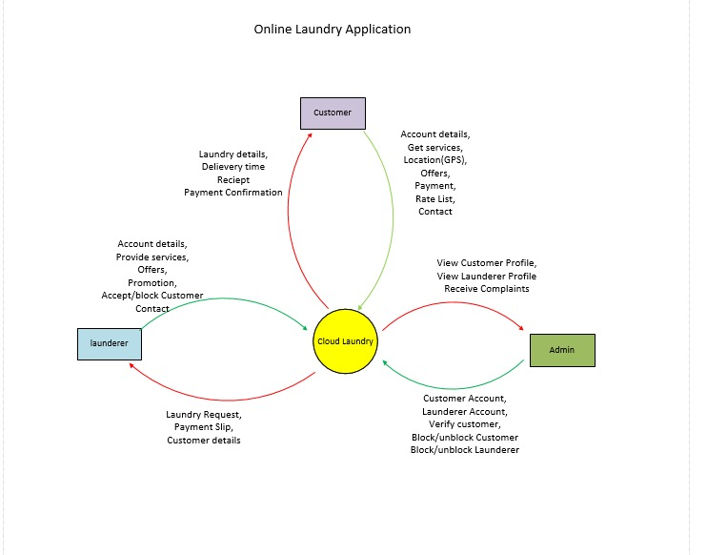

**Figure 1: Context Diagram of Cloud Launderette.**

# Modules

The prime modules which revolve around the app are listed below.



## Module 01: Profile Management:

Launderer and clients will both have their individual profiles. The profile will have functionalities like:

* + - Launderer profile will have the list of services and their respective rates.
    - Launderer profile will have the detail of their ongoing orders.
    - End Users (Launderer/Client) will be able to check their profile details and other users profile details also.
    - End Users (Launderer/Client) will be able to change their profile details.
    - End Users (Launderer/Client) will be able to login with their valid credentials.
    - End Users (Launderer/Client) will be able to create their account.
    - Password can be retrieved if forgotten.
    - Client profile will have a list of past launderer’s services that he or she has availed.

## Module 02: Booking Management:

The booking management will include features like:

* + - Launderer can accept or reject the order offers by client.
    - Launderer will select the time frame of the services.
    - Appropriate time will be scheduled for the client.
    - Total price based on and along with selected services will be shown.
    - Client will be able to book launderette.
    - Launderette will be shown to client based on location.
    - Client can then sort these Launderettes based on filters like price, rating, and location.
    - Client can change their address and services or cancel booking.
    - Client can check service details provided by relevant launderette.

## Module 03: Launderer Dashboard:

A Web Platform Interface for launderer dashboard where launderer will be able to manage all aspect of their profile and services from Appointments to Discounts rates and editing the services they provide.

* + - Seeing the list of Orders, they get and answering it with relevant things.
    - Check the details of Launderette.
    - Editing the Launderette details like the bio and description.
    - Editing the Launderette information like recent images and logos.
    - Checking the list of Service Launderette offers.
    - Adding new Service and specifying price details for it.
    - Deleting existing Service or editing it.
    - Checking reviews and performance with filters of date and clients.
    - Responding to reviews by the client.

.

## Module 04: Reviews Management:

After each job from launderer, the client will be able to review and rank their experience.

* + - Ranking launderer in five-star format.
    - Ranking the cleanliness and quality of work.
    - Submitting reports and complaints as well.
    - Adding, modifying, and deleting reviews.
    - Replays to review.
    - Management of reviews relating to launderettes and orders individually.

## Module 5: Notification and Order Management:

The app will provide bell Icon notification functionality where client/ launderer:

* + - Can receive appointment reminders.
    - Can receive prompt for starting and completion of service.
    - Addition of new notification or modification of previous notifications.
    - Removal of notification after read.
    - Launderer can check order history.
    - Launderer can sort these orders based on dates.
    - Categorization of orders into ongoing, completed, and rejected.

## Module 6: Admin Dashboard:

Admin will be able to regulate the whole system.

* + - Admin can review the membership of new Launderer.
    - Admin will face a record for day-to-day sale.
    - Admin can review the complaints.
    - Admin can respond to those complaints and mark them as resolved/in-process.
    - Admin can block or unblock the client/ launderer.
    - Admin can look at the details of client/launderer.
    - Admin can overlook orders and reviews.
    - Admin can check Launderer performance.

## Module 07: Payment (optional):

The app will provide multiple options for transactions to assist the client:

* + - Mainly Cash on Shop.
    - Payment through Credit Card.
    - Payment through PayPal.
    - End User (Launderer/Client) can choose default payment method.

# System Limitations/Constraints

* This system is limited to Pakistan Big cities
* Only registered barbers can be found in the search.
* Android Version should be at least 7.0.
* Smartphone and Internet connection is mandatory.

# Software Process Methodology

Incremental Methodology is selected for this project due to its resonation with the nature of the work. In which the model is designed, implemented, and tested incrementally till product is finished. Changes are highly probable which might cause us to change or revise some modules in future. The project is flexible which resonates with the methodology and in the incremental approach, backtracking is easy.

# Tools and Technologies

Table 2: Tools and Technologies for the Targeted Project.

|  |  |  |  |
| --- | --- | --- | --- |
| **Tools And**  **Technologies** | **Tools** | **Version** | **Rationale** |
| MS Visual Studio  Code | 1.41.1 | IDE |
| PostgreSQL | 13.1 | DBMS |
| Adobe Photoshop | CSC 6 | Design Work |
| Adobe Illustrator | CC 2019 | Design Work |
| MS Word | Microsoft 365 | Documentation |
| MS PowerPoint | Microsoft 365 | Presentation |
| MS Visio | 2016 | Charts Creation |
| Axure RP | 9.0 | Mockups Creation |
| AWS | 2 | RDBMS |
| **Technology** | **Version** | **Rationale** |
| Flutter | 1.12.13 | Mobile Application  Framework |
| Dart | 2.8 | Programming Language |
| Django | 3.1.1 | Web Backend |
| HTML | 5 | Markup Language |
| CSS | 3 | Style Sheet Language |
|  | Python | 3.8.6 | Programming Language |
|  | JavaScript | 1.8 | Programming Language |
|  | Django Rest Framework | 3.11 | API Creation |
|  | Bootstrap | 4 | CSS Framework |

# Project Stakeholders and Roles

Table 3: Project Stakeholders for the Targeted Project.

|  |  |
| --- | --- |
| **Project**  **Sponsor** | ***COMSATS University Islamabad*** |
| **Stakeholder** | * Muhammad Anwar Sameen * Muhammad Usman * Project Supervisor**:** Ms**.** Bushra Naz * Final Year Project Committee: Evaluation of a project |

# Team Members Individual Tasks/Work Division

Table 4: Team Member Work Division the Targeted Project.

|  |  |  |
| --- | --- | --- |
| **Student Name** | **Student Registration Number** | **Responsibility/ Modules** |
| * Muhammad Anwar Sameen | * SP17-BCS-076 | * Notifications * Find Launderer (location) * Booking * Reviews and Feedback * Maps * (Module 2,4,5) |
| * Muhammad Usman | * SP17-BCS-086 | * Client/Launderer Login/Signup * Launderer Dashboard * Admin Dashboard * Profile Management * Payment Integrations * Databases and API * (module 1, 3, 6,7) |

# Data Gathering Approach

We have interacted with multiple launderettes and taken useful suggestion as well opinion and used that as basis to analyze if there is need of automating laundry work of one’s life? And interestingly, it was the one of the few sectors left in Pakistan to be automated. Pieces of Advice has been taken from many Launderettes.

# Concepts

**Concept-1: Flutter Development** The complete full-fledged development through Mobile Framework called Flutter.

**Concept-2: Database Systems** In order to save the records of barbers and clients in an organized way.

**Concept-3: Django Web Framework** We will learn how to develop website with python web frame i.e., Django.

**Concept-4: API’s Code Injection** We will learn to make our own API’s with djangorestframework and implement them on app and same will also be used on web.

# Gantt chart

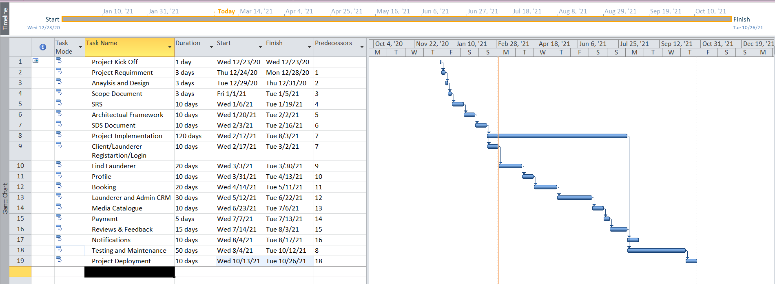

Figure 2: Gant Chart of the Targeted Project.

# Mockups



## Mobile Screens

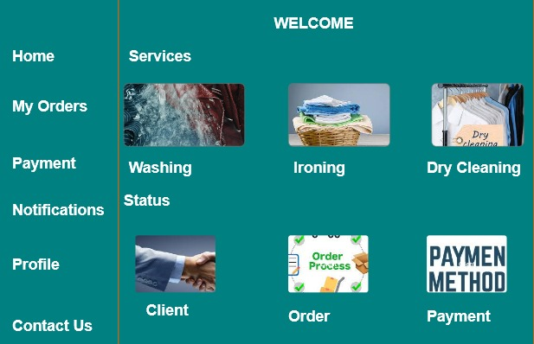

Figure 3: Home Screen.

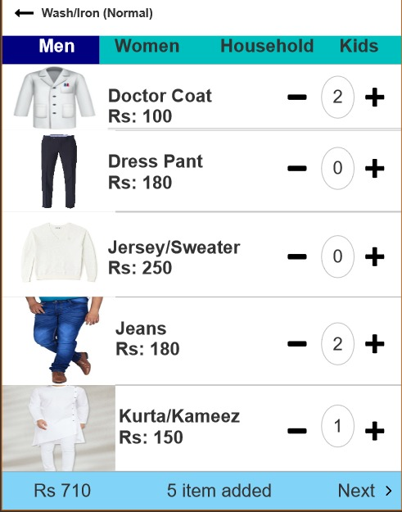

Figure 4: Wash Screen.

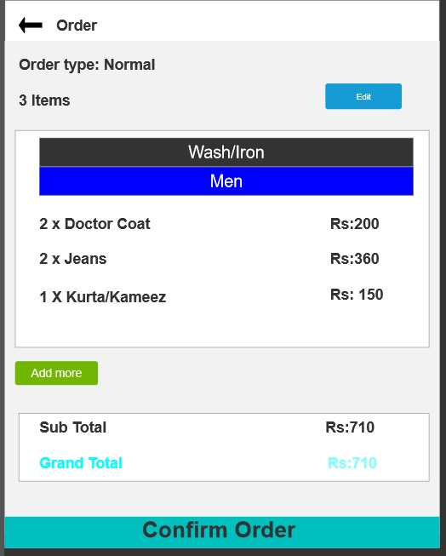

Figure 5: Order Screen.



## Website Screens

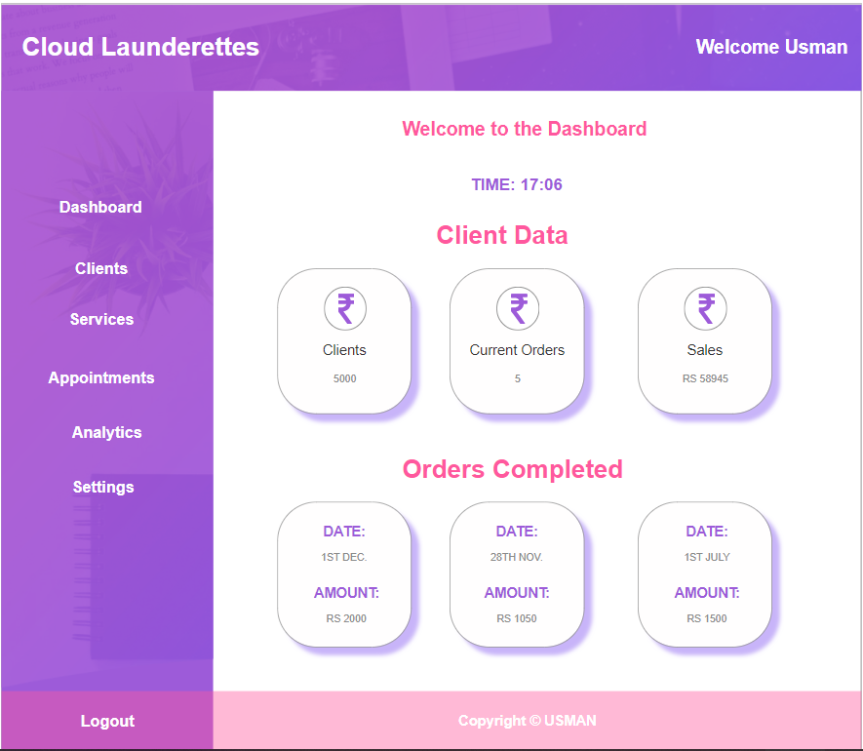

**Figure 8: Launderer Dashboard.**

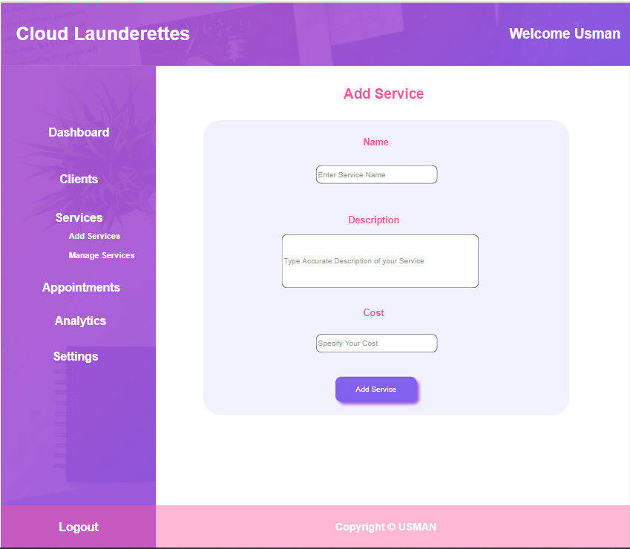

**Figure 9: Add Service.**

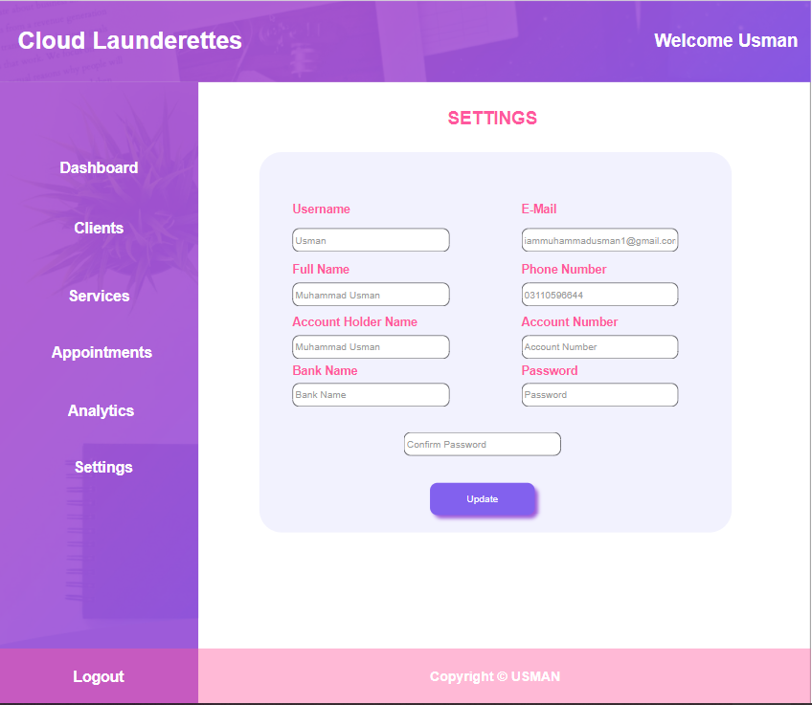

**Figure 10: Setting.**

# Conclusion

In the forever evolving world slightest effort can make big difference. The vital need of laundry work automation will forge this project a gem in daily routine work.

# References

<https://dhobionline.pk/>

<https://elaundry.pk/>

<https://www.laundryxpress.pk/>

# Plagiarism

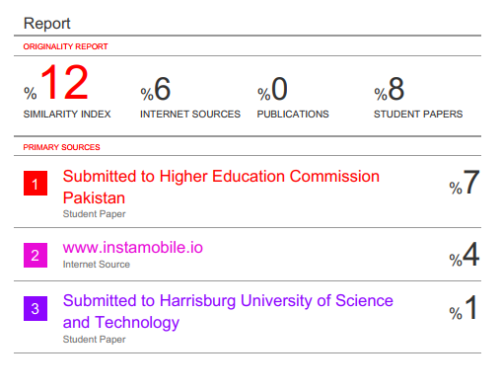

Figure 11: Plagiarism Report.