1.What are the two values of the Boolean data type? How do you write them?

Ans: True and False

2. What are the three different types of Boolean operators?

Ans : There are three basic Boolean search commands: AND, OR and NOT.

3. Make a list of each Boolean operator's truth tables (i.e. every possible combination of Boolean values for the operator and what it evaluate ).

Ans:

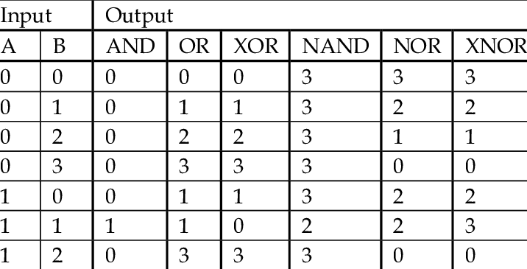

4. What are the values of the following expressions?

(5 > 4) and (3 == 5) : False

not (5 > 4) : False

(5 > 4) or (3 == 5) : True

not ((5 > 4) or (3 == 5)) : False

(True and True) and (True == False) : False

(not False) or (not True) True

5. What are the six comparison operators?

Ans : six comparison operators: less than (<), less than or equal to (<=), greater than (>), greater than or equal to (>=), equal to (==), and not equal to (!=).

6. How do you tell the difference between the equal to and assignment operators?Describe a condition and when you would use one.

Ans : = operator is used to assign value to a variable and == operator is used to compare two variable or constants.

Str = “Hello”

5==5

7. Identify the three blocks in this code:

spam = 0

if spam == 10:

print('eggs')

if spam > 5:

print('bacon')

else:

print('ham')

print('spam')

print('spam')

Ans: if,if,else are three block

8. Write code that prints Hello if 1 is stored in spam, prints Howdy if 2 is stored in spam, and prints Greetings! if anything else is stored in spam.

spam = input()

if spam == 1:

print('Hello')

elif spam == 2:

print('Howdy')

else:

print('Greetings!')

9.If your programme is stuck in an endless loop, what keys you’ll press?

Ans : CTRL + C

10. How can you tell the difference between break and continue?

Ans : Break statement stops the entire process of the loop. Continue statement only stops the current iteration of the loop. Break also terminates the remaining iterations. Continue doesn't terminate the next iterations; it resumes with the successive iterations.

11. In a for loop, what is the difference between range(10), range(0, 10), and range(0, 10, 1)?

Ans: range(10) mean run loop till 10, range(0,10) mean run loop from 0 to 10, range(0,10,1) mean run loop from 0 to 10 and itrate after 1.

12. Write a short program that prints the numbers 1 to 10 using a for loop. Then write an equivalent program that prints the numbers 1 to 10 using a while loop.

for n in range(1, 11):

print(n, end=' ')

i = 1

while(i<=10):

print(i)

i += 1