Web services project

Internet Programming: Assessment 2.

Tafe Coomera Campus

Diploma of Software Development

XMl screenshot (Code behind the website).

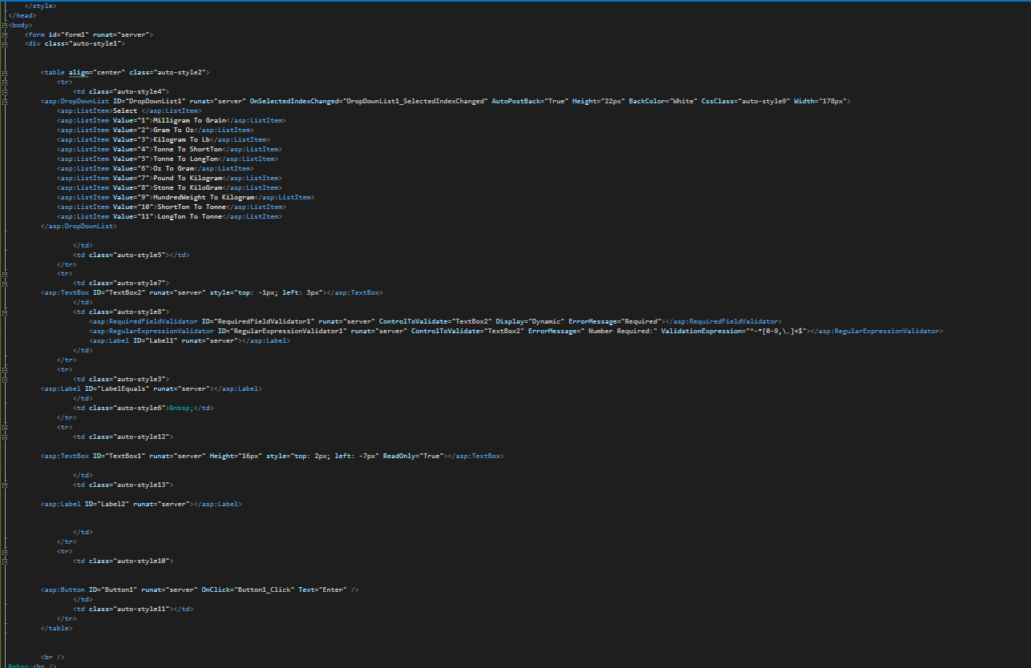

Design of the website.

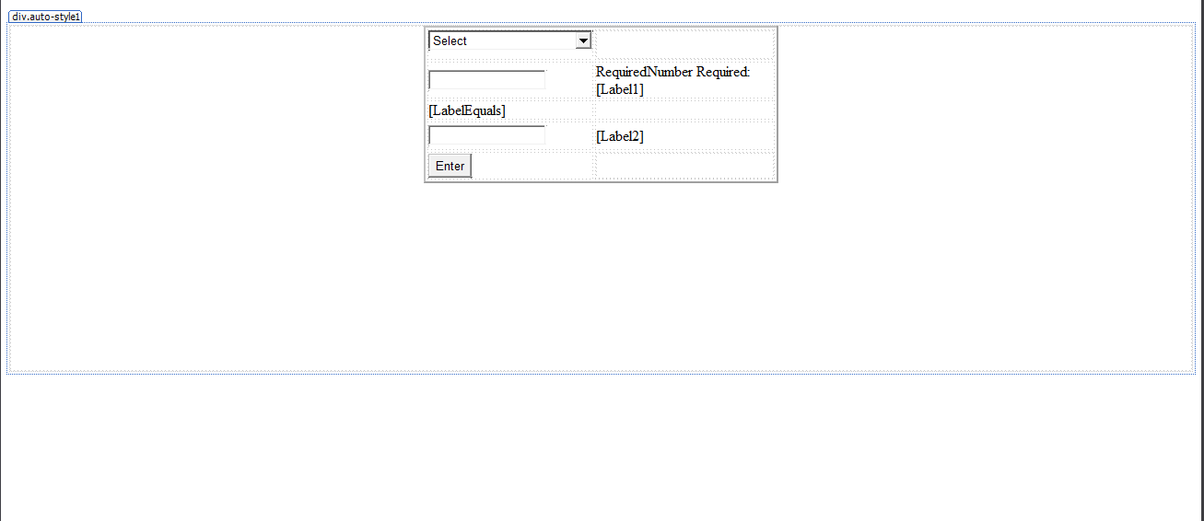

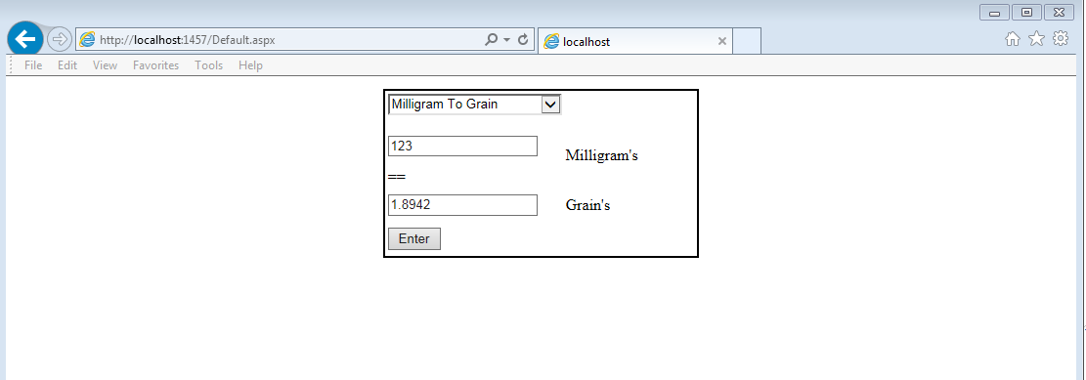Working Design of the website.