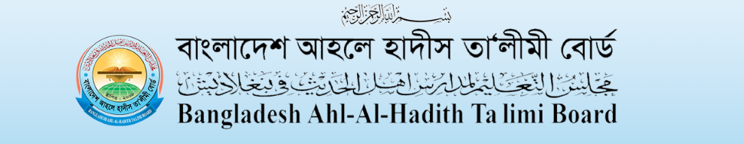Language
Home | About Board | Forms & Syllabus | Fees | Exam | Result | Result Challenge | Notice Board | Commite |  | Book List ( Class Sub manu) |  | Contract Us
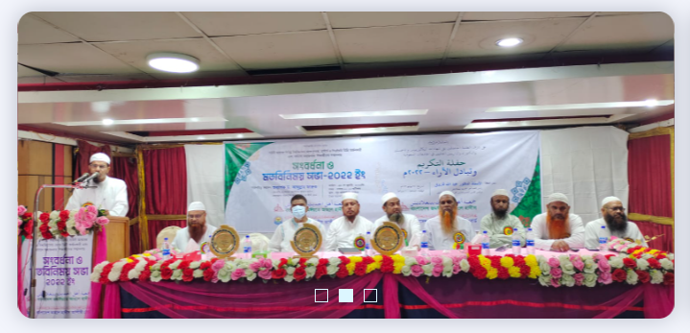 |  |  |  |  |  |  |  |  | Watch | Calendar | Notice
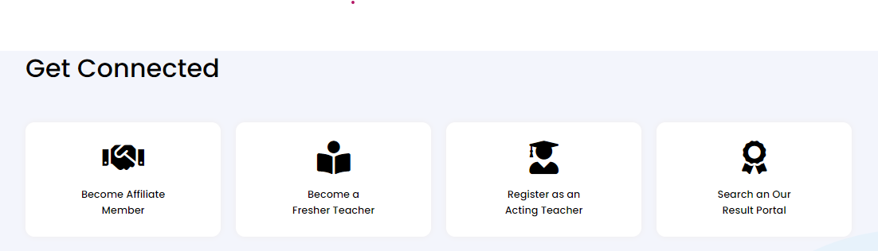
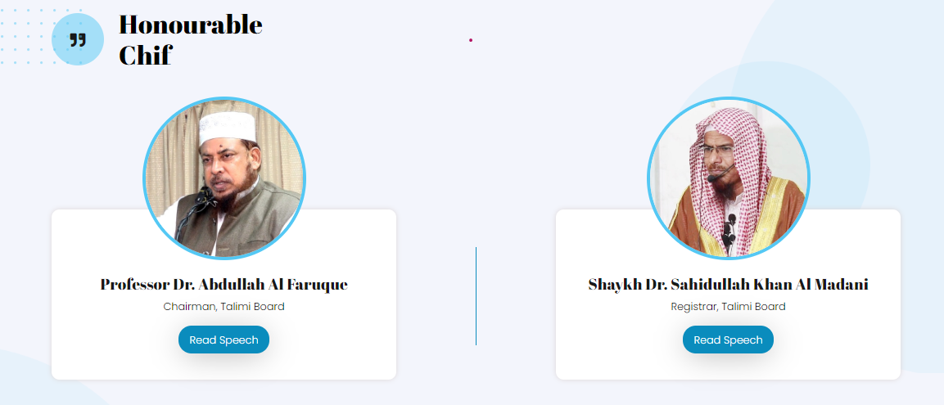
Publication
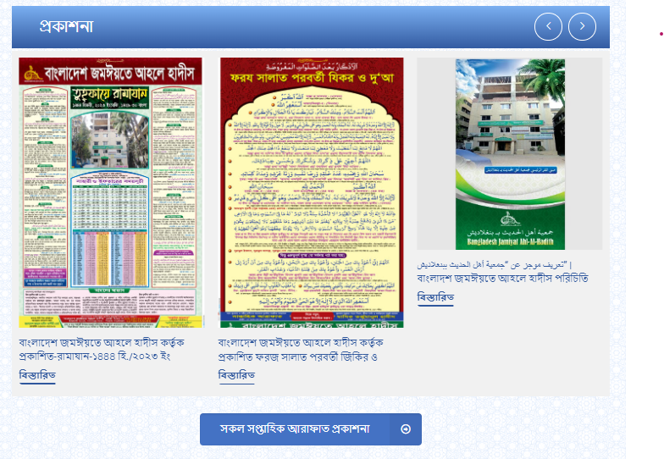
Event
