# EASY

## Case I

Replace red node with black node

## Case IV:

Replace black node with red node

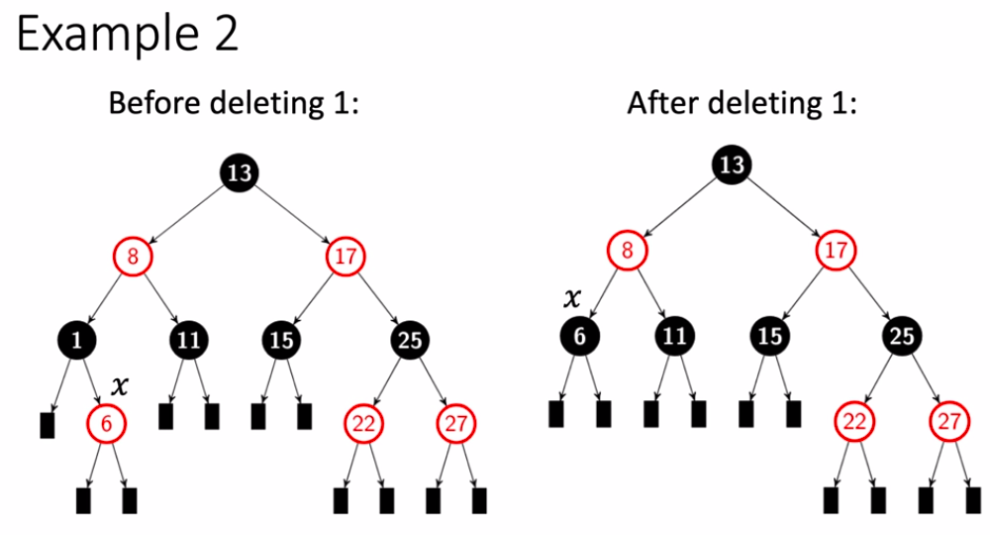

## Case II

Replace red node with red node

## Case IV

Replace black node with red node

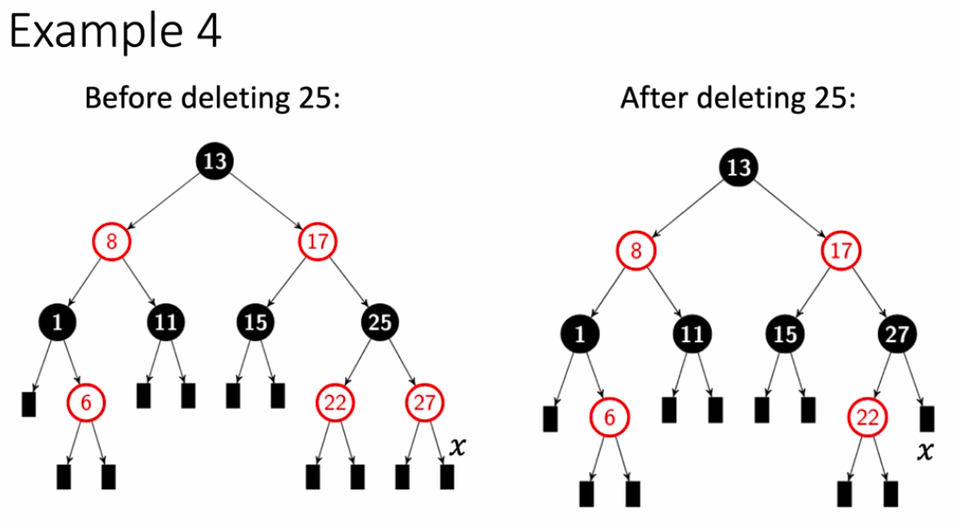

# MEDIUM

## Case I

Replace red node with red node

## Case IV

Replace black node with red node.

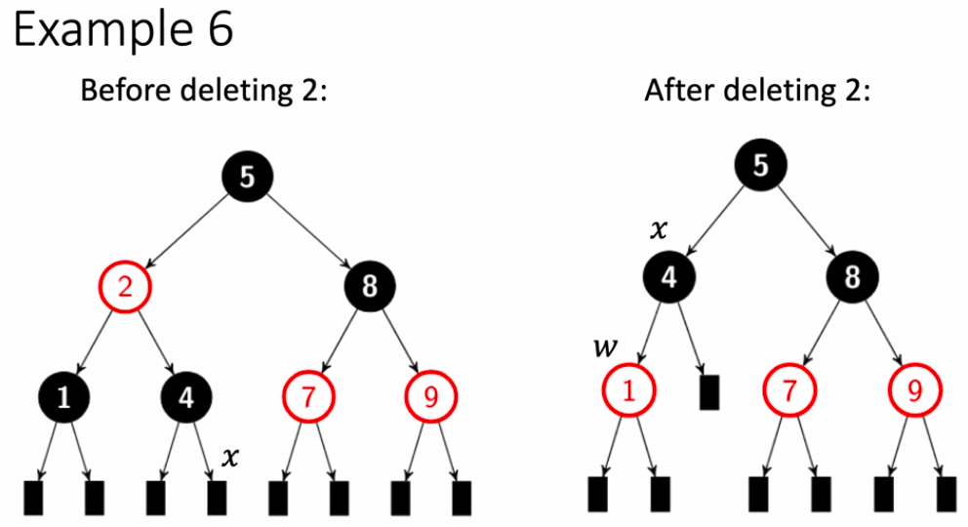

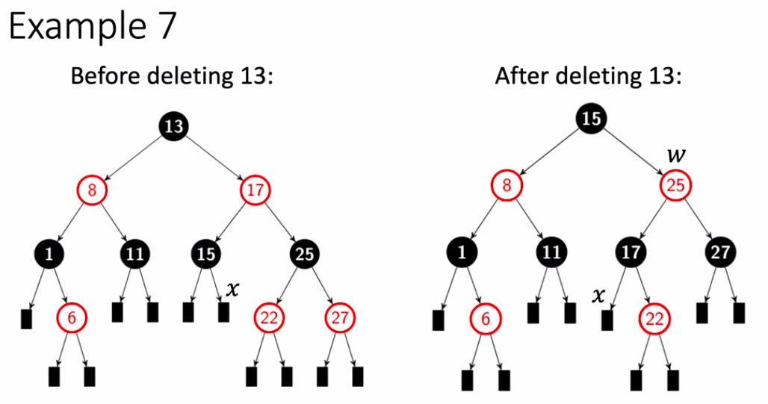

# HARD

