Exploratory Data
Analysis and Statistical Investigation of the Stack Overflow
Developer Survey Dataset

Dataset Summary

Introduction
The Stack Overflow Developer Survey dataset contains responses collected from software developers worldwide. The survey gathers information about education, employment status, programming languages, technologies used, salary, experience, and developer preferences. This dataset is widely used for understanding trends in the software development industry.

Dataset Size
Attribute Value Number of Rows 49191 Number of Columns 172 File Format CSV Missing Values 4447043
Duplicate Records 0

Key Features
Feature Description Age Age group of respondent
Country Country of residence
YearsCode Professional coding experience
Employment Employment status LanguageHaveWorkedWith Programming languages used ConvertedCompYearly Annual salary in USD

Dataset Snapshot
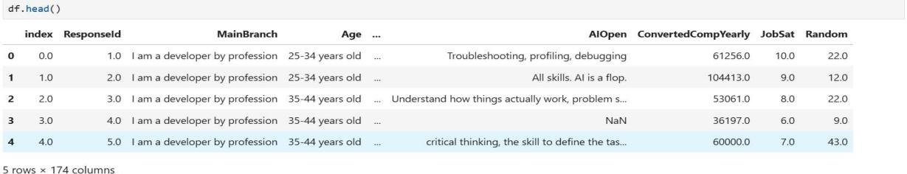

Data Exploration Plan

Purpose of Exploration
The purpose of exploratory data analysis is to understand the structure, quality, and characteristics of the Stack Overflow Developer Survey dataset. The analysis aims to identify patterns, trends, relationships, and anomalies within the data before applying statistical methods or predictive modeling techniques.

Planned Exploratory Techniques

Objective Technique Understand distributions Histograms Compare categories Bar Charts Compare salary groups Box Plots Study relationships Scatter Plots
Measure associations Correlation Heatmap Detect outliers Box Plots & IQR

Data Quality Assessment Plan
Before conducting analysis, the dataset will be examined for:

    - Missing values
    - Duplicate records
    - Inconsistent entries
    - Outliers
    - Incorrect data types

Expected Outcomes
Through exploratory analysis, the study aims to uncover trends in developer demographics, technology preferences, and compensation patterns. The findings will be used to formulate hypotheses and perform statistical testing in later sections of the report.

Exploratory Data Analysis
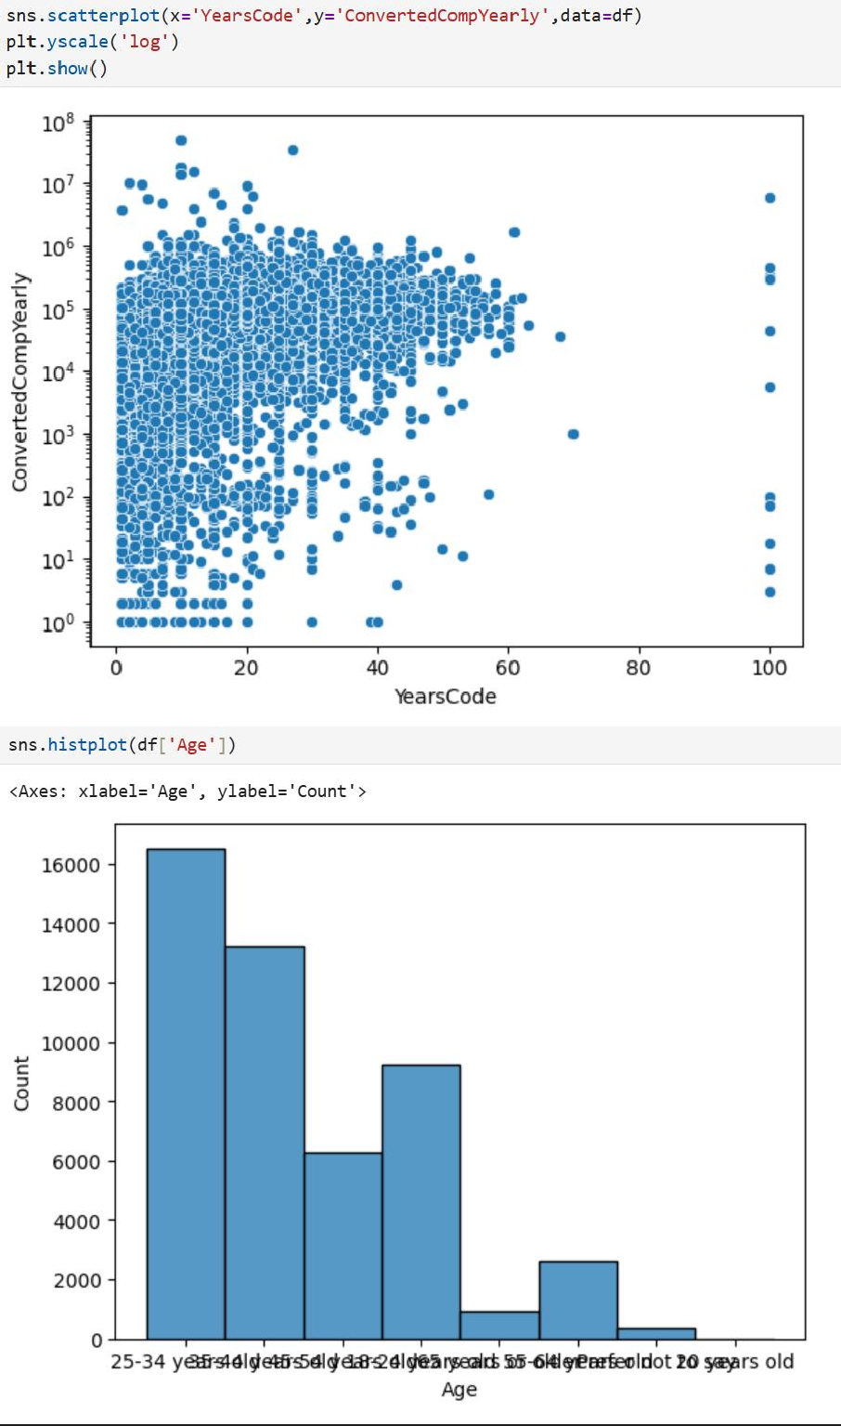

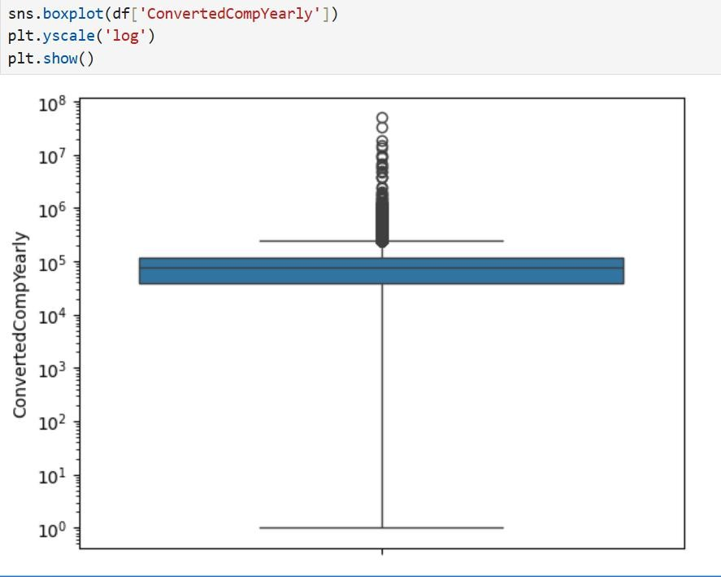
Key Findings
- The age distribution is concentrated within a few dominant age groups.
- Several salary outliers are present in the dataset.
- Professional experience shows a positive relationship with annual compensation.

Data Cleaning and Feature Engineering

Missing Value Treatment
Missing values were identified and handled using appropriate techniques. Rows containing critical missing information were removed, while non-critical missing values were retained or imputed where necessary.

Duplicate Data Check
The dataset was examined for duplicate records. However no duplicate values were found.

Data Type Conversion
Relevant columns were converted to appropriate data types to facilitate analysis and visualization.

Example:

YearsCode → numeric ConvertedCompYearly → numeric

Outlier Treatment
Salary data contained several extreme values. Outliers were identified using boxplot analysis.

Feature Engineering
A logarithmic transformation of annual compensation was created to reduce skewness and improve interpretability of salary distributions.

LogSalary = log(ConvertedCompYearly)

Summary
Data cleaning involved handling missing values, checking for duplicates, converting data types, and examining outliers. Feature engineering included creating derived variables to support exploratory and statistical analysis.

Key Findings and Insights
- Most respondents belong to a few dominant age groups.
- Salary distribution is heavily right-skewed with several high-income outliers.
- Professional experience is positively associated with annual compensation.
- Compensation varies considerably among respondents with similar experience levels.
- Additional factors beyond experience likely influence salary outcomes.

Hypothesis Formulation
H0: There is no relationship between professional experience and annual compensation.

H1: Professional experience has a significant positive relationship with annual compensation.

Conclusion
This report analyzed the Stack Overflow Developer Survey dataset using exploratory data analysis and data cleaning techniques. The analysis revealed that annual compensation is positively associated with professional experience and that salary distributions are highly right-skewed with the presence of outliers. The findings provide valuable insights into developer demographics and compensation patterns within the dataset.

References

Help from online resources and ai has been taken in taking guidance and adding general descriptions

