Login :

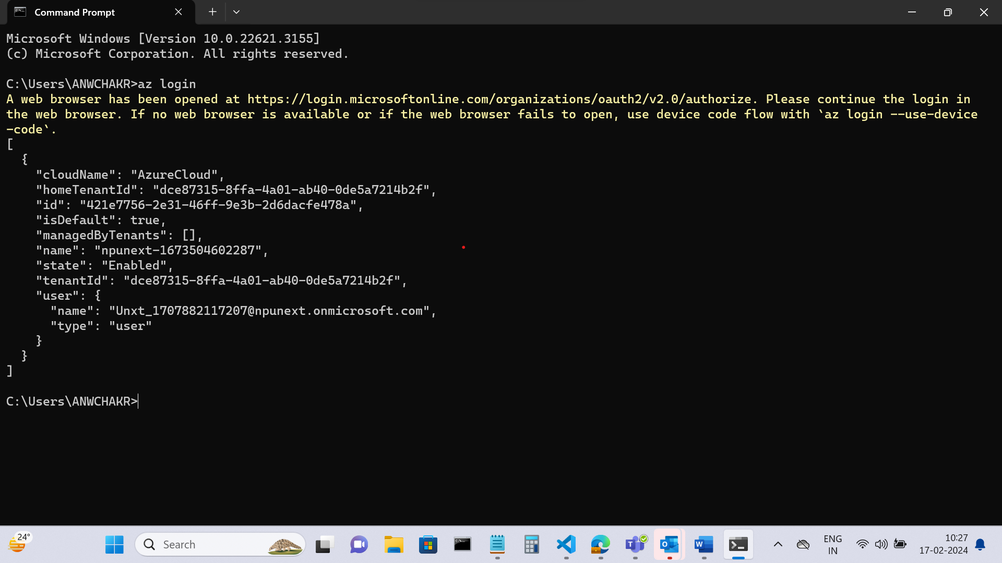

Creating a resource :

Resource is created in Resource Group:

Creating a VM :

List of VMs :

Entering the VM:

Updating all the packages :

Creating Inbound Security:

Default Html Page :

Visual Studio Code:

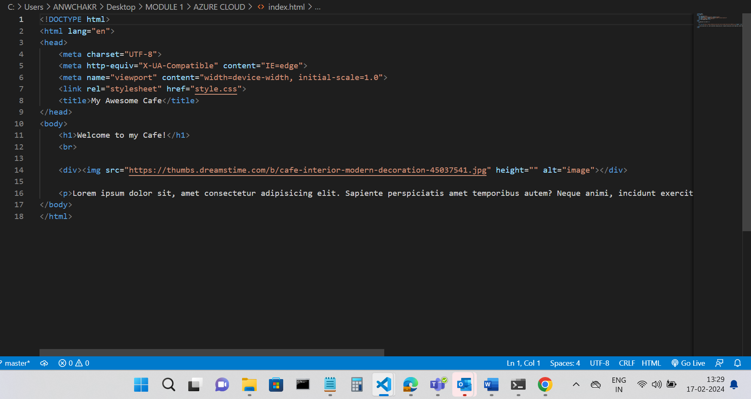

Style.css

Our Html Page :

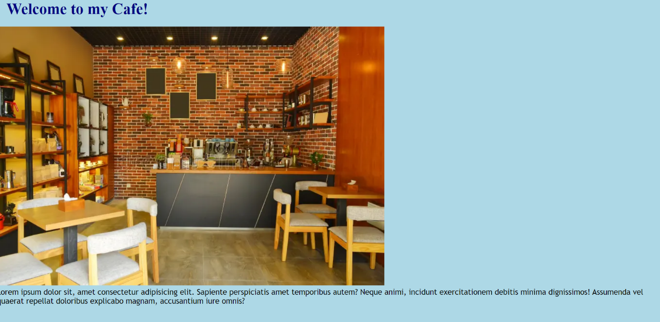

After that, we hosted our website on the server.