******The British College**

**KATHMANDU**

**Coursework Submission Coversheet**(individual coursework only)

**Faculty of Arts, Environment and Technology LBU Student Id:**

C7275280

**For checking by the student:**

Please ensure all information is complete and correct and attach this form securely to the front of your work before posting it in a coursework collection box.

Award name: BSc (Hons) Computing

Module code: 36549

Module name: Advanced Software Engineering

Module run: 2021

Coursework title: Graphical Programming Language Application

Due Date: 26th May, 2021

Module leader: (In LBU) Dr. Duncan Mullier

Module Supervisor: (In TBC) Resham Bahadur Pun

**TURNITIN** Checked: YES NO ***(please circle)***

Submission date & time: Date: 30th May, 2021 Time: 11:30

**Total Word Count: Total Number of Pages (including this front sheet):**

**In submitting this form with your assignment, you make the following declaration:**  
I declare, that the coursework submitted is my own work and has not (either in whole or part) been submitted towards the award of any other qualification either at LBU or elsewhere. I have fully attributed/referenced all sources of information used during the completion of my assignment, and I am aware that failure to do so constitutes an assessment offence.

Signed: Anwesh` ` Date: 30th May, 2021

**You are strongly advised to retain a second copy of your work in case of any query about the assignment.**

1113

17

**For completion by the faculty:**

**This mark is provisional and subject to moderation and approval by the relevant examining board**

**Teacher's Feedback**

**Teacher's Signature: __________________________________ Date: ________________**

Table of Contents

Introduction 2

Repository 2

Fig.1: Creating a repository. 3

After this a local repository is created. 3

Git Status 3

Git Add 4

Git commit 4

Fig.5: git commit. 5

Git push 5

Commit 5

Commit for Component2 6

Component2 6

Required in Component2 6

Fig.7: Form Layout for Component2 7

Drawto Command 7

Moveto Command 8

Loop Command 8

Loop command for rectangle 8

Loop command for Circle 10

If/End If 11

Syntax Checking 11

Fig.14: Syntax error in If statement 12

Limitation in this project 12

# Introduction

In this project we are going to talk about the process of setting up the process of creating a repository in both version control and local repository. My prefered version control is Bikbucket. Now let’s understand version control.

In simple words we can call version control as source control where we can rewrite the source code which acts as commit.the main advantage of using a version control is we can go back to the previous commits if any errors are found. Version control consists of two section repository and commits.

## Repository

Repository can be said as the project folder in version control. This is the place where we save our progress. In this project we are creating a new Repository Name “Component2”.

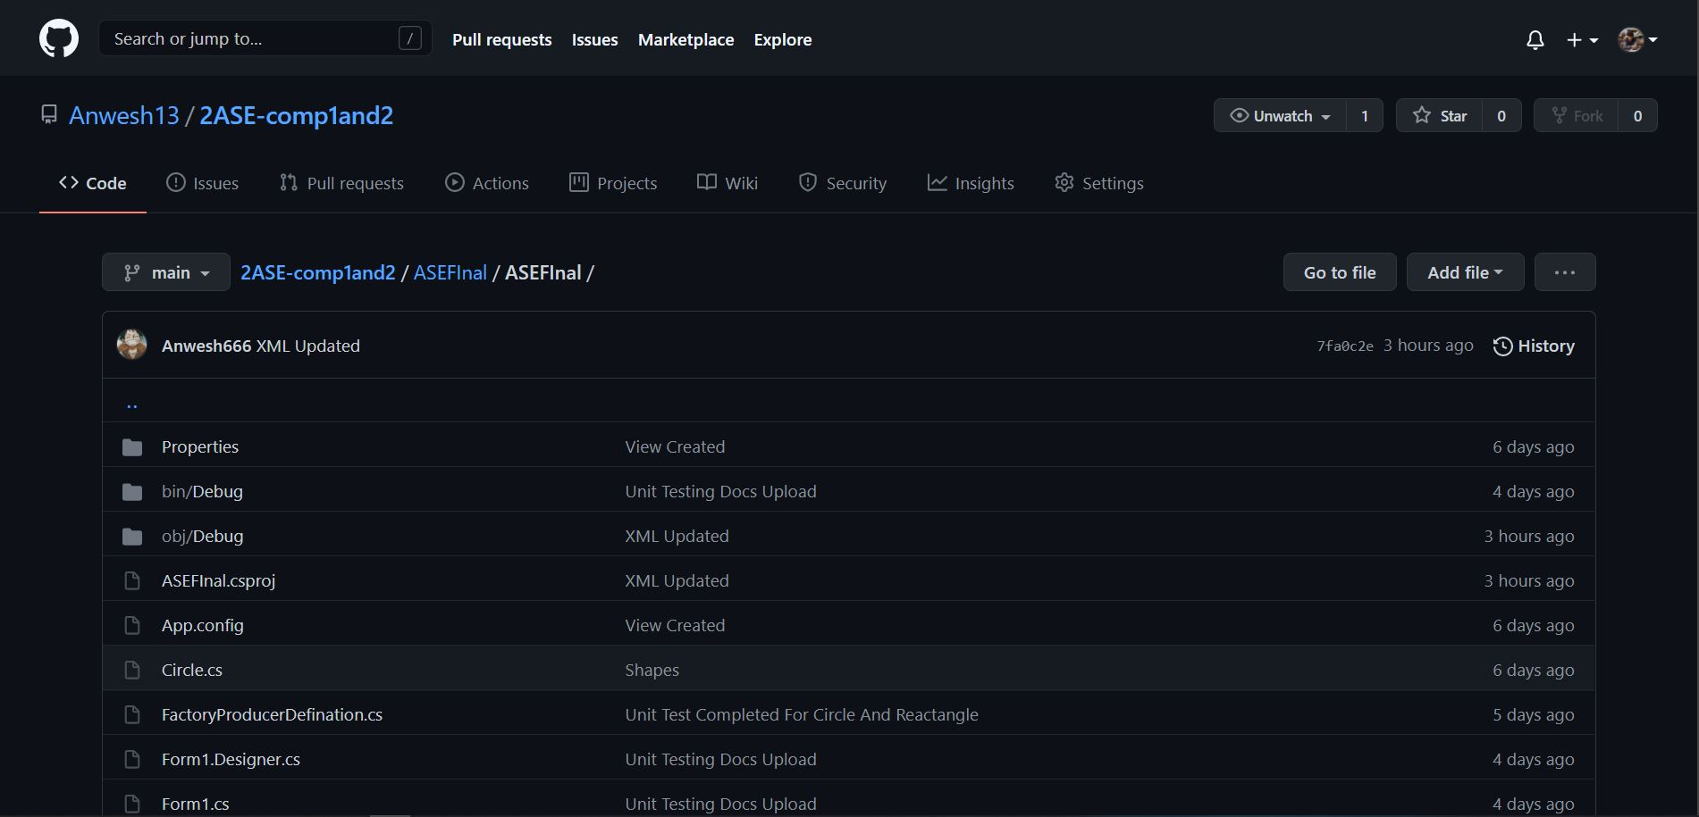

## Fig.1: Creating a repository.

After we create a repository we look forward for creating a local repository where we can save our file to later push to the main repository in version control. Where we go to the clone option and copy the git repository link and go to destination file in Command Prompt. After which we write following line

git clone https://dahalsarthak@bitbucket.org/dahalsarthak/component2-ase.git

## After this a local repository is created.

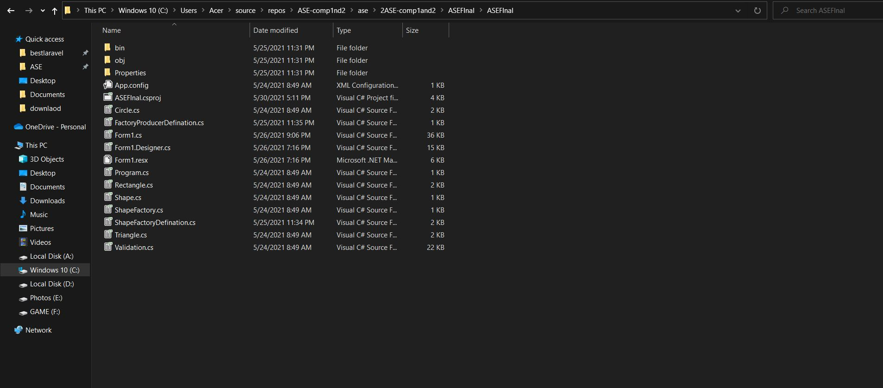

Fig.2: Local Repository

Now we are going to add the file to the local repository. After which we go to local repository and write following commands.

## Git Status

Here we see the repository which can not been added to be committed in Local repository Denoted by red color text.

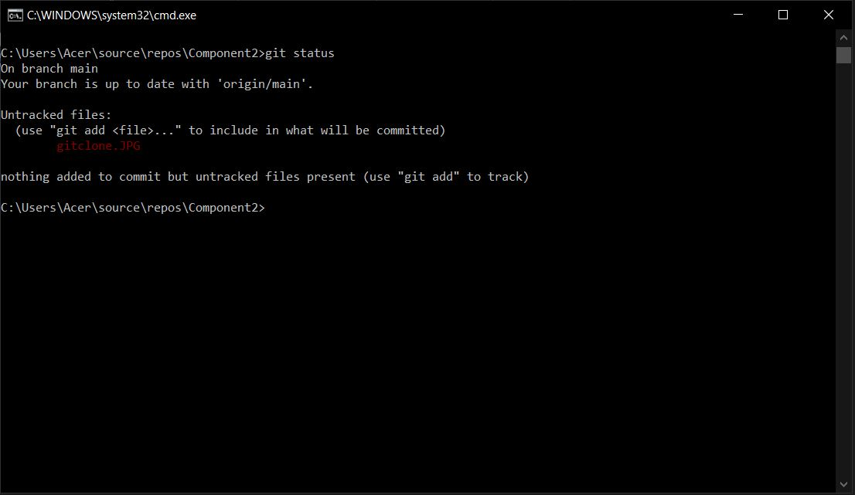

Fig.3: git status.

To add this to your main repository we will have to add this file. Where we follow:

## Git Add

Git add works as the function of adding the file to be commited. In my case I am trying to add all of my file to main repository so I use command “Git Add .”.

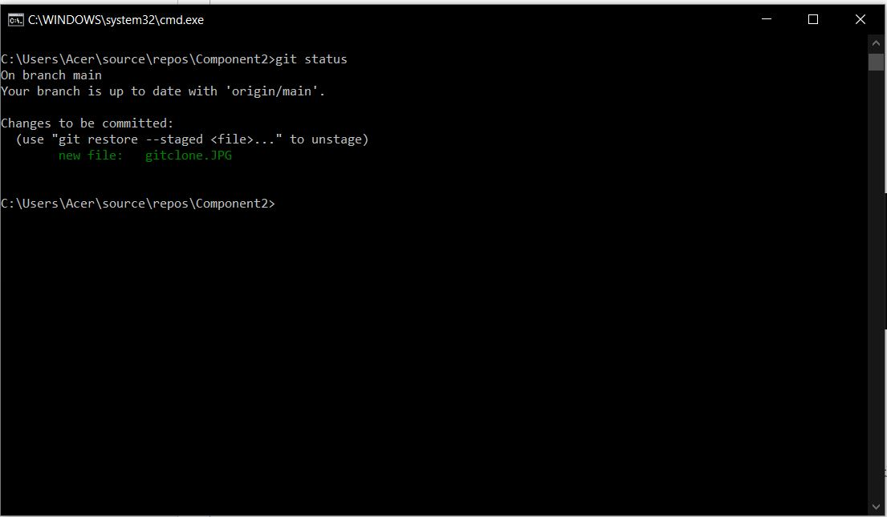

Fig.4: git add.

Now we can see that the file is added to be Committed.

## Git commit

Now we write the function ‘git commit –m “making of document”. Where –m denotes message of the commit where “is the message”.

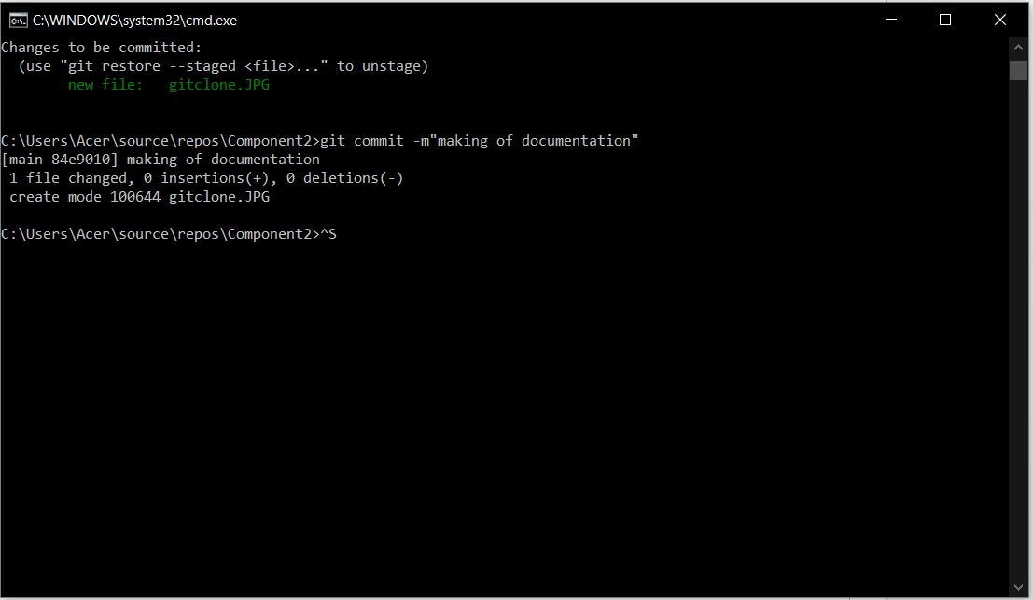

## Fig.5: git commit.

## Commit for Component2

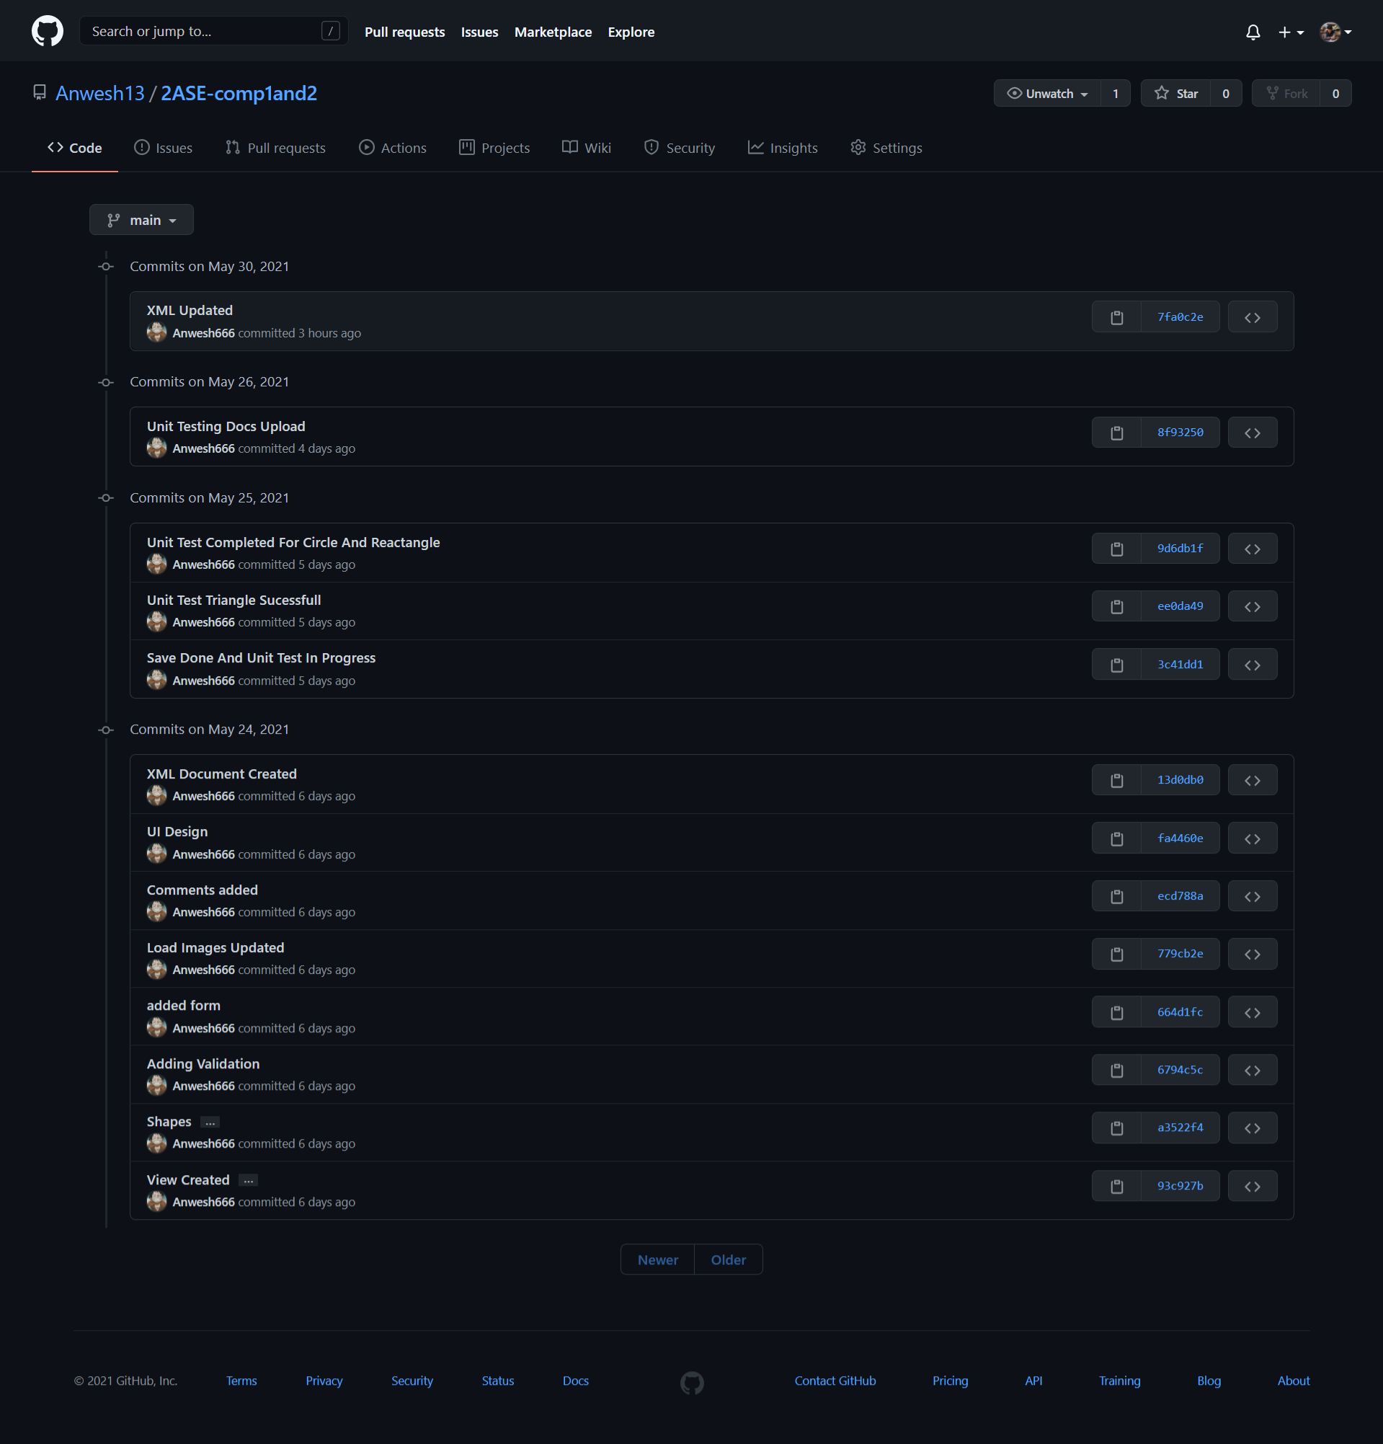

Fig.6: Commit for Component2

## Component2

### Required in Component2

* Loop command
* If statement
* Syntax checking
* Move To
* Draw To

For component2, we are using Visual Studio as the framework. Where we have cloned and copied our main Component1 which constits of Form and validation and classes for Component2. Now for the Form Layout we have added a new textbox, Button for execute and clear the text Box.

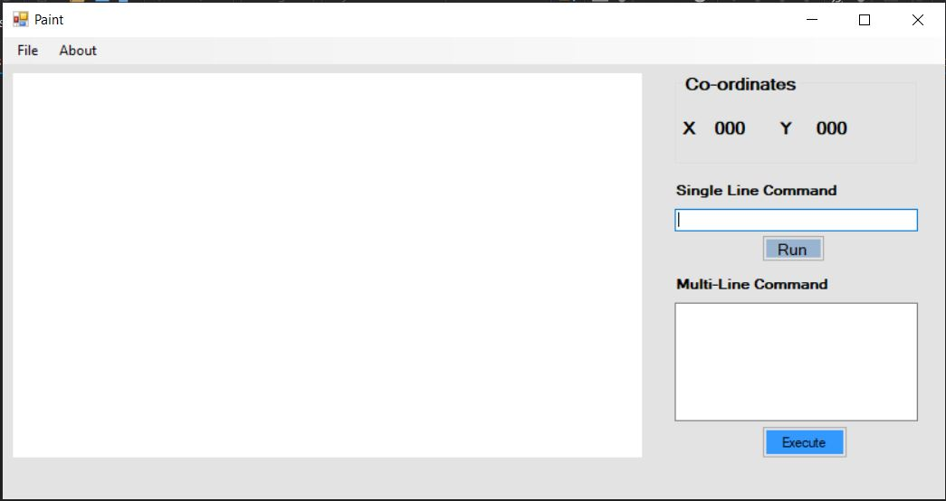

## Fig.7: Form Layout for Component2

## Drawto Command

Here we have created shape circle, rectangle, triangle and polygon with respective input. Now drawto acts as the command to draw the circle in respective Axis. Which include X-axis and Y-axis.

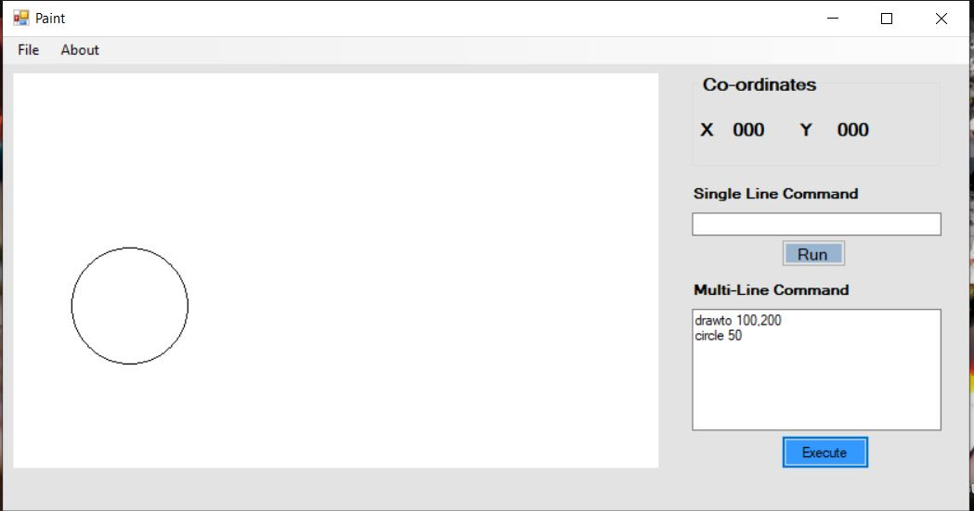

Fig.8: Drawto command.

## Moveto Command

This command helps to move the X-axis and Y-axis of the given input to given X and Y axis in input.

Fig.9: After the move to command.

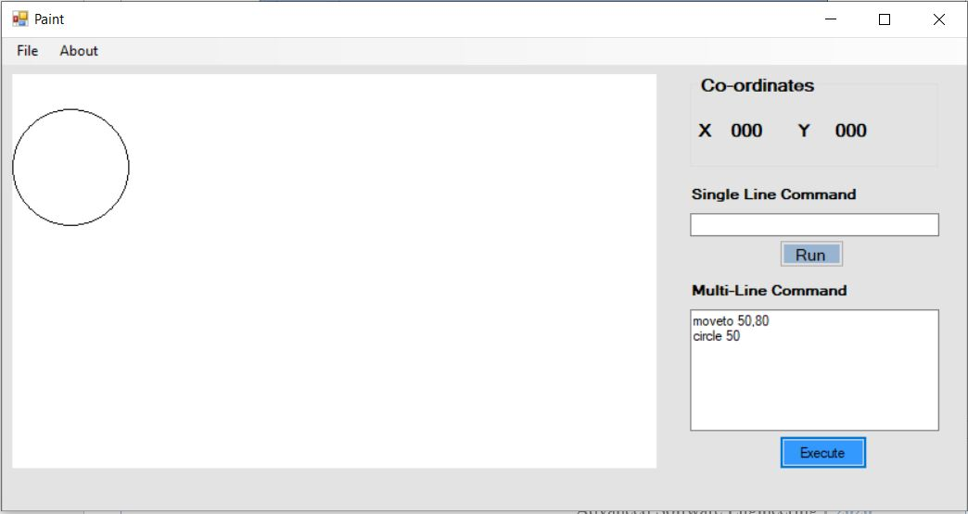

## Loop Command

### Loop command for rectangle

Here we are creating a rectangle with variable declared as height and width where we have created a loop command here height and width increases as the loop continues. After the use of loop command, we except the number of loops to show the number of rectangle with increase in height and width.

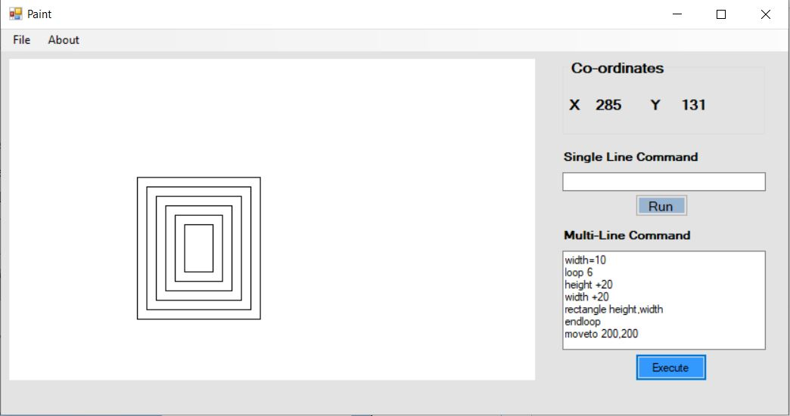

Fig.10: Loop for rectangle.

**Syntax Checking**

Let us check if we make some error the command.

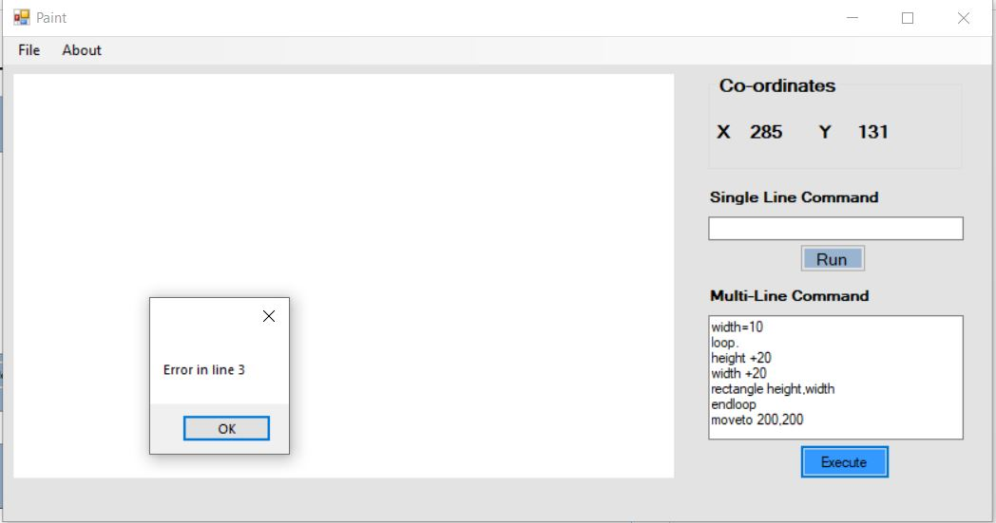

Fig.12: Syntax checking for loop

### Loop command for Circle

Here we are creating a circle with variable declared as radius where loop create a number of circle with the add in radius. Which shows the following result.

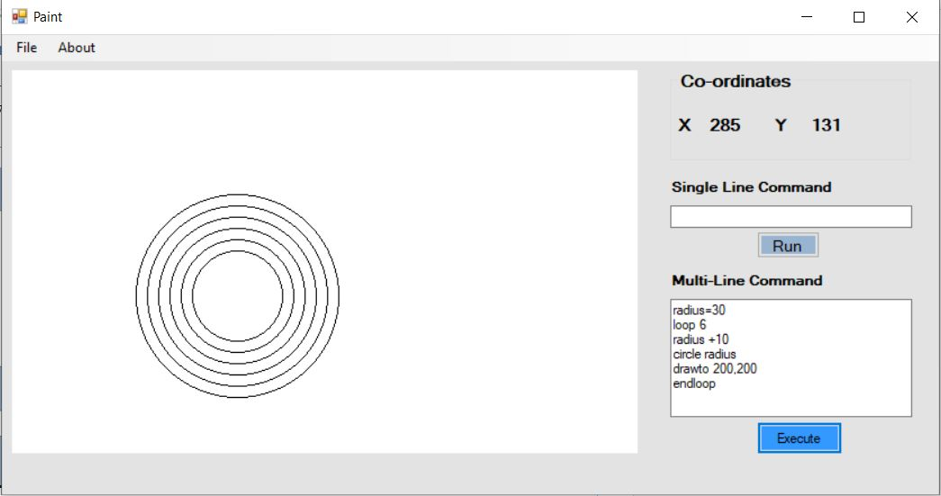

Fig.11: Loop for circle.

Fig 13 shows the loop for circle with radius as variable.

## 

## If/End If

In this condition we provide if condition where if condtion if true draws the shape otherwise shows the error.

End if variable is declared so that we can end the if command. The example is provided to the following figure.

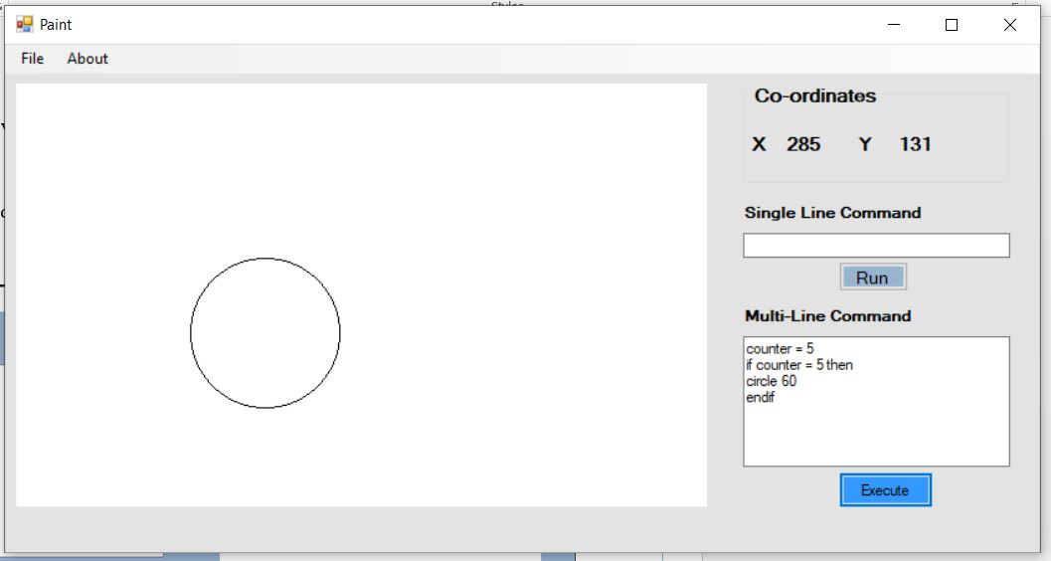

Fig.12: If Condition

Here the condition of counter = 5 is provided so here if the counter = 5 then the condtion draws circle of radius 50 else if the condition is not met then the d=circle is not drawn.

## Syntax Checking

Here let’s provide the wrong syntax if the app shows error. If it shows the error we will show it in dialogue box.

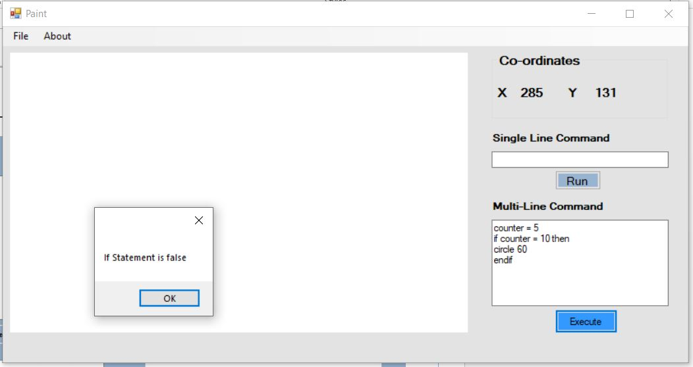

## Fig.13: Syntax error in If statement

**XML File:**

Xml stands for entensible markup Language. In Simple words XML is a set of code and tags that describe the code. Its widely used in Digital document. To look after the formatting.

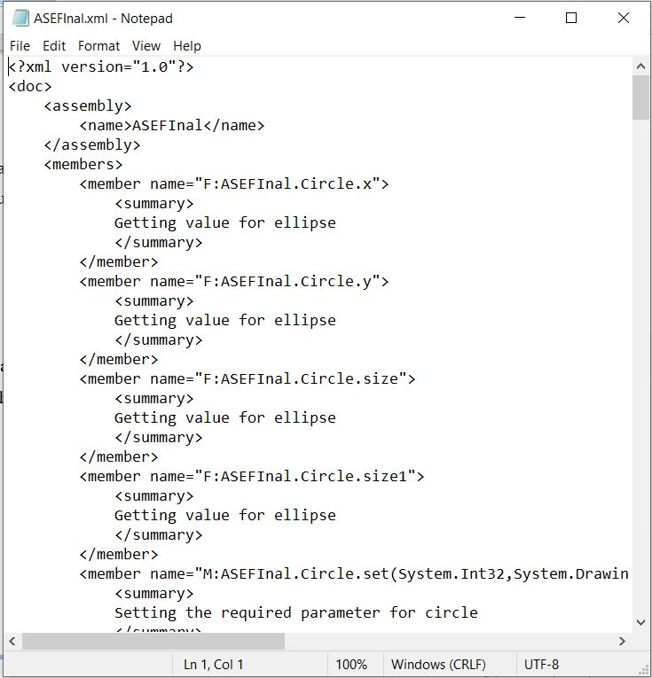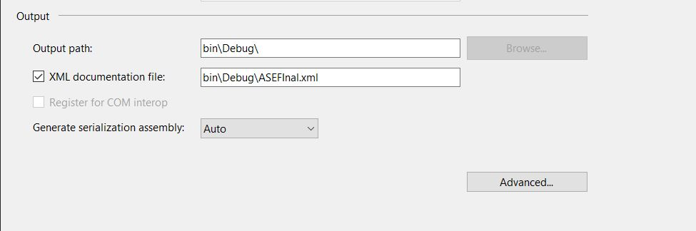

Fig.14: Xml document

## Limitation in this project

* Method haven’t been called
* Method doesn’t pass the variable and without variable test.