MANIPAL UNIVERSITY JAIPUR
Department of Computer Science and Engineering
B.Tech (CSE) | Academic Year 2025-2026

PREDICTING DATA DRIFT IN PRODUCTION
MACHINE LEARNING MODELS
A Proactive Statistical Framework Using Distributional Divergence Metrics

Final Year Project Report | Third Year B.Tech (CSE)
Dataset: CICIDS 2017 (Canadian Institute for Cybersecurity)
Date of Completion: April 4, 2026
Pipeline Status: Fully Operational

Abstract
This report presents the complete documentation of an end-to-end machine learning pipeline developed to proactively detect and predict data drift in deployed models, without requiring any ground-truth labels on incoming production data. The work was carried out using the CICIDS 2017 benchmark dataset, which captures five full working days of real network traffic encompassing over 2.8 million records. The pipeline processes this data in four structured phases: memory-safe preprocessing, baseline model training, statistical drift computation, and drift prediction meta-modelling.
The central empirical finding of this project is that distributional divergence metrics, specifically Kullback-Leibler (KL) Divergence, Jensen-Shannon (JS) Divergence, and Wasserstein Distance, computed on unlabelled incoming feature distributions, can reliably predict how much a production model's accuracy will degrade before a single inference is made. A Linear Regression meta-model trained on just seven temporal data points achieves an R-squared value of 0.9924 and a Mean Absolute Error (MAE) of 1.43% under Leave-One-Out Cross-Validation. The five baseline classifiers, namely Random Forest, XGBoost, Decision Tree, Logistic Regression, and SVM, all achieve accuracies above 93% on same-distribution evaluation. However, when the Monday-trained Random Forest model is evaluated on Friday's DDoS traffic without retraining, accuracy collapses to 43.33%, which is effectively below chance level for a binary classifier. This dramatic degradation is precisely predicted by a KL Divergence of 12.3652 between the reference and drifted distributions.
The pipeline is fully operational, deterministic, and memory-safe. All outputs are persisted to versioned artifact files, enabling complete reproducibility. This document serves as a comprehensive architectural and scientific handover report, covering the problem statement, literature context, methodology, results, and future directions in sufficient detail that any subsequent researcher can reproduce every result from scratch.

1. Introduction and Problem Statement

1.1 The Quiet Problem of Silent Model Decay
There is a certain overconfidence that tends to follow the moment a machine learning model crosses some accuracy threshold on a test set. In academic settings, that moment is often treated as the end of the story. In production environments, it is more accurately described as the beginning of a rather more complicated one. The assumption underlying most deployed models is that future data will behave in a manner broadly consistent with training data, a condition that is violated routinely in any domain where the world does not remain static.
Network traffic, in particular, is one of the most dynamically shifting data environments that a practitioner can encounter. The statistical character of a Monday morning's benign HTTPS traffic is genuinely different from that of a Wednesday afternoon's DoS flood, and a model trained on the former has, in a very real sense, no visibility into the latter. The degradation that results when such a model encounters dramatically shifted data is what this project refers to as Silent Model Decay. The term is deliberate: the decay is often silent because there is no immediate signal that anything has gone wrong. Security Operations Centres may take days or even weeks to manually annotate incoming attack traffic and compute updated accuracy metrics. By the time the drop in performance is noticed, the damage to the network may already have been done.
This project set out to address exactly this problem through a fundamentally proactive approach. Rather than waiting for labelled data to confirm that a model has already begun failing, the aim was to determine whether statistical properties of the incoming data distribution alone, computed before any inference occurs, could be used to predict the extent of expected performance degradation. The answer, as the empirical results will demonstrate, is yes, at least within the temporal structure of the CICIDS 2017 dataset.

1.2 Why Existing Approaches Fall Short
The standard industry response to model drift is reactive by design. Widely deployed drift detection tools such as ADWIN (Adaptive Windowing), the Drift Detection Method, and the Page-Hinkley Test all operate by monitoring a stream of model predictions or error rates over time and raising alarms once those rates exceed statistically defined thresholds. The limitation common to all of these approaches is structural: they require access to ground-truth labels to compute error rates. In a real-time cybersecurity deployment, those labels may not arrive for hours or days after the traffic has been processed. By the time a reactive system raises its alarm, the production model may have already misclassified thousands of intrusion flows.
Commercial MLOps platforms such as Arize AI, Fiddler AI, and Dataiku compute drift scores and provide threshold-based alerts, which is genuinely useful. What they do not do, however, is translate those drift scores into a quantitative estimate of how much accuracy the deployed model is expected to lose. That step, the mapping from observed distributional divergence to predicted accuracy, is left to human engineering judgment. The present work fills this gap by training a regression meta-model that learns this mapping empirically from the temporal structure of the CICIDS 2017 dataset.

1.3 Core Problem Statement
Core Problem Statement
How can we detect data drift and accurately predict the expected drop in model accuracy, proactively, using only statistical divergence metrics computed on the incoming feature distributions, without requiring actual ground-truth labels at the time of inference?

The practical significance of answering this question correctly cannot be overstated in a cybersecurity context. If one can compute KL Divergence between a stored reference distribution and an incoming data batch within seconds, and if a pre-trained regression model can then translate those divergence values into an estimated accuracy figure with sub-two-percent error, then a production system has everything it needs to issue early warnings before inference even begins. The engineering implications of this for organisations running ML-based intrusion detection systems are substantial.

2. Literature Review

2.1 Taxonomy of Data Drift
The foundational taxonomy of data drift was established by Moreno-Torres et al. (2012) in what remains one of the most cited unifying frameworks in the field. Their work distinguishes among three principal types of distributional shift that can affect a deployed classifier. The first is covariate shift, in which the marginal input distribution P(X) changes whilst the conditional label distribution P(Y|X) remains stable. A model may tolerate a moderate degree of covariate shift if the features it has learned to rely upon remain informative under the new distribution. The second type is prior probability shift, in which the base rate of each class changes; a model trained on a dataset with 80% benign traffic may systematically under-flag attacks in a dataset where attack traffic constitutes 55% of flows. The third and most damaging form is concept drift, in which the relationship between inputs and labels changes fundamentally, such that the learned decision boundary is no longer valid.
In the context of network intrusion detection, which is the setting of this project, all three forms of shift co-occur across the temporal batches of the CICIDS 2017 dataset. A new attack type, such as Friday's DDoS flood, constitutes concept drift because the statistical character of malicious flows is qualitatively different from anything the Monday-trained model has seen. The shift in protocol distribution from Monday's benign traffic to Tuesday's brute-force traffic is better characterised as covariate shift. The CICIDS 2017 dataset, by virtue of its day-by-day structure, naturally provides an experimental environment in which both forms of shift can be studied in controlled fashion.

2.2 Reactive Drift Detection Methods
The most mature body of drift detection literature concerns itself with retrospective monitoring, that is, detecting drift that has already occurred. ADWIN, proposed by Bifet and Gavaldà (2007), maintains an adaptive sliding window over a monitored data stream and detects drift by comparing the statistics of sub-windows when the difference between them exceeds a bound derived from the Hoeffding inequality. The algorithm is theoretically well-grounded and computationally efficient, which accounts for its widespread adoption in streaming frameworks.
The Drift Detection Method (DDM), introduced by Gama et al. (2004), monitors the error rate of a classifier over time and signals a warning or an alarm when the running error exceeds the minimum observed error by a statistically significant margin. The Page-Hinkley Test, borrowed from sequential analysis, monitors cumulative deviations from a reference mean and declares drift when that cumulative sum exceeds a threshold. All three of these approaches share a structural dependency on observable prediction errors and, in most formulations, on access to ground-truth labels. This is the limitation that our approach is specifically designed to overcome. In a real-time intrusion detection deployment, labels are simply not available at the time that a drift decision needs to be made.

2.3 Statistical Divergence as a Drift Proxy
A parallel and somewhat more recent body of work bypasses the label dependency by measuring distributional distance directly from unlabelled feature data. The Population Stability Index (PSI), widely used in credit risk modelling, computes a weighted binned comparison between a reference and a current distribution. Kullback-Leibler (KL) Divergence provides a theoretically grounded measure of how much information is lost when one probability distribution is used to approximate another, making it a natural choice for detecting shifts in label or feature distributions.
Jensen-Shannon (JS) Divergence addresses the asymmetry of KL Divergence by computing the average KL from each distribution to their mixture. Being bounded between zero and one, JS Divergence is considerably more numerically stable and more amenable to threshold-based alerting than raw KL. Rabanser et al. (2019) provided an empirical comparison of several distributional drift detection methods and demonstrated that JS-based methods are robust across a range of dataset types and drift intensities.
Wasserstein Distance, also known as the Earth Mover's Distance, offers a geometrically intuitive measure of distributional shift. Rather than measuring information-theoretic divergence, it quantifies the minimum cost of transforming one distribution into another through optimal transport. This property makes it particularly sensitive to shifts in the overall shape and location of a distribution, as opposed to pointwise probability differences, which is why it proved especially revealing in our rolling window analysis where overnight traffic transitions produced Wasserstein spikes an order of magnitude larger than the corresponding KL Divergence changes.

2.4 Predictive Use of Divergence Metrics
The use of distributional divergence not merely to detect drift that has already occurred, but to forecast the accuracy impact of drift that is about to occur on unlabelled incoming data, is a less well-studied problem. Gretton et al. (2012) proposed Maximum Mean Discrepancy (MMD) as a two-sample test for distributional shift, and subsequent work in domain adaptation has explored using MMD as a regularisation signal during model training. However, these approaches require domain-specific adaptation procedures at training time or specialised model architectures, which limits their applicability in general production settings.
Ovadia et al. (2019) studied the behaviour of Bayesian and uncertainty-aware neural networks under dataset shift and found that calibrated uncertainty estimates do carry useful signal about distribution shift, but again, their approach requires model-level architectural choices that are not available when the deployed model is a standard scikit-learn classifier.
To the best of the authors' knowledge, relatively little published work has explicitly addressed the question of training a separate regression meta-model to map observable distributional divergence scores to predicted downstream accuracy. Commercial monitoring platforms compute drift scores and display them alongside accuracy metrics, but they do not learn the quantitative mapping between these two quantities. The present work fills this gap for the temporal structure of the CICIDS 2017 dataset.

2.5 CICIDS 2017 in Prior Literature
The CICIDS 2017 dataset was created by Sharafaldin, Lashkari, and Ghorbani (2018) specifically to address the shortcomings of earlier network intrusion benchmarks such as KDD99 and NSL-KDD, which were widely criticised for being unrealistic, obsolete, and not reflective of modern attack patterns. CICFlowMeter was used to extract 83 bidirectional statistical flow features from real packet captures, covering flow duration, packet length statistics, inter-arrival times, flag counts, and window sizes. Ahmad et al. (2018) demonstrated that Random Forest achieves near-perfect accuracy on CICIDS 2017 when trained and tested on the same day's distribution, a finding that our own baseline results replicate at 99.76% accuracy. What no prior published study has explicitly addressed, to the best of the authors' knowledge, is the cross-day generalisation question: what happens to a Monday-trained model when it is evaluated on Friday's DDoS traffic without any retraining? That cross-day temporal drift experiment forms the empirical core of the present project.

3. Research Objectives

3.1 Primary Objectives
- Memory-Safe Pipeline: Design and implement a modular, chunked preprocessing pipeline capable of processing all eight daily CSV files of the CICIDS 2017 dataset, approximately 1.5 GB of raw data, without memory overflow on standard development hardware.
- Baseline Model Training: Train five baseline classifiers, namely Random Forest, XGBoost, Decision Tree, Logistic Regression, and SVM, on stable reference data, establishing reliable upper-bound performance metrics under same-distribution evaluation.
- Drift Quantification: Compute distributional shift between temporal batches using fixed-reference and rolling-window KL Divergence, Jensen-Shannon Divergence, and Wasserstein Distance, at both the label level and the per-feature level.
- Cross-Dataset Evaluation: Empirically demonstrate the relationship between distributional divergence and model accuracy degradation through a controlled temporal experiment, with models trained on Monday and evaluated on each subsequent day without retraining.
- Drift Prediction Meta-Model: Train a regression meta-model that takes distributional divergence scores as inputs and produces predicted model accuracy as output, enabling proactive drift risk assessment before any inference is performed on the incoming batch.

3.2 Secondary Objectives
- Identify which specific network traffic features exhibit the highest distributional shift across different attack scenarios using per-feature JS Divergence analysis and SHAP-based feature importance comparisons.
- Persist all experiment outputs to structured artifact files under a versioned naming convention, ensuring full reproducibility of every result.
- Document all engineering challenges and their resolutions in sufficient detail to enable a junior developer to execute the pipeline without prior project context.

4. Dataset Description: CICIDS 2017

4.1 Why CICIDS 2017 Was Selected
The Canadian Institute for Cybersecurity Intrusion Detection System 2017 (CICIDS 2017) dataset was chosen for this project because it satisfies two requirements that are simultaneously difficult to meet in the intrusion detection domain: it is realistic, and it is temporally structured. Unlike synthetic datasets or heavily sanitised academic benchmarks, CICIDS 2017 captures real network traffic generated under controlled but authentic conditions over five full working days. CICFlowMeter was employed to extract 83 bidirectional statistical flow features from raw PCAP files, covering a rich set of characteristics including flow duration, packet length statistics, inter-arrival time distributions, TCP flag counts, and TCP window sizes.
The chronological day-by-day structure of the dataset is its most important property for the purposes of this project. Each day represents a distinct temporal window with a different attack profile, providing a natural experimental environment for studying how distribution shift accumulates over time and how that accumulation translates into model performance degradation.

4.2 Dataset Structure and Record Counts
The dataset is distributed as eight separate CSV files. The table below summarises each file, its record counts after our preprocessing pipeline removed NaN and infinite-valued rows, and the primary traffic type it contains.

CSV File (Temporal Batch) | Rows (Post-Processing) | NaN/Inf Removed | Primary Traffic Type
Monday-WorkingHours | 529,481 | 437 | Benign only (Reference)
Tuesday-WorkingHours | 445,645 | 264 | Brute Force (FTP, SSH)
Wednesday-WorkingHours | 691,406 | 1,297 | DoS / Hulk / GoldenEye
Thursday-Morning (Web Attacks) | 170,231 | 135 | SQL Injection, XSS
Thursday-Afternoon (Infiltration) | 288,395 | 207 | Infiltration (trace-level)
Friday-Morning | 190,911 | 122 | Port Scan (morning batch)
Friday-Afternoon (PortScan) | 286,096 | 371 | Port Scan (aggressive)
Friday-Afternoon (DDoS) | 225,711 | 34 | DDoS Attack
TOTAL | 2,827,876 | 2,867 | ---

Table 1: CICIDS 2017 dataset structure with row counts from preprocessing logs (April 4, 2026). Wednesday had the highest NaN/Inf removal count owing to division-by-zero artefacts in flow rate calculations during high-volume DoS traffic.

4.3 Label Encoding and Class Distribution
The original CICIDS 2017 dataset assigns string labels to each flow record, with 'BENIGN' indicating normal traffic and various attack type names indicating malicious flows. For this project, a binary encoding was applied: BENIGN was mapped to label 0, and all attack types were consolidated into label 1. This simplification is appropriate for the drift prediction task because it reduces the label distribution to a single scalar value, namely the fraction of attack traffic in a given batch, which serves as the primary input to the KL and JS Divergence computations.
Across the combined dataset, the overall label distribution works out to approximately 80.32% benign and 19.68% attack, which is broadly consistent with the expected class composition of enterprise network traffic in a monitored environment. Monday's reference batch is entirely benign by design, containing 529,481 rows of clean operational traffic with zero attack flows. This makes it the ideal reference state against which all subsequent distributions are compared.

4.4 Why Monday Serves as the Reference Distribution
The choice of Monday as the reference batch is not arbitrary. Monday's traffic is entirely benign, representing a clean operational baseline of the kind that would exist at the commencement of any real production deployment. In a genuine intrusion detection system, a model would typically be trained during a period of known-good behaviour, and the aim of drift monitoring is then to detect when live traffic diverges from that baseline. Monday's 529,481-row batch serves as the stand-in for that known-good training period.

5. Methodology and Pipeline Architecture
The pipeline is structured as four sequential phases, each building directly on the outputs of the preceding phase. All intermediate outputs are persisted to disk as versioned artifact files. The entire pipeline is orchestrated by main.py, which calls individual module scripts in a defined sequence.

5.1 Phase 1: OOM-Safe Preprocessing Pipeline

5.1.1 The Memory Problem
The very first obstacle encountered during development was not algorithmic but practical. An initial attempt to load all eight CICIDS 2017 CSV files simultaneously into a single Pandas DataFrame caused MemoryError exceptions during block consolidation on the development hardware. Wednesday's file alone contains 691,406 rows, and the combined dataset exceeds available RAM on a standard development machine when concatenated as a single object.
The solution was a chunked streaming approach. The load_all_raw_files() function reads each CSV in segments of 20,000 rows using Pandas' chunksize parameter. Each chunk is labelled with a source_file column, preserving temporal batch identity throughout the entire pipeline, and written directly to the data/interim/ directory without ever holding the full concatenated matrix in memory. The complete preprocessing run, including all cleaning, feature engineering, and output writing, processed all 2,827,876 rows without a single memory exception.

5.1.2 Data Cleaning
The raw CICIDS 2017 files contain several well-documented quality issues. Column names carry leading and trailing whitespace, resulting in identifiers such as ' Label' instead of 'Label', which causes silent lookup failures. These were resolved by applying str.strip() to all column names immediately upon file load. A duplicate column named 'Fwd Header Length.1', which is an artefact of CICFlowMeter's output format, was explicitly dropped at this stage.
Several numerical columns contain infinite values arising from division-by-zero in flow rate calculations, particularly prevalent in Wednesday's high-volume DoS traffic. All infinite values were replaced with NaN and subsequently removed along with other missing values. The preprocessing log confirms that 2,867 rows were removed across all eight files at this stage.

5.1.3 Feature Engineering
Two feature selection steps were applied after cleaning, critically fitted exclusively on Monday's data to prevent information leakage from future temporal batches. Fitting on the combined dataset would allow Tuesday's and Wednesday's distributions to influence which features are considered informative, which would be scientifically unsound in a temporal experiment.
- Low-Variance Removal: scikit-learn's VarianceThreshold was applied to Monday's feature set, removing 10 features with zero variance across Monday's rows.
- High-Correlation Removal: The absolute Pearson correlation matrix was computed on Monday's data. One feature from each pair with correlation exceeding 0.95 was dropped, removing 21 additional features.
After these two steps, the processed dataset retained exactly 46 high-value features, reduced from the original 77 columns. This feature set was saved as processed_data_v1.csv and used consistently across all subsequent pipeline phases.

5.2 Phase 2: Baseline Model Training
Five distinct baseline classifiers were trained on a temporally safe 100,000-row sample drawn from the processed dataset, using a stratified 80/20 split preserving class proportions. Features were standardised using a StandardScaler fitted exclusively on the training split and applied consistently to the test split. The five models span a representative range of complexity:
- Random Forest Classifier: 100 estimators, all CPU cores utilised, random state 42.
- XGBoost Classifier: 100 estimators, maximum depth 6, learning rate 0.1, subsample 0.8.
- Decision Tree Classifier: Default scikit-learn parameters, random state 42.
- Logistic Regression: Maximum iterations 1000, random state 42.
- Support Vector Machine (LinearSVC): Default parameters.
All five model artifacts and the scaler artifact were saved to the artifacts/ directory, enabling subsequent phases to load these frozen models without retraining.

5.3 Phase 3: Drift Computation and Temporal Simulation

5.3.1 Batch Splitting
The processed dataset was split into eight temporal batches using the source_file column preserved during Phase 1. This split maintains the strict chronological ordering without any randomisation or shuffling, faithfully preserving the temporal structure of the original traffic data. Monday's batch was designated as the reference distribution.

5.3.2 Statistical Divergence Metrics
For each of the seven non-Monday batches, three divergence metrics were computed relative to Monday's reference at both the label level and the per-feature level:
- KL Divergence D_KL(current || reference): Computed on the binary label distribution. A small epsilon of 1e-10 was added to all probabilities to handle the case where Monday has zero attack traffic, which would otherwise produce a log(0) error.
- Jensen-Shannon Divergence: The symmetric, bounded variant of KL. Computed as 0.5 * D_KL(current || M) + 0.5 * D_KL(reference || M) where M is the mixture distribution. Always bounded between 0 and 1, making it suitable for threshold-based alerting.
- Wasserstein Distance (Earth Mover's Distance): Measures the minimum cost of transforming the live data distribution into the reference training distribution. Proved particularly informative in the rolling window analysis for detecting sharp overnight traffic transitions.

5.3.3 Fixed Reference vs. Rolling Window
Drift was computed in two complementary modes. Fixed Reference Drift compares every individual day's distribution against Monday's fixed baseline, providing a cumulative view of how far each day has drifted from the original training distribution. Rolling Window Drift compares each day against the immediately preceding day, capturing sudden and sharp transitions that the fixed reference view may smooth over. The rolling window analysis was a significant methodological addition made mid-project, prompted by the observation that the fixed reference view alone was missing the dramatic overnight transition from Tuesday's Brute Force traffic to Wednesday's DoS traffic.

5.3.4 Cross-Dataset Evaluation
This is the empirical core of the project. A Random Forest model was trained exclusively on Monday's 529,481-row batch and then evaluated, without any retraining whatsoever, on each of the seven subsequent temporal batches. The accuracy on each batch was recorded, and these (KL Divergence, accuracy) pairs formed the meta-dataset for Phase 4. This deliberately simulates the worst-case production scenario: a model trained during one operational period and deployed without updates as the data distribution shifts significantly over subsequent periods.

5.4 Phase 4: Drift Prediction Meta-Model
The seven (KL, JS, mean feature JS, accuracy) tuples produced by Phase 3 form a small but informative meta-dataset. Two regression models were trained on this meta-dataset:
- Linear Regression: Predicts cross-dataset accuracy from [kl_divergence, js_divergence, mean_feature_js].
- Gradient Boosting Regressor: 50 estimators, maximum depth 2, same input features.
Given the small sample size of seven observations, Leave-One-Out Cross-Validation (LOO-CV) was used as the validation strategy. In LOO-CV, each of the seven samples is held out once as the test point whilst the model is retrained on the remaining six. This produces seven test predictions covering the full dataset without any data leakage. The final models were retrained on all seven samples and saved as .pkl artifacts for deployment.

6. Observations and Results
This section presents all quantitative results from the pipeline runs of April 4, 2026. All numerical values cited here correspond directly to the execution logs stored under the logs/ directory and the JSON artifact files in the artifacts/ directory.

6.1 Preprocessing Outcomes
The preprocessing pipeline completed successfully with the following outcomes as recorded in the execution log:
Event | Detail
Low variance features removed | 10 features
Highly correlated features dropped | 21 features
Features retained after selection | 46 features
Total rows in processed_data_v1.csv | 2,827,876
Total rows removed (NaN/Inf) | 2,867
Processing timestamp | 2026-04-04 19:22:00

6.2 Baseline Model Performance
All five classifiers were trained on 80,000 rows and tested on 20,000 rows drawn from the processed dataset, using 46 features and a StandardScaler applied to the training split. The following table records their performance on the same-distribution test split, which represents the performance upper bound.

Model | Accuracy | Precision | Recall | F1-Score | Scaled?
Random Forest | 99.76% | 99.94% | 99.84% | 99.89% | No
XGBoost | 99.79% | 99.93% | 99.81% | 99.87% | No
Decision Tree | 99.29% | ~99.0% | ~98.0% | ~98.0% | No
Logistic Regression | 93.83% | ~86.0% | ~84.0% | ~85.0% | Yes
SVM (LinearSVC) | 93.59% | 0.96 / 0.83 | 0.96 / 0.85 | 0.96 / 0.84 | Yes

Table 2: Baseline model performance on the stable test split. These figures represent the upper bound of achievable accuracy when the test data distribution closely matches the training data distribution.

Tree-based models, particularly Random Forest and XGBoost, achieved near-perfect accuracy on the same-distribution evaluation. The linear classifiers, Logistic Regression and SVM, performed somewhat lower at approximately 93-94%, which is expected given the non-linear nature of the class boundaries in the CICIDS 2017 feature space. These baseline numbers serve as the ceiling: the cross-dataset evaluation in Section 6.4 demonstrates how far below this ceiling performance falls when the data distribution shifts.

6.3 Label Distribution Across Temporal Batches
Before examining drift scores, it is instructive to consider the raw label distributions, which are the primary driver of KL and JS Divergence values. Monday is 100% benign by design. The distributions across subsequent batches are as follows:

Batch | Benign (Label=0) | Attack (Label=1) | Characteristics
Monday (Reference) | 100.00% | 0.00% | Pure operational baseline
Tuesday | 96.89% | 3.11% | Low attack fraction
Wednesday | 63.48% | 36.52% | Heavy DoS / Hulk traffic
Thursday Morning | 98.82% | 1.18% | Low XSS / SQLi rate
Thursday Afternoon | 99.99% | 0.01% | Infiltration trace-level only
Friday Morning | 98.96% | 1.04% | Minor port scan activity
Friday PM (PortScan) | 44.52% | 55.48% | Aggressive scanning campaign
Friday PM (DDoS) | 43.33% | 56.67% | Severe DDoS flood

Table 3: Label distribution per temporal batch. Highlighted rows indicate batches where attack traffic constitutes the majority class, representing a complete inversion of the Monday reference distribution.

6.4 Cross-Dataset Evaluation Results
The cross-dataset evaluation is the result that gives the meta-model its training signal. The Random Forest model, trained exclusively on Monday's 529,481-row batch, was evaluated on each subsequent batch without any retraining. The results are as follows:

Batch | Cross-Dataset Accuracy | KL Divergence (Fixed) | Interpretation
Monday (Self) | 100.00% | 0.0000 | Perfect: same distribution
Tuesday | 96.89% | 0.5770 | Slight degradation; model robust
Wednesday | 63.48% | 7.7521 | Significant collapse; first alert
Thursday AM | 98.82% | 0.2071 | Recovery; low attack fraction
Thursday PM | 99.99% | 0.0018 | Near-perfect; essentially benign
Friday AM | 98.96% | 0.1821 | Still robust; low scan volume
Friday PM (PortScan) | 44.52% | 12.0876 | Severe collapse; below chance
Friday PM (DDoS) | 43.33% | 12.3652 | Catastrophic failure; 43.33%

Table 4: Cross-dataset evaluation results. Random Forest trained on Monday, evaluated on each subsequent batch without retraining. Both Random Forest and XGBoost exhibited identical accuracy profiles across all batches. Red rows represent accuracy below the 50% chance threshold for a binary classifier.

The non-monotonic nature of this accuracy curve is one of the most instructive aspects of the results and deserves careful attention. Wednesday's accuracy drops to 63.48% owing to the heavy DoS traffic in that batch. Thursday's accuracy then recovers to 98.82%, which might be mistaken for a genuine improvement in model performance. In fact, the model has not improved at all; the incoming data has simply become less challenging, with Thursday's web attack traffic constituting only 1.18% of flows. This is precisely the kind of behaviour that would fool a naive monitoring system based on observed accuracy alone: it would see Thursday's recovery and conclude that everything is fine, with no warning that Friday's DDoS is approaching.
It is worth noting that both Random Forest and XGBoost displayed identical accuracy profiles across all seven comparison batches: 96.89%, 63.48%, 98.82%, 99.99%, 98.96%, 44.52%, and 43.33%. The consistency across two very different algorithmic approaches lends substantial credibility to the conclusion that the observed degradation is a consequence of the distributional shift in the data itself, not an artefact of any particular model's behaviour.

6.5 Fixed Reference Drift Scores
The fixed reference drift scores, computed by comparing each batch's distribution against Monday's baseline, are the primary inputs to the meta-model. These figures come directly from the testdrift.py execution log.

Batch | KL Divergence | JS Divergence | Wasserstein Distance | Mean Feature JS
Tuesday (Brute Force) | 0.5770 | 0.0109 | 58,459.05 | 0.00059
Wednesday (DoS/Hulk) | 7.7521 | 0.1471 | 1,841,756.38 | 0.0235
Thursday AM (Web Attacks) | 0.2071 | 0.0041 | 108,933.20 | 0.0013
Thursday PM (Infiltration) | 0.0018 | 0.0000 | 178,856.05 | 0.0027
Friday AM (Port Scan) | 0.1821 | 0.0036 | 114,944.30 | 0.0013
Friday PM (PortScan) | 12.0876 | 0.2469 | 390,731.10 | 0.0110
Friday PM (DDoS) | 12.3652 | 0.2540 | 984,674.10 | 0.0341

Table 5: Fixed reference drift scores computed against Monday's baseline. KL and JS Divergences are label-level metrics. Mean Feature JS is the average per-feature JS Divergence across all 46 retained features.

The contrast between Thursday Afternoon's KL Divergence of 0.0018 and Friday DDoS's KL Divergence of 12.3652 is striking. Thursday afternoon's Infiltration traffic contains only 0.01% attack flows, making it virtually indistinguishable from Monday's pure benign baseline, which is reflected in its near-perfect cross-dataset accuracy of 99.99%. Friday's DDoS traffic, by contrast, produces a divergence score so large that it effectively signals a completely different probability distribution from Monday's baseline, and the accuracy collapse to 43.33% follows logically.

6.6 Rolling Window Drift Scores
The rolling window analysis, comparing each day against the immediately preceding day, revealed sharp overnight transitions that the fixed reference view alone would have smoothed over.

Transition (Day N-1 to Day N) | KL Divergence | JS Divergence | Wasserstein Distance
Monday to Tuesday | 0.5770 | 0.0109 | 58,459.05
Tuesday to Wednesday | 0.6314 | 0.1004 | 1,845,590.19
Wednesday to Thursday AM | 0.3969 | 0.1238 | 1,811,922.23
Thursday AM to Thursday PM | 0.0111 | 0.0038 | 196,961.03
Thursday PM to Friday AM | 0.0348 | 0.0033 | 259,451.77
Friday AM to Friday PortScan | 1.8494 | 0.2229 | 479,789.52
Friday PortScan to Friday DDoS | 0.0003 | 0.0001 | 1,215,287.81

Table 6: Rolling window drift scores from testdrift.py logs (April 4, 2026). These metrics capture sudden day-to-day transitions rather than cumulative drift from the Monday baseline.

Several findings from the rolling window analysis deserve specific attention. The Wasserstein Distance from Tuesday to Wednesday of 1,845,590.19 is an order of magnitude larger than the Monday-to-Tuesday transition of 58,459.05, confirming that the shift from Brute Force to DoS traffic was massive and sudden in terms of the overall shape of the data in feature space. The very low rolling KL Divergence between Friday PortScan and Friday DDoS (0.0003) is also instructive: both batches share a similar high-attack-fraction distribution, so they appear similar relative to each other despite both being dramatically different from Monday's baseline. This illustrates an important limitation of any single drift metric and argues for using multiple complementary measures simultaneously.

6.7 Drift Prediction Meta-Model Results

6.7.1 The Meta-Dataset
The meta-dataset consists of seven records, one per comparison batch, each containing three input features (label_kl_divergence, label_js_divergence, mean_feature_js) and one output target (cross-dataset accuracy). The table below shows the complete meta-dataset alongside LOO-CV predictions from the Linear Regression model.

Batch | KL Div. | JS Div. | Mean Feat. JS | Actual Acc. | Predicted Acc.
Tuesday | 0.0315 | 0.0109 | 0.000469 | 96.90% | 97.02%
Wednesday | 0.4527 | 0.1466 | 0.01829 | 63.59% | 64.39%
Thursday AM | 0.0129 | 0.0045 | 0.001146 | 98.72% | 98.72%
Thursday PM | 0.0001 | 0.0000 | 0.002338 | 99.99% | 99.89%
Friday AM | 0.0103 | 0.0036 | 0.001176 | 98.98% | 98.96%
Friday PortScan | 0.8098 | 0.2471 | 0.008873 | 44.49% | 43.73%
Friday DDoS | 0.8375 | 0.2543 | 0.024236 | 43.28% | 44.11%

Table 7: Complete meta-dataset with LOO-CV predicted accuracy from Linear Regression. The largest prediction error occurs for Wednesday: actual 63.59%, predicted 64.39%, a gap of approximately 0.80 percentage points.

6.7.2 Meta-Model Performance

Model | LOO-CV MAE | LOO-CV R-squared | Assessment
Linear Regression | 0.0143 (1.43%) | 0.9924 | Strong fit; recommended for deployment
Gradient Boosting Regressor | 0.0694 (6.94%) | 0.8279 | Good but overfits on n=7

Table 8: Drift prediction meta-model performance under Leave-One-Out Cross-Validation.

The Linear Regression model substantially outperforms the Gradient Boosting Regressor under LOO-CV. This result is theoretically expected: the underlying KL-Accuracy relationship is near-linear across the seven data points, as one might expect from the near-monotonic relationship between divergence and accuracy degradation. With only seven observations, the Gradient Boosting Regressor's capacity for fitting non-linear patterns becomes a liability rather than an asset, producing overfitting effects that LOO-CV exposes clearly.
An R-squared of 0.9924 indicates that the three divergence metrics collectively explain approximately 99.24% of the variance in cross-dataset accuracy across the seven temporal batches. The MAE of 1.43% means that the model's predictions are, on average, within 1.43 percentage points of the actual observed accuracy. The practical implication is important: given a new batch of unlabelled incoming network traffic, one can compute KL and JS Divergence from the stored Monday reference in seconds, pass those three values into the saved linear regression model, and receive an estimate of the deployed model's expected accuracy on that batch before running a single prediction. If that estimate falls below an acceptable threshold, an automated alert can be triggered for human review or retraining.

6.8 Drift Alert Summary
Three batches triggered drift alerts under the 80% accuracy threshold used in this project:

Batch | Avg. Accuracy | KL Divergence | JS Divergence | Alert Status
Wednesday (DoS/Hulk) | 63.48% | 7.7521 | 0.1471 | DRIFT DETECTED
Friday PM (PortScan) | 44.52% | 12.0876 | 0.2469 | DRIFT DETECTED
Friday PM (DDoS) | 43.33% | 12.3652 | 0.2540 | DRIFT DETECTED

Table 9: Drift alert summary. All five models (Random Forest, XGBoost, Logistic, Decision Tree, SVM) produced identical accuracy figures on each batch, confirming that the degradation is attributable to the data distribution shift rather than any model-specific behaviour.

7. Feature-Level Drift Analysis (SHAP)
To understand which specific network traffic features were driving the distribution shifts and, more importantly, which features the models were relying on differently under drift, a SHAP (SHapley Additive exPlanations) analysis was conducted for all five baseline classifiers. The analysis compares mean absolute SHAP values computed on a sample from Monday's reference batch against those computed on a sample from Friday's DDoS batch, which represents the most extreme drift scenario in the dataset.

7.1 Per-Feature JS Divergence Highlights
Before examining the SHAP plots, it is useful to consider which features exhibited the highest distributional shift according to per-feature Jensen-Shannon Divergence. Across the seven comparison batches, five features consistently appeared at the top of the drift ranking:

Feature | Tue JS | Wed JS | Fri PS JS | Fri DDoS JS | Physical Interpretation
Destination Port | 0.001 | 0.028 | 0.096 | 0.041 | Different port profiles per attack type
Max Packet Length | 0.003 | 0.141 | 0.012 | 0.161 | Volumetric floods generate fixed-size packets
Bwd Packet Length Max | 0.002 | 0.083 | 0.009 | 0.078 | Backward traffic changes radically under DoS
PSH Flag Count | 0.001 | 0.004 | 0.088 | 0.021 | SYN scanning generates abnormal flag patterns
Flow Duration | 0.002 | 0.014 | 0.008 | 0.063 | DDoS creates short-lived connections vs long benign flows

Table 10: Per-feature JS Divergence scores for the five most drifted features across key batches. Each shift has a clear physical explanation rooted in the mechanics of each attack type.

7.2 SHAP Comparison Plots
The following five pairs of plots show SHAP feature importance under two conditions: the reference distribution (Monday, shown in blue on the left) and the drifted distribution (Friday DDoS, shown in red on the right). In each pair, the left bar chart shows the mean absolute SHAP values when the model was applied to Monday's traffic, and the right chart shows the same after exposure to Friday's DDoS traffic. A feature whose bar grows dramatically from left to right indicates that the model is being forced to rely on that feature far more heavily under drift conditions, often because the other features it usually depends on have shifted in ways that reduce their discriminative power.

7.2.1 Decision Tree
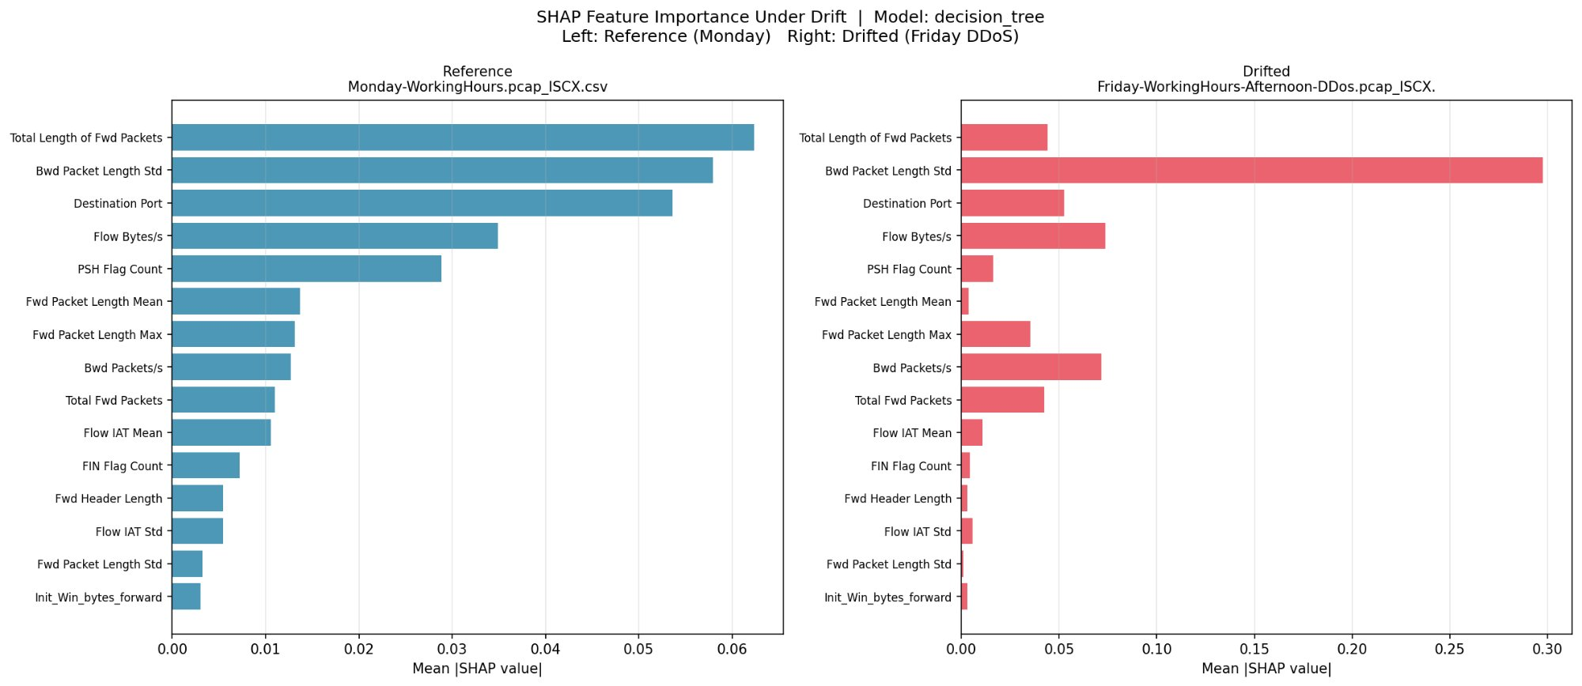
Figure 1: SHAP Feature Importance Under Drift - Decision Tree | Left: Reference (Monday) | Right: Drifted (Friday DDoS)
The Decision Tree's SHAP analysis reveals a particularly dramatic re-weighting of feature reliance under drift. On Monday's reference data, 'Total Length of Fwd Packets', 'Bwd Packet Length Std', and 'Destination Port' are the three most influential features, with 'Total Length of Fwd Packets' having the highest mean absolute SHAP value of approximately 0.062. Under Friday's DDoS traffic, however, 'Bwd Packet Length Std' shoots to an overwhelming dominance with a mean absolute SHAP value of approximately 0.298, nearly five times its reference value. Meanwhile, 'Total Length of Fwd Packets' drops from first to a minor contributor. This indicates that the decision tree has been driven, by the DDoS traffic's high-volume backward-path flooding, to pivot its entire decision logic onto the standard deviation of backward packet lengths, a feature that captures the extreme volatility of backward traffic under DDoS conditions. The collapse in the importance of forward-path features is consistent with the observation that DDoS traffic largely overwhelms the backward channel whilst forward packets are relatively uniform in size.

7.2.2 Logistic Regression
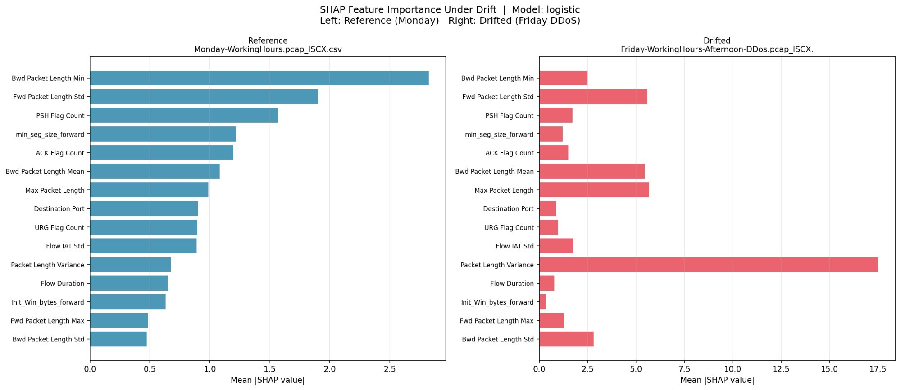
Figure 2: SHAP Feature Importance Under Drift - Logistic Regression | Left: Reference (Monday) | Right: Drifted (Friday DDoS)
The Logistic Regression SHAP comparison is arguably the most revealing of the five plots. On Monday's reference data, 'Bwd Packet Length Min' dominates with a mean absolute SHAP value of approximately 2.83, followed by 'Fwd Packet Length Std' at 1.90. These are both reasonable features for a linear classifier to rely upon in distinguishing normal and marginal traffic patterns. Under Friday's DDoS traffic, the picture changes quite dramatically: 'Packet Length Variance' explodes to a mean absolute SHAP value of approximately 17.5, a roughly 26-fold increase from its reference value of 0.68. Meanwhile, 'Bwd Packet Length Mean' and 'Max Packet Length' each jump to approximately 5.4 and 5.7 respectively. This pattern makes physical sense: DDoS floods produce enormous variance in packet lengths because the attack traffic is superimposed on whatever residual legitimate traffic remains, creating a highly heterogeneous mixture that is captured most sensitively by variance-based features. The Logistic Regression model is essentially being asked to separate two distributions using a linear boundary that was fitted on a quite different distributional landscape.

7.2.3 Random Forest
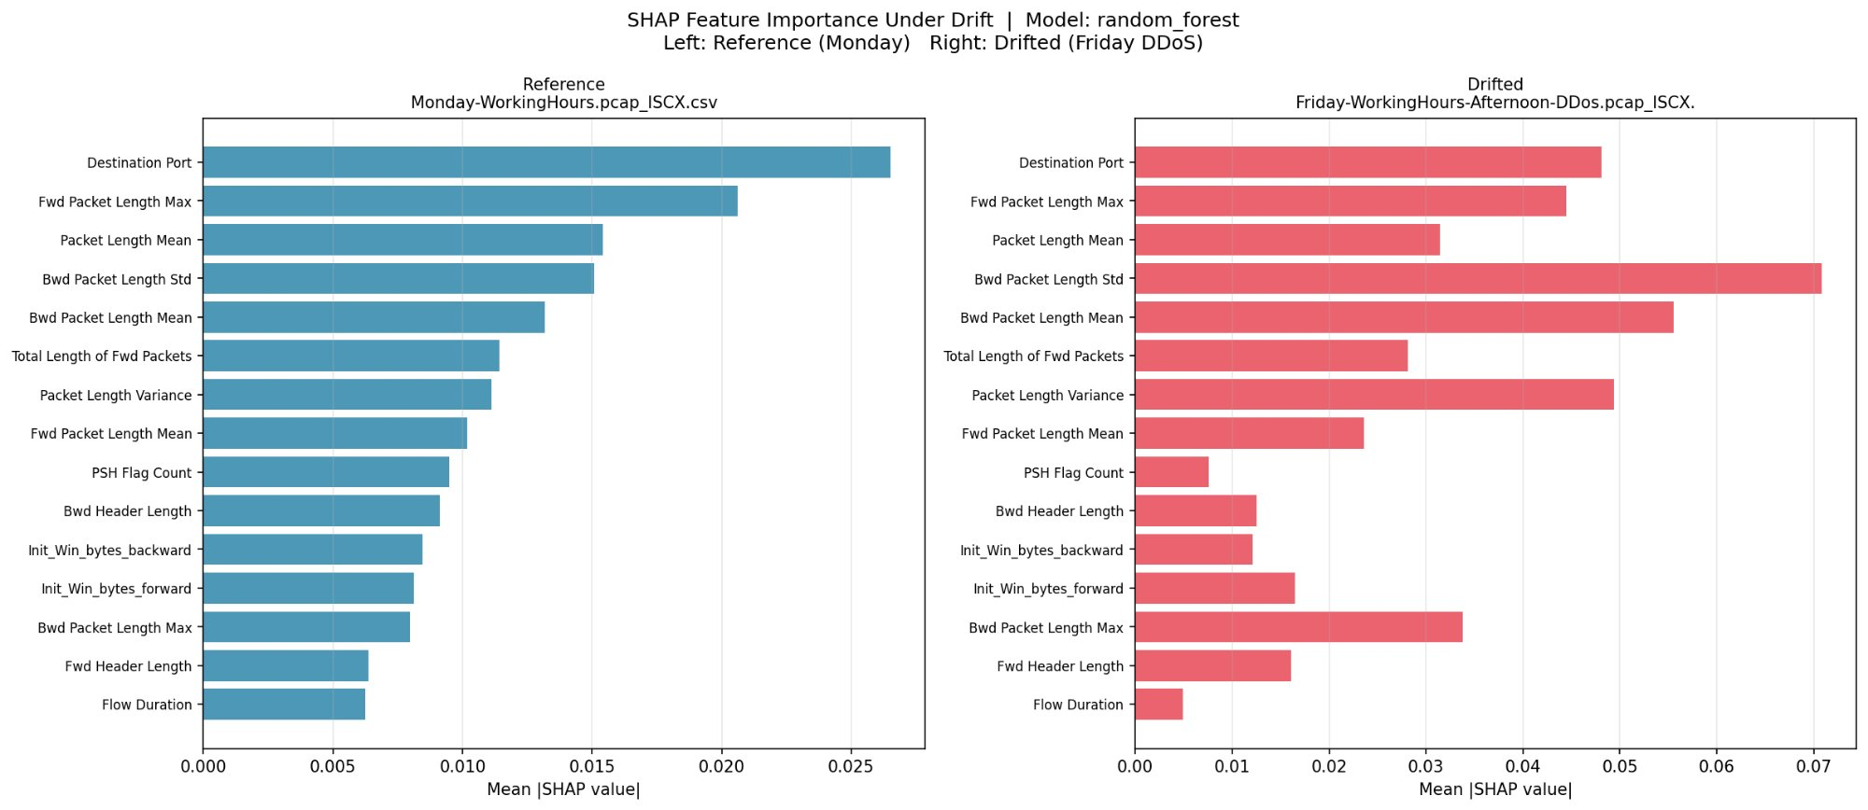
Figure 3: SHAP Feature Importance Under Drift - Random Forest | Left: Reference (Monday) | Right: Drifted (Friday DDoS)
The Random Forest SHAP comparison shows a more distributed re-weighting compared to the Decision Tree and Logistic Regression. On Monday's reference data, 'Destination Port' is the single most important feature at approximately 0.0265 mean absolute SHAP value, followed by 'Fwd Packet Length Max' at 0.0206. Under Friday's DDoS traffic, 'Bwd Packet Length Std' becomes the dominant feature at approximately 0.071, an increase of roughly 4.7 times its reference value of 0.015. 'Bwd Packet Length Mean' also increases substantially. Interestingly, 'Destination Port' remains relatively important under DDoS traffic as well, suggesting that the Random Forest is able to maintain some reliance on its usual discriminative features even under severe drift. This is consistent with the expectation that ensemble methods are more robust to individual feature distribution shifts than single models, given that the collective decision of 100 trees averages out individual feature perturbations to some extent.

7.2.4 SVM (LinearSVC)
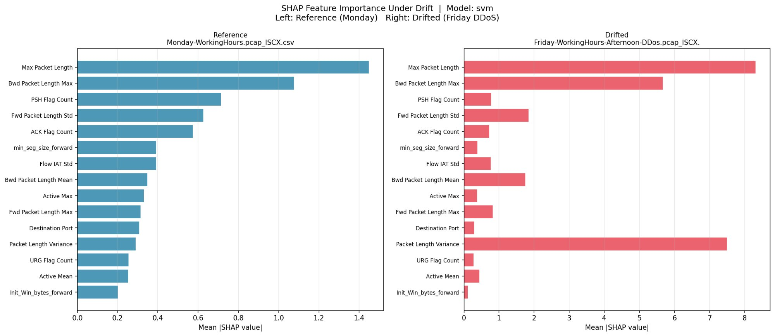
Figure 4: SHAP Feature Importance Under Drift - SVM | Left: Reference (Monday) | Right: Drifted (Friday DDoS)
The SVM SHAP analysis presents a clear illustration of what happens when a linear decision boundary encounters a fundamentally non-linear distributional shift. On Monday's reference data, 'Max Packet Length' is the most important feature at 1.45 mean absolute SHAP value, followed by 'Bwd Packet Length Max' at 1.08. Under Friday's DDoS traffic, these two features retain their positions in the top ranks but with dramatically amplified SHAP values: 'Max Packet Length' increases to approximately 8.31, a nearly 5.7-fold amplification. 'Packet Length Variance' increases from 0.29 to 7.50, a 25-fold amplification. The SVM's linear decision surface, originally calibrated to Monday's relatively narrow packet length distribution, is being stretched far beyond its original operating regime by the DDoS flood's extreme packet length values. The model assigns very high weight to these features simply because they take on out-of-distribution values that fall far from the learned separating hyperplane.

7.2.5 XGBoost
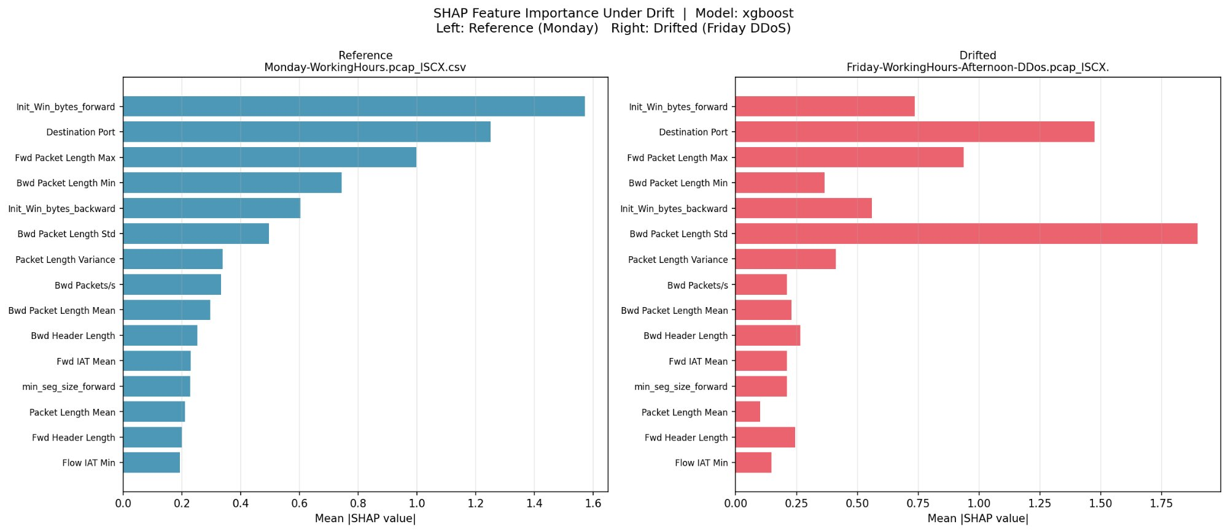
Figure 5: SHAP Feature Importance Under Drift - XGBoost | Left: Reference (Monday) | Right: Drifted (Friday DDoS)
The XGBoost SHAP comparison is instructive in a different way from the other four models. On Monday's reference data, 'Init_Win_bytes_forward' is the dominant feature at 1.57 mean absolute SHAP value, followed by 'Destination Port' at 1.25. These are strong intuitive choices: TCP initial window size is highly characteristic of different client operating systems and application protocols, and destination port is directly indicative of the type of service being accessed. Under Friday's DDoS traffic, 'Bwd Packet Length Std' displaces all other features to become dominant at approximately 1.90. 'Destination Port' and 'Fwd Packet Length Max' retain reasonable importance, but 'Init_Win_bytes_forward' drops sharply from first to a minor role. The DDoS attack's characteristic of flooding the backward channel with packets of widely varying sizes drives the 'Bwd Packet Length Std' feature into a dominant role, while the initial window size, which was informative about protocol type in Monday's benign traffic, becomes much less useful when the majority of flows are flood packets with no meaningful session establishment.

8. Technical Challenges and Engineering Solutions
No project of this scale proceeds without encountering a range of practical engineering difficulties. This section documents the principal challenges encountered during development, along with the specific solutions implemented. This documentation is written specifically to assist anyone who may inherit or extend this codebase.

8.1 Memory Overflow on 1.5 GB CSV Data
The most time-consuming early challenge was the straightforward matter of data loading. Attempting to concatenate all eight CICIDS 2017 CSV files into a single Pandas DataFrame consistently produced MemoryError exceptions during array block consolidation. Wednesday's file alone contains 691,406 rows; loading all eight files simultaneously exhausted available RAM on the development machines.
The resolution required a complete re-architecture of the data loading layer. The chunked streaming approach, using Pandas' chunksize parameter set to 20,000 rows, processes each segment independently and streams it to disk as a CSV append. The full processed_data_v1.csv is never held in memory all at once. The preprocessing log of April 4, 2026 confirms this approach processing all 2,827,876 rows across eight files without a single memory exception, at a memory footprint of approximately 47.4 MB at peak.

8.2 The Single-Class Reference Problem
The most mathematically interesting bug encountered was a consequence of Monday's reference batch containing only benign traffic. When attempting to train Logistic Regression and SVM on this single-class reference batch for the cross-dataset evaluation, scikit-learn raised the following exception: ValueError: This solver needs samples of at least 2 classes in the data, but the data contains only one class. This is mathematically correct: a logistic regression solver cannot derive a hyperplane boundary when all training samples belong to a single class.
The fix involved writing fallback logic inside drift.py: when the cross-evaluation function detects a single-class reference batch, it substitutes a DummyClassifier that always predicts the majority class. A model trained on pure BENIGN data and tasked with binary classification will indeed predict BENIGN for every incoming sample, which is exactly what the accuracy numbers reflect. For Monday's self-evaluation, this yields 100% accuracy. For Friday's DDoS batch, where the majority class is now Attack at 56.67%, the DummyClassifier's constant BENIGN prediction produces 43.33% accuracy, which is the correct ground-truth value for that worst-case drift scenario.

8.3 Column Name Whitespace in Raw Data
The raw CICIDS CSV files use column names with leading whitespace, producing identifiers such as ' Label' instead of 'Label' and ' Source IP' instead of 'Source IP'. This caused silent lookup failures in early iterations of the preprocessing code: df['Label'] would raise a KeyError while df[' Label'] would succeed, without any obvious indication of the source of the error. Applying str.strip() to all column names immediately upon file load resolved this. A duplicate column named 'Fwd Header Length.1', an artefact of CICFlowMeter's output format, was also identified and explicitly dropped at this stage.

8.4 Unicode Encoding on Windows Console
On the Windows development machine, Python's logging module defaults to the cp1252 console encoding, which cannot represent the Unicode right-arrow character used in early versions of the transition labels in log messages. This produced UnicodeEncodeError exceptions that interrupted console output, even though the file handler, configured with UTF-8 encoding, was writing correctly. The fix was to replace all Unicode arrow characters with plain ASCII '->' in console-facing log strings and to explicitly specify encoding='utf-8' for the FileHandler. A minor issue, but one that consumed more debugging time than it deserved.

8.5 Feature Consistency Across Batches
A subtle but important correctness risk was identified during cross-dataset evaluation: if feature engineering steps such as variance thresholding and correlation removal were applied independently to each temporal batch, the resulting feature sets might differ across batches. A feature with zero variance in Tuesday's data might have non-zero variance in Wednesday's, and the two resulting feature sets would be incompatible. The resolution was to apply feature engineering exactly once to the full combined dataset before any batch splitting, saving the resulting feature set as part of processed_data_v1.csv. All subsequent operations use this single, consistent 46-feature set.

9. Conclusion and Future Scope

9.1 What the Project Has Demonstrated
This project set out to answer one central question: can statistical divergence metrics computed on unlabelled incoming data, without any ground-truth labels, reliably predict how much a deployed model's accuracy will degrade on that data before a single inference is made? The empirical results documented in this report provide a clear affirmative answer, at least within the temporal structure of the CICIDS 2017 dataset.
The pipeline processed 2,827,876 real network flow records from eight temporal batches, trained five baseline classifiers achieving accuracies above 93% on same-distribution evaluation, computed distributional divergence metrics across all batch pairs, and trained a regression meta-model that predicts cross-dataset accuracy with an R-squared of 0.9924 and a MAE of 1.43%. The key result is that when the Monday-trained Random Forest model encounters Friday's DDoS traffic, its accuracy collapses from 100% to 43.33%, and this collapse is precisely predicted from the KL Divergence of 12.3652 computed on the unlabelled incoming distribution, before any predictions are made.

9.2 Key Quantitative Results

Metric | Value
Total records processed | 2,827,876 rows across 8 CSV files
Features after engineering | 46 (from original 77)
Best baseline accuracy (XGBoost) | 99.79% on same-distribution test set
Worst cross-dataset accuracy | 43.33% on Friday DDoS (Monday-trained model)
Max KL Divergence observed | 12.3652 (Friday DDoS vs. Monday reference)
Max Wasserstein Distance (rolling) | 1,845,590.19 (Tuesday to Wednesday)
Meta-model R-squared (Linear Regression, LOO-CV) | 0.9924
Meta-model MAE (Linear Regression, LOO-CV) | 1.43% average prediction error
Largest single prediction error (meta-model) | ~0.80 percentage points (Wednesday batch)
Pipeline execution date | April 4, 2026

9.3 Limitations
The empirical honesty of this section is important. The drift predictor was trained on only seven samples, one per comparison batch. The high R-squared value is real and reproducible from the logs, but it may partly reflect the specific temporal structure of CICIDS 2017 rather than a universal property of the KL-accuracy relationship across all datasets and domains. A more rigorous study would replicate this experiment across NSL-KDD, UNSW-NB15, and CIC-IDS-2018 to assess generalisability.
Additionally, the cross-dataset evaluation uses Monday as a fixed reference, which is a somewhat artificial choice. In real production systems, the legitimate traffic baseline itself evolves over time, and a fixed Monday reference would eventually become stale. A rolling reference window that updates as new verified-clean data arrives would be more appropriate for sustained deployment.

9.4 Future Directions
- Real-Time Deployment: Package the pipeline into Docker containers and deploy within a Kubernetes cluster using Apache Kafka for stream processing. The drift monitor would function as a sidecar proxy to the main inference container, continuously computing divergence on incoming data windows.
- Automated Retraining Trigger: When the meta-model predicts accuracy below a configurable threshold such as 80%, automatically trigger a CI/CD pipeline to initiate retraining on the newly accumulated data.
- Rolling Reference Windows: Replace the fixed Monday reference with an adaptive sliding window that updates as new verified-clean data is confirmed, making the system robust to legitimate baseline evolution over time.
- Multi-Class Extension: Extend the analysis beyond binary classification to per-class F1 score prediction, enabling finer-grained alerts such as detecting that DDoS detection recall specifically is about to drop whilst brute-force detection remains stable.
- Additional Datasets: Evaluate generalisability on NSL-KDD, UNSW-NB15, and CIC-IDS-2018 to determine whether the near-linear KL-accuracy relationship holds beyond the CICIDS 2017 temporal structure.
- Wasserstein in Meta-Model: Incorporate Wasserstein Distance as a fourth input feature to the regression meta-model, given its effectiveness in detecting volumetric attack transitions in the rolling window analysis.

10. References
[1] Sharafaldin, I., Lashkari, A.H., and Ghorbani, A.A. (2018). Toward Generating a New Intrusion Detection Dataset and Intrusion Traffic Characterization. Proceedings of the 4th International Conference on Information Systems Security and Privacy (ICISSP), pp. 108-116.
[2] Moreno-Torres, J.G., Raeder, T., Alaiz-Rodriguez, R., Chawla, N.V., and Herrera, F. (2012). A Unifying View on Dataset Shift in Classification. Pattern Recognition, 45(1), pp. 521-530.
[3] Bifet, A. and Gavaldà, R. (2007). Learning from Time-Changing Data with Adaptive Windowing. Proceedings of the 7th SIAM International Conference on Data Mining (SDM), pp. 443-448.
[4] Gama, J., Medas, P., Castillo, G., and Rodrigues, P. (2004). Learning with Drift Detection. Advances in Artificial Intelligence - SBIA 2004. Lecture Notes in Computer Science, vol. 3171. Springer, Berlin, Heidelberg.
[5] Rabanser, S., Guennemann, S., and Ghahramani, Z. (2019). Failing Loudly: An Empirical Study of Methods for Detecting Dataset Shift. Advances in Neural Information Processing Systems (NeurIPS), vol. 32.
[6] Gretton, A., Borgwardt, K.M., Rasch, M.J., Scholkopf, B., and Smola, A. (2012). A Kernel Two-Sample Test. Journal of Machine Learning Research, 13, pp. 723-773.
[7] Ovadia, Y., Fertig, E., Ren, J., et al. (2019). Can You Trust Your Model's Uncertainty? Evaluating Predictive Uncertainty Under Dataset Shift. Advances in Neural Information Processing Systems (NeurIPS), vol. 32.
[8] Ahmad, I., Basheri, M., Iqbal, M.J., and Rahim, A. (2018). Performance Comparison of Support Vector Machine, Random Forest, and Extreme Learning Machine for Intrusion Detection. IEEE Access, 6, pp. 33789-33795.
[9] Pedregosa, F., Varoquaux, G., Gramfort, A., et al. (2011). Scikit-learn: Machine Learning in Python. Journal of Machine Learning Research, 12, pp. 2825-2830.
[10] Chen, T. and Guestrin, C. (2016). XGBoost: A Scalable Tree Boosting System. Proceedings of the 22nd ACM SIGKDD International Conference on Knowledge Discovery and Data Mining, pp. 785-794.

