Project Report
On
Jenkins Job Template Engine
Submitted to Manipal University Jaipur
Towards the partial fulfilment for the Award of the Degree of
BACHELOR OF TECHNOLOGY
In Computers Science and Engineering
2025-2026
By
Anwesha Singh
23FE10CSE00299



______________________________
Signature of Supervisor

Department of Computer Science and Engineering
School of Computer Science and Engineering
Manipal University Jaipur
Jaipur, Rajasthan - 303007

Development and Implementation of a Jenkins Job Template Engine for Automated Continuous Integration Pipelines
ABSTRACT
The concept of Continuous Integration (CI) and Continuous Delivery (CD) has emerged as a crucial tool for ensuring rapid, reliable, and consistent software deployment methodologies and lifecycles. This report details the architectural design and practical implementation of a Jenkins Job Template Engine. The primary objective of the developed system is to automate the manual and error-prone process of making Jenkins jobs. By leveraging Infrastructure as Code (IaC) and Configuration as Code (CaC), the implemented architecture utilises a strictly decoupled approach wherein project-specific empirical data is stored in YAML configuration files, whilst the underlying pipeline execution logic is maintained within Jinja2 XML templates. A sophisticated Python orchestration script serves as the central operational nexus, interfacing seamlessly with the Jenkins Representational State Transfer (REST) Application Programming Interface (API) to programmatically create or update pipeline jobs. The findings conclusively substantiate that transitioning to a scripted, template-centric automation engine significantly enhances operational efficiency and systematically mitigates risks associated with human configurational errors.

1. INTRODUCTION
The historical progression of software development methodologies has witnessed a monumental paradigm shift, transitioning from rigid, sequential Waterfall models to highly iterative Agile frameworks, and subsequently evolving into the modern DevOps operational culture. Central to this transformational DevOps methodology is the rigorous implementation of Continuous Integration (CI) and Continuous Delivery/Deployment (CD) operational pipelines. Within academic and industrial contexts, CI/CD represents an automated, highly structured workflow explicitly designed to streamline and accelerate the entire software development lifecycle by entirely replacing manual, human-centric steps with automated pipelines that construct, validate, and deploy software artifacts with unwavering reliability.
Defining Continuous Integration (CI) Continuous Integration is formally defined as a rigorous developmental practice wherein software engineers frequently integrate and merge their discrete code modifications back into a central, shared source code repository, typically a designated main branch or trunk. This process is not an isolated event but a continuous cycle occurring multiple times throughout an operational day. The critical component is that every solitary integration is immediately validated by triggering an automated build process, sequentially followed by the execution of exhaustive automated testing suites, which generally encompass granular unit tests, comprehensive integration tests, and sweeping regression tests. The fundamental goal is to systematically avoid the notorious "integration hell" that traditionally occurred during prolonged periods of isolated development, allowing teams to identify and isolate syntax errors and logical bugs at the earliest possible juncture.
Continuous Delivery versus Continuous Deployment (CD) While CI focuses primarily on the build and testing phases, CD governs the subsequent staging and release phases. Continuous Delivery is aimed at ensuring an application is perpetually maintained in a production-ready state. It automates deployment to intermediate staging environments, but the definitive release into the live production environment deliberately requires a manual, human-initiated approval to align technical deployments with overarching business and marketing schedules.
Conversely, Continuous Deployment represents the absolute zenith of software delivery automation. It goes one definitive step further by entirely eliminating any manual human intervention from the release process. Under this advanced practice, every code modification that successfully passes all rigorous stages of the automated pipeline is instantaneously deployed to the end-user production environment, dramatically accelerating the feedback loop between developers and customers.
Jenkins as the Automation Backbone Within the expansive ecosystem of CI/CD orchestration tools, Jenkins stands out as the preeminent, open-source automation server. Originally developed under the nomenclature "Hudson," it has systematically evolved to serve as the critical infrastructural backbone of pipelines across diverse DevOps environments. The overwhelming market dominance of Jenkins—holding approximately a forty-four percent market share in recent years—is primarily attributed to its profound architectural flexibility, its capability to operate across virtually any infrastructural environment, and its extraordinarily expansive network of community-developed plugins. It offers native support for every popular version control system (including GitHub, Bitbucket, and GitLab) as well as common build systems (such as Maven, Gradle, and npm).
The Operational Bottleneck of Manual Configuration However, this extensive flexibility introduces significant operational complexities. Historically, the configuration of Jenkins jobs and pipelines relied heavily on manual interactions through its graphical user interface. This manual approach is inherently antithetical to the core tenets of modern DevOps. It introduces severe operational bottlenecks, leads to rampant configuration drifts across disparate environments, and completely lacks the version control necessary for infrastructural auditing and disaster recovery. Addressing these systemic inefficiencies forms the critical foundation for transitioning towards automated, template-driven job creation methodologies.

2. PROBLEM STATEMENT AND OBJECTIVES
In real-world projects, multiple Jenkins jobs need to be created, and the traditional manual configuration introduces severe operational bottlenecks. Manual job configuration is:
- Time-consuming.
- Highly repetitive.
- Inherently error-prone.
- Characterised by a profound lack of standardisation across pipelines.
- Difficult to manage across disparate environments.
The primary objective of the developed system is to automate the manual and error-prone process of making Jenkins jobs. The project aims to:
- Automate Jenkins job creation using the REST API.
- Reduce manual configuration effort.
- Improve CI/CD efficiency.
- Enable highly reusable job templates.
- Introduce parameterised pipelines to facilitate dynamic branch selection.

3. THEORETICAL FOUNDATIONS
3.1 Infrastructure and Configuration as Code
Definition and Fundamental Principles Infrastructure as Code (IaC) is a methodological operational approach that fundamentally mandates the management, provisioning, and configuration of computing infrastructure through machine-readable, declarative, or imperative definition files. This modern engineering philosophy stands in stark contrast to legacy infrastructure management, which relied heavily on physical hardware configuration or interactive, ad-hoc manual configuration utilities. A core principle of modern DevOps is to treat operational infrastructure with the exact same programmatic rigour, version control, and discipline that software developers apply to application source code.
The Rationale: Why is it Utilised? The primary motivation for adopting IaC is to rigorously address the systemic inefficiencies and operational fragilities inherently associated with manual configurations. Historically, manual configuration often led to undocumented changes, resulting in rampant configuration drifts across disparate operational environments. By defining infrastructure as code, organisations can systematically deploy identical environments repeatedly. This ensures that local development, staging, testing, and production environments remain flawlessly consistent. Furthermore, academic and industrial research actively indicates that organisations implementing comprehensive IaC approaches report a profound reduction in security incidents, specifically those related to unauthorised system modifications or unmanaged configurations.
Jenkins-Specific Application: Configuration and "Jobs as Code" Within the specific operational context of Jenkins, the overarching philosophy of IaC translates directly into the practical concepts of "Pipeline as Code" and "Configuration as Code". Jenkins initially popularised Pipeline as Code through the introduction of the Jenkinsfile, which allows a CI/CD pipeline's execution steps to become a version-controlled entity stored alongside the application code. However, a Jenkinsfile alone only addresses the execution steps and does not manage the programmatic creation of the Jenkins job itself on the server.
To bridge this operational gap, the automated Job Template Engine introduces a holistic "Jobs as Code" methodology. Instead of a systems administrator manually establishing a new Jenkins job through the web interface and pointing it to a specific source repository, the entire structural definition of the job is defined programmatically. This rigorous approach ensures that the total state of the CI server can be entirely and instantaneously reconstructed from a source repository, thereby achieving true infrastructural immutability and facilitating seamless disaster recovery operations.

3.2 Jenkins REST API and Security Postures
The Role of the Jenkins REST API To operationalise the automated creation of jobs, the system architecture relies heavily on the Jenkins Representational State Transfer (REST) Application Programming Interface (API). Jenkins provides a highly robust, comprehensive Remote Access API that explicitly allows external clients and scripts to interact with the server programmatically. This capability entirely circumvents the inherent need for manual User Interface interactions, allowing for highly scalable administration. The API is strategically utilised to execute idempotent operations; before creating a new job, a script proactively queries the server via a GET request to verify the job's preexisting existence. If the job does not exist, a creation protocol is initiated via a POST request to the /createItem endpoint. Alternatively, if it already exists, an update protocol seamlessly overwrites the old configuration via a targeted POST request to the specific job's /config.xml endpoint.
Navigating Strict Security Postures: Cross-Site Request Forgery (CSRF) While the REST API provides powerful backend automation capabilities, programmatic interactions must successfully navigate Jenkins' inherent, robust security protocols. The most notable and complex of these hurdles is the Cross-Site Request Forgery (CSRF) protection mechanism.
A CSRF attack typically involves a malicious adversary tricking a properly authenticated user into inadvertently submitting a malicious, forged request to a web application. To proactively thwart this severe vulnerability, Jenkins, by default, strictly mandates that any HTTP request capable of altering the server's internal state—such as creating a new project or updating an existing job via a POST method—must include a cryptographically valid CSRF crumb.
The Crumb Implementation Mechanism To successfully comply with these strict security constraints without requiring manual human intervention, automation scripts must implement a sophisticated two-step authentication handshake protocol:
- Step 1: The Preparatory Request: Prior to transmitting any actual configuration XML payloads, an initial GET request is specifically targeted at the /crumbIssuer/api endpoint. This request authenticates using standard administrative credentials or a secure API token to safely retrieve both the issued CSRF crumb and the associated web session cookie.
- Step 2: The Payload Injection: For all subsequent, state-altering POST requests (whether for creating or updating jobs), the automation script systematically injects this specific cryptographic crumb into the HTTP request headers while simultaneously passing the saved session cookie.
This meticulous, programmatic adherence to Jenkins' overarching security architecture ensures that the entire automation process remains both functionally seamless and highly secure against known forgery vectors. By heavily automating all interaction via the REST API using short-lived tokens and ensuring strict CSRF compliance, the systemic reliance on the potentially vulnerable web UI is heavily minimised, drastically improving the overall security posture of the enterprise.

4. SYSTEM ARCHITECTURE AND DESIGN METHODOLOGIES
The core architectural framework of the automated system represents a harmonious, programmatic integration of structured YAML data, dynamic templates, and programmatic API interactions. The overarching execution flow of this architecture can be visualised as a strict pipeline: jobs.yaml → Python → XML → Jenkins → Execution.
A paramount architectural decision in the sophisticated design of the Jenkins Job Template Engine was the strict, uncompromising decoupling of project-specific empirical data from the underlying operational pipeline execution logic. In the specific context of CI/CD orchestration, "logic" refers to the immutable sequence of operational procedures—for example, the programmatic steps required to clone a remote repository, execute a package manager to resolve dependencies, or run an automated test suite. Conversely, "data" refers to the highly specific, mutable parameters required by those operations to function correctly, such as the specific URL of the target repository, the designated Git branch, or the exact shell commands required for a particular software project.
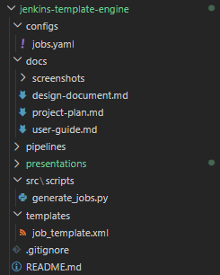
4.1 The Academic Rationale for Decoupling
Centralising and decoupling pipeline logic offers multifaceted and profound benefits for complex enterprise architectures.
- Adherence to DRY Principles: Primarily, this architecture strictly adheres to the fundamental software engineering principle of "Don't Repeat Yourself" (DRY). By methodically extracting the generic, universally applicable pipeline stages into a singular, overarching template, the engineered system systematically minimises redundant configurations distributed across potentially hundreds of different software repositories.
- Cascading Updates: When critical updates to the pipeline logic are required—such as the mandatory implementation of a new security patching protocol or the integration of a novel automated testing framework—the requisite modification is executed exactly once within the central template. Consequently, the operational benefits of this update cascade immediately and automatically to all dependent microservices and jobs.
- Separation of Concerns and Abstraction: Furthermore, decoupling facilitates a clear, unequivocal separation of concerns. Software developers can concentrate their efforts exclusively on defining the inputs for their specific applications via a highly simplified configuration file. They do not require deep, specialised expertise in Jenkins' underlying Groovy Domain Specific Language (DSL) or its complex XML structural schemas. This abstraction layer significantly accelerates new developer onboarding and dramatically reduces the immense cognitive load associated with maintaining complex CI/CD pipelines.
4.2 The Four Operational Layers
The system's design principle is fundamentally built upon the separation of concerns, functionally divided into four distinct operational layers:
1. The Config Layer (Data Operationalisation): To actively operationalise the theoretical decoupling, the implemented system strategically employs YAML (YAML Ain't Markup Language) for structured data serialisation. The specific file designated as configs/jobs.yaml serves as the singular, authoritative source of truth for all pipeline job definitions within the project scope. YAML was deliberately selected over alternative formats such as JSON (JavaScript Object Notation) or raw XML due to its vastly superior human readability and its widespread, unquestioned acceptance as an industry-standard format for infrastructural configuration files. Each distinct entry detailed within the YAML file meticulously encapsulates the unique parameters of an individual job, achieving a state where data is wholly independent of the execution engine.
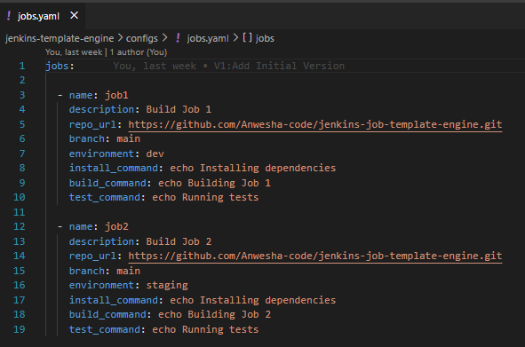

2. The Template Layer (Pipeline Logic Framework): The template layer houses the pipeline logic within job_template.xml. To successfully generate the complex, heavily nested XML configurations inherently required by the Jenkins automation server, the system effectively utilises the Jinja2 templating engine. Jinja2 was selected after rigorous evaluation against several alternative technologies (including Twig and standard Groovy string interpolation) driven by highly nuanced technical justifications:
- Ecosystem Familiarity: Jinja2 is deeply integrated into the broader Python development ecosystem and operates as the primary templating language for ubiquitous configuration management tools like Ansible, significantly lowering the requisite learning curve for DevOps engineers.
- Robust Handling of Undefined Variables: Jinja2 possesses a uniquely robust capability to process and handle undefined values gracefully. This allows systems engineers to establish predetermined default parameters directly within the template's structure. If the external YAML configuration inadvertently omits an optional parameter, the engine seamlessly falls back to the defined default value without halting rendering execution or throwing fatal compilation errors.
- Advanced Control Structures: Jinja2 inherently supports highly complex, programmatic control structures directly within the XML markup, ensuring the resulting configuration accurately and comprehensively reflects the desired infrastructural state.
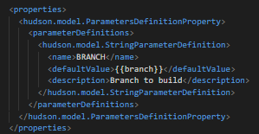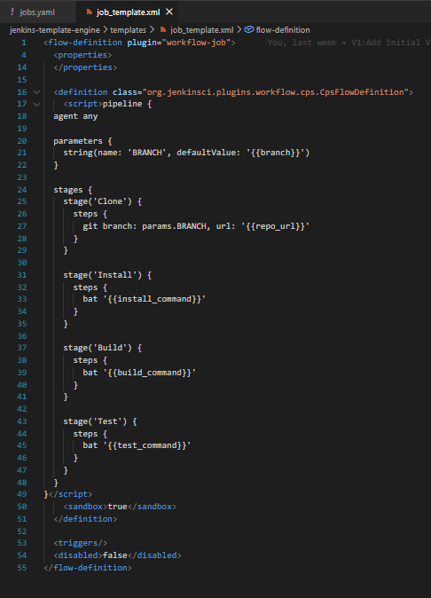
3. The Logic/Script Layer (Orchestration Hub): The absolute core orchestrator of the entire automated system is the meticulously engineered Python script, designated as generate_jobs.py. This powerful script functions as the vital, programmatic bridge connecting the static local configurations to the live, remote Jenkins server environment. Initially, the script relies heavily on the pyyaml library to accurately ingest and parse the jobs.yaml file, systematically converting the human-readable text into highly structured, iterable Python dictionary objects. It then dynamically injects these specific dictionary values (identified by placeholders) into their corresponding locations within the Jinja2 template. The definitive output of this intensive rendering process is a fully formed, syntactically perfect XML string.
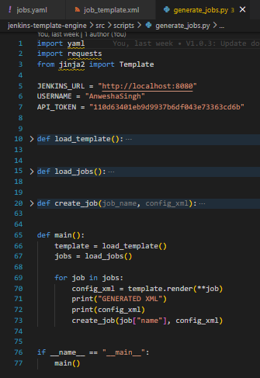
4. The Execution Layer (Jenkins Server Environment): The final tier is the Execution layer, represented by the Jenkins server itself. The Python script leverages the Jenkins REST API to wholly automate the entire lifecycle of the Jenkins jobs using integration logic that is specifically and carefully designed to be idempotent. In systems engineering, idempotency means that the script can be executed multiple times continuously without causing any unintended side effects, state corruptions, or the creation of duplicate entities. The Jenkins engine ultimately ingests the dynamically generated XML payloads, effectively creating reusable, parameterised multi-stage pipelines ready for execution.

5. PROJECT MODULES AND IMPLEMENTATION DETAILS
5.1 Module 1: The Data Layer (YAML Configuration)
To actively operationalise the theoretical decoupling, the system strategically employs YAML (YAML Ain't Markup Language) for structured data serialisation. The file designated as configs/jobs.yaml serves as the singular, authoritative source of truth for all pipeline job definitions within the project scope. YAML was deliberately selected over JSON or raw XML due to its vastly superior human readability and its unquestioned acceptance as an industry-standard format. Each distinct entry in the YAML file meticulously encapsulates unique parameters, including the designated job name, Git repository URL, default branch, and highly specific shell commands to be executed during the build stages.
5.2 Module 2: The Templating Engine Framework (Jinja2 Integration)
To successfully generate the complex, heavily nested XML configurations required by the Jenkins automation server, the system effectively utilises the Jinja2 templating engine. A specific template file acts as the foundational structural blueprint for all pipeline generation.
Jinja2 was selected for several technical justifications:
- Ecosystem Familiarity: It is deeply integrated into the Python development ecosystem, lowering the requisite learning curve for DevOps engineers.
- Robust Handling of Undefined Variables: Jinja2 allows systems engineers to establish predetermined default parameters directly within the template; if the YAML configuration omits an optional parameter, the engine seamlessly falls back to the defined default value.
- Advanced Control Structures: Jinja2 inherently supports programmatic control structures like conditional statements ({% if %}) and iterative loops ({% for %}) directly within the XML markup.
5.3 Module 3: Python Orchestration and API Integration
The absolute core orchestrator of the entire automated system is the meticulously engineered Python script, designated as generate_jobs.py. This script functions as the programmatic bridge connecting the static local configurations to the remote Jenkins server.
Python Parsing and Rendering:
- The script heavily relies on the pyyaml library to accurately ingest and parse the configs/jobs.yaml file into structured Python dictionary objects.
- It systematically iterates through every job definition, dynamically injecting specific dictionary values (identified by placeholders like {{ repo_url }}) into their corresponding locations within the Jinja2 template.
Idempotent API Orchestration: The integration logic is specifically designed to be idempotent, meaning the script can be executed continuously without causing unintended side effects or creating duplicate entities.
- Creation Protocol: If the job does not currently exist, the script initiates a POST request to the /createItem endpoint, passing the rendered XML string as the payload.
- Update Protocol: If the job already exists, the script seamlessly pivots to an update mechanism, dispatching a POST request to the specific job's /config.xml endpoint to overwrite the old configuration.
Overcoming CSRF Constraints: The Python script natively addresses Jenkins' stringent security requirements through a sophisticated two-step authentication handshake protocol. Prior to transmitting XML payloads, it executes a preparatory GET request targeting /crumbIssuer/api/json to retrieve the issued CSRF crumb and session cookie. For all subsequent state-altering POST requests, the script systematically injects this specific crumb into the HTTP request headers, ensuring the automation remains secure against forgery vectors.
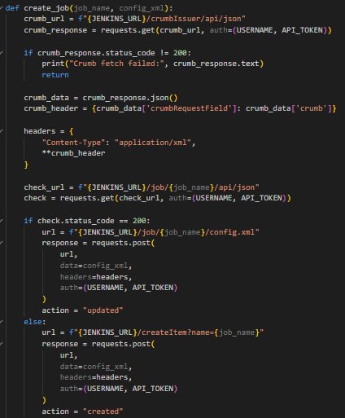
5.4 Module 4: Pipeline Execution and Parameterisation
The generated templates define a robust, strictly multi-stage pipeline. The division of the CI/CD operational process into discrete stages provides granular visibility into the build process.
- Clone Stage: Programmatically interfaces with Git to securely fetch the source repository and check out the designated branch.
- Install Stage: Systematically executes command line instructions to download and link all necessary software dependencies.
- Build Stage: The source code is systematically compiled or packaged into a deployable software artifact.
- Test Stage: Comprehensive automated testing frameworks are executed to unequivocally ensure code quality.
Furthermore, the Jinja2 template successfully injects <properties> and <parameterDefinitions> XML blocks into the final configuration. This allows the system to transition from a static job to a highly flexible pipeline, surfacing the "Build with Parameters" menu in the Jenkins UI, allowing users to dynamically dictate the exact Git branch to build at runtime.

6. EMPIRICAL RESULTS AND VALIDATION METHODOLOGIES
To empirically validate the structural integrity and programmatic logic of the engineered engine, a highly controlled testing methodology was established using two distinct jobs (job1 and job2).
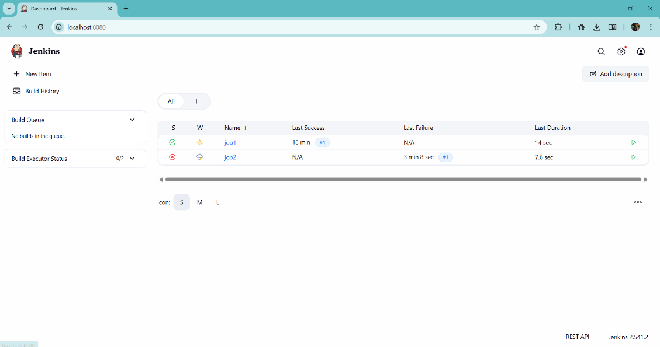

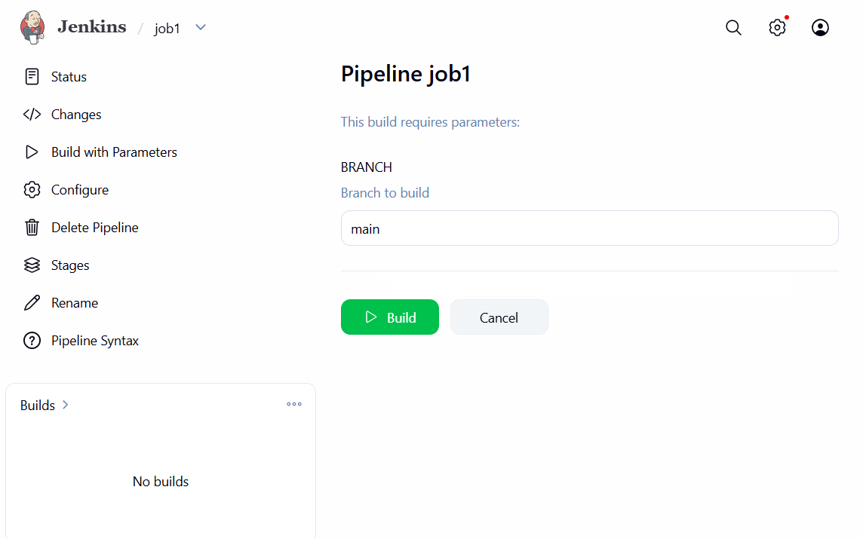
6.1 Scenario A: Job1 (The Empirical Success Case)
Job1 was intentionally configured with strictly valid parameters pointing to a legitimate Git repository and an existing main branch.
- Upon manual triggering, the automated pipeline advanced sequentially and flawlessly through all predefined stages.
- The initial Clone stage successfully retrieved the source code.
- The Install and Build stages outputted successful execution messages, confirming the compilation of the artifact.
- The execution concluded with a definitive Finished: SUCCESS status indicator, conclusively confirming the template and execution engine functioned exactly as intended.
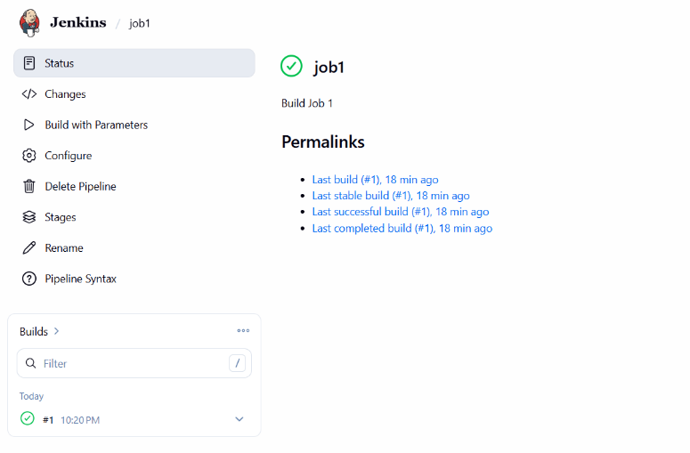
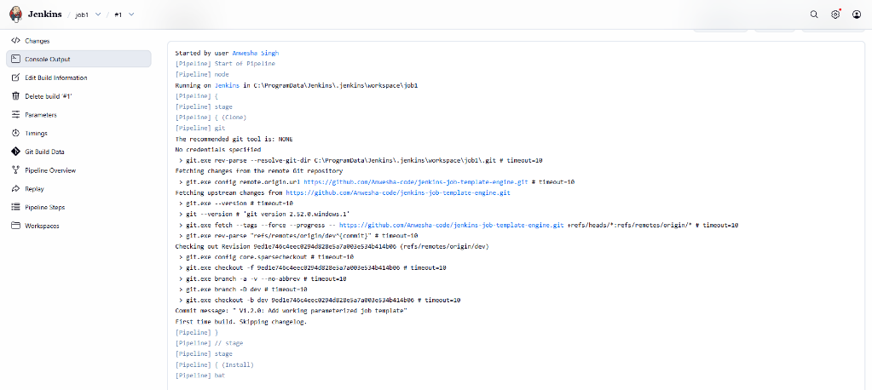
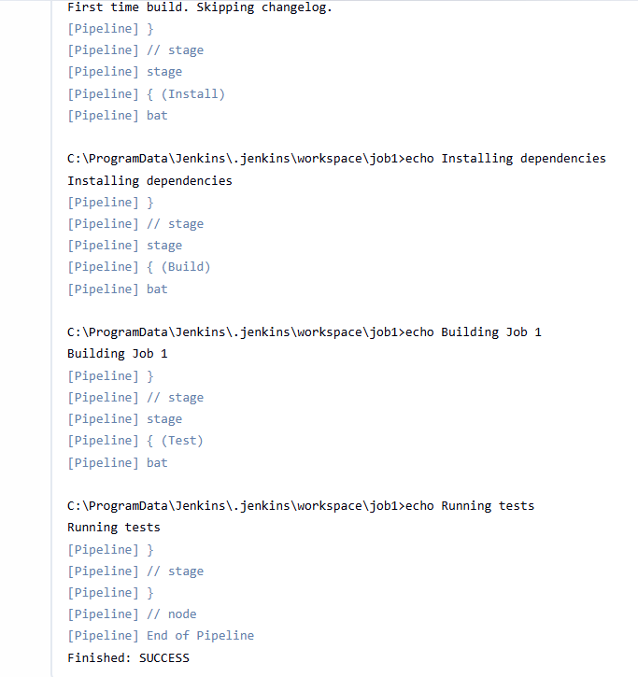
6.2 Scenario B: Job2 (The Implementation of Fail-Fast Behaviour)
The rigorous validation thoroughly tested the system's behaviour under failure states by deliberately configuring Job2 with an anomalous, incorrect branch parameter (dev).
- During the initial Clone stage, the internal Jenkins Git client attempted to fetch the non-existent dev revision.
- Encountering a non-existent entity, it promptly encountered a fatal error and automatically halted the entire pipeline execution process.
- All subsequent operational stages were instantaneously bypassed, and the execution status was flagged as Finished: FAILURE.
- This textbook "fail-fast" behaviour prevents the massive waste of computational resources that occurs when a critical upstream dependency is fundamentally invalid.
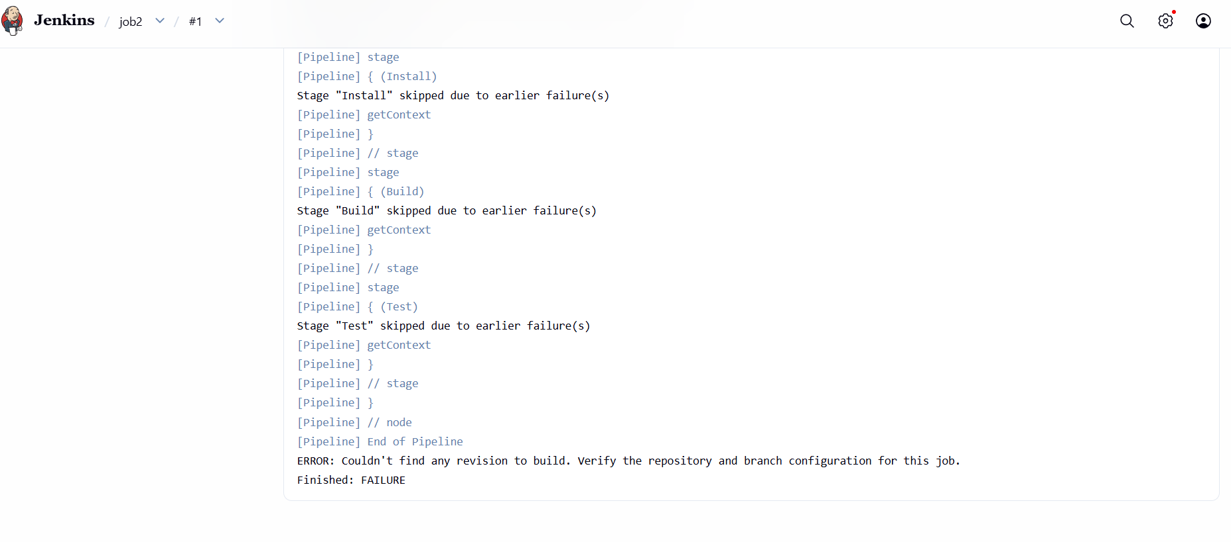

8. CONCLUSION AND FUTURE DIRECTIONS
The conceptualisation and successful deployment of the Jenkins Job Template Engine unequivocally demonstrate the profound, measurable efficacy of comprehensively automating Continuous Integration infrastructure. By rigorously applying the principles of Infrastructure as Code and strictly decoupling configuration data from reusable execution logic, the project permanently eliminates the massive redundancies inherently present in manual job creation methodologies. The engineered Python orchestration script securely adheres to vital security protocols such as CSRF token management, ensuring the reliable, idempotent creation of jobs.
Beyond the immediate technical achievements, this project serves as a foundational blueprint for massive enterprise CI/CD scalability. Future iterations could seamlessly integrate webhook listeners for completely autonomous, event-driven job synchronisation directly upon Git push events or integrate with container orchestration tools like Kubernetes for dynamic agent provisioning. It conclusively validates the premise that treating the deployment pipeline itself as a rigorously engineered software product is an absolute, indispensable practice in modern software delivery.
Github link: https://github.com/Anwesha-code/jenkins-job-template-engine

