**BEMM457**

**Coursework 2: Mini business analytics report**

By Anwesha Dhar, 16th of December 2024

Link to code: https://github.com/Anwesha-dhar/anwesha_miniproject/blob/main/Consumer_Complaints.ipynb

**Financial Consumer Complaints**

Table of content:

1. Introduction
2. An overview of CFPB
3. Exploring the data
4. The role of technology in complaint resolution
5. Why do companies/businesses need complaint management
6. The objectives we want to have
7. The outcome we want to have
8. The potential questions for analysis
9. The conclusion
10. The citation
11. **Introduction:**

I, Anwesha Dhar, as an international student of University of Exeter, Devon (UK), am obliged to be a part of the course, MSc. Business Analytics, where our professor Dr Rom Okeke gave all of us an opportunity to work on a mini project analytics report - a complete individual report in which we are free to choose project with publicly free dataset available online and do analysis and important findings on the dataset that we chose. This opens an elbow room to upskill our ways of understanding and analysing various datasets, help us learn on how to tackle with the current issues and business analytics, implement business analytics models and approaches, find business solutions, decisions and conclusions and how we can come up with a solution that could resolve any issue.

The mini business analytics report that I chose is based on managing a financial consumer complaint system. It shows data on consumer grievances over Bank of America's financial services and products from 2017 to 2023. Together with the dates, the complaint was filed with the CFPB and subsequently forwarded to the business, the product and problem the complaint raised, and the business's response back to the consumer.

The dataset that I have chosen to work on has been taken from <https://mavenanalytics.io/data-playground>. The file types are in Excel and csv. There exists a dataset containing 62,516 records and 12 fields. The date on which the data was published on the website of mavenanalytics was on 02/07/2024 by the source - Consumer Financial Protection Bureau and licensed by - Public Domain.

**2.Overview of CFPB:**

Effective July 21, 2010, the Consumer Financial Protection Bureau (CFPB) was created in accordance with Title X of the Dodd-Frank Wall Street Reform and Consumer Protection Act, Public Law No. 111-203 (Dodd-Frank Act). The CFPB is an Executive agency as defined by Section 105 of Title 5 of the US Code and an independent bureau within the Federal Reserve System.

The CFPB is empowered by the Dodd-Frank Act to use its powers to guarantee that, in relation to consumer financial products and services:

1. Customers are given access to timely and clear information so they can make informed financial transaction decisions;
2. The rights of consumers are safeguarded against discriminatory and unfair, dishonest, or abusive behaviours and practices.
3. Identifying and addressing outdated, superfluous, or excessively burdensome regulations is a common practice to minimize unneeded regulatory burdens;
4. Fair competition is encouraged by the continuous enforcement of federal consumer financial law;
5. Access and innovation are facilitated by the effective and transparent operation of consumer financial product and service markets.

The CFPB is headed by a sole Director, appointed by the President, by and with the advice and consent of the Senate, to a five-year term.

**3.Exploring the data:**

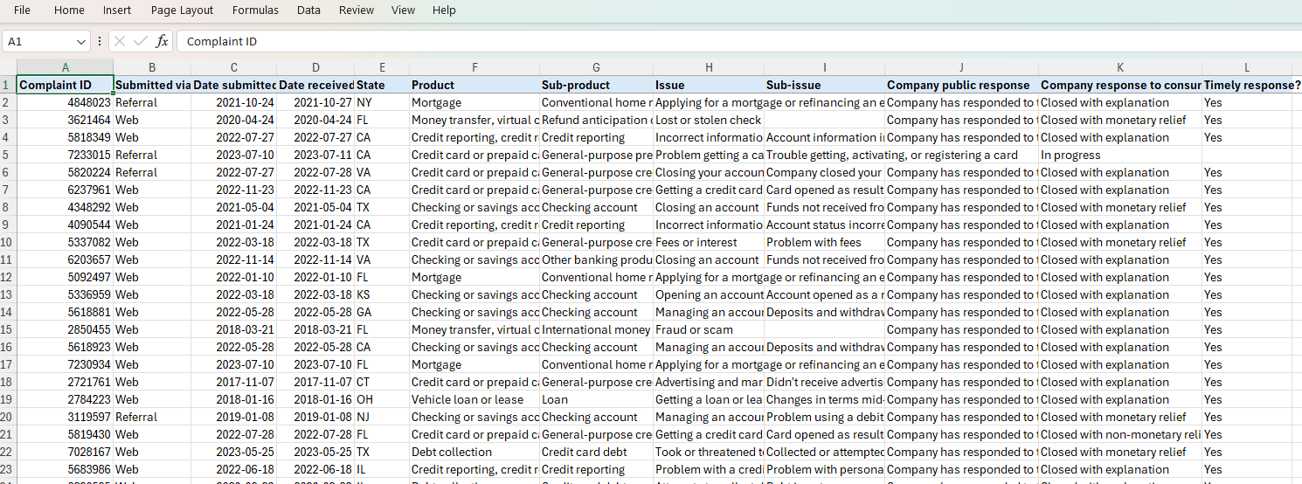

Let's examine the contents of the file named Consumer_Complaints.xlsx to determine the kind of structure and organization of the data they include. There are 12 columns and 62,516 entries in the dataset. The columns are summarized as follows:

1. Complaint ID: The unique/distinct identifying number associated with the complaint
2. Submitted via: How the complaint was filed via web, phone, postal mail, etc to the CFPB
3. Date submitted: The date or the day on which the complaint was received by the CFPB
4. Date received: The date on which the bank/company received the complaint from the CFPB
5. State: U.S. state where the complaint has been originated. There are 50 states in U.S.
6. Product: The type of financial product involved that the consumer identified in the complaint
7. Sub-product: The type of sub-product that the customer or consumer mentioned in the complaint (not all items have sub-products)
8. Issue: Overall problems and issues that the customer or consumer faces
9. Sub-issue: More specific details of the issue that the consumer pointed out (Not every issue has a matching sub-issue, and potential values vary depending on the product and issue)
10. Company public response: The optional, publicly visible reaction of the business or company to a customer's grievance. Businesses will be able to choose from a predetermined selection of choices that will be displayed on the public database. As an instance, "Company believes complaint is the result of an isolated error."

11.Company response to consumer: The response back to the consumer by the company or bank/business. For example, “closed with explanation, monetary or non-monetary relief”.

12.Timely response?: Whether the bank/business or company responded within the allotted timeframe in Yes or No.

The python code df.shape displays the number of rows and columns in the dataset:



**4.The role of technology in complaint resolution:**

A successful company/business/bank is built on its ability to handle client concerns. An organized framework is made to record, monitor, address, and evaluate customer or stakeholder complaints. The days of manually processing complaints are long gone. Automation of repetitive chores, process streamlining, and actionable insights are all made possible by modern CMS solutions.

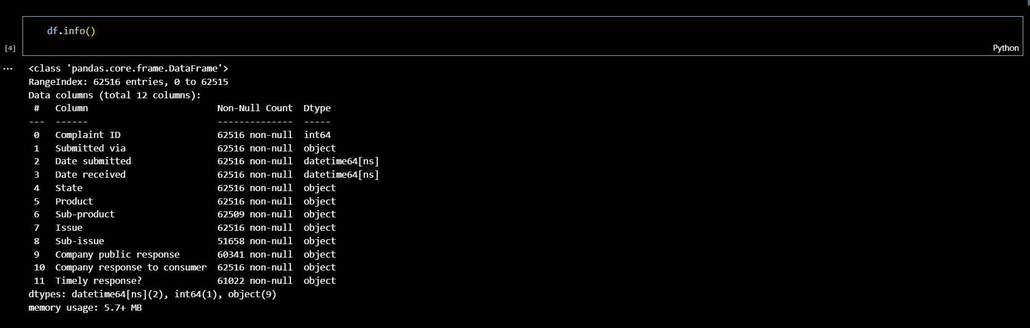

**5.Why do Companies/businesses need complaint management:**

The aim to have a complaint management system and analyse the data for financial consumer complaint is an approach on how a company/business/bank uses its power and tools to protect its current consumers of financial services, in line with consumer protection objectives.

This helps in further developing the strategy as the scope and responsibilities change (due to modifications in main and secondary legislation, for instance), the workplace environment changes, and the difficulties that consumers encounter in their financial lives change.

Every complaint is an opportunity to find problems, fix them, respond back with clarity and explanation and raise client satisfaction levels. Ignoring concerns is not an option in the competitive environment of today. Good complaint handling preserves brand reputation, increases loyalty, and fosters trust.

Here, python code in visual studio has been used to analyse the data. The codes to display the dataset is:

# python library imported

import numpy as np

import pandas as pd

import matplotlib.pyplot as plt

import seaborn as sns

#the Excel file Consumer_Complaints.xlsx into a pandas dataframe df

#pd.read_excel() reads the file and displays the first few data

df = pd.read_excel("Consumer_Complaints.xlsx")

df.head()

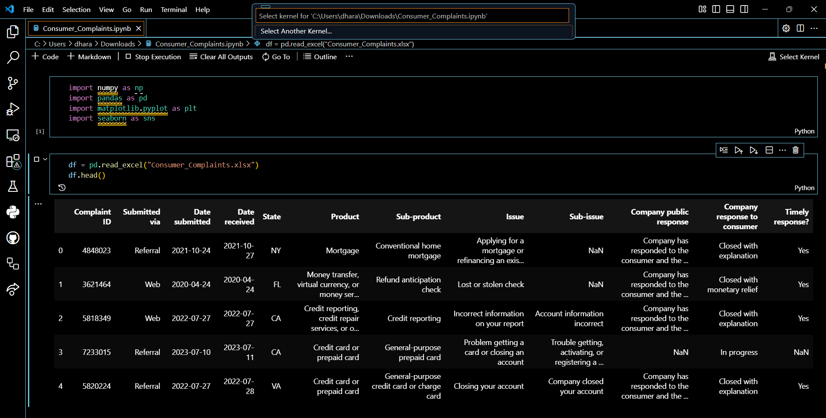

**6.Objectives:**

The objectives of the analysis are interconnected and helps to contribute in protecting the bank’s/company’s consumer/customer from any harm. The main operational objectives are as follows:

* Protecting customers: ensuring that customers have a suitable level of protection.
* Protect the financial market: safeguard and improve the integrity of the financial system in the United States of America.
* Promotes Competition: encourage healthy competition for the benefit of customers.

The secondary objective to facilitate the international competitiveness and growth of the US economy of each state.

In order to make a bank or a company work well for consumers, the bank or company need to ensure that they meet the market's interest and target in which firms are competing vigorously for consumers’ business, and where consumers are well-informed and empowered to make decisions, give feedbacks, generate complaints on various issues and concerns, this in turn increases competitive

pressures on companies and businesses, supporting innovation, quality and lower in price.

We are all aware that competition by itself may not always be enough to ensure that markets function effectively and provide the required results for customers. Business analysts should step in as needed to safeguard customers when this occurs.

The requirements, problems, and grievances of various consumer groups vary throughout the financial services industry and evolve throughout the course of their lives. As an analyst, one must make sure that one addresses and analysis the areas of greatest harm and that the work represents the varied demands of the American people.

In addition to the fact that financial products and services can be complex and challenging to comprehend, consumers who make poor decisions may suffer both financial and psychological effects. For customers who exhibit vulnerabilities, this could be more challenging.

Bank, firm, Businesses and enterprises need to be aware of and consider how these issues may affect the requirements and choices of their customers. It is only reasonable to assume that consumers will take accountability for their actions when they have confidence that the items and services they select are tailored to their requirements and that they receive the information and assistance they need to make their decisions.

Addressing information gaps between American banks and consumers regarding financial services is the goal of an analyst. An analyst keeps working with customers so they can defend themselves. Additionally, it establishes unambiguous standards for companies and enterprises. To make sure that markets function properly, an analyst will constantly try to increase customers' awareness of their rights, obligations, and risks.

**7.The outcome we want to have:**

The results we hope to achieve: -

Analysts must have four broad expectations for financial services that apply to all of the areas and industries that we oversee. We want to observe:

1. Fair value: customers get reasonable costs, high-quality products and services, response to their queries and complaints in time and with valid reasons.
2. Suitability and treatment: customers are given appropriate goods and services and are treated with respect.
3. Consumers' high levels of confidence and market engagement are mostly due to

(a) less damage when businesses fail and

(b) a decrease in financial crime.

1. Access: (a) strong operational resilience and

(b) minimal exclusion are used to satisfy a variety of customer needs.

**8.Potential questions for analysis:**

1.How has the quantity of complaints/grievances from the consumer end has changed over different states?

2. What are the states with the most complaints?

x = df.groupby(['State'])['Complaint ID'].count()

df1 = pd.DataFrame(x)

df1.head()

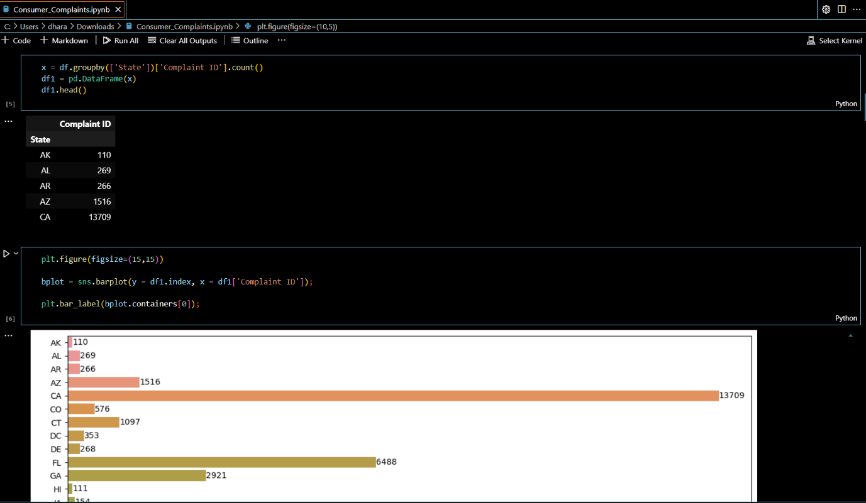

3. Which financial products are the most frequently complained about?

x = df.groupby(['Product'])['Complaint ID'].count()

df2 = pd.D x = df.groupby(['Product'])['Complaint ID'].count()

df2 = pd.DataFrame(x)

df2 = df2.sort_values(by = 'Complaint ID', ascending = False)

df2ataFrame(x)

df2 = df2.sort_values(by = 'Complaint ID', ascending = False)

df2

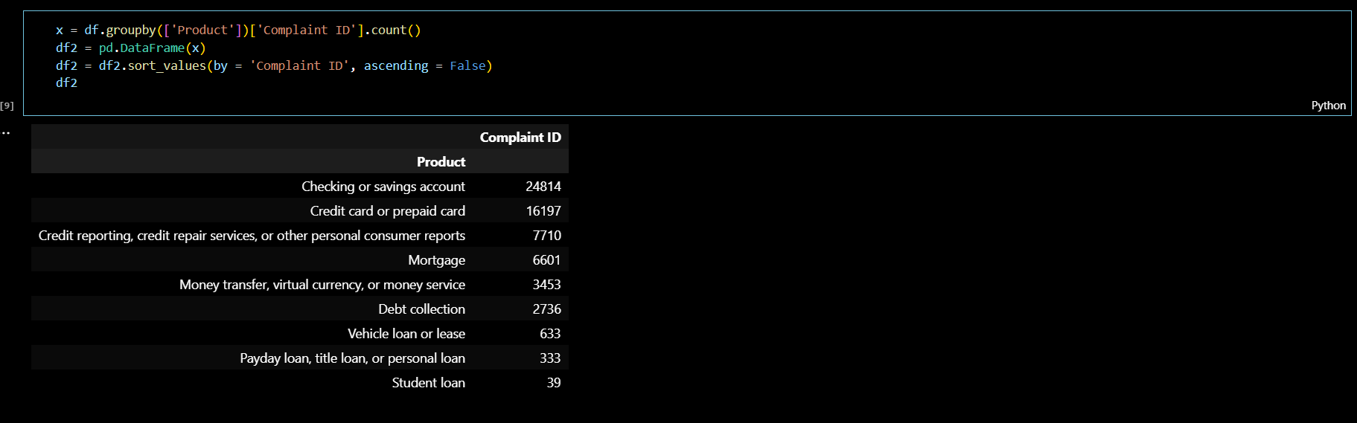

The python code to plot the graph:

plt.figure(figsize=(12,10))

bplot = sns.barplot(y = df2.index, x = df2['Complaint ID']);

plt.bar_label(bplot.containers[0]);

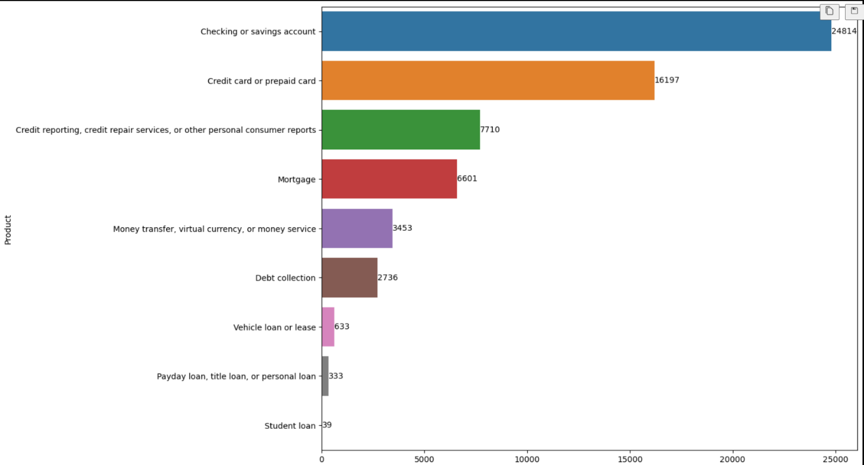

4. What quantity and percentage of complaints are addressed in a "Timely response" manner?

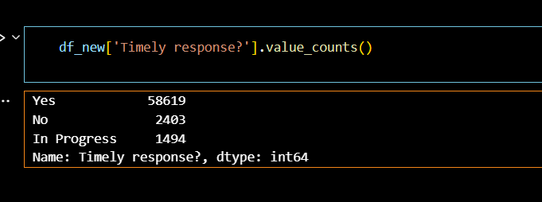

In numbers:

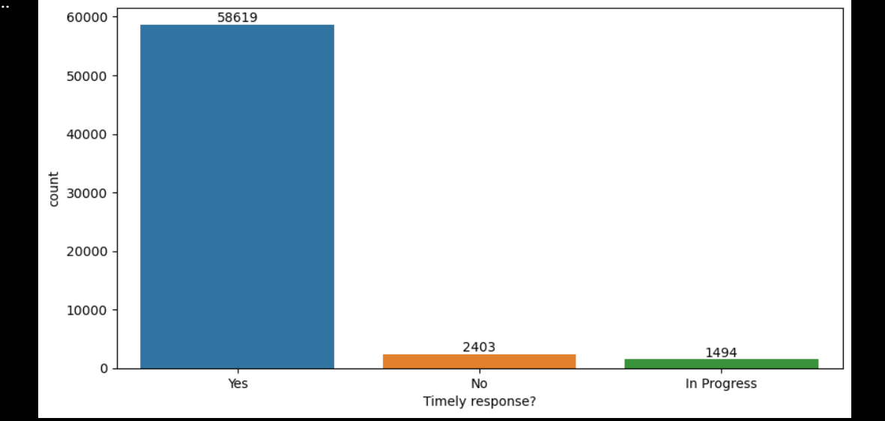

In percentage: 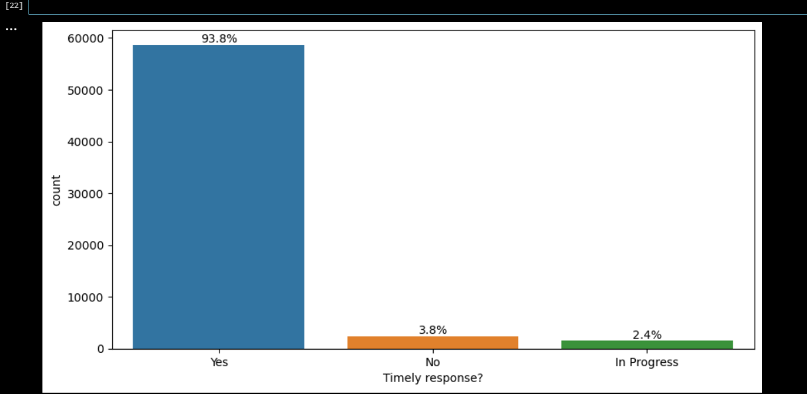

5. How do different concerns differ in the kind of reaction (e.g., monetary relief, non-monetary relief, explanation)?

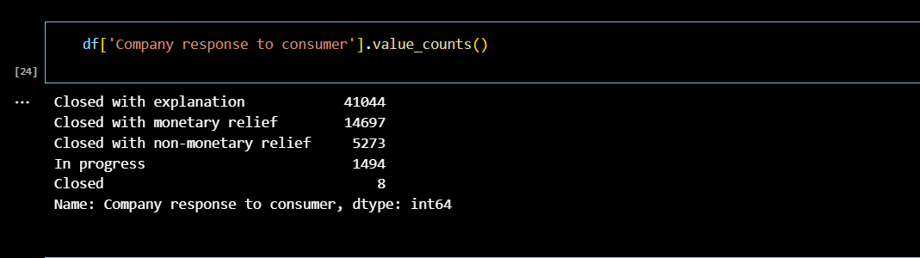

**Conclusion:**

From the given dataset of financial consumer complaint of America’s bank that I have chosen from <https://mavenanalytics.io/data-playground>, we can conclude

1. The number of complaints by the consumers through their unique complaint ID
2. We can find the number of responses in count and in percentage value

that were given back on time and those that are pending.

1. We can find and analyse the complaints that got resolved with monetary relief.
2. We could find data and create graph on which state of America has majority of complaints lodged
3. Which product has the most complaint by the consumer
4. How the complaint has been resolved

**10.Citation:**

Consumer Financial Protection Bureau. (2022). Consumer Financial Protection Bureau Strategic Plan FY 2022 - 2026. <https://files.consumerfinance.gov/f/documents/cfpb_strategic-plan_fy2022-fy2026.pdf>

Free data sets & Dataset samples | Maven Analytics. (n.d.). <https://mavenanalytics.io/data-playground?page=4&pageSize=5>

Babkins, J., & Babkins, J. (2024, September 14). Goals and Objectives for Business Plan with Examples. OGS Capital. <https://www.ogscapital.com/article/goals-and-objectives-for-business-plan-with-examples/>

Mahawar, S. (2022, April 29). Consumer Protection Act, 2019 - IPLeaders. iPleaders. <https://blog.ipleaders.in/consumer-protection-act-2019-2/>

Pavlounis, I. (2024, August 22). The benefits of consumer complaints: Improve processes and achieve business goals. Guidepost Solutions. <https://guidepostsolutions.com/insights/blog/the-benefits-of-consumer-complaints-improve-processes-and-achieve-business-goals/>

Consumer Protection Act, Definition, aiM, Objectives,. (2024, October 2). The Intact One. <https://theintactone.com/2019/03/08/lab-u4-topic-4-consumer-protection-act-objectives-definition/>