**1.Git-HOL**

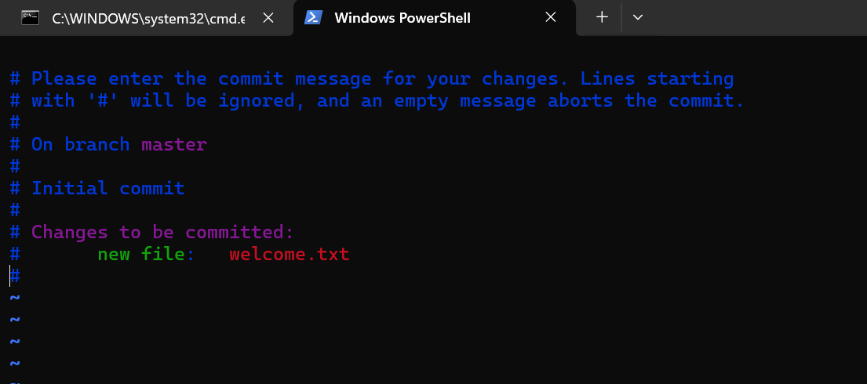

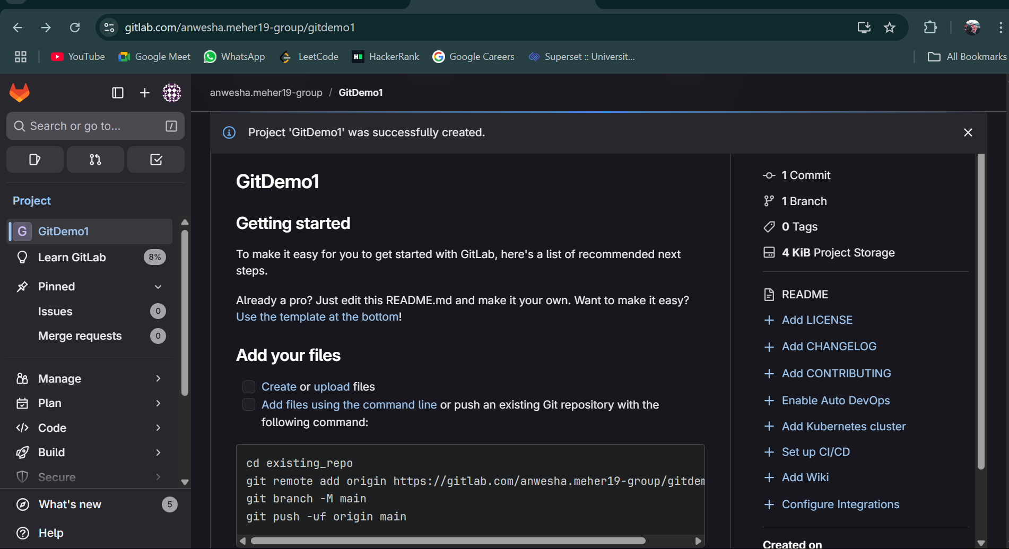

**2.Git-HOL**

**CODE:**

echo "this is s sample log file. " > app.log

mkdir log

notepad .gitignore

git status

git add .gitignore

git commit -m "Add .gitignore to ignore log files and folders"

**OUTPUT:**

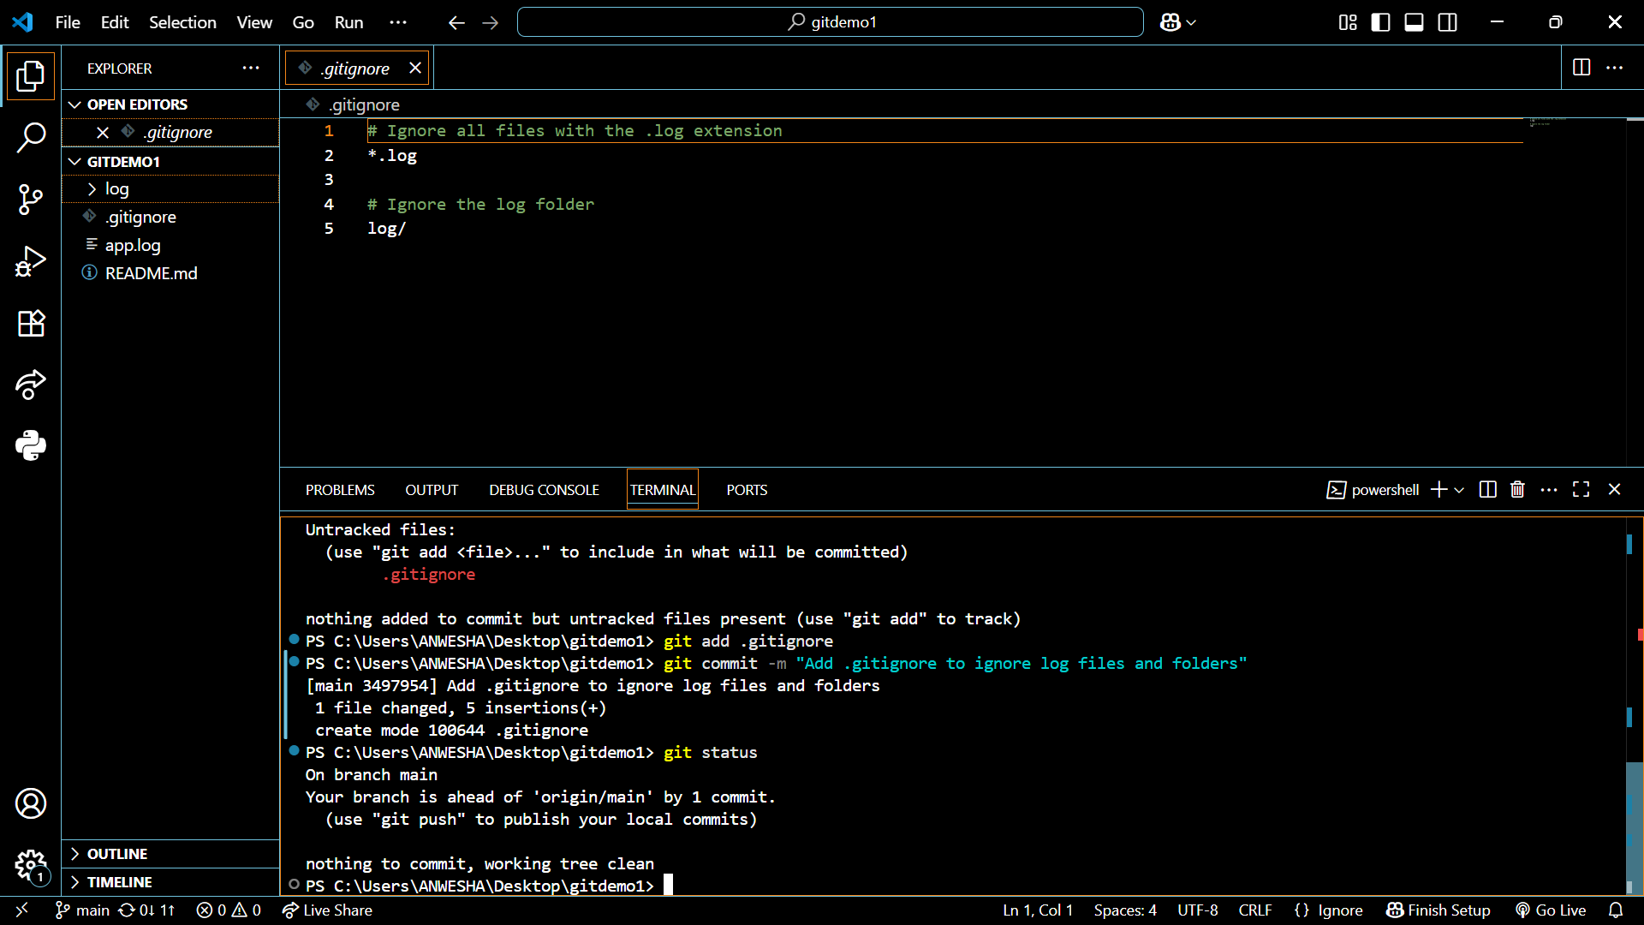

**3.Git-HOL**

**CODE**

git branch GitNewBranch

git branch -a

git switch GitNewBranch

echo "This is a new feature." > feature.txt

git add feature.txt

git commit -m "Add new feature file"

git status

git switch master

git diff GitNewBranch

git difftool GitNewBranch

git merge GitNewBranch

git log --oneline --graph –decorate

git branch -d GitNewBranch

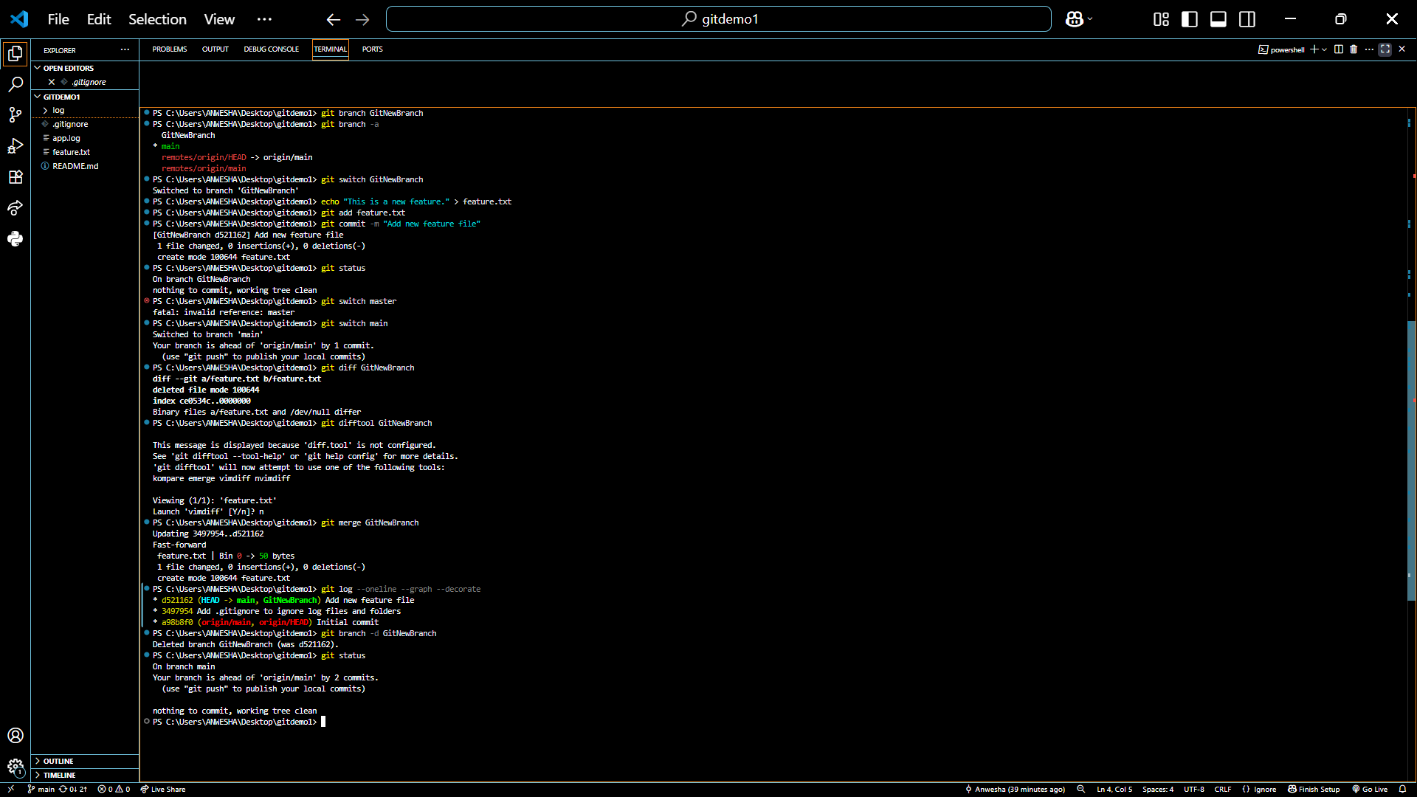

**4.Git-HOL**

**CODE:**

git switch main

git status

git branch GitWork

git switch GitWork

echo "<xml><message>Hello from the branch!</message></xml>" > hello.xml

git add hello.xml

git commit -m "Add hello.xml on GitWork branch"

git switch main

echo "<xml><message>Hello from the main branch!</message></xml>" > hello.xml

git add hello.xml

git commit -m "Add hello.xml on main branch"

git log --oneline --graph --decorate –all

git merge GitWork

git mergetool

git commit

git status

echo "*.orig" >> .gitignore

git add .gitignore

git commit -m "Ignore mergetool backup files"

git branch

git branch -d GitWork

git log --oneline --graph --decorate

**OUTPUT:**

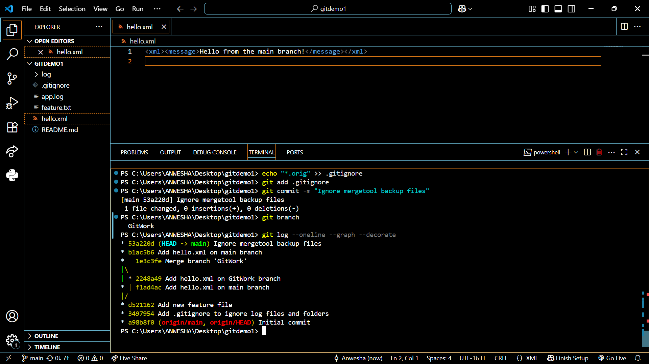

**5.Git-HOL**

**CODE:**

git branch

git pull origin main

git push origin main

