Q1. Display the Name, manager Id, and hire date of all employees who are either clerk or

works in dept 20. the date should be in the following format:

DATE_HIRED

Seventeenth December, 1980

Second April, 1981

SELECT ENAME, MGR, TO_CHAR(HIREDATE,'DDSPTH MONTH,YYYY') AS DATE_HIRED FROM EMP WHERE JOB = 'CLERK' OR DEPTNO = 20;

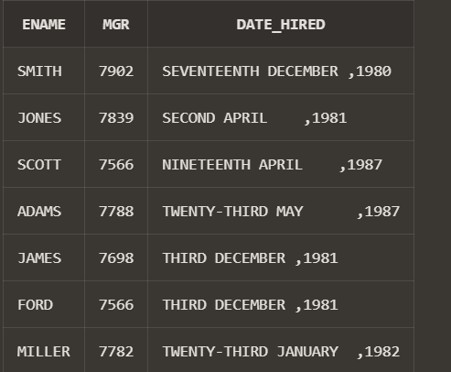

Q2.List the employee name and old salary and new increased salary by 25% and expressed

as a whole number.

SELECT

ename AS "Employee Name",

sal AS "Old Salary",

ROUND(sal * 1.25) AS "New Salary"

FROM

emp;

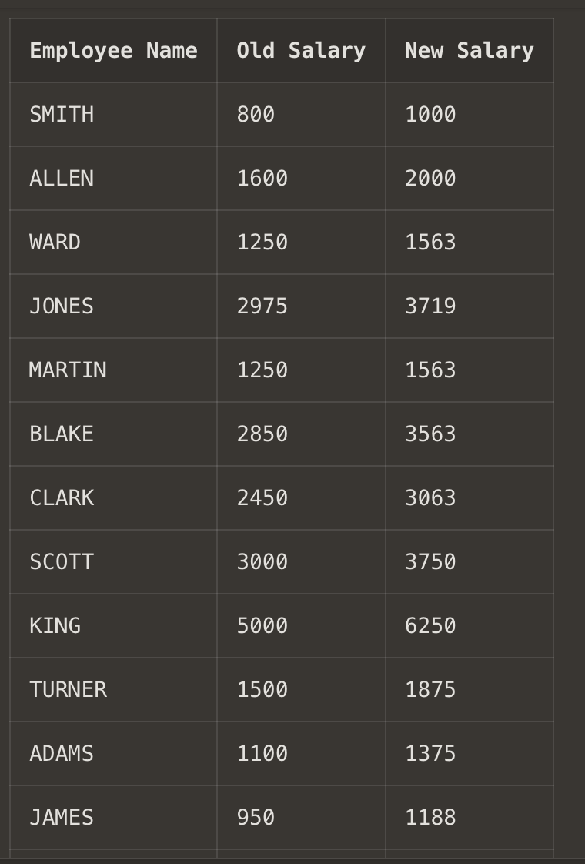

Q3. List the employee name and salary where name is displayed as left justified and salary

with right justified.

SELECT

RPAD(ename, 20) AS "Employee Name",

LPAD(TO_CHAR(sal), 10) AS "Salary"

FROM

emp;

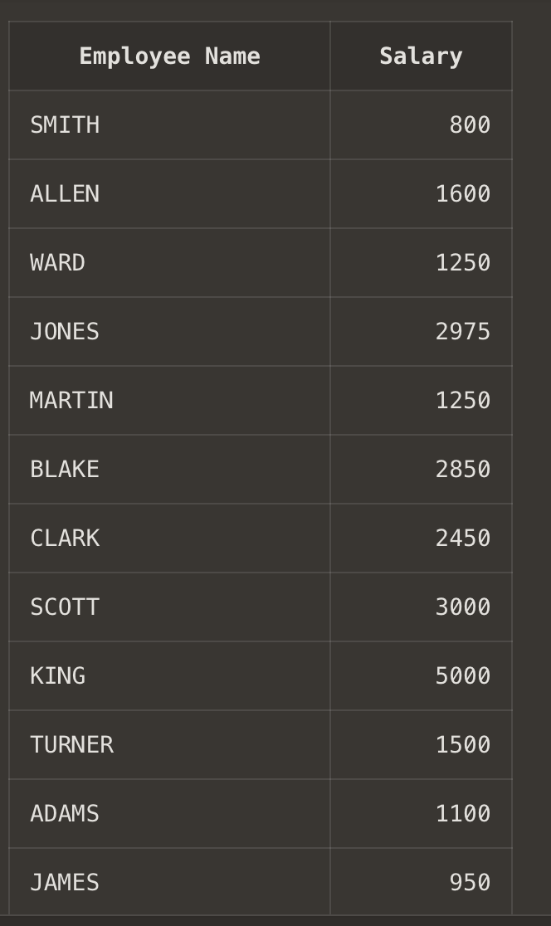

Q4.Produce the output as follows(for all employees)

ROLE OF THE EMPLOYEE

Name1 (<Job of Name 1>)

Name2 (<Job of Name 2>)

........

Note: Only first character of Name and job will be in uppercase.

SELECT

INITCAP(LOWER(SUBSTR(ENAME, 1, 1))) || LOWER(SUBSTR(ENAME, 2)) ||

' (' ||

INITCAP(LOWER(SUBSTR(JOB, 1, 1))) || LOWER(SUBSTR(JOB, 2)) ||

')' AS "ROLE OF THE EMPLOYEE"

FROM

EMP;

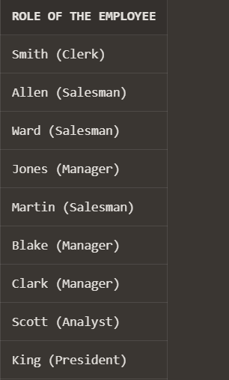

Q5.Give the details of an employees with job is clerk (enter the job value clerk as input).

SELECT * FROM EMP WHERE JOB = 'CLERK';

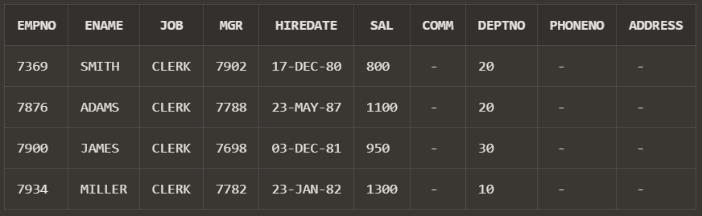

Q6.Display each employee name with hiredate and salary review date. Assume that date is

one year after hiredate. Order the output in ascending review date order.

SELECT

ENAME AS "Employee Name",

HIREDATE AS "Hire Date",

ADD_MONTHS(HIREDATE, 12) AS "Salary Review Date"

FROM

EMP

ORDER BY

"Salary Review Date" ASC;

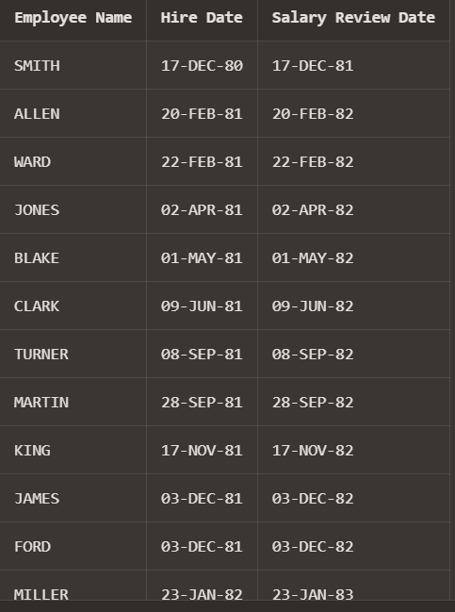

Q7.Find the employees(s) who earn the highest salary in each job type sort in descending

salary order(Use IN operator and subqueries)

SELECT *

FROM EMP

WHERE SAL IN (

SELECT MAX(SAL)

FROM EMP

GROUP BY JOB

)

ORDER BY SAL DESC;

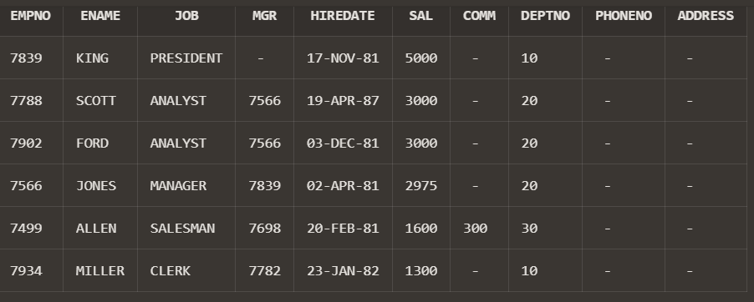

Q8.Find the most recently hired employee in each department (give number only).

SELECT EMPNO

FROM EMP e

WHERE HIREDATE = (

SELECT MAX(HIREDATE)

FROM EMP

WHERE DEPTNO = e.DEPTNO

);

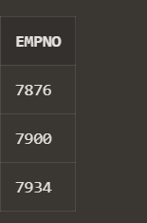

Q9.Show the name of the department and no of employees who works in that department.

Sort in department number.

SELECT

d.dname AS "Department Name",

COUNT(e.empno) AS "Number of Employees"

FROM

DEPT d

LEFT JOIN

EMP e

ON

d.deptno = e.deptno

GROUP BY

d.dname, d.deptno

ORDER BY

d.deptno;

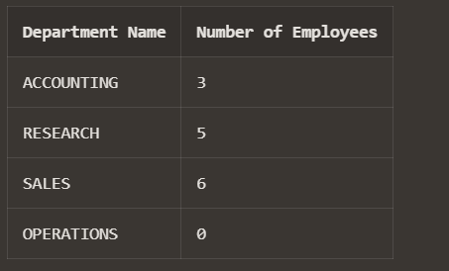

Q10.Display the Id, name, salary and the salary grade for any employee who earns the

maximum salary for their department. Sort in department number.

SELECT

e.EMPNO AS "Employee ID",

e.ENAME AS "Name",

e.SAL AS "Salary",

s.GRADE AS "Salary Grade"

FROM

EMP e

JOIN

SALGRADE s

ON

e.SAL BETWEEN s.LOSAL AND s.HISAL

WHERE

e.SAL = (

SELECT MAX(e1.SAL)

FROM EMP e1

WHERE e1.DEPTNO = e.DEPTNO

)

ORDER BY

e.DEPTNO;

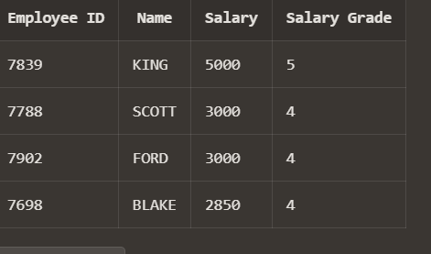

Q11.In which year did most people join the company? Display the year and number of

employees.

SELECT TO_CHAR(HIREDATE, 'YYYY') AS YEAR, COUNT(EMPNO) AS NO_OF_EMPLOYEES FROM EMP GROUP BY TO_CHAR(HIREDATE, 'YYYY') HAVING COUNT(EMPNO)=(SELECT MAX(COUNT(EMPNO)) FROM EMP GROUP BY TO_CHAR(HIREDATE, 'YYYY'));

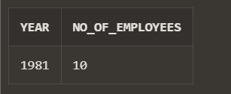

Q12.Show the every alternate row in employee table.

SELECT EMPNO, ENAME, JOB, MGR, HIREDATE,SAL, COMM, DEPTNO, PHONENO, ADDRESS FROM(SELECT EMPNO, ENAME,JOB, MGR, HIREDATE, SAL, COMM, DEPTNO, PHONENO, ADDRESS, ROWNUM RN FROM EMP) WHERE MOD(RN,2)=1;

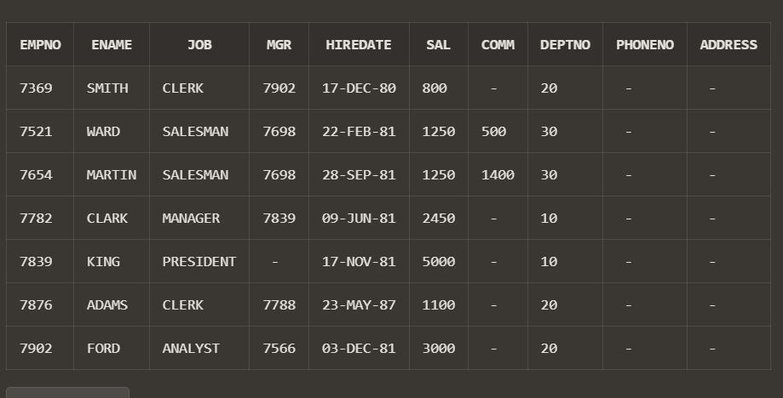

Q13.Display the total salary of all employees. Total salary = salary + commission.

SELECT EMPNO, ENAME, JOB, (SAL + NVL(COMM, 0)) AS TOTAL_SALARY

FROM EMP;

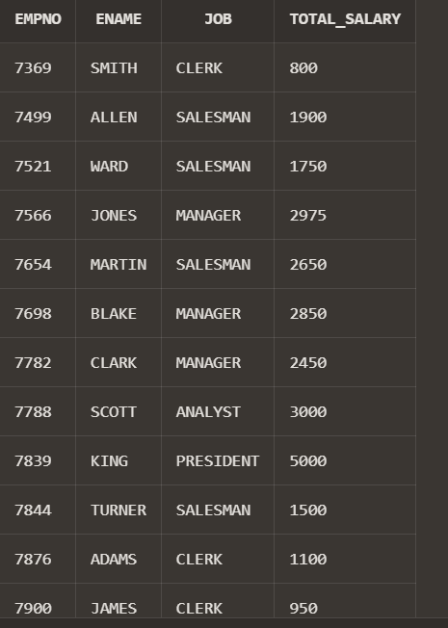

Q14.Display the department name and available jobs in that department.

SELECT DISTINCT(JOB) AS AVAILABLE_JOBS,DNAME

FROM EMP,DEPT

WHERE DEPT.deptno=EMP.deptno

ORDER BY DNAME

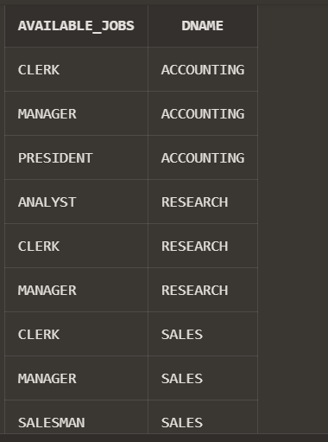

Q15.Display all the available departments and the employee(s) works under it.

SELECT DNAME,ENAME

FROM EMP,DEPT

WHERE DEPT.deptno=EMP.deptno

ORDER BY DNAME

