1. Conversion:
2. A screen shot of a computer code

   Description automatically generatedBinary to decimal

1. Decimal to binary

1. A screenshot of a computer program

   Description automatically generatedImplementation of 1’s complement

1. Implementation of 2’s complement

1. A screenshot of a computer program

   Description automatically generatedImplementation of Binary Adder

1. A screenshot of a computer program

   Description automatically generatedA screenshot of a computer program

   Description automatically generatedImplementation of Binary Adder-Subtractor

1. 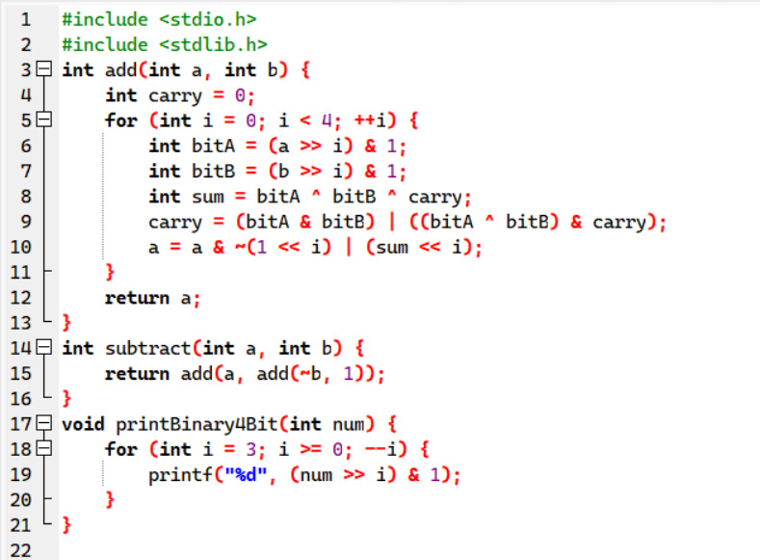Implementation of Addition and Subtraction of signed 2’s complement data

1. A screenshot of a computer program

   Description automatically generated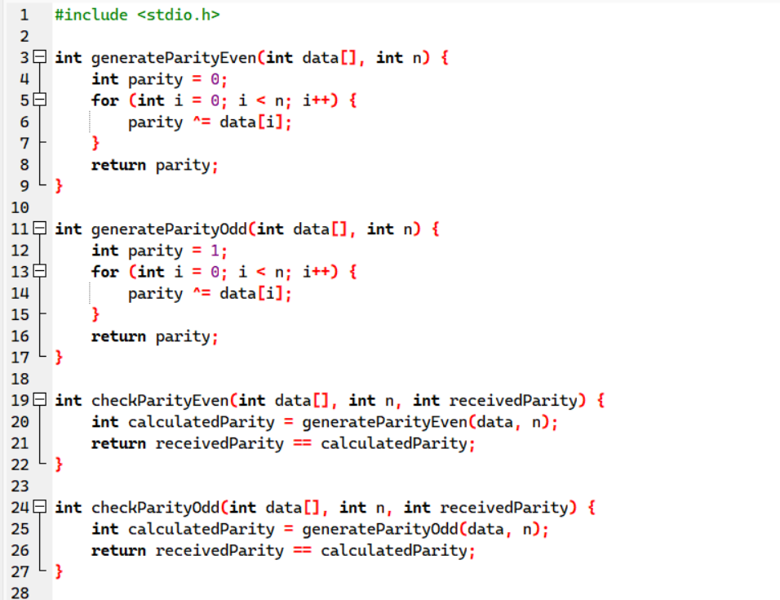Design parity generator and checker

1. A computer code with red and blue text

   Description automatically generated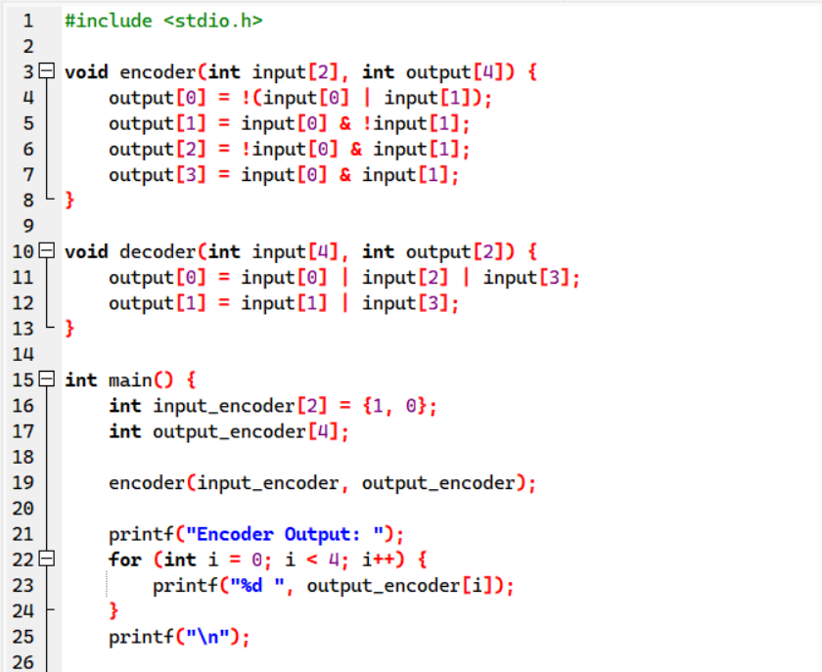Design of encoder and decoder

1. A screenshot of a computer program

   Description automatically generatedA screen shot of a computer program

   Description automatically generatedImplementation of Booth Algorithm

1. A screenshot of a computer code

   Description automatically generatedA screenshot of a computer program

   Description automatically generatedRestoring Algorithm

