1. A screenshot of a computer

   Description automatically generatedA screenshot of a computer

   Description automatically generated

2)

1)

1. A screenshot of a computer

   Description automatically generated
2. A screenshot of a computer

   Description automatically generated

4)

1. A screenshot of a computer

   Description automatically generated

2)

3)

1)

1. 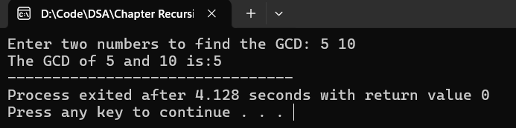

4)

5)

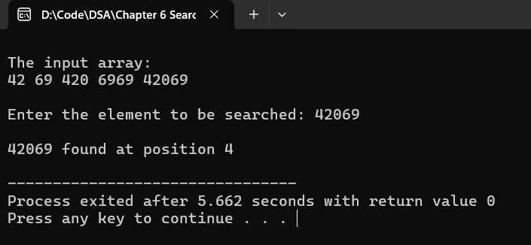

1)

2)

3)

1)

2)

3)

4)

5)

2)

3)

4)

