the website I have analyzed is apple.com
Part 1: The Network Panel (The "What's Loading?" Audit)
Goal: Understand what resources the page fetches and identify potential bottlenecks.
In the Network tab, check "Disable cache," reload the page, and screenshot the loaded network waterfall.
Answer these questions:
- Total Requests & Transfer Size: How many total requests were made? What was the total transferred size (e.g., 2.5 MB)?
- Largest Resource: What was the single largest resource (by size)? What type was it (image, JavaScript, font)?
Resource: applyThemes-BDW-3pth.js
Size: 1,028 kB (approx 1 MB)
Type: script

- Slowest Resource: Find the resource with the longest Time (hover to see Waiting (TTFB), Content Download). Why do you think it was slow? (Hint: Look at its type and initiator).

- Analysis: Identify one potential optimization. (e.g., "The hero image is a 1.2MB PNG; it could be compressed to WebP.")
Optimization: Convert the Hero Image (apple.png) to a modern format.
Problem: The file apple.png is using the older PNG format.
Solution: Converting this image to WebP or AVIF could significantly reduce its file size (often by 30-50%) without losing quality, leading to faster load times for users.

Part 2: The Performance Panel (The "User Experience" Audit)
Goal: Analyze how the page performs during a realistic user interaction.
In the Performance tab, start recording, then perform this sequence: scroll, click a navigation link, wait for the page to load, and stop the recording.
Answer these questions:
- Main Thread Work: In the flame chart, find a long yellow (JavaScript) or purple (Rendering/Layout) block. What was happening at that time? (Click on it for details).
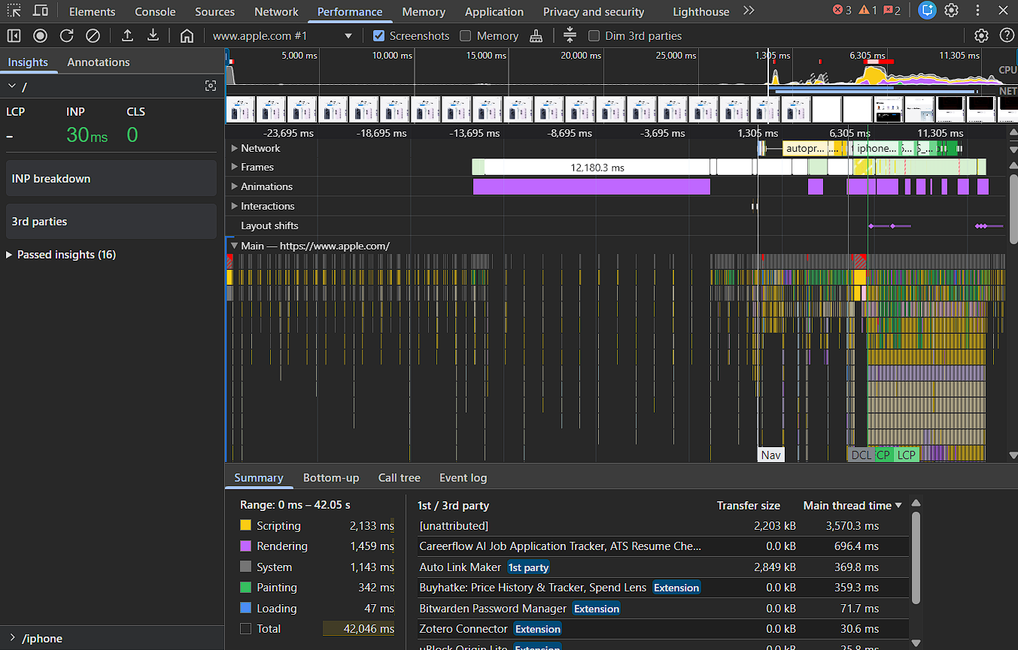
Main Thread Work
Dominant Color: Yellow (Scripting).
What was happening: According to the "Summary" pane at the bottom of the screenshot, Scripting took 2,133 ms (over 2 seconds) and Rendering took 1,459 ms.
The Culprit (Crucial Finding): "1st / 3rd party" list in the bottom right corner.
A massive chunk of the work is NOT coming from the Apple website.
It is coming from browser extensions: Careerflow AI Job Application Tracker took nearly 700ms, and Buyhatke and Auto Link Maker took another 700ms+ combined.

- Visual Metrics: What was the approximate Total Blocking Time (TBT)? Was there a Layout Shift (a red bar in the Experience section)? Describe what caused it.
We can see Red Hatched Bars in the "Main" timeline (around the 6,305ms mark). These indicate Long Tasks (tasks taking >50ms), which cause blocking.
Layout Shift (CLS): 0
Interaction to Next Paint (INP): 30 ms
- Summary: In your own words, did the page feel janky or smooth during your interaction? Does the performance recording support your feeling?

Likely not heavily, as the INP is fast (30ms).
Yes. Despite the heavy yellow bars (Scripting), the "Input Delay" was low. However, your CPU was working hard to process all those extensions (2.1s of scripting), which might drain battery on a laptop even if the page feels smooth.

Part 3: The Memory Panel (The "Efficiency" Audit)
Goal: Check for potential memory leaks or heavy memory usage.
In the Memory tab, take a Heap snapshot and note its size. Perform a repetitive action (e.g., open/close a modal, scroll an infinite list, filter products), take a second snapshot, then use the Comparison view to compare them.
Answer these questions:
- Memory Delta: Did the total memory increase between snapshots? By how much?
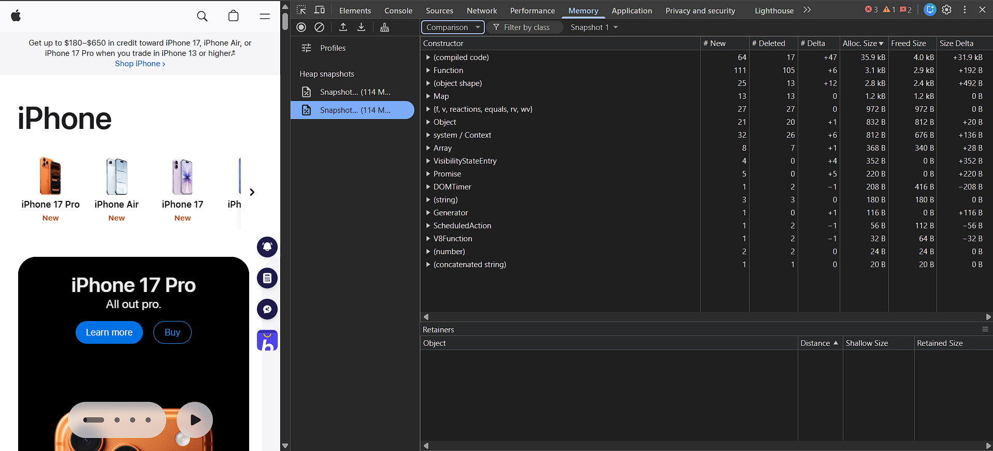
Observation: The memory growth is negligible.
The Numbers: Looking at the "Size Delta" column on the far right, the largest increases are in Kilobytes (+31.9 kB) and Bytes (+492 B).
Verdict: This is excellent. It means that after the interacted with the page 10+ times and forced garbage collection, the page essentially returned to its original state. It did not hold onto large chunks of data.

- Object Analysis: Look at the "# New" and "# Deleted" columns. Are a significant number of new objects being created but not cleaned up? List the top 2 "Constructor" types that increased the most.
(compiled code): +47 objects (+31.9 kB)
(object shape): +12 objects (+492 B)

- Conclusion: Based on this quick test, does the page seem to manage memory well during your repeated action, or is there a suspicion of a leak?
Status: Healthy / No Leaks Detected.
Summary: The page manages memory efficiently during interaction. The slight increase in memory is due to standard browser optimizations (compiled code) rather than the application failing to clean up variables or DOM elements.

Part 4: The Lighthouse Panel (The "Automated Quality" Audit)
Goal: Use Lighthouse to generate an automated report on the website's performance, accessibility, SEO, and best practices.
In the Lighthouse tab, set the device to Desktop, check all categories (Performance, Accessibility, Best Practices, SEO), and click "Analyze page load." Screenshot the full report.
Answer these questions:
- Overall Scores: What were the performance, accessibility, best practices, and SEO scores (out of 100)?

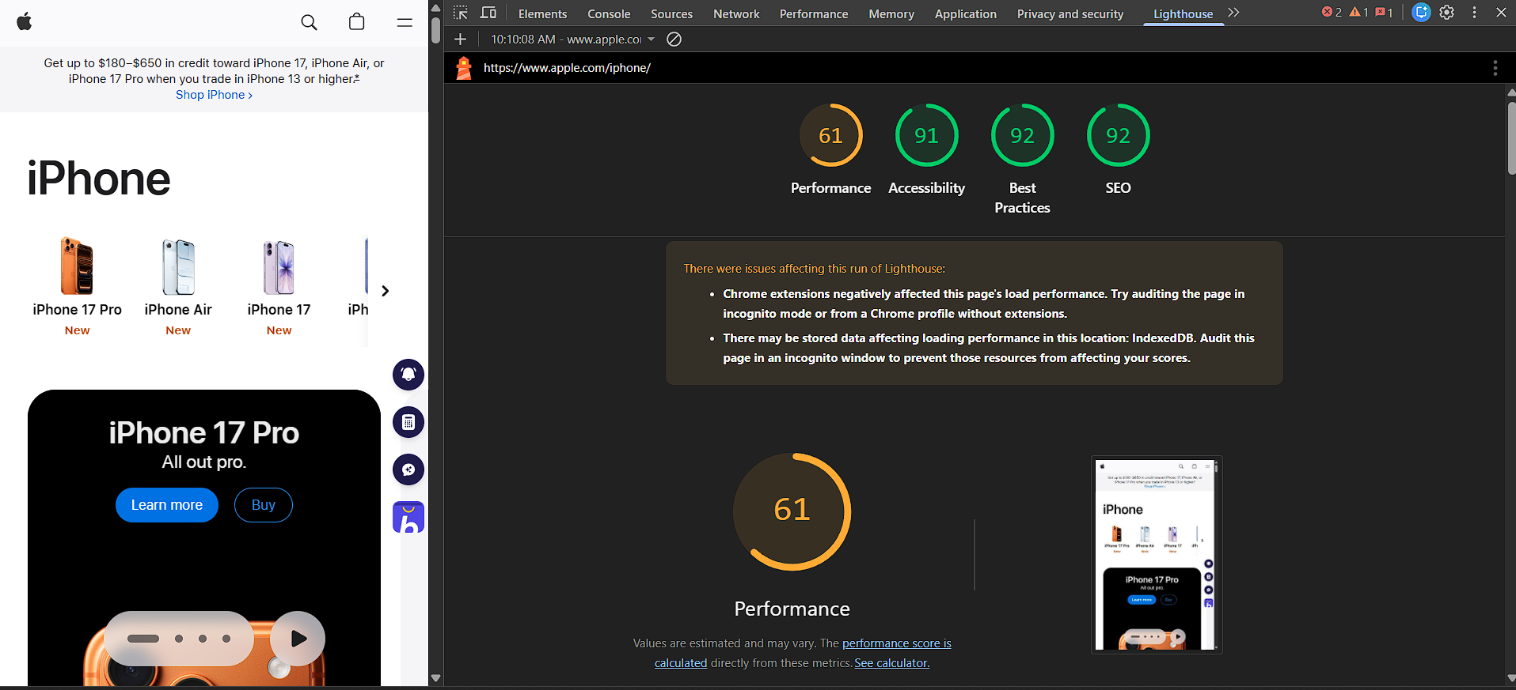

Overall Scores
Performance: 61 (Needs Improvement - Orange)
Accessibility: 91 (Good - Green)
Best Practices: 92 (Good - Green)
SEO: 92 (Good - Green)

- Core Web Vitals: What were the specific metrics for Largest Contentful Paint (LCP), First Input Delay (FID), and Cumulative Layout Shift (CLS)? Does the page pass these Core Web Vitals?
Largest Contentful Paint (LCP): 2.03 s (Good). The main content loads quickly.
Cumulative Layout Shift (CLS): 0.00 (Excellent). The page is stable.
Interaction to Next Paint (INP): 0 - 30 ms (Excellent). The page is responsive.
Why is the score only 61? Even though the "Vitals" are good, the Total Blocking Time (TBT) is likely very high due to the extensions, which drags the score down.

- Top Opportunity: What is the #1 most impactful performance opportunity Lighthouse suggests? (e.g., "Remove unused JavaScript").
Inferred Opportunity: "Reduce the impact of third-party code" or "Minimize main-thread work."
Evidence: The warning banner in your screenshot explicitly states: "Chrome extensions negatively affected this page's load performance."
What this means: Lighthouse detected the same heavy scripts (Careerflow, Buyhatke, etc.) that we found in Part 2. These are "blocking" the CPU, lowering the score from a potential 90+ down to 61.

- Cross-Verification: Does Lighthouse's report confirm or contradict any of your findings from the Network or Performance panels? Give one example.
Does it match? Yes, perfectly.
The Connection:
In Part 2 (Performance), we saw huge yellow bars (2.1s of Scripting) and identified extensions like Careerflow taking up 700ms.
In Part 4 (Lighthouse), the Performance score dropped to 61, and Lighthouse added a specific warning blaming "Chrome extensions."

