- Display all Amrita campuses with a CSS grid layout. Bengaluru Campus in the centre( big size) – all other campuses on the sides(small blocks) as shown in Figure.
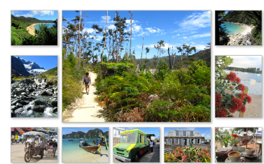
- For your profile page
- Create a new CSS file named "styles.css."
- Link the CSS file to your HTML document using the <link> tag in the <head> section.
- Apply the following styles to your webpage using CSS:
  - Set a background image for the entire page.
  - Center-align the text in the header.
  - Style the tagline text to have a larger font size and different color.
  - Apply a different background color to the "About Me" section.
  - Style the skills list to have bullet points and a different font.
  - Use a grid or flexbox layout to arrange the projects in a visually appealing way.
  - Apply a consistent font to all text on the page.
  - Style the contact information to have a distinct appearance. Modify the Contact us page using flexbox
  - 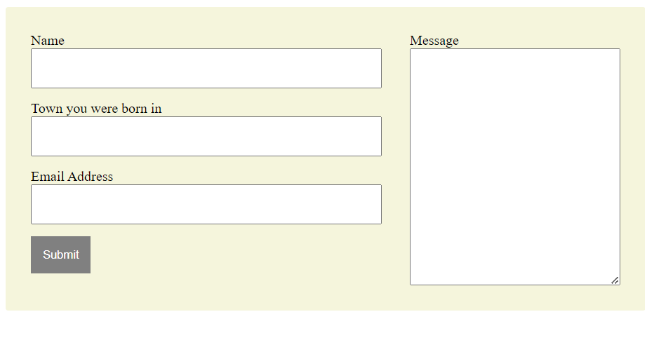
- Experiment with additional CSS properties to enhance the overall visual design.

