2022-2023学年第二学期

模式识别原理与应用实验考试

学号： 20202202851 班级 电信2002 姓名 栾相林

考试要求：在答题区域粘贴源代码以及实验结果的截图，上交试卷时提交

试卷以及源代码文件。试卷命名： 学号_姓名.doc 源代码命名 exp1.py

exp2.py 将三个文件打一个压缩包命名为学号_姓名.rar 通过系统上交。

- 利用KNN算法对给定的数据进行分类。训练数据存放在train.txt,测试数据存放在test.txt。分别设置K为5和7。
- 打印两种情况下分类的准确率。
- 打印两种情况下错误样本的数据、检测标签、真实标签
import numpy as np
import operator
import matplotlib.pyplot as plt
'''
trainData - 训练集 N
testData - 测试 1
labels - 训练集标签
'''
def knn(trainData, testData, labels, k):
# 计算训练样本的行数
rowSize = trainData.shape[0]
# 计算训练样本和测试样本的差值
diff = np.tile(testData, (r owSize, 1)) - trainData
# 计算差值的平方和
sqrDiff = diff ** 2
sqrDiffSum = sqrDiff.sum(axis=1)
# 计算距离
distances = sqrDiffSum ** 0.5
# 对所得的距离从低到高进行排序
sortDistance = distances.argsort()
count = {}
for i in range(k):
vote = labels[sortDistance[i]]
# print(vote)
count[vote] = count.get(vote, 0) + 1
# 对类别出现的频数从高到低进行排序
sortCount = sorted(count.items(), key=operator.itemgetter(1), reverse=True)
# 返回出现频数最高的类别
return sortCount[0][0]
def evaluate_KNN(train_datas, train_labs, test_datas, test_labs, K=5):
N_test = test_datas.shape[0]
N_right = 0
for i in range(N_test):
det_lab = knn(train_datas, test_datas[i], train_labs, K)
if det_lab == test_labs[i]:
N_right += 1 # N_right +1
# 计算准确率
acc = N_right * 100 / N_test
return acc
def evaluate_KNN_fold(datas, labs, k_fold, K=10):
N = np.shape(datas)[0]
n_each_fold = int(N / k_fold)
N_used = n_each_fold * k_fold
index = np.random.permutation(N)[:N_used]
index_fold = np.reshape(index, (k_fold, n_each_fold))
acc_all = []
for i in range(k_fold):
index_test = index_fold[i, :]
sel_train = [i for i in range(k_fold)]
sel_train.remove(i)
index_train = index_fold[sel_train, :].flatten()
train_datas = datas[index_train]
train_labs = labs[index_train]
test_datas = datas[index_test]
test_labs = labs[index_test]
acc = evaluate_KNN(train_datas, train_labs, test_datas, test_labs, K)
print("acc in fold %d = %.2f %%" % (i, acc))
acc_all.append(acc)
return np.average(acc_all)
def indexSplit(N, train_ratio):
N_train = int(N * train_ratio)
index_random = np.random.permutation(N)
index_train = index_random[:N_train]
index_test = index_random[N_train:]
return index_train, index_test
def autoNorm(datas):
val_min = np.min(datas, axis=0, keepdims=True)
val_max = np.max(datas, axis=0, keepdims=True)
val_range = val_max - val_min
norm_datas = (datas - val_min) / val_range
return norm_datas, val_range, val_min
def evaluate_KNN_fold_norm(datas, labs, k_fold, K=10):
pass

if __name__ == "__main__":
# iris 数据处理
file_data_train = 'train.txt'
file_data_test = 'test.txt'
# 数据读取
datas_train = np.loadtxt(file_data_train, dtype=float, delimiter=',', usecols=(0, 1, 2, 3))
labs_train = np.loadtxt(file_data_train, dtype=str, delimiter=',', usecols=(4))
N_train, D_train = np.shape(datas_train)
datas_test = np.loadtxt(file_data_test, dtype=float, delimiter=',', usecols=(0, 1, 2, 3))
labs_test = np.loadtxt(file_data_test, dtype=str, delimiter=',', usecols=(4))
N_test, D_test = np.shape(datas_test)
train_datas = datas_train
train_labs = labs_train
test_datas = datas_test
test_labs = labs_test
# 一般测试
K = 5
acc = evaluate_KNN(train_datas, train_labs, test_datas, test_labs, K)
print("k = %d , acc= %.2f%%" % (K, acc))
# 参数设定
n_right_5 = 0
for i in range(N_test):
test = datas_test[i, :]
det = knn(datas_train, test, labs_train, K)
if det == labs_test[i]:
n_right_5 = n_right_5 + 1
if det != labs_test[i]:
print('Sample %d lab_ture = %s lab_det = %s' % (i, labs_test[i], det))
# 结果分析
print('Accuracy = %.2f %%' % (n_right_5*100/N_test))
K = 7
acc = evaluate_KNN(train_datas, train_labs, test_datas, test_labs, K)
print(" k = %d , acc = %.2f%%" % (K, acc))
n_right_7 = 0
for i in range(N_test):
test = datas_test[i, :]
det = knn(datas_train, test, labs_train, K)
if det == labs_test[i]:
n_right_7 = n_right_7 + 1
if det != labs_test[i]:
print('Sample %d lab_ture = %s lab_det = %s' % (i, labs_test[i], det))
# 结果分析
print('Accuracy = %.2f %%' % (n_right_7 * 100 / N_test))

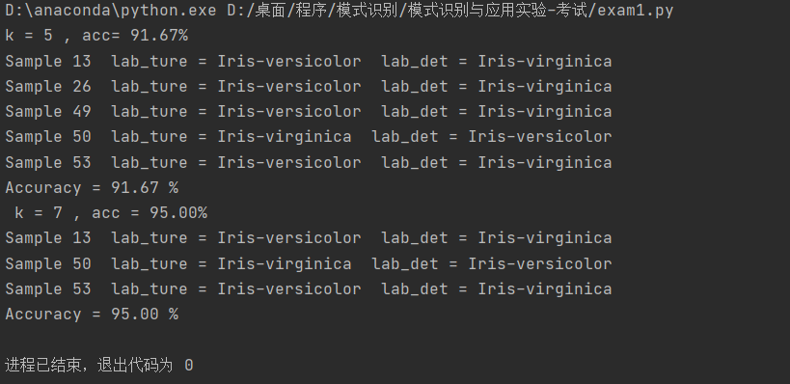

二、利用kmeans算法对给定的2维数据（数据存放在data.txt中）进行聚类，聚成2类，利用matplotlib绘制聚类的结果，分别用红色和蓝色标记两类数据，两个聚类中心用黑色的“+”标识。
from sklearn.cluster import KMeans
import matplotlib.pyplot as plt
# 从文件中读取数据
with open('data.txt', 'r') as f:
lines = f.readlines()
data = []
for line in lines:
x, y = line.strip().split(',')
data.append([float(x), float(y)])
# 运行kmeans算法
kmeans = KMeans(n_clusters=2, random_state=0).fit(data)
labels = kmeans.labels_
centers = kmeans.cluster_centers_
# 绘制散点图
colors = ['r', 'b']
for i in range(len(data)):
plt.scatter(data[i][0], data[i][1], c=colors[labels[i]])
# 绘制聚类中心
for i in range(len(centers)):
plt.scatter(centers[i][0], centers[i][1], marker='+', s=100, c='k')
# 显示图像
plt.show()

