“Київський фаховий коледж зв’язку”

Циклова комісія Комп’ютерної інженерії

ЗВІТ ПО ВИКОНАННЮ

ЛАБОРАТОРНОЇ РОБОТИ 6

з дисципліни: «Операційні системи»

Тема: “Команди Linux для архівування та стиснення даних. Робота з текстом”

Виконала студентка групи Бікс-03

Жукова А.О.

Перевірив викладач Сушанова В.С.

Київ 2023

**Мета роботи**: 1. Отримання практичних навиків роботи з командною оболонкою Bash.

2. Знайомство з базовими командами для архівування та стиснення даних.

3. Знайомство з базовими діями при роботі з текстом у терміналі.

**Матеріальне забезпечення занять** 1. ЕОМ типу IBM PC.

2. ОС сімейства Windows (Windows 7).

3. Віртуальна машина – Virtual Box (Oracle).

4. Операційна система GNU/Linux – CentOS.4.

### Завдання для попередньої підготовки.

1. Прочитайте короткі теоретичні відомості до лабораторної роботи та зробіть невеликий словник базових англійських термінів з питань призначення команд та їх параметрів.

| Термін англійською | Термін українською |
| --- | --- |
| compress | стискати |
| directories | папки |
| archiving | архівувати |
| formatted | відформатований |
| lossless | без втрат |
| utility | корисність |
| sequential | послідовний |
| deflate | здути |
| protocol | протокол |
| advantages | переваги |

1. Дайте відповіді на наступні питання:

**Яке призначення команд tar, xz, zip, bzip, gzip? Зробіть короткий опис кожної команди та виділіть їх основні параметри. Яким чином їх можна встановити.**

These commands are used to archive and compress files

The tar (Tape Archive) command is used to archive files and directories as a single file. Main parameters:

-c: create an archive -x: unzip the archive -f: specify the name of the archive file -v: display the list of files to be archived/unzipped

tar is usually installed with the system, but additional features of the command, such as support for different archive formats, can be installed using additional packages.

The xz command is used to compress files. It uses the LZMA compression algorithm, which provides a high level of compression. Main parameters:

-c: output the result to standard output -d: extract the file -z: use a gzip-like compression algorithm

xz is usually installed with the system, but can be installed separately via your OS’s package manager.

The zip command is used to archive and compress files. It uses the ZIP format, which is one of the most common archive formats in the Windows environment. Main parameters:

-r: recursively add files from subdirectories -u: update the archive, adding only new files to it -d: delete file from archive

**Наведіть три приклади реалізації архівування та стискання даних різними командами.**

The gzip command is used to compress files. For example, to compress file.txt, run the following command:

gzip file.txt

This command will compress file.txt and save it as file.txt.gz.

The tar command:

The tar command is used to archive multiple files into one archive. For example, to create an archive of a folder named folder and all its files, run the following command:

tar -czvf folder.tar.gz folder/

This command will create a folder.tar.gz archive containing all the files and folders from the folder folder.

The zip command:

The zip command is used to archive and compress files in ZIP format. For example, to create an archive file.zip that contains the files file1.txt and file2.txt, run the following command:

python

zip file.zip file1.txt file2.txt

This command will create a file.zip archive that contains the files file1.txt and file2.txt.

**Яке призначення команд cat, less, more, head and tail? Зробіть короткий опис кожної команди та виділіть їх основні параметри. Яким чином їх можна встановити**

These commands are used to view and edit text files. The main purpose of these commands is to allow the user to view and edit large files without having to open them in an editor.

The command cat (Concatenate) is used to output the contents of text files to the console. Main parameters:

-n: output line numbers -s: merge consecutive empty lines into one -E: show the end of each line with a $ character

cat is usually installed with the system, but can be installed separately via your OS’s package manager.

The less command is used to view text files, allowing the user to easily navigate through the file. Main parameters:

-N: display line numbers -S: disable wrapping of lines that do not fit in the window -F: Automatically exit if the entire file is displayed

less is usually installed with the system, but can be installed separately through your OS’s package manager.

The more command is similar to `less’, but usually less powerful. It is used to gradually output text files to the console. Main parameters:

-n: display line numbers -d: Wait for a command from the user before going to the next screen -c: clear the screen before displaying the next screen

more is usually installed with the system, but can be installed separately via your OS’s package manager.

The head command is used to output the first few lines

**Поясніть принципи роботи командної оболонки з каналами, потоками та фільтрами**

A shell such as bash can work with pipes, streams, and filters to handle and redirect I/O.

Channels (Pipes):

Channels allow you to forward the output of one command to the input of another. The "|" symbol is used to create a channel. For example, the command "ls | grep file" will list the files and folders in the current directory that contain the word "file".

Streams:

Linux has three data streams: standard input (stdin), standard output (stdout), and standard error output (stderr). These streams can be redirected to other files or channels using redirection operators. For example, the command "ls > files.txt" will redirect the output of the "ls" command to a file named "files.txt".

Filters:

Filters are commands that process input data and output the result to the output stream. For example, the "grep" command is used to search for text in the input data, and the "sort" command is used to sort strings. Filters can be used in conjunction with channels to process and redirect the output of one command to the input of another command.

The application of channels, flows and filters allows you to create complex and powerful teams that can process large amounts of data and do it quickly and efficiently.

**Яке призначення команди grep?**

The grep (Global Regular Expression Print) command is used to search input data using a specific string or regular expression.

### Хід роботи

1. Опрацюйте всі приклади команд, що представлені у лабораторних роботах курсу NDG Linux Essentials-Lab 9: Archiving and Compression та Lab 10: Working With Text. Створіть таблицю для опису цих команд

| Назва команди | Її призначення та функціональність |
| --- | --- |
| mkdir mybackups | Creating a new mybackups directory in the user's home directory |
| tar -cvf mybackups/udev.tar /etc/udev | The tar command is used to combine multiple files into a single file. In this case, the contents of the /etc/udev directory will be saved in the udev.tar archive in the mybackups directory. The -c option tells the tar command to create a tar file. The -v option stands for “verbose”, which tells the tar command to demonstrate what it is doing. The -f option is used to specify the name of the tar file. |
| tar | Originally, tar was used to archive data on tape devices. But it also allows you to write the output to a file, and this method has become widely used in Linux for its intended purpose |
| gzip | The gzip command is designed for lossless data compression using the utility of the same name, which uses the Lempel-Ziv algorithm (LZ77) with Huffman encoding. The purpose of using this utility is to save disk space. |
| bzip2 | The bzip2 command is designed to compress data without loss using a utility that uses the Barrows-Wheeler algorithm. The purpose of using this utility is to save disk space. |
| xz | the XZXZ Utils command is a tool for developing high compression ratios for the POSIX platform |
| unzx | command in Linux terminal is used to extract files from archives created by zx |
| zip | This command includes only files ending in .c in the current directory and its subdirectories. |
| unzip | Unzip files from the ZIP archive (a / s) (you can specify several through a space |
| > | Used to redirect the stdout from first command to rewrite the file |
| >> | Used to redirect the stdout from first command to append the new output in the end of file |
| find | command starts the search in the directory specified and recursively search all of the subdirectories. |
| 2> | Used to redirect the stderr error message to a file |
| tr | Used to translate the characters |
| cut | Used to extract specific columns or fields of text from a file or input stream. |
| more and less | Allows for the user to the view data a “page” or a line at a time. |
| head | Used to display the top part of a file. By default, the head command will display the first ten lines of the file |
| tail | displays the last ten lines of the file |
| grep | Will print the entire line containing the match in file, that given by an argument, that can use some of regular expressions |
| egrep | Will print the entire line containing the match in file, that given by an argument, that can use all parts of regular expressions |

1. Ознайомтесь з командою tar та за її допомогою виконати у терміналі наступні дії:

* створити файл з розширенням .tar;
* створити файл з розширенням .tar, що складається з декількох файлів і каталогів одночасно;
* перегляду вмісту файлу;
* витягти вміст файлу tar; - створити архівний файл tar, стиснений за допомогою bzip;
* витягти вміст файлу tar bzip; - створити архівний tar файл, стисненого за допомогою gzip;
* витягти вміст файлу tar gzip.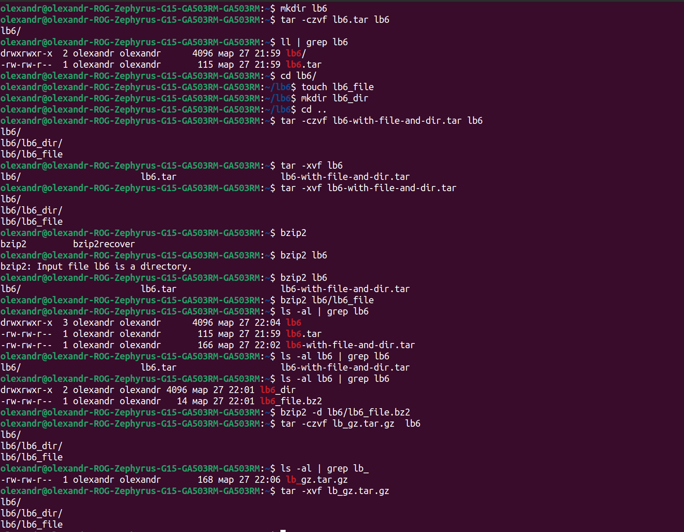

1. Як буде відбуватись перенаправлення потоків виведення в bash для наступних дій з командами (позначено як cmd) та файлами (позначено як file):

| Команда | Що виконує команда? |
| --- | --- |
| cmd 1> file | The command writes the output to the file file, overwriting the contents of the file. |
| cmd > file | The command writes the output to the file file, overwriting the contents of the file. This command is equivalent to the command cmd 1> file. |
| cmd 2> file | The command writes errors to the file file, overwriting the contents of the file. |
| cmd >> file | The command adds output to the end of the file file. |
| cmd &> file | The command writes both output and errors to the file file, overwriting the contents of the file. This command is equivalent to cmd > file 2>&1. |
| cmd > file 2>&1 | The command redirects output to the file file and errors to the same file. This command is equivalent to the cmd &> file command. |
| cmd >> file 2>&1 | The command adds output and errors to the end of the file file. |
| cmd 2>&1 > /dev/null | The command redirects errors to stdout and then rejects (sends) the output. |
| cmd 2> /dev/null | The command sends errors to nowhere. |
| cmd1 | cmd2 | The command feeds output from cmd1 to input cmd2. |
| cmd1 2>&1 | cmd2 | The command redirects both output and errors from cmd1 to stdout and passes them as input to cmd2. |

1. Розгляньте наведені нижче приклади та поясніть, що виконують дані команди та який тип перенаправлення потоків вони використовують:

| Команда (контейнер команд) | Що виконує команда? | Який потік перенаправлення? |
| --- | --- | --- |
| $echo "It is a new story." > story|Записує рядок "It is a new story." в файл з іменем "story".|>| |$ date > date.txt | Writes the current date and time to a file named “date.txt”. | > |
| $ cat file1 file2 file3 > bigfile | Combines the contents of three files (file1, file2, file3) into a file named “bigfile”. | > |
| $ls -l >> directory|Додає вміст виведення команди ls -l в кінець файлу з іменем "directory"|>>| |$ sort < file1_unsorted > file2_sorted | Sorts the contents of the file “file1_unsorted” and writes it to a file named “file2_sorted”. | <, > |
| $ find -name ’*.txt’ > file.txt 2> /dev/null | Finds all files with the extension .txt and writes their names to a file named “file.txt”. Redirects the error stream (stderr) to nowhere. | >, 2> (stderr is redirected to /dev/null) |
| $ cat file1_unsorted | sort > file2_sorted | Sorts the contents of the file “file1_unsorted” and writes it to a file named “file2_sorted”. | | |$ cat myfile \| grep student \| wc -l|Reads the contents of the file "myfile", finds lines that contain the word "student" and counts their number.| |

### Контрольні запитання

1. **Надайте порівняльну характеристику процесам стискання та архівування.**

The main difference between compression and archiving is that compression reduces the size of a file by removing redundant information, while archiving allows you to save the contents of a file in the form of an archive, which reduces its size by combining multiple files into a single archive.

Other differences between compression and archiving include the following:

Usage: Compression is used to reduce file size to save disk space or for faster network transfer, while archiving is used to save a large number of files as a single archive.

Technique: compression can be lossless or lossy, depending on what data is removed to reduce the file size. Archiving is usually lossless, preserving all the original information.

Integrity check: Some data can sometimes be lost during compression, so you should use integrity check to ensure that the data has been restored correctly. Data integrity is usually not lost during archiving, so integrity control is not always necessary.

**2. Які програми, окрім наведених в роботі, можуть використовуватись для стискання та архівування файлів та каталогів в ОС Linux? Наведіть приклади та їх короткий опис.**

7zip is an open source program that supports many compression and archiving formats, including 7z, ZIP, TAR, and WIM. It has a high degree of compression and can work with encrypted archives.

PeaZip is an open source program that supports many compression and archiving formats, including 7z, ZIP, TAR, GZ, and XZ. It has a graphical user interface and can be used to create archives, unpack and view their contents.

rar is a program for compressing and archiving files that supports the RAR format. It has a high degree of compression and can work with encrypted archives.

1. **Порівняйте алгоритми стискання, що використовуються в командах (програмах), використовуваних в Linux. Які з алгоритмів можна вважати найшвидшим та найефективнішим?**

| Алгоритм стискання | Швидкість | Ступінь стиснення | Використання ресурсів |
| --- | --- | --- | --- |
| gzip | Fast | Low | low |
| bzip2 | Moderate | High | Високе |
| xz | Slow | Extremely high | high |

**Висновок:**

During this lab work, I learned about ways to compress and archive files in Linux and tested them in practice. But she got practical skills of working with the Bash command shell.