**Website Development Analysis Report**

**Website Structure and Design**

**Overview:**

The website developed consists of three key pages:

1. **Homepage:** Introduces the purpose of the site, provides an overview of the company’s services, and includes basic navigation.
2. **About/Contact Page:** Contains company information, contact details, and a form for user input (email, message).
3. **Services/Product Page:** Displays structured content regarding the company's products or services, including images and descriptions.

**HTML Structure:**

The website is built using fundamental HTML elements:

* **<header>** and **<footer>** for site-wide navigation and copyright information.
* **<section>** elements for content segmentation (e.g., "About Us," "Products").
* **Forms:** The contact page includes a simple form for users to enter their details and queries, using <form>, <input>, and <textarea> elements.

Each page uses appropriate semantic HTML tags to improve accessibility and search engine optimization (SEO).

**CSS Design and Layout:**

The website uses **external CSS** for all styling. A **consistent color scheme** of blue (#1E90FF), orange (#FFA500), and white (#FFFFFF) is implemented throughout the website, maintaining visual coherence. Typography is chosen with accessibility in mind, using common web-safe fonts such as Arial and sans-serif.

* **Homepage Layout:**
  + **Flexbox** is used for aligning items horizontally and vertically within the header, navigation, and hero section. This provides a responsive design that adapts to different screen sizes.
* **Product Section Layout:**
  + **CSS Grid** is used for the products section to display products in a responsive grid, ensuring that the layout adjusts smoothly to varying screen sizes.

css

Copy

.product-list {

display: grid;

grid-template-columns: repeat(auto-fill, minmax(250px, 1fr));

gap: 20px;

}

* **Responsive Design:** The CSS includes media queries that ensure the layout adapts to smaller screens, like mobile devices. For instance, the product list layout switches from grid to a column-based layout on smaller screens.

**HTTP Protocol and Web Behavior**

**Request-Response Cycle:**

HTTP (Hypertext Transfer Protocol) is the protocol used to communicate between the client (browser) and the server. When a user navigates to a webpage, the following steps occur:

1. **Client Request:** The browser sends an HTTP request to the web server. For example, when a user enters the website's URL (e.g., www.anyasuperphones.com), the browser sends an HTTP GET request.
2. **Server Response:** The server processes the request and responds with the requested resources (HTML, CSS, JavaScript files, images, etc.) along with an HTTP status code.
3. **Rendering:** The browser processes the response, rendering the web page as per the HTML and CSS provided.

**HTTP Methods:**

* **GET:** The GET method is used when the browser requests data from the server (e.g., loading a page or fetching resources like images).
* **POST:** The POST method is used for sending data to the server, such as when a user submits a form on the "Contact Us" page. This method ensures data is sent in the request body and not as part of the URL.

**HTTP Status Codes:**

Common HTTP status codes include:

* **200 OK:** The request was successfully processed and the page is displayed.
* **404 Not Found:** The requested resource (webpage) could not be found.
* **500 Internal Server Error:** There is a problem with the server that prevents it from fulfilling the request.

**Status Codes and User Experience:**

Using proper HTTP status codes improves user experience by providing appropriate feedback. For instance, a **404 error** should direct users to a custom "Not Found" page rather than just displaying a browser error.

**Security Considerations**

**Concerns Related to HTTP:**

1. **Lack of Encryption in HTTP:**
   * **Problem:** Data transmitted via HTTP is sent in plaintext, which can be intercepted by attackers using man-in-the-middle attacks. This poses a serious risk, especially for sensitive data like passwords and personal details.
   * **Solution:** Implement HTTPS (Hypertext Transfer Protocol Secure). HTTPS encrypts data between the client and server using SSL/TLS certificates, ensuring data integrity and confidentiality.
2. **Cross-Site Scripting (XSS):**
   * **Problem:** XSS attacks occur when an attacker injects malicious scripts into web pages. These scripts can steal session cookies, log user activity, or hijack forms.
   * **Solution:** Input sanitization and validation should be performed on all user inputs. This includes escaping special characters (e.g., <, >, &) in form fields to prevent script execution.

**Mitigation Strategies:**

* Use **HTTPS** for secure communication, ensuring that sensitive information is encrypted during transmission.
* Sanitize and validate **user inputs** on both the client-side and server-side to prevent malicious code injection.
* Implement **Content Security Policy (CSP)** headers to prevent unauthorized JavaScript from running.

**Conclusion**

The website is designed with fundamental web development principles in mind, using HTML for structure, CSS for styling, and adhering to HTTP protocols for communication between the server and client. Security concerns such as encryption (HTTPS) and input sanitization have been addressed to ensure safe and secure user interactions. The use of external CSS and responsive design principles makes the site visually appealing and adaptable across devices.

HOME PAGE:

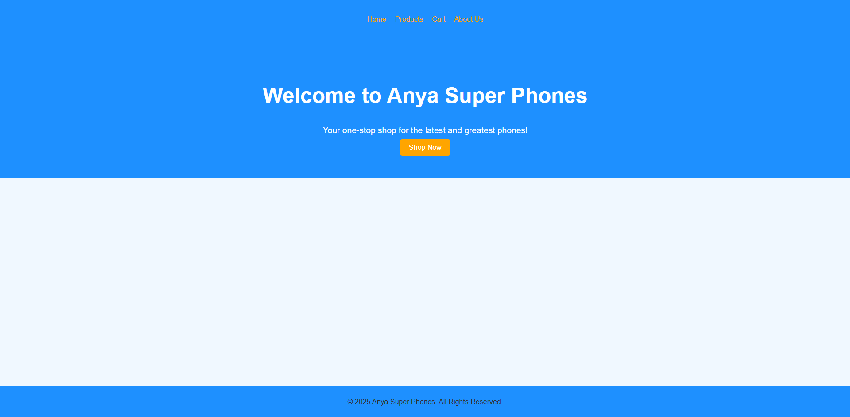

PRODUCT PAGE:

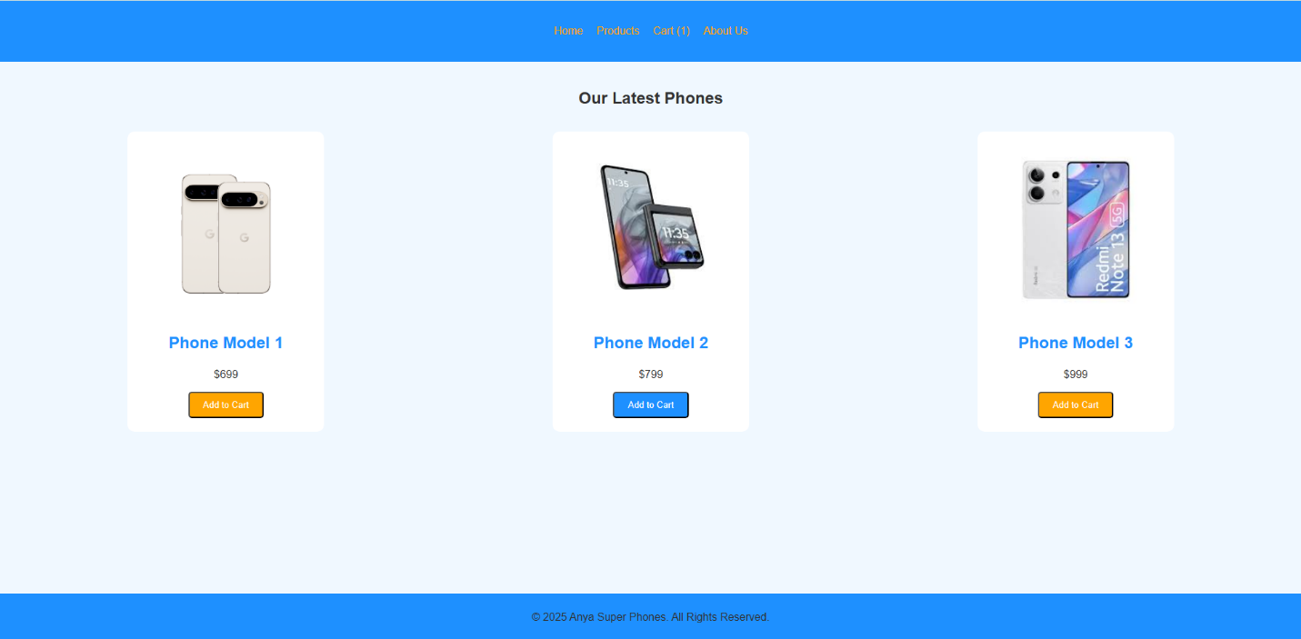

CART PAGE:

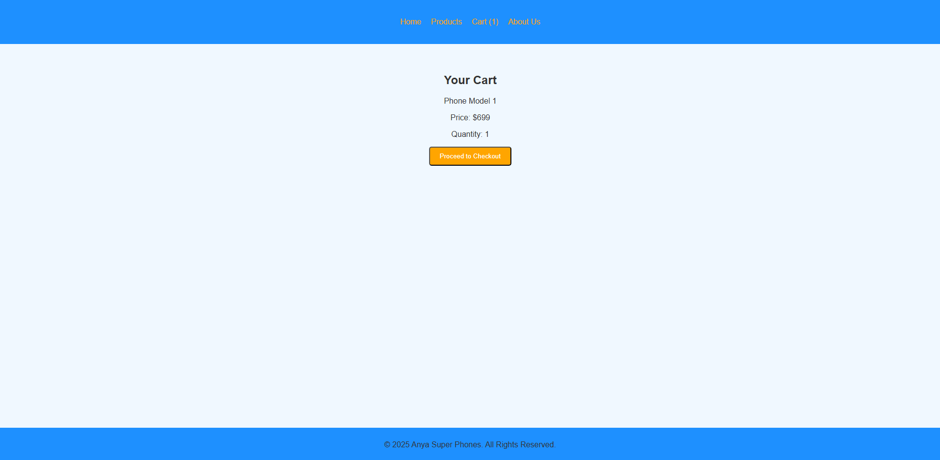

ABOUT US PAGE:

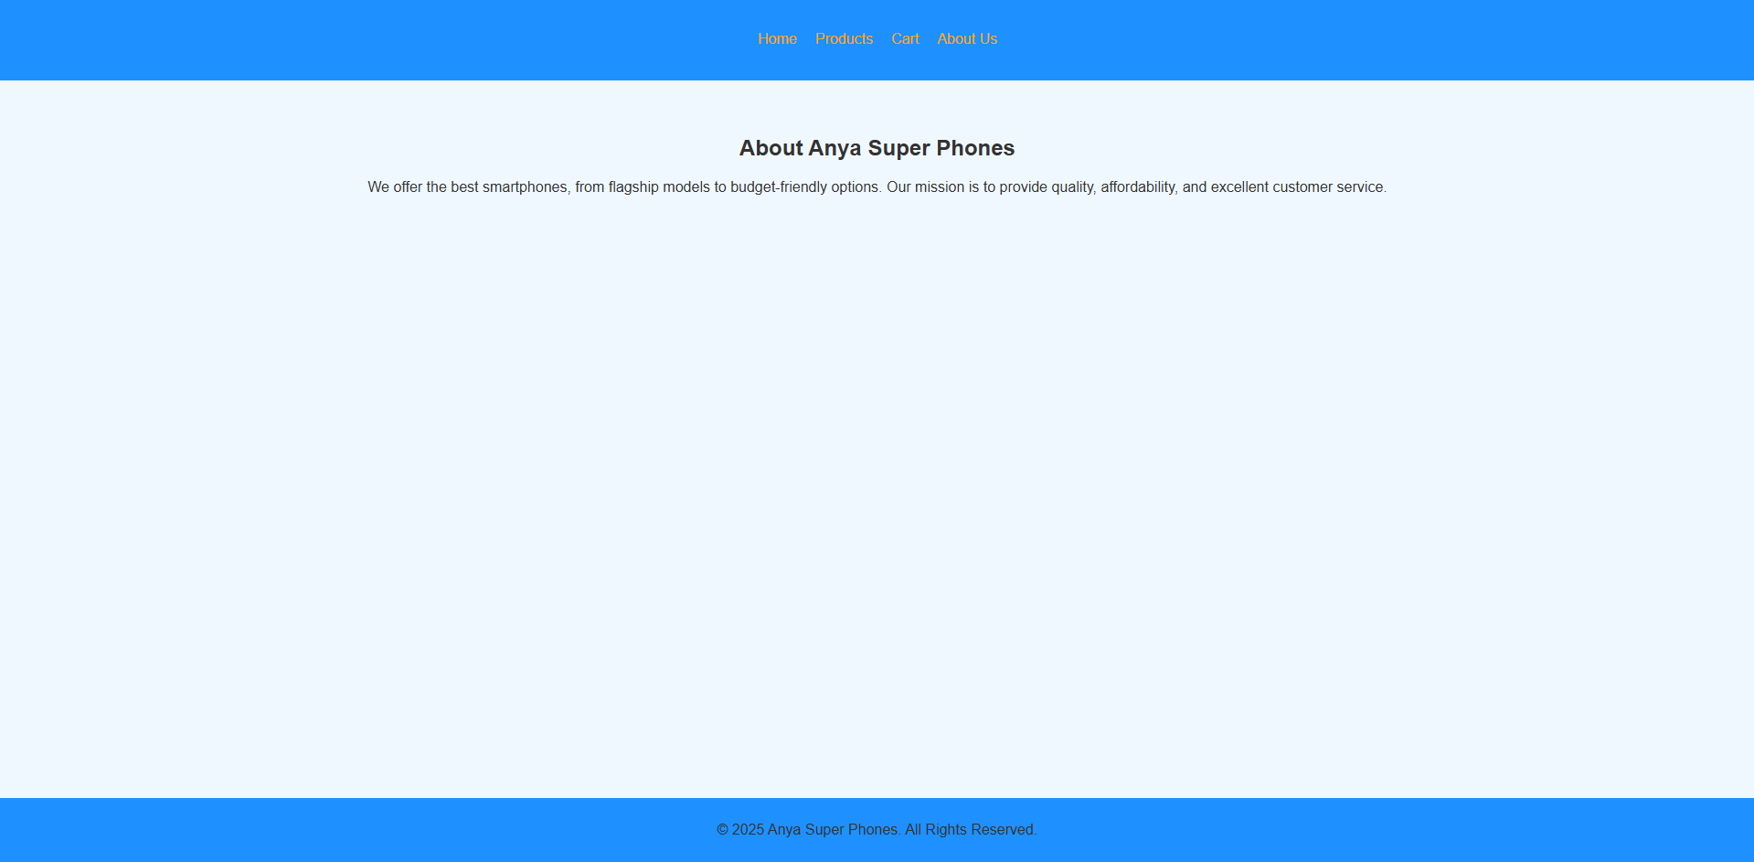

WEB CODE:

INDEX.HTML:

<!DOCTYPE html>

<html lang="en">

<head>

    <meta charset="UTF-8">

    <meta name="viewport" content="width=device-width, initial-scale=1.0">

    <title>Anya Super Phones - Products</title>

    <link rel="stylesheet" href="style.css">

    <script src="script.js" defer></script> <!-- Link to the JavaScript file -->

</head>

<body>

    <!-- Navbar -->

    <header>

        <nav>

            <ul>

                <li><a href="index.html">Home</a></li>

                <li><a href="products.html">Products</a></li>

                <li><a href="cart.html" id="cartLink">Cart (0)</a></li> <!-- Cart link showing number of items -->

                <li><a href="about.html">About Us</a></li>

            </ul>

        </nav>

    </header>

    <!-- Products Section -->

    <section class="products">

        <h2>Our Latest Phones</h2>

        <div class="product-list">

            <div class="product">

                <img src="https://lh3.googleusercontent.com/m3jyXIWFa3r79AHpTTIWxcV2YGo_3rHH2Xro8F8dokRcqtTU8EwMZ38v5g7foE-eMiNFSP2gPkuM8xElgnCrd8CrXG8nON5MokQ=s0" alt="Phone 1">

                <h3>Phone Model 1</h3>

                <p>$699</p>

                <button class="btn" onclick="addToCart('Phone Model 1', 699)">Add to Cart</button>

            </div>

            <div class="product">

                <img src="https://encrypted-tbn0.gstatic.com/images?q=tbn:ANd9GcSSF32q3MtJQbvW_9F0nIZz57tNWdgne0mQRA&s" alt="Phone 2">

                <h3>Phone Model 2</h3>

                <p>$799</p>

                <button class="btn" onclick="addToCart('Phone Model 2', 799)">Add to Cart</button>

            </div>

            <div class="product">

                <img src="https://encrypted-tbn0.gstatic.com/images?q=tbn:ANd9GcRRofE5oiS2zO9sQy8rKQe4wijwNqdbT1-m1A&s">

                <h3>Phone Model 3</h3>

                <p>$999</p>

                <button class="btn" onclick="addToCart('Phone Model 3', 999)">Add to Cart</button>

            </div>

        </div>

    </section>

    <!-- Footer -->

    <footer>

        <p>&copy; 2025 Anya Super Phones. All Rights Reserved.</p>

    </footer>

</body>

</html>

PRODUCT.HTML:

<!DOCTYPE html>

<html lang="en">

<head>

    <meta charset="UTF-8">

    <meta name="viewport" content="width=device-width, initial-scale=1.0">

    <title>Anya Super Phones - Products</title>

    <link rel="stylesheet" href="style.css">

    <script src="script.js" defer></script> <!-- Link to the JavaScript file -->

</head>

<body>

    <!-- Navbar -->

    <header>

        <nav>

            <ul>

                <li><a href="index.html">Home</a></li>

                <li><a href="products.html">Products</a></li>

                <li><a href="cart.html" id="cartLink">Cart (0)</a></li> <!-- Cart link showing number of items -->

                <li><a href="about.html">About Us</a></li>

            </ul>

        </nav>

    </header>

    <!-- Products Section -->

    <section class="products">

        <h2>Our Latest Phones</h2>

        <div class="product-list">

            <div class="product">

                <img src="https://lh3.googleusercontent.com/m3jyXIWFa3r79AHpTTIWxcV2YGo_3rHH2Xro8F8dokRcqtTU8EwMZ38v5g7foE-eMiNFSP2gPkuM8xElgnCrd8CrXG8nON5MokQ=s0" alt="Phone 1">

                <h3>Phone Model 1</h3>

                <p>$699</p>

                <button class="btn" onclick="addToCart('Phone Model 1', 699)">Add to Cart</button>

            </div>

            <div class="product">

                <img src="https://encrypted-tbn0.gstatic.com/images?q=tbn:ANd9GcSSF32q3MtJQbvW_9F0nIZz57tNWdgne0mQRA&s" alt="Phone 2">

                <h3>Phone Model 2</h3>

                <p>$799</p>

                <button class="btn" onclick="addToCart('Phone Model 2', 799)">Add to Cart</button>

            </div>

            <div class="product">

                <img src="https://encrypted-tbn0.gstatic.com/images?q=tbn:ANd9GcRRofE5oiS2zO9sQy8rKQe4wijwNqdbT1-m1A&s">

                <h3>Phone Model 3</h3>

                <p>$999</p>

                <button class="btn" onclick="addToCart('Phone Model 3', 999)">Add to Cart</button>

            </div>

        </div>

    </section>

    <!-- Footer -->

    <footer>

        <p>&copy; 2025 Anya Super Phones. All Rights Reserved.</p>

    </footer>

</body>

</html>

CART.HTML:

<!DOCTYPE html>

<html lang="en">

<head>

    <meta charset="UTF-8">

    <meta name="viewport" content="width=device-width, initial-scale=1.0">

    <title>Anya Super Phones - Products</title>

    <link rel="stylesheet" href="style.css">

    <script src="script.js" defer></script> <!-- Link to the JavaScript file -->

</head>

<body>

    <!-- Navbar -->

    <header>

        <nav>

            <ul>

                <li><a href="index.html">Home</a></li>

                <li><a href="products.html">Products</a></li>

                <li><a href="cart.html" id="cartLink">Cart (0)</a></li> <!-- Cart link showing number of items -->

                <li><a href="about.html">About Us</a></li>

            </ul>

        </nav>

    </header>

    <!-- Products Section -->

    <section class="products">

        <h2>Our Latest Phones</h2>

        <div class="product-list">

            <div class="product">

                <img src="https://lh3.googleusercontent.com/m3jyXIWFa3r79AHpTTIWxcV2YGo_3rHH2Xro8F8dokRcqtTU8EwMZ38v5g7foE-eMiNFSP2gPkuM8xElgnCrd8CrXG8nON5MokQ=s0" alt="Phone 1">

                <h3>Phone Model 1</h3>

                <p>$699</p>

                <button class="btn" onclick="addToCart('Phone Model 1', 699)">Add to Cart</button>

            </div>

            <div class="product">

                <img src="https://encrypted-tbn0.gstatic.com/images?q=tbn:ANd9GcSSF32q3MtJQbvW_9F0nIZz57tNWdgne0mQRA&s" alt="Phone 2">

                <h3>Phone Model 2</h3>

                <p>$799</p>

                <button class="btn" onclick="addToCart('Phone Model 2', 799)">Add to Cart</button>

            </div>

            <div class="product">

                <img src="<!DOCTYPE html>

                <html lang="en">

                <head>

                    <meta charset="UTF-8">

                    <meta name="viewport" content="width=device-width, initial-scale=1.0">

                    <title>Anya Super Phones - Products</title>

                    <link rel="stylesheet" href="style.css">

                    <script src="script.js" defer></script> <!-- Link to the JavaScript file -->

                </head>

                <body>

                    <!-- Navbar -->

                    <header>

                        <nav>

                            <ul>

                                <li><a href="index.html">Home</a></li>

                                <li><a href="products.html">Products</a></li>

                                <li><a href="cart.html" id="cartLink">Cart (0)</a></li> <!-- Cart link showing number of items -->

                                <li><a href="about.html">About Us</a></li>

                            </ul>

                        </nav>

                    </header>

                    <!-- Products Section -->

                    <section class="products">

                        <h2>Our Latest Phones</h2>

                        <div class="product-list">

                            <div class="product">

                                <img src="https://lh3.googleusercontent.com/m3jyXIWFa3r79AHpTTIWxcV2YGo_3rHH2Xro8F8dokRcqtTU8EwMZ38v5g7foE-eMiNFSP2gPkuM8xElgnCrd8CrXG8nON5MokQ=s0" alt="Phone 1">

                                <h3>Phone Model 1</h3>

                                <p>$699</p>

                                <button class="btn" onclick="addToCart('Phone Model 1', 699)">Add to Cart</button>

                            </div>

                            <div class="product">

                                <img src="https://encrypted-tbn0.gstatic.com/images?q=tbn:ANd9GcSSF32q3MtJQbvW_9F0nIZz57tNWdgne0mQRA&s" alt="Phone 2">

                                <h3>Phone Model 2</h3>

                                <p>$799</p>

                                <button class="btn" onclick="addToCart('Phone Model 2', 799)">Add to Cart</button>

                            </div>

                            <div class="product">

                                <img src="https://encrypted-tbn0.gstatic.com/images?q=tbn:ANd9GcRRofE5oiS2zO9sQy8rKQe4wijwNqdbT1-m1A&s"ALT="PHONE 3">

                                <p>$999</p>

                                <button class="btn" onclick="addToCart('Phone Model 3', 999)">Add to Cart</button>

                            </div>

                        </div>

                    </section>

                    <!-- Footer -->

                    <footer>

                        <p>&copy; 2025 Anya Super Phones. All Rights Reserved.</p>

                    </footer>

                </body>

                </html>

                ">

                <h3>Phone Model 3</h3>

                <p>$999</p>

                <button class="btn" onclick="addToCart('Phone Model 3', 999)">Add to Cart</button>

            </div>

        </div>

    </section>

    <!-- Footer -->

    <footer>

        <p>&copy; 2025 Anya Super Phones. All Rights Reserved.</p>

    </footer>

</body>

</html>

ABOUT.HTML:

<!DOCTYPE html>

<html lang="en">

<head>

    <meta charset="UTF-8">

    <meta name="viewport" content="width=device-width, initial-scale=1.0">

    <title>Anya Super Phones - About Us</title>

    <link rel="stylesheet" href="style.css">

</head>

<body>

    <!-- Navbar -->

    <header>

        <nav>

            <ul>

                <li><a href="index.html">Home</a></li>

                <li><a href="products.html">Products</a></li>

                <li><a href="cart.html">Cart</a></li>

                <li><a href="about.html">About Us</a></li>

            </ul>

        </nav>

    </header>

    <!-- About Us Section -->

    <section class="about">

        <h2>About Anya Super Phones</h2>

        <p>We offer the best smartphones, from flagship models to budget-friendly options. Our mission is to provide

            quality, affordability, and excellent customer service.</p>

    </section>

    <!-- Footer -->

    <footer>

        <p>&copy; 2025 Anya Super Phones. All Rights Reserved.</p>

    </footer>

</body>

</html>

STYLE.CSS:

/* General Styles */

body {

    font-family: Arial, sans-serif;

    margin: 0;

    padding: 0;

    background-color: #f0f8ff; /* Light Blue */

    color: #333;

}

a {

    color: #FFA500; /* Orange */

    text-decoration: none;

}

ul {

    list-style-type: none;

    padding: 0;

}

header {

    background-color: #1E90FF; /* Blue */

    padding: 20px 0;

    text-align: center;

}

nav ul {

    display: flex;

    justify-content: center;

    gap: 20px;

}

nav ul li {

    display: inline;

}

footer {

    background-color: #1E90FF; /* Blue */

    color: #333;

    text-align: center;

    padding: 10px 0;

    position: fixed;

    bottom: 0;

    width: 100%;

}

/* Hero Section */

.hero {

    background-color: #1E90FF; /* Blue */

    color: white;

    padding: 60px 0;

    text-align: center;

}

.hero h1 {

    font-size: 3em;

}

.hero p {

    font-size: 1.2em;

}

.hero .btn {

    background-color: #FFA500; /* Orange */

    color: white;

    padding: 10px 20px;

    font-size: 1em;

    border-radius: 5px;

    margin-top: 20px;

}

.hero .btn:hover {

    background-color: #1E90FF; /* Blue */

    color: white;

}

/* Products Section */

.products {

    padding: 20px;

    text-align: center;

}

.product-list {

    display: flex;

    justify-content: space-around;

    flex-wrap: wrap;

}

.product {

    background-color: #fff;

    padding: 20px;

    margin: 15px;

    border-radius: 10px;

    width: 250px;

    text-align: center;

}

.product img {

    width: 100%;

    height: auto;

}

.product h3 {

    font-size: 1.5em;

    color: #1E90FF; /* Blue */

}

.product p {

    color: #333;

}

.product .btn {

    background-color: #FFA500; /* Orange */

    padding: 10px 20px;

    color: white;

    border-radius: 5px;

}

.product .btn:hover {

    background-color: #1E90FF; /* Blue */

}

/* Cart Section */

.cart {

    padding: 40px 20px;

    text-align: center;

}

.cart .btn {

    background-color: #FFA500; /* Orange */

    padding: 10px 20px;

    color: white;

    border-radius: 5px;

}

/* About Us Section */

.about {

    padding: 40px 20px;

    text-align: center;

}

/* Responsive Design */

@media (max-width: 768px) {

    .product-list {

        flex-direction: column;

        align-items: center;

    }

    .product {

        width: 80%;

        margin: 10px 0;

    }

    nav ul {

        flex-direction: column;

        gap: 10px;

    }

}