Practicum Case | 
SCIE6062 | SCIE6062001 | SCIE6062016 | SCIE6062049
Computational Biology
Mathematics & Statistics | E231-SCIE6062-VO01-05
Valid on Even Semester Year 2022/2023 | Revision 00

Learning Outcome
- LO3 – implement basic bioinformatics analysis in scope of DNA composition and sequence analysis, protein synthesis, sequence alignment, and other works related to biological database using Biopython
- LO4 – analyze the basic bioinformatics analysis results using Biopython

Topic
- Session 05 – Working with Biological GenBank Files

Sub Topics
- Working with FASTA files
- Working with PDB files
- Protein Explanatory Data Analysis

Materi
Material
- How to download FASTA / GenBank file from the NCBI website:
- Go to the NCBI website at https://www.ncbi.nlm.nih.gov/.
- In the search bar, select “Nucleotide” from the drop-down options and type in the name of the sequence. Click on “Search”.
- Find the desired entry in the search results and click on its title to access its information page.
- On the information page, you can view the details of the sequence. To download the sequence data in FASTA format, click on the “Send to” button on the top right corner of the section. Then, select “File” as the destination type.
- Choose the desired file format (e.g., FASTA, GenBank) and click on the “Create File” button.
- The file will be downloaded to your computer, and you can then use it for your research.
- Upload the ".fasta" and ".gb" files to Google Colab's session storage by clicking the upload button or dragging and dropping the files.
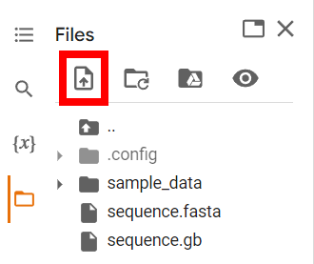

- import Bio.SeqIO module
The Bio.SeqIO module from the BioPython library is used for reading and writing sequence data in a variety of formats, including fasta, and genbank. It provides a unified interface for reading and writing sequence data, making it easy to switch between different file formats without having to change the code.
- Load and read the “.fasta” file.
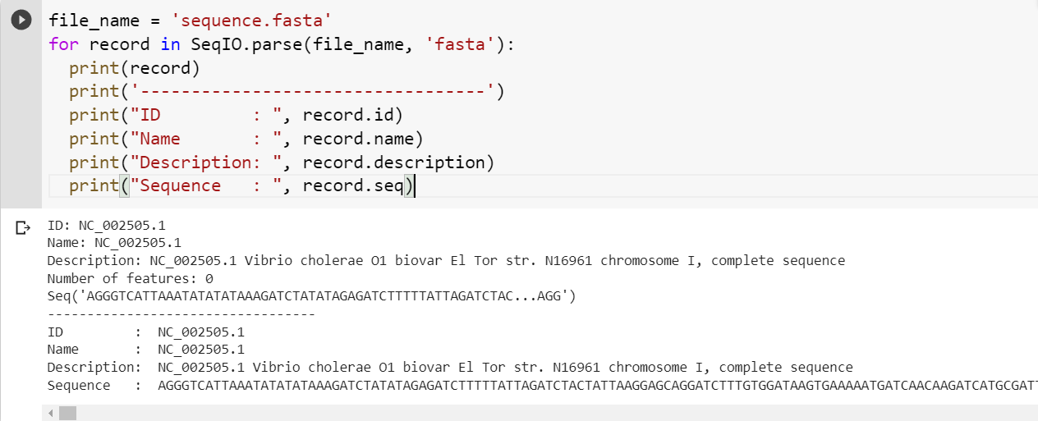
- Load and read the “.gb” file.
