Practicum Case | 
SCIE6062 | SCIE6062001 | SCIE6062016 | SCIE6062049
Computational Biology
Mathematics & Statistics | E231-SCIE6062-VO01-03
Valid on Even Semester Year 2022/2023 | Revision 00

Learning Outcome
- LO3 – implement basic bioinformatics analysis in scope of DNA composition and sequence analysis, protein synthesis, sequence alignment, and other works related to biological database using Biopython
- LO4 – analyze the basic bioinformatics analysis results using Biopython

Topic
- Session 03 – Protein Synthesis

Sub Topics
- Protein Synthesis
- Amino Acid Codon Table
- 3D Structure of Protein

Soal
Case
For given DNA sequences:
Sequence A:
ATGCGTTTATGACGTATCTGAAGTCTACTAGGGTGATCTGACTAA
Sequence B:
GTGTTAGTGCGCTAGTGCTGACTAGGTACAGTAGCTAGTTACTAG
And following mRNA codon arrangements table:
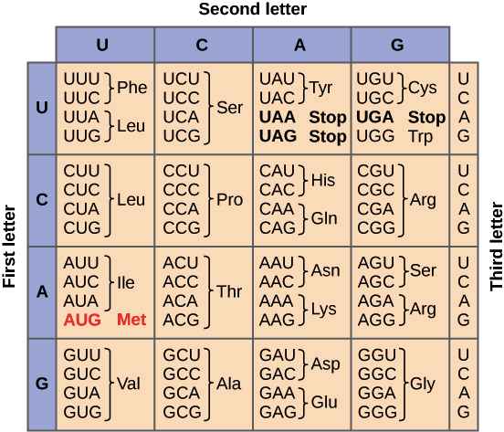

Please use Biopython to:
- Transcribe the DNA sequence A and sequence B into mRNA.
- Combine 24 starting nucleotides of mRNA sequence A and 21 ending nucleotides of mRNA sequence B and set it as mRNA sequence C.
- Translate the mRNA sequence A, sequence B, and sequence C into amino acids sequences.
- Transcribe back the mRNA sequence C into DNA.
- Calculate the complementary sequences of DNA sequence A, sequence B, and sequence C.

