**Data Analysis**

District Summary



With 15 schools and over 39,000 students, the district faces the challenge of meeting diverse educational needs and ensuring fair resource allocation across schools

The district-wide data shows that while 86% of students achieve passing scores in reading, only 75% do so in math. This disparity, combined with a low overall passing rate of 65%, indicates a *critical need* for targeted interventions in math education and better support students in mastering the subject.

Further analysis will help identify the root causes and inform strategies for boosting overall academic achievement.

School Summary:

So, there are 8 charter schools and 7 district schools in the district.

And two Charts of best and lowest performing schools of the district looks like this:

*Top5 Highest-Performing Schools:*

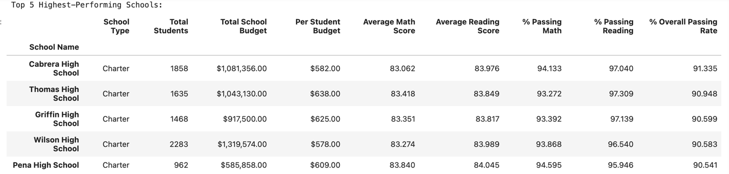

*Bottom5 Lowest-Performing Schools*

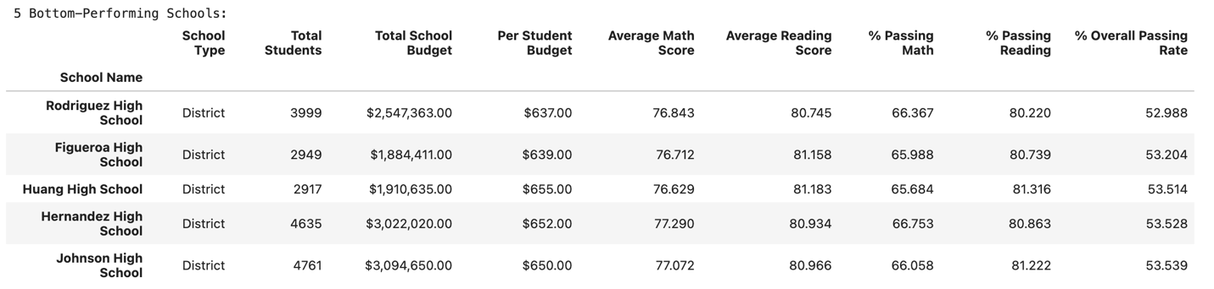

The top-performing schools are *all charter schools*, with average math scores exceeding 83, while the lowest-performing schools are district-run, with scores around 77.

Even though the district schools spend more per student and have larger budgets, their passing rates are below 54%, indicating that the money isn't being used effectively. The district definitely should study more about certain schools’ budget allocation and if further investments in academic support are necessary, especially in math.

*Next Table shows the same issue closer:*

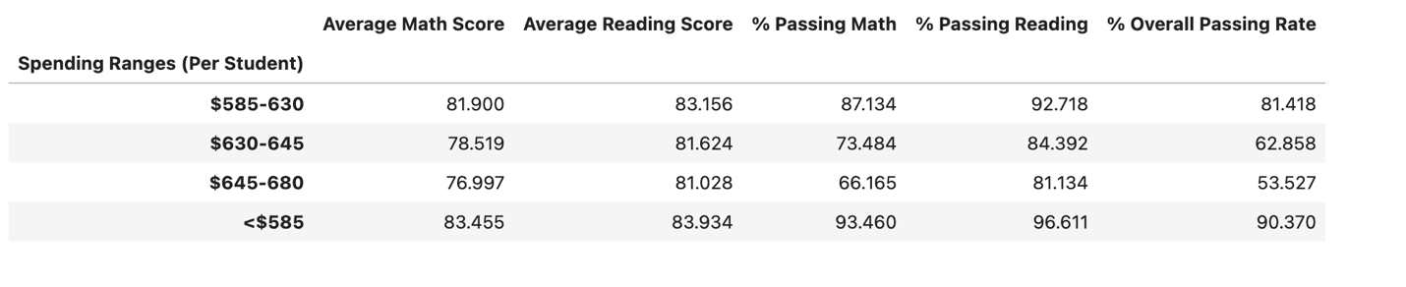

Next issue we can connect in failure in passing is

*School Size*

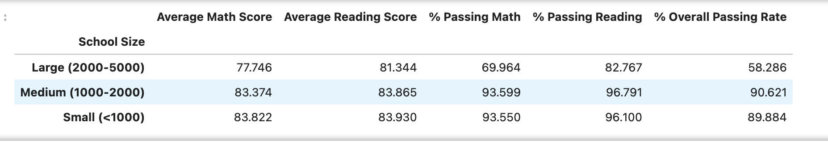

The lowest-performing schools have significantly more students, which could mean less individual attention from teachers. Although class size data isn’t available, it's well-known that larger classes often lead to less engagement for each student, which may be contributing to the lower passing rates.

Analyzing scores by grade

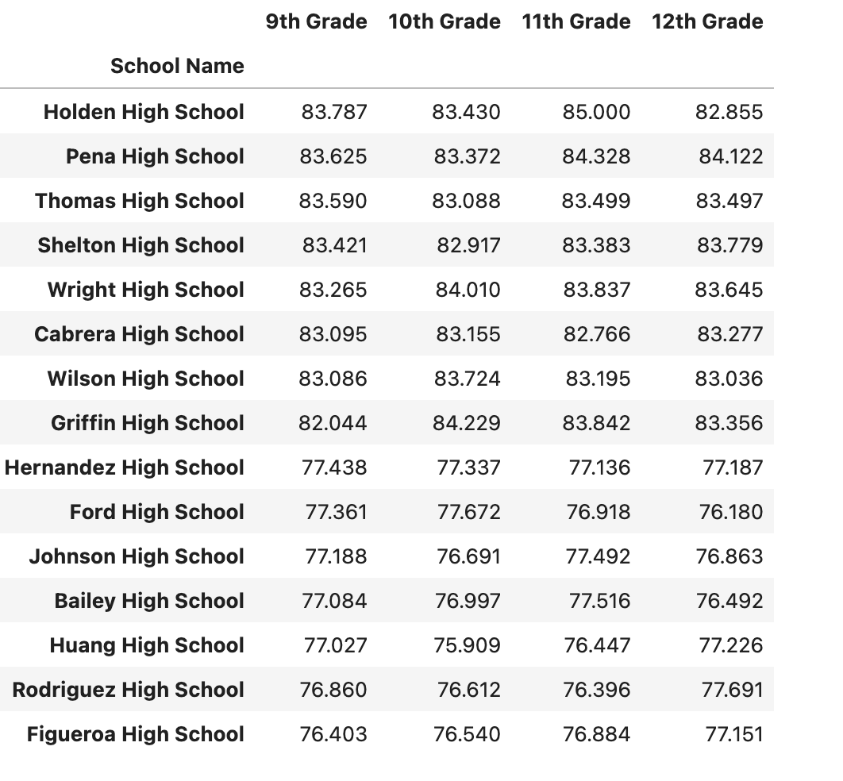

Reveals no significant performance differences within individual schools, indicating that trends are consistent across grade levels. This suggests that any efforts to improve academic outcomes should address school-wide factors rather than focusing on specific grades.

**Conclusions:**

To improve student outcomes, the district could consider several strategies:

* Implementing *tutoring programs* for struggling students.
* *Adjusting the curriculum* and reviewing how many hours students spend on math each week.
* Conducting *student surveys* to understand the difficulties they face. Even if 80% of the responses seem trivial, they could highlight issues like conflicts or other overlooked factors.
* Providing *additional training for math teachers*.
* Increasing *parental involvement* in school life. When parents are engaged in their child’s education, it shows the child that education is valued. This support can motivate students to take their studies more seriously.
* Assessing whether current *funding* is used effectively or if more investment in academic support, especially for math, is needed.
* *Learning from the top 5 performing schools* (Cabrera High School, Thomas High School, Griffin High School, Wilson High School, and Pena High School), all of which are charter schools with math scores above 83 and math passing rates around 93%. These schools could serve as models for success, offering valuable insights into effective teaching practices, curriculum design, and student support strategies. By adopting some of these methods across the district, particularly in lower-performing schools, the district could help boost academic achievement overall."