
LAGOS STATE UNIVERSITY
FACULTY OF COMPUTING
DEPARTMENT OF COMPUTER SCIENCE

DESIGN AND DOCUMENTATION OF THE DATABASE FOR THE LFZDC FLEET MANAGEMENT SYSTEM
A DATABASE PROJECT REPORT
Submitted to the Department of Computer Science, Faculty of Computing, Lagos State University, in partial fulfilment of the requirements for the award of a degree in Computer Science.
BY
AYASI BOLUATIFE ANTHONY
MATRIC NUMBER: 2305-9-1-0-4-5
SUPERVISOR: ______________________________________
SUBMISSION DATE: _________________________________

DECLARATION
I, Ayasi Boluatife Anthony, declare that this database report documents the design and implementation submitted for academic assessment. The schema descriptions, diagrams, queries and restoration procedures are based on the accompanying LFZDC Fleet Management System database package. Sources used to support the database concepts are acknowledged in the references section.
Student Signature: ________________________________
Date: ___________________________________________

CERTIFICATION
This is to certify that the database project titled “Design and Documentation of the Database for the LFZDC Fleet Management System” was carried out by Ayasi Boluatife Anthony, matric number 2305-9-1-0-4-5, in the Department of Computer Science, Faculty of Computing, Lagos State University.
Supervisor: ______________________________________
Signature: _______________________________________
Date: ___________________________________________

ACKNOWLEDGEMENTS
I acknowledge the academic guidance and feedback that supported this project. I also appreciate the operational context of Lekki Free Zone Development Company, which helped define the records, relationships and controls represented in the database. I am grateful to my lecturers, colleagues and family for their support during the analysis, implementation, testing and documentation of the system.

ABSTRACT
The LFZDC Fleet Management System requires a database that can connect vehicle, driver, assignment, trip, fuel, maintenance, incident, document, notification and import records without losing operational history. This report presents the analysis, design, implementation and evaluation of that database. PostgreSQL is used as the relational database engine through Supabase, which also provides authentication, object storage, REST access and server-side functions. The implemented schema contains fourteen application tables, foreign-key relationships, uniqueness constraints, JSONB audit fields, timestamp triggers and Row Level Security policies. Three canonical application roles separate system administration, operational record management and read-only access. A profile-protection trigger prevents non-administrators from changing authorization fields, while storage policies restrict file modification and deletion. The submission contains ten ordered SQL scripts that recreate the schema, supporting functions, policies, storage bucket and fictional demonstration records. The design was evaluated against data integrity, referential consistency, authorization, restoration order and reporting requirements. The result is a portable and inspectable PostgreSQL database package that supports the implemented fleet application while remaining suitable for academic assessment and future extension.
Keywords: PostgreSQL, Supabase, relational database, fleet management, Row Level Security, database restoration, data integrity.

TABLE OF CONTENTS
CHAPTER ONE: INTRODUCTION 1
1.1 Background of the Study 1
1.2 Statement of the Problem 1
1.3 Aim and Objectives 1
1.4 Scope and Limitations 2
1.5 Methodology 2
CHAPTER TWO: REQUIREMENTS AND CONCEPTUAL DESIGN 3
2.1 Data Requirements 3
2.2 Business Rules 4
2.3 Entity Identification 4
2.4 Core Entity Relationships 5
2.5 Support and Governance Relationships 5
2.6 Normalization 6
CHAPTER THREE: LOGICAL AND PHYSICAL DESIGN 7
3.1 Relational Schema Overview 7
3.2 Core Table Design 7
3.3 Supporting Table Design 8
3.4 Keys, Constraints and Delete Behaviour 8
3.5 Data Types and JSONB Use 9
3.6 Indexing and Performance 9

CONTENTS (CONTINUED)
CHAPTER FOUR: DATABASE IMPLEMENTATION 10
4.1 PostgreSQL and Supabase Environment 10
4.2 Scripted Restoration Package 10
4.3 Functions and Triggers 11
4.4 Row Level Security 12
4.5 Storage Integration 12
4.6 Demonstration Data 13
CHAPTER FIVE: DATABASE OPERATIONS AND QUERIES 14
5.1 Application Data Access 14
5.2 Representative Queries 14
5.3 Transaction and Concurrency Considerations 15
5.4 Reporting and Import Audit 15
5.5 Practical Database Demonstration 16
5.6 Hosted Supabase SQL Evidence 23
CHAPTER SIX: TESTING AND EVALUATION 28
6.1 Verification Strategy 28
6.2 Integrity and Security Tests 28
6.3 Restoration Evaluation 29
6.4 Limitations 29
CHAPTER SEVEN: ADMINISTRATION AND RESTORATION GUIDE 30
7.1 Requirements and Safe Handling 30
7.2 Restoration Procedure 30
7.3 Verification and Maintenance 31
CHAPTER EIGHT: CONCLUSION AND RECOMMENDATIONS 32
8.1 Conclusion 32
8.2 Recommendations 32
REFERENCES 33
APPENDIX A: KEY DATA DICTIONARY 34
APPENDIX B: RESTORATION SCRIPT MANIFEST 36
APPENDIX C: SAMPLE SQL QUERIES 37

LIST OF FIGURES
Figure 2.1 Database platform context
Figure 2.2 Core fleet entity relationship model
Figure 2.3 Support and governance entity relationship model
Figure 4.1 Portable database restoration workflow
Figure 4.2 Database authorization flow
Figure 5.1 Creating a vehicle and returning the stored row
Figure 5.2 Reading and searching vehicle records
Figure 5.3 Updating a vehicle with before and after results
Figure 5.4 Joining vehicles, drivers and assignments
Figure 5.5 Calculating fuel and maintenance totals
Figure 5.6 Unique and foreign key constraint errors
Figure 5.7 Deleting a vehicle and verifying its removal
Figure 5.8 Hosted vehicle table structure in Supabase
Figure 5.9 Hosted vehicle status aggregation
Figure 5.10 Hosted current assignment join
Figure 5.11 Hosted assignment foreign key inspection
Figure 5.12 Hosted core-table Row Level Security flags

LIST OF TABLES
Table 1.1 Database project objectives
Table 2.1 Principal business rules
Table 2.2 Entity inventory
Table 2.3 Normalization decisions
Table 3.1 Core table summary
Table 3.2 Supporting table summary
Table 3.3 Relationship delete behaviour
Table 3.4 Data type rationale
Table 4.1 Restoration script responsibilities
Table 4.2 Database functions and triggers
Table 4.3 Role capability matrix
Table 4.4 Demonstration data inventory
Table 6.1 Database test cases
Table 7.1 Post-restoration checks
Table A.1 Key data dictionary
Table B.1 Script manifest

ABBREVIATIONS
Abbreviation | Meaning
API | Application Programming Interface
CRUD | Create, Read, Update and Delete
DBMS | Database Management System
ERD | Entity Relationship Diagram
FK | Foreign Key
JSONB | Binary JSON data type in PostgreSQL
JWT | JSON Web Token
LFZDC | Lekki Free Zone Development Company
PK | Primary Key
RDBMS | Relational Database Management System
RLS | Row Level Security
SQL | Structured Query Language
UQ | Unique Constraint
UUID | Universally Unique Identifier

CHAPTER ONE

INTRODUCTION
This chapter introduces the database problem, project purpose, scope and development method.

1.1 Background of the Study
Fleet operations produce records that are meaningful only when their relationships are preserved. A fuel purchase belongs to a vehicle; a trip connects a vehicle and driver; a maintenance record changes the operational state of an asset; and an incident can affect cost, readiness and compliance. A database therefore provides more than storage. It establishes a controlled structure in which these facts can be connected, validated, searched and reported.
The LFZDC Fleet Management System uses PostgreSQL through Supabase. PostgreSQL supplies the relational engine, constraints, functions, triggers and Row Level Security. Supabase adds hosted authentication, Storage, REST access and Edge Functions while leaving the application data in a standard PostgreSQL database. This combination supports the web application and also permits the schema to be submitted as portable SQL files.

1.2 Statement of the Problem
Before centralization, related fleet facts may exist in separate spreadsheets, documents or informal records. Repeated vehicle details create inconsistent copies, deleted rows can erase useful history, and unrestricted editing makes it difficult to identify who should change operational data. A lecturer assessing the project also needs a database package that can be inspected and recreated without receiving live credentials or password hashes.
The database problem is therefore to represent the complete fleet domain with dependable relationships, preserve historical records, control access by role, support reporting and imports, and remain portable enough for academic restoration.

1.3 Aim and Objectives
The aim is to design and implement a secure relational database for the LFZDC Fleet Management System.
No. | Objective
1 | Identify the entities and relationships required for fleet operations.
2 | Define primary keys, foreign keys, uniqueness rules and suitable data types.
3 | Preserve assignments, odometer readings and other operational history.
4 | Apply role-based database policies instead of relying only on interface controls.
5 | Integrate Supabase Auth and Storage without exposing privileged credentials.
6 | Provide realistic fictional data for safe demonstration and query testing.
7 | Package the database as ordered SQL scripts that can be restored independently.

1.4 Scope and Limitations
The database covers profiles, vehicles, drivers, assignments, fuel logs, maintenance, incidents, trips, documents, document categories, notifications, email-delivery records, odometer history and import batches. It also documents the Storage bucket and the relationship between application profiles and Supabase Auth users.
The submitted package does not contain live user passwords, hosted binary files, private API keys or production credentials. It is not a physical copy of the hosted service; it is a schema-and-sample-data representation that recreates the implemented design. Geographic tracking, procurement approvals, payroll and external telematics are outside the current schema.

1.5 Methodology
Development followed an iterative database design process: requirements were extracted from application workflows; entities and business rules were identified; the conceptual relationships were converted into relational tables; constraints and policies were implemented; fictional data was added; and the restoration order was reviewed. The final audit also checked that no script referenced a function before that function was created and that later storage policies did not weaken role restrictions.

CHAPTER TWO

REQUIREMENTS AND CONCEPTUAL DESIGN
This chapter translates fleet operations into data requirements, entities, relationships and normalization decisions.

2.1 Data Requirements
The database must identify every vehicle and driver, retain operational and compliance facts, connect event records to their owners, and support filtered totals and histories. Authentication identity must remain separate from the application profile so that the hosted Auth service controls credentials while the database controls roles and business metadata.
- Vehicle data includes plate, type, make, model, year, cost, warranty, status and mileage.
- Driver data includes identity, contact, licence, employment dates and status.
- Operational events include assignments, trips, fuel, maintenance, incidents and odometer readings.
- Document records connect stored files to a vehicle or driver and may carry expiry dates.
- Governance records include user profiles, alerts, email-delivery deduplication and import audits.
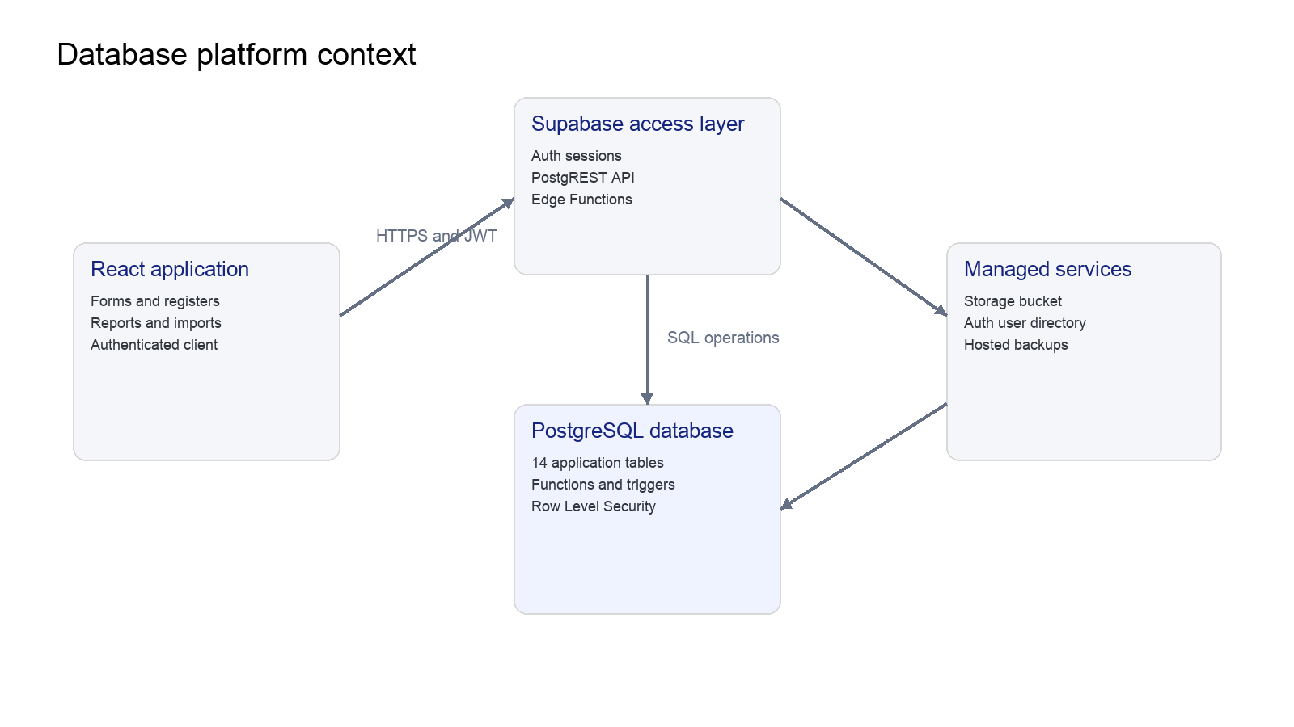
Figure 2.1: Database platform context. Source: Author’s design, 2026.

2.2 Business Rules
Rule | Database interpretation
BR-01 | A vehicle plate number is unique.
BR-02 | A profile corresponds to one Supabase Auth user.
BR-03 | An assignment must reference an existing vehicle and driver.
BR-04 | A trip requires both a vehicle and a driver; an incident driver may be unknown.
BR-05 | Deleting a vehicle removes dependent operational rows, while deleting an incident driver reference sets it to null.
BR-06 | Only system administrators and editors may create or update operational records.
BR-07 | Only system administrators may delete stored document objects.
BR-08 | A non-administrator cannot change profile role or account status.
BR-09 | Import outcomes retain aggregate counts and row-level issues in JSONB.
BR-10 | The same notification-recipient pair can have only one recorded email delivery.

2.3 Entity Identification
Group | Entities | Purpose
Identity | profiles | Application role and user metadata linked to Auth.
Master data | vehicles, drivers | Stable records referenced by operational events.
Operations | assignments, trips, fuel_logs, maintenance, incidents | Day-to-day fleet activities and costs.
History | vehicle_odometer_logs, import_batches | Mileage provenance and migration audit.
Documents | documents, document_types | File metadata, categories and expiry tracking.
Communication | notifications, notification_email_deliveries | Alerts and email deduplication.

2.4 Core Entity Relationships
Vehicles and drivers are the central master entities. Assignment and trip records resolve their many-to-many operational relationship over time. Fuel, maintenance and odometer records belong to vehicles, while incidents may also identify a driver. Dependent rows use foreign keys so the database does not accept an event for an unknown asset.
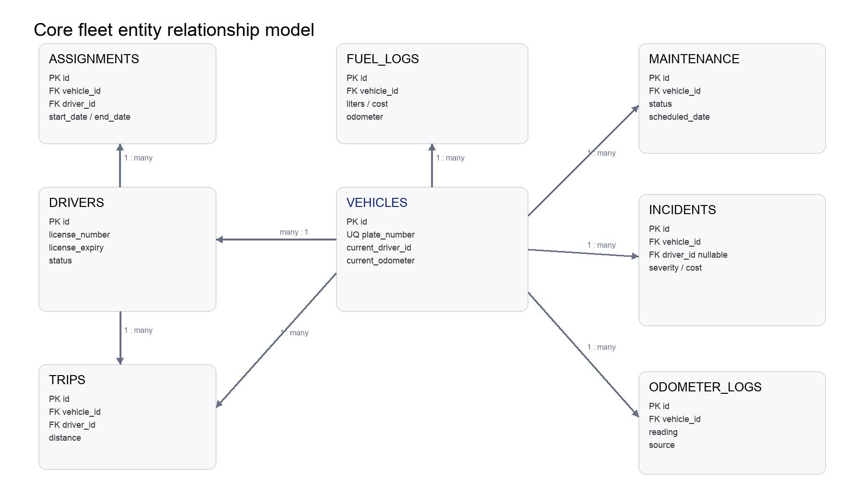
Figure 2.2: Core fleet entity relationship model. Source: Author’s design, 2026.

2.5 Support and Governance Relationships
The profile table extends Supabase Auth without storing passwords. Notifications may reference a vehicle or driver. Email deliveries use a composite primary key to prevent duplicate delivery records. Documents store relational metadata while binary objects remain in Storage. Import batches retain the operator identity when available but use a null reference if that profile is later removed.
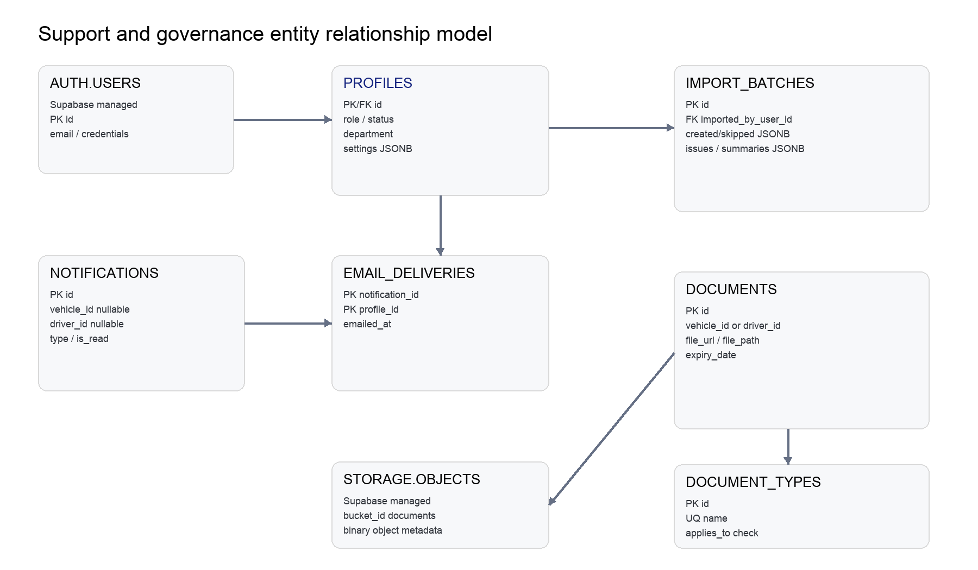
Figure 2.3: Support and governance entity relationship model. Source: Author’s design, 2026.

2.6 Normalization
The operational schema largely follows third normal form. Repeating groups are separated into child tables, relationships use keys rather than duplicated descriptive fields, and non-key attributes describe the row identified by the primary key. Selected denormalization is intentional where it preserves an audit snapshot or improves operational access.
Design choice | Reason
Separate vehicles and drivers | Avoids repeating master details in every assignment, trip or incident.
Assignment history table | Represents relationship changes over time instead of overwriting one current-driver field.
Document type lookup | Standardizes categories while permitting controlled extension.
imported_by_name snapshot | Preserves the visible operator name even if a profile is later removed.
JSONB import details | Stores variable sheet summaries and row issues without creating sparse fixed columns.
vehicles.current_driver_id | Provides a fast operational pointer while assignments remain the historical source.

CHAPTER THREE

LOGICAL AND PHYSICAL DESIGN
This chapter documents the relational schema, table responsibilities, keys, constraints, data types and performance considerations.

3.1 Relational Schema Overview
The public schema contains fourteen application tables. Supabase-managed auth.users and storage.objects remain external dependencies rather than copied application tables. Text identifiers are used for most fleet records because the application generates readable stable IDs during normal forms and imports; UUIDs are retained for hosted user identities and document categories.
Module | Tables | Primary relationship
Identity | profiles | profiles.id → auth.users.id
Fleet | vehicles, drivers, assignments | assignments → vehicles and drivers
Operations | fuel_logs, maintenance, incidents, trips | each event → vehicle; selected events → driver
Documents | documents, document_types | documents → vehicle or driver; file_path → Storage
Audit | vehicle_odometer_logs, import_batches | odometer log → vehicle; import batch → profile
Alerts | notifications, notification_email_deliveries | delivery → notification and profile

3.2 Core Table Design

3.2.1 Vehicles and Drivers
These tables hold the stable master records from which operational relationships are formed.
Table | Primary key | Identifier or reference | Responsibility
vehicles | id | plate_number | Asset identity, commercial data, readiness and service mileage.
drivers | id | license_number | Driver identity, licence, employment and status data.

3.2.2 Assignments and Trips
Assignments preserve periods of responsibility, while trips record completed journeys and distances.
Table | Primary key | Identifier or reference | Responsibility
assignments | id | vehicle_id, driver_id | Start and optional end date for vehicle-driver allocation.
trips | id | vehicle_id, driver_id | Journey date, route, distance and purpose.

3.2.3 Fuel, Maintenance and Incidents
These event tables support cost reporting, readiness decisions and traceable operational history.
Table | Primary key | Identifier or reference | Responsibility
fuel_logs | id | vehicle_id | Litres, cost, station and odometer at purchase.
maintenance | id | vehicle_id | Service type, workflow state, dates, cost and provider.
incidents | id | vehicle_id, driver_id | Severity, workflow state, location and repair costs.

3.3 Supporting Table Design
Table | Key design | Responsibility
profiles | UUID PK and FK to auth.users | Application name, role, status, department and settings.
documents | Text PK; nullable vehicle/driver FKs | File metadata and expiry tracking.
document_types | UUID PK; unique name; applies_to check | Controlled shared document categories.
notifications | Text PK; nullable vehicle/driver FKs | Operational alert feed.
notification_email_deliveries | Composite PK | One delivery record per notification and recipient.
vehicle_odometer_logs | Text PK; vehicle FK | Reading provenance and source notes.
import_batches | Text PK; nullable profile FK | Workbook counts, issues and sheet summaries.

3.4 Keys, Constraints and Delete Behaviour
Primary keys provide row identity, foreign keys prevent orphaned events, and unique constraints protect natural identifiers such as profile email, vehicle plate and document type name. The database uses delete actions deliberately according to the lifecycle of each relationship.
Parent | Dependent relationship | Delete action | Reason
auth.users | profiles.id | CASCADE | Remove the application identity when the Auth account is removed.
vehicles | assignments, fuel, maintenance, trips, documents, notifications, odometer logs | CASCADE | Dependent fleet records have no meaning without the asset.
drivers | assignments and trips | CASCADE | Operational history is tightly linked to the driver record.
drivers | incidents.driver_id | SET NULL | Retain the incident even if the driver reference is unavailable.
profiles | import_batches.imported_by_user_id | SET NULL | Retain migration history after account removal.
notifications/profiles | notification_email_deliveries | CASCADE | Delivery audit belongs to both referenced records.

3.5 Data Types and JSONB Use
Type | Use | Rationale
text | Record IDs, labels and identifiers | Matches application-generated IDs and variable-length operational text.
uuid | Auth-linked profiles and document types | Compatible with Supabase identities and generated lookup keys.
date | Operational and expiry dates | Represents calendar dates without unintended time-zone conversion.
timestamptz | Creation, update and audit times | Stores absolute instants consistently in UTC.
numeric(p,s) | Fuel, distance and monetary values | Avoids binary floating-point error for measured and financial values.
integer/bigint | Mileage and file size | Efficient whole-number storage with appropriate range.
boolean | Notification read state | Represents a two-state fact directly.
jsonb | Import outcomes, attachments and preferences | Supports variable structured data and future indexing when needed.
app_role enum | Profile role | Restricts role values to known database-level labels.

3.6 Indexing and Performance
Primary and unique keys create indexes automatically, but foreign keys do not. Candidate indexes include vehicle-and-date lookups, assignment references and document expiry dates. Add indexes only when measured query plans justify their cost. Appendix C.5 lists two optional examples; these are not part of the restoration package.

CHAPTER FOUR

DATABASE IMPLEMENTATION
This chapter explains the PostgreSQL environment, restoration scripts, functions, triggers, security policies, Storage integration and sample data.

4.1 PostgreSQL and Supabase Environment
The implementation runs on PostgreSQL provided by Supabase. The frontend accesses tables through PostgREST using the authenticated user’s JWT. The anonymous browser key identifies the project but does not bypass RLS. Privileged Edge Functions use the service-role credential only in the hosted server environment. Database passwords, service keys and SMTP credentials are excluded from the submission.

4.2 Scripted Restoration Package
The database-submission folder contains ten numbered scripts. Their order is significant because later scripts depend on objects created earlier. The package audit moved document-type write authorization into script 08, after the role helper functions exist, and ensures script 09 leaves Storage with the intended role restrictions.
Order | Script | Responsibility
01 | 01-schema.sql | Core enum, tables, timestamp function, triggers, RLS and read policies.
02 | 02-vehicle-odometer.sql | Current odometer field, odometer history table and read policy.
03 | 03-vehicle-service-mileage.sql | Next-service mileage field.
04 | 04-document-types.sql | Document category table and authenticated read policy.
05 | 05-document-file-path.sql | Storage object path and transitional document policy.
06 | 06-profile-settings.sql | JSONB settings on profiles.
07 | 07-notification-email-deliveries.sql | Email delivery deduplication table.
08 | 08-role-access-policies.sql | Canonical roles, helper functions, safeguards and final table write policies.
09 | 09-storage-documents.sql | Documents bucket and final object access policies.
10 | 10-sample-data.sql | Fictional data for assessment and demonstrations.

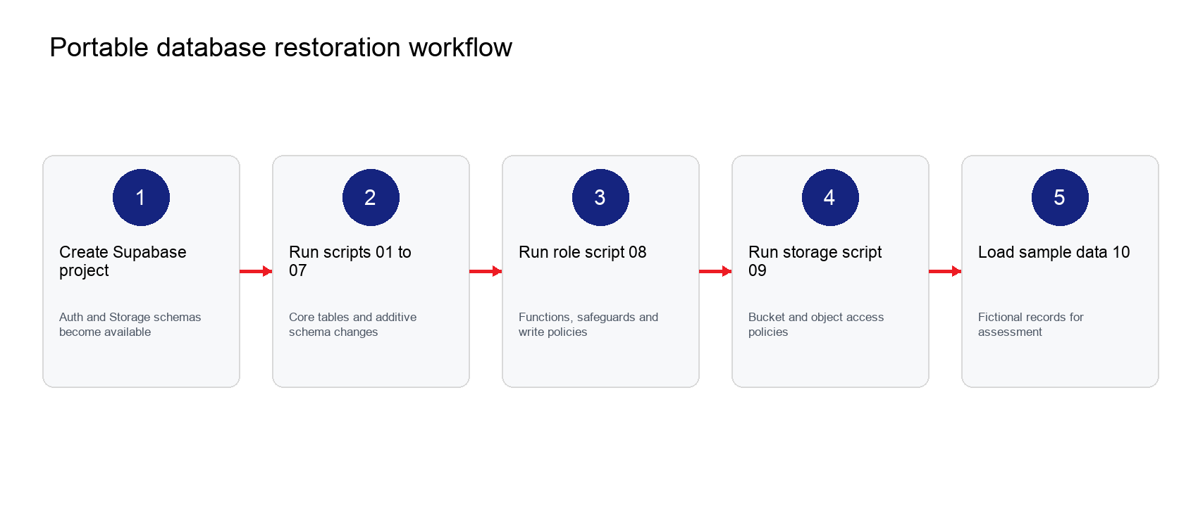
Figure 4.1: Portable database restoration workflow. Source: Author’s design, 2026.

4.3 Functions and Triggers
Object | Type | Purpose
set_updated_at | Trigger function | Writes the current UTC timestamp before updates.
current_app_role | Security-definer SQL function | Returns the signed-in profile role without recursive RLS.
is_system_admin | Security-definer SQL function | Checks administrator capability.
can_manage_records | Security-definer SQL function | Allows system_admin and editor write operations.
protect_profile_authorization_fields | Trigger function | Blocks non-admin changes to role and account status.

The update timestamp trigger is attached to profiles, vehicles, drivers, maintenance, incidents and documents. The profile authorization trigger executes before every profile update. Service-role operations remain possible because server-side administration does not carry an ordinary end-user auth.uid value.
if auth.uid() is not null
and not public.is_system_admin()
and (new.role is distinct from old.role
or new.status is distinct from old.status) then
raise exception 'Only system administrators can change profile roles or account status';
end if;

4.4 Row Level Security
RLS is enabled on every application table. Read policies allow authenticated staff to view operational information, while write policies call role helpers. The interface mirrors these permissions for usability, but the database remains the enforcement boundary.
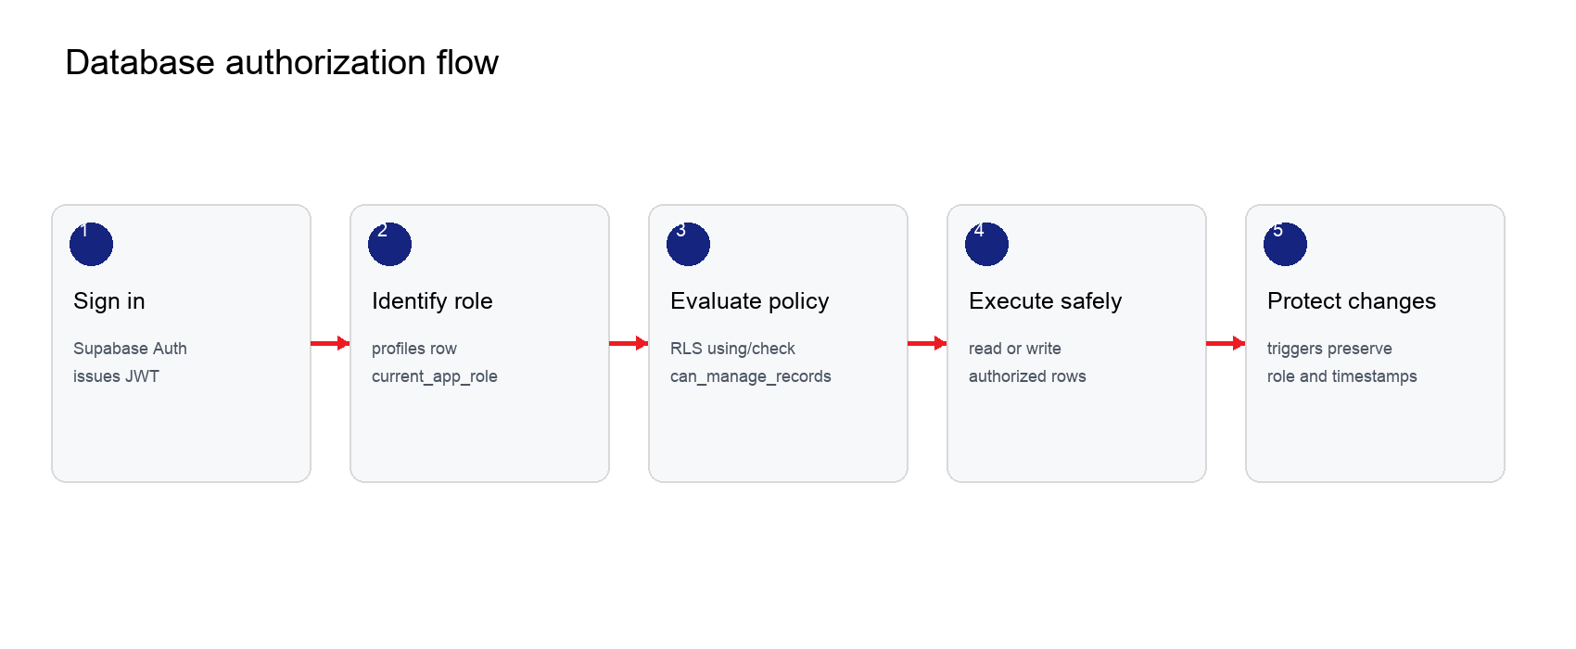
Figure 4.2: Database authorization flow. Source: Author’s design, 2026.
Capability | System admin | Editor | End user
Read fleet records | Yes | Yes | Yes
Create/update fleet records | Yes | Yes | No
Create document types | Yes | Yes | No
Insert import batches | Yes | Yes | No
View all profiles | Yes | Own profile | Own profile
Change another profile role/status | Yes | No | No
Upload/update stored files | Yes | Yes | No
Delete stored files | Yes | No | No

4.5 Storage Integration
Document metadata is stored in public.documents while binary files are stored in the Supabase documents bucket. Authenticated users may read objects, editors and administrators may upload or update them, and only administrators may delete them. The current bucket is public because the application uses public URLs. A production deployment handling confidential documents should convert the bucket to private access and use short-lived signed URLs.

4.6 Demonstration Data
Script 10 inserts fictional operational records only. It does not create Auth users, password hashes or real files. Conflict handling makes the inserts repeatable for stable IDs and unique document type names.
Dataset | Demonstration coverage
Vehicles and drivers | Multiple asset classes, statuses, mileage levels and licence dates.
Assignments | Current and historical vehicle-driver allocations.
Fuel and trips | March 2026 transactions for expenditure and distance reporting.
Maintenance and incidents | Completed, scheduled, in-progress, overdue and under-review cases.
Documents | Vehicle and driver categories with optional expiry dates.
Notifications | Maintenance, document, incident, fuel and licence alerts.
Odometer history | Manual, trip, fuel and maintenance reading sources.

CHAPTER FIVE

DATABASE OPERATIONS AND QUERIES
This chapter presents the main access patterns, representative SQL, transaction considerations and reporting support.

5.1 Application Data Access
The application does not maintain a separate custom REST server for ordinary records. The Supabase JavaScript client sends authenticated requests to PostgREST, which converts allowed operations into SQL against the public schema. Edge Functions are reserved for privileged account administration and email delivery. This separation keeps routine data access direct while protecting service-role operations.

5.2 Representative Queries

5.2.1 Fleet Readiness Summary
select status, count(*) as vehicle_count
from public.vehicles
group by status
order by status;

5.2.2 Vehicle Operating Cost
select v.plate_number,
coalesce(f.total, 0) as fuel_cost,
coalesce(m.total, 0) as maintenance_cost
from public.vehicles v
left join (
select vehicle_id, sum(cost) as total
from public.fuel_logs group by vehicle_id
) f on f.vehicle_id = v.id
left join (
select vehicle_id, sum(cost) as total
from public.maintenance group by vehicle_id
) m on m.vehicle_id = v.id
order by v.plate_number;
Each event table is aggregated to one row per vehicle before the joins. This prevents fuel and maintenance rows from multiplying each other and inflating the totals. COALESCE returns zero for a vehicle with no matching costs. Section 5.5 demonstrates the query using two fuel entries and two maintenance entries for the same vehicle.

5.2.3 Current Assignments
select v.plate_number, d.full_name, a.start_date
from public.assignments a
join public.vehicles v on v.id = a.vehicle_id
join public.drivers d on d.id = a.driver_id
where a.end_date is null
order by a.start_date desc;

5.2.4 Expiring Documents
select title, document_type, expiry_date
from public.documents
where expiry_date between current_date and current_date + interval '60 days'
order by expiry_date;

5.2.5 Import Audit Review
select file_name, imported_at, imported_by_name,
total_rows, valid_rows, issue_count
from public.import_batches
order by imported_at desc;

5.3 Transaction and Concurrency Considerations
Several workflows change related rows. Driver assignment closes conflicting active assignments, inserts a new assignment and updates the vehicle pointer. Maintenance and odometer workflows can also update both an event row and the vehicle summary state. The current application sequences these calls; future hardening should move multi-step invariants into PostgreSQL functions executed as one transaction so concurrent operators cannot create an inconsistent intermediate state.
Uniqueness constraints already protect profile email, vehicle plate and document type name. Assignment exclusivity is currently enforced by application logic. A partial unique index on active assignments would provide stronger database enforcement if the operational rule remains one active vehicle per driver and one active driver per vehicle.
create unique index on public.assignments (vehicle_id)
where end_date is null;
create unique index on public.assignments (driver_id)
where end_date is null;

5.4 Reporting and Import Audit
The report module filters operational events by vehicle and date range, then calculates fuel cost, maintenance cost, incident cost and distance. Import batches retain aggregate counts and row-level issues so a historical workbook can be reviewed after migration. JSONB is appropriate because sheet summaries and errors have variable structures, but important filter fields such as file name, operator and timestamp remain normal columns.

5.5 Practical Database Demonstration
The following walkthrough shows the input SQL and actual database response for Create, Read, Update, Delete and search operations, followed by relationship and integrity checks. The sequence uses fictional LFZ-DEMO records and does not modify the hosted fleet database.
Evidence was executed in isolated PostgreSQL 18.3 through PGlite 0.5.8. Seven core table definitions and the vehicle timestamp trigger were taken from 01-schema.sql. The figures are screenshots of rendered execution transcripts, not screenshots of the Supabase dashboard. They verify the demonstrated SQL behaviour, not hosted authentication, RLS policies, Storage or a complete restoration.

5.5.1 Create a Vehicle
Enter a unique record ID and plate number, then supply the vehicle type, brand, model, year and status. INSERT stores the row; RETURNING displays the stored values immediately. In the application, the Add Vehicle form reaches the equivalent insert through createVehicle in src/lib/fleet-data.ts.
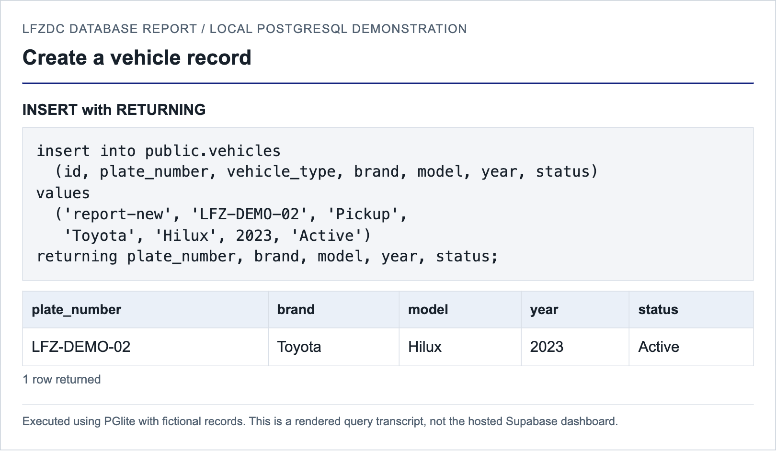
Figure 5.1: Creating a vehicle and returning the stored row
The returned LFZ-DEMO-02 row confirms that the Toyota Hilux was inserted with year 2023 and status Active. Its ID, report-new, is used in the later update and delete operations so that only this demonstration record is changed.

5.5.2 Read and Search Records
Run SELECT to display the vehicle register, then add a WHERE condition to narrow the result. The first query returns the original demonstration vehicle and the newly inserted vehicle. The second uses ILIKE for a case-insensitive partial plate-number search.
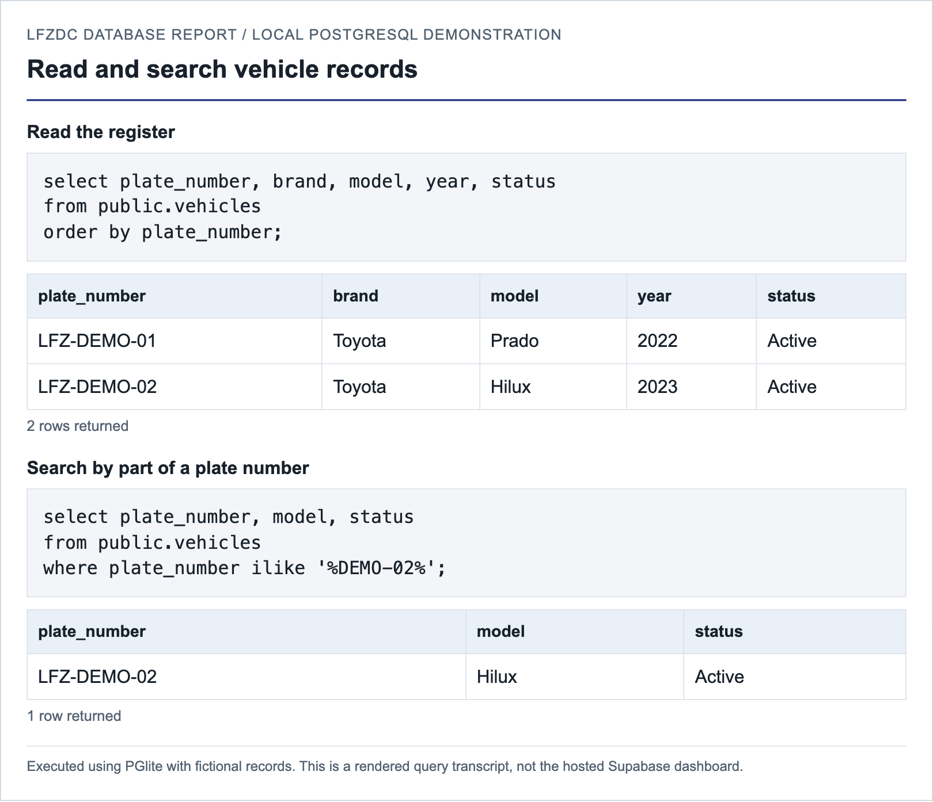
Figure 5.2: Reading and searching vehicle records
The full read returns two rows. Searching for DEMO-02 returns only the Hilux. These operations retrieve records without changing them; the percent signs allow text before or after the search term.

5.5.3 Update a Vehicle
Read the selected record before editing it. Change its status from Active to Under Maintenance and retain the WHERE condition on its primary key. RETURNING makes the new value visible without requiring a separate refresh.
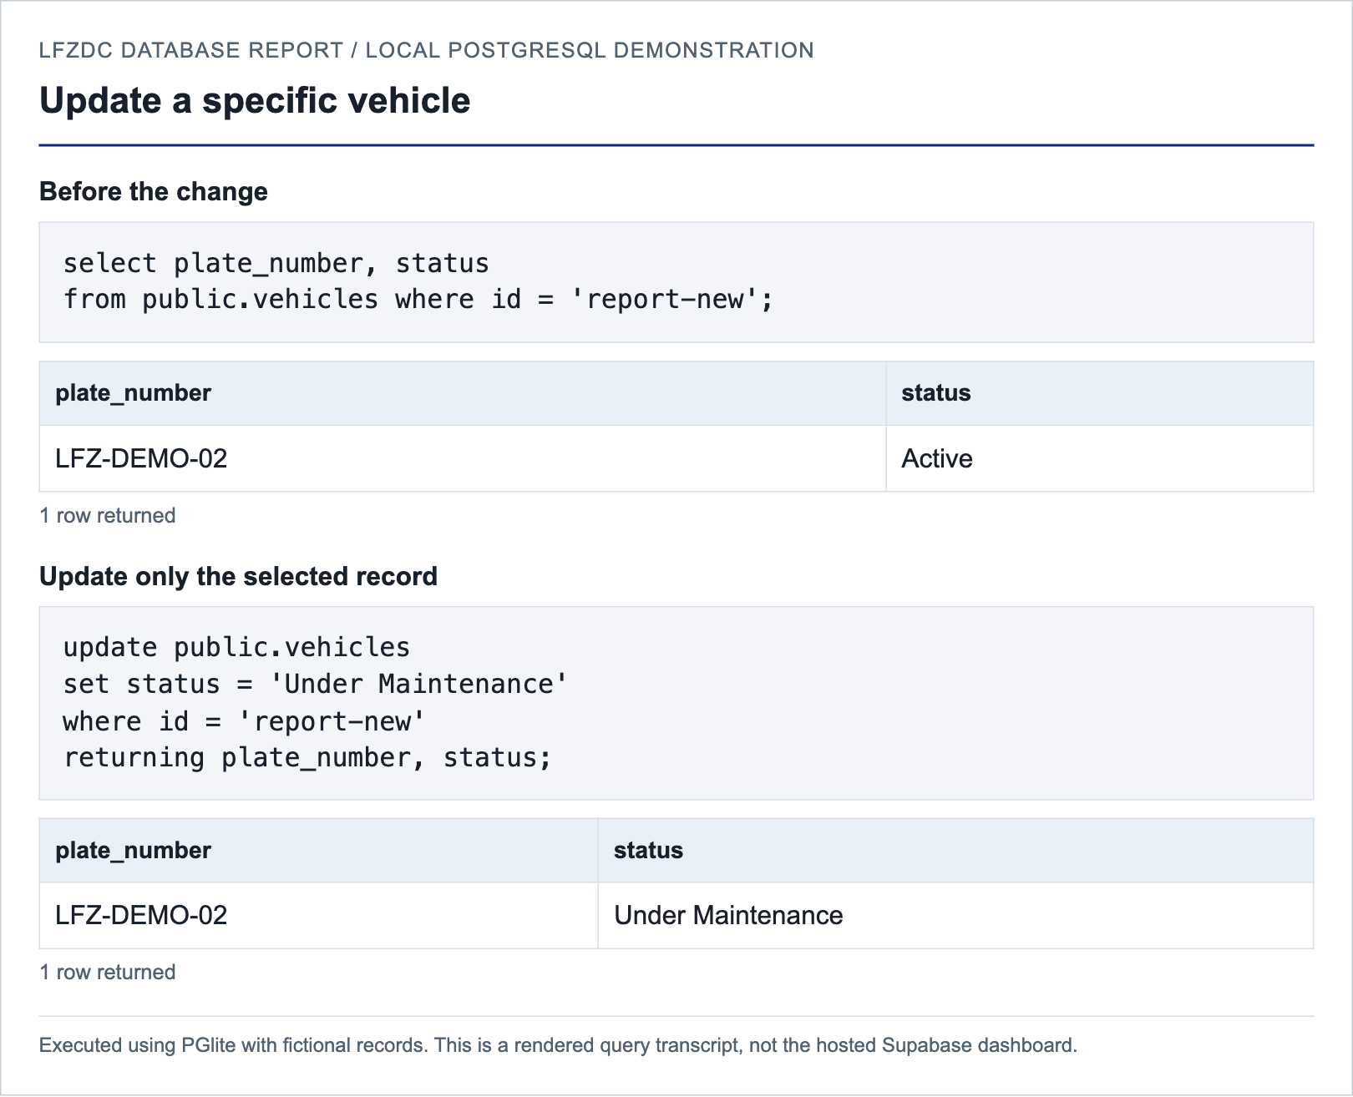
Figure 5.3: Updating a vehicle with before and after results
The same plate number appears before and after the change, while the status changes. A separate automated assertion also confirmed that the vehicle updated_at trigger advanced the timestamp. Without the WHERE condition, an UPDATE would affect every row in the table.

5.5.4 Retrieve Related Records
The assignment fixture links vehicle report-base to driver report-driver from 1 September 2026. Rather than storing another copy of the plate number and driver name in the assignment, the query joins their IDs to the corresponding parent records.
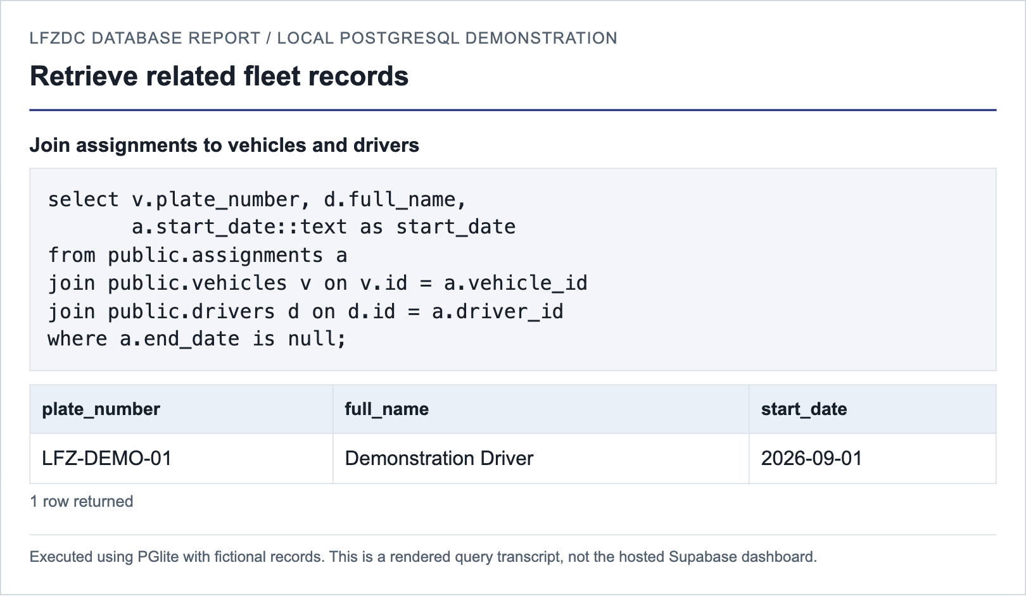
Figure 5.4: Joining vehicles, drivers and assignments
The result associates LFZ-DEMO-01 with Demonstration Driver. The condition end_date IS NULL restricts the result to an assignment that has not been closed. An inner join requires the referenced vehicle and driver to exist.
This example illustrates why the database separates vehicles, drivers and assignments: the assignment stores the relationship and its dates, while the vehicle and driver tables remain the authoritative sources for their own details.

5.5.5 Summarize Operating Costs
The fixture contains fuel costs of NGN 20,000 and NGN 30,000, plus maintenance costs of NGN 10,000 and NGN 15,000 for LFZ-DEMO-01. Aggregate the tables separately before combining them by vehicle ID.
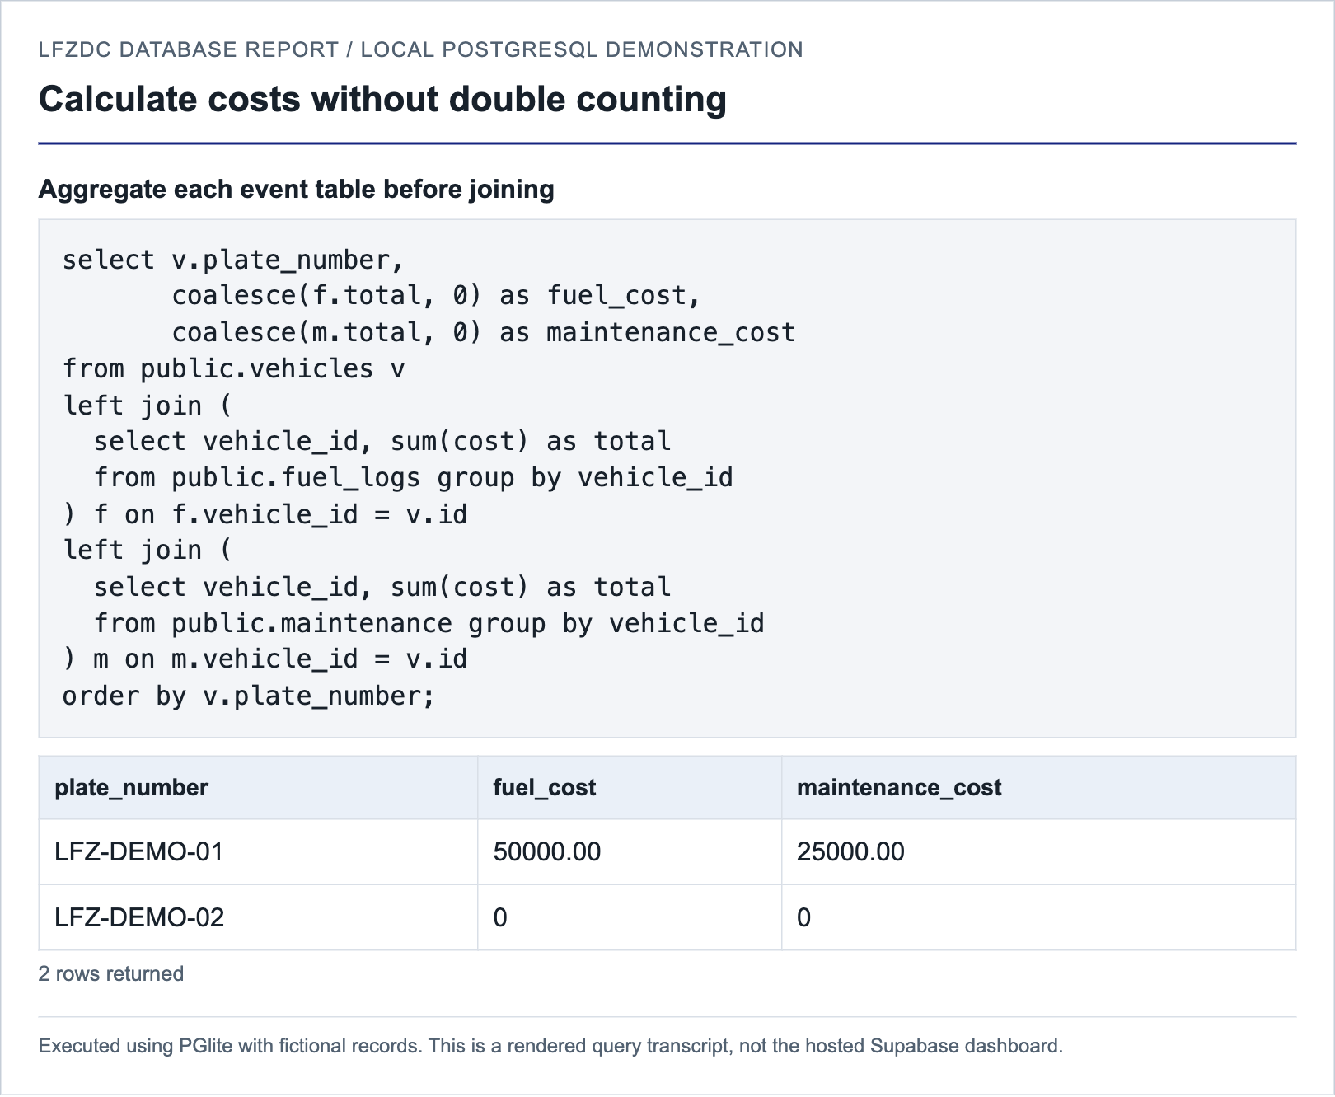
Figure 5.5: Calculating fuel and maintenance totals
The correct totals are NGN 50,000 for fuel and NGN 25,000 for maintenance. The second vehicle has no cost records and returns zero. Joining the two raw event tables first would produce four combinations and incorrectly double both totals for LFZ-DEMO-01.

5.5.6 Demonstrate Integrity Constraints
The following invalid inputs were deliberately submitted to the isolated database. The first repeats an existing plate number. The second creates a trip with a vehicle ID that is absent from the vehicle table. Both operations must fail.
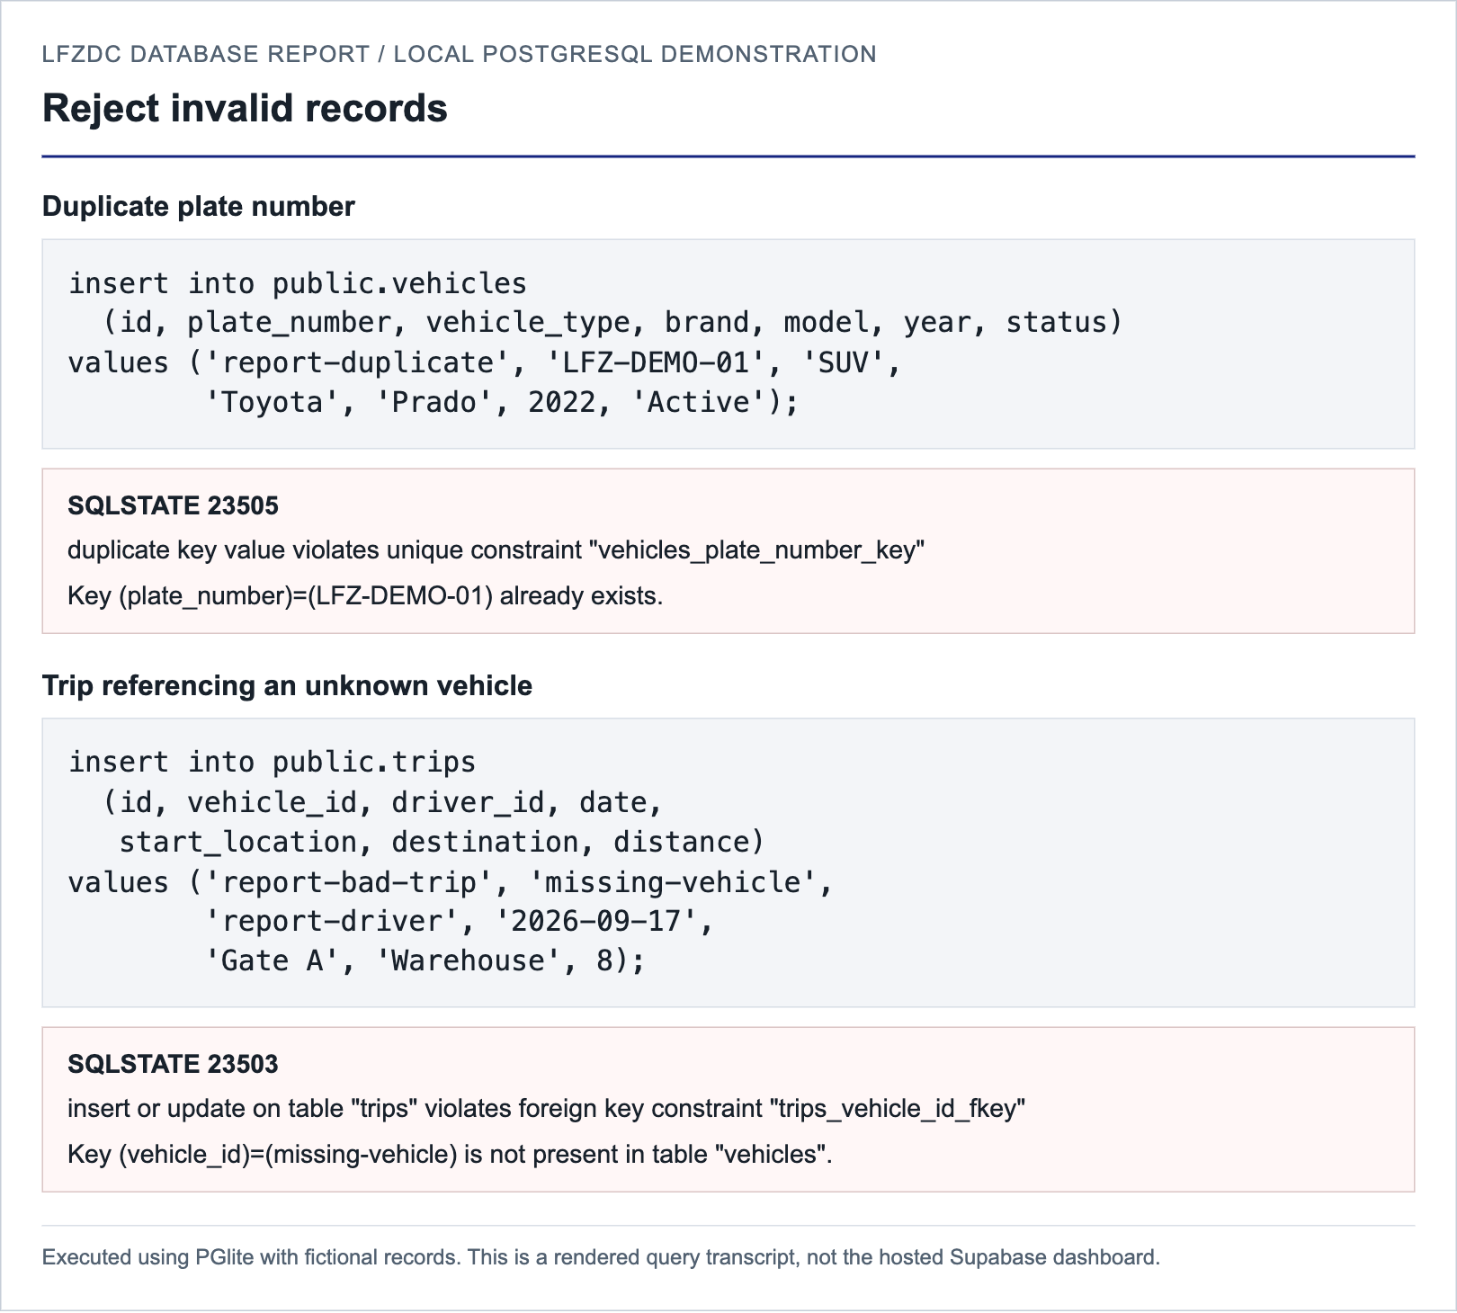
Figure 5.6: Unique and foreign key constraint errors
SQLSTATE 23505 identifies the duplicate plate-number violation. SQLSTATE 23503 identifies the invalid vehicle reference. These are expected test results, not unresolved application faults; neither invalid row was stored.

5.5.7 Delete and Verify Removal
Delete only the temporary report-new vehicle. The RETURNING clause displays the removed record, and a subsequent count verifies that no row with that ID remains. This final step completes the Create, Read, Update and Delete sequence.
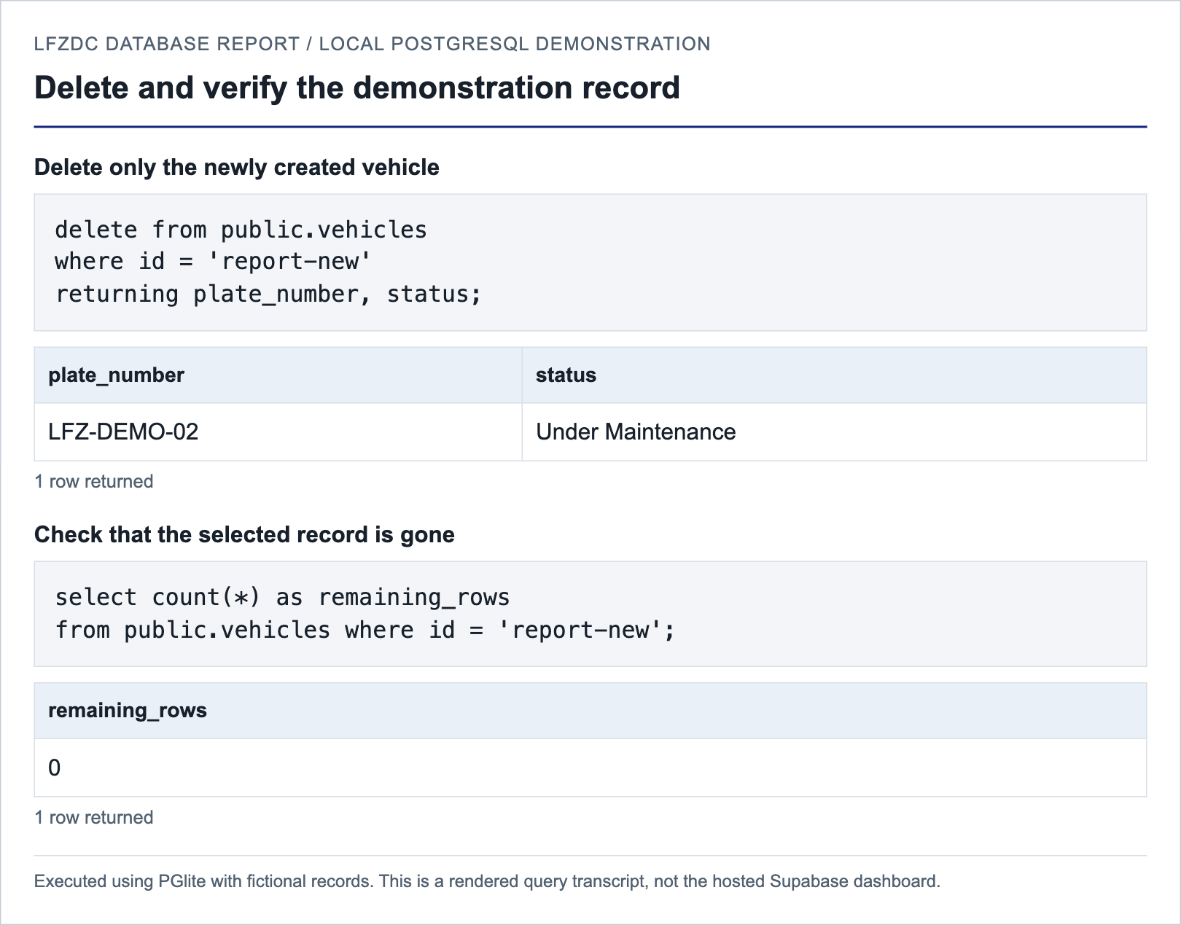
Figure 5.7: Deleting a vehicle and verifying its removal
The returned row is LFZ-DEMO-02 with its updated Under Maintenance status. The verification count is zero. The original report-base vehicle is not targeted by this statement.
In a real project, review related records and take an appropriate backup before deleting a vehicle. Several child tables use ON DELETE CASCADE, so deletion can remove its operational history. These demonstrations use only disposable fictional records in a separate database.

5.6 Hosted Supabase SQL Evidence
Figures 5.8 to 5.12 are actual screenshots of the hosted project SQL Editor, captured on 17 September 2026. Each shows the executed SELECT statement and its returned results. These read-only checks did not create, update or delete live records. Counts reflect the database at capture time, not the fictional local fixtures in Section 5.5.

5.6.1 Inspect the Vehicle Table
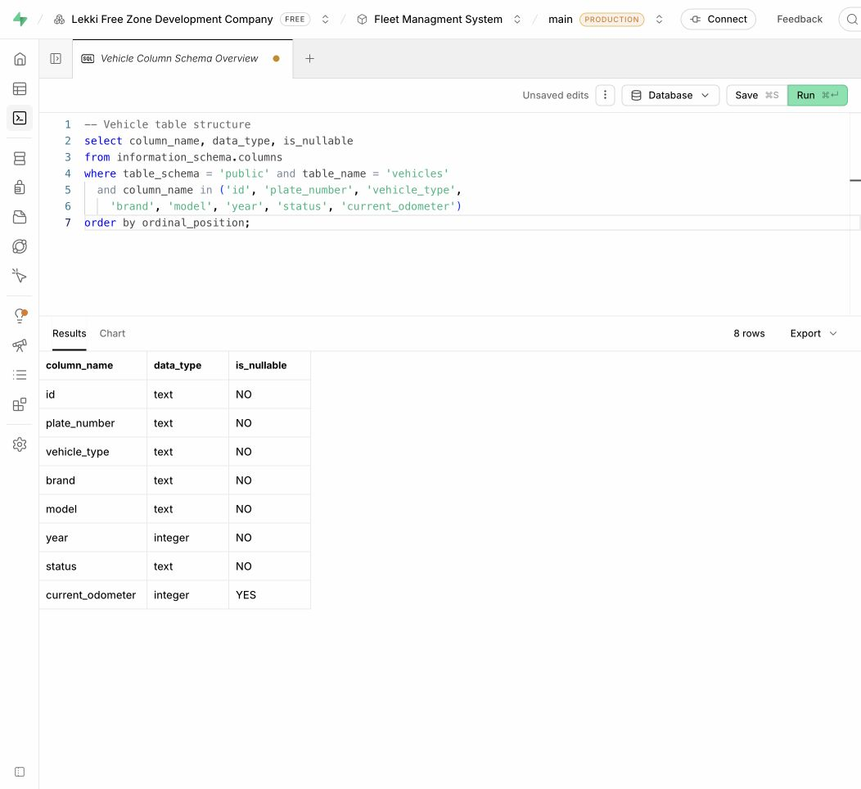
Figure 5.8: Hosted vehicle table structure in Supabase
The information_schema query returns eight selected columns with their data types and nullability. Seven are mandatory; current_odometer permits NULL. This confirms the inspected fields in the deployed table rather than merely reproducing a proposed schema.

5.6.2 Summarize the Live Vehicle Register
COUNT and GROUP BY reduce the vehicle register to one row per status. The statement is useful for a dashboard summary because it returns counts instead of the complete register. ORDER BY makes the output predictable.
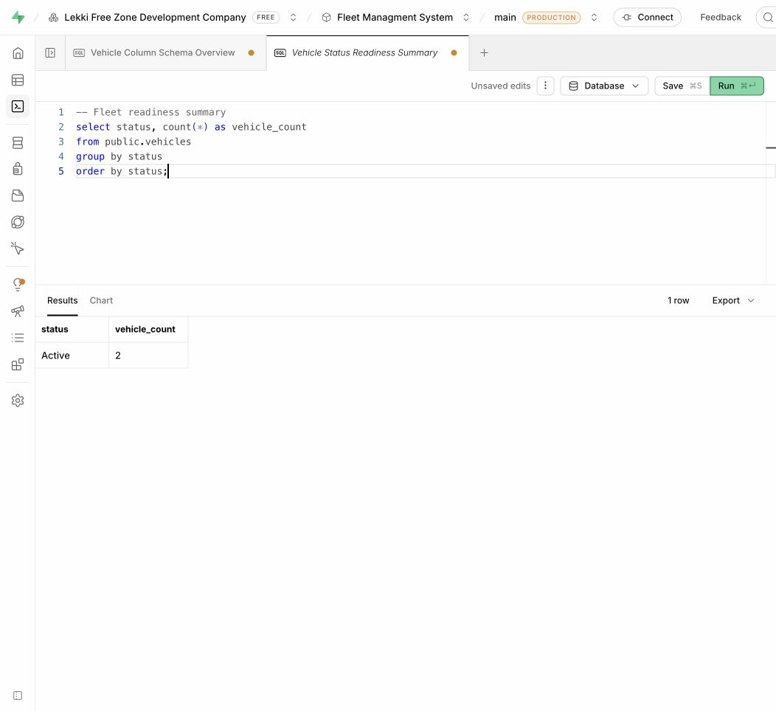
Figure 5.9: Hosted vehicle status aggregation
The live query returns Active with a vehicle_count of 2. Only statuses represented by stored rows appear; the absence of another status does not mean that status is invalid. The result is a point-in-time observation and can change when records are edited.

5.6.3 Join Vehicles, Drivers and Assignments
This statement follows the assignment foreign keys to the vehicle and driver tables. It displays the vehicle plate, model, driver status and assignment start date. Driver names, contact details and licence numbers are intentionally excluded from this report evidence.
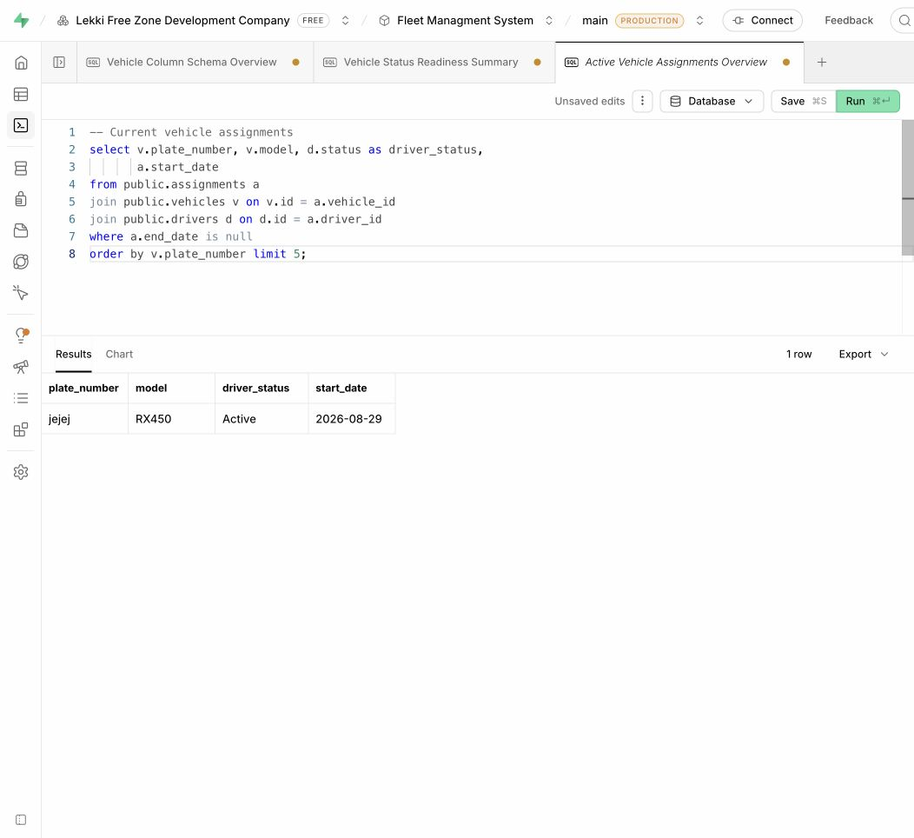
Figure 5.10: Hosted current assignment join
One current assignment is returned: vehicle plate jejej, model RX450, driver status Active and start date 2026-08-29. The condition end_date IS NULL selects open assignments. LIMIT 5 caps the displayed rows; the result contains one matching row at capture time.

5.6.4 Inspect Referential Integrity Rules
The PostgreSQL pg_constraint catalogue records the constraints installed in the database. This query selects foreign keys on public.assignments, identifies their referenced tables and translates the cascade delete code into a readable label.
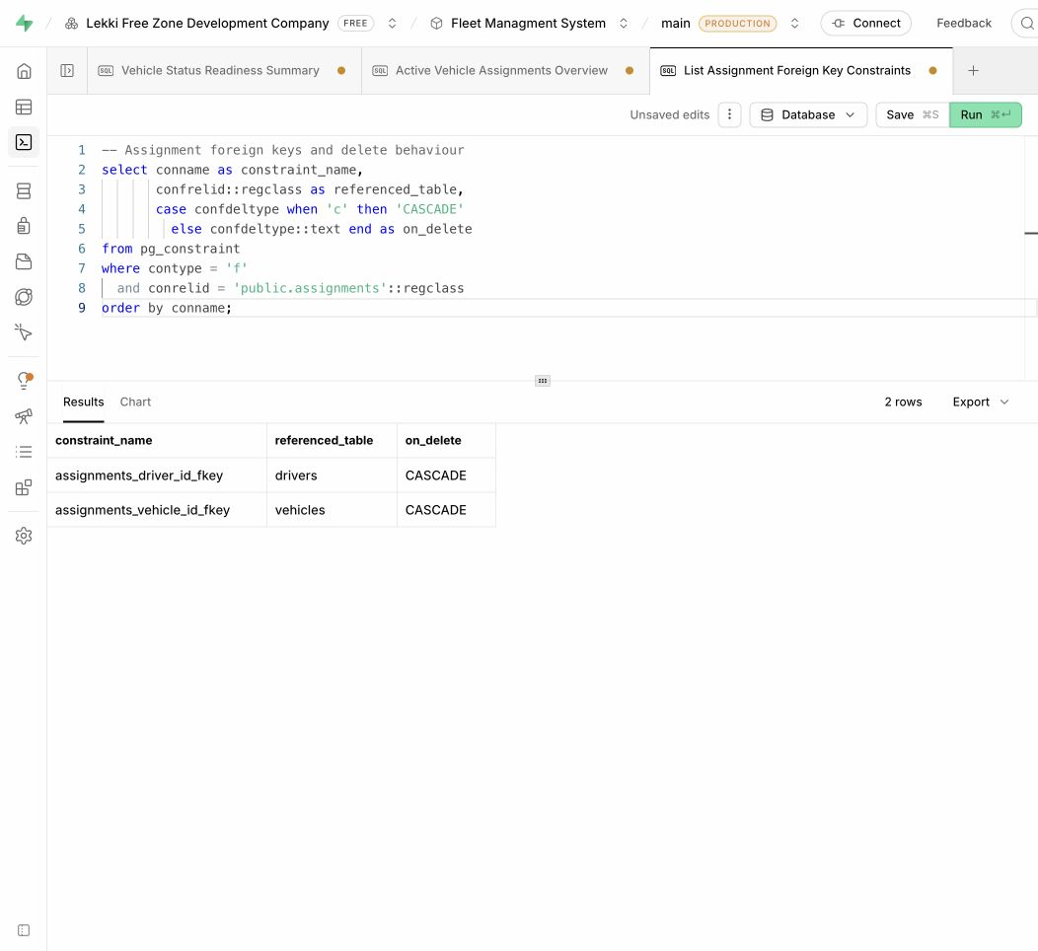
Figure 5.11: Hosted assignment foreign key inspection
Two foreign keys are present: assignments_driver_id_fkey references drivers and assignments_vehicle_id_fkey references vehicles. Both report CASCADE. Deleting a referenced parent can therefore remove its assignment rows. The screenshot inspects that configuration; it does not execute a deletion or prove every integrity case.

5.6.5 Inspect Row Level Security Flags
The pg_tables view exposes whether Row Level Security is enabled. This query checks seven core fleet tables and presents their flags without reading user accounts, credentials or private profile information.
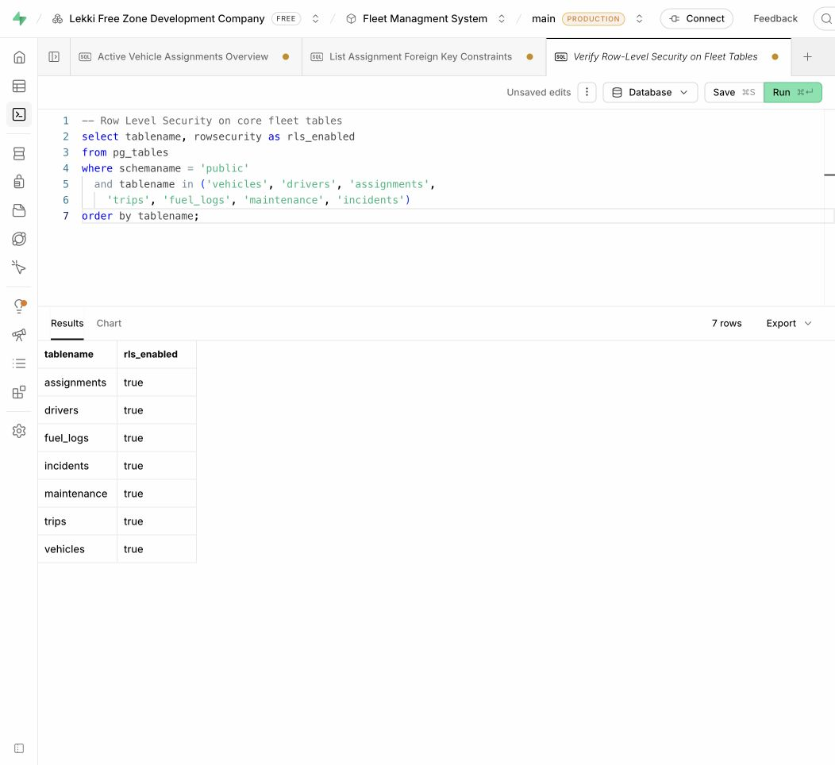
Figure 5.12: Hosted core-table Row Level Security flags
All seven inspected tables return true: assignments, drivers, fuel_logs, incidents, maintenance, trips and vehicles. This verifies that RLS is enabled on this subset of tables. It does not prove that each policy grants or denies the correct application role; authenticated role-by-role tests remain necessary.

CHAPTER SIX

TESTING AND EVALUATION
This chapter records the database verification strategy, representative results, restoration evaluation and limitations.

6.1 Verification Strategy
Verification distinguishes executed local SQL tests from controls that still require hosted integration testing. The Chapter Five walkthrough ran against seven core tables copied from the submission schema, with fictional fixtures and the vehicle timestamp trigger. Automated assertions checked CRUD, search, joins, aggregate totals, duplicate rejection, foreign keys, timestamp updates and delete behaviour. No live project records were changed.
The local engine does not reproduce Supabase Auth or Storage. Its owner-level SQL queries cannot establish whether an authenticated application role passes or fails an RLS policy. Those checks, and a full ten-script restoration, remain separate assessment steps. The test matrix therefore does not mark unexecuted security cases as passed.

6.2 Integrity and Security Tests
ID | Test | Expected result | Outcome
DB01 | Insert duplicate vehicle plate | Unique constraint rejects the row. | Local pass
DB02 | Insert trip with unknown vehicle | Foreign key rejects the row. | Local pass
DB03 | Delete driver referenced by incident | Incident remains and driver_id becomes null. | Local pass
DB04 | Update timestamped vehicle | updated_at advances after the update. | Local pass
DB05 | End user inserts vehicle | RLS rejects the operation. | Not run
DB06 | Editor inserts vehicle | RLS permits the operation. | Not run
DB07 | End user changes own role | Authorization trigger raises an exception. | Not run
DB08 | Editor uploads document object | Storage policy permits the insert. | Not run
DB09 | Editor deletes document object | Storage policy rejects deletion. | Not run
DB10 | Repeat notification delivery pair | Composite primary key rejects duplicate. | Not run
DB11 | Restore all ten scripts | Schema, policies and fixtures restore successfully. | Not run
DB12 | Final submission secret audit | No credentials or private tokens in the delivery. | Pending
DB13 | Create, read, search, update, delete | Stored values and row counts match each step. | Local pass
DB14 | Two fuel and two service entries | Fuel 50,000; maintenance 25,000; no duplication. | Local pass

6.3 Restoration Evaluation
The package is structured for a new Supabase project rather than a plain PostgreSQL server because profiles reference auth.users and the storage script references storage.objects. Scripts 01 through 09 establish the schema and security model; script 10 adds assessment data. Hosted Auth users must be created separately because password material is intentionally excluded.
The review corrected two order and security issues before this report was produced: document-type write policy creation now occurs after the role helpers exist, and Storage finishes with role-based write policies rather than a broader authenticated-user policy. Import batch creation is also restricted to record managers, and a trigger protects profile authorization fields.

6.4 Limitations
- The public documents bucket is convenient but unsuitable for confidential files without conversion to private signed URLs.
- Status values are mainly validated by the application rather than check constraints or lookup tables.
- Foreign-key indexes and reporting indexes should be selected using production query plans.
- Multi-step assignment and state synchronization are not yet encapsulated in database transactions.
- The package recreates schema and fictional rows but not hosted Auth accounts or binary Storage objects.

CHAPTER SEVEN

ADMINISTRATION AND RESTORATION GUIDE
This chapter explains safe handling, restoration, verification and routine maintenance for assessors and administrators.

7.1 Requirements and Safe Handling
- A Supabase project with access to its SQL Editor.
- The database-submission folder containing scripts 01 through 10.
- A test email address for any Auth account created after restoration.
- No .env.local file, service-role key, SMTP password or personal credential on the flash drive.

7.2 Restoration Procedure
- Create or select a new Supabase project and wait for the database to become available.
- Open the SQL Editor and run 01-schema.sql.
- Run scripts 02 through 07 in numeric order.
- Run 08-role-access-policies.sql to establish canonical roles and final table write access.
- Run 09-storage-documents.sql to create the bucket and final object policies.
- Run 10-sample-data.sql to load fictional demonstration records.
- Create at least one Auth user in Supabase Authentication.
- Insert a matching public.profiles row using the same Auth UUID and assign system_admin for assessment administration.
- Configure the frontend with the project URL and anonymous key, then sign in and verify the registers.

7.3 Verification and Maintenance
Check | Expected result
Tables | Fourteen public application tables are visible.
RLS | Enabled on every application table.
Roles | system_admin, editor and end_user are available.
Storage | documents bucket exists with authenticated read and role-based writes.
Sample data | Vehicle, driver and operational records load without real credentials.
Application | Dashboard and registers return data for a signed-in profile.
Security | An end_user cannot create records or change authorization fields.

Routine maintenance should include backup verification, review of slow queries, index evaluation, monitoring of connection usage, inspection of RLS changes and controlled testing of every migration in a non-production project before deployment.

CHAPTER EIGHT

CONCLUSION AND RECOMMENDATIONS
This chapter summarizes the database outcome and identifies the next improvements.

8.1 Conclusion
The database meets the project objective of centralizing LFZDC fleet records in a relational structure that preserves operational relationships and history. PostgreSQL constraints protect row identity and references, triggers maintain timestamps and authorization fields, and RLS separates read-only users from record managers and system administrators. Supabase provides the surrounding Auth, Storage and API services without changing the underlying relational model.
The ten-script submission package makes the implemented database inspectable and portable for academic assessment. Its fictional data supports meaningful reports and demonstrations without exposing organizational records or private credentials. The audit completed during documentation also improved restoration order and closed policy gaps that could otherwise weaken role separation.

8.2 Recommendations
- Convert the documents bucket to private access and issue short-lived signed URLs for sensitive files.
- Add check constraints or lookup tables for vehicle, driver, maintenance and incident statuses.
- Add measured indexes for foreign keys, dates, unread notifications and document expiry queries.
- Move assignment and synchronized state changes into transactional PostgreSQL functions.
- Add automated database tests for migrations, RLS policies and restoration scripts.
- Establish scheduled backups and perform periodic restoration drills in a separate project.

REFERENCES
[1] PostgreSQL Global Development Group. (2026). PostgreSQL 17 Documentation: Data Definition. https://www.postgresql.org/docs/17/ddl.html
[2] PostgreSQL Global Development Group. (2026). Constraints. https://www.postgresql.org/docs/17/ddl-constraints.html
[3] PostgreSQL Global Development Group. (2026). Row Security Policies. https://www.postgresql.org/docs/17/ddl-rowsecurity.html
[4] PostgreSQL Global Development Group. (2026). Indexes. https://www.postgresql.org/docs/17/indexes.html
[5] Supabase. (2026). Database Overview. https://supabase.com/docs/guides/database/overview
[6] Supabase. (2026). Row Level Security. https://supabase.com/docs/guides/database/postgres/row-level-security
[7] Supabase. (2026). Securing Your Data. https://supabase.com/docs/guides/database/secure-data
[8] Supabase. (2026). Storage Access Control. https://supabase.com/docs/guides/storage/security/access-control
[9] Supabase. (2026). Auth Architecture. https://supabase.com/docs/guides/auth/architecture
[10] Elmasri, R. and Navathe, S. B. (2016). Fundamentals of Database Systems. 7th ed. Pearson.
[11] Silberschatz, A., Korth, H. F. and Sudarshan, S. (2019). Database System Concepts. 7th ed. McGraw-Hill.
[12] LFZDC Fleet Management System database-submission package and backend documentation (project submission, 2026).

APPENDIX A: KEY DATA DICTIONARY
The SQL files remain the complete machine-readable definition of every column. This appendix summarizes the fields most important to identity, relationships, authorization, reporting and audit behaviour.
Table | Column | Type | Constraint | Meaning
profiles | id | uuid | PK/FK auth.users | Application user identity.
profiles | email | text | NOT NULL, UNIQUE | Account email.
profiles | role | app_role | NOT NULL | Authorization role.
profiles | settings | jsonb | DEFAULT '{}' | User preferences.
vehicles | id | text | PK | Vehicle identifier.
vehicles | plate_number | text | NOT NULL, UNIQUE | Registration plate.
vehicles | status | text | NOT NULL | Operational lifecycle state.
vehicles | current_odometer | integer | Nullable | Latest accepted mileage.
vehicles | next_service_due_odometer | integer | Nullable | Mileage-based service threshold.
drivers | id | text | PK | Driver identifier.
drivers | license_number | text | NOT NULL | Driving licence reference.
drivers | license_expiry | date | NOT NULL | Licence expiry date.
assignments | vehicle_id | text | FK vehicles | Assigned vehicle.
assignments | driver_id | text | FK drivers | Assigned driver.
assignments | end_date | date | Nullable | Null indicates active assignment.
fuel_logs | liters | numeric(10,2) | NOT NULL | Fuel volume.
fuel_logs | cost | numeric(12,2) | NOT NULL | Fuel transaction cost.
fuel_logs | odometer | integer | NOT NULL | Mileage at fueling.
maintenance | status | text | NOT NULL | Service workflow state.
maintenance | scheduled_date | date | NOT NULL | Planned service date.
maintenance | cost | numeric(12,2) | NOT NULL | Estimated or recorded cost.
incidents | driver_id | text | FK drivers, nullable | Associated driver when known.
incidents | severity | text | NOT NULL | Incident severity.
incidents | attachments | jsonb | Nullable | Attachment metadata.
trips | distance | numeric(10,2) | NOT NULL | Journey distance.
documents | vehicle_id | text | FK vehicles, nullable | Related vehicle.
documents | driver_id | text | FK drivers, nullable | Related driver.
documents | file_path | text | Nullable | Storage object path.
documents | expiry_date | date | Nullable | Document expiration.
document_types | name | text | NOT NULL, UNIQUE | Category name.
document_types | applies_to | text | CHECK | vehicle, driver or both.
notifications | is_read | boolean | DEFAULT false | Read status.
notifications | vehicle_id | text | FK vehicles, nullable | Related vehicle.
notifications | driver_id | text | FK drivers, nullable | Related driver.
notification_email_deliveries | notification_id | text | Composite PK/FK | Delivered notification.
notification_email_deliveries | profile_id | uuid | Composite PK/FK | Recipient profile.
vehicle_odometer_logs | reading | integer | NOT NULL | Recorded mileage.
vehicle_odometer_logs | source | text | NOT NULL | manual, trip, fuel or maintenance.
import_batches | created_counts | jsonb | DEFAULT '{}' | Created rows by entity.
import_batches | issues | jsonb | DEFAULT '[]' | Row-level validation issues.
import_batches | sheet_summaries | jsonb | DEFAULT '[]' | Per-sheet import outcome.

APPENDIX B: RESTORATION SCRIPT MANIFEST
File | Creates or changes | Depends on
01-schema.sql | Core schema and read access | Supabase auth schema
02-vehicle-odometer.sql | Mileage field and log table | vehicles
03-vehicle-service-mileage.sql | Service mileage field | vehicles
04-document-types.sql | Document category table | pgcrypto extension
05-document-file-path.sql | Document object path | documents
06-profile-settings.sql | Profile JSONB settings | profiles
07-notification-email-deliveries.sql | Delivery audit table | notifications, profiles
08-role-access-policies.sql | Roles, safeguards and final writes | all application tables
09-storage-documents.sql | Bucket and object policies | Storage schema, role helpers
10-sample-data.sql | Fictional operational rows | scripts 01 through 09

The scripts are idempotent where practical through IF NOT EXISTS, DROP POLICY IF EXISTS and ON CONFLICT clauses. They should still be tested in a fresh project before assessment because enum additions and data migrations are state-dependent operations.

APPENDIX C: SAMPLE SQL QUERIES

C.1 List Active Vehicles and Current Drivers
select v.plate_number, v.brand, v.model, d.full_name
from public.vehicles v
left join public.drivers d on d.id = v.current_driver_id
where v.status = 'Active'
order by v.plate_number;

C.2 Monthly Fuel Cost by Vehicle
select v.plate_number, sum(f.cost) as monthly_fuel_cost
from public.fuel_logs f
join public.vehicles v on v.id = f.vehicle_id
where f.date >= date_trunc('month', current_date)::date
group by v.id, v.plate_number
order by monthly_fuel_cost desc;

C.3 Outstanding Maintenance
select v.plate_number, m.service_type, m.status, m.scheduled_date, m.cost
from public.maintenance m
join public.vehicles v on v.id = m.vehicle_id
where m.status in ('Scheduled', 'In Progress', 'Overdue')
order by m.scheduled_date;

C.4 Expiring Driver Licences
select full_name, license_number, license_expiry
from public.drivers
where license_expiry between current_date and current_date + interval '90 days'
order by license_expiry;

C.5 Suggested Indexes for Future Tuning
These optional statements are recommendations, not changes applied by the submission scripts. Test query plans before introducing them.
create index if not exists idx_fuel_logs_vehicle_date
on public.fuel_logs (vehicle_id, date desc);
create index if not exists idx_documents_expiry
on public.documents (expiry_date)
where expiry_date is not null;

