
LAGOS STATE UNIVERSITY

SIWES TECHNICAL REPORT
STUDENTS INDUSTRIAL WORK EXPERIENCE SCHEME
UNDERTAKEN AT
LEKKI FREE ZONE DEVELOPMENT COMPANY
IT UNIT
2 MARCH TO 2 SEPTEMBER 2026
BY
ANYASI BOLUATIFE ANTHONY
MATRICULATION NUMBER 230591045
SUBMITTED TO
DEPARTMENT OF COMPUTER SCIENCE
FACULTY OF COMPUTING
LAGOS STATE UNIVERSITY OJO
IN PARTIAL FULFILMENT OF THE REQUIREMENTS FOR
THE AWARD OF BACHELOR OF SCIENCE IN COMPUTER SCIENCE
Submission date __________________________

DECLARATION
I, Anyasi Boluatife Anthony, with matriculation number 230591045, declare that this report describes my industrial training in the IT Unit of Lekki Free Zone Development Company from 2 March to 2 September 2026. It presents the activities I carried out, the work I assisted with and the knowledge I acquired during the attachment.
External material used for the background of SIWES and the company profile is acknowledged in the references. Practical accounts are written from my training experience, while application screenshots illustrate the documented version of my Fleet Management System.
Student signature _______________________ Date _______________________

SUPERVISOR CONFIRMATION
Academic supervisor name ____________________________________________
Signature ______________________________ Date _______________________

DEDICATION
I dedicate this report to my family and everyone who supported my education and encouraged me throughout my industrial training. Their support helped me remain committed to learning and completing the responsibilities assigned to me.

ACKNOWLEDGEMENTS
I appreciate the management of Lekki Free Zone Development Company for accepting me for industrial training and giving me the opportunity to work within its IT Unit.
I thank my industry supervisor and the members of the IT team for their guidance, practical explanations and support. Working alongside them helped me understand how technical decisions affect staff, equipment and the daily activities of an organisation. I also appreciate the colleagues and technicians who allowed me to observe their work, ask questions and participate in assigned tasks.
I acknowledge the Department of Computer Science, Faculty of Computing, Lagos State University, and the SIWES coordinators for facilitating the industrial attachment. I thank my family and friends for their encouragement throughout the six-month period.

ABSTRACT
This report presents my six-month Students Industrial Work Experience Scheme attachment in the IT Unit of Lekki Free Zone Development Company, Lagos, from 2 March to 2 September 2026. My work combined technical support, networking, hardware troubleshooting, documentation, interface design and software development. I participated in access-point and network-switch activities, CCTV installation and inspection, printer diagnosis, computer setup, storage replacement and data recovery. I also prepared technical reports and procurement memos and contributed to the company website redesign.
A major part of the training was the development of a Fleet Management System. I gathered requirements from the Administration Department, designed interfaces in Figma and implemented the frontend using React, TypeScript and Tailwind CSS. Supabase supported the backend and database. The project helped me connect requirements, interface design, record management and testing within one application. The company began using the system before the end of my attachment.
The training improved my ability to investigate faults systematically, explain technical issues to users, document work and balance a development project with routine support requests. This report discusses the work performed, its relationship to Computer Science, the challenges encountered and recommendations for future training.

TABLE OF CONTENTS
CHAPTER ONE INTRODUCTION 1
1.1 Background of SIWES 1
1.2 Purpose of My Attachment 1
1.3 Responsibilities During Training 2
1.4 Scope of This Report 2
CHAPTER TWO COMPANY PROFILE 3
2.1 Background of LFZDC 3
2.2 The IT Unit 3
2.3 Organisational Structure 4
CHAPTER THREE INDUSTRIAL EXPERIENCE 5
3.1 Orientation and Infrastructure 5
3.2 Networking and Connectivity 6
3.3 CCTV and Telephone Support 8
3.4 Computer Hardware and System Support 9
3.5 Printer Diagnosis and Repair Support 11
3.6 Documentation and Vendor Communication 12
3.7 Website Redesign and Interface Design 13
3.8 Programming and Independent Learning 14
3.9 Fleet Management System 15
3.10 Relationship to Computer Science 21
3.11 Professional Skills Acquired 22
CHAPTER FOUR EVALUATION AND CONCLUSION 23
4.1 Summary of Experience 23
4.2 Challenges Encountered 23
4.3 Recommendations 25
4.4 Conclusion 26
REFERENCES 27
APPENDIX A PHOTOGRAPHIC RECORD 28

LIST OF FIGURES
Figure 2.1 Indicative organisational structure and IT reporting line
Figure 3.1 Fleet overview dashboard
Figure 3.2 Vehicle entry form before data entry
Figure 3.3 Completed vehicle entry form
Figure 3.4 Saved vehicle in the register
Plates A.1-A.9 Photographic record (Appendix A, pages 28-33)

ABBREVIATIONS
Term | Meaning
AP | Access point
CCTV | Closed-circuit television
CSS | Cascading Style Sheets
ERP | Enterprise Resource Planning
FMS | Fleet Management System
HTML | Hypertext Markup Language
ICT | Information and Communication Technology
ITF | Industrial Training Fund
LFZDC | Lekki Free Zone Development Company
SIWES | Students Industrial Work Experience Scheme
SSD | Solid-state drive
UI and UX | User Interface and User Experience

CHAPTER ONE

INTRODUCTION
CHAPTER ONE: INTRODUCTION
1.1 Background and Evolution of SIWES
The early phase of science and technology education in Nigeria was characterized predominantly by theoretical lectures in universities and polytechnics. This instructional approach proved insufficient, as students frequently graduated with little or no technical experience in their fields of study, which hampered the technological advancement and economic development of the country. Industrialists and employers increasingly expressed concern that graduates lacked the adequate practical experience needed to operate and maintain resources effectively in the workplace, noting that academic theory did not sufficiently address labor needs. To address this critical gap between academic learning and the practical demands of employment, the Industrial Training Fund (ITF) established the Students Industrial Work Experience Scheme (SIWES) in 1973.
The program officially commenced in 1974 with an initial intake of 748 students drawn from 11 institutions of higher learning. As the industrial value of the program became evident, participation expanded rapidly, reaching approximately 5,000 students from 32 tertiary institutions by 1978. During its early stages, SIWES was solely funded by the ITF. However, due to economic stress and financial constraints in 1978, the ITF temporarily withdrew its funding support. Consequently, the Federal Government intervened, sharing the responsibility and entrusting the management of the scheme to the National Universities Commission (NUC) and the National Board for Technical Education (NBTE) between 1979 and 1984. Recognizing the paramount importance of skills training, the Federal Government fully reassigned the management and implementation of SIWES back to the ITF in November 1984, with funding borne directly by the government. Between 1985 and 1995, the scheme grew to encompass 141 institutions and 57,433 students, and it continues to expand to this day.
1.2 The Significance of SIWES: Integrating Theory and Practice
In today's dynamic work environment, theoretical knowledge alone is insufficient to prepare individuals for the challenges they will encounter. An educated professional must possess a combination of "know-how" ability (theoretical knowledge) and "do-how" ability (practical skills). True education encompasses both elements, allowing students to apply their theoretical understanding to real-world scenarios through industrial training. This holistic approach is particularly crucial for individuals pursuing careers in Science, Engineering, and Technology (SET) disciplines, where the complexity and dynamic nature of the fields demand adaptability and practical problem-solving skills. By integrating theory with practice, SIWES cultivates a mindset of continuous learning, empowers students to remain competitive, and equips them to directly contribute to the production of goods and services in the economy.

1.3 Bodies Involved in the Management of SIWES
The successful administration of SIWES relies on a cooperative framework involving the Federal Government, the ITF, supervisory agencies, and training institutions.
- The Federal Government: Mandates all ministries, companies, and parastatals to offer places of attachment for students in accordance with the provisions of Decree No. 47 of 1971, which was amended in 1990. The government also provides necessary and adequate funds to the ITF through the federal ministries of industries to sustain the scheme.
- The Industrial Training Fund (ITF): Acts as the primary managerial body, providing the logistics and materials needed to administer the scheme. The ITF establishes policies, supervises students through its Area offices, processes logbooks, and ensures the payment of allowances to students and supervisors.
- Supervising Agencies (NUC, NBTE, NCCE): Accredit SIWES units within approved institutions, formulate guidelines for participating bodies, and collaborate with the ITF to oversee the scheme's execution across universities, polytechnics, and colleges of education.
- Educational Institutions: Appoint SIWES coordinators, prepare students for attachment, supervise them at their workplaces, and grade their logbooks and technical reports.
- Employers of Labour: Accept trainees and provide a practical learning environment, enlisting industry supervisors to monitor students' daily activities, work methods, and technical progress.
1.4 Aims, Objectives, and Benefits of SIWES
The overarching objective of SIWES is to foster effective production within specific disciplines by preparing students for the industrial work environments they will face upon graduation. The specific aims and benefits include:
- Providing an avenue for students to acquire industrial skills and practical experience relevant to their academic disciplines.
- Bridging the gap between theoretical classroom education and the practical demands of the professional workplace.
- Exposing students to advanced work methods, techniques, state-of-the-art equipment, and machinery that may not be available within their educational institutions.
- Enhancing students' contacts with potential employers during their training, thereby facilitating networking and increasing their chances of job placement after graduation.
- Helping students appreciate the practical role their professions play in society and national development.
- Nurturing the development of critical intellectual skills, such as problem-solving and analytical abilities, required to tackle complex field challenges.
- Strengthening the active involvement of employers in the educational process, ensuring that academic programs align with the current needs of the job market.
1.5 Significance of SIWES to Computer Science Education
For a Computer Science student, industrial training extends far beyond writing software programs. It provides opportunities to understand how an IT team supports a working organization, involving tasks such as maintaining computers, investigating network problems, protecting information, and supporting everyday users. A placement setting, such as the Lekki Free Zone Development Company (LFZDC), demonstrates why organizations depend on reliable IT services for basic operations, even if their principal business is not software development. Staff rely heavily on connectivity, communications, surveillance, and accurate records; thus, the training bridges the gap between studying algorithms or networks in a classroom and actually restoring a service that enables an entire office to continue working.
1.6 Purpose of My Attachment and Scope of This Report
I undertook this attachment as a 300-level Computer Science student of Lagos State University, stationed at the IT Unit of LFZDC from 2 March to 2 September 2026. My main objective was to apply my classroom studies to real tasks, become more confident in investigating faults, communicate effectively with users, and develop a useful software system. During this six-month period, my responsibilities developed from orientation and supervised infrastructure tasks into independent support, equipment documentation, and the complete development of a digital Fleet Management System.
This report outlines the experience comprehensively. Chapter Two introduces the company profile and IT Unit structure. Chapter Three details my practical work across networking, CCTV and telephony support, hardware maintenance, interface design, and software programming. Chapter Four evaluates the experience, outlines challenges encountered, and presents recommendations for future training.

1.7 Purpose of My Attachment
I undertook the attachment as a 300-level Computer Science student of Lagos State University. My main objective was to apply what I had studied to real tasks and understand how an IT team supports a working organisation. I wanted to become more confident in investigating faults, communicating with users and developing a useful software system.
The placement lasted from 2 March to 2 September 2026. Over this period, my responsibilities developed from orientation and supervised participation into more independent support, documentation and project work. I still needed guidance when an issue exceeded my experience, but I became better at recognising what to check and what information to report.

1.8 Responsibilities During Training
My responsibility as a trainee was to learn from assigned work, follow the direction of the IT team and keep an accurate record of my activities. I was expected to treat staff equipment and information carefully, seek clarification when necessary and avoid making unsupported assumptions about a fault.
The employer provided a workplace in which I could observe and participate in IT activities. Supervision helped connect individual tasks to the organisation's priorities. For example, restoring connectivity was not simply a networking exercise: it enabled a member of staff or an office to continue working.
The university provided the academic context for the attachment and the requirement to document the experience. The logbook helped me record tasks and reflect on what I had learned. This report draws those activities together by technical area rather than repeating every daily entry.

1.9 Scope of This Report
Chapter Two introduces LFZDC, the IT Unit and the reporting structure relevant to my placement. Chapter Three explains my work in networking, surveillance support, hardware, printers, documentation, website design and software development. Chapter Four evaluates the experience and presents challenges, recommendations and conclusions.
The report distinguishes work I performed from work I assisted with or observed. The Fleet Management System figures show the application as documented in September 2026, after the attachment period, using fictional demonstration records. They explain the software workflow rather than serving as dated photographs of activities during the placement.
CHAPTER TWO

COMPANY PROFILE

2.1 Background of LFZDC
Lekki Free Zone Development Company was established in May 2006 as a joint venture involving Chinese investors, the Lagos State Government and Lekki Worldwide Investments Limited. The company develops, operates, administers and manages the south-west quadrant of the Lekki Free Zone (LFZDC, n.d.-a).
The company is located at Lekki Free Zone, opposite Tiye Town, Akodo Road, off the Lekki-Epe Coastal Road, Lagos. Its stated direction emphasises attracting investment, supporting export activity and employment, and providing a business environment for economic development (LFZDC, n.d.-a).
This setting helped me understand why a zone-development company needs reliable IT services even though its principal business is not software development. Staff depend on computers, connectivity, communications, surveillance and accurate records to carry out their work. Faults in these services can affect activities across departments.

2.2 The IT Unit
I was attached to the IT Unit. My experience in the unit included user support, network troubleshooting, computer and printer maintenance support, CCTV-related activities, equipment documentation and contributions to digital projects.
The unit interacted with other departments when faults were reported or requirements had to be clarified. For the Fleet Management System, I obtained requirements from the Administration Department so that the application would address the way fleet information was actually managed. This interaction was as important as the technical implementation because it helped me identify the information users needed to enter and retrieve.

2.3 Organisational Structure
The company structure includes a Managing Director and controller-level management. The company website identifies Managing Director and Commercial Controller roles (LFZDC, n.d.-b). Figure 2.1 provides an indicative wider structure using the controller and staff levels described during preparation of this report.
Within my placement area, the Head of IT reports to the Head of Administration, who reports to the Administrative Controller. This IT reporting chain is confirmed. The wider diagram is not an official organogram; departmental titles, staff grades and reporting allocations outside this chain require company confirmation.
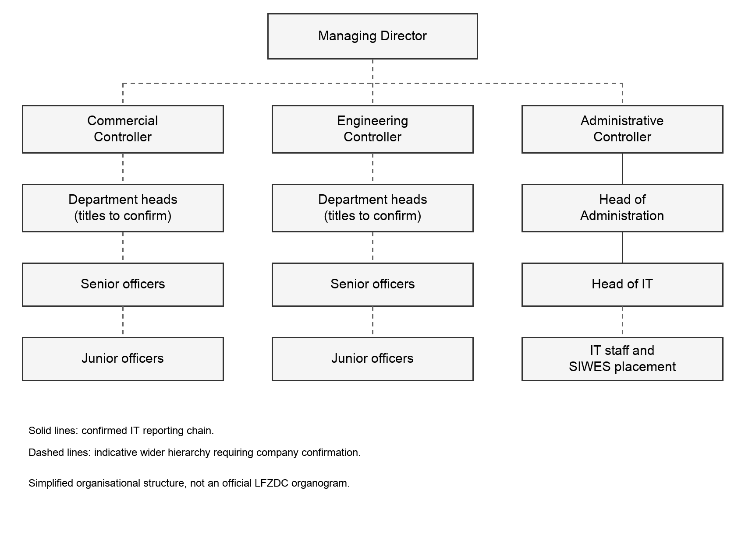
Figure 2.1 Indicative organisational structure with the confirmed IT reporting chain
CHAPTER THREE

INDUSTRIAL EXPERIENCE

3.1 Orientation and Infrastructure
My first day involved brief onboarding and an introduction to the team. The orientation became more detailed as I was shown the infrastructure supporting the organisation. This included Fortinet firewall and security equipment, networking, IP addressing, server infrastructure and data-backup arrangements.
I was also introduced to policies relating to cybersecurity, email, CCTV and data backup. The experience helped me understand that technical infrastructure operates alongside rules about how it should be used. A working device or connection is only one part of a reliable IT service; access, continuity and responsible handling of information also matter.
The introduction provided context for later tasks. When I encountered connectivity problems, I could begin to relate the user's complaint to a device, cable, wireless connection or upstream service rather than treating the network as a single item. I did not independently administer every system I was shown, but the exposure helped me understand the responsibilities of the unit.

3.1.1 Exposure to the Smart Zone Project
I attended presentations and meetings about the proposed Smart Zone project, which concerned moving manual processes towards more digital operations using ERP systems. The presentations introduced me to modules, layered systems and phased implementation.
These discussions showed me why organisations usually begin with requirements and implementation planning rather than immediately building every feature. I became interested in how an individual ERP module could be developed, and this led to further research into fleet management as a focused software project.

3.2 Networking and Connectivity

3.2.1 Network Switch and Access Point Work
Early in the attachment, I participated in replacing a network switch to support additional access-point connections. This gave me practical exposure to the relationship between wired network equipment and the wireless devices that serve users.
On another occasion, two access points repeatedly went offline. A network service provider attended to the problem, and I assisted with replacing and reconnecting the affected equipment. Working with the technicians helped me observe how a reported connectivity fault is investigated before equipment is replaced.
I also assisted when a guest could not obtain internet access. We checked the connection, considered whether the RJ45 termination needed attention and tested whether power was reaching the equipment through the cable. The access point was identified as the problem, and I removed and replaced it. The task reinforced the need to distinguish a cable or power fault from a faulty endpoint.

3.2.2 Wireless Radio and Internet Service Faults
I took part in troubleshooting a case in which the internet connection was not communicating properly through the radio link. The radio and access points had to be reconfigured. This helped me understand that a local wireless network can appear available while the connection beyond it is still faulty.
In a separate building, a Starlink connection stopped providing internet access. We investigated the fault and eventually restored service by restarting the equipment. I learned that a simple recovery step can resolve a particular incident, but it should not be confused with proof of the underlying cause or treated as the solution to every network problem.

3.2.3 RJ45 Cable Recrimping
I was assigned to investigate a network cable that was not transmitting a signal to an access point. The connection had become loose at the RJ45 termination. I recrimped the cable, reconnected it and tested the link to confirm that communication with the access point had been restored.
The task connected a physical fault to a service-level symptom. To the user, the issue was a lack of connectivity. At the equipment level, the problem was an unreliable termination. This helped me appreciate why physical checks should form part of troubleshooting before more complicated configuration changes are considered.
A cable termination must hold its conductors securely and maintain the required connection arrangement. My practical learning was to treat the connector and cable as part of the network, not as accessories that could be ignored once the equipment was powered on. Successful troubleshooting ended with testing, not just with replacing the connector.

3.2.4 Lessons From Network Support
Across these tasks, I became more systematic in identifying the scope of a fault. I learned to ask whether one user, one access point or an entire area was affected. The answer helped narrow the investigation and made it easier to communicate useful information to the team.
I also learned to separate observations from conclusions. A device that cannot reach the internet is an observation; a failed access point is a conclusion that needs support. This distinction reduced guesswork and improved the way I explained problems to colleagues.

3.3 CCTV and Telephone Support

3.3.1 CCTV Installation and Inspection
I participated in CCTV installation work in a new area of the zone. My involvement included assisting with drilling, wiring and connections, and overseeing parts of the work as the cameras were mounted in their intended positions. The installation continued across more than one day.
After installation, I inspected the camera positioning to assess whether the cameras were suitably placed for surveillance. I also prepared a memo requesting a broader assessment of CCTV equipment at the staff camp and standard factory.
On another occasion, I supervised the installation of SIM cards in CCTV cameras intended for remote viewing and monitoring. This exposed me to the way surveillance equipment can depend on communications services as well as power and correct installation. I did not design a new surveillance network; my contribution was practical participation, inspection and documentation of assigned work.

3.3.2 Telephone Cabling
I inspected offices to identify telephones that were not working. I later supervised the reclipping and rerouting of telephone cables as part of the corrective work. The experience showed me that communications faults may arise from the physical cable route or connection rather than from the telephone itself.
Both the CCTV and telephone activities helped me connect Computer Science knowledge with physical infrastructure. Networked and communications systems depend on installation quality, reliable connections and accurate reporting of where a problem occurs.

3.4 Computer Hardware and System Support

3.4.1 Replacing a Faulty SSD
I replaced the SSD in a laptop whose storage device had failed. The task gave me practical experience with a component that directly affects whether a computer can store information and operate reliably.
The main lesson was that a visible software symptom can have a hardware cause. Reinstalling or repairing an application will not resolve every problem if the underlying storage is unreliable. I became more aware of the need to identify the faulty component before choosing a remedy and to handle internal parts carefully during maintenance.

3.4.2 Recovering Data From a Damaged Desktop
I worked on recovering files from a damaged desktop computer. I opened the system unit and connected its storage to another computer so that the files could be accessed. This helped me distinguish between a computer that no longer functions as a complete system and a storage device that may still contain accessible data.
The task strengthened my understanding of data as an asset separate from the original machine. It also showed why backup arrangements are important: attempting recovery after a failure is different from having a dependable copy available before the failure occurs. Access to another person's files must remain limited to the support task and handled responsibly.

3.4.3 Provisioning New Laptops
I set up three new laptops during the attachment. This involved preparing the systems for their intended users, including the required software and drivers. The work showed me that equipment delivery does not mean a device is ready for productive use.
A useful setup process has to consider the user's needs and the working environment. I learned to pay attention to whether the required programs could run and whether the computer could be used for its assigned purpose. Consistency also matters when preparing several computers, because overlooked setup differences can create avoidable support requests later.

3.4.4 Applications and Display Problems
I assisted a member of staff whose laptop applications failed to start. I investigated the affected applications and carried out repairs and troubleshooting to restore their operation. I also resolved a display-connection problem after identifying its cause.
These tasks required me to listen to the user's description, inspect the reported behaviour and check whether the problem was limited to one application or connection. I learned that a user may describe several different faults with the same phrase, such as the computer not working. Clarifying the actual symptom is an important part of technical support.
I was also assigned to restore access to a PC after its password had been forgotten. This was a support task undertaken on request, not a reason to weaken normal access controls. It reinforced the importance of confirming authority before working on access-related problems.

3.5 Printer Diagnosis and Repair Support

3.5.1 Routine Printer Support
I attended to printer problems reported by staff, including unresponsive printing, connection difficulties and driver-related issues. I also troubleshot a Brother printer that was not operating correctly.
Printer support helped me understand the interaction between hardware, the computer, installed drivers and the connection between them. A printer may be physically present and powered on while the computer still cannot use it correctly. I therefore learned not to treat every failed print request as a mechanical fault.

3.5.2 Inspection of Printers in the Admin Building
I was assigned to inspect the printers in the Admin Building, diagnose their faults and compile a detailed report for the repair technician. The purpose was to provide an organised account of the equipment requiring attention rather than passing on vague complaints.
This task required both observation and communication. I had to distinguish the reported symptom from what I could establish during inspection and document the information in a form that another person could use. A useful technical report should make the next step clearer, including which device needs attention and what problem has been observed.
When the technician later attended to the printers, I supervised the repair work and followed the process. I learned more about printer components and the practical diagnosis of faults. This linked the original inspection, written report and eventual corrective work into one complete support activity.

3.6 Documentation and Vendor Communication

3.6.1 Internal Memos
One of my early tasks was learning to prepare an internal memo for the repair of a laptop keyboard and a desktop screen. I later prepared memos relating to a new desktop, replacement UPS batteries, a Starlink router and the purchase of two printers.
The work taught me to explain a technical need in terms that could support a decision. A memo should identify the problem or requirement, explain why action is needed and make the requested action clear. It is different from a troubleshooting note: its reader may need to approve a purchase or repair rather than perform the work personally.
For the purchase of two printers, I contacted vendors, obtained quotations and prepared the memo with supporting information. This gave me experience communicating requirements outside the IT team and organising information for consideration. My involvement did not mean that I independently approved purchases.

3.6.2 Vendor Records and Accountability
I introduced a digital vendor-management form for the IT division to support a more structured record of vendors supplying hardware and related services. The intention was to improve organisation and accountability in the way vendor information was handled.
Together with the printer assessment report, these activities showed me that documentation is part of an IT solution, not something added only after the technical work. Clear records help a colleague understand what has happened, what is required and which information supports the request.

3.7 Website Redesign and Interface Design

3.7.1 LFZDC Website Work
I contributed to the company website redesign by working on interface mock-ups. Specific pages included About Us, Management Profile and the LFZ Master Plan. I also gathered and organised information from the existing website for the redesign work.
Later in the attachment, I reviewed proposed website designs and provided feedback from a UI and UX perspective. I attended a management review meeting and took notes on the comments and preferred direction. This showed me how design decisions are affected by the organisation's priorities as well as by the designer's preferences.
My contribution was not to claim responsibility for the entire company website. I worked on assigned designs, content organisation and review activities. These tasks helped me think about navigation, the order in which information appears and whether the purpose of a page is clear to its audience.

3.7.2 Figma and Visual Communication
I used Figma to work on application interfaces, dashboard layouts and data visualisation. Some design practice was independent learning rather than a commissioned company deliverable. It still helped me build skills that I could apply to the Fleet Management System.
The experience taught me to make a distinction between a visually attractive screen and a usable workflow. A user needs to know where to begin, what information to provide, whether an action succeeded and how to return to the record afterwards. These questions became important when I moved from static mock-ups to a working application.

3.8 Programming and Independent Learning

3.8.1 Web Foundations
During the attachment, I studied HTML and CSS alongside my practical work. The topics included headings, paragraphs, links, images, formatting, quotations, comments, tables, lists, classes, IDs, buttons and iframes. I also learned the difference between relative and absolute URLs and the different ways CSS can be applied.
These topics helped me understand the structure beneath a webpage. They were useful when I reviewed website content and later built application interfaces. A design tool shows how a screen should look, while implementation requires decisions about structure, styling and behaviour.
I also spent time learning programming concepts and TypeScript while developing my frontend skills. Applying the learning to the fleet project was more useful than studying every topic in isolation because I could see how a type, component or state change affected a real screen.

3.8.2 Introductory AI and Machine Learning Study
I undertook introductory learning on artificial intelligence and machine learning. Topics included training data, categories of machine learning, inference, neural networks, computer vision, natural language processing and foundation models.
I also learned about stages in a foundation-model lifecycle, including data selection, pretraining, optimisation, evaluation, deployment and feedback. This was a learning activity, not a claim that I trained or deployed a machine-learning system at LFZDC. It broadened my understanding of the field while my main implemented project remained the Fleet Management System.

3.9 Fleet Management System

3.9.1 Problem Definition and Requirements
The Fleet Management System became the main software project of my attachment. My interest developed from the Smart Zone discussions and research into individual ERP modules. I began by gathering requirements from the Administration Department to understand the information it needed to manage about the fleet.
The project brought together vehicles, drivers and operational records such as trips, fuel and maintenance. The purpose was to organise related information in one application and make records easier to enter, retrieve and review. Understanding those relationships was necessary before deciding what the interface should contain.
Requirements gathering changed the way I approached development. Instead of beginning with a dashboard simply because it looked impressive, I had to consider what users would do with it. A useful summary depends on meaningful underlying records, and those records depend on forms that collect the right information.

3.9.2 Wireframes and Interface Development
I first developed low-fidelity wireframes for the different screens, then progressed to more detailed Figma mock-ups. After the initial dashboard design, I worked on the other pages and features so that the application would function as a connected system rather than a single polished screen.
As the project developed, I reviewed spacing, navigation, forms and the presentation of records. The implementation required further adjustments because a static design does not fully show loading behaviour, validation messages or how a screen changes after a record is added.

3.9.3 Frontend and Backend Implementation
I implemented the frontend using React, TypeScript and Tailwind CSS. React supported the interface components, TypeScript helped describe the expected data and Tailwind CSS supported layout and styling. Working on the application helped me practise reusable components rather than rebuilding the same control independently on every page.
I used Supabase for the backend and database. Connecting the interface to stored records moved the project beyond temporary values shown only in the browser. Record creation, retrieval and updates had to work with the database and be reflected correctly in the interface.
The project also involved authentication and access control so that access to information and administrative actions could be managed. I learned that displaying or hiding an interface control is not the same as enforcing a permission at the backend. These concerns had to be considered as part of the system rather than as cosmetic additions.

3.9.4 Testing and Completion
Testing and refinement formed part of development rather than a single final task. I worked through interface inconsistencies, responsiveness issues and application behaviour while continuing with routine IT support responsibilities.
I completed the system before the end of the attachment, and the company began using it. This was important because it connected my design and programming work to a real organisational need. Further refinements and documentation continued afterwards; the following figures show the September 2026 documentation version, not a claim that every later interface refinement existed on the final day of SIWES.

3.9.5 Dashboard and Operational Overview
The dashboard brings together fleet status and operational summaries. Its purpose is to help users identify information worth investigating, while the individual registers retain the underlying records. Figures 3.1 to 3.4 use fictional demonstration data from the software documentation.
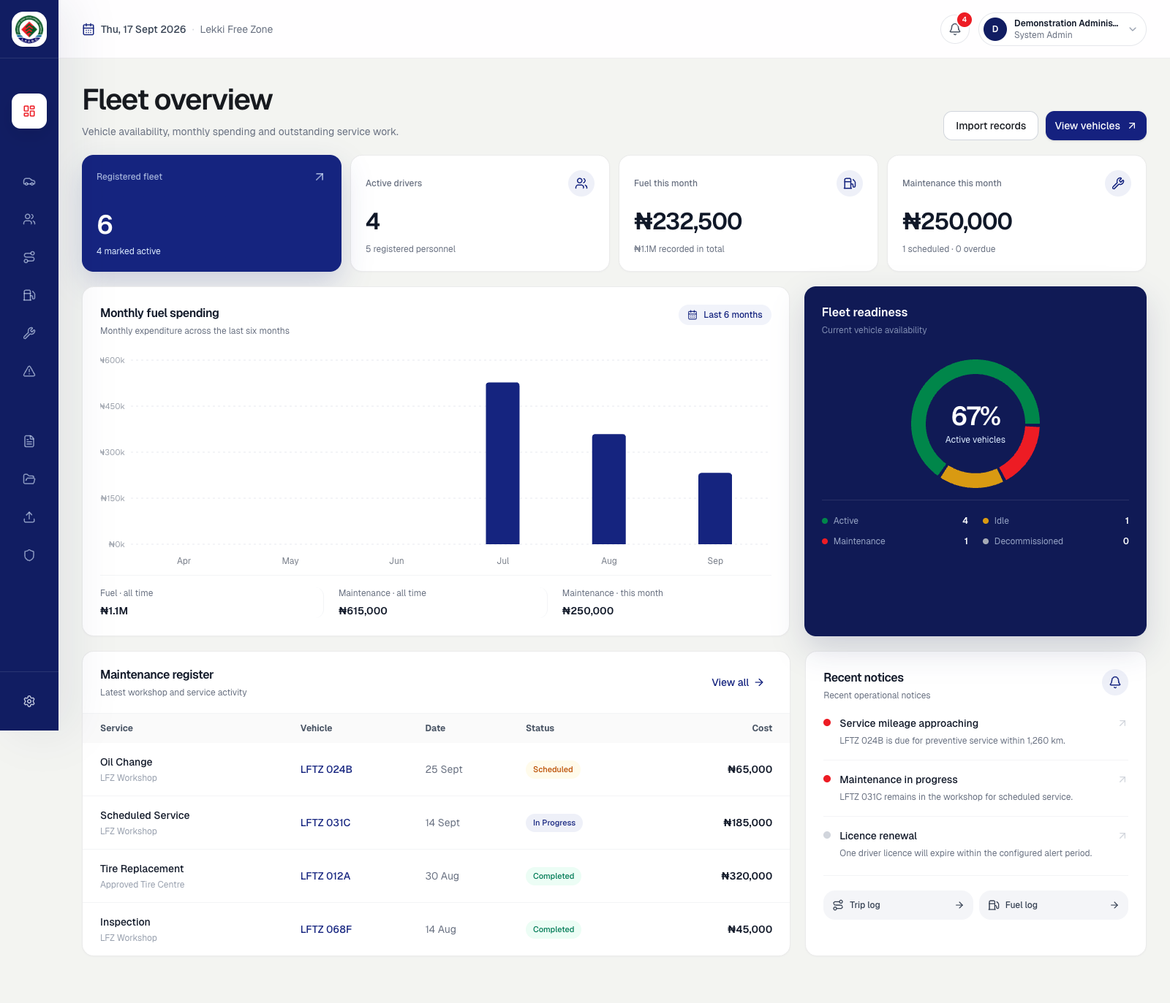
Figure 3.1 Fleet overview dashboard in the September 2026 documentation version
Designing this screen helped me practise information hierarchy. A summary should be understandable at a glance, but users also need a clear route to the detailed records behind it.

3.9.6 Adding a Vehicle
The vehicle workflow begins in the vehicle register. Selecting Add Vehicle opens a form for the new record. The form makes the main fields visible and separates additional details so that a user is not faced with every possible field at once.
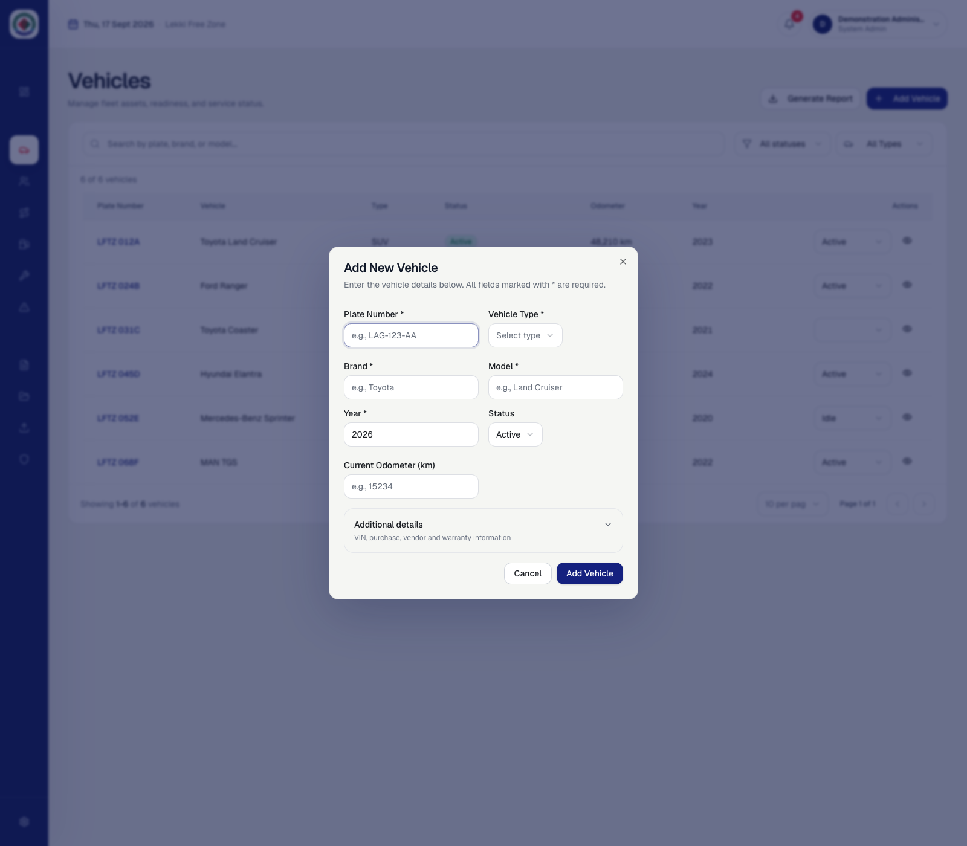
Figure 3.2 Vehicle entry form before data entry using demonstration records
The form illustrates the relationship between interface design and data quality. Clear field labels, required information and appropriate feedback help users understand what is needed before they submit a record.

3.9.7 Completing and Saving the Record
The user supplies the vehicle details and reviews the additional information before saving. The example below shows a completed form. After submission, the saved vehicle should appear in the register, completing the transition from data entry to retrieval.
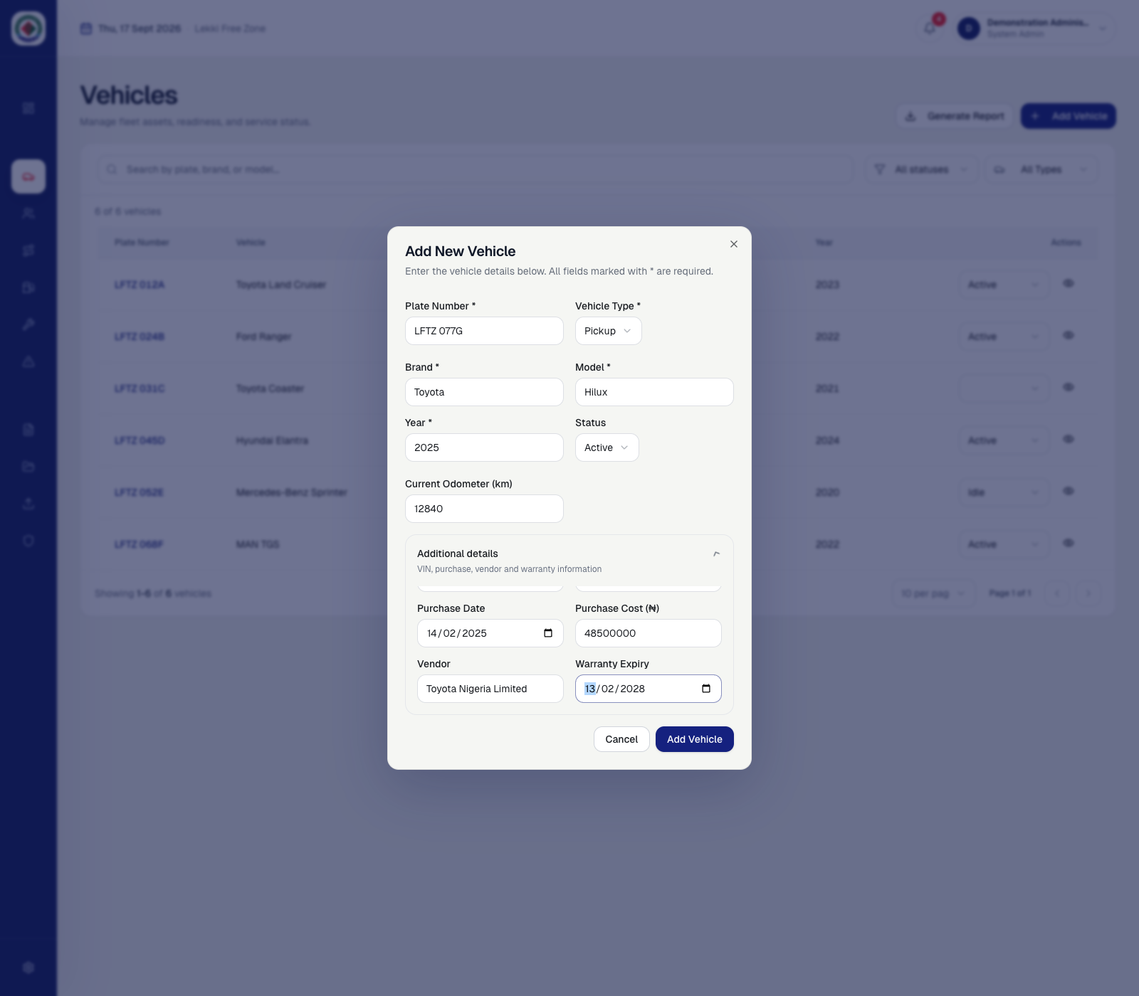
Figure 3.3 Completed vehicle entry form with additional details expanded
This workflow helped me connect a visual form to structured storage. A successful implementation must do more than close the form: it must save the intended values and give the user a reliable way to find the new record.

3.9.8 Reviewing the Saved Vehicle
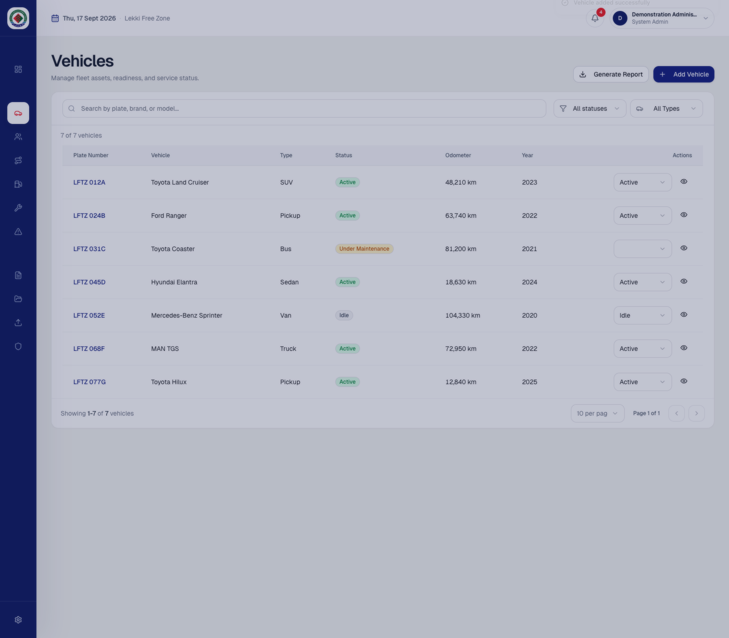
Figure 3.4 Saved demonstration vehicle visible in the vehicle register
The refreshed register provides visible confirmation that the new record is available. This stage is important because users may repeat an action if they cannot tell whether the first attempt succeeded.
The project strengthened my understanding of the full interaction between requirements, interface controls, validation, database operations and feedback. It also helped me explain a software workflow to someone who is more interested in completing a task than in the technology behind it.

3.10 Relationship to Computer Science
Networking tasks connected concepts such as addressing, connectivity and communication paths to actual equipment. Recrimping a cable or replacing an access point showed that higher-level services depend on a working physical connection. The experience made network troubleshooting more concrete than a diagram alone.
Hardware and system support connected computer organisation and operating-system concepts with maintenance. Storage replacement and file recovery showed the relationship between physical components, software behaviour and the availability of data. Application and driver problems also required attention to the interaction between the operating system and the device or program being used.
The Fleet Management System applied software engineering and database concepts. Requirements gathering helped define the problem. Interface design translated requirements into workflows. React and TypeScript supported implementation, while Supabase connected the application to stored records. Testing helped check whether the parts worked together as intended.
The website and Figma work related to human-computer interaction. I had to consider how users interpret labels, navigate pages and respond to feedback. The experience made me more aware that a technically working feature may still be difficult to use.
Technical reports and memos developed a skill that connects these areas: communicating an investigation clearly enough for someone else to act on it. A useful explanation identifies the problem, describes the relevant evidence and states what needs to happen next.

3.11 Professional Skills Acquired
The attachment improved my interpersonal skills, particularly the way I communicate with people who have different levels of technical knowledge. I learned to ask for a clear description of a problem without making the user feel that they were expected to diagnose it themselves.
I also became more aware of expectations. A member of staff may need a quick update while a fault is still being investigated. Explaining what is known, what is being checked and whether assistance is required is often more useful than giving an unsupported promise about when the issue will be resolved.
Working with colleagues, technicians and vendors helped me practise professional communication. I had to listen, take notes, clarify requirements and pass on information accurately. During design reviews, this meant separating personal preference from a requirement that affected the organisation or its users.
The mix of project development and support work improved my ability to manage attention. A development task might require a long period of concentration, while a support request could need immediate investigation. I learned to keep enough notes to return to unfinished work without losing the context.
I also learned to recognise the limits of my knowledge. Asking for guidance was often the responsible choice when working with equipment or systems used by other people. Over time, this helped me become more confident without treating confidence as a substitute for careful checking.
CHAPTER FOUR

EVALUATION AND CONCLUSION

4.1 Summary of Experience
My six-month attachment combined infrastructure support and software development. I participated in networking and CCTV activities, investigated computer and printer faults, prepared equipment documentation and contributed to website design work. I also developed a Fleet Management System from requirements gathering to implementation and use within the company.
The most useful aspect of the placement was seeing how these activities connect. A software application needs accurate requirements and reliable data. A user-support task needs technical investigation and clear communication. An equipment repair needs documentation that another person can understand. The work helped me move from thinking only about individual technical skills to understanding complete tasks.

4.2 Challenges Encountered

4.2.1 Working With Incomplete Fault Descriptions
Some support requests began with broad descriptions such as a printer not working or a computer failing to connect. The challenge was to identify what the user was actually experiencing before choosing a remedy. I became more careful about clarifying symptoms and separating possible causes.
The range of equipment also required different approaches. A connection problem, a storage failure and an application that would not start could not all be treated in the same way. Working through these differences improved my troubleshooting discipline.

4.2.2 Balancing Development and Support
The Fleet Management System required sustained design and development work, while the IT Unit also had everyday support responsibilities. Moving between these tasks could interrupt the flow of development. I learned to organise the work into smaller activities and keep track of what remained to be checked.
Another challenge was moving from mock-ups to a functioning application. A screen could look complete before its data handling, validation or feedback was reliable. I had to treat implementation and testing as part of the design process rather than assuming that a finished visual layout meant a finished feature.

4.2.3 Recording the Experience Accurately
When logbook entries were not written promptly, it became harder to recall the exact order of activities. This showed me the value of brief daily notes that record the task, the action taken and the outcome. A detailed report is easier to prepare when those notes are available.
Accuracy is especially important when describing collaborative work. I learned to distinguish between a task I completed, a task I assisted with and a procedure I observed. This makes the account more useful and avoids overstating responsibility.

4.2.4 Managing Expectations
Technical work also involved people waiting for a repair, an explanation or a decision. I learned that communication should continue while the work is still in progress. A clear update can help a user understand the next step even when the problem has not yet been resolved.

4.3 Recommendations

4.3.1 Recommendations to the Organisation
A simple support register would help record the affected equipment, reported symptom, investigation, action taken and final outcome. This would make recurring faults easier to recognise and give technicians useful context when an issue has to be escalated.
Routine equipment inspections and clearly maintained asset records would support repair planning. The printer assessment exercise showed the value of collecting information before a technician arrives. Similar documentation can help with computers, access points and other frequently supported equipment.
Digital projects should have a clear owner, user feedback process and maintenance plan after deployment. For the Fleet Management System, continued use should be supported by appropriate account management, backup arrangements, user guidance and testing of future changes.

4.3.2 Recommendations to the University and Future Trainees
The university should continue encouraging placements that expose students to meaningful practical tasks and provide opportunities to discuss how those tasks relate to their course. Report guidance supplied early in the attachment would also help students collect suitable evidence without trying to reconstruct everything at the end.
Future trainees should keep brief daily notes, ask questions when the purpose of a task is unclear and record their actual level of involvement. Photographs should be taken only when permitted and should avoid passwords, private information and sensitive operational details. A smaller number of well-explained examples is more useful than a large collection of unrelated pictures.

4.4 Conclusion
My SIWES attachment at Lekki Free Zone Development Company gave me practical experience beyond classroom exercises. I worked on real equipment and user requests, learned from colleagues and technicians, and developed a software application for an organisational need.
The experience strengthened my technical skills in networking, system support, interface design and web development. It also improved how I investigate problems, document work and communicate with people. These professional skills were important because the success of a technical task depends not only on the solution, but also on whether it addresses the user's problem and can be understood by others.
Developing the Fleet Management System was a significant part of the attachment. It allowed me to follow a project from requirements and design through implementation and testing. The company's use of the system gave the work a practical outcome and showed me the value of applying Computer Science to an existing process.
Overall, the placement helped me understand the responsibilities of an IT professional and identify areas for further development. I left with greater confidence in practical work, a better appreciation of careful testing and a stronger commitment to continued learning.

REFERENCES
Industrial Training Fund. (n.d.-a). SIWES introduction and objectives. https://itf.gov.ng/pdf/SIWES%20Work.pdf Accessed 18 September 2026.
Industrial Training Fund. (n.d.-b). SIWES portal and programme objectives. https://www.siwes.itf.gov.ng/ Accessed 18 September 2026.
Lekki Free Zone Development Company. (n.d.-a). Our company background. https://lfzdc.org/about-us/ Accessed 18 September 2026.
Lekki Free Zone Development Company. (n.d.-b). Management profile. https://lfzdc.org/management-profile/ Accessed 18 September 2026.
Primary records: personal SIWES activity accounts for the attachment from 2 March to 2 September 2026.
Application illustrations: LFZDC Fleet Management Software Report, September 2026 documentation version. The figures use fictional demonstration records.

APPENDIX A PHOTOGRAPHIC RECORD
The following plates show the placement environment and selected technical activities from my SIWES photo and video collection. Each group is linked to the corresponding discussion in the report. Images extracted from videos are identified as stills.

A.1 Placement Location
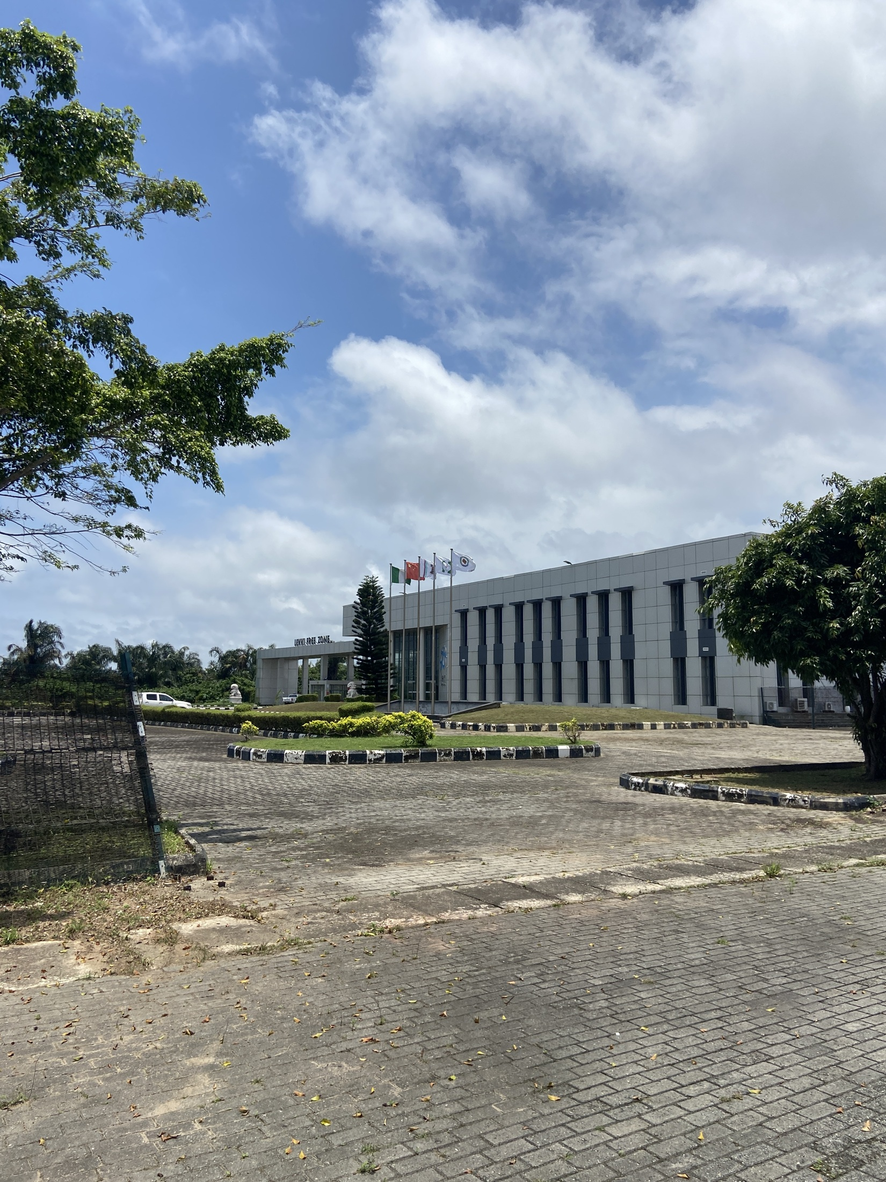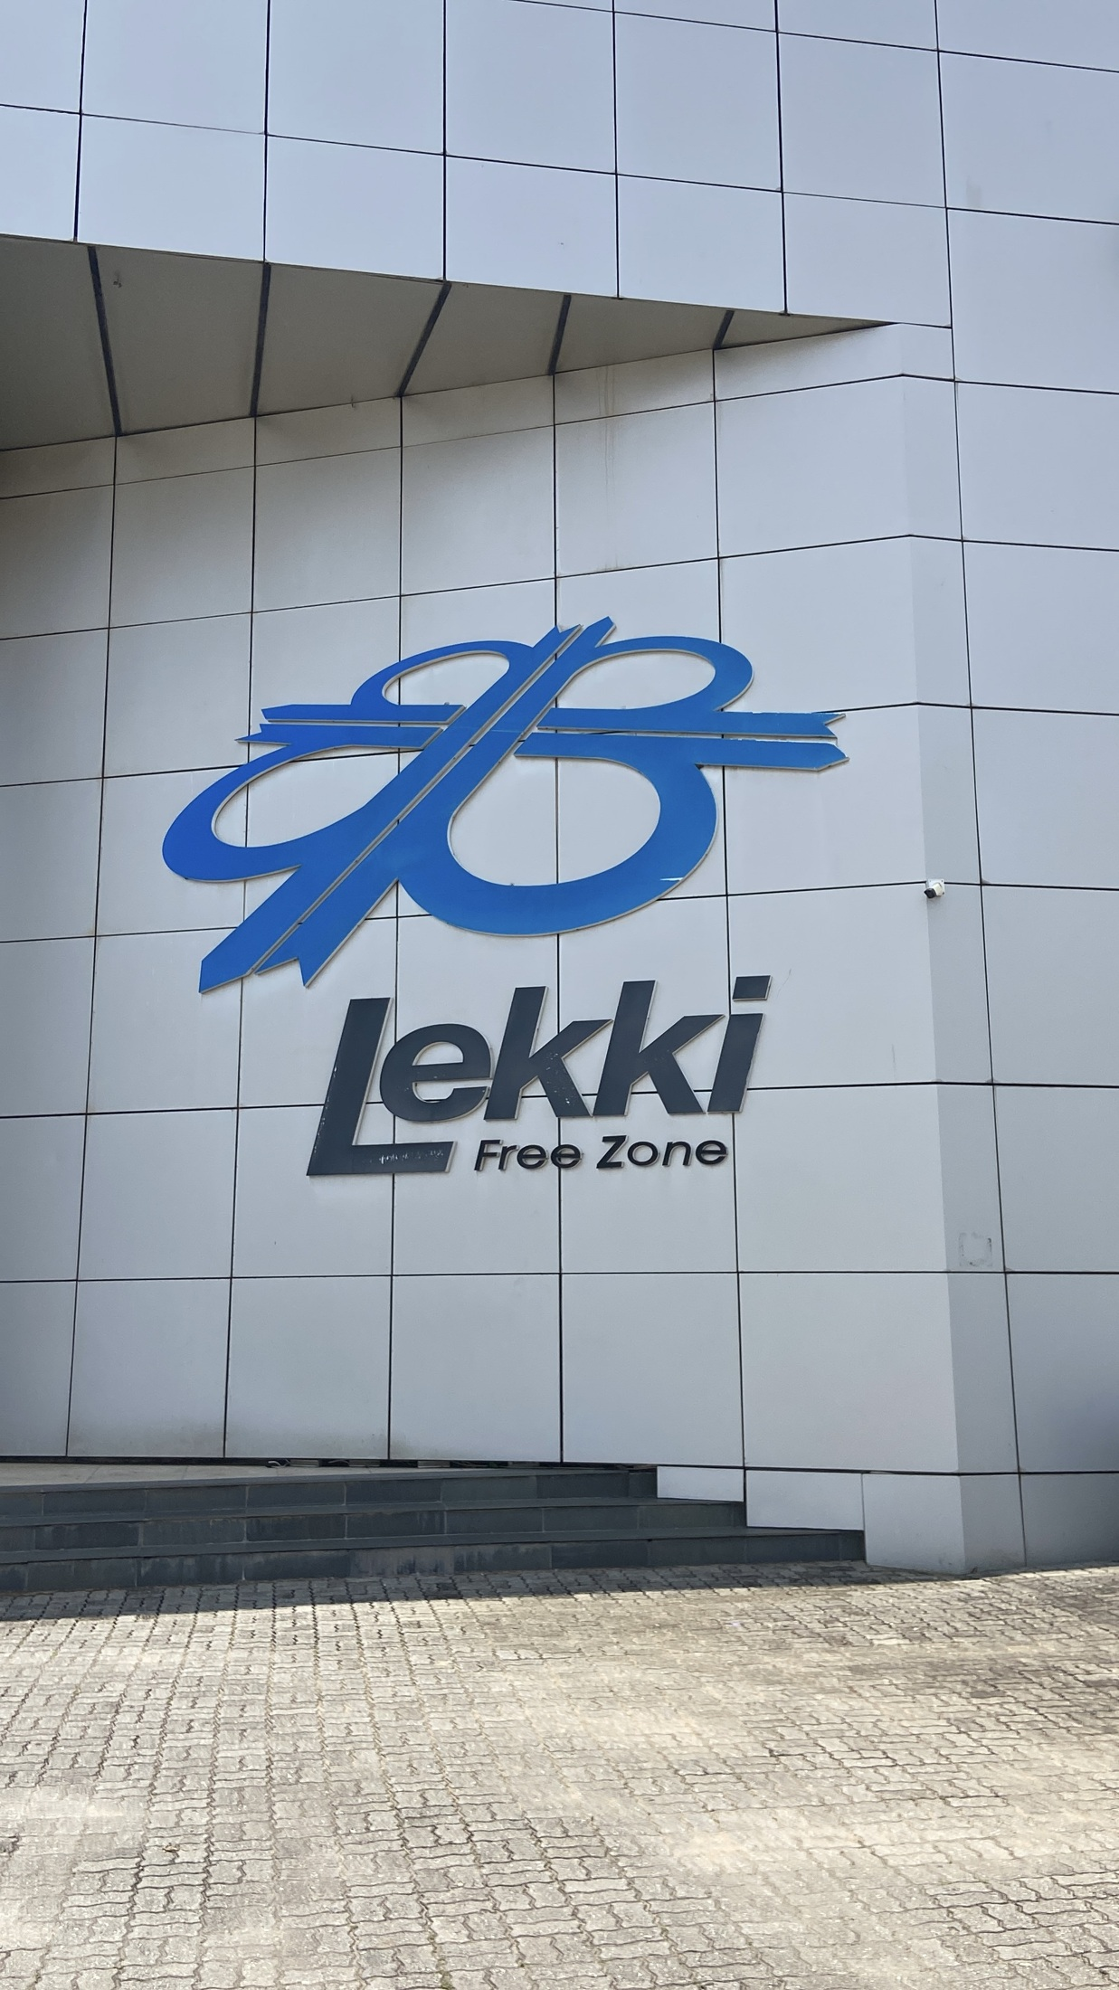
Plate A.1 Building and grounds at Lekki Free Zone (left).
Plate A.2 Lekki Free Zone signage (right).
Source: Personal SIWES photo collection.
These views provide context for the company profile in Section 2.1. They show the physical environment in which the organisation operates and the signage identifying the location.

A.2 Network Infrastructure
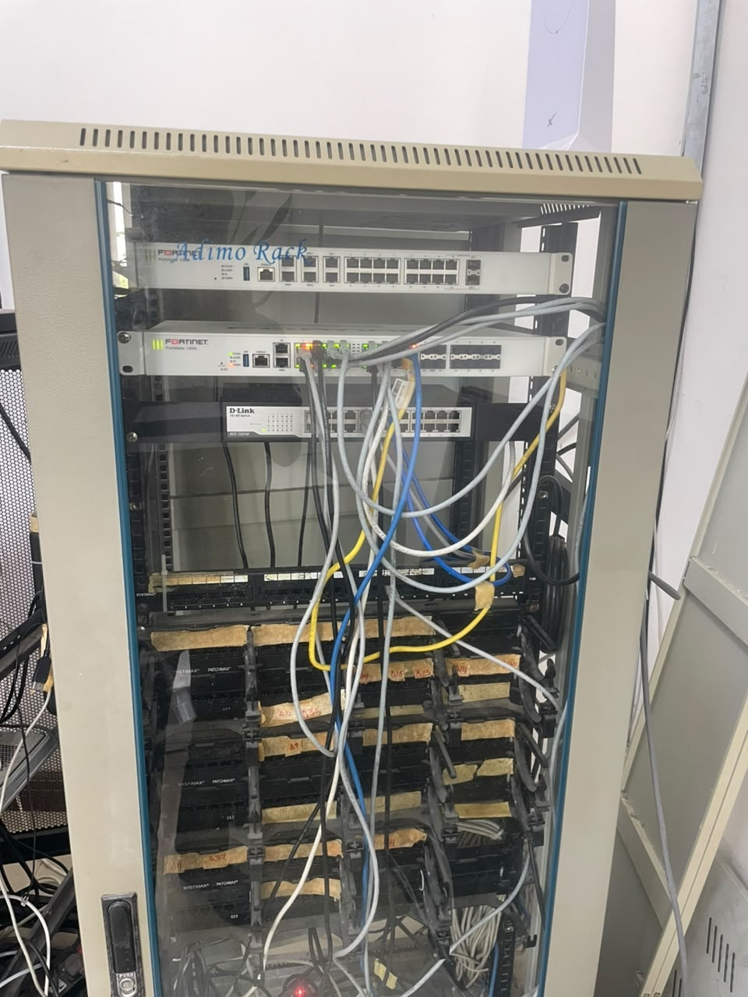
Plate A.3 Network cabinet containing Fortinet equipment, a D-Link switch and patch cabling.
Source: Personal SIWES photo collection.
The cabinet illustrates the physical infrastructure discussed in Sections 3.1 and 3.2. Network devices, ports and cabling form part of the path through which users reach services. The photograph shows the equipment arrangement, rather than a complete network topology or its configuration.

A.3 Installation and Cabinet Work
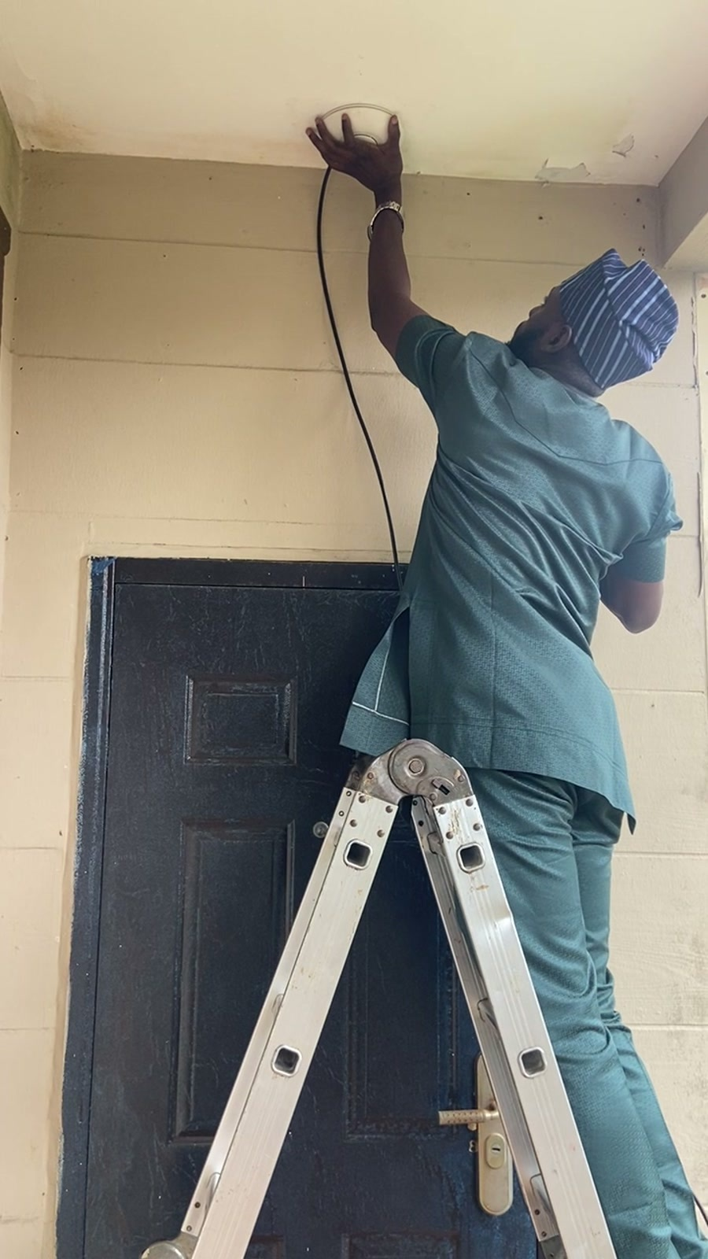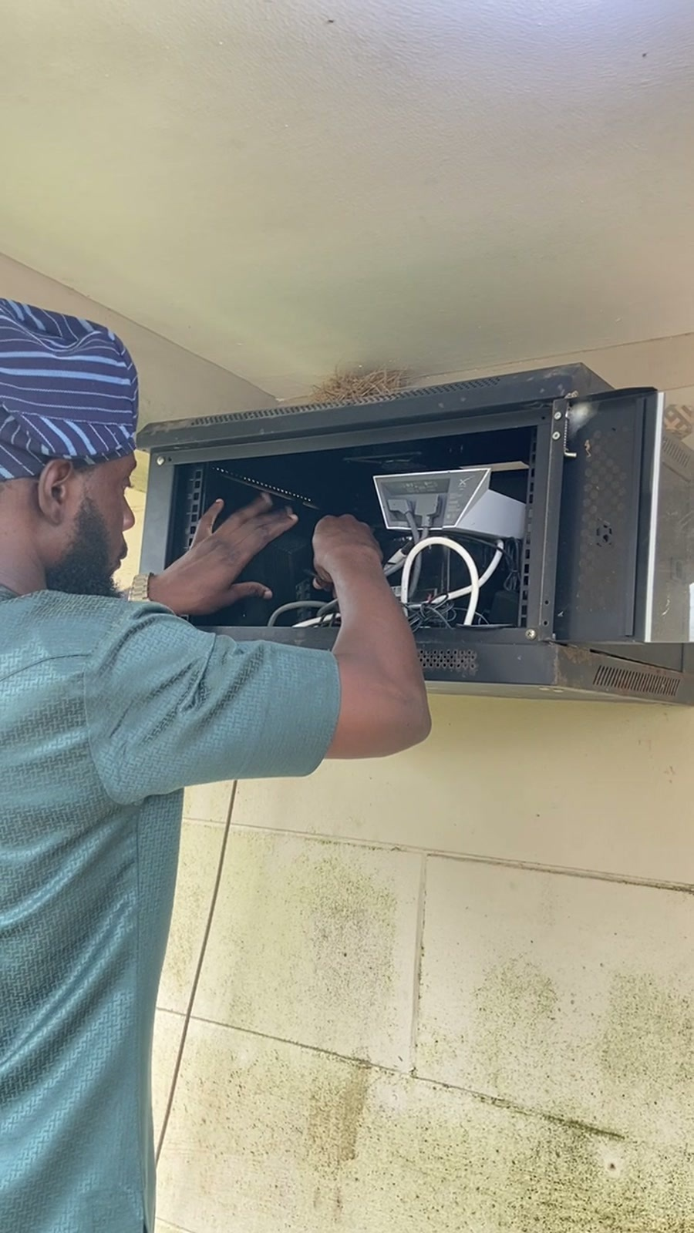
Plate A.4 Work on a ceiling-mounted device and its cable (left).
Plate A.5 Work inside a wall-mounted equipment cabinet (right).
Source: Stills from IMG_0117.MOV and IMG_0118.MOV in the personal SIWES video collection.
The stills show two aspects of physical installation work: fitting a device at its mounting point and attending to the equipment and connections in a cabinet. They accompany the infrastructure and connectivity discussion in Section 3.2. The installation process involves both the endpoint and the connections serving it.

A.4 Laptop Hardware Maintenance
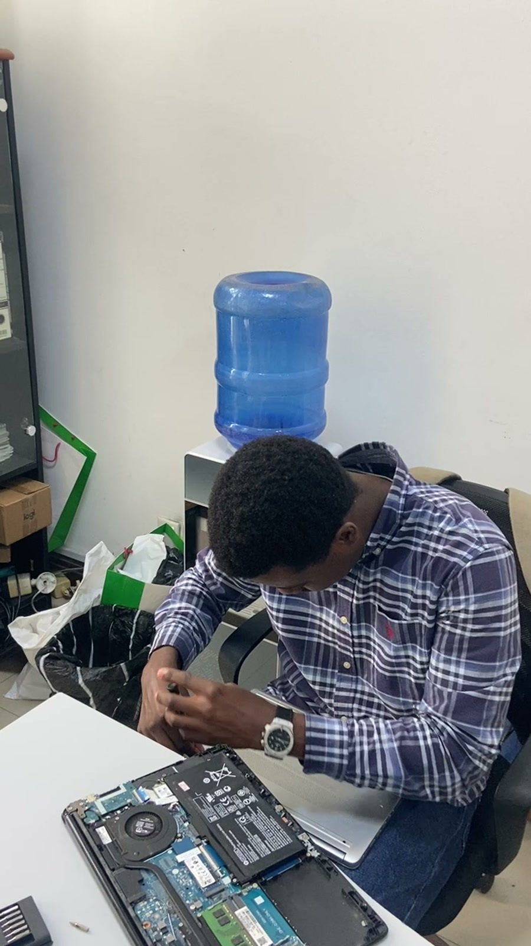
Plate A.6 Laptop maintenance with the base cover removed and internal components exposed.
Source: Still from IMG_9814.MOV in the personal SIWES video collection.
This view accompanies Section 3.4 on computer hardware and system support. The battery, cooling assembly, memory and storage area are visible inside the opened laptop. It illustrates the physical access involved in hardware maintenance; the photograph alone does not establish which component was faulty or the result of a repair.

A.5 Laptop Preparation
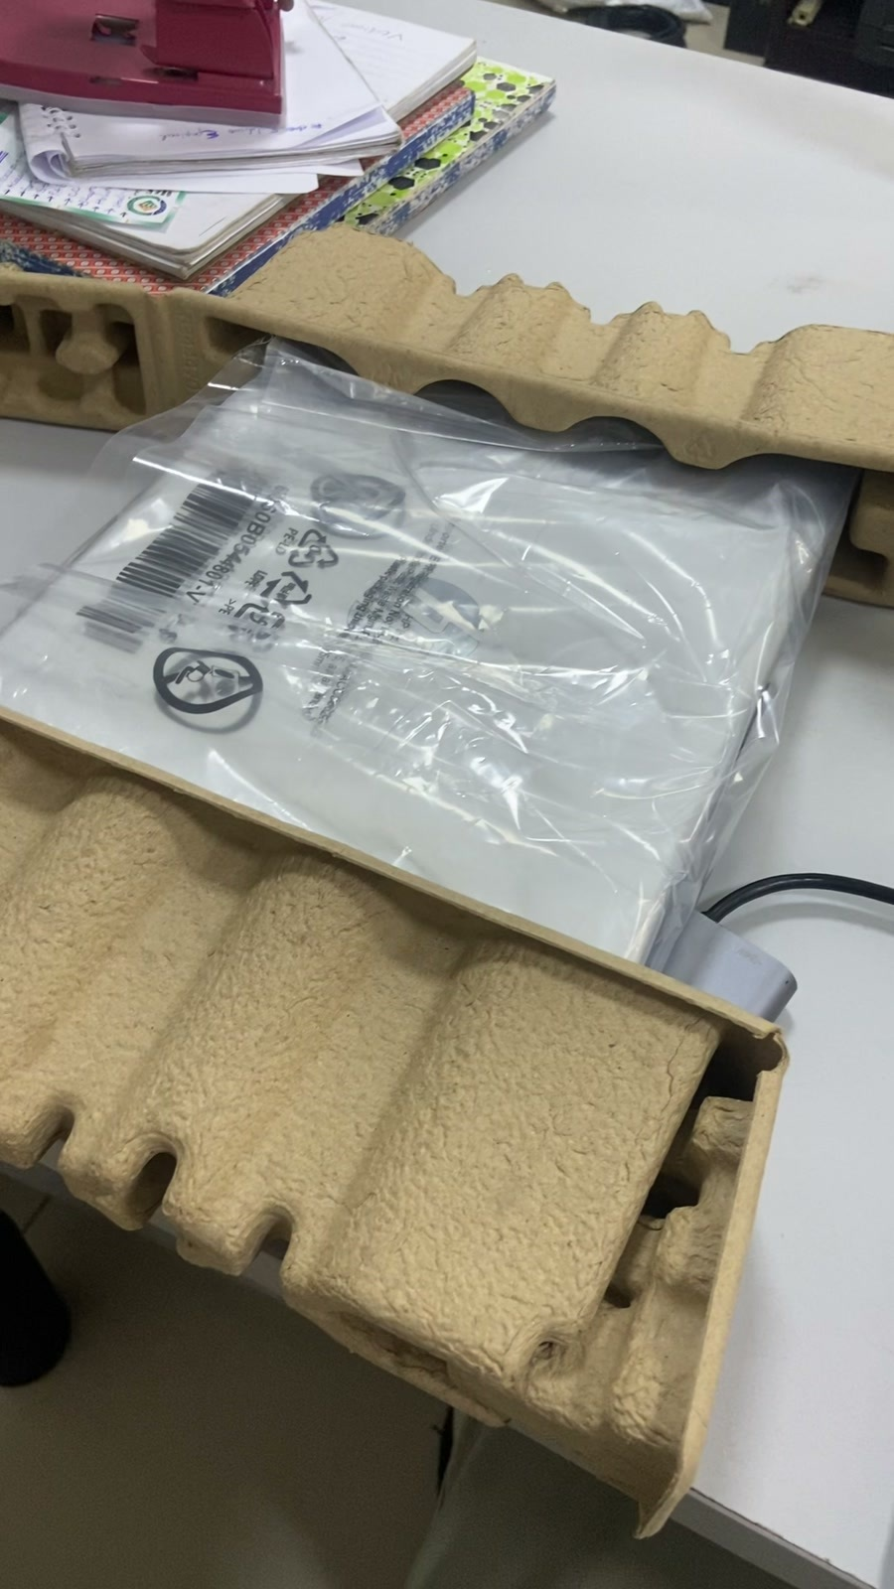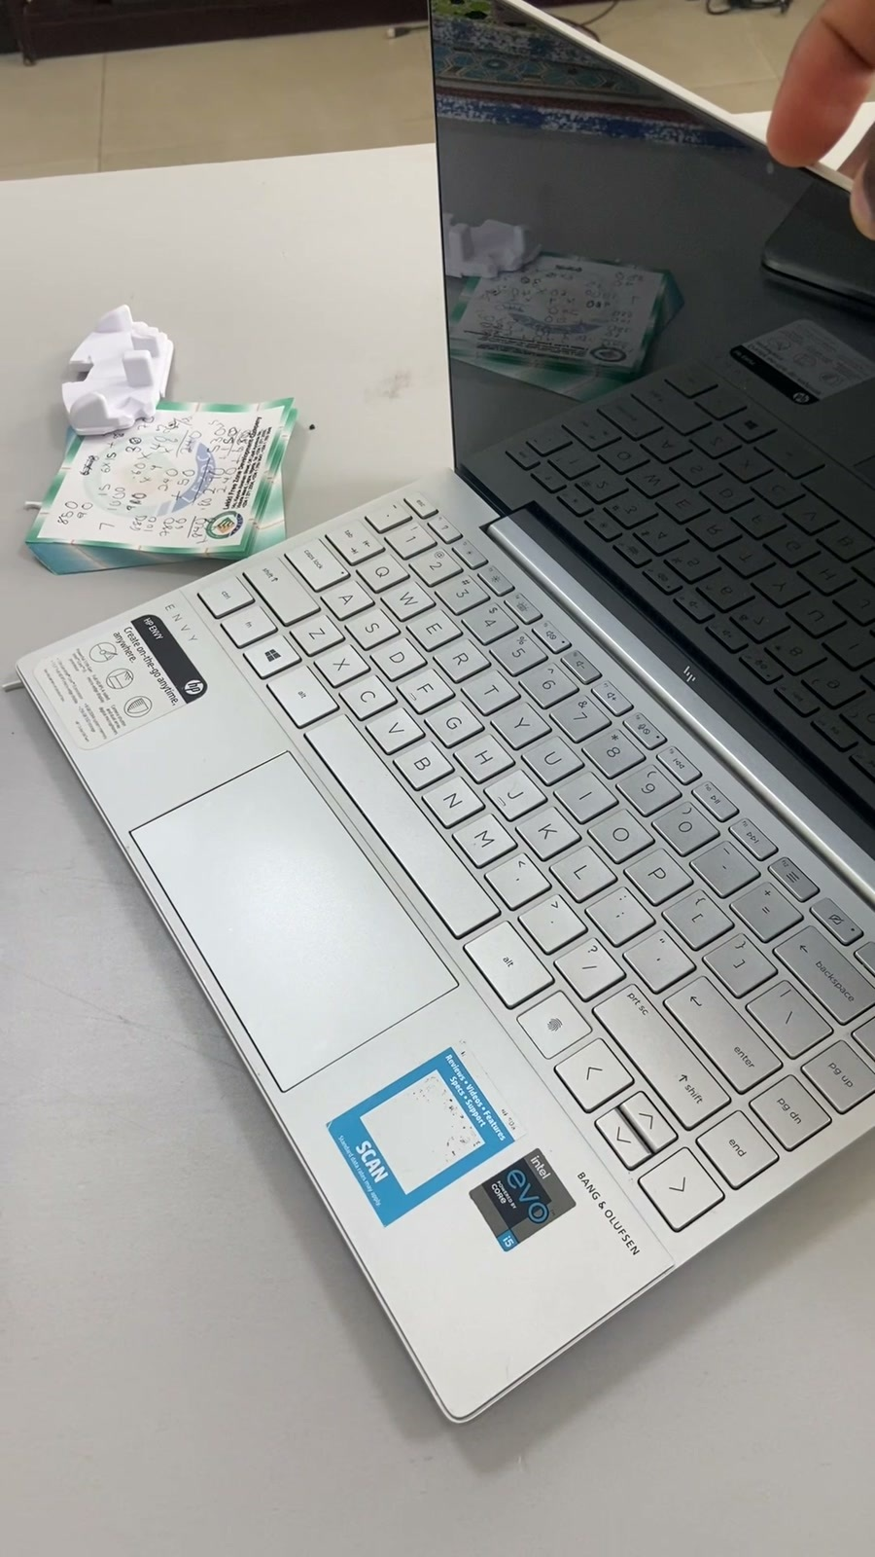
Plate A.7 Laptop in protective packaging (left).
Plate A.8 Open laptop on the work desk (right).
Source: Stills from two laptop recordings in the personal SIWES video collection.
These equipment views accompany the laptop-provisioning discussion in Section 3.4.3. Receiving and unpacking a computer are preliminary steps; preparing it for an assigned user also requires the appropriate software, drivers and checks. The images show the equipment, not evidence that every setup step has been completed.

A.6 Workplace Interaction
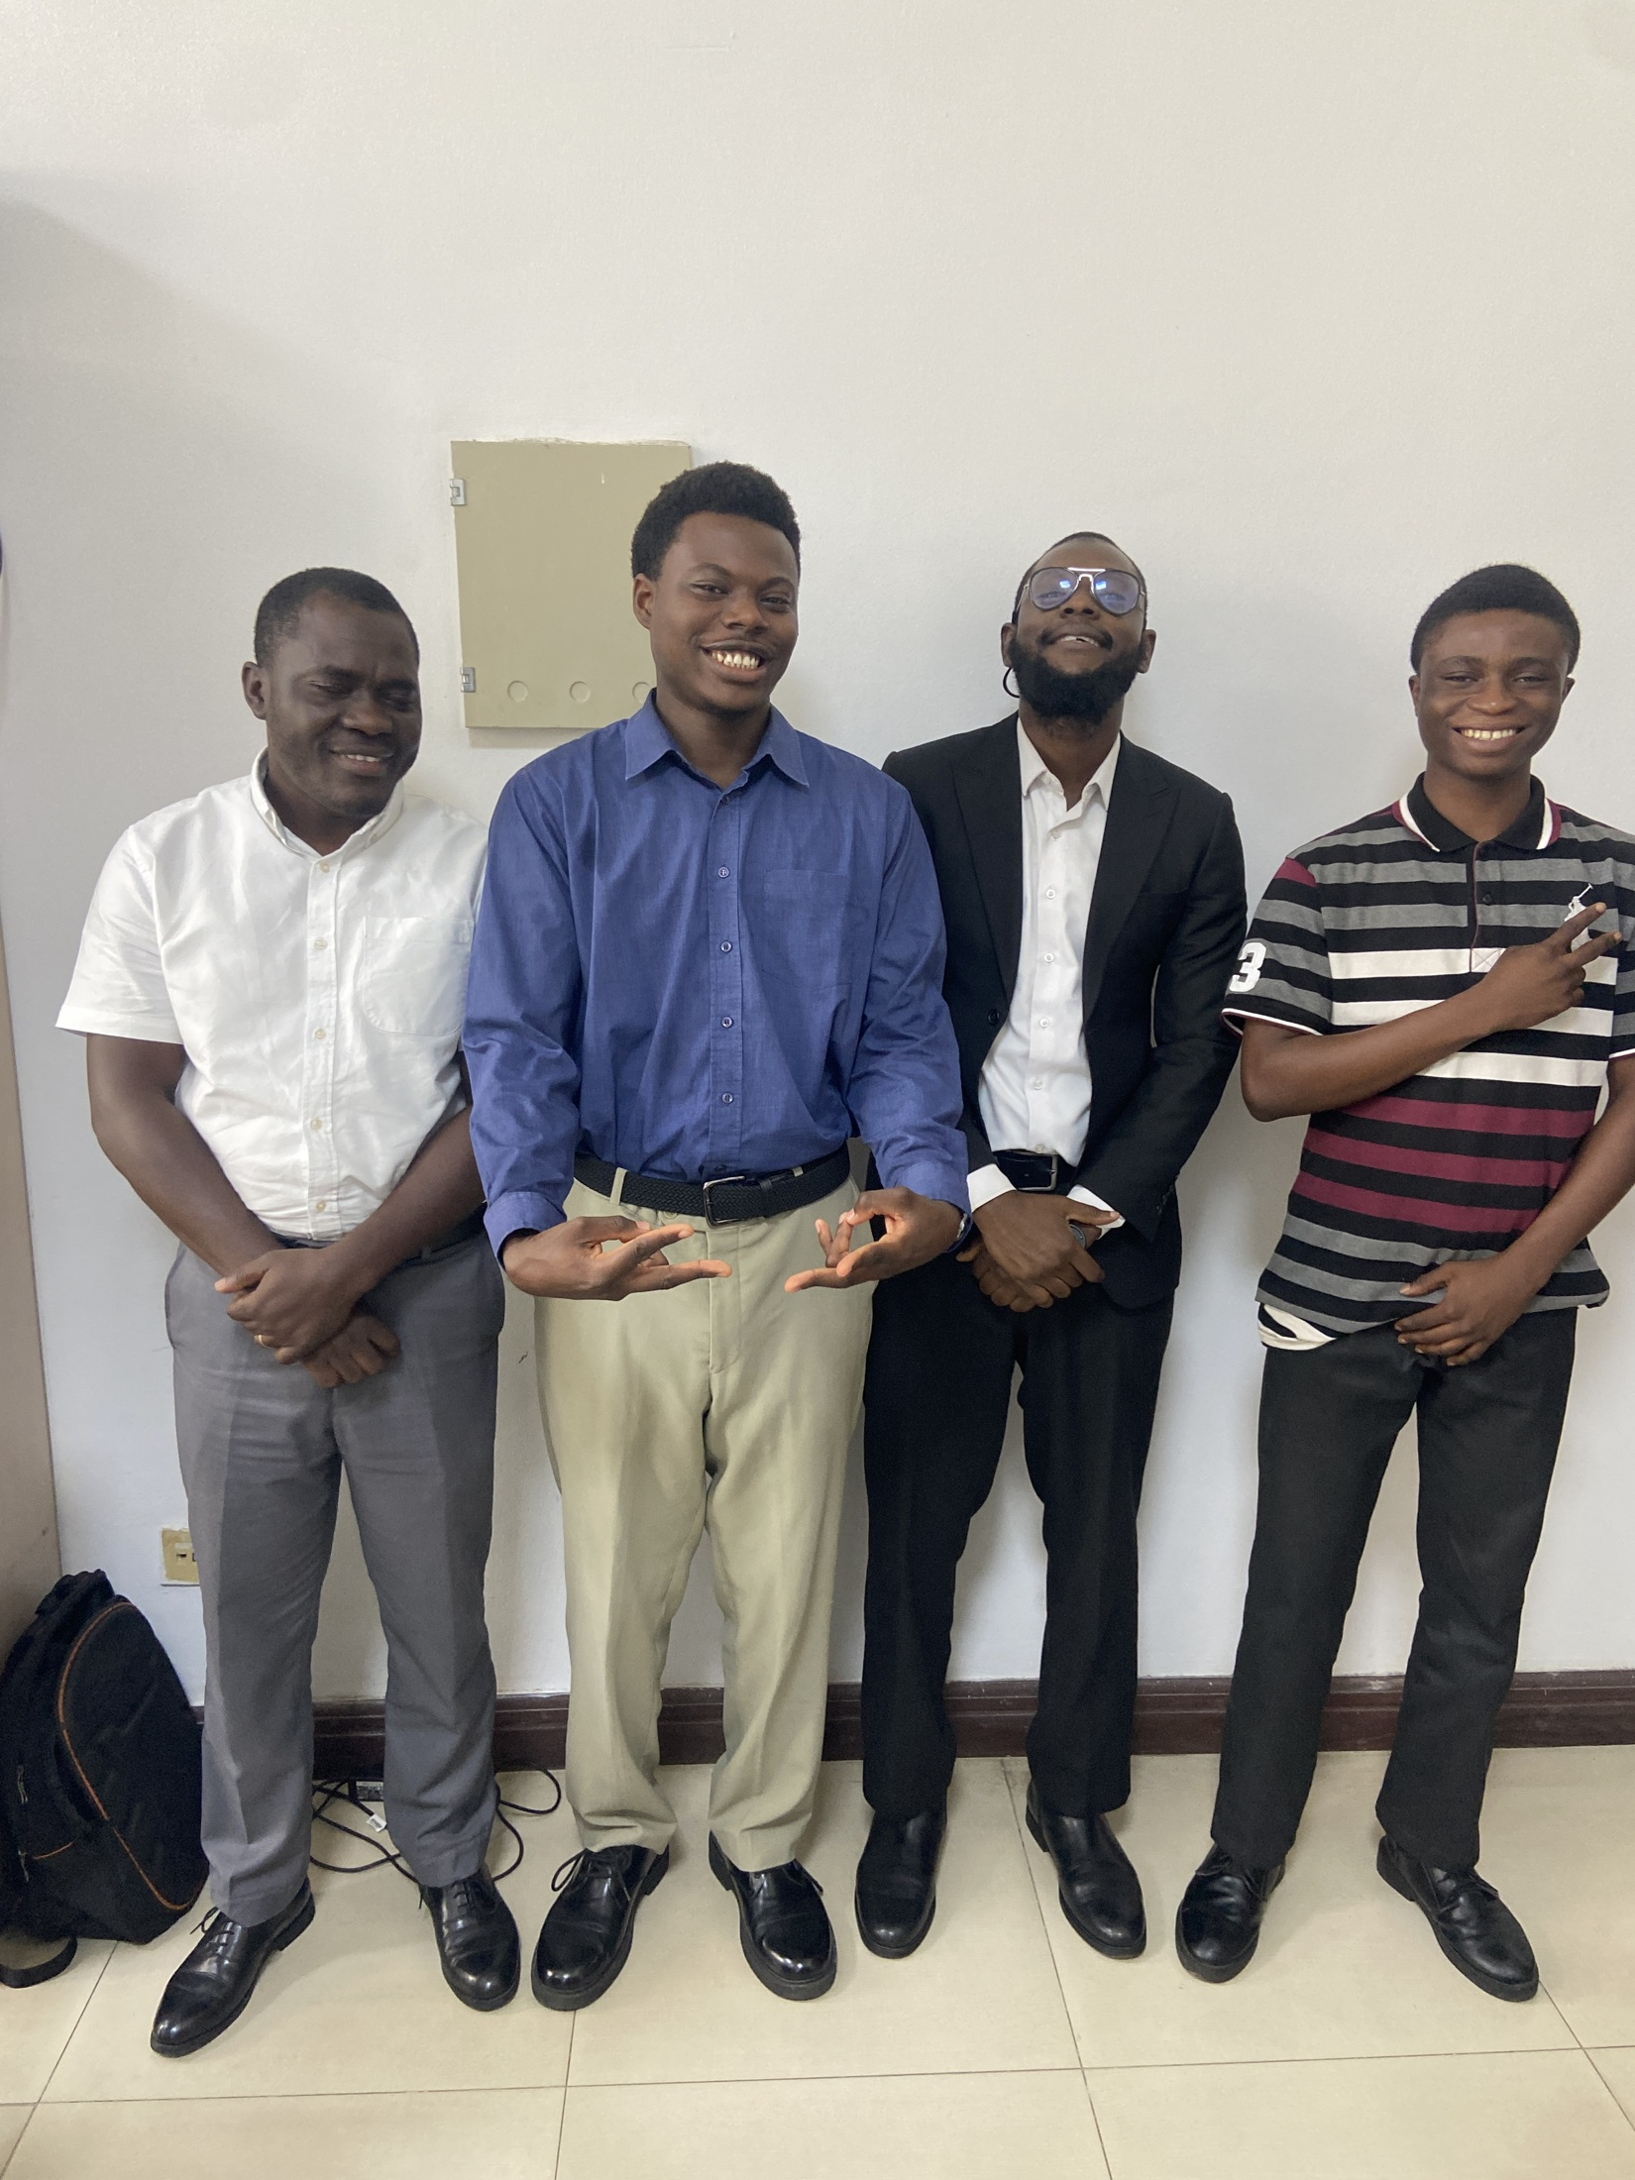
Plate A.9 Group photograph in the workplace.
Source: Personal SIWES photo collection.
The photograph accompanies Section 3.11 on professional skills. Working in an office environment gave me opportunities to communicate with others, learn from practical discussions and develop more confidence in workplace relationships.

