Appendix A — Data provenance and extended descriptive summaries
These observed summaries preceded fold-local imputation. Percentages used the full analytical sample; recorded variable codes were not assigned additional clinical interpretations.

Observed missingness by predictor
Predictor | Missing n | Missing % of analytical sample
age | 0 | 0.0%
sex | 0 | 0.0%
cp | 0 | 0.0%
trestbps | 0 | 0.0%
chol | 0 | 0.0%
fbs | 0 | 0.0%
restecg | 0 | 0.0%
thalach | 0 | 0.0%
exang | 0 | 0.0%
oldpeak | 0 | 0.0%
slope | 0 | 0.0%
ca | 4 | 1.3%
thal | 2 | 0.7%

Extended numeric descriptions
Recorded predictor | Observed n | M | SD | Minimum | 25th percentile | Median | 75th percentile | Maximum
age | 303 | 54.44 | 9.04 | 29 | 48 | 56 | 61 | 77
trestbps | 303 | 131.69 | 17.60 | 94 | 120 | 130 | 140 | 200
chol | 303 | 246.69 | 51.78 | 126 | 211 | 241 | 275 | 564
thalach | 303 | 149.61 | 22.88 | 71 | 133.50 | 153 | 166 | 202
oldpeak | 303 | 1.04 | 1.16 | 0 | 0 | 0.80 | 1.60 | 6.20

Complete categorical frequencies
Predictor | Recorded code / status | n | % of full analytical sample
sex | 1.0 | 206 | 68.0%
sex | 0.0 | 97 | 32.0%
cp | 4.0 | 144 | 47.5%
cp | 3.0 | 86 | 28.4%
cp | 2.0 | 50 | 16.5%
cp | 1.0 | 23 | 7.6%
fbs | 0.0 | 258 | 85.1%
fbs | 1.0 | 45 | 14.9%
restecg | 0.0 | 151 | 49.8%
restecg | 2.0 | 148 | 48.8%
restecg | 1.0 | 4 | 1.3%
exang | 0.0 | 204 | 67.3%
exang | 1.0 | 99 | 32.7%
slope | 1.0 | 142 | 46.9%
slope | 2.0 | 140 | 46.2%
slope | 3.0 | 21 | 6.9%
ca | 0.0 | 176 | 58.1%
ca | 1.0 | 65 | 21.5%
ca | 2.0 | 38 | 12.5%
ca | 3.0 | 20 | 6.6%
ca | Missing (blank source level) | 4 | 1.3%
thal | 3.0 | 166 | 54.8%
thal | 7.0 | 117 | 38.6%
thal | 6.0 | 18 | 5.9%
thal | Missing (blank source level) | 2 | 0.7%

Figure 4.1
Observed outcome distribution and missingness before imputation.
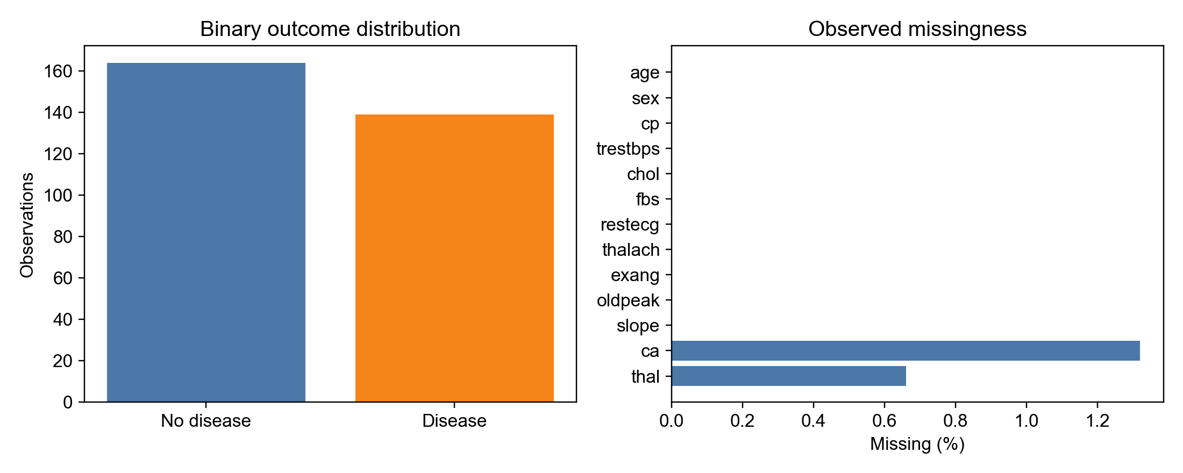
Source: present study, executed workflow.

Electronic supporting records
data provenance
dataset class distribution
dataset missingness
dataset numeric summary
dataset categorical frequencies
Data source: Janosi et al. (1989), Heart Disease dataset, University of California, Irvine Machine Learning Repository. Dataset attribution is listed separately in the chapter reference file.

Appendix B — Fold performance, calibration and paired summaries
Fold descriptions concerned dependent validation splits. Conditional bootstrap intervals described realised aggregated predictions and did not repeat model development or test the approved fold-mean hypotheses.

Full secondary metric contrasts and conditional intervals
Classifier | Subtraction direction | Metric | Difference; conditional interval | Interval spans/touches zero
LR | GA minus ALL | MCC | -0.0474; 95% CI [-0.0907, -0.0067] | false
LR | GA minus ALL | Brier | +0.0018; 95% CI [-0.0072, +0.0104] | true
LR | GA minus ALL | Average precision | -0.0123; 95% CI [-0.0310, +0.0081] | true
LR | PSO minus ALL | MCC | -0.0474; 95% CI [-0.1011, +0.0065] | true
LR | PSO minus ALL | Brier | +0.0032; 95% CI [-0.0054, +0.0117] | true
LR | PSO minus ALL | Average precision | -0.0201; 95% CI [-0.0421, +0.0058] | true
LR | GA minus PSO | MCC | +0.0001; 95% CI [-0.0399, +0.0400] | true
LR | GA minus PSO | Brier | -0.0014; 95% CI [-0.0055, +0.0031] | true
LR | GA minus PSO | Average precision | +0.0078; 95% CI [-0.0044, +0.0191] | true
DT | GA minus ALL | MCC | +0.0351; 95% CI [-0.0361, +0.1070] | true
DT | GA minus ALL | Brier | -0.0038; 95% CI [-0.0210, +0.0139] | true
DT | GA minus ALL | Average precision | -0.0039; 95% CI [-0.0471, +0.0375] | true
DT | PSO minus ALL | MCC | +0.0333; 95% CI [-0.0462, +0.1134] | true
DT | PSO minus ALL | Brier | -0.0065; 95% CI [-0.0233, +0.0096] | true
DT | PSO minus ALL | Average precision | +0.0161; 95% CI [-0.0253, +0.0578] | true
DT | GA minus PSO | MCC | +0.0018; 95% CI [-0.0588, +0.0621] | true
DT | GA minus PSO | Brier | +0.0028; 95% CI [-0.0093, +0.0161] | true
DT | GA minus PSO | Average precision | -0.0200; 95% CI [-0.0645, +0.0243] | true
RF | GA minus ALL | MCC | +0.0066; 95% CI [-0.0335, +0.0517] | true
RF | GA minus ALL | Brier | +0.0014; 95% CI [-0.0045, +0.0074] | true
RF | GA minus ALL | Average precision | -0.0106; 95% CI [-0.0240, +0.0024] | true
RF | PSO minus ALL | MCC | +0.0267; 95% CI [-0.0202, +0.0801] | true
RF | PSO minus ALL | Brier | -0.0020; 95% CI [-0.0073, +0.0033] | true
RF | PSO minus ALL | Average precision | -0.0068; 95% CI [-0.0209, +0.0055] | true
RF | GA minus PSO | MCC | -0.0200; 95% CI [-0.0600, +0.0188] | true
RF | GA minus PSO | Brier | +0.0034; 95% CI [-0.0010, +0.0076] | true
RF | GA minus PSO | Average precision | -0.0039; 95% CI [-0.0140, +0.0077] | true
SVM | GA minus ALL | MCC | +0.0264; 95% CI [-0.0270, +0.0866] | true
SVM | GA minus ALL | Brier | -0.0002; 95% CI [-0.0117, +0.0116] | true
SVM | GA minus ALL | Average precision | -0.0031; 95% CI [-0.0190, +0.0132] | true
SVM | PSO minus ALL | MCC | +0.0264; 95% CI [-0.0261, +0.0802] | true
SVM | PSO minus ALL | Brier | +0.0006; 95% CI [-0.0118, +0.0130] | true
SVM | PSO minus ALL | Average precision | -0.0078; 95% CI [-0.0263, +0.0102] | true
SVM | GA minus PSO | MCC | 0.0000; 95% CI [-0.0401, +0.0400] | true
SVM | GA minus PSO | Brier | -0.0008; 95% CI [-0.0074, +0.0062] | true
SVM | GA minus PSO | Average precision | +0.0046; 95% CI [-0.0063, +0.0155] | true
XGB | GA minus ALL | MCC | +0.0270; 95% CI [-0.0326, +0.0805] | true
XGB | GA minus ALL | Brier | -0.0034; 95% CI [-0.0118, +0.0051] | true
XGB | GA minus ALL | Average precision | -0.0008; 95% CI [-0.0207, +0.0170] | true
XGB | PSO minus ALL | MCC | +0.0270; 95% CI [-0.0203, +0.0761] | true
XGB | PSO minus ALL | Brier | -0.0021; 95% CI [-0.0101, +0.0061] | true
XGB | PSO minus ALL | Average precision | +0.0002; 95% CI [-0.0148, +0.0144] | true
XGB | GA minus PSO | MCC | 0.0000; 95% CI [-0.0535, +0.0532] | true
XGB | GA minus PSO | Brier | -0.0013; 95% CI [-0.0091, +0.0070] | true
XGB | GA minus PSO | Average precision | -0.0009; 95% CI [-0.0174, +0.0159] | true

Registered disagreement in ROC-AUC direction
Classifier | Subtraction direction | Paired-fold mean direction | Aggregated-OOF direction
DT | GA minus ALL | negative | positive
XGB | GA minus ALL | negative | positive

Figure 4.2
Descriptive ROC-AUC distributions across dependent outer folds.
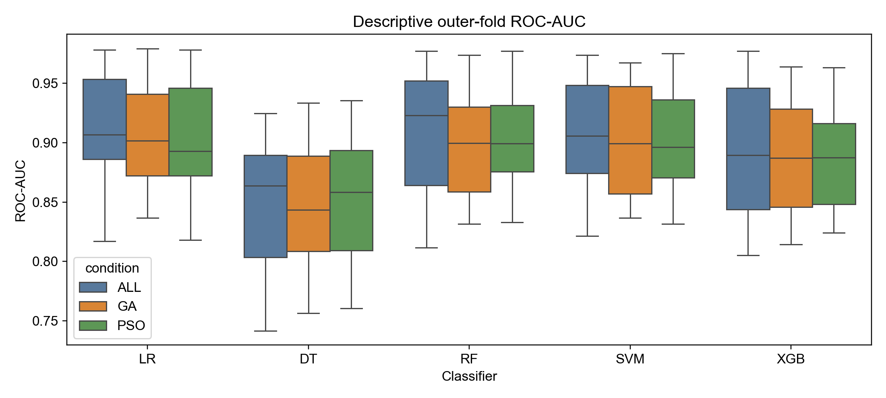
Source: present study, executed workflow.

Figure 4.3 LR
Aggregated OOF ROC and precision–recall curves. Precision–recall legend values reported average precision.
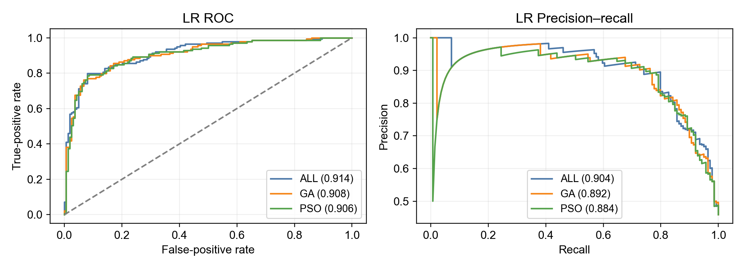
Source: present study, executed workflow.

Figure 4.3 DT continued
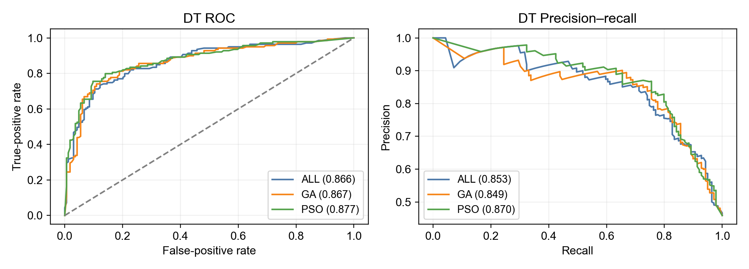
Source: present study, executed workflow.

Figure 4.3 RF continued
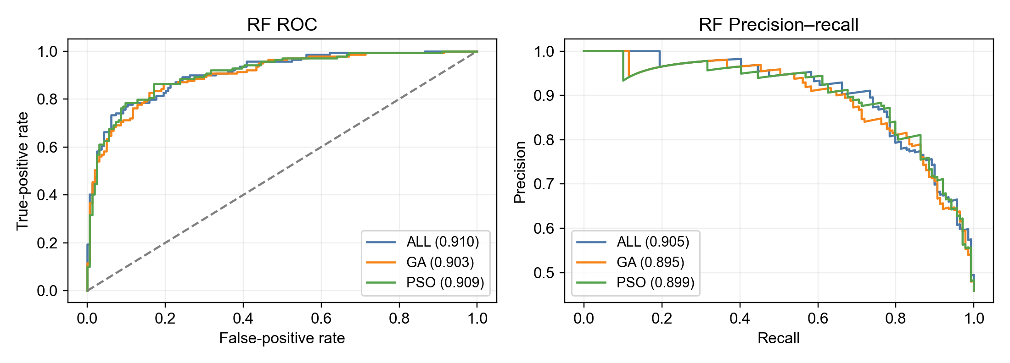
Source: present study, executed workflow.

Figure 4.3 SVM continued
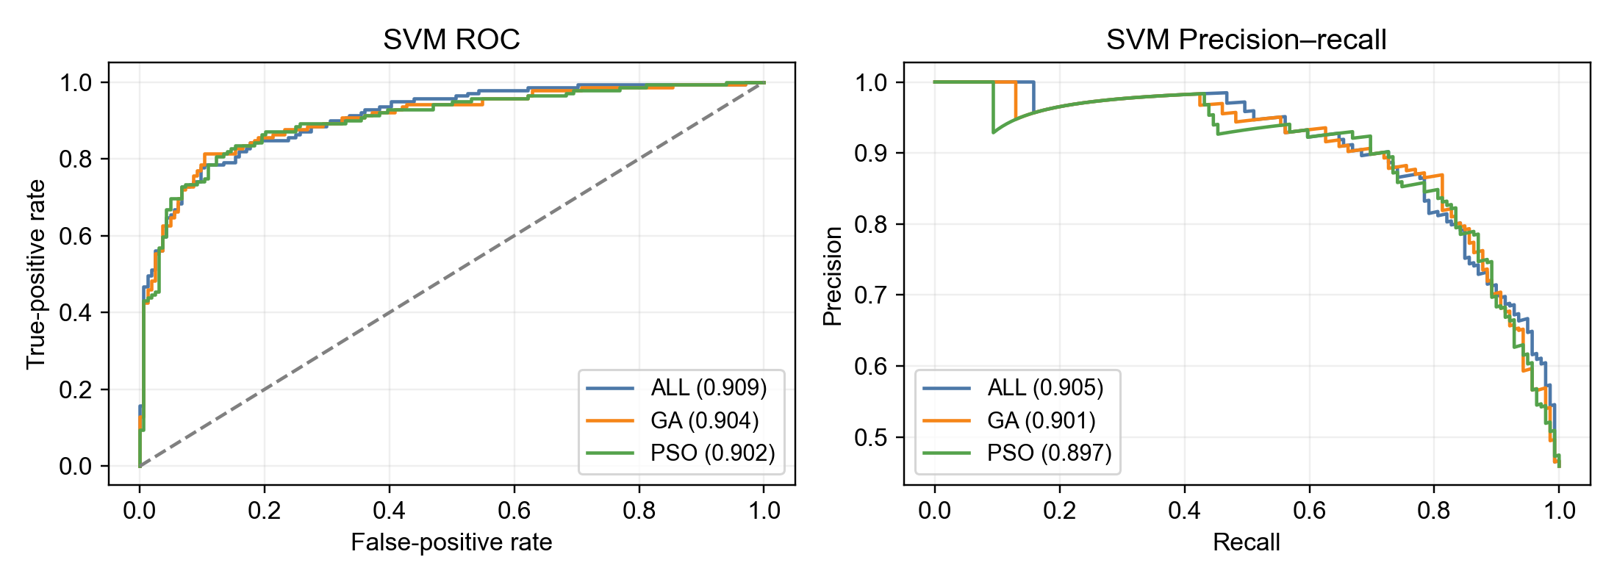
Source: present study, executed workflow.

Figure 4.3 XGB continued
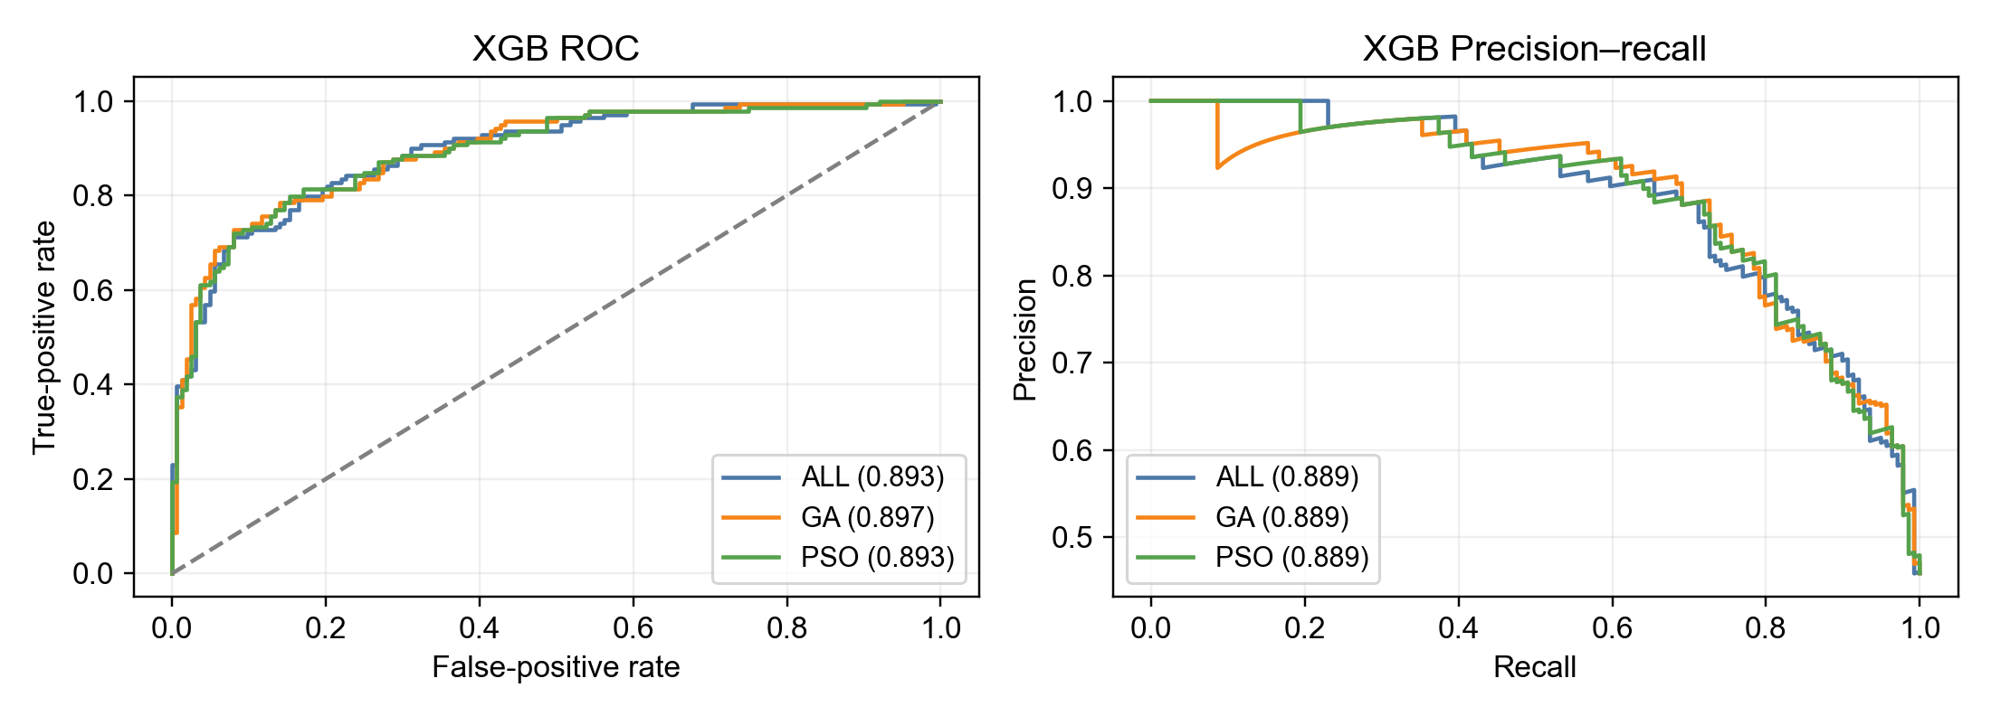
Source: present study, executed workflow.

Figure 4.4
Secondary descriptive calibration of aggregated OOF probabilities; visual proximity to the diagonal did not establish clinical calibration.
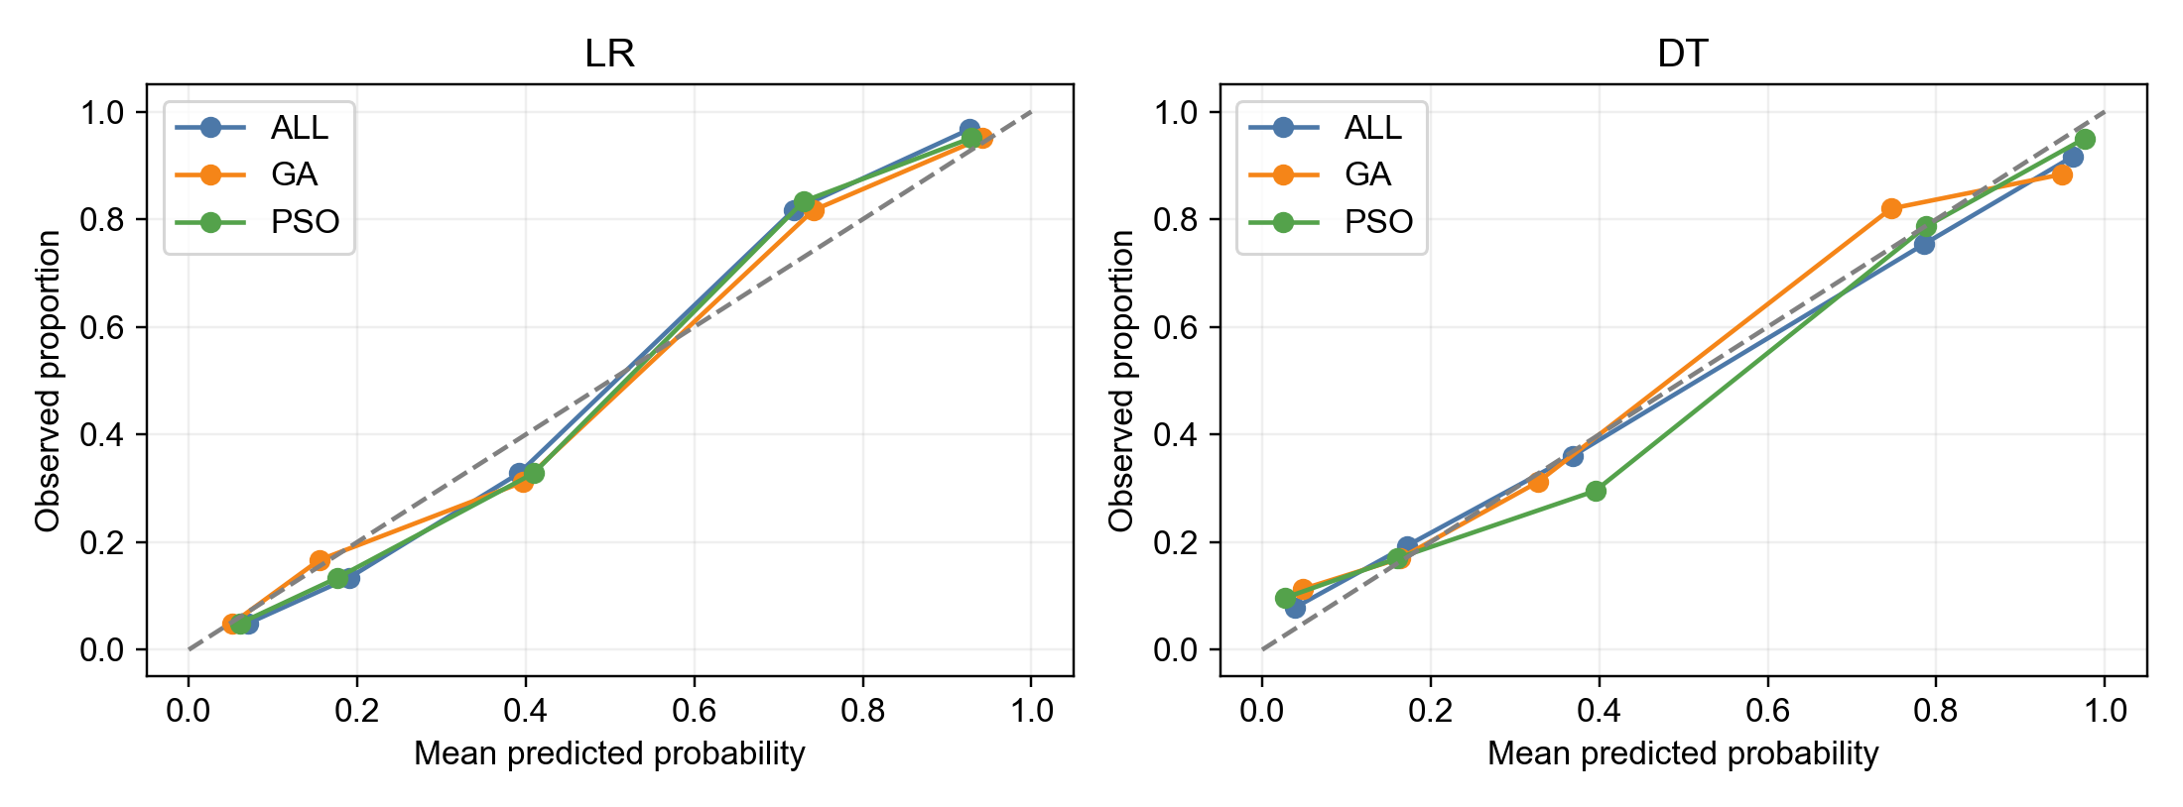
Source: present study, executed workflow.

Figure 4.4 continued
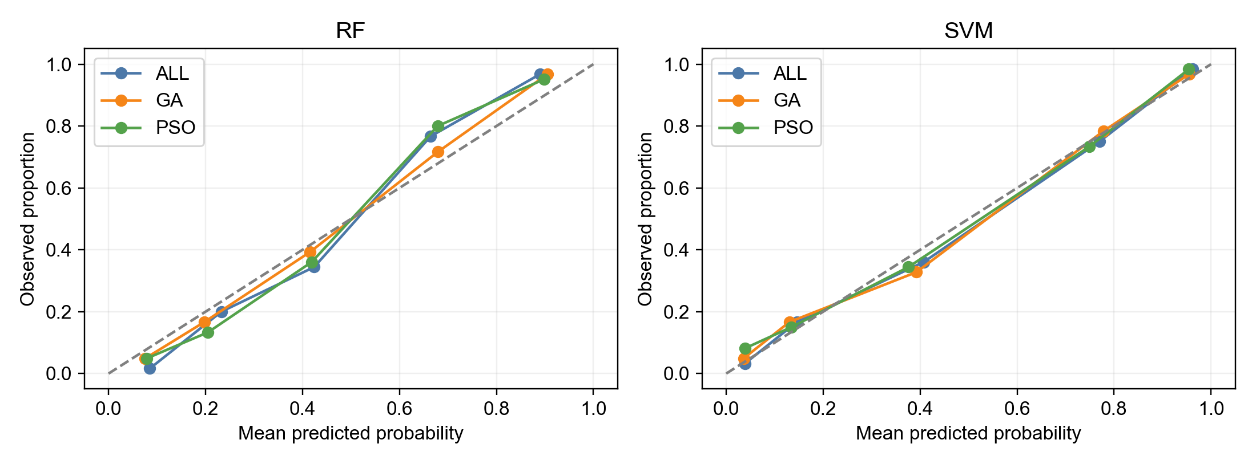
Source: present study, executed workflow.

Figure 4.4 continued
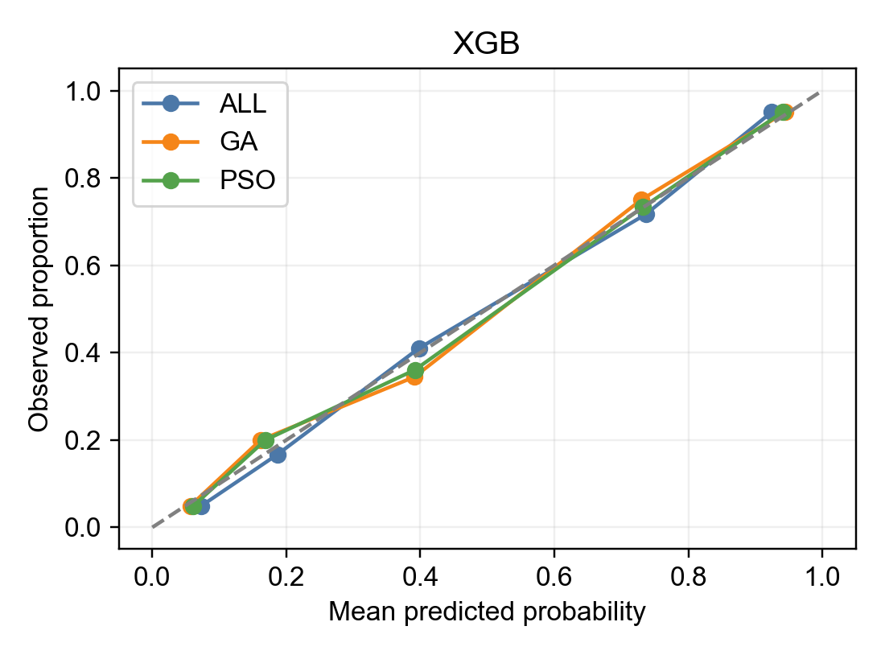
Source: present study, executed workflow.

Figure 4.5
Secondary aggregated OOF ROC-AUC differences with 95% outcome-stratified paired bootstrap intervals conditional on realised aggregated predictions. These were not intervals for paired outer-fold means.
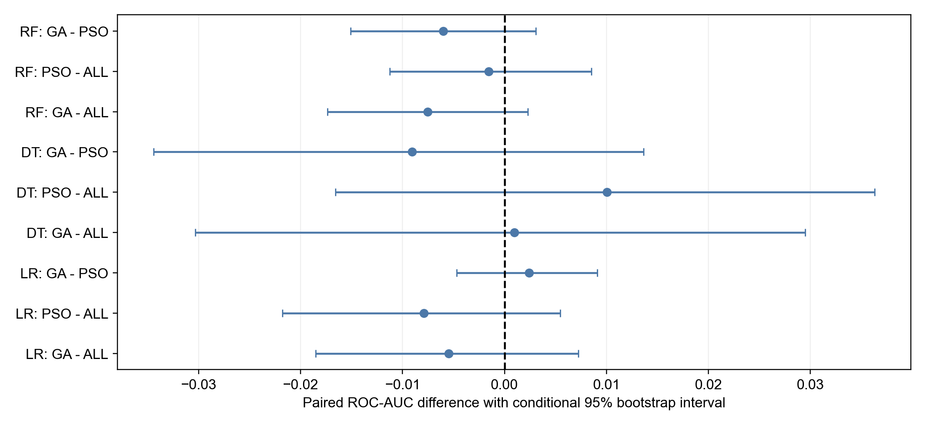
Source: present study, executed workflow.

Figure 4.5 continued
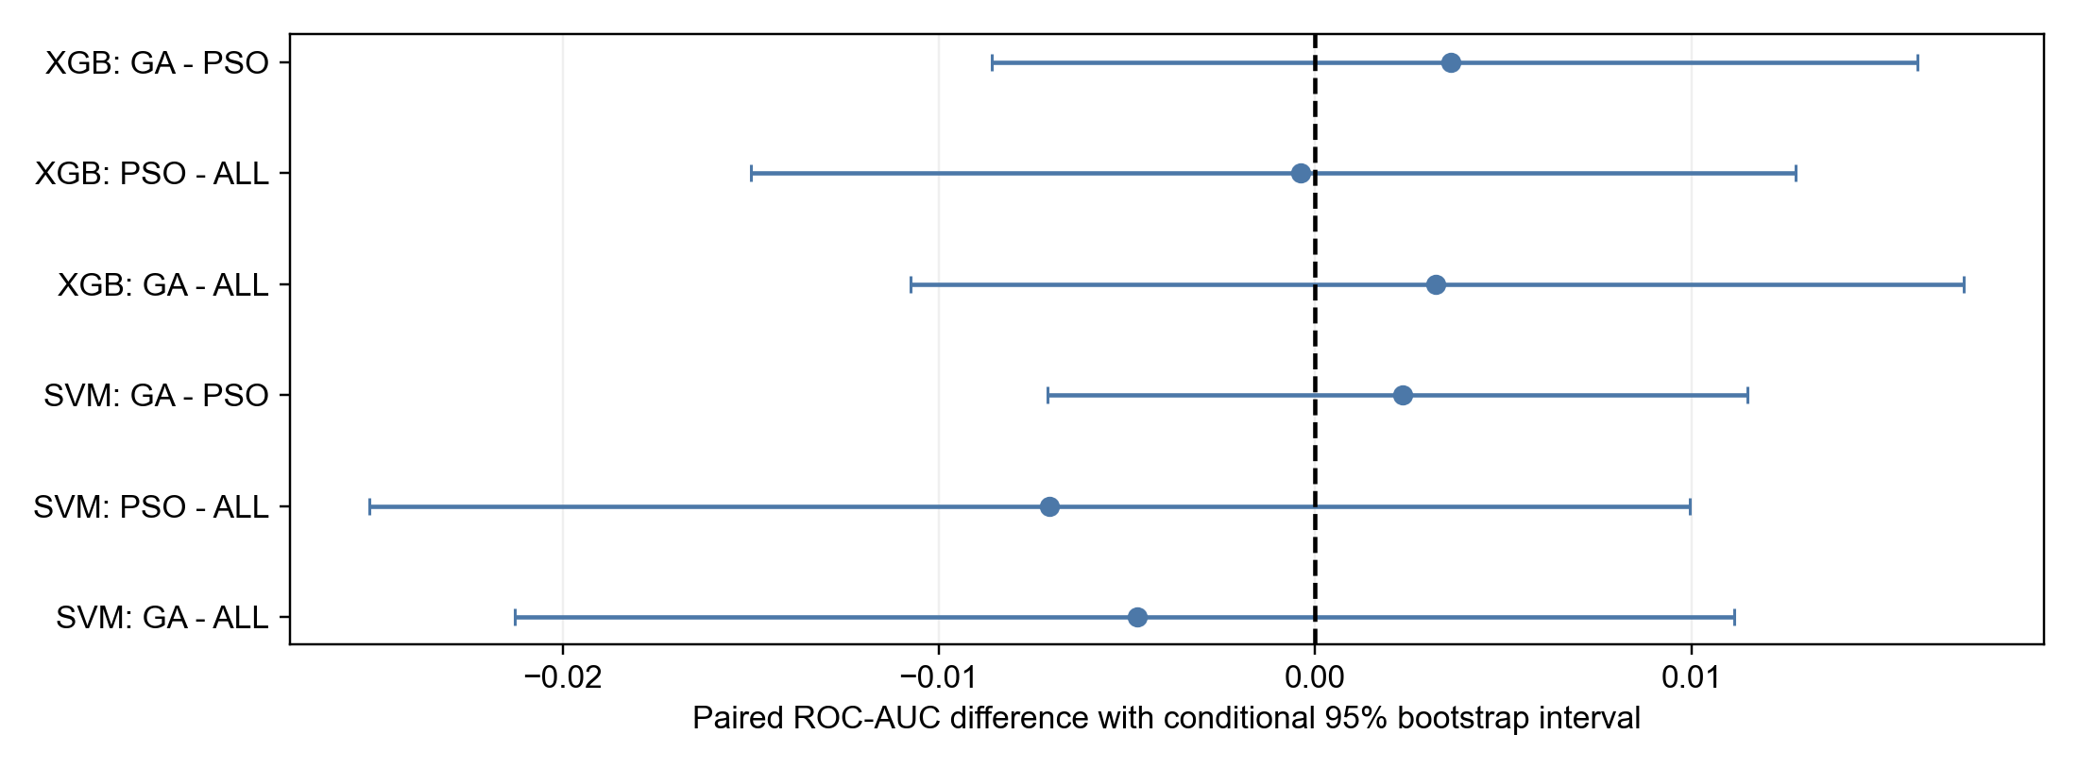
Source: present study, executed workflow.

Electronic supporting records
fold metrics
outer split metadata
aggregated oof performance
descriptive outer fold performance
calibration results
paired bootstrap differences
paired outer fold roc auc differences
outer fold roc auc contrast summary
estimand alignment summary
Verified precision supplement

Appendix C — Individual and aggregated prediction records
These electronic records preserve individual held-out predictions and their repeated-probability aggregation. They are supporting data, not additional participants or a prospectively deployed model.
all outer predictions
aggregated oof predictions

Appendix D — Feature masks, selection frequencies and stability
Prediction-selected masks supplied feature counts and matched GA–PSO overlap. Seed-best masks supplied frequencies and within-classifier stability. Recurrence was not causal or clinical importance.

Complete GA frequencies

Feature-frequency panel 1
Classifier | age | sex | cp | trestbps | chol | fbs | restecg
LR | 0.17 | 0.97 | 1.00 | 0.67 | 0.37 | 0.30 | 0.23
DT | 0.17 | 0.70 | 0.73 | 0.10 | 0.07 | 0.40 | 0.17
RF | 0.77 | 1.00 | 1.00 | 0.30 | 0.20 | 0.33 | 0.63
SVM | 0.47 | 0.97 | 1.00 | 0.47 | 0.30 | 0.27 | 0.63
XGB | 0.77 | 0.80 | 0.90 | 0.10 | 0.27 | 0.60 | 0.37

Feature-frequency panel 2
Classifier | thalach | exang | oldpeak | slope | ca | thal
LR | 0.53 | 0.73 | 0.40 | 0.87 | 1.00 | 0.93
DT | 0.00 | 0.60 | 0.17 | 0.53 | 0.93 | 0.70
RF | 0.27 | 0.50 | 0.57 | 0.87 | 1.00 | 1.00
SVM | 0.63 | 0.53 | 0.57 | 0.87 | 1.00 | 1.00
XGB | 0.13 | 0.57 | 0.37 | 0.70 | 0.97 | 0.97

Complete PSO frequencies

Feature-frequency panel 1
Classifier | age | sex | cp | trestbps | chol | fbs | restecg
LR | 0.10 | 0.93 | 1.00 | 0.60 | 0.50 | 0.37 | 0.30
DT | 0.07 | 0.77 | 0.87 | 0.13 | 0.10 | 0.33 | 0.33
RF | 0.57 | 0.93 | 1.00 | 0.40 | 0.30 | 0.60 | 0.77
SVM | 0.30 | 0.90 | 1.00 | 0.43 | 0.33 | 0.50 | 0.57
XGB | 0.53 | 0.83 | 0.90 | 0.27 | 0.13 | 0.60 | 0.37

Feature-frequency panel 2
Classifier | thalach | exang | oldpeak | slope | ca | thal
LR | 0.50 | 0.70 | 0.23 | 0.90 | 1.00 | 0.97
DT | 0.13 | 0.63 | 0.20 | 0.77 | 0.90 | 0.80
RF | 0.47 | 0.67 | 0.47 | 0.70 | 1.00 | 0.97
SVM | 0.57 | 0.70 | 0.47 | 0.73 | 1.00 | 0.97
XGB | 0.17 | 0.80 | 0.43 | 0.70 | 1.00 | 0.87

Cross-classifier recurrence
Original feature | GA mean cross-classifier frequency | PSO mean cross-classifier frequency
age | 0.47 | 0.31
sex | 0.89 | 0.87
cp | 0.93 | 0.95
trestbps | 0.33 | 0.37
chol | 0.24 | 0.27
fbs | 0.38 | 0.48
restecg | 0.41 | 0.47
thalach | 0.31 | 0.37
exang | 0.59 | 0.70
oldpeak | 0.41 | 0.36
slope | 0.77 | 0.76
ca | 0.98 | 0.98
thal | 0.92 | 0.91

Pairwise Jaccard and Nogueira stability
Classifier | Selector | Seed-best masks | Pairwise Jaccard M | Median | Minimum | Maximum | Nogueira | Status
LR | GA | 30 | 0.62 | 0.62 | 0.33 | 1.00 | 0.36 | estimated
LR | PSO | 30 | 0.63 | 0.62 | 0.27 | 1.00 | 0.37 | estimated
DT | GA | 30 | 0.46 | 0.43 | 0.10 | 1.00 | 0.35 | estimated
DT | PSO | 30 | 0.52 | 0.50 | 0.18 | 1.00 | 0.38 | estimated
RF | GA | 30 | 0.65 | 0.64 | 0.33 | 1.00 | 0.37 | estimated
RF | PSO | 30 | 0.61 | 0.60 | 0.33 | 1.00 | 0.22 | estimated
SVM | GA | 30 | 0.62 | 0.64 | 0.25 | 1.00 | 0.28 | estimated
SVM | PSO | 30 | 0.59 | 0.58 | 0.25 | 1.00 | 0.23 | estimated
XGB | GA | 30 | 0.57 | 0.56 | 0.25 | 1.00 | 0.33 | estimated
XGB | PSO | 30 | 0.56 | 0.56 | 0.18 | 1.00 | 0.30 | estimated

Matched GA–PSO overlap across outer splits
Classifier | Outer split (saved index) | GA–PSO Jaccard | Intersection features | Union features
LR | 0 | 0.89 | 8 | 9
LR | 1 | 0.70 | 7 | 10
LR | 2 | 0.56 | 5 | 9
LR | 3 | 0.86 | 6 | 7
LR | 4 | 1.00 | 8 | 8
LR | 5 | 0.73 | 8 | 11
LR | 6 | 0.90 | 9 | 10
LR | 7 | 0.78 | 7 | 9
LR | 8 | 0.88 | 7 | 8
LR | 9 | 0.67 | 6 | 9
DT | 0 | 0.71 | 5 | 7
DT | 1 | 0.50 | 4 | 8
DT | 2 | 0.80 | 4 | 5
DT | 3 | 1.00 | 6 | 6
DT | 4 | 0.57 | 4 | 7
DT | 5 | 0.25 | 2 | 8
DT | 6 | 0.43 | 3 | 7
DT | 7 | 0.57 | 4 | 7
DT | 8 | 0.44 | 4 | 9
DT | 9 | 0.50 | 4 | 8
RF | 0 | 0.80 | 8 | 10
RF | 1 | 0.88 | 7 | 8
RF | 2 | 1.00 | 8 | 8
RF | 3 | 0.78 | 7 | 9
RF | 4 | 0.78 | 7 | 9
RF | 5 | 0.55 | 6 | 11
RF | 6 | 0.73 | 8 | 11
RF | 7 | 0.70 | 7 | 10
RF | 8 | 0.80 | 8 | 10
RF | 9 | 0.50 | 5 | 10
SVM | 0 | 0.64 | 7 | 11
SVM | 1 | 0.70 | 7 | 10
SVM | 2 | 0.89 | 8 | 9
SVM | 3 | 1.00 | 8 | 8
SVM | 4 | 0.80 | 8 | 10
SVM | 5 | 0.89 | 8 | 9
SVM | 6 | 0.89 | 8 | 9
SVM | 7 | 0.80 | 8 | 10
SVM | 8 | 0.90 | 9 | 10
SVM | 9 | 0.50 | 5 | 10
XGB | 0 | 1.00 | 9 | 9
XGB | 1 | 0.62 | 5 | 8
XGB | 2 | 1.00 | 9 | 9
XGB | 3 | 0.60 | 6 | 10
XGB | 4 | 0.88 | 7 | 8
XGB | 5 | 0.44 | 4 | 9
XGB | 6 | 0.70 | 7 | 10
XGB | 7 | 0.60 | 6 | 10
XGB | 8 | 0.62 | 5 | 8
XGB | 9 | 0.78 | 7 | 9

Figure 4.6a
GA selection frequencies over seed-best masks, not causal importance.
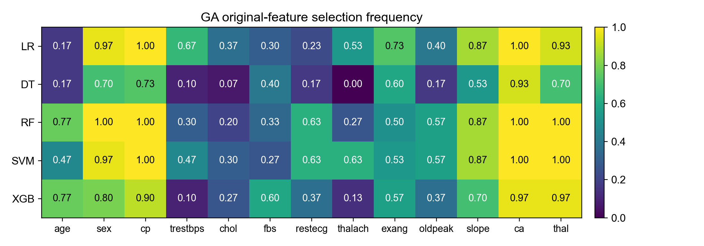
Source: present study, executed workflow.

Figure 4.6b
PSO selection frequencies over seed-best masks, not causal importance.
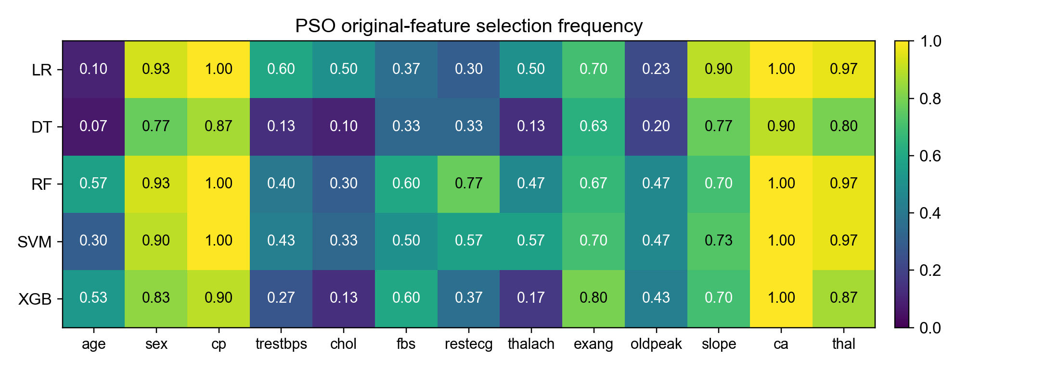
Source: present study, executed workflow.

Electronic supporting records
selected masks
selected feature counts
feature selection frequencies
cross classifier consensus
ga pso overlap
stability jaccard nogueira

Appendix E — Hyperparameter grids and selected configurations

E.1 Tuning context
The following tables reproduce the saved condition-specific tuning grid and selected parameter records. Grid-search ROC-AUC used frozen inner partitions within outer training. Selection preceded tuning; the inner partitions were reused, and selection was not repeated within every tuning/calibration fold. The selected inner scores are optimisation records, not unbiased held-out performance estimates. ALL used every original predictor; GA and PSO used their prediction-selected original-variable masks before condition-specific tuning.
LR = logistic regression; DT = decision tree; RF = random forest; SVM = support vector machine; XGB = extreme gradient boosting; ALL = all-feature condition; GA = genetic algorithm; PSO = particle swarm optimisation; ROC-AUC = area under the receiver operating characteristic curve. Parameter names preserve the pipeline's model__ prefix. Encoded column widths are not inferred from the masks.
Table E.1
Complete saved hyperparameter grids
Classifier | Pipeline parameter | Candidate values
LR | model__C | [0.1, 1.0, 10.0]
DT | model__max_depth | [None, 3, 5]
DT | model__min_samples_leaf | [1, 5, 10]
RF | model__n_estimators | [150, 300]
RF | model__max_depth | [None, 5]
RF | model__min_samples_leaf | [1, 5]
SVM | model__C | [0.1, 1.0, 10.0]
SVM | model__gamma | ['scale', 0.01, 0.1]
XGB | model__n_estimators | [100, 200]
XGB | model__max_depth | [2, 3]
XGB | model__learning_rate | [0.03, 0.1]

Note. Candidate lists are reproduced from the saved grid table. None is the recorded unset limit, not a missing result. These were final condition-specific tuning grids, not a claim that every wrapper fitness evaluation used this full grid. Fixed wrapper settings are documented in the Methodology and executed Method Register.

E.2 Selected configurations by outer split
Table E.2
Selected parameters and recorded inner scores for all classifier–condition records
Outer split | Classifier | Condition | Selected parameters | Best inner ROC-AUC | Training calibration
0 | LR | ALL | {"model__C": 0.1} | 0.894 | Not used
0 | LR | GA | {"model__C": 0.1} | 0.900 | Not used
0 | LR | PSO | {"model__C": 0.1} | 0.899 | Not used
0 | DT | ALL | {"model__max_depth": 3, "model__min_samples_leaf": 5} | 0.813 | Not used
0 | DT | GA | {"model__max_depth": null, "model__min_samples_leaf": 5} | 0.840 | Not used
0 | DT | PSO | {"model__max_depth": null, "model__min_samples_leaf": 10} | 0.842 | Not used
0 | RF | ALL | {"model__max_depth": 5, "model__min_samples_leaf": 5, "model__n_estimators": 300} | 0.886 | Not used
0 | RF | GA | {"model__max_depth": 5, "model__min_samples_leaf": 5, "model__n_estimators": 300} | 0.893 | Not used
0 | RF | PSO | {"model__max_depth": null, "model__min_samples_leaf": 5, "model__n_estimators": 150} | 0.895 | Not used
0 | SVM | ALL | {"model__C": 1.0, "model__gamma": 0.01} | 0.891 | sigmoid
0 | SVM | GA | {"model__C": 1.0, "model__gamma": 0.01} | 0.893 | sigmoid
0 | SVM | PSO | {"model__C": 10.0, "model__gamma": 0.01} | 0.899 | sigmoid
0 | XGB | ALL | {"model__learning_rate": 0.03, "model__max_depth": 2, "model__n_estimators": 100} | 0.860 | Not used
0 | XGB | GA | {"model__learning_rate": 0.1, "model__max_depth": 2, "model__n_estimators": 200} | 0.883 | Not used
0 | XGB | PSO | {"model__learning_rate": 0.1, "model__max_depth": 2, "model__n_estimators": 200} | 0.883 | Not used
1 | LR | ALL | {"model__C": 0.1} | 0.920 | Not used
1 | LR | GA | {"model__C": 0.1} | 0.932 | Not used
1 | LR | PSO | {"model__C": 0.1} | 0.930 | Not used
1 | DT | ALL | {"model__max_depth": 3, "model__min_samples_leaf": 10} | 0.835 | Not used
1 | DT | GA | {"model__max_depth": 3, "model__min_samples_leaf": 10} | 0.914 | Not used
1 | DT | PSO | {"model__max_depth": null, "model__min_samples_leaf": 5} | 0.903 | Not used
1 | RF | ALL | {"model__max_depth": 5, "model__min_samples_leaf": 1, "model__n_estimators": 150} | 0.923 | Not used
1 | RF | GA | {"model__max_depth": 5, "model__min_samples_leaf": 1, "model__n_estimators": 150} | 0.926 | Not used
1 | RF | PSO | {"model__max_depth": 5, "model__min_samples_leaf": 1, "model__n_estimators": 150} | 0.928 | Not used
1 | SVM | ALL | {"model__C": 1.0, "model__gamma": 0.01} | 0.923 | sigmoid
1 | SVM | GA | {"model__C": 1.0, "model__gamma": 0.01} | 0.929 | sigmoid
1 | SVM | PSO | {"model__C": 1.0, "model__gamma": "scale"} | 0.927 | sigmoid
1 | XGB | ALL | {"model__learning_rate": 0.03, "model__max_depth": 2, "model__n_estimators": 100} | 0.896 | Not used
1 | XGB | GA | {"model__learning_rate": 0.03, "model__max_depth": 2, "model__n_estimators": 100} | 0.920 | Not used
1 | XGB | PSO | {"model__learning_rate": 0.03, "model__max_depth": 2, "model__n_estimators": 100} | 0.924 | Not used
2 | LR | ALL | {"model__C": 0.1} | 0.899 | Not used
2 | LR | GA | {"model__C": 1.0} | 0.914 | Not used
2 | LR | PSO | {"model__C": 1.0} | 0.909 | Not used
2 | DT | ALL | {"model__max_depth": null, "model__min_samples_leaf": 10} | 0.851 | Not used
2 | DT | GA | {"model__max_depth": null, "model__min_samples_leaf": 5} | 0.885 | Not used
2 | DT | PSO | {"model__max_depth": 5, "model__min_samples_leaf": 5} | 0.876 | Not used
2 | RF | ALL | {"model__max_depth": 5, "model__min_samples_leaf": 5, "model__n_estimators": 300} | 0.904 | Not used
2 | RF | GA | {"model__max_depth": 5, "model__min_samples_leaf": 1, "model__n_estimators": 150} | 0.908 | Not used
2 | RF | PSO | {"model__max_depth": 5, "model__min_samples_leaf": 1, "model__n_estimators": 150} | 0.908 | Not used
2 | SVM | ALL | {"model__C": 1.0, "model__gamma": 0.01} | 0.901 | sigmoid
2 | SVM | GA | {"model__C": 10.0, "model__gamma": 0.01} | 0.912 | sigmoid
2 | SVM | PSO | {"model__C": 10.0, "model__gamma": 0.01} | 0.913 | sigmoid
2 | XGB | ALL | {"model__learning_rate": 0.03, "model__max_depth": 2, "model__n_estimators": 200} | 0.893 | Not used
2 | XGB | GA | {"model__learning_rate": 0.1, "model__max_depth": 2, "model__n_estimators": 100} | 0.907 | Not used
2 | XGB | PSO | {"model__learning_rate": 0.1, "model__max_depth": 2, "model__n_estimators": 100} | 0.907 | Not used
3 | LR | ALL | {"model__C": 0.1} | 0.917 | Not used
3 | LR | GA | {"model__C": 1.0} | 0.930 | Not used
3 | LR | PSO | {"model__C": 1.0} | 0.929 | Not used
3 | DT | ALL | {"model__max_depth": 3, "model__min_samples_leaf": 1} | 0.833 | Not used
3 | DT | GA | {"model__max_depth": null, "model__min_samples_leaf": 10} | 0.892 | Not used
3 | DT | PSO | {"model__max_depth": null, "model__min_samples_leaf": 10} | 0.892 | Not used
3 | RF | ALL | {"model__max_depth": null, "model__min_samples_leaf": 5, "model__n_estimators": 150} | 0.918 | Not used
3 | RF | GA | {"model__max_depth": null, "model__min_samples_leaf": 5, "model__n_estimators": 300} | 0.922 | Not used
3 | RF | PSO | {"model__max_depth": 5, "model__min_samples_leaf": 5, "model__n_estimators": 300} | 0.924 | Not used
3 | SVM | ALL | {"model__C": 1.0, "model__gamma": 0.01} | 0.914 | sigmoid
3 | SVM | GA | {"model__C": 10.0, "model__gamma": 0.01} | 0.924 | sigmoid
3 | SVM | PSO | {"model__C": 10.0, "model__gamma": 0.01} | 0.924 | sigmoid
3 | XGB | ALL | {"model__learning_rate": 0.03, "model__max_depth": 2, "model__n_estimators": 100} | 0.903 | Not used
3 | XGB | GA | {"model__learning_rate": 0.03, "model__max_depth": 2, "model__n_estimators": 200} | 0.919 | Not used
3 | XGB | PSO | {"model__learning_rate": 0.03, "model__max_depth": 2, "model__n_estimators": 200} | 0.916 | Not used
4 | LR | ALL | {"model__C": 0.1} | 0.906 | Not used
4 | LR | GA | {"model__C": 0.1} | 0.926 | Not used
4 | LR | PSO | {"model__C": 0.1} | 0.926 | Not used
4 | DT | ALL | {"model__max_depth": 3, "model__min_samples_leaf": 10} | 0.833 | Not used
4 | DT | GA | {"model__max_depth": 5, "model__min_samples_leaf": 5} | 0.880 | Not used
4 | DT | PSO | {"model__max_depth": null, "model__min_samples_leaf": 5} | 0.871 | Not used
4 | RF | ALL | {"model__max_depth": null, "model__min_samples_leaf": 5, "model__n_estimators": 150} | 0.911 | Not used
4 | RF | GA | {"model__max_depth": 5, "model__min_samples_leaf": 1, "model__n_estimators": 150} | 0.917 | Not used
4 | RF | PSO | {"model__max_depth": null, "model__min_samples_leaf": 5, "model__n_estimators": 150} | 0.916 | Not used
4 | SVM | ALL | {"model__C": 1.0, "model__gamma": 0.01} | 0.910 | sigmoid
4 | SVM | GA | {"model__C": 10.0, "model__gamma": 0.01} | 0.921 | sigmoid
4 | SVM | PSO | {"model__C": 10.0, "model__gamma": 0.01} | 0.923 | sigmoid
4 | XGB | ALL | {"model__learning_rate": 0.1, "model__max_depth": 2, "model__n_estimators": 200} | 0.894 | Not used
4 | XGB | GA | {"model__learning_rate": 0.03, "model__max_depth": 2, "model__n_estimators": 200} | 0.912 | Not used
4 | XGB | PSO | {"model__learning_rate": 0.03, "model__max_depth": 2, "model__n_estimators": 200} | 0.910 | Not used
5 | LR | ALL | {"model__C": 1.0} | 0.910 | Not used
5 | LR | GA | {"model__C": 1.0} | 0.917 | Not used
5 | LR | PSO | {"model__C": 1.0} | 0.915 | Not used
5 | DT | ALL | {"model__max_depth": 3, "model__min_samples_leaf": 10} | 0.818 | Not used
5 | DT | GA | {"model__max_depth": null, "model__min_samples_leaf": 5} | 0.889 | Not used
5 | DT | PSO | {"model__max_depth": 3, "model__min_samples_leaf": 5} | 0.860 | Not used
5 | RF | ALL | {"model__max_depth": 5, "model__min_samples_leaf": 5, "model__n_estimators": 150} | 0.905 | Not used
5 | RF | GA | {"model__max_depth": 5, "model__min_samples_leaf": 5, "model__n_estimators": 300} | 0.916 | Not used
5 | RF | PSO | {"model__max_depth": null, "model__min_samples_leaf": 5, "model__n_estimators": 150} | 0.914 | Not used
5 | SVM | ALL | {"model__C": 1.0, "model__gamma": 0.01} | 0.904 | sigmoid
5 | SVM | GA | {"model__C": 10.0, "model__gamma": 0.01} | 0.914 | sigmoid
5 | SVM | PSO | {"model__C": 10.0, "model__gamma": 0.01} | 0.913 | sigmoid
5 | XGB | ALL | {"model__learning_rate": 0.03, "model__max_depth": 2, "model__n_estimators": 200} | 0.883 | Not used
5 | XGB | GA | {"model__learning_rate": 0.1, "model__max_depth": 2, "model__n_estimators": 100} | 0.902 | Not used
5 | XGB | PSO | {"model__learning_rate": 0.03, "model__max_depth": 3, "model__n_estimators": 200} | 0.895 | Not used
6 | LR | ALL | {"model__C": 1.0} | 0.926 | Not used
6 | LR | GA | {"model__C": 1.0} | 0.932 | Not used
6 | LR | PSO | {"model__C": 1.0} | 0.929 | Not used
6 | DT | ALL | {"model__max_depth": null, "model__min_samples_leaf": 10} | 0.812 | Not used
6 | DT | GA | {"model__max_depth": null, "model__min_samples_leaf": 10} | 0.895 | Not used
6 | DT | PSO | {"model__max_depth": 5, "model__min_samples_leaf": 5} | 0.875 | Not used
6 | RF | ALL | {"model__max_depth": null, "model__min_samples_leaf": 5, "model__n_estimators": 150} | 0.916 | Not used
6 | RF | GA | {"model__max_depth": 5, "model__min_samples_leaf": 1, "model__n_estimators": 150} | 0.921 | Not used
6 | RF | PSO | {"model__max_depth": 5, "model__min_samples_leaf": 5, "model__n_estimators": 150} | 0.917 | Not used
6 | SVM | ALL | {"model__C": 10.0, "model__gamma": 0.01} | 0.919 | sigmoid
6 | SVM | GA | {"model__C": 1.0, "model__gamma": "scale"} | 0.922 | sigmoid
6 | SVM | PSO | {"model__C": 10.0, "model__gamma": 0.01} | 0.921 | sigmoid
6 | XGB | ALL | {"model__learning_rate": 0.1, "model__max_depth": 2, "model__n_estimators": 100} | 0.893 | Not used
6 | XGB | GA | {"model__learning_rate": 0.1, "model__max_depth": 2, "model__n_estimators": 200} | 0.908 | Not used
6 | XGB | PSO | {"model__learning_rate": 0.1, "model__max_depth": 2, "model__n_estimators": 100} | 0.911 | Not used
7 | LR | ALL | {"model__C": 0.1} | 0.924 | Not used
7 | LR | GA | {"model__C": 1.0} | 0.937 | Not used
7 | LR | PSO | {"model__C": 10.0} | 0.936 | Not used
7 | DT | ALL | {"model__max_depth": null, "model__min_samples_leaf": 5} | 0.844 | Not used
7 | DT | GA | {"model__max_depth": 3, "model__min_samples_leaf": 10} | 0.894 | Not used
7 | DT | PSO | {"model__max_depth": 5, "model__min_samples_leaf": 5} | 0.887 | Not used
7 | RF | ALL | {"model__max_depth": null, "model__min_samples_leaf": 1, "model__n_estimators": 150} | 0.939 | Not used
7 | RF | GA | {"model__max_depth": 5, "model__min_samples_leaf": 1, "model__n_estimators": 300} | 0.941 | Not used
7 | RF | PSO | {"model__max_depth": null, "model__min_samples_leaf": 5, "model__n_estimators": 300} | 0.938 | Not used
7 | SVM | ALL | {"model__C": 1.0, "model__gamma": 0.1} | 0.930 | sigmoid
7 | SVM | GA | {"model__C": 1.0, "model__gamma": "scale"} | 0.943 | sigmoid
7 | SVM | PSO | {"model__C": 1.0, "model__gamma": "scale"} | 0.937 | sigmoid
7 | XGB | ALL | {"model__learning_rate": 0.1, "model__max_depth": 2, "model__n_estimators": 200} | 0.932 | Not used
7 | XGB | GA | {"model__learning_rate": 0.1, "model__max_depth": 3, "model__n_estimators": 100} | 0.940 | Not used
7 | XGB | PSO | {"model__learning_rate": 0.03, "model__max_depth": 3, "model__n_estimators": 200} | 0.929 | Not used
8 | LR | ALL | {"model__C": 0.1} | 0.890 | Not used
8 | LR | GA | {"model__C": 1.0} | 0.905 | Not used
8 | LR | PSO | {"model__C": 0.1} | 0.905 | Not used
8 | DT | ALL | {"model__max_depth": 3, "model__min_samples_leaf": 10} | 0.816 | Not used
8 | DT | GA | {"model__max_depth": null, "model__min_samples_leaf": 5} | 0.873 | Not used
8 | DT | PSO | {"model__max_depth": null, "model__min_samples_leaf": 5} | 0.870 | Not used
8 | RF | ALL | {"model__max_depth": null, "model__min_samples_leaf": 5, "model__n_estimators": 300} | 0.896 | Not used
8 | RF | GA | {"model__max_depth": null, "model__min_samples_leaf": 5, "model__n_estimators": 300} | 0.899 | Not used
8 | RF | PSO | {"model__max_depth": 5, "model__min_samples_leaf": 1, "model__n_estimators": 300} | 0.900 | Not used
8 | SVM | ALL | {"model__C": 1.0, "model__gamma": 0.01} | 0.893 | sigmoid
8 | SVM | GA | {"model__C": 1.0, "model__gamma": "scale"} | 0.901 | sigmoid
8 | SVM | PSO | {"model__C": 1.0, "model__gamma": 0.1} | 0.899 | sigmoid
8 | XGB | ALL | {"model__learning_rate": 0.03, "model__max_depth": 2, "model__n_estimators": 100} | 0.864 | Not used
8 | XGB | GA | {"model__learning_rate": 0.03, "model__max_depth": 3, "model__n_estimators": 100} | 0.894 | Not used
8 | XGB | PSO | {"model__learning_rate": 0.03, "model__max_depth": 2, "model__n_estimators": 100} | 0.891 | Not used
9 | LR | ALL | {"model__C": 0.1} | 0.905 | Not used
9 | LR | GA | {"model__C": 1.0} | 0.919 | Not used
9 | LR | PSO | {"model__C": 0.1} | 0.919 | Not used
9 | DT | ALL | {"model__max_depth": null, "model__min_samples_leaf": 10} | 0.820 | Not used
9 | DT | GA | {"model__max_depth": null, "model__min_samples_leaf": 5} | 0.876 | Not used
9 | DT | PSO | {"model__max_depth": 5, "model__min_samples_leaf": 5} | 0.862 | Not used
9 | RF | ALL | {"model__max_depth": 5, "model__min_samples_leaf": 5, "model__n_estimators": 300} | 0.907 | Not used
9 | RF | GA | {"model__max_depth": 5, "model__min_samples_leaf": 1, "model__n_estimators": 300} | 0.913 | Not used
9 | RF | PSO | {"model__max_depth": 5, "model__min_samples_leaf": 5, "model__n_estimators": 150} | 0.910 | Not used
9 | SVM | ALL | {"model__C": 1.0, "model__gamma": 0.01} | 0.904 | sigmoid
9 | SVM | GA | {"model__C": 1.0, "model__gamma": 0.1} | 0.914 | sigmoid
9 | SVM | PSO | {"model__C": 10.0, "model__gamma": 0.01} | 0.911 | sigmoid
9 | XGB | ALL | {"model__learning_rate": 0.03, "model__max_depth": 2, "model__n_estimators": 100} | 0.888 | Not used
9 | XGB | GA | {"model__learning_rate": 0.03, "model__max_depth": 3, "model__n_estimators": 100} | 0.910 | Not used
9 | XGB | PSO | {"model__learning_rate": 0.03, "model__max_depth": 2, "model__n_estimators": 100} | 0.912 | Not used

Note. Split identifiers are the saved zero-based indices. Inner scores are displayed to three decimals; the electronic record preserves saved precision, runtime, calibration ensemble fields and training hashes. Rows cover every classifier under ALL, GA and PSO on each saved outer split. Sigmoid calibration was specific to SVM within outer training; it was separate from secondary calibration assessment of aggregated predictions. Reused selection/hyperparameter choices limit independence of training-stage calibration predictions.

E.3 Supporting electronic records
Record | Purpose | Electronic evidence
model_tuning_grids.csv | Complete candidate grid | Full record
tuning_results.json | Canonical complete selected configurations | Full record

The saved best-hyperparameters alias was byte-identical to the canonical tuning record. It is not an independent replication or additional tuning run. Source identities and table-rendering checks are documented in the separate appendix audit; no model was refitted to produce this appendix.

Appendix F — Optimiser runs, computational accounting and histories
Runtime, attempts, unique requests, cache events and stopping labels were separate quantities. Shared cache contexts and equal request caps did not equalise actual fits or elapsed time.

Runtime with robust summaries and observed limits
Classifier | Selector | Runs | M (s) | SD (s) | Median (s) | IQR (s) | Minimum (s) | Maximum (s)
LR | GA | 30 | 14.47 | 2.97 | 15.21 | 4.27 | 7.74 | 18.54
LR | PSO | 30 | 8.10 | 1.54 | 7.62 | 2.29 | 5.42 | 10.78
DT | GA | 30 | 14.46 | 1.83 | 14.48 | 2.72 | 11.18 | 17.46
DT | PSO | 30 | 9.50 | 1.70 | 9.90 | 1.45 | 5.43 | 13.16
RF | GA | 30 | 112.65 | 20.65 | 109.36 | 27.98 | 67.28 | 161.78
RF | PSO | 30 | 64.56 | 11.50 | 67.10 | 13.25 | 40.25 | 86.78
SVM | GA | 30 | 15.63 | 3.45 | 16.70 | 3.83 | 7.58 | 20.15
SVM | PSO | 30 | 9.17 | 2.19 | 9.85 | 2.32 | 4.49 | 12.15
XGB | GA | 30 | 31.12 | 5.18 | 31.20 | 7.50 | 18.66 | 38.88
XGB | PSO | 30 | 17.16 | 4.24 | 18.55 | 6.32 | 8.27 | 23.73

Complete request and cache accounting
Classifier | Selector | Counter | Runs | M | SD | Median | Minimum | Maximum | Total
LR | GA | attempted_evaluations | 30 | 145.77 | 4.63 | 145.50 | 137.00 | 153.00 | 4373.00
LR | GA | unique_requested | 30 | 123.07 | 6.83 | 122.50 | 107.00 | 134.00 | 3692.00
LR | GA | cache_hits | 30 | 32.47 | 13.71 | 28.50 | 14.00 | 61.00 | 974.00
LR | GA | cache_misses | 30 | 113.30 | 16.56 | 116.50 | 80.00 | 134.00 | 3399.00
LR | PSO | attempted_evaluations | 30 | 160.00 | 0.00 | 160.00 | 160.00 | 160.00 | 4800.00
LR | PSO | unique_requested | 30 | 86.07 | 10.78 | 81.50 | 67.00 | 103.00 | 2582.00
LR | PSO | cache_hits | 30 | 99.13 | 10.39 | 103.00 | 81.00 | 120.00 | 2974.00
LR | PSO | cache_misses | 30 | 60.87 | 10.39 | 57.00 | 40.00 | 79.00 | 1826.00
DT | GA | attempted_evaluations | 30 | 149.43 | 5.80 | 150.50 | 141.00 | 162.00 | 4483.00
DT | GA | unique_requested | 30 | 124.50 | 7.05 | 124.00 | 111.00 | 139.00 | 3735.00
DT | GA | cache_hits | 30 | 33.77 | 9.55 | 33.00 | 16.00 | 53.00 | 1013.00
DT | GA | cache_misses | 30 | 115.67 | 13.71 | 117.00 | 88.00 | 139.00 | 3470.00
DT | PSO | attempted_evaluations | 30 | 160.00 | 0.00 | 160.00 | 160.00 | 160.00 | 4800.00
DT | PSO | unique_requested | 30 | 100.63 | 8.61 | 101.00 | 78.00 | 121.00 | 3019.00
DT | PSO | cache_hits | 30 | 83.10 | 9.20 | 81.50 | 58.00 | 105.00 | 2493.00
DT | PSO | cache_misses | 30 | 76.90 | 9.20 | 78.50 | 55.00 | 102.00 | 2307.00
RF | GA | attempted_evaluations | 30 | 146.03 | 4.77 | 145.00 | 139.00 | 156.00 | 4381.00
RF | GA | unique_requested | 30 | 122.60 | 7.05 | 121.50 | 113.00 | 139.00 | 3678.00
RF | GA | cache_hits | 30 | 32.17 | 11.40 | 29.50 | 15.00 | 55.00 | 965.00
RF | GA | cache_misses | 30 | 113.87 | 13.95 | 116.50 | 90.00 | 139.00 | 3416.00
RF | PSO | attempted_evaluations | 30 | 160.00 | 0.00 | 160.00 | 160.00 | 160.00 | 4800.00
RF | PSO | unique_requested | 30 | 90.10 | 7.92 | 90.50 | 74.00 | 108.00 | 2703.00
RF | PSO | cache_hits | 30 | 93.87 | 7.42 | 92.50 | 77.00 | 109.00 | 2816.00
RF | PSO | cache_misses | 30 | 66.13 | 7.42 | 67.50 | 51.00 | 83.00 | 1984.00
SVM | GA | attempted_evaluations | 30 | 147.47 | 4.72 | 147.00 | 136.00 | 158.00 | 4424.00
SVM | GA | unique_requested | 30 | 123.43 | 6.33 | 123.50 | 113.00 | 135.00 | 3703.00
SVM | GA | cache_hits | 30 | 32.70 | 10.68 | 30.50 | 19.00 | 55.00 | 981.00
SVM | GA | cache_misses | 30 | 114.77 | 13.14 | 115.00 | 92.00 | 135.00 | 3443.00
SVM | PSO | attempted_evaluations | 30 | 160.00 | 0.00 | 160.00 | 160.00 | 160.00 | 4800.00
SVM | PSO | unique_requested | 30 | 90.83 | 9.20 | 90.00 | 77.00 | 112.00 | 2725.00
SVM | PSO | cache_hits | 30 | 93.40 | 8.10 | 93.00 | 79.00 | 106.00 | 2802.00
SVM | PSO | cache_misses | 30 | 66.60 | 8.10 | 67.00 | 54.00 | 81.00 | 1998.00
XGB | GA | attempted_evaluations | 30 | 148.70 | 5.59 | 148.00 | 140.00 | 159.00 | 4461.00
XGB | GA | unique_requested | 30 | 125.03 | 7.71 | 125.00 | 113.00 | 142.00 | 3751.00
XGB | GA | cache_hits | 30 | 32.27 | 11.57 | 29.50 | 14.00 | 58.00 | 968.00
XGB | GA | cache_misses | 30 | 116.43 | 15.09 | 117.00 | 89.00 | 142.00 | 3493.00
XGB | PSO | attempted_evaluations | 30 | 160.00 | 0.00 | 160.00 | 160.00 | 160.00 | 4800.00
XGB | PSO | unique_requested | 30 | 92.00 | 9.90 | 90.50 | 74.00 | 107.00 | 2760.00
XGB | PSO | cache_hits | 30 | 92.50 | 9.64 | 91.00 | 75.00 | 116.00 | 2775.00
XGB | PSO | cache_misses | 30 | 67.50 | 9.64 | 69.00 | 44.00 | 85.00 | 2025.00

Termination and recorded-history behaviour
Classifier | Selector | Histories with a decrease | Saved termination label | Runs with label
LR | GA | 0 | generation limit | 30
LR | PSO | 10 | fixed matched evaluation batches | 30
DT | GA | 0 | generation limit | 30
DT | PSO | 8 | fixed matched evaluation batches | 30
RF | GA | 0 | generation limit | 30
RF | PSO | 6 | fixed matched evaluation batches | 30
SVM | GA | 0 | generation limit | 30
SVM | PSO | 10 | fixed matched evaluation batches | 30
XGB | GA | 0 | generation limit | 30
XGB | PSO | 10 | fixed matched evaluation batches | 30

Figure 4.7 panel 1
Parsimony, stability, optimiser runtime and unique requests. The existing display bars were seaborn bootstrap display intervals, not sample SD or paired hypothesis intervals.
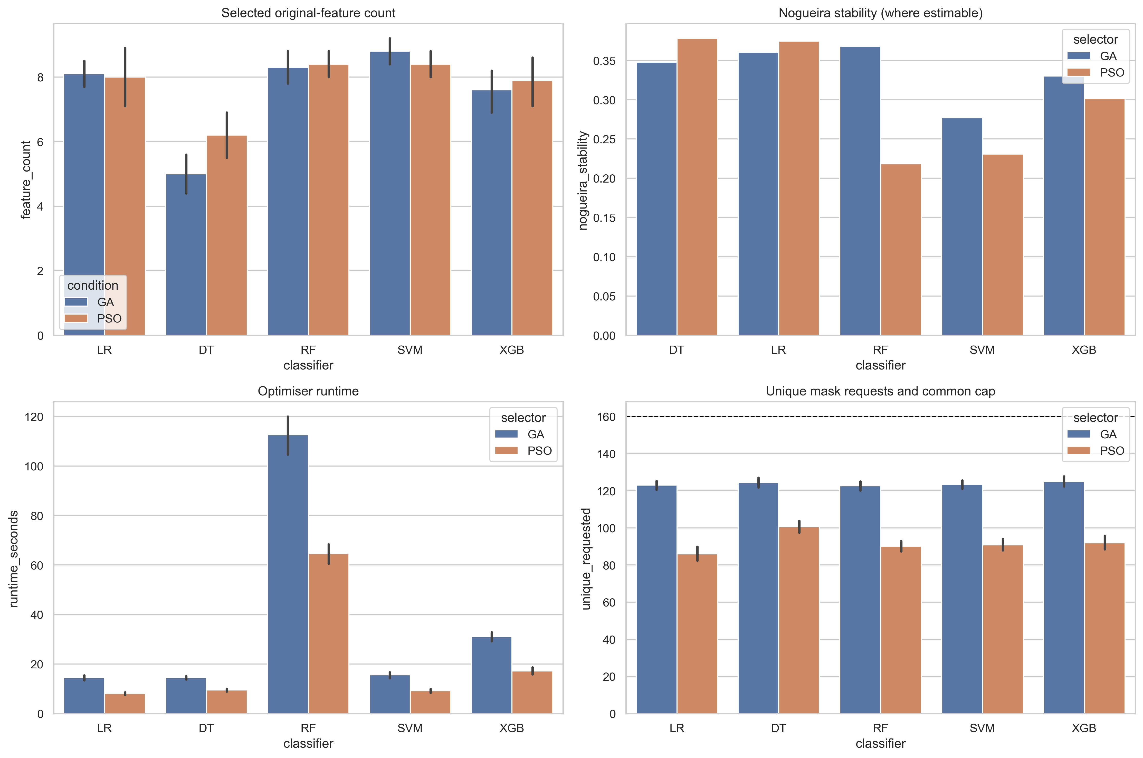
Source: present study, executed workflow.

Figure 4.7 panel 2
Source: present study, executed workflow.

Figure 4.7 panel 3
Source: present study, executed workflow.

Figure 4.7 panel 4
Source: present study, executed workflow.

Figure 4.8 LR
Recorded optimiser histories. PSO curves were negated cost histories, not uniformly monotone best-so-far trajectories; stopping did not establish predictive superiority.
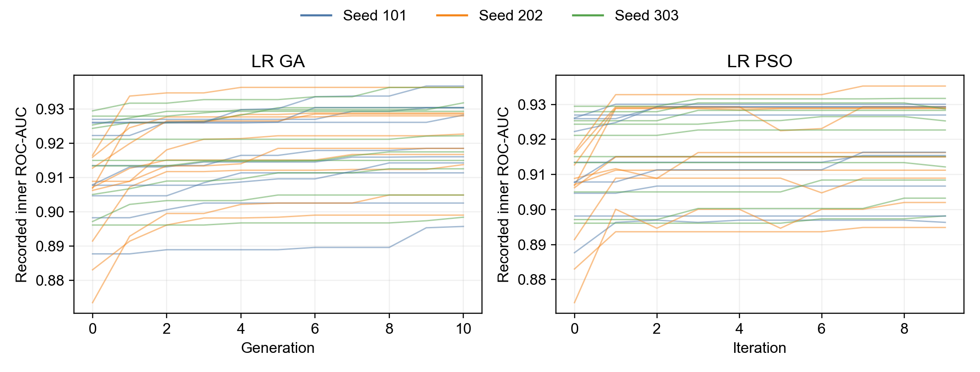
Source: present study, executed workflow.

Figure 4.8 DT continued
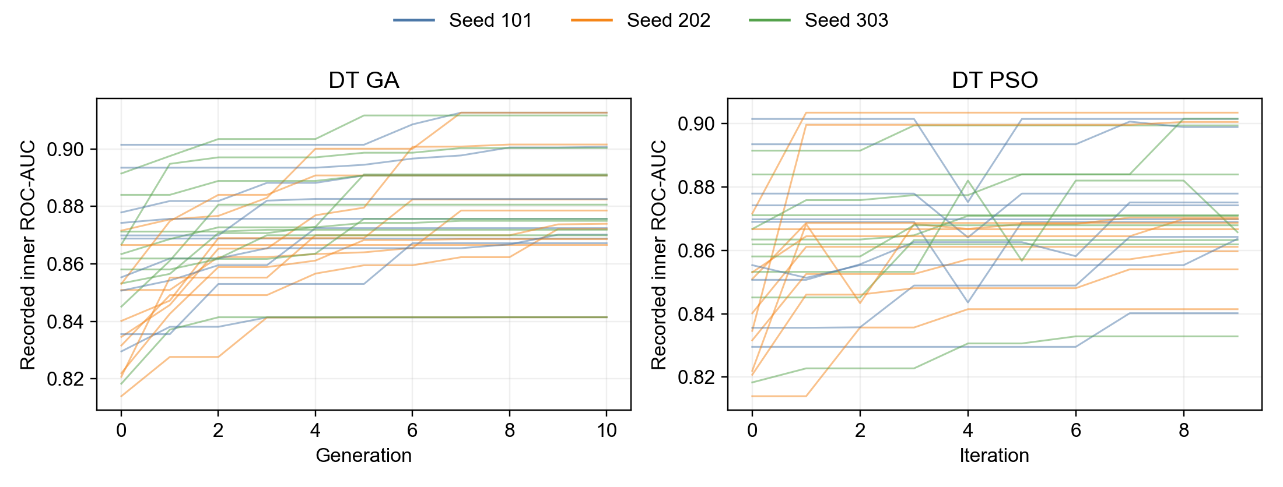
Source: present study, executed workflow.

Figure 4.8 RF continued
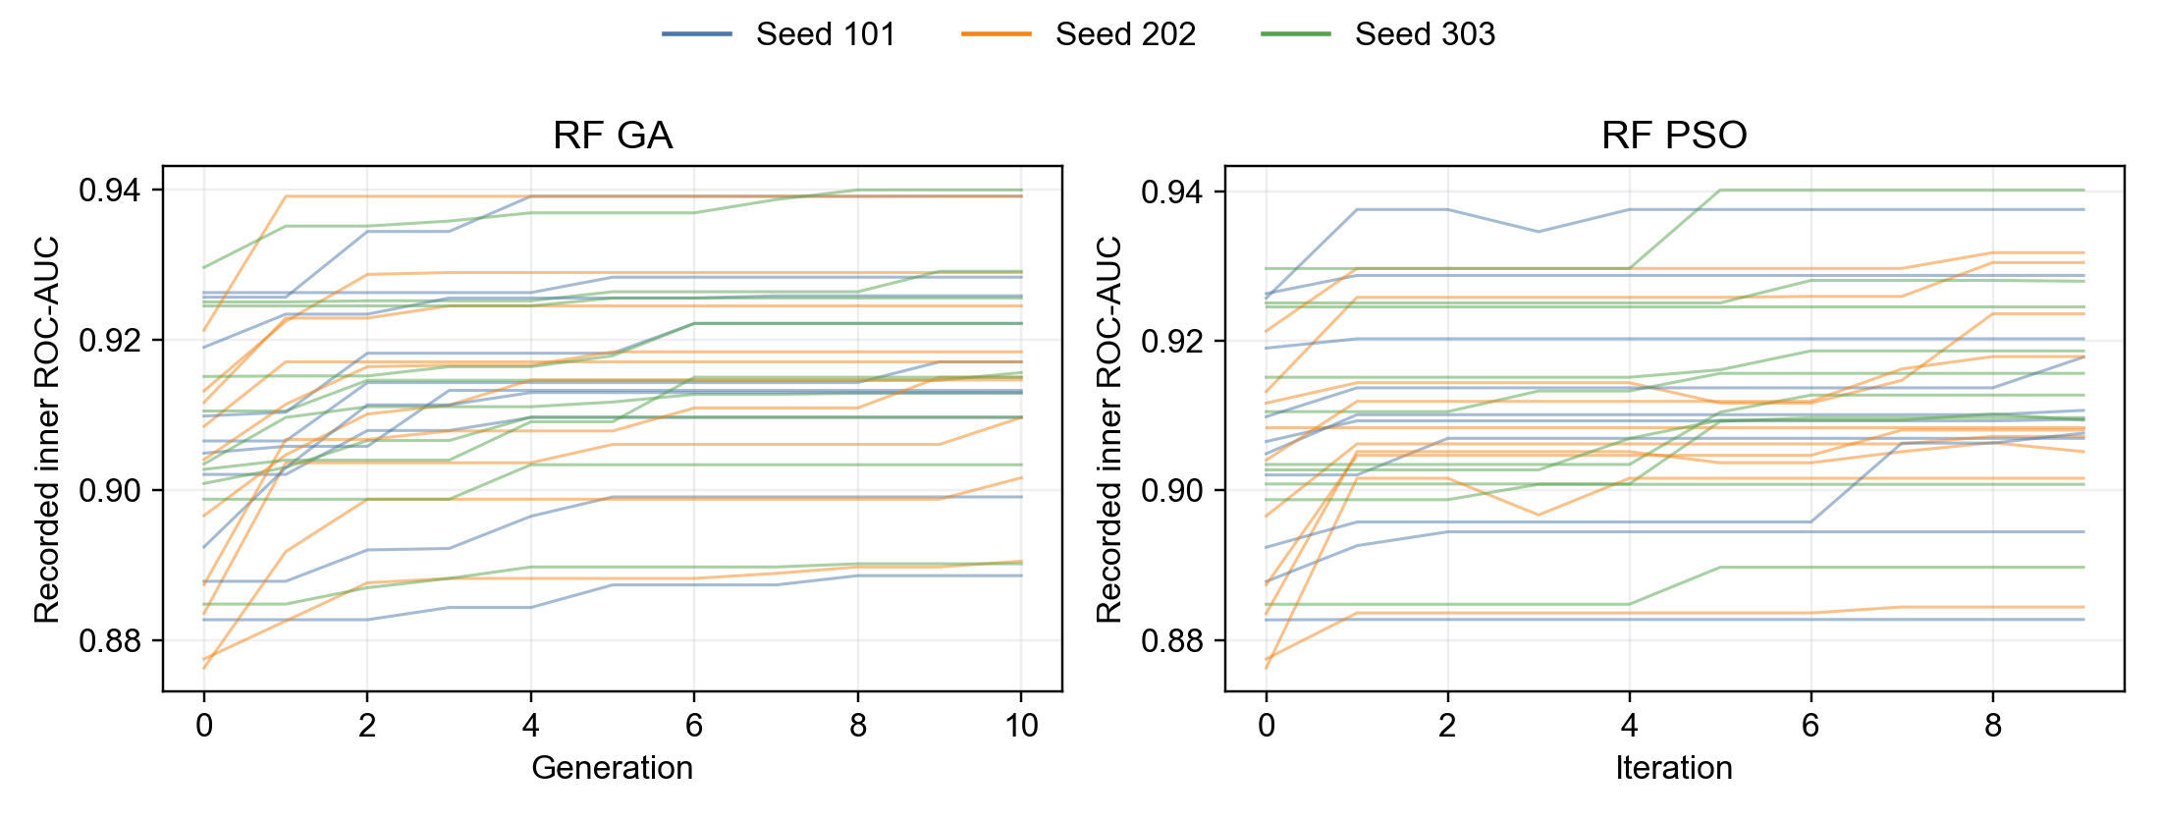
Source: present study, executed workflow.

Figure 4.8 SVM continued
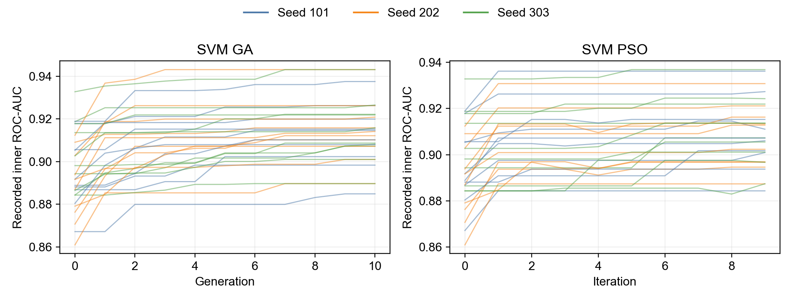
Source: present study, executed workflow.

Figure 4.8 XGB continued
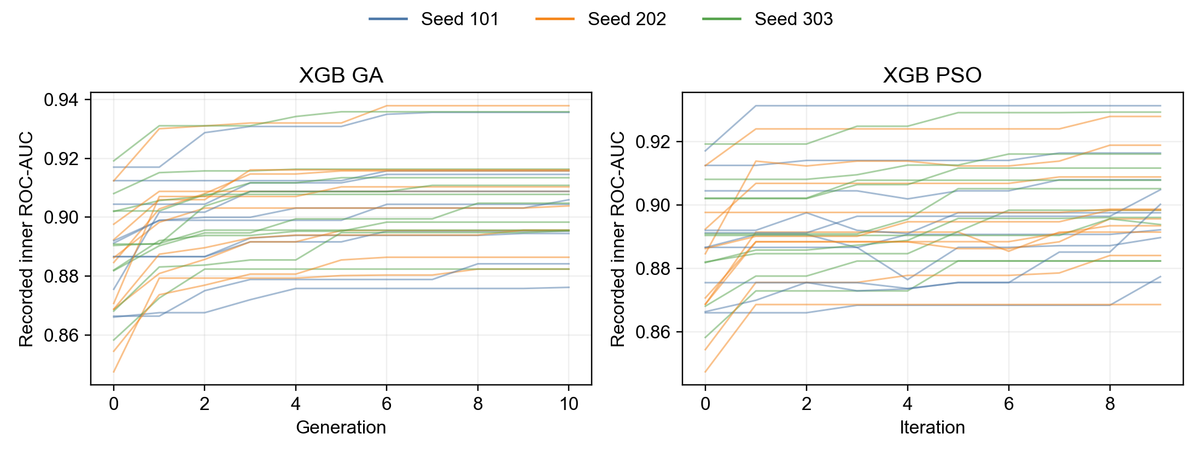
Source: present study, executed workflow.

Electronic supporting records
all optimiser runs
optimiser efficiency

Appendix G — Collected notebook telemetry and stage-event coverage
Notebook telemetry and stage-event records provided resource context for the local run. Reconciled experiment windows distinguished recorded modelling stages from smoke calls. The available process/system processor, memory and page-fault channels were not equivalent to a complete record of every process, disk transfer or paging event.
Page faults alone did not establish hard paging. Sleep duration and the contribution of competing tasks were not established by the available channels. No timing cause was assigned to hardware, paging, sleep or competing processes. Resource comparisons were limited by sampling, stage/timer boundaries and unisolated monitoring overhead.
Evidence | Available interpretation | Boundary
Notebook telemetry | Sampled process/system resource context | Whole-session samples are not automatically a single optimiser-run measurement
Stage-event records | Context keys and stage start/end records | Recorded windows require reconciliation before resource attribution
Current-process processor time | Processor use in the recorded process/threads | Not a complete accounting of child or competing processes
Page-fault channel | Recorded process page-fault events | Does not identify hard paging or prove a paging-related delay

The full raw monitoring files may include machine/account identifiers and were not copied into the accompanying manuscript archive. The source dataset and analytical records were not altered. This appendix describes collected evidence and its inference limits, rather than claiming unavailable measurements were obtained.

Appendix H — Integrity, configuration, software and warning records

H.1 Scope and interpretation
This appendix reproduces selected configuration fields, software versions, recorded integrity assertions, fitting-boundary documentation and warning/error summaries. The supporting files are unchanged copies of saved records. Hash agreement establishes file identity; it does not establish analytical correctness, historical blinding, absence of every leakage mechanism or clinical validity. Workflow assertions are distinguished from independent review.
The executed records described the original fold-mean hypothesis framework. The later two-component directional family was formulated after analysis and was not a new executed test. That change is documented separately; original analytical metadata have not been rewritten to imply prespecification.

H.2 Configuration
Table H.1
Recorded analytical and telemetry settings
Saved field | Recorded value
workflow_version | 2.2.0-monitoring-estimands
fast_mode | False
allow_final_run | True
random_state | 20260817
outer_folds | 5
outer_repeats | 2
inner_folds | 3
optimiser_seeds | [101, 202, 303]
fitness_eval_budget | 160
fitness_tolerance | 1e-06
ga_population | 16
pso_particles | 16
decision_threshold | 0.5
bootstrap_replicates | 2000
n_jobs_outer | 1
monitoring_interval_seconds | 5.0
monitoring_version | 1.0.0
source_member | processed.cleveland.data
expected_sha256 | a74b7efa387bc9d108d7d0115d831fe9b414b29ae7124f331b622b4efa0427c8

Note. This is a selected configuration schedule, not a claim that every saved field is printed. Only collected notebook telemetry and stage-event evidence is described in the manuscript. The electronic configuration remains complete and unchanged. Budget caps concerned run-local unique nonempty requests; common caps did not establish equal model fits or elapsed time. Original-variable masks preceded training-local encoding.

H.3 Software and provenance acknowledgement
Table H.2
Saved software/platform versions
Package/platform | Recorded version
joblib | 1.4.2
matplotlib | 3.10.1
numpy | 2.2.4
pandas | 2.2.3
platform | Windows-11-10.0.26300-SP0
pygad | 3.7.0
pyswarms | 1.3.0
python | 3.13.2
scikit-learn | 1.6.1
scipy | 1.15.2
seaborn | 0.13.2
xgboost | 2.1.4

Table H.3
Recorded run acknowledgement and its boundary
Saved field | Recorded value
configuration_fingerprint | c2c87bcc95ecdf7f
historical_run_freeze_verified | False
meaning | Operator acknowledgement for this new run, not independent proof about prior result inspection.
mode | final
operator_budget_freeze_acknowledgement | True
recorded_utc | 2026-10-21T08:38:41.950306+00:00
source_notebook_sha256 | b2ce58ade83487fd0e5a361495ecc73f380497d81196813a33a09908abbbb129

Note. The acknowledgement documented fixed settings for this run. It was not independent evidence of preregistration, prior-result blinding or a historically verified budget freeze. The stored notebook provenance hash is a field in that record, not a newly verified hash of every later notebook file. Verification of execution provenance and integrity is separate from ethical approval; no approval, exemption or consent waiver is created by these records.

H.4 Executed estimands and fitting-boundary documentation
Table H.4
Saved estimand definitions
Recorded field | Executed-record wording
bootstrap_scope | conditional on realised aggregated OOF predictions; not an interval for the fold-mean hypothesis estimand
chapter_correction_rule | Register new deterministic summaries separately; correct Chapter 4 through a traceable amendment, never silently through Discussion.
configuration_fingerprint | c2c87bcc95ecdf7f
hypothesis_estimand | equal-weight mean of matched outer-fold ROC-AUC differences
hypothesis_inference | descriptive direction only; no new test or interval
secondary_estimand | difference of ROC-AUCs calculated from averaged OOF probabilities
smoke_mode | False

Table H.5
Method-to-code fitting-boundary record
Method | Function/stage | Fitting data | Independent review recorded
Fold-local preprocessing | build_pipeline/evaluate_mask/tune_and_evaluate | inner training or complete outer training | False
Classifier-specific feature selection | run_ga/run_binary_pso | outer training with frozen inner folds | False
Condition-specific tuning | GridSearchCV in tune_and_evaluate | outer training with frozen inner folds | False
SVM sigmoid calibration | CalibratedClassifierCV in tune_and_evaluate | outer training only | False

Note. False in the independent-review field is preserved. Listed functions and fitting arguments support the documented procedure but are not independent witnesses that leakage was impossible. Repeated folds are dependent. Conditional aggregated-prediction intervals did not refit development and were not intervals or tests for fold means or the later joint proposition.

H.5 Integrity assertions, warnings and fitness errors
Table H.6
Complete saved integrity-assertion schedule
Check | Recorded status | Critical | Saved note
Fold contrast rows | PASS | True | —
Approved hypothesis contrasts | PASS | True | —
Separate estimand alignment rows | PASS | True | —
No bootstrap intervals assigned to fold-mean summaries | PASS | True | —
Exactly five classifiers | PASS | True | —
Exactly three conditions | PASS | True | —
Expected outer splits completed | PASS | True | —
Matched outer-test indices | PASS | True | —
No duplicate prediction keys | PASS | True | —
All masks have 13 original-feature bits | PASS | True | —
Every retained optimiser mask is non-empty | PASS | True | —
GA/PSO respect common unique-request cap | PASS | True | The cap does not equalise attempted calls or model fits
Finite probabilities | PASS | True | —
Probabilities in [0, 1] | PASS | True | —
Aggregated prediction keys unique | PASS | True | —
Each aggregate uses the mode-specific prediction count | PASS | True | Expected 2 prediction(s) per observation-condition; complete repeated outer validation
Paired comparison rows aligned | PASS | True | —
Classifier-specific selector recorded | PASS | True | —
Selection and tuning restricted by function interfaces | PASS | True | Recorded design assertion using frozen inner indices; no independent code audit
SVM calibration restricted by fitting function | PASS | True | Recorded outer-training hash; no independent code audit
Cache context excludes optimiser seed | PASS | True | —
FAST output not labelled final | PASS | True | —
Final execution mode | PASS | False | fast_mode=false and final execution explicitly authorised
Analytical observations | PASS | True | —
Fold metric rows | PASS | True | —
Raw prediction rows | PASS | True | —
Aggregated prediction rows | PASS | True | —
Optimiser runs | PASS | True | —
Selected mask rows | PASS | True | —
Tuning rows | PASS | True | —
Paired bootstrap rows | PASS | True | —
Stability rows | PASS | True | —
Thirty retained runs per stability row | PASS | True | —
All bootstrap rows have 2000 valid replicates | PASS | True | —
No skipped bootstrap replicates | PASS | True | —

Table H.7
Saved warning/error-log scope
Record/field | Saved value | Interpretation
fitness_error_count | 0 | Recorded fitness failures, not every possible execution issue
warning_count | 0 | Captured warning entries only
warnings | [] | Saved warning list
reconciled_after_figures | True | Recorded export-stage reconciliation flag
fitness_errors.csv | Header only; no data records | Complete copied fitness-error record

Note. Empty captured-warning and fitness-error records do not prove that every library warning was collected or every possible execution issue absent. PyGAD warning suppression limited completeness. Warning capture, fitting failures, integrity assertions and collected telemetry have different scopes. These distinctions do not justify inventing an error or repairing a saved result.

H.6 Manifest and supporting records
Table H.8
Manifest verification scope
Item | Recorded/checked value
Configuration fingerprint | c2c87bcc95ecdf7f
Manifest SHA-256 | 825379f698120a35ed42dc58ba7eb452da23bb61a833a7997a18584a4d161d4d
Detached digest comparison | MATCH
Coverage rule | Every file listed in the saved manifest matched its recorded size and SHA-256

Note. The manifest covers its listed artifacts; this is not a claim that later notebook/HTML exports, supplementary audits or every file in the parent folder were inside that manifest. The complete per-file identity schedule accompanies the electronic records. There is no self-referential claim that the manifest's own digest was stored inside itself.
Supporting record | Electronic evidence
configuration.json | Full record
software_versions.json | Full record
run_authorisation_record.json | Full record
analysis_estimands.json | Full record
integrity_audit.csv | Full record
method_to_code_audit.csv | Full record
warning_error_log.json | Full record
fitness_errors.csv | Full record
run_manifest.json | Full record
run_manifest.sha256 | Full record

The later framework revision is documented in the separate research-framework map and aligned-chapter change log. Original metadata continue to describe the executed analysis; they are not retrospective proof of the revised propositions. The reviewed notebook is linked in Section H.6; raw HTML and machine-identifying monitoring logs are not reproduced here. Public access to the dataset does not establish an institutional ethics exemption or unrestricted sharing of computational logs.

H.6 Reviewed notebook and project access
The complete reviewed notebook and the supporting electronic records are provided through the project repository for grading. The notebook copy includes its saved outputs and personal details, which were preserved at the author’s explicit request. No notebook content was removed or redacted for this copy.
Heart-disease feature selection with GA and PSO project
Heart_Disease_GA_PSO_Analysis_Workflow_v3_Monitored-IR.ipynb notebook
Project note for the grading notebook
Export-copy SHA-256 manifest
Notebook SHA-256: 69516c91adcf7af7a9b94ebff6ac4e958d6339b4b0e0fed550533cb405232e04
The repository links point to the main branch. The export-copy checksum manifest identifies the published evidence files and is separate from the original analytical run manifest. The reviewed notebook was added after that analytical run; it is not retrospectively included in the original manifest. The filename does not establish independent human review, and the recorded independent-review fields have not been changed.

