# Git Overview: (Draft)

Visual Studio IDE (or any other Git client should work)

* https://fundationtechteam.visualstudio.com/_projects

<https://marketplace.visualstudio.com/items?itemName=GitHub.GitHubExtensionforVisualStudio>

Example from GitHub Account:

1. Create a Git Repository
2. Open with (GitHub Desktop, or other Git client)
3. **Clone** to your local PC

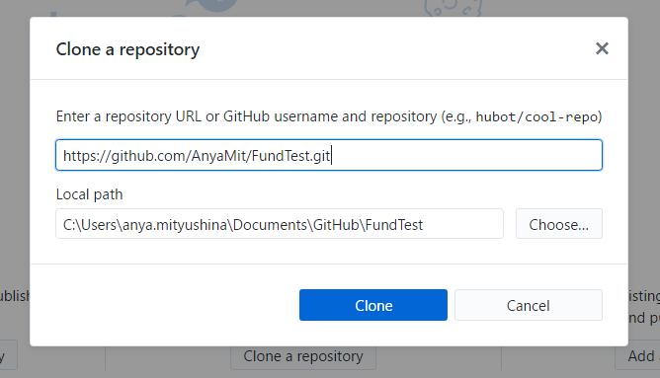

4. You will have a Master Branch called

# Proposed set up

Git – Fundation Tech Team

* Fundation Analytics
  + MRMU
  + Portfolio Reports
  + Modeling
  + Projects: Main Repository that links to other projects **(Must be updated when new projects are added)**
  + <https://github.com/rdpeng/courses>
    - Sub Projects will be here
    - <https://github.com/rdpeng/courses/tree/master/01_DataScientistToolbox>
      * Sub projects: https://github.com/rdpeng/courses/tree/master/01_DataScientistToolbox/01_01a_toolBoxOverview

Example: <https://github.com/DataScienceSpecialization> (our Fundation Analytics)

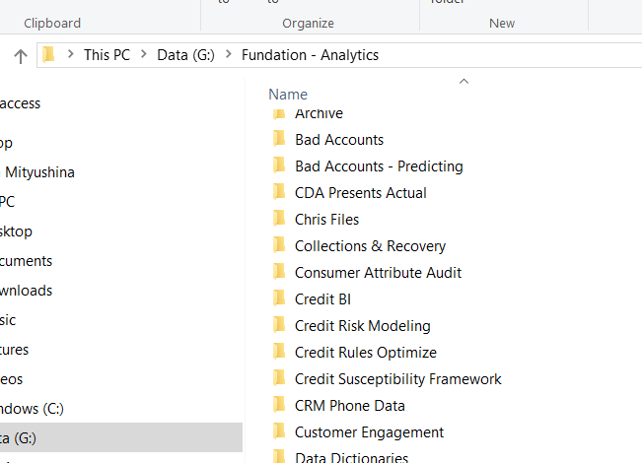

* Modeling
* 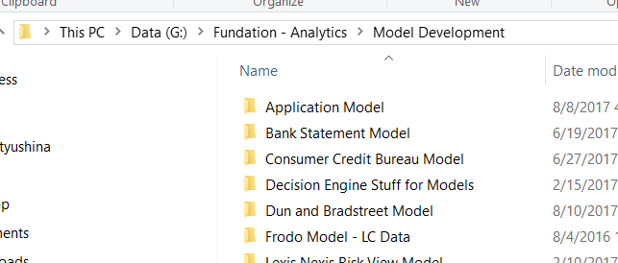
  + Ex: (<https://github.com/DataScienceSpecialization/courses>)
  + Model 1
  + 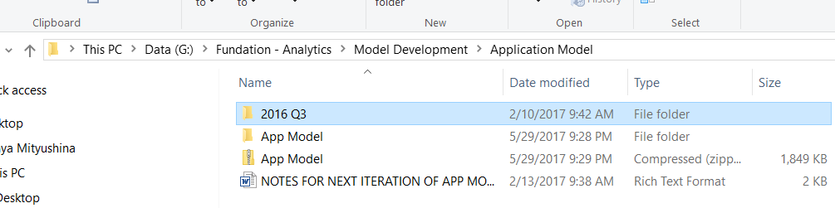
    - Ex(<https://github.com/DataScienceSpecialization/courses/tree/master/01_DataScientistToolbox>)
  + Model 2
  + Model 3
  + Model 4
  + Model 5
  + Model 6
  + Etc.
* Analytics
* Etc.

Ok with struct

Add app model for example

* App model under application model
  + Version 1
  + 2016 Q3

Walk through how to add

Quickly show them the structure

More to come in the next weeks as we migrate

* Git Migration Project

As the new ones come up, we should as need.

* Example for Regions Marketing (code based, etc.)
* Separate folder within each model

** Documentation Documentation Documentation.

* Each has a “How to”
* Read me file
* Data Dictionary
* + Code

Youtube how to use Git on VS

Branch is “save as”

Upload is pull

The basics:

* hdfs