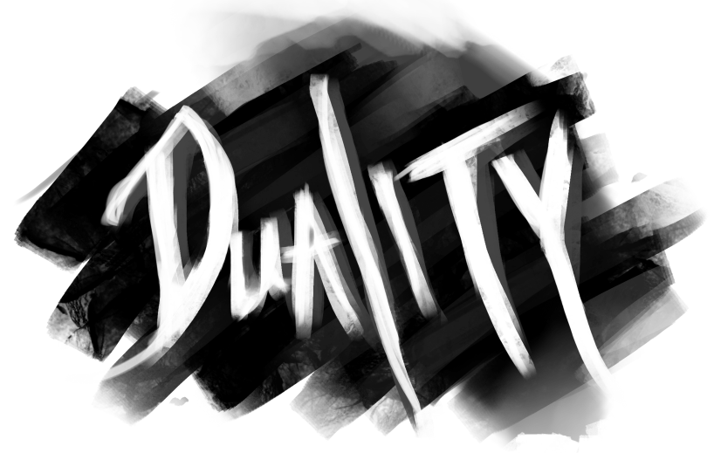

**Game Walkthrough**

Hubs

Each of the levels in our game can be reached through the central Hub room.

When the player is in this room, a white light will indicate which mirrors the player can go through.

In the first Hub, the player can choose to enter either the Observatory or the Music Room. This choice will determine what they get as a reward. (The Observatory rewards you with a Suit of Armor that has the power to heal you. The Music Room rewards you with an Intontimento Spell that has the power to stun shadows for 10 seconds. Both rewards are restricted, so use them wisely)

After playing through the level of your choice, you will return to the Hub. From there you must go through the opposite mirror into the other room.

After returning to the Hub again, you will be allowed access to the Final Room.

Upon completion of the Final puzzle, you will once again return to the Hub. At this point all that is left is to exit via the last remaining mirror portal.

Observatory

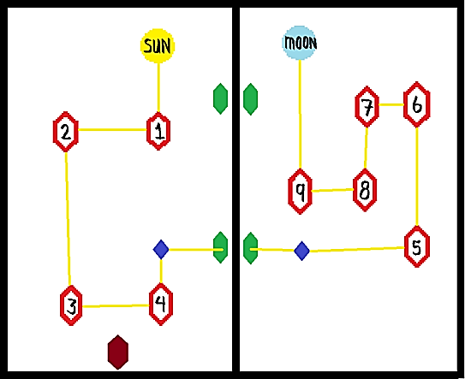After initial cutscene:

Click Mirror #2 three times

Click Mirror #4 twice

Click Sun

Go through one of the Portal Mirrors (Green in image)

Click Mirror #5 twice

Click Mirror #6 once

Click Mirror #7 three times

Click Mirror #9 twice

Click Crystal (Dark blue in image)

If this is the first puzzle you’ve played:

Obtain silver armor from the “mysterious” dresser which will have appeared near the moon.

Equip the armor (If you are playing with someone other than the pre-made character Mia, you will likely be unable to equip the armor and move past this level)

Return to the main room via one of the Portal Mirrors

Exit the observatory via the Exit Mirror (maroon in image)

If this is the second puzzle you’ve played:

Return to the main room via one of the Portal Mirrors

Exit the observatory via the Exit Mirror (maroon in image)

Music Room

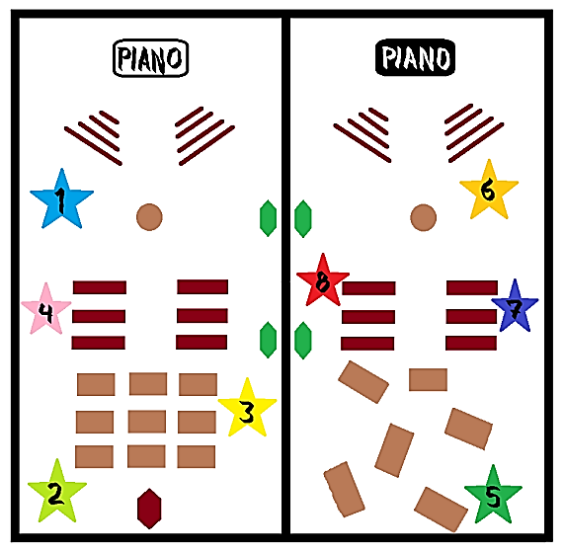

After Initial Cutscene:

Click the white piano and wait half a minute as the music plays.

Click the blue orb (star #1)

Click the green orb (star #2)

Click the yellow orb (star #3)

Click the pink orb (star #4)

Go through one of the portal mirrors (Green in image)

Click the black piano and wait half a minute as the music plays

Click the green orb (star #5)

Click the yellow orb (star #6)

Click the blue orb (star #7)

Click the pink orb (star #8)

If this is the first puzzle you’ve played:

Obtain Stunning Spell from the Mysterious Object which will have appeared next to the tables in the dark room.

Drag the spell to the F1 key for easy accessibility

Exit the Music Room via the Exit Mirror (maroon in image)

If this is the second puzzle you’ve played:

Return to the main room via one of the portal mirrors

Exit the Music Room via the Exit Mirror (maroon in image)

Final Room

After the initial cutscene:

Walk up to the Shadow at the back of the room

After the shadows multiply and the cutscene ends:

Search the room for the red “real” shadow. She spawns from a random mirror each time.

Find and click on the “real” shadow 5 times.

After final cutscene:

Exit the Final Room via the Exit Mirror

