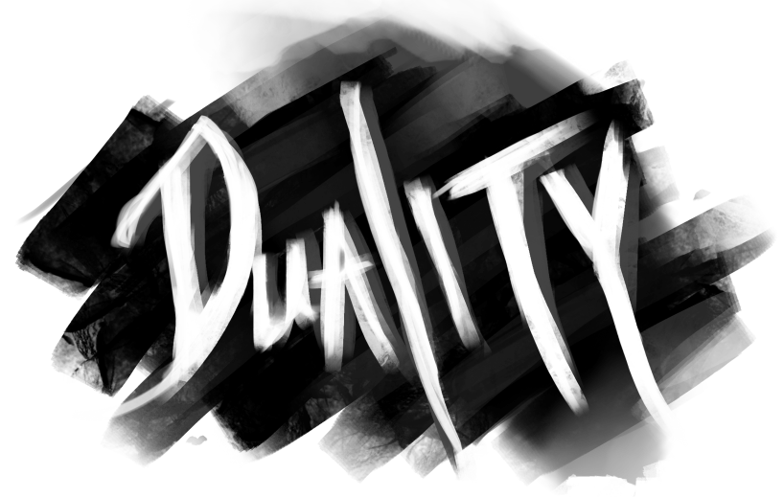

Walkthrough

# Hubs

Each of the levels in our game can be reached through the central Hub room. When the player is in this room, a white light will indicate which mirrors the player can go through.

In the first Hub, the player can choose to enter either the Observatory or the Music Room. This choice will determine what they get as a reward. The Observatory rewards you with a Suit of Armor that has the power to heal half of Mia’s health when she is gravely injured. This healing effect can occur only once in each room. The Music Room rewards you with an Intontimento Spell that has the power to stun shadows for 10 seconds. This spell can be used up to 5 times, so the player must use them wisely.

After playing through the level of your choice, you will return to the Hub. From there you must go through the opposite mirror into the other room. After returning to the Hub again, you will be allowed access to the Final Room.

Upon completion of the Final puzzle, you will once again return to the Hub. At this point all that is left is to exit via the last remaining portal mirror.

# Observatory

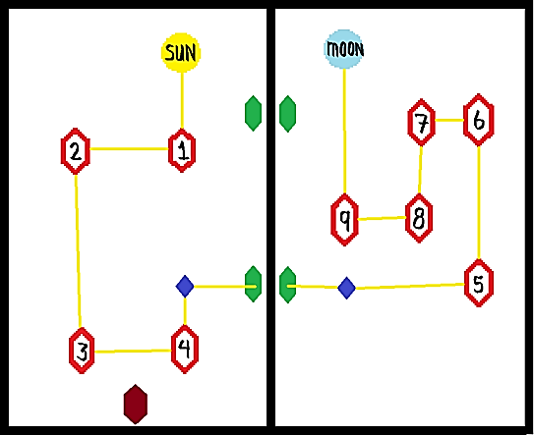

After initial cutscene:

1. Click Mirror #2 three times
2. Click Mirror #4 twice
3. Click Sun
4. Go through one of the Portal Mirrors (Green in image)
5. Click Mirror #5 twice
6. Click Mirror #6 three times
7. Click Mirror #7 three times
8. Click Mirror #9 twice
9. Click Crystal (Dark blue in image)

If this is the first puzzle you’ve played:

1. Obtain silver armor from the “mysterious” dresser which will have appeared near the moon.
2. Equip the armor (If you are playing with someone other than the pre-made character Mia, you will likely be unable to equip the armor and move past this level)
3. Return to the main room via one of the Portal Mirrors
4. Exit the observatory via the Exit Mirror (maroon in image)

If this is the second puzzle you’ve played:

1. Return to the main room via one of the Portal Mirrors
2. Exit the observatory via the Exit Mirror (maroon in image)

# Music Room

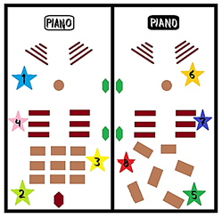

After Initial Cutscene:

1. Click the white piano and wait half a minute as the music plays.
2. Click the blue orb (star #1)
3. Click the green orb (star #2)
4. Click the yellow orb (star #3)
5. Click the pink orb (star #4)
6. Go through one of the portal mirrors (Green in image)
7. Click the black piano and wait half a minute as the music plays
8. Click the green orb (star #5)
9. Click the yellow orb (star #6)
10. Click the blue orb (star #7)
11. Click the pink orb (star #8)

If this is the first puzzle you’ve played:

1. Obtain Stunning Spell from the Mysterious Object which will have appeared next to the tables in the dark room.
2. Drag the spell to the F1 key for easy accessibility
3. Exit the Music Room via the Exit Mirror (maroon in image)

If this is the second puzzle you’ve played:

1. Return to the main room via one of the portal mirrors
2. Exit the Music Room via the Exit Mirror (maroon in image)

# Final Room

After the initial cutscene, walk up to the Shadow standing next to the easel at the back of the room. A cutscene will play where the Shadow multiplies and Rays of Light fill the center of the room.

After the shadows multiply and the cutscene ends, protect the Rays of Light from the shadows which periodically spawn from the red mirrors along the perimeter of the room.

One of the shadows each wave is the “real” shadow. Eliminate each wave of shadows by searching the room for the “real” shadow, which spawns at a random mirror every wave. This shadow will identify itself when the payer gets close by emitting a large, circular red aura and taunting the player. Interact with the “real” shadow to destroy the wave. Repeat this five times to complete this room.

After final cutscene, exit the Final Room via the Exit Mirror.

