520 HW3 YukunZhou

Animation JPEG files are under the corresponding model folders.

I use 3 late days in this assignment, and I did not use any in the previous assignment.

Extra Credits:

1. I implemented Pseudo Inverse method as another IK method. We can obviously observe due to the alpha in TIKHONOV REGULARIZATION method :



We can see TIKHONOV REGULARIZATION method can maintain its original shape better than Pseudo Inverse, which has more stable deformation. But this method can lead to slow deformation, which is not we want when we need dramatic change.

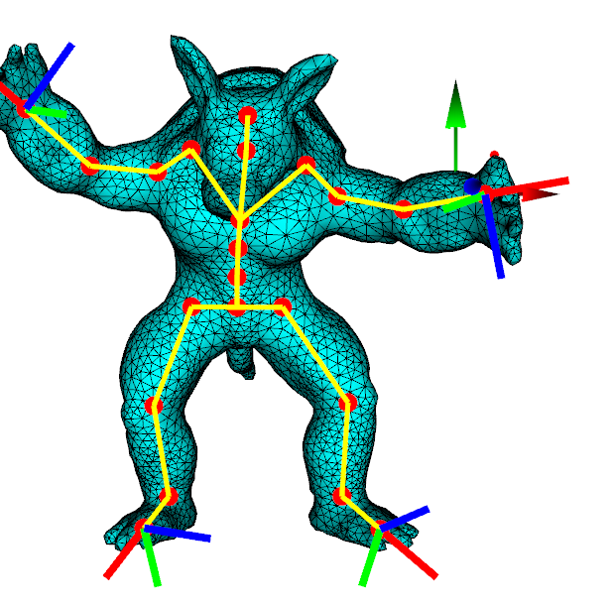 TIKHONOV REGULARIZATION : it has some resistence towards the deformation and not so perfectly meet the handler position. When alpha is larger, deformation can be quite small and slow and remain a obvious distance to the handler.

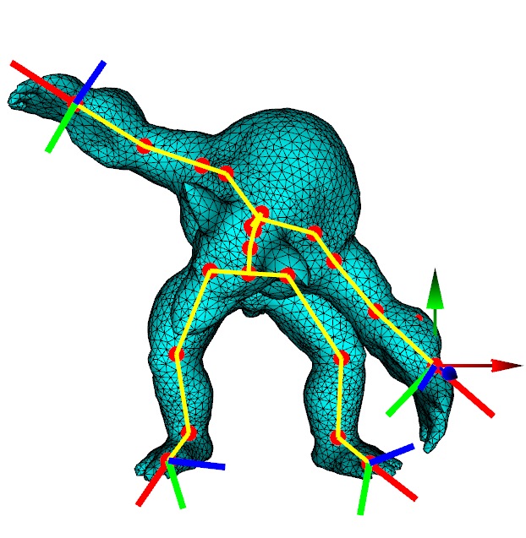Pseudo Inverse: The shape is just following the handler accurately and fast.

1. Step the long move distance.

In doIK function of IK.cpp, I implemented this to make long distance movements of the handlers are divided into small steps to finish.

The key idea here is to check the difference between target positions given and current global positions. I set the threshold to 0.4 and each step is 0.2:

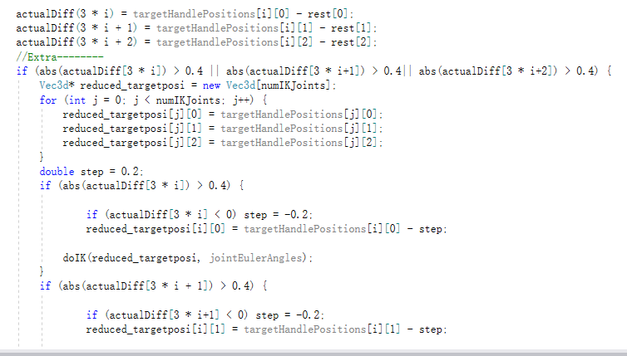

If the difference is larger than the threshold, then we create a new target position called reduced_targetposi, feeding to a doIK call. Then it will return from the furthest position to nearest one with step 0.2:



Some hazards are: 1. Target positions can be smaller or larger than current global joint position, so absolute value is considered, and I decide the step is added to or reduced from the target position values. 2. We need to consider different axises. We just need to change the position of the axis which exceed our threshold.

1. I also tried Dual Quaternion, but it seems some problems.