Backend Engineering

1. Architect and implement a normalized PostgreSQL database, and the database_description is stored in the written_responses folder. The dbexport.psql are stored in the backend/scripts folder.
2. Return the player summary Successfully.

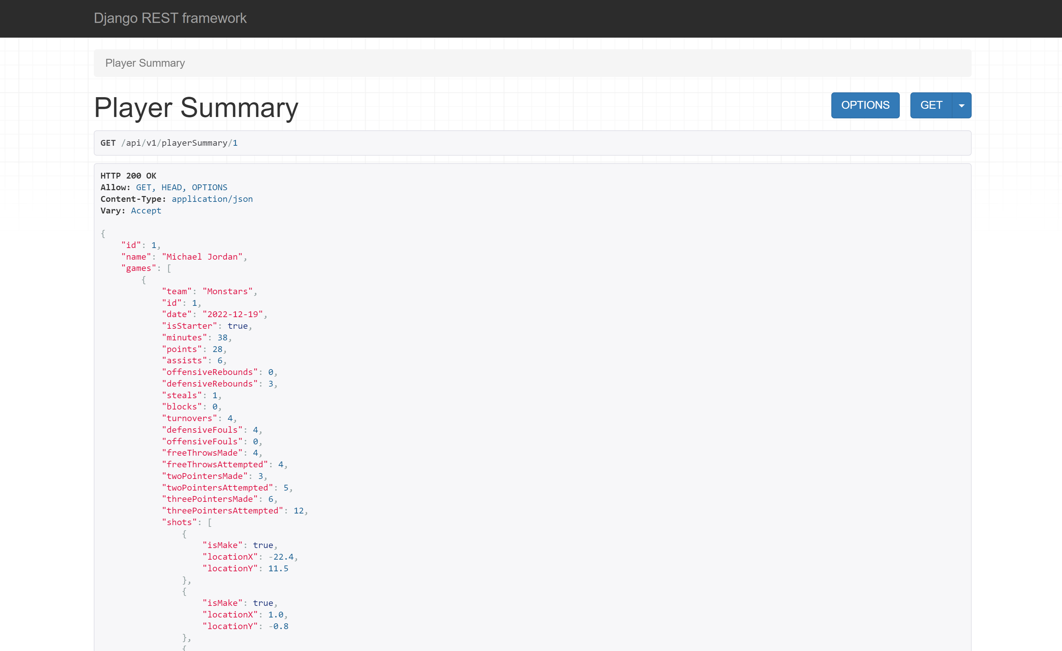

Frontend Engineering

1. Implement the player-summary component that returns player summary data.
2. Shows all the games and player summary  related to the selected player.
3. Shows the shot's x and y coordinates related to the selected game of the selected player on the court diagram, wherein the red circle means the shot is not make, and the green circle means the shot is make.

