AnythingNet Community CMS – How to create theme

Before you start:

* The CMS runs on CakePHP. The theme must also follow CakePHP file structures. For details: <http://book.cakephp.org/2.0/en/views/themes.html>
* You must know how to use XAMPP
* You are recommended to know how to write basic PHP
* You are also recommended to know how CakePHP works, but this is not required.

Process to develop theme:

**PartA: Set up development environment**

Please see how-to-install.docx.

**PartB: Put your theme files in structured folders**

**1**. **Understand where you will put your theme**.

You must follow the CakePHP folder structure to build theme.

If you look inside the anythingnet_cms folder, you will see the structure like this.

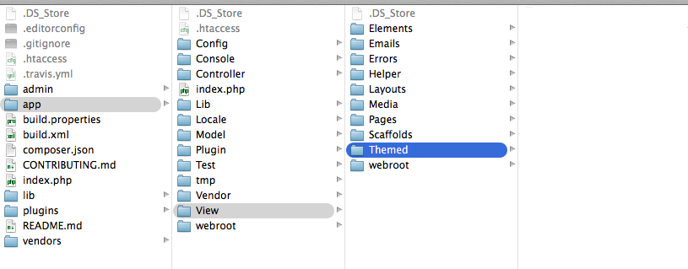

The location **anythingnet_cms/app/View/Themed/** is where you will place your theme.

So if you make a theme named ‘AnythingNet’, it will be located at **anythingnet_cms/app/View/Themed/AnythingNet** .

Also keep in mind that **files in other folder must NOT be edited**.

**2. Understand the theme file structure and place your theme**

Develop your theme in one folder, and inside the folder you must have these folders and files below.

* + Layouts/
    - This folder must have template.php, which will have the core part of the them such as <head> tag, header and footer.
  + Pages/
    - This folder must have index.php, which will have the content part of the website.
  + Errors/
    - This folder must have error400.php, error500.php, which are displayed when user accesses a page that does not exist or the web server causes an error.
  + webroot/
    - This folder must hold css/ folder, js/ folder, and img/ folder, which will hold all the css, javascript, and image files.

There is a sample theme named AnythingNet. You can refer this as a sample for the folder and file structure.

Follow the structure above, refer to AnythingNet sample and create your theme and install it under the **anythingnet_cms/app/View/Themed/** .

1. **Access the admin area to enable the theme**.

Go to <http://localhost/anythingnet_cms/admin/> and login. You will use the admin username and password that you set in PartA.

Go to Page > Add new page > Then create a page > Save and publish.

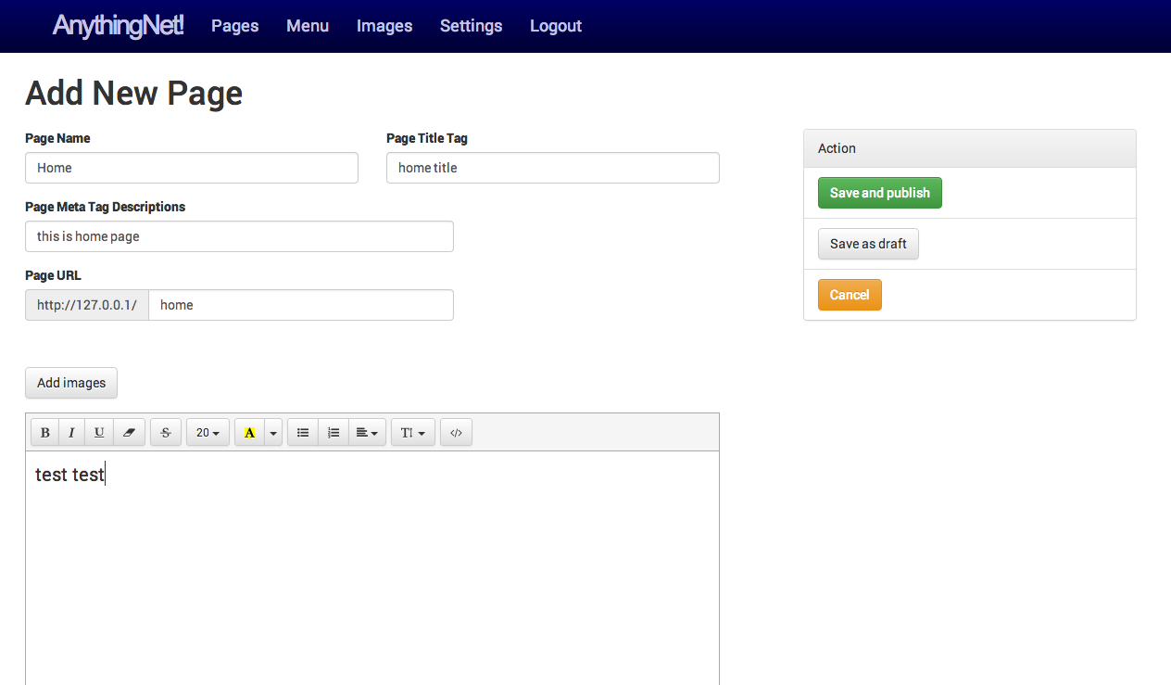

Go to Settings and you will see the screen below.

In the ‘Home Page’ dropdown, select the page you created.

In the ‘Theme’ dropdown, you can select a theme installed. Select your theme and press ‘Save’.

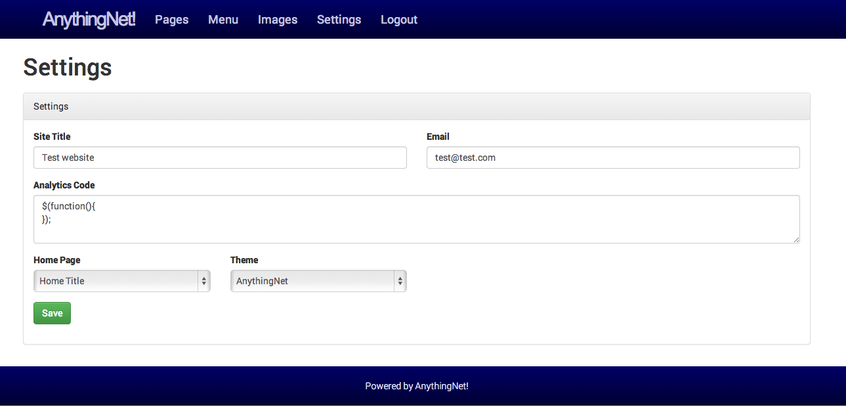

Now access <http://localhost/anythingnet_cms> . If you see the page dressed up with your theme, that’s success!

(The page will look like this if you select ‘AnythingNet’ theme)

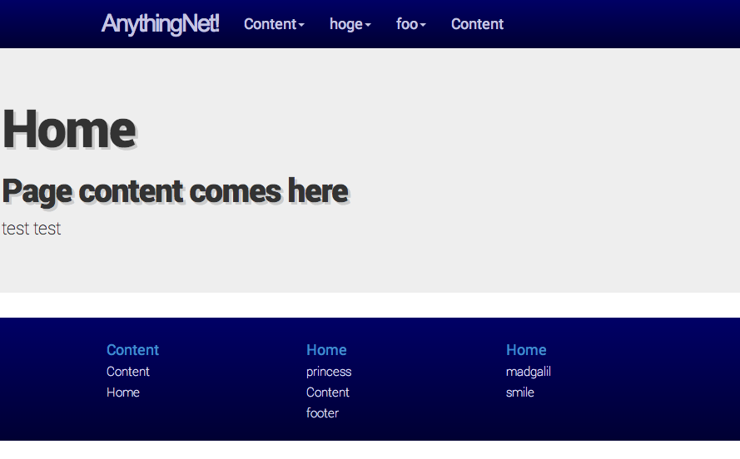

**Part C: Some additional reference..**

If you refere to AnythingNet theme, you will notice that it uses some php codes. Here are list of variables you can use in your theme.

* $title : title of the page (goes to <title> tag).
* $meta_description : meta tag description (goes to <meta> tag).
* $name: name of the page (goes to <h1> tag).
* $content : html of the content page.
* $header and $footer : holds an array of navigation that you can set at Menu section of the admin.

The array structure is like this for example:

$header[group][parent][label]

$header[group][parent][url]

$header[group][children][order][label]

$header[group][children][order][url]

* Some CakePHP HtmlHelpers

You can refer to: <http://book.cakephp.org/2.0/en/core-libraries/helpers/html.html>

You do not have to use CakePHP HtmlHelper to write your theme, but some functions will be necessary:

* + $this->Html->css() : loads css file from webroot/css
  + $this->Html->script() : loads javascript file from webroot/js
  + $this->Html->image() : loads image from webroot/img
  + $this->Html->link() : creates a link with <a> tag.

These functions ideally deal with file paths.

**Remember NOT to use <style>, <script>, <img>, <a href=””>**