AnythingNet Community CMS – How to install

1. **Import database to from PHPMyAdmin**

Go to PHPMyAdmin (from cPanel or XAMPP Admin), create a database (you can use any database name) with utf_8_general_ci encoding and import anythingnet_sql.

1. **Install the CMS**

Simply extract the anythingnet_cms.zip under public_html (or htdocs if you are using XAMPP), and access the website from web browser. You will see the screen like this below.

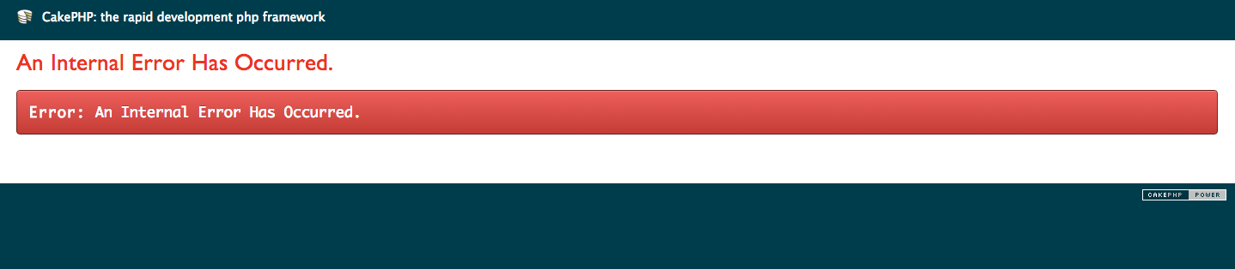

Now you have to do some database and admin user setting.

1. **Configure database, admin username and password**

Open **anythingnet_cms/app/Config/UserConfig.php** with a text editor.

You will see code like this. Enter all the necessary data.

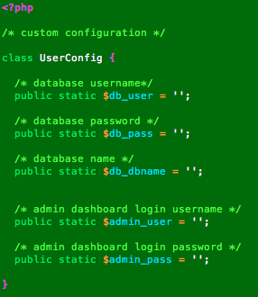

Save the file and access your website

If the screen below appears the installation is successful.

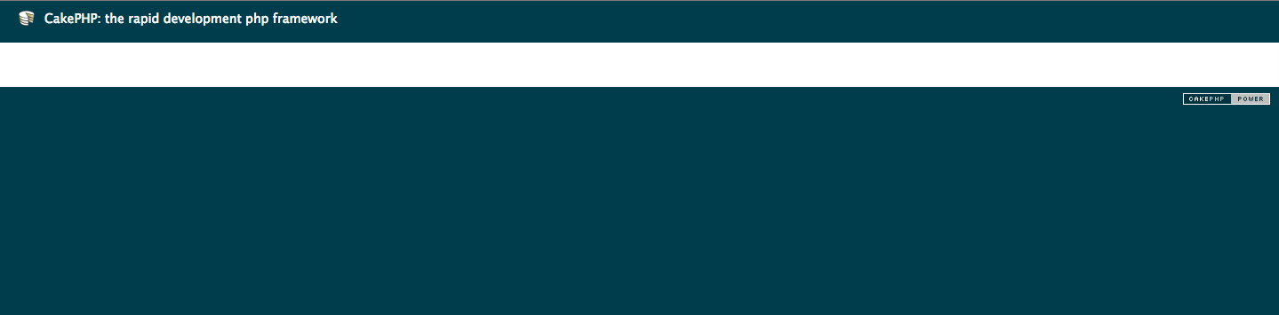

To access admin dashboard, go to <http://yourdomain.com/admin>

You will use the username and password that you set.

