B4x Booklets





CustomViews

Copyright: © 2018 Anywhere Software Edition 1.2

Last update: 2018.01.30

1 General information 4

2 Class modules 5

2.1 Getting started 5

2.1.1 Adding a class module 6

2.1.2 Polymorphism 7

2.1.3 Self-reference 8

2.1.4 Activity object B4A only 9

3 Standard class 10

3.1 Standard class structure 10

4 CustomViews 12

4.1 CustomView class structure 12

4.1.1 Event declarations 13

4.1.2 Designer properties declarations 13

4.1.3 Global variable declarations 13

4.1.4 Initialization routine 14

4.1.5 Designer support routine 14

4.1.6 Routine to get the base Panel 15

4.2 Adding a custom view by code 15

4.3 Add properties 16

4.4 Custom view and custom properties in the Designer 17

4.5 Complie to a library 20

4.5.1 Library specific attributes 22

4.6 Program flow 24

4.7 Intellisense help 25

4.7.1 Comments before Sub Class_Globals 25

4.7.2 Comments before a routine 25

4.7.3 Comments before an event routine 26

4.8 Help tool 27

5 First example CustomButton 28

5.1 Event declarations 28

5.2 Custom properties for the Designer 28

5.3 Class help header 29

5.4 Global variables 29

5.5 Initialize routine 30

5.6 DesignerCreateView routine 31

5.7 Base_Resize routine B4i / B4J only 32

5.8 AddToParent routine 33

5.9 InitClass routine 34

5.10 Click / LongClick event routines 36

5.11 Property routines 37

5.12 Main code 38

5.12.1 Globals 38

5.12.2 Program start 39

5.13 Click event routine 40

5.14 Compile to Library 41

5.15 Use the library in a program 42

6 LimitBar 43

6.1 Event declaration 44

6.2 Custom properties for the Designer 44

6.3 Class help header 44

6.4 Global variables 45

6.5 Initialize routine 46

6.6 DesignerCreateView routine 47

6.7 Base_Resize routine B4i / B4J only 48

6.8 AddToParent routine 49

6.9 InitClass routine 50

6.10 InitCursors routine 53

6.11 Draw the background line 54

6.12 DrawCursors routine 55

6.13 Cursor moving 57

6.14 Properties 59

6.15 Compile to a Library 60

6.15.1 Using the library in a program 61

Main contributors: Klaus Christl (klaus) Erel Uziel (Erel).

**To search for a given word or sentence use the Search function in the Edit menu.**

All the source code and files needed (layouts, images etc.) of the example projects in this guide are included in the SourceCode folder.

Updated for:

B4A version 7.80

B4i version 4.81

B4J version 6.01

B4X Booklets:

[B4x Getting Started](https://www.b4x.com/android/forum/threads/b4x-booklets-basic-language-and-ide.79951/#content)

[B4x Baisc Language](https://www.b4x.com/android/forum/threads/b4x-booklets-basic-language-and-ide.79951/#content)

[B4x IDE Integrated Development Environment](https://www.b4x.com/android/forum/threads/b4x-booklets-basic-language-and-ide.79951/#content)

[B4x Visual Designer](https://www.b4x.com/android/forum/threads/b4x-booklets-basic-language-and-ide.79951/#content)

[B4x CustomViews](https://www.b4x.com/android/forum/threads/b4x-b4x-booklet-customviews.76229/#content)

# General information

This guide is dedicated for more advanced users and treats the CustomView topic.

It covers B4A, B4i and B4J.

All the source code and files needed (layouts, images etc) for the example projects in this guide are included in the SourceCode folder.

For each project, there are three subfolders, one for each operating system.

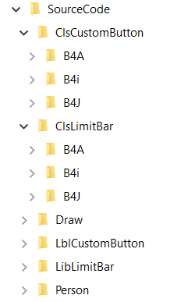

# Class modules

In B4x, you can use two types of Class Modules:

* Standard Class modules standard classes
* CustomView Class Modules specialized for custom views

## Getting started

Classes definition from [Wikipedia](http://en.wikipedia.org/wiki/Classes_%28computer_science%29):

In object-oriented programming, a class is a construct that is used to create instances of itself – referred to as class instances, class objects, instance objects or simply objects. A class defines constituent members which enable its instances to have state and behaviour. Data field members (member variables or instance variables) enable a class instance to maintain state. Other kinds of members, especially methods, enable the behaviour of a class instances. Classes define the type of their instances.  
  
A class usually represents a noun, such as a person, place or thing, or something nominalized. For example, a "Banana" class would represent the properties and functionality of bananas in general. A single, particular banana would be an instance of the "Banana" class, an object of the type "Banana".

Let’s start with an example, the source code: *Person* in the / Person folder.

In the Person module

'Class Person module

Sub **Class_Globals**

Private FirstName, LastName As String

Private BirthDate As Long

End Sub

Sub **Initialize** (aFirstName As String, aLastName As String, aBirthDate As Long)

FirstName = aFirstName

LastName = aLastName

BirthDate = aBirthDate

End Sub

Public Sub **GetName** As String

Return FirstName & " " & LastName

End Sub

Public Sub **GetCurrentAge** As Int

Return GetAgeAt(DateTime.Now)

End Sub

Public Sub **GetAgeAt**(Date As Long) As Int

Private diff As Long

diff = Date - BirthDate

Return Floor(diff / DateTime.TicksPerDay / 365)

End Sub

Main module.

Sub **Activity_Create**(FirstTime As Boolean)

Private p As Person

p.Initialize("John", "Doe", DateTime.DateParse("05/12/1970"))

Log(p.GetCurrentAge)

End Sub

I will start by explaining the differences between classes, code modules and types.  
  
Similar to types, classes are templates. From this template, you can instantiate any number of objects.   
The type fields are similar to the classes global variables. However, unlike types which only define the data structure, classes also define the behaviour. The behaviour is defined in the classes’ subs.  
  
Unlike classes which are a template for objects, code modules are collections of subs. Another important difference between code modules and classes is that code modules always run in the context of the calling sub. The code module doesn't hold a reference to any context. For that reason it is impossible to handle events or use CallSub with code modules.  
Classes store a reference to the context of the module that called the Initialize sub. This means that classes objects share the same life cycle as the module that initialized them.

### Adding a class module

Adding a new or existing class module is done by choosing Project > Add New Module > Class module or Add Existing module.  
Like other modules, classes are saved as files with *bas* extension.

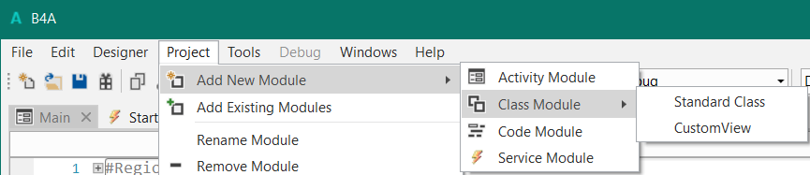

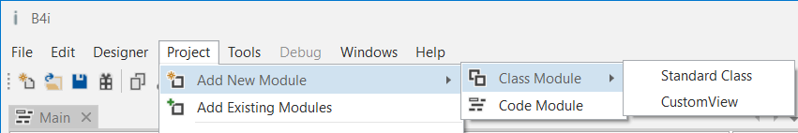

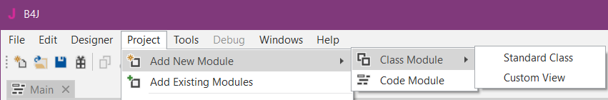

There are two class module types:

Standard Class

CustomView

### Polymorphism

Polymorphism allows you to treat different types of objects that adhere to the same interface in the same way.  
B4x polymorphism is similar to the [Duck typing](http://en.wikipedia.org/wiki/Duck_typing) concept.  
  
As an example we will create two classes named: Square and Circle.  
Each class has a sub named Draw that draws the object to a canvas:

Source code *Draw* in the Draw folder.

The code below is the B4A code.

'Class Square module

Sub **Class_Globals**

Private mx, my, mWidth As Int

End Sub

'Initializes the object. You can add parameters to this method if needed.

Sub **Initialize** (Shapes As List, x As Int, y As Int, length As Int)

mx = x

my = y

mLength = length

Shapes.Add(Me)

End Sub

Sub **Draw**(c As Canvas)

Private r As Rect

r.Initialize(mx, my, mx + mLength, my + mLength)

c.DrawRect(r, Colors.Red, False, 1dip)

End Sub

'Class Circle module

Sub **Class_Globals**

Private mx, my, mRadius As Int

End Sub

'Initializes the object. You can add parameters to this method if needed.

Sub **Initialize** (Shapes As List, x As Int, y As Int, radius As Int)

mx = x

my = y

mRadius = radius

Shapes.Add(Me)

End Sub

Sub **Draw**(cvs As Canvas)

cvs.DrawCircle(mx, my, mRadius, Colors.Blue, False, 1dip)

End Sub

In the main module, we create a list Shapes with Squares and Circles. We then go over the list and draw all the objects:

Sub **Process_Globals**

Public Shapes As List

End Sub

Sub **Globals**

Private cvs As Canvas

End Sub

Sub **Activity_Create**(FirstTime As Boolean)

cvs.Initialize(Activity)

Private Square1, Square 2 As Square

Private Circle1 As Circle

Shapes.Initialize

Square1.Initialize(Shapes, 110dip, 110dip, 50dip)

Square2.Initialize(Shapes, 10dip, 10dip, 100dip)

Circle1.Initialize(Shapes, 50%x, 50%y, 100dip)

DrawAllShapes

End Sub

Sub **DrawAllShapes**

For i = 0 To Shapes.Size - 1

CallSub2(Shapes.Get(i), "Draw", cvs)

Next

Activity.Invalidate

End Sub

As you can see, we do not know the specific type of each object in the list. We just assume that it has a Draw method that expects a single Canvas argument. Later we can easily add more types of shapes.  
You can use the SubExists keyword to check whether an object includes a specific sub.  
  
You can also use the Is keyword to check if an object is of a specific type.

### Self-reference

The Me keyword returns a reference to the current object. Me keyword can only be used inside a class module.  
Consider the above example. We have passed the Shapes list to the Initialize sub and then add each object to the list from the Initialize sub:

Sub **Initialize** (Shapes As List, x As Int, y As Int, radius As Int)

mx = x

my = y

mRadius = radius

Shapes.Add(Me)

End Sub

### Activity object B4A only

This point is related to the Android Activities special life cycle.

Make sure to first read the [activities and processes life-cycle tutorial](http://www.basic4ppc.com/forum/basic4android-getting-started-tutorials/6487-android-process-activities-life-cycle.html).  
  
Android UI elements hold a reference to the parent activity. As the OS is allowed to kill background activities in order to free memory, UI elements cannot be declared as process global variables (these variables live as long as the process lives). Such elements are named Activity objects. The same is true for custom classes. If one or more of the class global variables is of a UI type (or any activity object type) then the class will be treated as an "activity object". The meaning is that instances of this class cannot be declared as process global variables.

# Standard class

## Standard class structure

Default template of a standard class:

**B4A and B4i**

Sub **Class_Globals**

End Sub

'Initializes the object. You can add parameters to this method if needed.

Public Sub **Initialize**

End Sub

**B4J**

Sub **Class_Globals**

Private fx As JFX

End Sub

'Initializes the object. You can add parameters to this method if needed.

Public Sub **Initialize**

End Sub

Only two routines are predefined:

Sub **Class_Globals** - This sub is similar to the Main Globals sub. These variables will be the class global variables (sometimes referred to instance variables or instance members).

In B4J, the fx library library is declared by default. You can remove it if not needed.  
  
Sub **Initialize** - A class object must be initialized before you can call any other sub. Initializing an object is done by calling the Initialize sub. When you call Initialize you set the object's context (the parent object or service).  
Note that you can modify this sub signature and add arguments as needed.

Example: Person class module

The source codes are in the Person folder.

The code is the same for all three B4x platforms (B4A. B4i, B4J).

'Class Person module

Sub **Class_Globals**

Private mFirstName, mLastName As String

Private mBirthDate As Long

End Sub

Sub **Initialize** (FirstName As String, LastName As String, BirthDate As Long)

mFirstName = FirstName

mLastName = LastName

mBirthDate = BirthDate

End Sub

Public Sub **GetName** As String

Return mFirstName & " " & mLastName

End Sub

Public Sub **GetCurrentAge** As Int

Return GetAgeAt(DateTime.Now)

End Sub

Public Sub **GetAgeAt**(Date As Long) As Int

Dim diff As Long

diff = Date - mBirthDate

Return Floor(diff / DateTime.TicksPerDay / 365)

End Sub

In the above code, we created a class named Person and later instantiate an object of this type in the main module:

Private p As Person

p.Initialize("John", "Doe", DateTime.DateParse("05/12/1970"))

Log(p.GetCurrentAge)

Calling initialize is not required if the object itself was already initialized:

Private p2 As Person

p2 = p 'both variables now point to the same Person object.

Log(p2.GetCurrentAge)

# CustomViews

With custom view classes, you can create your own custom views which can be based on other standard or custom views, with more functions.

## CustomView class structure

Several declarations and routines are predefined:

Default template of a CustomView class:

'Custom View class

#Event: ExampleEvent (Value As Int)

#DesignerProperty: Key: BooleanExample, DisplayName: Boolean Example, FieldType: Boolean, DefaultValue: True, Description: Example of a boolean property.

#DesignerProperty: Key: IntExample, DisplayName: Int Example, FieldType: Int, DefaultValue: 10, MinRange: 0, MaxRange: 100, Description: Note that MinRange and MaxRange are optional.

#DesignerProperty: Key: StringWithListExample, DisplayName: String With List, FieldType: String, DefaultValue: Sunday, List: Sunday|Monday|Tuesday|Wednesday|Thursday|Friday|Saturday

#DesignerProperty: Key: StringExample, DisplayName: String Example, FieldType: String, DefaultValue: Text

#DesignerProperty: Key: ColorExample, DisplayName: Color Example, FieldType: Color, DefaultValue: 0xFFCFDCDC, Description: You can use the built-in color picker to find the color values.

#DesignerProperty: Key: DefaultColorExample, DisplayName: Default Color Example, FieldType: Color, DefaultValue: Null, Description: Setting the default value to Null means that a nullable field will be displayed.

Sub **Class_Globals**

Private mEventName As String 'ignore

Private mCallBack As Object 'ignore

Private mBase As Panel

Private Const DefaultColorConstant As Int = -984833 'ignore

End Sub

Public Sub **Initialize** (Callback As Object, EventName As String)

mEventName = EventName

mCallBack = Callback

End Sub

Public Sub **DesignerCreateView** (Base As Panel, Lbl As Label, Props As Map)

mBase = Base

End Sub

Public Sub **GetBase** As Panel

Return mBase

End Sub

Additional routine in B4i and B4J:

Private Sub **Base_Resize** (Width As Double, Height As Double)

End Sub

This event routine is raised every time a resize occurs, device rotation in B4i or Form resize in B4J.

### Event declarations

You should add Event declarations if you compile the custom view into a library.

If the event routine has parameters, these must also be declared.

#Event: ExampleEvent (Value As Int) important for intellisense.

#RaisesSynchronousEvents: ExampleEvent important for library compilation.

### Designer properties declarations

#DesignerProperty: Key: BooleanExample, DisplayName: Boolean Example, FieldType: Boolean, DefaultValue: True, Description: Example of a boolean property.

You can add custom properties for the Designer.

More details in the chapter Custom view in the Designer.

### Global variable declarations

In this routine, you should declare all global variables used in the class.

The variables below are mandatory.

Sub **Class_Globals**

Private EventName As String 'ignore

Private CallBack As Object 'ignore

Private mBase As Panel

End Sub

EventName Event name used for the events in the code, same as for standard views.

CallBack Module where the class is declared, used for event calls.

mBase Main panel of the custom view.

You can, if you want, change the name of the base panel.

What is this for 'ignore ?

It avoids a warning of the compiler that these variables are unused.

Variables only used in the class should be declared as Private.

If you want to have access to variables from other modules you must declare them as Public.

### Initialization routine

The initialize routine initiates a new instance of the custom view.

Public Sub **Initialize** (Callback As Object, EventName As String)

mCallBack = Callback

mEventName = EventName

End Sub

The two variables will be used to call event routines in the module where the custom view is initialized.

You should not modify its signature.

Example:

' if a callback routine exists in the calling module we call it

If SubExists(mCallback, mEventName & "_ValuesChanged") Then

CallSub3(mCallback, mEventName & "_ValuesChanged", mLimit(0), mLimit(1))

End If

### Designer support routine

This routine assures the support for the Designer, it is called directly after the Initialize routine of the custom view class.

You should not modify its signature.

Public Sub **DesignerCreateView** (Base As Panel, Lbl As Label, Props As Map)

mBase = Base

End Sub

Base Is the base panel defined in the Designer, it holds the Left, Top, Width, Height and   
 Parent properties of the custom view. The Base panel can be used or not.

Lbl Is a Label which holds all the text properties defined in the Designer.   
 This Label can be used or not.

Props Is a Map holding additional properties.  
 The ones you defined yourself in the designer properties definition.

Default properties:  
 ‘activity’ gets the parent view/node

mParent = Props.Get("activity")

### Routine to get the base Panel

You can use this routine if you want to access the base panel / pane from other modules.

**B4A / B4J B4J**

Public Sub **GetBase** As Panel Public Sub **GetBase** As Pane

Return mBase Return mBase

End Sub End Sub

In the calling module:

Private pnlClass As Panel Private pnlClass As Pane

pnlClass = clsTest.GetBase pnlClass = clsTest.GetBase

## Adding a custom view by code

To offer the possibility to add the custom view by code you must add a routine in the class which adds the custom view onto a parent view which can be either for:

**B4A** an Activity or a Panel. Public Sub **AddToParent**(Parent As Activity,

**B4i** a Panel. Public Sub **AddToParent**(Parent As Panel,

**B4J** a Pane. Public Sub **AddToParent**(Parent As Pane,

Example:

Public Sub **AddToParent**(Parent As Activity, Left As Int, Top As Int, Width As Int, Height As Int)

mBase.Initialize("mBase")

Parent.AddView(mBase, Left, Top, Width, Height)

End Sub

Parent is the parent view which can be an Activity, Panel or a Pane.

Left is the Left property.

Top is the Top property.

Width is the Width property.

Height is the Height property.

You can add other parameters or properties to the routine if necessary.

And in the calling module:

**B4A / B4i**

Private clsTest2 As ClsCustomView

clsTest2.Initialize(Me, "clsTest2")

clsTest2.AddToParent(MyPanel, 10dip, 10dip, 200dip, 50dip)

**B4J** Pane instead of Panel and no dip values.

Private clsTest2 As ClsCustomView

clsTest2.Initialize(Me, "clsTest2")

clsTest2.AddToParent(MyPane, 10, 10, 200, 50)

## Add properties

Property routines can be added which work like any property of the standard views.

These properties can be read and or set.

To read a property you must add a routine beginning with get, **lower case** and the property name.

Examples:

Get the *Left* Property.

'gets the Left property

Public Sub **getLeft** As Int

Return ltbPanelBack.Left

End Sub

Get the custom *Max* property.

'gets the Max value

Public Sub **getMax** As Int

Return MaxValue

End Sub

To set a property you must add a routine beginning with set, **lower case** and the property name.

Examples:

Set the *Left* Property.

'sets the Left property

Public Sub **setLeft**(Left As Int)

ltbPanelBack.Left = Left

End Sub

Set the custom *Max* property.

'sets the Max value

Public Sub **setMax**(MaxValue As Int)

mMaxValue = MaxValue

Scale = (x1 - x0) / mMaxValue

End Sub

If you define only a get routine the property is read only.

If you define only a set routine the property is write only.

If you define both a set and a get routine, the property is write and read.

**Note:**

Public Sub **setMax** and Public Sub **SetMax** are not the same!

Public Sub **setMax** is considered as a Property.

Public Sub **SetMax** is considered as a Public Subroutine.

## Custom view and custom properties in the Designer

You can add code to make custom properties visible in the Designer.

The images below are from the DefaultLayout project in the SourceCode\ DefaultLayout folder.

Only the B4A version.

On the top of the code you must include declaration lines. The default layout of a custom view class includes these example declarations:

#DesignerProperty: Key: BooleanExample, DisplayName: Boolean Example, FieldType: Boolean, DefaultValue: True, Description: Example of a boolean property.

#DesignerProperty: Key: IntExample, DisplayName: Int Example, FieldType: Int, DefaultValue: 10, MinRange: 0, MaxRange: 100, Description: Note that MinRange and MaxRange are optional.

#DesignerProperty: Key: StringWithListExample, DisplayName: String With List, FieldType: String, DefaultValue: Sunday, List: Sunday|Monday|Tuesday|Wednesday|Thursday|Friday|Saturday

#DesignerProperty: Key: StringExample, DisplayName: String Example, FieldType: String, DefaultValue: Text

#DesignerProperty: Key: ColorExample, DisplayName: Color Example, FieldType: Color, DefaultValue: 0xFFCFDCDC, Description: You can use the built-in color picker to find the color values.

#DesignerProperty: Key: DefaultColorExample, DisplayName: Default Color Example, FieldType: Color, DefaultValue: Null, Description: Setting the default value to Null means that a nullable field will be displayed.

Each property declaration is made of several fields, the following fields are required:

Key Is the key value for the Map.

This will be used to get the value from the Props map.

DisplayName Is the name displayed in the Designer property grid.

FieldType Is the type of the field.

Possible values: String, Int, Double, Boolean or Color.

DefaultValue Is the default value which is set in the Designer.

Optional fields:

Description Is the explanation text displayed in the Designer.

MinRange / MaxRange Minimum and maximum numeric values allowed.

List A pipe (|) separated list of items from which the developer can choose (should be used with string fields).

In the Designer, you can add a CustomView like this:

Right click in the screen area, select Add View and select CustomView.

Select the custom from the list of available custom views *ClsCustomView* in the example.

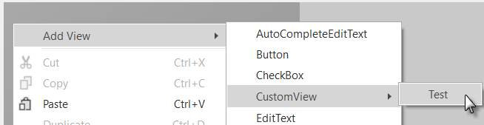

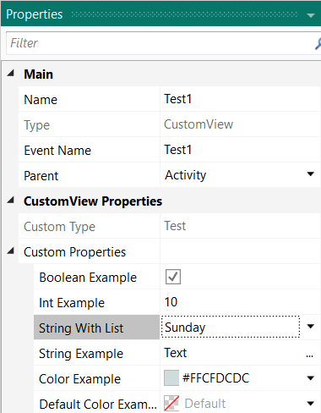

In the Properties window, you find all the properties for the selected custom view.

Imges B4A.

**Custom properties**:

Here we see the six custom properties declared on top of the Class code.

Example with the String With List property.

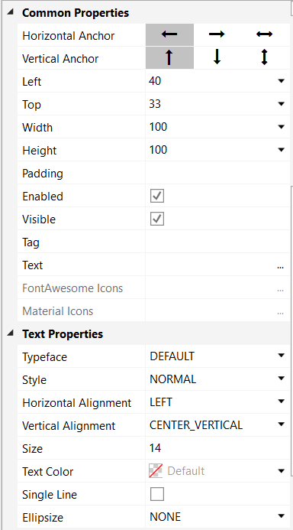 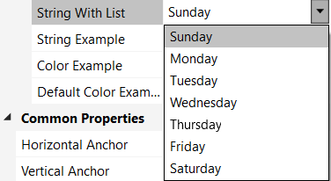

**Common Properties**:

The common properties like any view.

**Text Style**:

The properties are set to the Lbl Label of the class.

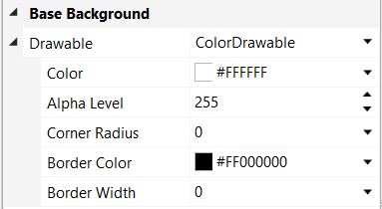

**Base Background**:

Background of the base panel Base.

To access the custom properties you must use the Props Map in the **DesignerCreateView** routine.

Variable declaration:

Private BooleanTest As Boolean

Private IntTest As Int

Private Day As String

Private StringTest As String

Private ColorTest As Int

Private DefaultColorTest As Int

And the DesignerCreateView routine:

Public Sub **DesignerCreateView** (Base As Panel, Lbl As Label, Props As Map)

mBase = Base

BooleanTest = Props.Get("BooleanExample")

IntTest = Props.Get("IntExample")

Day = Props.Get("StringWithListExample")

StringTest = Props.Get("StringExample")

ColorTest = Props.Get("ColorExample")

DefaultColorTest = Props.Get("DefaultColorExample")

End Sub

**B4J** the Base declaration is different, Pane instead of Panel.

Public Sub **DesignerCreateView** (Base As Pane, Lbl As Label, Props As Map)

You can get properties of the Base Panel / Pane like:

**B4A / B4i / B4J**

Private mWidth As Int

mWidth = Base.Width

Private mHeight As Int

mHeight = Base.Height

You can get text properties from the Lbl Label like:

**B4A B4i B4J**

Private mText As String Private mText As String Private mText As String

mText = Lbl.Text mText = Lbl.Text mText = Lbl.Text

Private mTextColor As Int Private mTextColor As Int Private mTextColor As Paint

mTextColor = Lbl.TextColor mTextColor = Lbl.TextColor mTextColor = Lbl.TextColor

Private mTextSize As Float Private fnt As Font Private mTextSize As Double

mTextSize = Lbl.TextSize Private mTextSize As Float mTextSize = Lbl.TextSize

fnt = Lbl.Font

mTextSize = fnt.Size

## Complie to a library

In B4A, B4i and B4J you can compile your project, or part of it to a regular library.  
  
Why should we compile a library?

* Break large projects into several smaller (more maintainable) projects.
* Build reusable components and use them from any number of projects.
* Share components with other developers without sharing the source code.
* Create different versions of your application (free, pro...) by referencing the same "core" library.

The output of library compilation is:

* Two files for B4A and B4J:   
  A jar file with the compiled code and a xml file that includes the metadata that is required by the IDE.  
  These two files are automatically saved in the additional libraries folders.
* Three files for B4i:   
  The xml file like above which is copied to the additional libraries folders.  
  And, .a and .h files are created in the Mac Libs folder.

You can exclude other modules as well with the ExcludeFromLibrary attribute.

#ExcludeFromLibrary: True  
  
**The Main module ia always excluded from the library!**

The Main module and the other excluded modules can be used to test the library.  
  
You can reference the library from other projects and access the same functionality as in the original project.

Compiling to a library is quite simple.

Under Project menu there is the compile option - "Compile To Library (Alt + 5)".

When you choose this option all the modules **except** of the main activity are compiled into a library.

**B4A** **B4J**

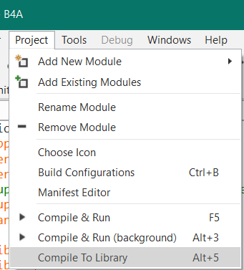 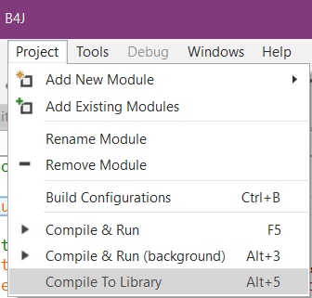

**B4i**

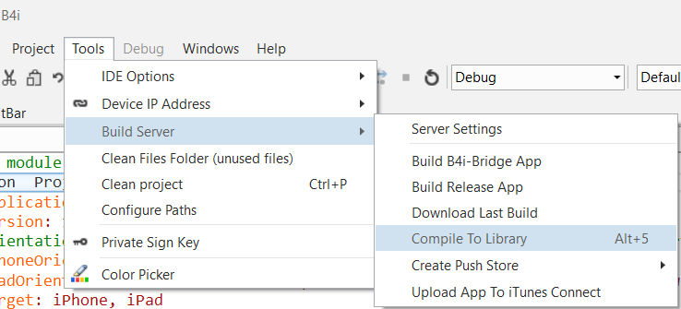

**Note:** If you are using the hosted builder then you need to first receive a permission to compile a specific library. Please contact [support@basic4ppc.com](mailto:support@basic4ppc.com) and send your hosted builder id and the library name.

You find the hosted builder id in Tools / Build Server / Server Settings.

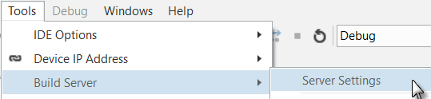 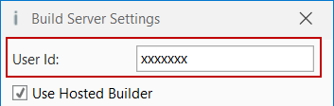

### Library specific attributes

The following attributes are specific for library compilation:

**Main module:**

Project attributes (placed on top of the code in the Main module):  
#LibraryName   
 - The compiled library name. Sets the library name.  
#LibraryAuthor  
 - The library author. This value is added to the library xml file.  
#LibraryVersion   
- A number that represents the library version. This number will appear next to the library name in the libraries list.

Example, LimitBar projects.

**B4A B4i B4J**

#LibraryName: LimitBar #LibraryName: iLimitBar #LibraryName: jLimitBar

#LibraryAuthor: Klaus Christl #LibraryAuthor: Klaus Christl #LibraryAuthor: Klaus Christl

#LibraryVersion: 1.0 #LibraryVersion: 1.0 #LibraryVersion: 1.0

**All modules:**  
#ExcludeFromLibrary - Whether to exclude this module during library compilation. Values: True or False. Note that the Main activity is always excluded.

**CustomView classes:**  
#Event - Adds an event to the list of events. This attribute can be used multiple times.

The parameters must be included.

Note that the events list only affects the IDE events autocompletion feature.  
#RaisesSynchronousEvents - Needed if you compile the CustomView into a library.

It is used for the Rapid Debugger. You need one for each event.

Details in the LimitBar project here.

Example, LimitBar projects.

#Event: ValuesChanged(LimitLeft As Int, LimitRight As Int)

#RaisesSynchronousEvents: ValuesChanged  
ValuesChanged is the name of the event for its call.

If you have other modules in the same project which should not be in the library, you must add

#ExcludeFromLibrary: True

**Notes**  
  
- You should right click on the libraries list and choose Refresh after a library update.  
- CallSub / CallSubDelayed - The first parameter for these keywords is a reference to the target module. When working with modules that reside in a library you should pass the module reference and not the module name as string (this is the better way to reference all modules in all cases).  
- Code obfuscation - Libraries can be obfuscated during library compilation. Strings will not be obfuscated in this mode.  
- Services that host home screen widgets cannot be compiled into a library.

The library files are automatically saved in the Additional Libraries folder.

You can see it in the Libraries Manager Tab.

Right click somewhere in the Libraries Manager Tab and click on .

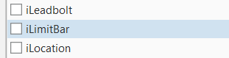 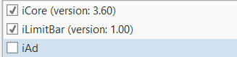

Example with the B4i LimitBar project.

The library name is the name you entered in #LibraryName: iLimitBar.

When you select the library, it moves on top of the list and shows the version number.

You should not have the modules and the library in the same project!

When you declare a custom view, you must use the Module/Object name:

Library: iLimitBar Object: LimitBar

Private ltbTest, ltbTest1 As LimitBar

## Program flow

Below a comparison of the program flow with two custom views, one added in the Designer and the other in the code.

**B4A B4i B4J**

0 Process_Globals 0 Process_Globals 0 Process_Globals

0 Globals 0 Application_Start 0 AppStart

0 Activity_Create 1 Class_Globals 1 Class_Globals

1 Class_Globals 1 Class Initialize 1 Class Initialize

1 Class Initialize 1 DesignerCreateView 1 DesignerCreateView

1 DesignerCreateView 1 Base_Resize 1 Base_Resize

2 Class_Globals 2 Class_Globals 2 Class_Globals

2 Class Initialize 2 Class Initialize 2 Class Initialize

2 AddToParent 2 AddToParent 2 AddToParent

0 Activity_Resume 0 Page1_Resize 0 MainForm_Resize

**Turn device Turn device Resize Main Form**

0 Activity_Pause 0 Page1_Resize 0 MainForm_Resize

1 Class_Globals 1 Base_Resize 1 Base_Resize

1 Class Initialize

1 DesignerCreateView

2 Class_Globals

2 Class Initialize

2 AddToParent

0 Activity_Resume

0 = Main

1 = CustomView Designer

2 = CustomView code

Note: The B4A example project above has no Starter service module.

We notice that when we start the program the flow is the same in B4i and B4J but in B4A it is a bit different.

When we turn the B4i device or resize the B4J form the program flow is the same.

In B4A it is quite different.

In B4A, the Activity is destroyed and recreated.

In B4i and B4J, the layout remains and a Resize event is raised.

The advantage of adding custom views in the Designer, in B4i and B4J, is that it handles the resize event and reapplies the anchors and designer script (and variant changes).

In B4A this is also executed because the Activity is recreated at every change.

This is shown in the LimitBar projects.

## Intellisense help

It is adviced to add help comments in the code for the users of your library.

### Comments before Sub Class_Globals

Comments before Sub **Class_Globals** are considered as the help header when the class is compiled to a Library.

'LimitBar CustomView class.

'This CustomView allows the user to set two limits with two cursors.

'The Min value is 0 and the Max value is 100.

'The Max value can be changed by the programmer.

Sub **Class_Globals**

Example with the B4x Help Viewer and the LimitBar library.

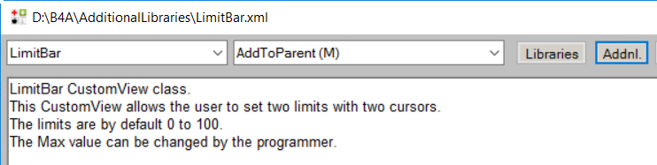

### Comments before a routine

Comments before a routine are considered as intellisense help.

'Initializes the object.

'Callback = name of the calling module

'EventName = event name

'Example if added in the code:

'<code>ltbTest.Initialize(Me, "ltbTest")'</code>

Public Sub **Initialize**(Callback As Object, EventName As String)

Type ‘lbtTest.’ , the method and property list is displayed.

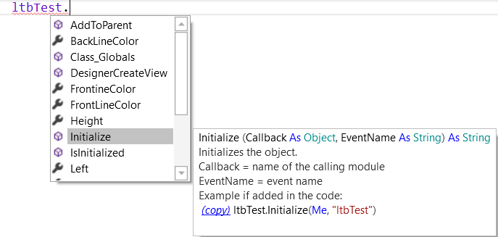

### Comments before an event routine

Events declared on top of the code in the class module with #Event: are displayed as intellisense when the class is compiled to a Library.

'Custom View class LimitBar

'Events declaration

#Event: ValuesChanged(LimitLeft As Int, LimitRight As Int)

When you use the library in another project, type ‘Public Sub ‘ (with a space at the end) and press on Tab to show the objects list.

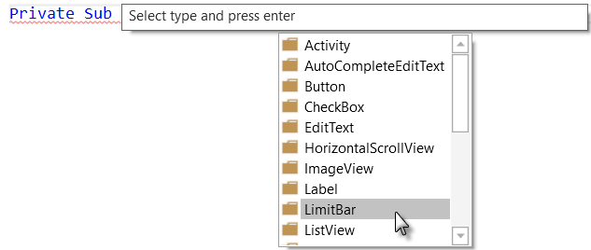

Select .



Select .

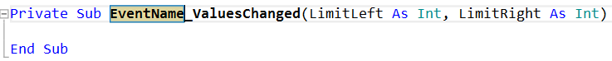

The sub frame is added.



Enter the LimitBar name and press Return and the sub frame is finished.



## Help tool

If you have the [B4x Help Viewer](https://www.b4x.com/android/forum/threads/b4x-help-viewer.46969/#content) you can look at the help for the library.

Example with the B4A LimitBar library.

Click on  to load LimitBar.xml.

And the result.

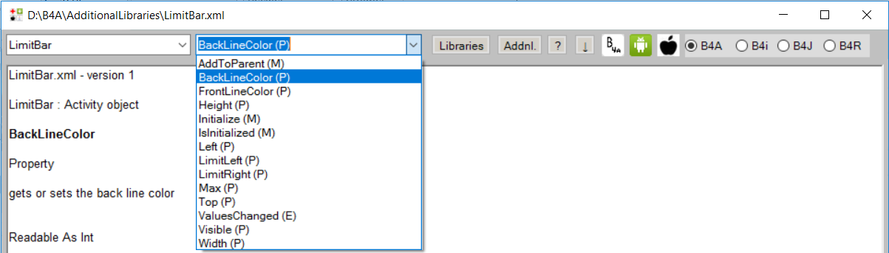

Then you can select any method, event or property in the list to show the help.

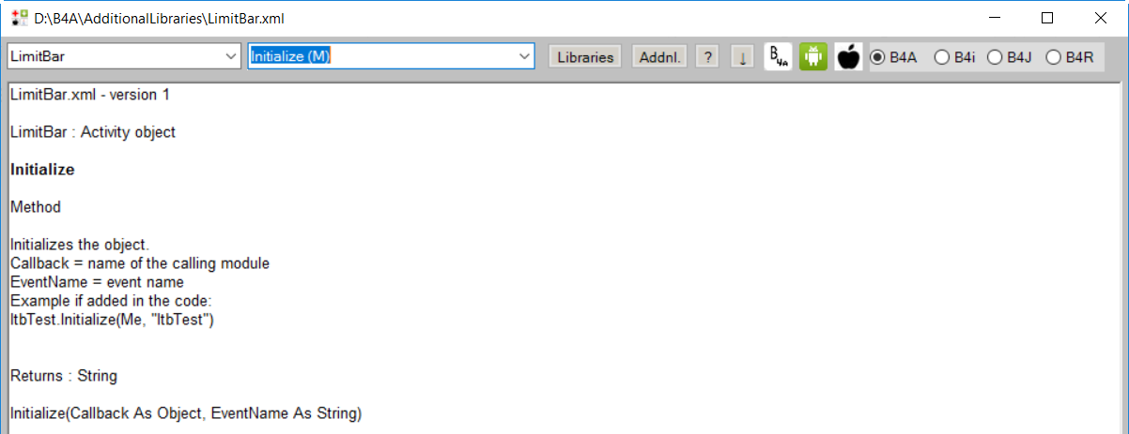

# First example CustomButton

We will make a simple CustumButton.

B4A B4i B4J

  C:\Users\klaus\AppData\Local\Temp\SNAGHTML15ff3b85.PNG

The button has a transparent base Panel (B4A, B4i) / Pane (B4J) plus one Label with a

Material Icon and a second Label with text.

The CustumButton can be added in the Designer or in the code.

The CustumButton has two events Click and LongClick.

B4J has no Click nor LongClick event, Click is called Action or MouseClicked.

I kept the Click name and added the LongClick event.

The code is kept simple and minimalistic, the main goal here is to show the principle.

Feel free to add more properties and functionalities.

## Event declarations

First, we declare the events on top of the code.

Needed when the class is compiled to a library.

'CustomButton Class

#Event: Click

#Event: LongClick

#RaisesSynchronousEvents: Click

#RaisesSynchronousEvents: LongClick

## Custom properties for the Designer

We have only one custom property: Text.

This is the text below the icon.

The other properties, like icon character and text color, are defined in the Designer or in the AddToParent routine.

The icon and text sizes are calculated in the class code acording to the button height.

#DesignerProperty: Key: Text, DisplayName: Text, FieldType: String, DefaultValue: Text, Description: Text at the bottom of the button.

## Class help header

We add a header text, just before Sub **Class_Globals**, explaining the purpose of the button as a help for the user.

'CustomButton is a button based on a Panel with two Labels

'one with a Material Icon and the other with text.

'It has two events: Click and LongClick.

Sub **Class_Globals**

## Global variables

We define the global variables below. There are some differences between the three operating systems.

**B4A**

Sub **Class_Globals**

Private mEventName As String

Private mCallBack As Object

Private mBase As Panel

Private mLeft, mTop, mWidth, mHeight As Int

Private mText, mIcon As String

Private mIconTypeface As Typeface

Private mTextColor As Int

Private mIconTextSize, mTextSize As Float

Private mTag As Object

Private mLabel, mIconLabel As Label

Private mParent As Panel

End Sub

**B4i** Typeface is replaced by Font.

Private mIconTypeface As Font

**B4J** Typeface is replaced by Font. For the color Int is replaced by Paint.

We add another variable for the LongClick event timing

Private mIconTypeface As Font

Private mTextColor As Paint

Private mClickTime As Long 'used to distinguish Click and LongClick

## Initialize routine

We get the CallBack module and EventName and initialize three default values.

**B4A / B4i**

Public Sub **Initialize** (Callback As Object, EventName As String)

mEventName = EventName

mCallBack = Callback

mIcon = Chr(0xE859)

mText = "Test"

mTextColor = Colors.Black

End Sub

**B4J** the color is fx.Colors.Black instead of Colors.Black.

mTextColor = fx.Colors.Black

## DesignerCreateView routine

Here we get the properties from the Designer.

We initialize mBase and add it to the parent view.

We need this because we use event routines of the base panel / pane.

Just setting mBase = Base does not enable to use events.

**B4A**

Public Sub **DesignerCreateView** (Base As Panel, Lbl As Label, Props As Map)

mLeft = Base.Left

mTop = Base.Top

mWidth = Base.Width

mHeight = Base.Height

mIcon = Lbl.Text

mText = Props.Get("Text")

mBase.Initialize("mBase")

mParent = Base.Parent

Base.AddView(mBase, 0, 0, mWidth, mHeight)

mTextColor = Lbl.TextColor

mIconTypeface = Lbl.Typeface

mTag = Base.Tag

InitClass

End Sub

**B4i** Typeface is replaced by Font.

mIconTypeface = Lbl.Font

Plus, the Base_Resize routine.

**B4J** Typeface is replaced by Font. Base.AddView is replaced by Base.AddNode

mIconTypeface = Lbl.Font

Base.AddNode(mBase, 0, 0, mWidth, mHeight)

mHeight = Base.Height

Plus, the Base_Resize routine.

The InitClass routine, mWidth = Base.Width and mHeight = Base.Height are moved to the **Base_Resize** routine.

## Base_Resize routine B4i / B4J only

The Base_Resize routine is called every time a resize is done.

Device orientation change in B4i or a Form resize in B4J.

**B4i**

Private Sub **Base_Resize** (Width As Double, Height As Double)

mHeight = Height

mWidth = Width

End Sub

**B4J**

Private Sub **Base_Resize** (Width As Double, Height As Double)

mWidth = Width

mHeight = Height

mBase.PrefWidth = mWidth

mBase.PrefHeight = mHeight

InitClass

End Sub

## AddToParent routine

This routine is needed when we add the CustomButton in the code.

We memorize the position, dimensions and properties.

And call InitClass

**B4A / B4i**

Public Sub **AddToParent**(Parent As Panel, Left As Int, Top As Int, Width As Int, Height As Int, TextColor As Int, Icon As String, Text As String)

mLeft = Left

mTop = Top

mWidth = Width

mHeight = Height

mParent = Parent

mBase.Initialize("mBase")

Parent.AddView(mBase, mLeft, mTop, mWidth, mHeight)

mIcon = Icon

mText = Text

mTextColor = TextColor

InitClass

End Sub

**B4J** Parent.AddView is relaced by Parent.AddNode.

Parent.AddNode(mBase, mLeft, mTop, mWidth, mHeight)

## InitClass routine

Here we initialize the common part independent if the CustomButton is added in the Designer or in the code.

**B4A**

Private Sub **InitClass**

'calculate the dimensions of the internal Labels

Private lblLeft, lblWidth As Int

lblWidth = 2 * mHeight / 3 'icon Label width and height = 2/3 of button height

lblLeft = (mWidth - lblWidth) / 2

'initialize and add the icon Label

mIconLabel.Initialize("")

mIconTextSize = mHeight / 2 / GetDeviceLayoutValues.Scale 'B4A, B4i

mIconLabel.Typeface = mIconTypeface 'B4A

mIconLabel.TextSize = mIconTextSize 'B4A, B4J

mIconLabel.Gravity = Gravity.CENTER 'B4A

mIconLabel.TextColor = mTextColor

mBase.AddView(mIconLabel, lblLeft, 0, lblWidth, lblWidth) 'B4A, B4i

mIconLabel.Text = mIcon

'initialize and add the text Label

mLabel.Initialize("")

mTextSize = lblWidth / 3 / GetDeviceLayoutValues.Scale 'B4A, B4i

mLabel.TextSize = mTextSize 'B4A, B4J

mLabel.TextColor = mTextColor

mLabel.Gravity = Bit.Or(Gravity.CENTER_HORIZONTAL, Gravity.TOP) 'B4A

mBase.AddView(mLabel, 0, 2 * mHeight / 3, mWidth, mHeight / 3) 'B4A, B4i

mLabel.Text = mText

End Sub

'B4A means that this line is only for B4A and different from B4i and B4J.

'B4A, B4i means that this line is the same for B4A and B4i, but is different in B4J.

**B4i**

Private Sub **InitClass**

'calculate the dimensions of the internal Labels

Private lblLeft, lblWidth As Int

lblWidth = 2 * mHeight / 3 'icon Label width and height = 2/3 of button height

lblLeft = (mWidth - lblWidth) / 2

'initialize and add the icon Label

mIconLabel.Initialize("")

mIconTextSize = mHeight / 2 / GetDeviceLayoutValues.Scale 'B4i, B4A

mIconFont = Font.CreateNew2(mIconFont.Name, mIconTextSize) 'B4i

mIconLabel.Font = mIconFont 'B4i, B4J

mIconLabel.TextAlignment = mIconLabel.ALIGNMENT_CENTER 'B4i

mIconLabel.TextColor = mTextColor

mBase.AddView(mIconLabel, lblLeft, 0, lblWidth, lblWidth) 'B4i, B4A

mIconLabel.Text = mIcon

'initialize and add the text Label

mLabel.Initialize("")

mTextSize = lblWidth / 3 / GetDeviceLayoutValues.Scale 'B4i, B4A

mLabel.Font = Font.CreateNew(mTextSize) 'B4i

mLabel.TextColor = mTextColor

mLabel.TextAlignment = mIconLabel.ALIGNMENT_CENTER 'B4i

mBase.AddView(mLabel, 0, 2 * mHeight / 3, mWidth, mHeight / 3) 'B4i, B4A

mLabel.Text = mText

End Sub

**B4J**

Private Sub **InitClass**

'calculate the dimensions of the internal Labels

Private lblLeft, lblWidth As Int

lblWidth = 2 * mHeight / 3 'icon Label width and height = 2/3 of button height

lblLeft = (mWidth - lblWidth) / 2

'initialize and add the icon Label

mIconLabel.Initialize("")

mIconTextSize = mHeight / 2 'B4J

mIconLabel.Font = mIconFont 'B4J, B4i

mIconLabel.TextSize = mIconTextSize 'B4J, B4A

mIconLabel.Alignment = "CENTER" 'B4J

mIconLabel.TextColor = mTextColor

mBase.AddNode(mIconLabel, lblLeft, 0, lblWidth, lblWidth) 'B4J

mIconLabel.Text = mIcon

'initialize and add the text Label

mLabel.Initialize("")

mTextSize = lblWidth / 3 'B4J

mLabel.TextSize = mTextSize 'B4J, B4A

mLabel.TextColor = mTextColor

mLabel.Alignment = "TOP_CENTER" 'B4J

mBase.AddNode(mLabel, 0, 2 * mHeight / 3, mWidth, mHeight / 3) 'B4J

mLabel.Text = mText

End Sub

## Click / LongClick event routines

The two event routines.

**B4A / B4i**

Private Sub **mBase_Click**

If SubExists(mCallBack, mEventName & "_Click") = True Then

CallSub(mCallBack, mEventName & "_Click")

End If

End Sub

Private Sub **mBase_LongClick**

If SubExists(mCallBack, mEventName & "_LongClick") = True Then

CallSub(mCallBack, mEventName & "_LongClick")

End If

End Sub

**B4J**

Very different, because the LongClick event doesn’t exist in B4J.

Private Sub **mBase_MousePressed** (EventData As MouseEvent)

mClickTime = DateTime.Now

End Sub

Private Sub **mBase_MouseReleased** (EventData As MouseEvent)

If DateTime.Now - mClickTime < 500 Then

If SubExists(mCallBack, mEventName & "_Click") = True Then

CallSub(mCallBack, mEventName & "_Click")

End If

Else

If SubExists(mCallBack, mEventName & "_LongClick") = True Then

CallSub(mCallBack, mEventName & "_LongClick")

End If

End If

End Sub

In **mBase_MousePressed**, we memorize the time when the mouse is pressed.

In **mBase_MousePressed**, we check the time elapsed between press and release.

If the time is less than 500 milli-seconds, then we admid a Click and if time is longer we admit a LongClick event.

## Property routines

Below the routine to set the IconTypeFace / IconFont property.

**B4A**

'set the icon typeface

'must be FontAwsome or Material Icons

Public Sub **setIconTypeface**(IconTypeface As Typeface)

mIconTypeface = IconTypeface

End Sub

**B4i / B4J**

'set the icon typeface

'must be FontAwsome or Material Icons

Public Sub **setIconFont**(IconFont As Font)

mIconFont = IconFont

End Sub

And the Tag property.

**B4A / B4i / B4J**

'get or set the Tag property

Public Sub **setTag**(Tag As Object)

mTag = Tag

mBase.Tag = Tag

End Sub

Public Sub **getTag** As Object

Return mTag

End Sub

I haven’t added other properties to not overload the code.

## Main code

### Globals

Only two variables, in addition to the default declarations in B4i and B4J.

**B4A / B4i B4J**

Sub **Globals**

Private cbtTest10 As CustomButton

Private lblDummy As Label

End Sub

We need a dummy invisible Label to get the Material Icons TypeFace / Font for the icon Label when the CustomButton is added in the code.

**B4A** **B4i / B4J**

 

### Program start

**B4A**

Sub **Activity_Create**(FirstTime As Boolean)

Activity.LoadLayout("Main")

cbtTest10.Initialize(Me, "cbtTest")

cbtTest10.IconTypeface = lblDummy.Typeface

cbtTest10.AddToParent(Activity, 20dip, 200dip, 60dip, 60dip, Colors.RGB(0, 0, 139), Chr(0xE149), "Test 10")

cbtTest10.Tag = 10

End Sub

**B4i**

Private Sub **Application_Start** (Nav As NavigationController)

NavControl = Nav

Page1.Initialize("Page1")

Page1.Title = "Page 1"

Page1.RootPanel.Color = Colors.White

Page1.RootPanel.LoadLayout("Main")

NavControl.ShowPage(Page1)

cbtTest10.Initialize(Me, "cbtTest")

cbtTest10.IconFont = lblDummy.Font

cbtTest10.AddToParent(Page1.RootPanel, 30, 100, 60, 60, Colors.RGB(0, 0, 139), Chr(0xE05C), "Test 10")

cbtTest10.Tag = 10

End Sub

**B4J**

Sub **AppStart** (Form1 As Form, Args() As String)

MainForm = Form1

MainForm.RootPane.LoadLayout("Main") 'Load the layout file.

MainForm.Show

MainForm.Title = "jClsCustomButton"

cbtTest10.Initialize(Me, "cbtTest")

cbtTest10.IconFont = lblDummy.Font

cbtTest10.AddToParent(MainForm.RootPane, 100, 100, 60, 60, fx.Colors.RGB(0, 0, 139), Chr(0xE05C), "Test 10")

cbtTest10.Tag = 10

End Sub

Besides the default operating system methods, the CustomButton declaration is also a bit different.

* Parent object: **B4A** Activity (Panel), **B4i** Page1.RootPanel, **B4J** MainForm.RootPane.
* Font type:   
  **B4A** TypeFace  
  cbtTest10.IconTypeface = lblDummy.Typeface  
  **B4i / B4J** Font  
  cbtTest10.IconFont = lblDummy.Font

## Click event routine

The Click event routine is the same for all three operating systems:

Private Sub **cbtTest_Click**

Private cbt As CustomButton

Private Index As Int

cbt = Sender

Index = cbt.Tag

Select Index

Case 1

Log("cbtTest1_Click")

Case 2

Log("cbtTest2_Click")

Case 10

Log("cbtTest10_Click")

Case Else

Log("cbtTest" & Index & "_Click")

End Select

End Sub

I set the same event name for all CustomButtons and use the Tag property of the Sender object to know which button raised the event.

The LongClick event routine is almost the same, LongClick replaces Click.

## Compile to Library

We add the library declarations on top of the code in the Main module.

**B4A**

#LibraryName: CustomButton

#LibraryAuthor: Klaus CHRISTL

#LibraryVersion: 1.0

**B4i**

#LibraryName: iCustomButton

#LibraryAuthor: Klaus CHRISTL

#LibraryVersion: 1.0

**B4J**

#LibraryName: jCustomButton

#LibraryAuthor: Klaus CHRISTL

#LibraryVersion: 1.0

And we compile the CustomButton module to a Library.

The Library files are automatically copied to the AdditionalLibraries folder.

If you use the hosted compiler for B4i, you must ask Erel for permission to be able to compile a library.

## Use the library in a program

Copy the projects to new folders where you replace *Cls* by *Lib*.

The source codes are in the *LibCustomButton* folders

Then:

* Load the projects in the IDE.
* Rename the package name.
* Rename the #ApplicationLabel: LblCustomButton (B4A and B4i only)
* Remove the three lines:  
  #LibraryName: CustomButton  
  #LibraryAuthor: Klaus CHRISTL  
  #LibraryVersion: 1.0
* Remove the CustomButton class module.  
  Select the CustomButton module and remove it.  
  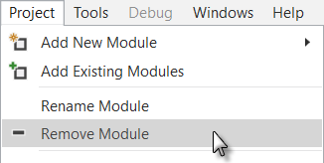
* Select the CustomButton library in the Labaraies Manager Tab.  
  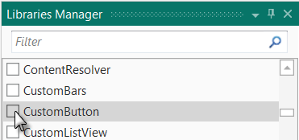
* Run the program.

The rest of the code in the Main module remains the same.

The layout file remains the same.

# LimitBar

Another concrete example, a LimitBar.

The LimitBar looks like this, images from the B4A project:



Two cursors allow to define two limits between 0 and a max value.

In the demo program, we add two labels, one on each side, to display the two limit values these are not part of the custom view.



There are two projects for each operating system:

* ClsLimitBarDemo, project with the custom view class module.
* LibLimitBarDemo, project with the custom view as a library (class module compiled to a library).

It supports adding a LimiBar in the Designer or in the code.

In the demo projects two LimitBars are added, one in the Designer and one in the code.

The source codes are in the \ClsLimitBar and \LibLimitBar folders, one folder for each operating system.

We use for:

**B4A / B4i**

Two panels:

* ltbPanelBack the background with the background color and the red 'background' line.  
  
* ltbPanelFront the foreground, transparent with the 'foreground' line and the two cursors.  
   

and two canvases:

* cvsPanelBack to draw the background line onto ltbPanelBack.
* cvsPanelFront to draw the foreground line and the cursors onto ltbPanelFront.

**B4J**

One pane as the custom view holder ltbPanelBack and two canvases cvsBack and cvsFront.

The difference in B4J is that canvases are objects on their own, not linked to anoter object like in B4A and B4i.

The LimitBar customView raises one event:

ValuesChanged(LimitLeft As Int, LimitRight As Int)

In the next chapters, the code is explained from top to down.

## Event declaration

On top of the code we declare the event:

'Events declaration

#Event: ValuesChanged(LimitLeft As Int, LimitRight As Int)

#RaisesSynchronousEvents: ValuesChanged

We need this for the intellisense system when the class module is compiled to a library.

## Custom properties for the Designer

The LimitBar has following custom properties:

* Max   
  Sets or gets the max limit value when the curser is at the most right position.  
  The default value is 100.
* LimitLeft   
  Sets or gets the left limit value. The default value is 0.
* LimitRight  
  Sets or gets the right limit value. The default value is 100.
* BackLineColor  
  Sets or gets the back-line color. The default value is red (0xFFFF0000).
* FrontLineColor  
  Sets or gets the front-line color. The default value is light blue (0x FF33B5E5).

Tu support setting these properties in the Designer we must declare them:

'Designer property declarations

#DesignerProperty: Key: Max, DisplayName: Max, FieldType: Int, DefaultValue: 100, Description: Sets the max value.

#DesignerProperty: Key: LimitLeft, DisplayName: Left limit, FieldType: Int, DefaultValue: 10, Description: Sets the left limit value.

#DesignerProperty: Key: LimitRight, DisplayName: Right limit, FieldType: Int, DefaultValue: 100, Description: Sets the right limit value.

#DesignerProperty: Key: Radius, DisplayName: Radius, FieldType: Int, DefaultValue: 5, Description: Sets the corner radius.

#DesignerProperty: Key: BackgroundColor, DisplayName: BackgroundColor, FieldType: Color, DefaultValue: 0xFF0000FF, Description: Sets the background color.

#DesignerProperty: Key: BackLineColor, DisplayName: BackLineColor, FieldType: Color, DefaultValue: 0xFFFF0000, Description: Sets the back line color.

#DesignerProperty: Key: FrontLineColor, DisplayName: FrontLineColor, FieldType: Color, DefaultValue: 0xFF33B5E5, Description: Sets the front line color.

We will add also code to set or get these properties in the code.

## Class help header

Class header help text, just before Sub **Class_Globals**.

'LimitBar CustomView class.

'This CustomView allows the user to set two limits with two cursors.

'The Min value is 0 and the Max value is 100.

'The Max value can be changed by the programmer.

Sub **Class_Globals**

## Global variables

In Sub Class_Globals we declare the objects and variables.

**B4A / B4i** the only difference is cdwBackground As ColorDrawable used in B4A.

Sub **Class_Globals**

Private mCallback As Object ' calling module

Private mEventName As String ' event name

Private mWidth, mHeight, mRadius As Int

Private ltbPanelBack As Panel ' the background panel

Private ltbPanelFront As Panel ' the foreground panel

Private cvsPanelBack As Canvas ' the background canvas

Private cvsPanelFront As Canvas ' the foreground canvas

Private rectPanelFront As Rect ' a rectangle for the foreground canvas

Private mBackgroundColor As Int ' color for the background

Private cdwBackground As ColorDrawable ' background drawable, only for B4A

Private mBackLineColor As Int ' color for the background line

Private mFrontLineColor As Int ' color for the foreground line

Private mMargin As Int ' left and right margins for the line

Private x0, y0, x1, y1, y2 As Int ' backline and cursor coordinates

Private mMaxValue As Int ' value of the Max property

Private mScale As Double ' scale between position value and pixels

Private mLimit(2) As Int ' values of the limits

Private PositionPixels(2) As Int ' left and right positions in pixels

Private Paths(2) As Path ' two paths for the cursor shape

Private PosIndex As Int ' current index of the cursor position

' 0 = left 1 = right cursor

End Sub

**B4J**

Sub **Class_Globals**

Private fx As JFX ' B4J specific

Private mCallback As Object ' calling module

Private mEventName As String ' event name

Private mWidth, mHeight, mRadius As Double

Private ltbPanelBack As Pane ' the background pane

Private cvsBack As Canvas ' the background canvas

Private cvsFront As Canvas ' the foreground canvas

Private mBackgroundColor As Paint ' color for the background

Private mBackLineColor As Paint ' color for the background line

Private mFrontLineColor As Paint ' color for the foreground line

Private mMargin As Double ' left and right margins for the line

Private x0, y0, x1, y1, y2 As Double ' backline and cursor coordinates

Private mMaxValue As Int ' value of the Max property

Private mScale As Double ' scale between position value and pixels

Private mLimit(2) As Int ' value of the limits

Private PositionPixels(2) As Double ' left and right positions in pixels

Private PosIndex As Int

' 0 = left 1 = right

Private Graph, jCanvasFront As JavaObject ' B4J specific used to draw the cursors

End Sub

There are some differences between B4J and B4A / B4i. B4J needs of the jFX library.

Some differences for the canvases. No foreground panel but two JavaObjects.

## Initialize routine

Then we need the routine to initialize the LimitBar, the code is self explanatory.

This routine is automatically called if you add the LimitBar in the Designer.

If you add the LimitBar in the code, you must call this routine first.

You should not modify the signature of this routine

**B4A / B4i / B4J**

'Initializes the object.

'Callback = name of the calling module

'EventName = event name

'Example if added in the code:

'<Code>ltbTest.Initialize(Me, "ltbTest")'</Code>

Public Sub **Initialize**(Callback As Object, EventName As String)

mCallback = Callback

mEventName = EventName

' initialize default values

mBackgroundColor = Colors.Blue

mBackLineColor = Colors.Black

mFrontLineColor = Colors.RGB(51, 181, 229)

mMargin = 15

mMaxValue = 100

mLimit(0) = 0

mLimit(1) = mMaxValue

End Sub

## DesignerCreateView routine

Then we have the DesignerCreateView routine.

This routine is called automatically after Initialize when the LimitBar is added in the Designer.

It is NOT used when you add the LimitBar in the code.

**B4A / B4i**

Public Sub **DesignerCreateView**(Base As Panel, Lbl As Label, Props As Map)

' we use the Base panel as the background panel

ltbPanelBack = Base

' we memorize the Base Width and Height properties

mWidth = Base.Width

mHeight = Base.Height

' we memorize the custom properties

mMaxValue = Props.Get("Max")

mLimit(0) = Props.Get("LimitLeft")

mLimit(0) = Max(0, mLimit(0)) ' we check the min value, not less than 0

mLimit(1) = Props.Get("LimitRight")

mLimit(1) = Min(mMaxValue, mLimit(1)) ' we check the max value, not higher than Max

mRadius = Props.Get("Radius")

mBackgroundColor = Props.Get("BackgroundColor")

mBackLineColor = Props.Get("BackLineColor")

mFrontLineColor = Props.Get("FrontLineColor")

InitClass ' initializes the common parts for Designer and code

End Sub

We use the Base Panel with the name ltbPanelBack, and get the custom properties from the Props Map object.

As the LimitBar custom view can also be added in the code we initialize the rest in the InitClass routine.

**B4J** at end of the routine with B4i specific code.

mBackLineColor = Props.Get("BackLineColor")

mFrontLineColor = Props.Get("FrontLineColor")

End Sub

The InitClass routine is moved to a B4J specific routine **Base_Resize**:

Note that the signature of the routine is different:

Public Sub **DesignerCreateView**(Base As Panel, Lbl As Label, Props As Map)

Base As Pane instead of Base As Panel.

## Base_Resize routine B4i / B4J only

In B4i and B4J there is a specific routine Private Sub **Base_Resize**.

This routine is executed every time a resize is operated.

**B4i**

Private Sub **Base_Resize** (Width As Double, Height As Double)

setWidth(Width)

End Sub

**B4J**

Private Sub **Base_Resize** (Width As Double, Height As Double)

mWidth = ltbPanelBack.Width

mHeight = ltbPanelBack.Height

If cvsBack.IsInitialized = False Then

InitClass ' initializes the common parts for Designer and code

End If

setWidth(Width)

End Sub

In B4J the width and height of the Base pane is known only in the **Base_Resize** routine.

This routine is called directly after **DesignerCreateView** when the LimitBar is added in the Designer.

It is not called when the LimitBar is added in the code.

## AddToParent routine

The AddToParent routine.

This routine must be called when you add the LimitBar in the code.

It is not used when the LimitBar is added in the Designer.

**B4A / B4i / B4J**

'Adds the LimitBar to the Parent object

'Parent = parent view, the Activity or a Panel

'Left, Right, Width, Height = position and dimensions properties of the LimitBar

'Color = background color of the LimitBar

'Radius = corner radius of the LimitBar

Public Sub **AddToParent**(Parent As Activity, Left As Int, Top As Int, Width As Int, Height As Int, BackgroundColor As Int, Radius As Int)

mWidth = Width

mHeight = Max(Height, 30dip) ' limits the height to min 30dip

mRadius = Min(Radius, Height / 2) ' limits the max radius to half the height

mBackgroundColor = BackgroundColor

' initialize the background panel ltbPanelBack and add it onto the parent view

ltbPanelBack.Initialize("")

Parent.AddView(ltbPanelBack, Left, Top, Width, Height)

InitClass ' initializes the common parts for Designer and code

End Sub

We memorize several properties, initialize ltbPanelBack and add it onto the parent view and set its background and call InitClass.

Example:

'adds a second LimitBar in the code

ltbTest1.Initialize(Me, "ltbTest1")

ltbTest1.FrontLineColor = Colors.Blue

ltbTest1.AddToParent(Activity, 30dip, 100dip, 200dip, 30dip, Colors.Red, 5dip)

## InitClass routine

In this routine, we initialize the common code parts independent if the LimitBar is added in the Designer or in the code.

This routine is called either from the **DesignerCreateView** when the LimitBar is added in the Designer or from the **AddToParent** routine when the custom view is added in the code.

**B4A**

Private Sub **InitClass**

InitCursors

' initialize and set the ColorDrawable for the background panel

cdwBackground.Initialize(mBackgroundColor, mRadius)

ltbPanelBack.Background = cdwBackground

' initialize the foreground panel and add it onto the background panel

ltbPanelFront.Initialize("ltbPanelFront")

ltbPanelBack.AddView(ltbPanelFront, 0, 0, ltbPanelBack.Width, ltbPanelBack.Height)

' initialize the foreground panel rectangle used to erase ltbPanelFront

rectPanelFront.Initialize(0, 0, ltbPanelFront.Width, ltbPanelFront.Height)

ltbPanelFront.BringToFront

' initialize the background canvas and draw the background line

cvsPanelBack.Initialize(ltbPanelBack)

DrawBackGroundLine

' initialize the foreground canvas

cvsPanelFront.Initialize(ltbPanelFront)

' set the limit max value, which calculates also the scale limit values <> pixels

setMax(mMaxValue)

End Sub

The code is self explanatory.

**B4i** The background color setting is different from B4A.

Private Sub **InitClass**

InitCursors

' set the background color and the radius for the background panel

ltbPanelBack.Color = mBackgroundColor

ltbPanelBack.SetBorder(0, mBackgroundColor, mRadius)

' initialize the foreground panel and add it onto the background panel

ltbPanelFront.Initialize("ltbPanelFront")

ltbPanelBack.AddView(ltbPanelFront, 0, 0, ltbPanelBack.Width, ltbPanelBack.Height)

' initialize the foreground panel rectangle used to erase ltbPanelFront

rectPanelFront.Initialize(0, 0, ltbPanelFront.Width, ltbPanelFront.Height)

ltbPanelFront.BringToFront

' initialize the background canvas and draw the background line

cvsPanelBack.Initialize(ltbPanelBack)

DrawBackGroundLine

' initialize the foreground canvas

cvsPanelFront.Initialize(ltbPanelFront)

setMax(mMaxValue)

End Sub

**B4J** the code is somewhat more specific.

Private Sub **InitClass**

InitCursors

' set the background color and the radius for the background panel

CSSUtils.SetBackgroundColor(ltbPanelBack, mBackgroundColor)

CSSUtils.SetBorder(ltbPanelBack, 0, mBackgroundColor, mRadius)

' initialize the background canvas and draw the background line

cvsBack.Initialize("cvsBack")

ltbPanelBack.AddNode(cvsBack, 0, 0, mWidth, mHeight)

DrawBackGroundLine

' initialize the foreground canvas

cvsFront.Initialize("cvsFront")

ltbPanelBack.AddNode(cvsFront, 0, 0, mWidth, mHeight)

' set a JavaObject for CanvasFront, needed for the drawing of the cursors

jCanvasFront = cvsFront

Graph = jCanvasFront.RunMethod("getGraphicsContext2D", Null)

' set the limit max value, which calculates also the scale limit values <> pixels

setMax(mMaxValue)

End Sub

To set the background color and corner radius we need the CSSUtils library.

We initialize the back and front canvases and add them to the base pane.

As there is no direct Path object in B4J to draw the cursors we use a JavaObject Graph for this and initialize it here.

## InitCursors routine

In this routine, we initialize the variables used for the background line and the cursors drawing.

**B4A / B4i / B4J**

Private Sub **InitCursors**

x0 = mMargin

x1 = mWidth - mMargin

mScale = (x1 - x0) / mMaxValue

PositionPixels(0) = mLimit(0) * mScale + x0

PositionPixels(1) = mLimit(1) * mScale + x0

y0 = 0.2 * mHeight

y1 = y0 + 8dip + 0.05 * mHeight

y2 = 0.9 * mHeight

End Sub

0

x0

x1



0



y2

y1

y0

## Draw the background line

We need to draw the background color and background line from several places in the code so we use a routine.

**B4A**

Private Sub **DrawBackGround**

ltbPanelBack.Background = cdwBackground

cvsPanelBack.Initialize(ltbPanelBack)

cvsPanelBack.DrawLine(x0, y0, x1, y0, mBackLineColor, 2dip)

ltbPanelBack.Invalidate

End Sub

We set the background of ltbPanelBack.

Reinitialize the background canvas, needed when the dimensions of ltbPanelBack change.

Draw the background line.

Force ltbPanelBack to redraw.

ltbPanelBack.Invalidate is equivalent to cvsPanelBack.Refresh in B4i.

**B4i**

Private Sub **DrawBackGround**

cvsPanelBack.Initialize(ltbPanelBack)

cvsPanelBack.DrawRectRounded(rectPanelFront, mBackgroundColor, True, 1, mRadius)

cvsPanelBack.DrawLine(x0, y0, x1, y0, mBackLineColor, 2dip)

cvsPanelBack.Refresh

End Sub

Reinitialize the background canvas, needed when the dimensions of ltbPanelBack change.

Draw the background onto the canvas.

Draw the background line.

Force ltbPanelBack to redraw.

cvsPanelBack.Refresh is equivalent to ltbPanelBack.Invalidate in B4A.

**B4J**

Private Sub **DrawBackGround**

cvsBack.ClearRect(0, 0, mWidth, mHeight)

cvsBack.DrawLine(x0, y0, x1, y0, mBackLineColor, 2)

End Sub

The background color is on the base pane.

So, we set the background canvas to transparent.

Draw the background line.

No need for ltbPanelBack.Invalidate nor cvsPanelBack.Refresh to redraw the canvas.

## DrawCursors routine

The drawing routine for the cursors and the foreground line:

We use two Path objects to draw the cursor shapes.

**B4A / B4i**

Private Sub **DrawCursors**

' draw a transparent rectangle to erase the foreground panel

cvsPanelFront.DrawRect(rectPanelFront, Colors.Transparent, True, 1)

' define the left cursor path according to its current position

Paths(0).Initialize(PositionPixels(0), y0)

Paths(0).LineTo(PositionPixels(0), y2)

Paths(0).LineTo(PositionPixels(0) - 12dip, y2)

Paths(0).LineTo(PositionPixels(0) - 12dip, y1)

Paths(0).LineTo(PositionPixels(0), y0)

' define the right cursor path according to its current position

Paths(1).Initialize(PositionPixels(1), y0)

Paths(1).LineTo(PositionPixels(1), y2)

Paths(1).LineTo(PositionPixels(1) + 12dip, y2)

Paths(1).LineTo(PositionPixels(1) + 12dip, y1)

Paths(1).LineTo(PositionPixels(1), y0)

' draw the two cursors and the front line

cvsPanelFront.DrawPath(Paths(0), mFrontLineColor, True, 1)

cvsPanelFront.DrawPath(Paths(1), mFrontLineColor, True, 1)

cvsPanelFront.DrawLine(PositionPixels(0), y0, PositionPixels(1), y0, mFrontLineColor, 3dip)

ltbPanelFront.Invalidate

End Sub

We:

* Erase the whole panel by drawing a transparent rectangle.
* Define both cursors according to the current position.  
  The cursor shapes are defined with two Paths.
* Draw the cursors.
* Draw the foreground line.

The only difference between B4A and B4i is the redraw method at the end of the routine:

B4A ltbPanelFront.Invalidate

B4i cvsPanelFront.Refresh

**B4J** the routine is different because the Path object doesn’t exist like in B4A / B4i.

The path methods are different and not directly exposed to B4J, but we can use those with the JavaObject Graph which is defined in the InitClass routine.

Private Sub **DrawCursors**

' draw a transparent rectangle to erase the foreground panel

cvsFront.ClearRect(0, 0, cvsFront.Width, cvsFront.Height)

' draw the left cursor

Graph.RunMethod("setFill", Array As Object(mFrontLineColor))

Graph.RunMethod("beginPath", Null)

Graph.RunMethod("moveTo", Array As Object(PositionPixels(0), y0))

Graph.RunMethod("lineTo", Array As Object(PositionPixels(0), y2))

Graph.RunMethod("lineTo", Array As Object(PositionPixels(0) - 12, y2))

Graph.RunMethod("lineTo", Array As Object(PositionPixels(0) - 12, y1))

Graph.RunMethod("fill", Null)

' draw the right cursor

Graph.RunMethod("setFill", Array As Object(mFrontLineColor))

Graph.RunMethod("beginPath", Null)

Graph.RunMethod("moveTo", Array As Object(PositionPixels(1), y0))

Graph.RunMethod("lineTo", Array As Object(PositionPixels(1), y2))

Graph.RunMethod("lineTo", Array As Object(PositionPixels(1) + 12dip, y2))

Graph.RunMethod("lineTo", Array As Object(PositionPixels(1) + 12dip, y1))

Graph.RunMethod("fill", Null)

' draw the front line

cvsFront.DrawLine(PositionPixels(0), y0, PositionPixels(1), y0, mFrontLineColor, 3dip)

End Sub

## Cursor moving

To detect cursor moves we use the touch event of the foreground panel in B4A / B4i and the mouse events of the front canvas in B4J:

**B4A / B4i** same routine

Private Sub **ltbPanelFront_Touch** (Action As Int, X As Float, Y As Float)

' check if the cursor is outsides the limits

X = Max(x0, X)

X = Min(x1, X)

' select the Action type

Select Action

Case 0 'DOWN

If X < Abs(PositionPixels(0) + PositionPixels(1)) / 2 Then

' if X is closer to the left cursor we choose it

PosIndex = 0

Else

' otherwise we choose the right cursor

PosIndex = 1

End If

mLimit(PosIndex) = Floor((X - x0) / mScale + .5)

PositionPixels(PosIndex) = X

DrawCursors

Case 2 ' MOVE

mLimit(PosIndex) = Floor((X - x0) / mScale + .5)

PositionPixels(PosIndex) = X

DrawCursors

Case 1 ' UP

' when Action is UP (mouse released) check if mLimit(0) > mLimit(1)

' if yes we invert the limit values and redraw the cursors

If mLimit(0) > mLimit(1) Then

Private val As Int

val = mLimit(0)

mLimit(0) = mLimit(1)

mLimit(1) = val

PositionPixels(0) = mLimit(0) * mScale + x0

PositionPixels(1) = mLimit(1) * mScale + x0

DrawCursors

End If

End Select

' if a callback routine exists in the calling module we call it

If SubExists(mCallback, mEventName & "_ValuesChanged") Then

CallSub3(mCallback, mEventName & "_ValuesChanged", mLimit(0), mLimit(1))

End If

End Sub

**B4J** very different because the Touch event doesn’t exist in B4J and we must use the mouse event routines. But, as we have a routine handling the Touch event in B4A and B4i we use the same routine and call it from the mouse event routines.

Mouse event routines:

* MouseClicked equivalent to the Click event.
* MouseDragged equivalent to the Touch event MOVE with a button pressed.
* MouseMoved no equivalent in B4A / B4i MOVE but no button pressed.
* MousePressed equivalent to the Touch event DOWN.
* MouseReleased equivalent to the Touch event UP.

These routines return a MouseEvent object with following properties.

* ClickCount
* Consume
* MiddleButtonDown
* MiddleButtonPressed
* PrimaryButtonDown
* PrimaryButtonPressed
* SecondaryButtonDown
* SecondaryButtonPressed

We use the MousePressed (DOWN), MouseDragged (MOVE) and MouseReleased (UP) events.

Private Sub **cvsFront_MousePressed** (EventData As MouseEvent)

cvsFront_Touch (0, EventData.X)

End Sub

Private Sub **cvsFront_MouseDragged** (EventData As MouseEvent)

cvsFront_Touch (2, EventData.X)

End Sub

Private Sub **cvsFront_MouseReleased** (EventData As MouseEvent)

cvsFront_Touch (1, EventData.X)

End Sub

And another routine wich is internally exactly the same as the Touch event routine in B4A / B4i.

The only difference is its signature. Private Sub **cvsFront_Touch** (Action As Int, X As Double)

Instead of Private Sub **ltbPanelFront_Touch** (Action As Int, X As Float, Y As Float).

We transmit the ‘Action’ parameter and only the X coordinate because we don’t need the Y coordinate.

## Properties

Finally, we add a few properties:

To add properties, see more details in Add properties.

The Max property:

'gets or sets the max value

Sub **setMax**(cMax As Int)

MaxVal = cMax

Scale = (x1 - x0) / MaxVal

End Sub

Sub **getMax** As Int

Return MaxVal

End Sub

The LimitLeft property:

'gets or sets the left limit

Sub **setLimitLeft**(Pos As Int)

' if Pos is lower than 0 set cLimitLeft to 0

cLimitLeft = Max(0, Pos)

PosIndex = 0

DrawPos(x0 + cLimitLeft * Scale, 0)

End Sub

Sub **getLimitLeft** As Int

Return cLimitLeft

End Sub

The LimitRight property:

'gets or sets the right limit

Sub **setLimitRight**(Pos As Int)

' if Pos is higher than MaxVal set cLimitRight to MaxVal

cLimitRight = Min(MaxVal, Pos)

PosIndex = 1

DrawPos(x0 + cLimitRight * Scale, 0)

End Sub

Sub **getLimitRight** As Int

Return cLimitRight

End Sub

The Visible property:

'gets or sets the Visible property

Sub **setVisible**(IsVisible As Boolean)

ltbPanelBack.Visible = IsVisible

End Sub

Sub **getVisible** As Boolean

Return ltbPanelBack.Visible

End Sub

I didn't add more properties to keep the example code 'simple'.

But other properties could easily be added.

## Compile to a Library

In the Project Attributes Region in the Main module we add following new attributes:

Example, LimitBar projects.

**B4A B4i B4J**

#LibraryName: LimitBar #LibraryName: iLimitBar #LibraryName: jLimitBar

#LibraryAuthor: Klaus Christl #LibraryAuthor: Klaus Christl #LibraryAuthor: Klaus Christl

#LibraryVersion: 1.0 #LibraryVersion: 1.0 #LibraryVersion: 1.0

And we compile the Limitbar module to a Library.

The Library files are automatically copied to the AdditionalLibraries folder.

If you use the hosted compiler for B4i, you must ask Erel for permission to be able to compile a library.

### Using the library in a program

Copy the projects to new folders where you replace *Cls* by *Lib*.

The source codes are in the *LibLimitBar* folders.

Then:

* Load the projects in the IDE.
* Rename the package name.
* Rename the #ApplicationLabel: LblLimitBar (B4A and B4i only)
* Remove the three lines:  
  #LibraryName: LimitBar  
  #LibraryAuthor: Klaus CHRISTL  
  #LibraryVersion: 1.0
* Remove the LimitBar class module.  
  Select the LimitBar module and remove it.  
  
* Select the LimitBar library in the Labaraies Manager Tab.  
  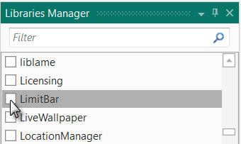
* Run the program.

The rest of the code in the Main module remains the same.

The layout file remains the same.