**AIct Lab**

Task#7 – Create Six Games Related to Kindergarten Activities.

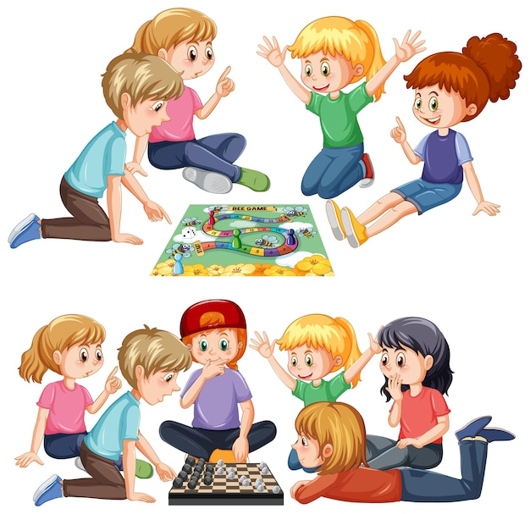

Department of Computer Science UET LHR

**Submitted by: Anza Tamveel**

**Roll No. :2023-CS-87**

Your Name:

Copy living things and non-living things separately and paste them in the following boxes:

|  |  |  |  |  |
| --- | --- | --- | --- | --- |
|  |  |  |  |  |
|  |  |  |  |  |

↓↓↓↓

**Paste Here:**

|  |  |
| --- | --- |
| **Living Thing** | **Non-Living thing** |
|  |  |
|  |  |
|  |  |
|  |  |

Your Name:

Copy input and output devices separately and paste them in the following boxes:

|  |  |  |  |  |
| --- | --- | --- | --- | --- |
|  |  |  |  |  |
|  |  |  |  |  |

**↓↓↓↓**

**Paste Here:**

You have to paste the input and output devices separately here

IInput devices are those through which we enter data into the computer.

|  |  |
| --- | --- |
| **Input Devices** | **Output Devices** |
|  |  |
|  |  |
|  |  |
|  |  |

Output devices area those through which we get data after processing.

Name :

HIDDEN LETTER **Colour all Aa**

**A J S E A H J B V E Q Y P M L J N O K N J Z X C V B N M M A S D F G H J K L A Q W A E R T Y U I O P E S S S D E R R T T T Q A R U I O P V**

**Name :**

**MATCHING:**

Oval

Rectangle

Square

Triangle

**Name :**

Separate consonants and vowels from the following table:

**J S E A H J B V E Q Y P M L J N O K N J Z X C V B N M M A S D F G H J K L A Q W A E R T Y U I O P E S S S D E R R T T Q A R U I O P V**

Consonants:

Vowels**:**

Your Name:

|  |  |  |
| --- | --- | --- |
| 1. |  |  |
| 2. |  |  |
| 3. |  |  |
| 4. |  |  |