**AIct Lab**

Task#7 – Create Six Games Related to Kindergarten Activities.

**Submitted by: Anza Tamveel**

**Roll no. :2023-CS-87**

Your Name:

Copy living things and non- living things separately and paste them in the following boxes:

|  |  |  |  |  |
| --- | --- | --- | --- | --- |
|  |  |  |  |  |
|  |  |  |  |  |

↓↓↓↓

**Paste Here:**

|  |  |
| --- | --- |
| **Living Thing** | **Non-Living thing** |
|  |  |
|  |  |
|  |  |
|  |  |

Your Name:

Copy input and output devices separately and paste them in the following boxes:

|  |  |  |  |  |
| --- | --- | --- | --- | --- |
|  |  |  |  |  |
|  |  |  |  |  |

↓↓↓↓

**Paste Here:**

You have to paste the input and output devices separately here

Output devices area those through which we get data after processing.

IInput devices are those through which we enter data into the computer.

|  |  |
| --- | --- |
| **Input Devices** | **Output Devices** |
|  |  |
|  |  |
|  |  |
|  |  |

Name :

HIDDEN LETTER **Colour all Aa**

**A J S E A H J B V E Q Y P M L J N O K N J Z X C V B N M M A S D F G H J K L A Q W A E R T Y U I O P E S S S D E R R T T T Q A R U I O P V**

**Name :**

**MATCHING:**

Oval

Rectangle

Square

Triangle

**Name :**

Separate consonants and vowels from following table:

**J S E A H J B V E Q Y P M L J N O K N J Z X C V B N M M A S D F G H J K L A Q W A E R T Y U I O P E S S S D E R R T T Q A R U I O P V**

Consonants:

Vowels**:**

Your Name:

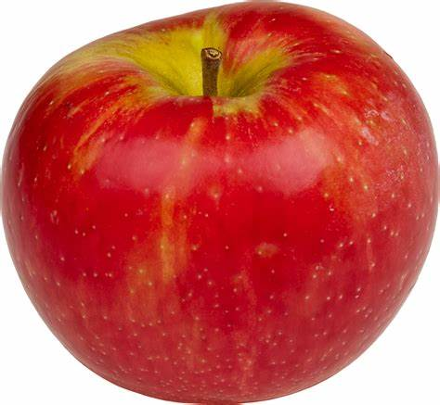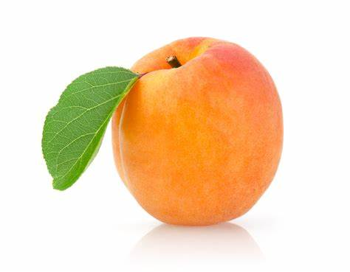

2. 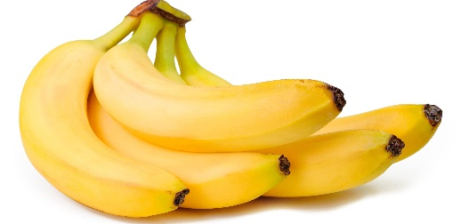
3. 