
AICT Lab Task
Submit To: Ms. Aqba Javed

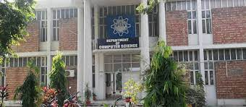
Submitted by: 2023-CS-87

Facilities:

With the expansion in academic program, computer laboratories in the department have risen to nine spreads over two buildings. The laboratories are equipped with 200+ computers fully network with state of the art server.
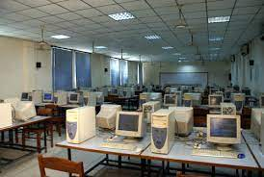

Computer to student ratio is 1:1. The department is proud of it's piracy policy. Oracle has contributed software worth more 40 million.

Faculty:
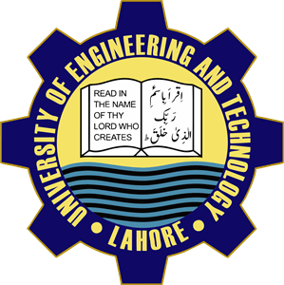

•Prof. Dr. Khaldoon khurseed
• Prof. Dr. Shazad(chairman). Amai Farooq.
• Professor Dr. Amai Farooq

Contact Detail:
For queries contact us on our official website.

www.uet.edu.pk.
Or
call on:
03025332001

University of Engineering and
Technology

A brief description of Computer science and Engineering Department is here.

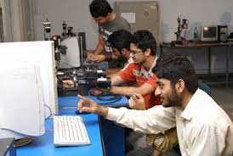

Here now we also offer double degree program. Three student each from the graduating class of computer science and computer engineering may opt for a second degree in computer engineering and science as.tbe.case may he subiect to fulfillment of prescribe conditions, from fall semester 2011.

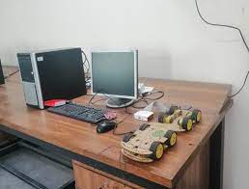
Research:

Estimate Theory, signals processing, modern control and related areas. Data bases, semantic web and related areas.

To the students of the department emphasizing entrepreneurship and ethical standards while encouraging them to remain abreast with latest developments in computing tools and processes and use their skills to identify and find solution to society's problems; And to use department's resources and computing expertise to help industry, government and community in solving their problems.

Computer Science jobs should be way more interesting than even going to Wall Street or being a lawyer-or, I can argue, than anything but perhaps biology, and there it's just a tie.
"Bill Gates.."

Degree & double degree Program:
Here we offer four year degree programs in terms of Bs (hons) which was introduced by the department in 1999.The degree of this program is affiliated by PEC (Pakistan Engineering council). PhD. Program in computer science was launched in 2002 and twenty six students have completed.

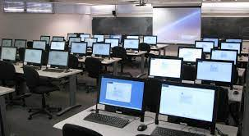

Introduction:

The Department of Computer Science and Engineering was originally established as Department of Computer Science in 1991.Its history dates back to the year 1968 when University of Engineering and Technology Lahore established a computer center. This center was responsible for planning and teaching courses in Computer Science and Numerical Analysis which formed an integral part of the curricular for all the disciplines of Bus. The center also offered short term computer courses for other private and public sector organization.

Mission:

To disseminate computing education.

Student’s Information Form

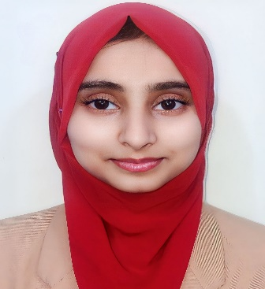
Session2023/1st Semester
Department of Computer Science and Engineering
University of Engineering and Technology, Lahore

- Name: Anza Tamveel
Tick ✔ one of the following

- Gender: Female ✔ Male ☐

- Date of Birth: 18/10/2006

- Age: 17

- Residence: Street No.31, House No.29/B Canal Park Gulberg 2 Lahore

- City: Lahore

- Mobile: 03270866411

- Email: anzatamveel@gmail.com
Sport Gala
2023
Come and Join the Match



Date and Time
October 18, 2023
Location
UET

