Olist Brazilian E-Commerce
Customer behaviour, delivery performance and satisfaction analysis
Dape Alexander Naanret | October 2026 | Python, pandas, seaborn

1. Executive Summary
This report analyses roughly 99,000 orders placed on Olist, a Brazilian online marketplace, between September 2016 and October 2018. It covers customer behaviour, revenue, product categories, geography, payment methods, RFM segmentation, delivery performance, cohort retention and customer satisfaction.
Bottom line. Olist’s growth was driven by acquiring new customers, not keeping them: about 97% of customers bought only once. The clearest operational lever in the data is delivery reliability. Late orders average a review score of 2.55 against 4.20 for on-time orders, and the late-delivery rate ranges from 3.8% to 27.2% depending on the state.

Metric | Value | Figure
Customers who ordered once | ~97% (about 93K of 96K) | Figure 1
Peak monthly revenue | ~BRL 1.6M (Nov 2017) | Figure 2
Largest state share of order records | São Paulo, ~42% | Figure 4
Credit card share of payment records | ~74% | Figure 5
Late-delivery rate by state | 3.8% (AC) to 27.2% (AL) | Figure 8
Average review score, on time vs late | 4.20 vs 2.55 | Figure 11

Key findings
- Retention is the weak point. Around 3,000 of roughly 96,000 customers ordered more than once. Cohort retention in any given month after the first purchase is mostly below 0.7%.
- Growth plateaued. Monthly revenue rose from under BRL 0.2M in January 2017 to a peak near BRL 1.6M in November 2017, then held between about BRL 1.25M and 1.5M through August 2018.
- Revenue is spread across categories. Six categories sit between roughly BRL 1.4M and 1.7M, led by bed_bath_table, health_beauty and computers_accessories.
- Demand is concentrated geographically. São Paulo accounts for about 42% of order records; São Paulo, Rio de Janeiro and Minas Gerais together account for about two-thirds.
- Delivery performance varies sharply by region. Most orders arrive well ahead of the estimate, but six Northeast states top the late-rate ranking, and Rio de Janeiro (15.6% late) is the outlier among large markets.
- Lateness and satisfaction move together. About 77% of reviews are 4 or 5 stars, yet late orders score 1.65 points lower than on-time orders.
A note on the numbers. Figures are read from the notebook’s charts and printed outputs and are rounded. Several absolute totals (revenue, and counts of orders, payments and reviews) are computed on a merged table that has more than one row per order, so treat them as indicative. Section 7 explains the issue and the fix.

2. Objectives and Scope
The analysis set out to answer six questions:
- Who buys, and how often do they come back?
- How has revenue evolved, and which categories and regions drive it?
- How do customers pay?
- How can customers be segmented by recency, frequency and monetary value (RFM)?
- How reliable is delivery, and does it affect customer satisfaction?
- Do customers return after their first purchase, and has that changed over time?

3. Data and Method
The source is the Brazilian E-Commerce Public Dataset by Olist, published on Kaggle. Seven tables were loaded; six were merged and one was inspected but not used in the final charts.
Table | Contribution to the analysis
Orders | Order status and purchase, approval, carrier, delivery and estimated-delivery timestamps
Customers | Unique customer ID and customer state (99,441 records)
Order items | Item price per order (112,650 rows)
Order payments | Payment type, installments and payment value (103,886 rows)
Products and translation | Product category, translated from Portuguese to English (32,951 products, 71 translations)
Order reviews | Review score per order
Geolocation | Loaded and inspected (1,000,163 rows, 261,831 duplicates); not used in the final charts

The merged table has 118,434 rows and 31 columns, reduced to the 17 columns needed for analysis, with all date columns converted to datetime. Key metric definitions:
- Delivery gap = estimated delivery date minus actual delivery date, in whole days. Positive means early, negative means late. An order is flagged late when the gap is below zero. Delivery analysis uses delivered orders only.
- RFM = recency (days since last purchase, measured from the day after the latest purchase in the data), frequency (distinct orders) and monetary value (sum of payment value). Each is scored 1 to 4 by quartile, summed to a composite of 3 to 12, and mapped to tiers: Champions (10 or more), Loyal Customers (8 to 9), At Risk (6 to 7) and Lost/Low Value (below 6).
- Cohort retention = for each first-purchase month, the share of that cohort that purchased again in each later month.

4. Findings

4.1 Customers overwhelmingly buy once
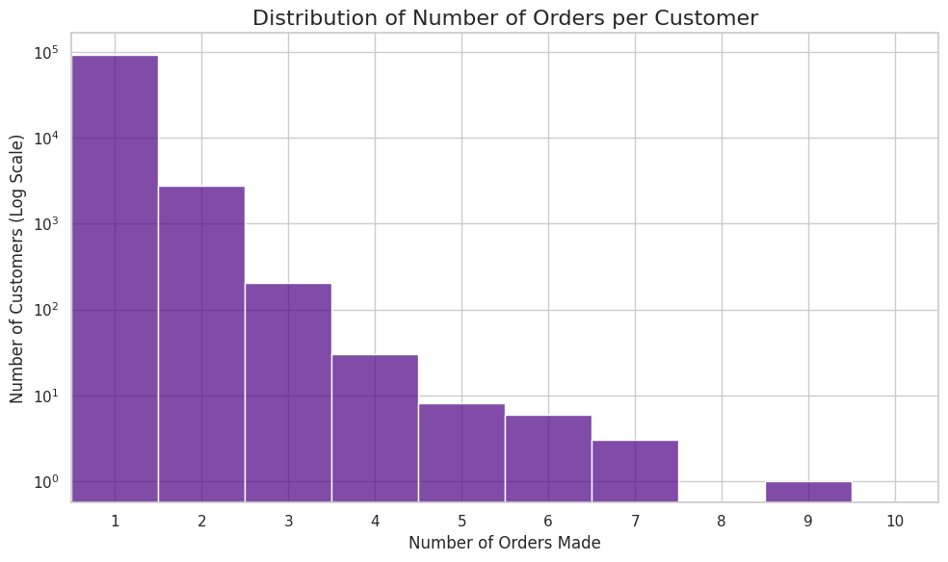
Figure 1. Distribution of orders per customer (log scale).
On a log scale, the first bar dwarfs the rest: roughly 93,000 customers ordered once, about 2,700 ordered twice and around 200 ordered three times. Only a handful ordered five or more times, and the maximum shown is nine. That puts the one-time share at roughly 97%.
Why it matters. Revenue depends almost entirely on continually acquiring new customers. Any gain in repeat purchasing starts from a very small base, so even modest improvements are large in relative terms.

4.2 Revenue grew through 2017, then plateaued
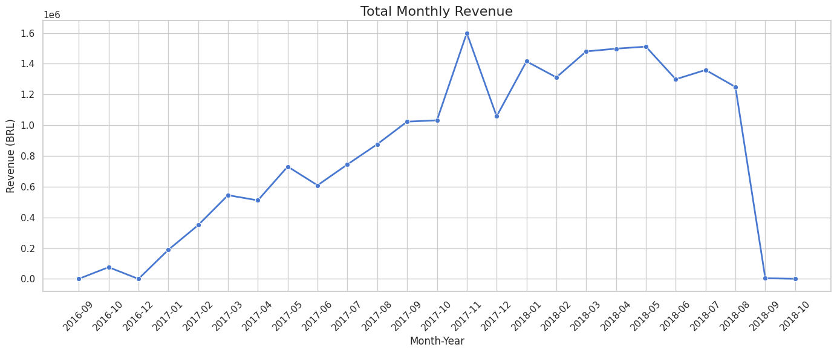
Figure 2. Total monthly revenue (BRL), September 2016 to October 2018.
Monthly revenue climbed from under BRL 0.2M in January 2017 to a peak close to BRL 1.6M in November 2017. December dipped to about BRL 1.06M. From January to August 2018 it stayed between roughly BRL 1.25M and 1.5M with no further growth.
September and October 2018 show almost nothing, and 2016 is sparse. Both are most likely edge effects of the dataset’s date range rather than business events. The November 2017 peak coincides with the Black Friday period, a plausible driver that the notebook does not test.

4.3 Home and lifestyle categories lead
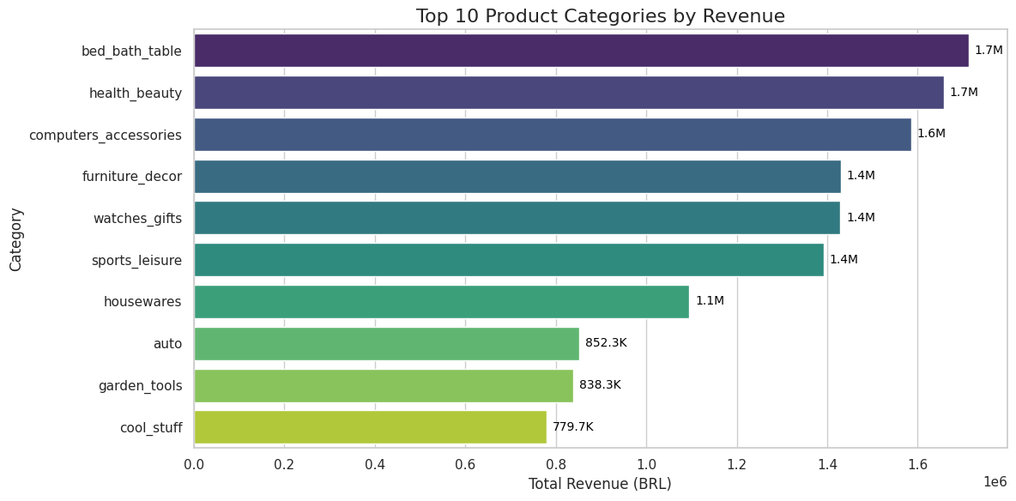
Figure 3. Top 10 product categories by revenue.
bed_bath_table and health_beauty lead at about BRL 1.7M each, followed by computers_accessories (1.6M) and furniture_decor, watches_gifts and sports_leisure (about 1.4M each). housewares follows at 1.1M, and auto, garden_tools and cool_stuff close the top ten between BRL 0.78M and 0.85M.
Revenue is spread across six comparably sized categories rather than resting on one, which limits category risk. Three of the top seven (bed_bath_table, furniture_decor, housewares) are home-related.

4.4 Demand is concentrated in São Paulo
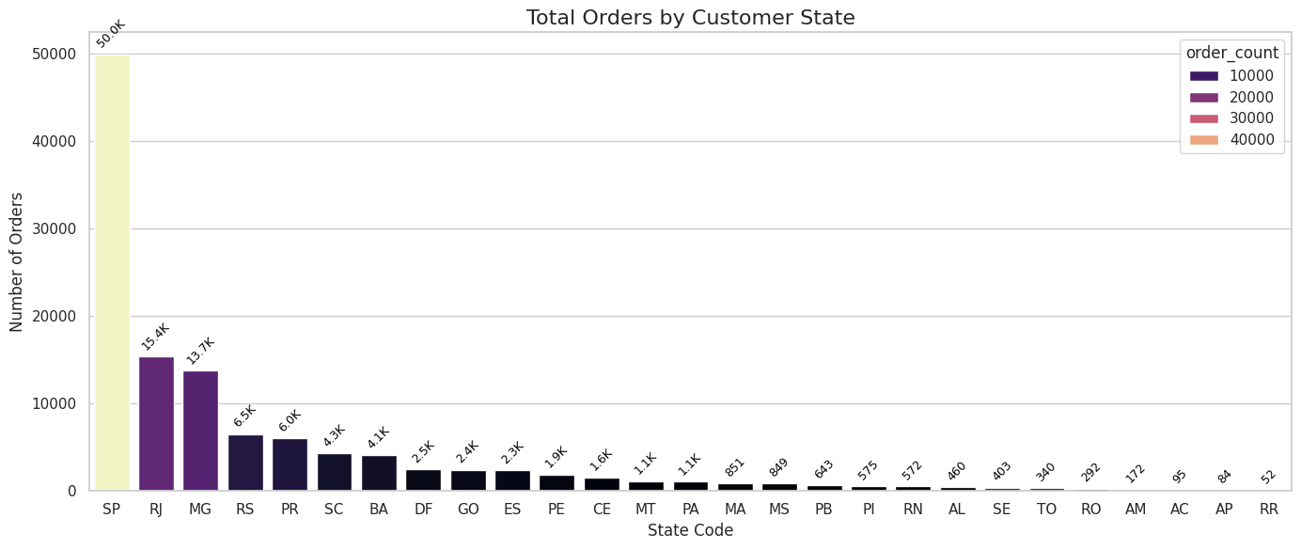
Figure 4. Order records by customer state.
São Paulo (SP) has about 50,000 order records, roughly 42% of the total. Rio de Janeiro (15.4K) and Minas Gerais (13.7K) follow, and the three states together hold about two-thirds. Seven states exceed 4,000 records each; the smallest (AM, AC, AP, RR) have fewer than 200.

4.5 Credit cards dominate payments
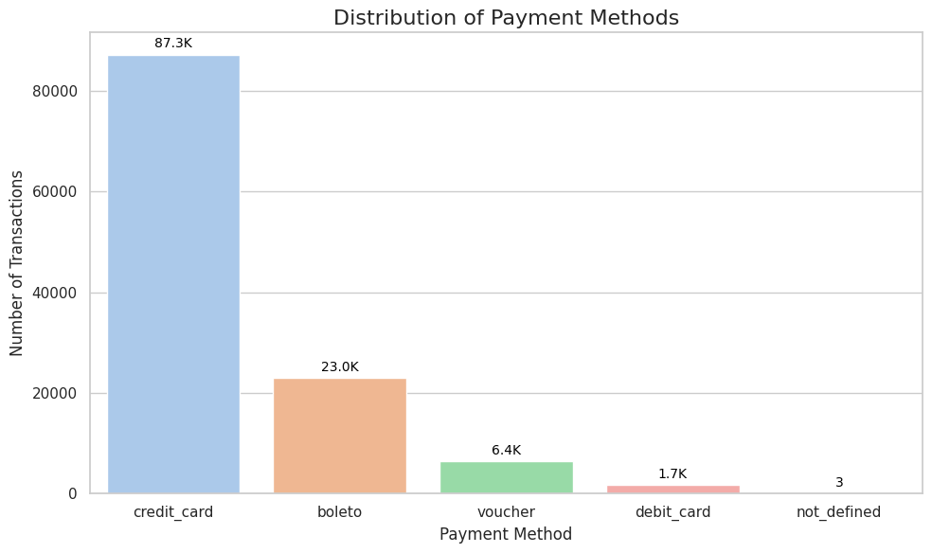
Figure 5. Distribution of payment methods (payment records).
Credit card accounts for 87.3K of about 118.4K payment records (74%). Boleto, a bank-slip payment made outside the card system, accounts for 23.0K (19%), vouchers for 6.4K (5%) and debit cards for 1.7K (1%). Three records have an undefined payment type. Roughly one in five payment records uses boleto, which points to a sizeable group paying outside cards. Installment behaviour was loaded but not analysed.

4.6 RFM segmentation
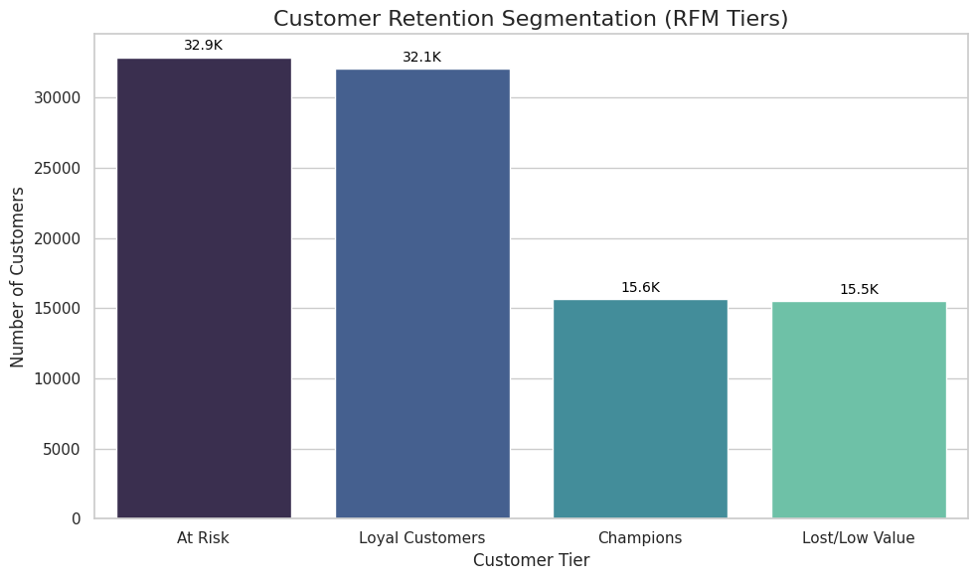
Figure 6. Customers by RFM tier.
The four tiers are At Risk (32.9K customers, 34%), Loyal Customers (32.1K, 33%), Champions (15.6K, 16%) and Lost/Low Value (15.5K, 16%).
Read with caution. Because about 97% of customers have a frequency of one, the frequency score cannot separate customers by behaviour. Ties are broken by row order, so the score is effectively arbitrary. The tiers mostly reflect recency and spend, and “Loyal” and “Champions” should not be read as repeat buyers. See Section 7.

4.7 Delivery: usually early, with a long late tail
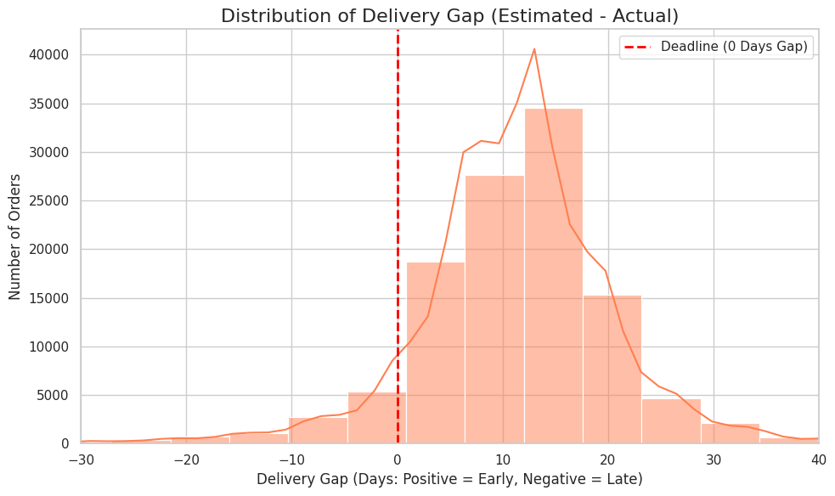
Figure 7. Distribution of delivery gap (estimated minus actual, days).
Most of the distribution sits to the right of zero: the bulk of delivered orders arrive 5 to 20 days ahead of the estimate, peaking at roughly 12 to 17 days early. A thinner tail extends left of the deadline, with some orders more than 20 days late. This suggests that estimated delivery dates are padded on average.
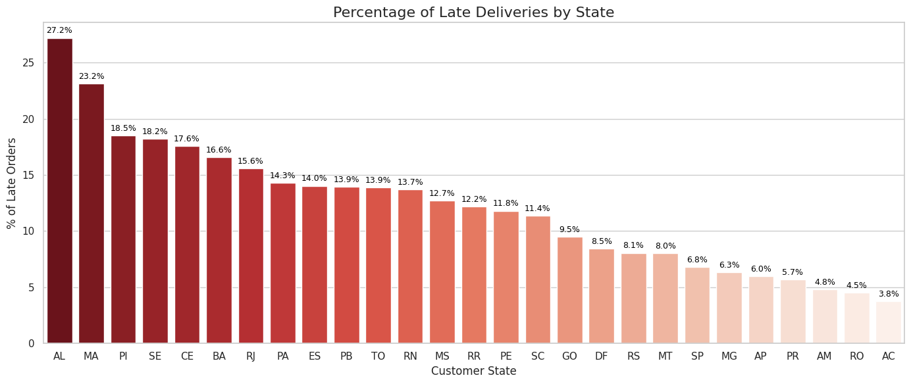
Figure 8. Percentage of late deliveries by state (delivered orders).
The late rate ranges from 3.8% in Acre (AC) to 27.2% in Alagoas (AL). Alagoas, Maranhão (23.2%), Piauí (18.5%), Sergipe (18.2%), Ceará (17.6%) and Bahia (16.6%) are all Northeast states and lead the ranking.
Rio de Janeiro is the notable exception among high-volume markets. It is the second-largest state by order records and has a 15.6% late rate, compared with 6.8% in São Paulo and 6.3% in Minas Gerais. Remote Amazon-region states such as AC, RO and AM have low late rates despite long distances, which suggests heavier padding of estimates there. The notebook does not test this.

4.8 Cohort retention is very low and not improving
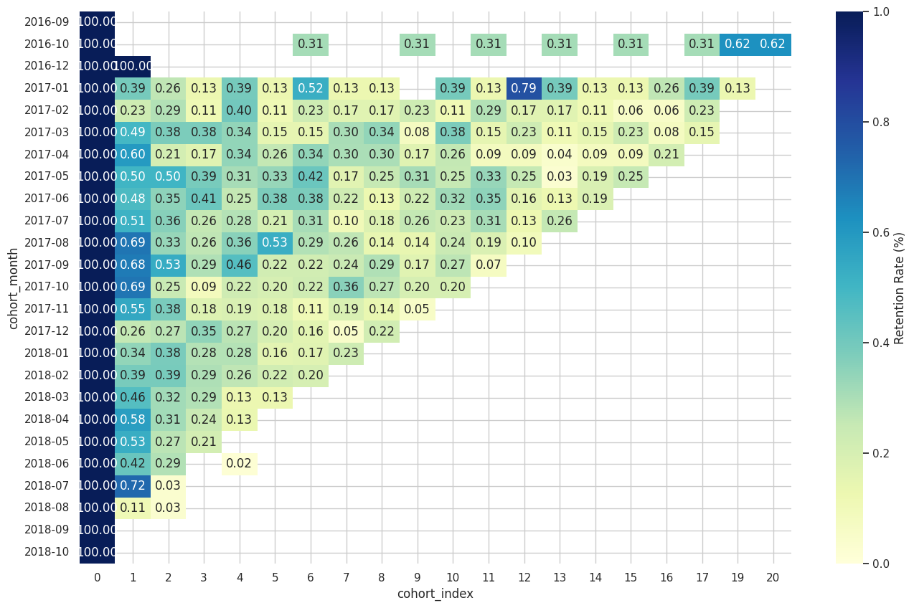
Figure 9. Monthly cohort retention heatmap (% of cohort active, colour scale capped at 1%).
For 2017 cohorts, retention in the month after the first purchase is mostly 0.2% to 0.7%, and later months mostly fall between 0.1% and 0.5%. Month-1 retention shows no clear upward trend from 2017 into 2018. Retention here means purchasing in that specific month, not cumulatively. Isolated spikes in the small late-2016 cohorts are noise.

4.9 Satisfaction is high overall but drops sharply when orders are late
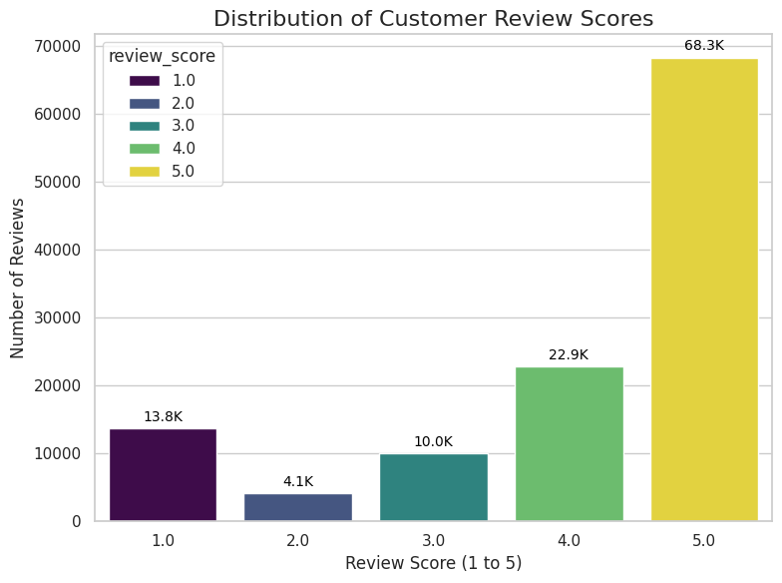
Figure 10. Distribution of customer review scores (delivered orders with a review).
Of about 119.1K review records, 68.3K (57%) are five stars and roughly 77% are four or five stars. One-star reviews (13.8K, 12%) outnumber two-star reviews (4.1K, 3%), a polarised pattern.
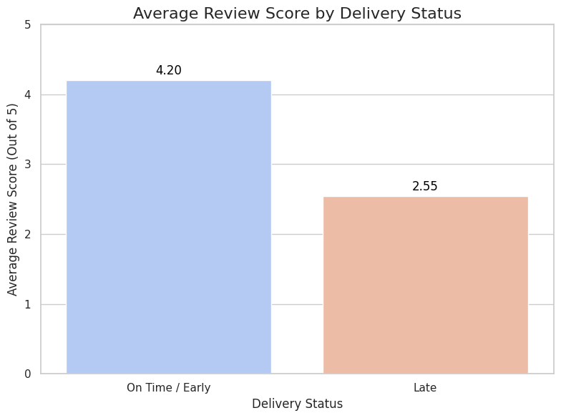
Figure 11. Average review score by delivery status.
Late orders average 2.55 against 4.20 for on-time or early orders, a gap of 1.65 points, or about 39% lower. This is an association. The notebook does not control for category, seller or order value, so lateness may not explain the whole difference. A gap this large still makes delivery the clearest operational lever visible in this analysis.

5. Recommendations
These follow from the findings above. Items 1, 3 and 4 are hypotheses to test, not conclusions the data has proven.
- Treat repeat purchase as the primary growth problem. With about 97% one-time buyers, test post-purchase campaigns in the first 30 days and recency-triggered offers aimed at the At Risk tier.
- Fix delivery where it is worst and where volume is highest. Start with Rio de Janeiro, where high volume meets a 15.6% late rate, then the Northeast states (AL, MA, PI, SE, CE, BA). Review carrier and seller dispatch performance in those lanes.
- Calibrate delivery estimates by region. Estimates look padded in some states and miss badly in others. Set the promised date from the observed distribution per state so the promise is both competitive and reliable.
- Intervene before the review is written. Notify customers proactively when an order is likely to miss its date, and test whether this narrows the 1.65-point review gap.
- Sequence expansion with logistics. Growth outside São Paulo should be paired with delivery improvements, since the regions with the most room to grow are also those with the weakest delivery record.

6. Next Steps
- Rebuild the merged table at order grain and re-run revenue, category, state and review figures (Section 7).
- Replace the frequency score with a meaningful scale (1, 2, 3 or more orders) or segment on recency and monetary value only.
- Analyse review comment text (Portuguese) to see what late-order customers complain about.
- Add seller-level analysis and a map using the geolocation table.
- Analyse payment installments against order value.
- Build a simple model of late-delivery risk using state, category, weight and seller.

7. Limitations and Data Quality Notes
These issues affect how far the figures above can be pushed. None changes the direction of the main findings on retention and delivery, but several change absolute values.
Issue | Effect | Fix
Merged table has several rows per order (118,434 rows) | Orders with several items or payments repeat payment_value, which inflates revenue and category revenue. State, payment and review counts are per row, not per distinct order. | Aggregate payments to order level before merging, and count distinct order_id.
RFM frequency score | About 97% of customers have frequency 1. Ties are split by row order, so the F score is arbitrary and Champions and Loyal tiers are inflated. | Use a 1, 2, 3+ scale, or segment on R and M only.
Dataset edges | 2016 is sparse and September to October 2018 is almost empty, so the trend line falls at both ends. | Exclude partial months when reading trends.
Association, not causation | The review gap between late and on-time orders is not controlled for category, seller or price. | Compare within category and seller, or use a regression.
Small early cohorts | Late-2016 cohorts have very few customers, so their retention values are noisy. | Drop cohorts below a minimum size.

Appendix: Tools and Reproducibility
- Python 3 with pandas, matplotlib and seaborn. folium was imported but no map is used in the final charts.
- Dataset: Brazilian E-Commerce Public Dataset by Olist (Kaggle). See the Kaggle page for licence terms.
- The notebook reads data from the Kaggle input path; update the path when running elsewhere.

