--Q1

Select * from hotel where city='London' ORDER BY hotelname DESC;

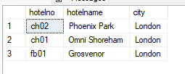

--Q2

select * from hotel where hotelname like '__t%';

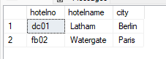

--Q3

select * from Booking where dateto is NULL;

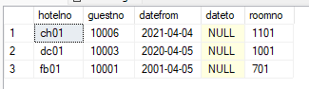

--Q4

select guestname, guestaddress from guest where guestaddress like '%Glasgow%' AND (guestname LIKE '%Tony %' OR guestname LIKE '% Farrel%');

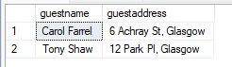

--Q5

select R.roomno, R.hotelno from Room as R inner join Booking as B on R.hotelno = B.hotelno AND R.roomno = B.roomno where Year(B.datefrom) <= 2010 AND Year(B.datefrom) >= 2005 ;



--Q6

select roomno from room where hotelno='ch02' AND type='single' AND price > 20 AND price < 40;

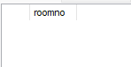

--Q7

select top 1 roomno, hotelno from room ORDER BY price DESC;



--Q8

select ('The hotel whose id is ' + hotelno + ' is in ' + city + ' and its name is' + hotelname + '.') AS operatorMethod from hotel;

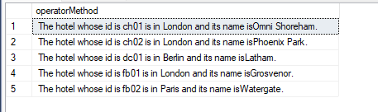

select CONCAT('The hotel whose id is ' , hotelno , ' is in ' , city , ' and its name is' , hotelname , '.') AS functionMethod from hotel;

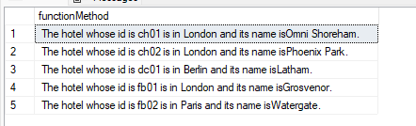

--Q9

select h.hotelname, h.hotelno from hotel AS h inner join room as r on r.hotelno = h.hotelno where r.type='double'

intersect

select h.hotelname, h.hotelno from hotel AS h inner join room as r on r.hotelno = h.hotelno where r.type='family';

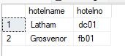

--Q10

(select h.hotelname, h.hotelno from hotel AS h inner join room as r on r.hotelno = h.hotelno where r.type='double'

intersect

select h.hotelname, h.hotelno from hotel AS h inner join room as r on r.hotelno = h.hotelno where r.type='single')

except

select h.hotelname, h.hotelno from hotel AS h inner join room as r on r.hotelno = h.hotelno where r.type='family';

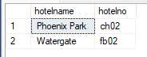

--Q11

(select r.roomno from room as r inner join booking as b on r.roomno = b.roomno where b.guestno = 10003

intersect

select r.roomno from room as r inner join booking as b on r.roomno = b.roomno where b.guestno = 10007)

except

select r.roomno from room as r inner join booking as b on r.roomno = b.roomno where b.guestno = 10001;

