Wireframe

Created on April 06 2025

Table of Contents

1.0. Page 1
2.0. Page 2
3.0. Page 3

1.0. Page 1

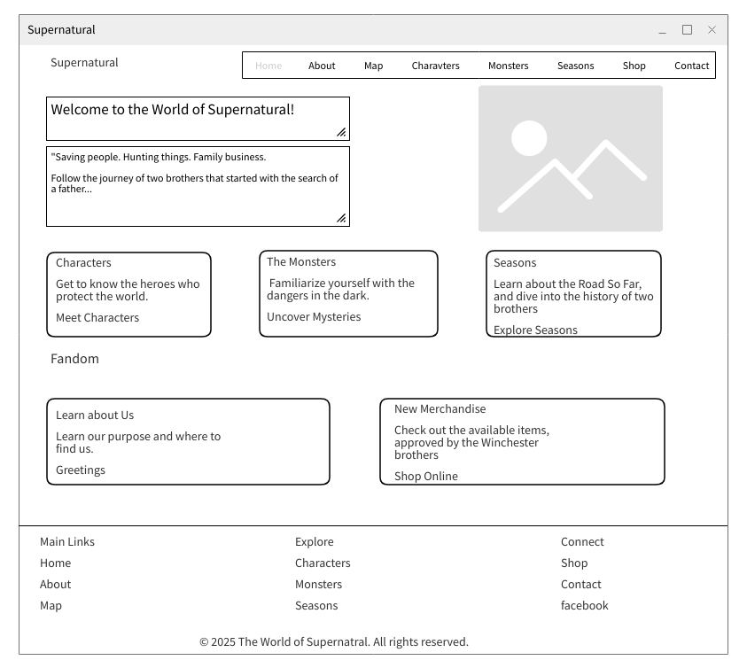

2.0. Page 2

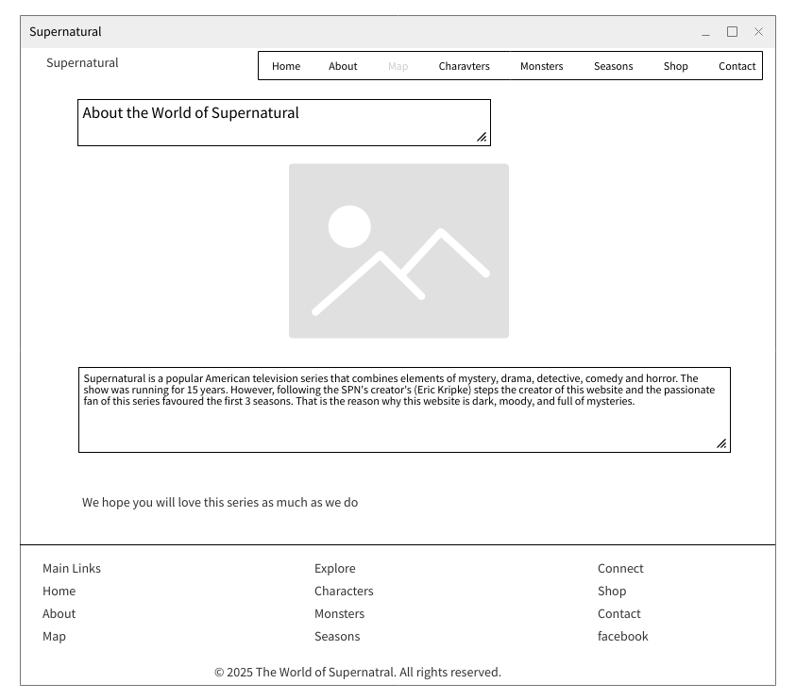

3.0. Page 3



