**Software Requirements Specification**

**for**

**Informatic distributed system for the management of art club activities**

**Version 1.0 approved**

**Prepared by**

**Rosiu Marius Gabriel 3.3A**

**Qasem Odai 3.3A**

**ABDALLA ABDELKARIM GAMAA GADAM 3.3A**

**<organization>**

**06.03.2021**

**Table of Contents**

**Table of Contents ii**

**Revision History ii**

**1. Introduction 1**

1.1 Purpose 1

1.2 Document Conventions 1

1.3 Intended Audience and Reading Suggestions 1

1.4 Product Scope 1

1.5 References 1

**2. Overall Description 2**

2.1 Product Perspective 2

2.2 Product Functions 2

2.3 User Classes and Characteristics 2

2.4 Operating Environment 2

2.5 Design and Implementation Constraints 2

2.6 User Documentation 2

2.7 Assumptions and Dependencies 3

**3. External Interface Requirements 3**

3.1 User Interfaces 3

3.2 Hardware Interfaces 3

3.3 Software Interfaces 3

3.4 Communications Interfaces 3

**4. System Features 4**

4.1 System Feature 1 4

4.2 System Feature 2 (and so on) 4

**5. Other Nonfunctional Requirements 4**

5.1 Performance Requirements 4

5.2 Safety Requirements 5

5.3 Security Requirements 5

5.4 Software Quality Attributes 5

5.5 Business Rules 5

**6. Other Requirements 5**

**Appendix A: Glossary 5**

**Appendix B: Analysis Models 5**

**Appendix C: To Be Determined List 6**

**Revision History**

|  |  |  |  |
| --- | --- | --- | --- |
| **Name** | **Date** | **Reason For Changes** | **Version** |
| Rosiu Marius Gabriel | 01.03.2021 | Completed the introduction chapter | 0.1 |
| Team | 03.03.2021 | Completed the second and third chapter | 0.2 |
| Team | 05.03.2021 | Completed 2 more chapters | 0.3 |
|  |  |  |  |
| Team | 10.03.2021 | Completed the last chapter | 1.0 |

# **Introduction**

## **Purpose**

The purpose of our document is to present in great detail the description of our web application “Chromatic Canvas”. The paper goes in detail about the purpose and features of the application, the interfaces, the capabilities and the constrains under which it must operate.

## **Document Conventions**

The Document was created based on the IEEE template for System Requirement Specification Documents fallowing the standard writing procedure.

Inside of the document there are some terms that need to be explained beforehand:

|  |  |
| --- | --- |
| User | Person who interacts with the application |
| Member | User that has agreed to register and purchased the membership |
| Administrator | Staff member with special permissions and privileges who manages and controls the system |
| Resources | Object or places belonging to the art club that can be rented to members for events. |
| Fees | Costs required for creating an event (200 lei/day/resource if the user bought a membership or 400 lei/day/resource if the user did not buy a membership) or the monthly payment |
| Event | Meeting organized by a member/user/admin using the application. The meeting requires the use of different resources (provided by the art club) and funds(payment fees). |

## **Intended Audience and Reading Suggestions**

All readers of the document are advised to read section 1 of the document if they are planning to continue reading the other sections as well. For a detailed assessment of the recommended section for each type of reader fallow the guidelines presented below:

-Typical users (such as art students, artists, art collectors): Eventho this document is not meant for direct users of the web application, they can may find useful information in the fourth section of the document, to better understand all the features provided

-Sponsor: They are advised to read all sections of the document to ensure proper understanding of the scope of our product.

-Developers/Testers/Maintenance- Those were not part of our team when this paper was created will find most use from reading the detailed specification of the features the web application must include and how they function in section four.

## **Product Scope**

The “Chromatic Canvas” web application is a reliable and ingenious tool that offers art enthusiasts a way to greatly increase their collection, share their preferences and expand their own circle of influence by participating or hosting impressive art galleries. All of this will be provided for a small commission that fallows an affordable monetization plan.

Since this is a web application the software will always require Internet access. All system information is maintained in a database, which is located on a web-server. The application will also allow a special log in option for administrators that will come with additional perks.

## **References**

[1] IEEE Software Engineering Standards Committee, “IEEE Std 830-1998, IEEE Recommended

Practice for Software Requirements Specifications”, June 25, 1998.

[2] GitHub: <https://github.com/Aodai/ArtClub>

[3] California art club provided example text and imagery for the web application: <https://www.californiaartclub.org/>

# **Overall Description**

## **Product Perspective**

The system will consist of a web application that will allow the user to access all the benefits offered by our product (event creation, borrow club resources etc.).

The web application will need constant internet access to function correctly. Since the product is web reliant it will need storage unit. For that we will use a database which will communicate with the web portal and the application.

## **Product Functions**

The web application will have a vast array of different functionalities such as:

-Users can create/login inside of their account

-Users have the capacity to create/edit events

-Users can select the members they wish to invite for their events

-Subscription payment system

-The ability to add/edit members if you are an administrator

-The ability to rent resources for certain events

-Viewing the participants in a certain event

-The option to add fees/donations

-The ability to see the reserved resources and events through a calendar

## **User Classes and Characteristics**

There are 3 different types of users that come with specific benefits based on their class:

[1] Guest: Guests are expected to posses very basic computer knowledge so the user interface should be extremely user friendly.

[2] Member: Same thing applied as in the case of the guest.

[3] Admin: They are expected to posses vaster computer knowledge and thus will be able to navigate the web application a lot more easily.

## **Operating Environment**

The web application must work in all computers compatible with the fallowing browsers:

* Google Chrome
* Mozilla Firefox
* Safari
* Opera

The web application should also be compatible with all the major operating systems such as:

* Windows 7 and above
* Linux Debian/Ubuntu/Fedora
* macOS 10.6 and above
* Android 4.1 and above
* iOS 6 and above

## **Design and Implementation Constraints**

ChromaticCanvas is developed in C#, it uses ASP.NET framework and Entity Framework, it has been built using Visual Studio and uses http/hrrps communication protocol.

Because this is a web application it requires internet access at all and one of the most used web browsers to be installed and compatible with the device.

For a functional experience there is also a memory requirement of at least 4 GB of RAM and 50-100 MG minimum local memory.

For the implementation aspect the developers will use the fallowing :

**Programs:**

* Visual Studio 2019
* Microsoft SQL

**Languages:**

* C#
* HTML
* CSS
* SQL

## **User Documentation**

The user will receive a web link available in the contacts section that will forward them to a tutorial about the functionalities of the web application on YouTube. The web application will also have a FAQ section that will further help in providing information as well as a well trained group of administrators and staff members who will address more serious issues.

## **Assumptions and Dependencies**

ChromaticCanvas is developed in C# and therefore requires .NET Core 3 runtime to be installed on the server hosting the web app, it also needs a SQL Server database for its data storage.

The application also depends on a modern, a stable internet connection , and an up to date OS, a compatible browser (Opera, Google Chrome, Microsoft Edge Mozilla Firefox, Safari).

# **External Interface Requirements**

## **User Interfaces**

The fallowing are concepts of the user interface:

1.Home Menu

2.Account Menu

3.Event Menu

4.Log In

5.Sign Up

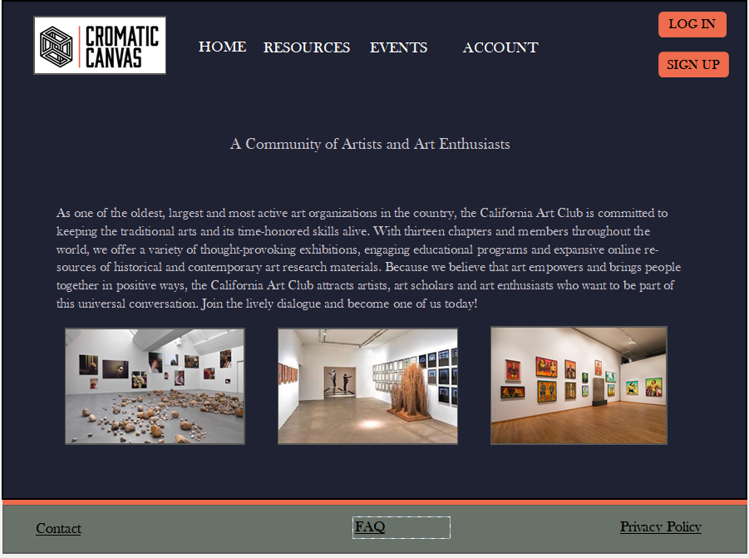

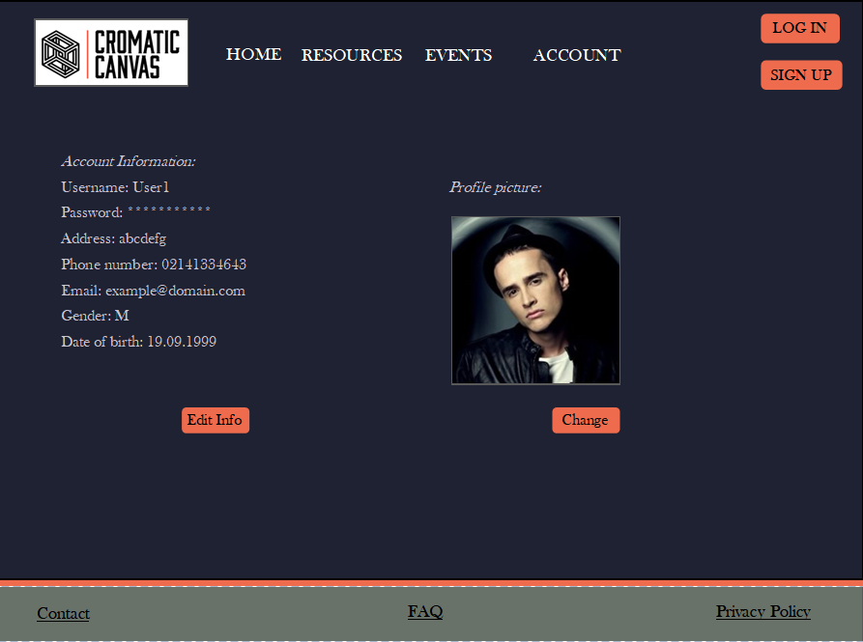

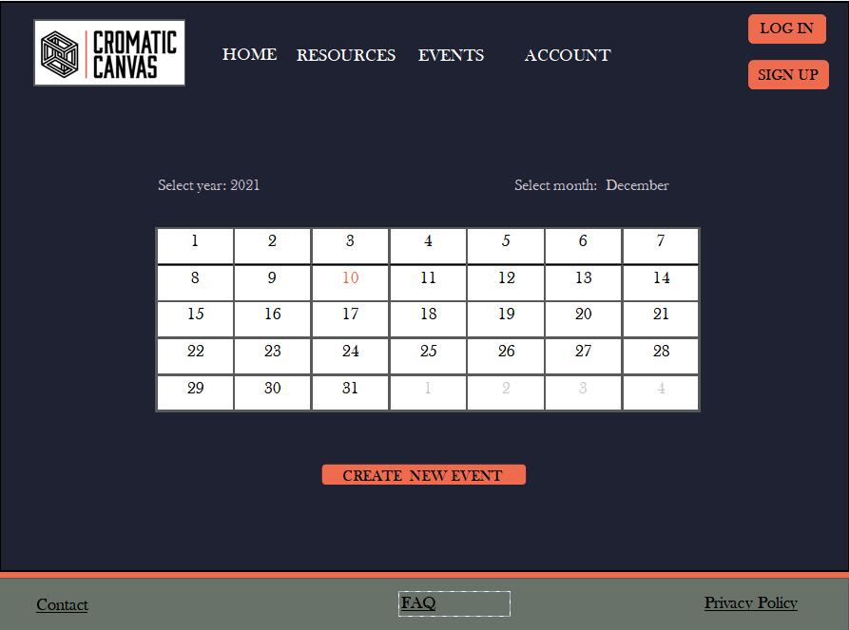

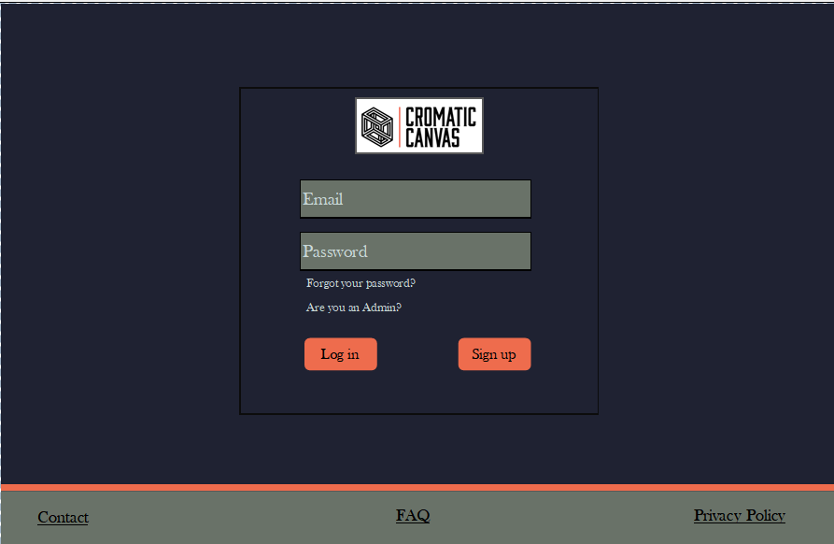

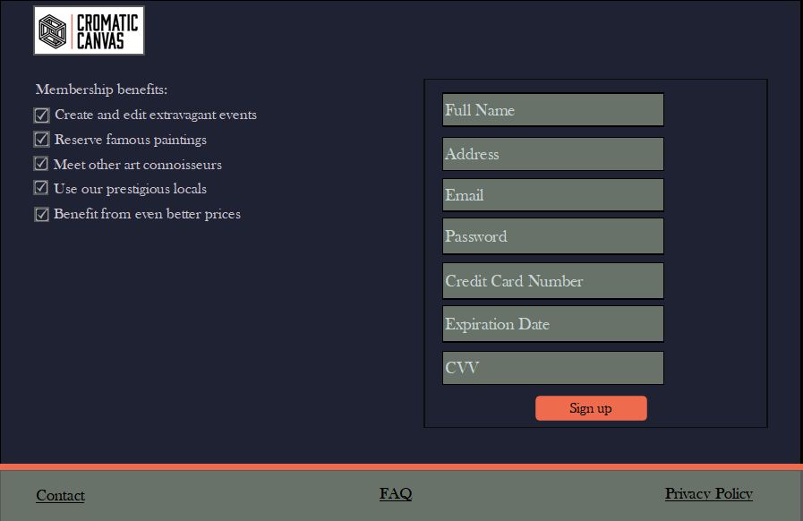

## **Hardware Interfaces**

This section does not apply to our wen application since there is no direct hardware interface.

## **Software Interfaces**

ChromaticCavnas needs a SQL Server database to store its data as well as an up-to-date browser(Google Chrome,Opera,Microsoft Edge,Safari,Modzilla Firefox).

## **Communications Interfaces**

ChromaticCanvas requires an internet connection so that the users can connect to the website over HTTP/S protocol.

The way in which the communication is achieved is not important for the system and is

therefore handled by the underlying operating systems for the web portal.

# **System Features**

This section demonstrates CromaticCanvas’s most prominent features and explains how they can be used.

## **Users can log in based on email and password**

4.1.1 Description and Priority

The user has the capacity to log in inside of their account.

Priority for this operation is considered high.

4.1.2 Stimulus/Response Sequences

The user shall be able to access a log in page from which they can log in using the information they provide during sign up.

4.1.3 Functional Requirements

REQ-1: Read the email and password parameters

REQ-2: Compare them to those in the database

REQ-3: If they match they can access the account

## **Users can sign up on the application**

4.2.1 Description and Priority

The user has the capacity to sign up and create an account.

Priority for this operation is considered high.

4.2.2 Stimulus/Response Sequences

The user shall be able to access a sign up page from which they can sign up using their information.

4.2.3 Functional Requirements

REQ-1: Read all the information parameters provided by the user.

REQ-2: Compare them to those in the database.

REQ-3: If they are unique save the information and create an account corresponding to it.

## **Users can check/create events**

4.3.1 Description and Priority

The user has the capacity to create/check for events using the application.

Priority for this operation is considered high.

4.3.2 Stimulus/Response Sequences

The user shall be able to access an events page, whether they are currently logged in or not, where they will be able to hover over a calendar to see all available events and information about them. For event creation they have the additional option to press a button and start the procedure for creation.

4.3.3 Functional Requirements

REQ-1: User must navigate to the Events page.

REQ-2: If the user hovers over a date on the calendar, information about the events happening that day will be displayed under the cursor from the Database.

REQ-3: If there are no events on a specified day the user can press the Create an event button

## **Users can edit their account information**

4.4.1 Description and Priority

The user has the capacity to update their account credentials.

Priority for this operation is considered high.

4.4.2 Stimulus/Response Sequences

The user shall be able to access an account page if they are currently logged in where they can change all of their credentials.

4.4.3 Functional Requirements

REQ-1: If the user is currently logged in he has the option to access the account page.

REQ-2: The user can alter all of their information.

REQ-3: If the user presses the “Change info” button, all the new credentials will be saved on the database.

## **Users can reserve resources for their events**

4.5.1 Description and Priority

The user has the capacity to reserve different resources for their events.

Priority for this operation is considered high.

4.5.2 Stimulus/Response Sequences

If the user is currently in the process of creating an event they will have the capability to choose the resources they wish to use for their event.

4.5.3 Functional Requirements

REQ-1: If the user is currently creating an event he has the option to choose all the resources that are marked as available in the data base.

REQ-2: Once the resources are selected they are marked as unavailable on the database.

# **Other Nonfunctional Requirements**

## **Performance Requirements**

* The web app should load in less than 3 seconds.
* The web app shouldn’t load unnecessary assets (Images/CSS/JS files)

## **Safety Requirements**

To ensure that no one of our users loses any data while using CromaticCanvas (due to a crash or a bug of some kind) the developer team updates the web application regularly. There is a bug tracker available where users can report any bugs they have encountered so that the developers can fix it in the update.

## **Security Requirements**

For proper security, the user authentication requires a unique username and a password corresponding to their account. The passwords are encrypted into the data base to guarantee that the credentials are secured.

A password reset link shall be sent the a user’s email address in order to reset a password

## **Software Quality Attributes**

* The code should follow SOLID principles.
* The code should follow MVC pattern.
* The web app should be secure and not store passwords in plain-text.
* The web app should have unit tests.

## **Business Rules**

*<List any operating principles about the product, such as which individuals or roles can perform which functions under specific circumstances. These are not functional requirements in themselves, but they may imply certain functional requirements to enforce the rules.>*

1. Only users that have an account can log in.
2. Only users are currently subscribed benefit from half the prices
3. Only administrators can add/edit members
4. Only administrators can have access to he administrator web section
5. Only administrators can add fees for the members
6. Only administrators can modify available resources
7. Only available resources can be used for events
8. Only administrators can reserve resources at any time, as long as they are available
9. The subscriber must provide a valid credit card
10. If the profit is lower than the loss, there can be no resource booking during that month

# **Other Requirements**

*<Define any other requirements not covered elsewhere in the SRS. This might include database requirements, internationalization requirements, legal requirements, reuse objectives for the project, and so on. Add any new sections that are pertinent to the project.>*

**Appendix A: Glossary**

*<Define all the terms necessary to properly interpret the SRS, including acronyms and abbreviations. You may wish to build a separate glossary that spans multiple projects or the entire organization, and just include terms specific to a single project in each SRS.>*

TBD=To be determined.

**Appendix B: Analysis Models**

*<Optionally, include any pertinent analysis models, such as data flow diagrams, class diagrams, state-transition diagrams, or entity-relationship diagrams*.>

TBD.

**Appendix C: To Be Determined List**

Not applicable.