Agnos Candidate Assignment
Backend Developer — Development Planning & Technical Documentation
Go • Gin • PostgreSQL • Docker Compose • Nginx

A hospital middleware API for authenticated, hospital-scoped patient discovery and HIS integration.

1. Executive Summary
This implementation provides APIs for hospital staff registration and authentication, retrieves patient records from a hospital information system (HIS), normalizes and caches those records in PostgreSQL, and supports multi-field patient search. The authenticated staff member's hospital is derived from the signed JWT and applied to every patient query, preventing cross-hospital data access.
Requirement | Implementation
Backend | Go 1.23 with Gin HTTP framework
Database | PostgreSQL 16 with constraints, indexes, and seed migration
Authentication | bcrypt password hashes and expiring HS256 JWT access tokens
HIS integration | Timeout-bound HTTP adapter for GET /patient/search/{id}
Deployment | Docker Compose with private API/PostgreSQL network and Nginx ingress
Quality | Unit, regression, OpenAPI syntax, and Docker runtime acceptance tests

2. Architecture and Project Structure

2.1 Request Flow
- Staff registration resolves the hospital, hashes the password with bcrypt, and stores a hospital-scoped account.
- Login verifies hospital, username, and password, then returns a signed JWT containing staff_id and hospital_id.
- JWT middleware validates the signature and expiry and places the trusted hospital_id in request context.
- An ID search calls the configured HIS, validates the payload, and upserts the normalized patient record.
- The repository searches PostgreSQL with hospital_id as the mandatory first predicate and adds only parameterized filters.

2.2 Package Layout
cmd/api/ Application entry point and graceful shutdown
internal/auth/ JWT creation and validation
internal/config/ Environment configuration
internal/domain/ Entities, filters, and domain errors
internal/his/ Hospital A HTTP adapter
internal/httpapi/ Gin routes, middleware, handlers, response mapping
internal/repository/postgres/ Parameterized PostgreSQL repositories
internal/service/ Authentication and patient use cases
migrations/ Schema, constraints, indexes, and seed data
deploy/ Nginx reverse-proxy configuration
test/e2e/ Deterministic mock HIS fixture
docs/ OpenAPI, ER diagram, and implementation plan

2.3 Component Responsibilities
Layer | Responsibility | Reason
HTTP | Validation, status codes, DTO mapping | Keeps transport concerns out of business rules
Service | Authentication and patient workflows | Use cases can be unit-tested with interfaces
Repository | SQL persistence and hospital-scoped queries | Centralizes data ownership enforcement
HIS adapter | External HTTP request and response normalization | Isolates upstream failure behavior
Domain | Entities, filters, stable errors | Avoids framework coupling

3. API Specification
Base URL: http://localhost:8080. The complete machine-readable contract is available in docs/openapi.yaml (OpenAPI 3.0.3).
Method | Path | Authentication | Purpose
GET | /healthz | None | Container liveness check
POST | /staff/create | None | Create hospital staff login credentials
POST | /staff/login | None | Authenticate staff and issue JWT
GET | /patient/search | Bearer JWT | Search patients in the authenticated hospital

3.1 Create Staff
POST /staff/create
Content-Type: application/json
{
"username": "alice",
"password": "password123",
"hospital": "hospital-a"
}
Status | Meaning
201 | Staff created
400 | Invalid request or unknown hospital
409 | Username already exists in the hospital

3.2 Staff Login
POST /staff/login
Content-Type: application/json
{
"username": "alice",
"password": "password123",
"hospital": "hospital-a"
}
200 OK
{
"access_token": "<JWT>",
"token_type": "Bearer",
"expires_in": 28800
}

3.3 Patient Search
All query parameters are optional. With no parameters, the API returns up to 100 most recently updated patients in the caller's hospital.
Parameter | Type | Matching behavior
national_id | string | Exact; refreshes from HIS first
passport_id | string | Exact; refreshes from HIS first
first_name | string | Case-insensitive partial match across Thai/English
middle_name | string | Case-insensitive partial match across Thai/English
last_name | string | Case-insensitive partial match across Thai/English
date_of_birth | YYYY-MM-DD | Exact date
phone_number | string | Exact
email | email | Case-insensitive exact match

GET /patient/search?national_id=1234567890123
Authorization: Bearer <access_token>
200 OK
{
"data": [{
"first_name_th": "อลิส",
"middle_name_th": "",
"last_name_th": "ทดสอบ",
"first_name_en": "Alice",
"middle_name_en": "",
"last_name_en": "Test",
"date_of_birth": "1990-01-02",
"patient_hn": "HN-A-001",
"national_id": "1234567890123",
"phone_number": "0812345678",
"email": "alice@example.com",
"gender": "F"
}],
"count": 1
}

3.4 Error Contract
{
"error": {
"code": "VALIDATION_ERROR",
"message": "one or more search parameters are invalid"
}
}
HTTP | Code | When
400 | VALIDATION_ERROR / UNKNOWN_HOSPITAL | Request validation or hospital lookup fails
401 | UNAUTHORIZED / INVALID_CREDENTIALS | Missing/invalid token or login fails
409 | STAFF_EXISTS | Duplicate hospital-scoped username
500 | INTERNAL_ERROR | Unexpected internal failure without leaked details
502 | HIS_UNAVAILABLE | HIS timeout, 5xx, or invalid upstream payload

4. Database Schema and ER Diagram
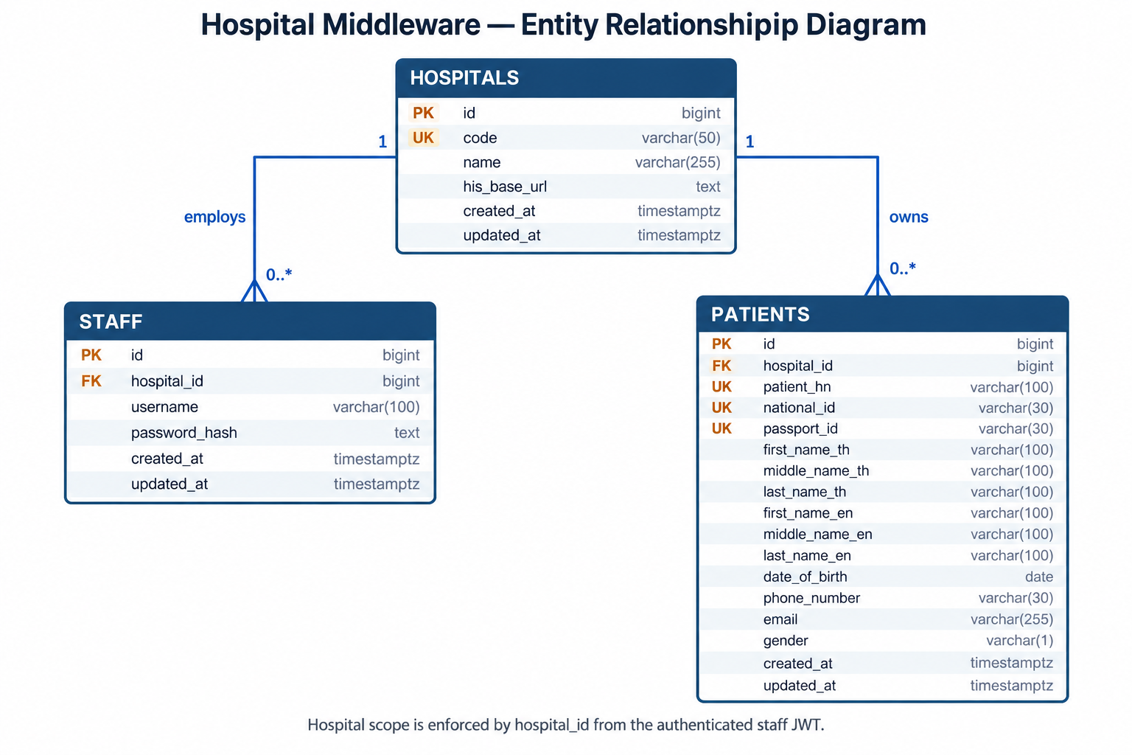
Figure 1. Hospital ownership model and patient/staff relationships.

4.1 Constraints and Indexes
- hospitals.code is globally unique and lowercase.
- staff (hospital_id, username) is unique.
- patients (hospital_id, patient_hn) is the unique HIS cache/upsert key.
- Non-null national_id and passport_id are individually unique within each hospital.
- Every patient requires at least one national or passport identifier; gender is M or F when present.
- Hospital/name and hospital/date-of-birth indexes support common search patterns.

5. Docker Compose Deployment
Client
│
▼
Nginx :8080 ──private network──> Go/Gin API :8080 ──> PostgreSQL :5432
│
└────────────> Hospital HIS HTTPS API
Service | Image/Build | Exposure | Health
nginx | nginx:1.27-alpine | Host port 8080 | Proxies only to API
api | Multi-stage Go build; distroless runtime | Private network | GET /healthz
postgres | postgres:16-alpine | Private network | pg_isready

docker compose up -d --build
docker compose ps
docker compose logs -f api nginx
docker compose down

6. Security and Privacy
- Hospital scope comes from the validated JWT, never from patient-search input.
- Passwords are bcrypt-hashed and are never returned or logged.
- SQL uses positional parameters; no user input is concatenated into queries.
- HIS calls have a configurable timeout and a 1 MiB response-body limit.
- Gin and Nginx access logs deliberately omit query strings containing patient identifiers.
- The API image runs as the distroless nonroot user, and only Nginx publishes a host port.
- Nginx limits request rate and body size; API responses do not leak internal errors.

7. Testing and Verification
Test layer | Coverage
HTTP handlers | Positive/negative staff creation, login, authorization, validation, HIS failure mapping
Services | bcrypt, token claims, HIS cache workflow, hospital scope propagation
HIS adapter | Valid response normalization, not found, invalid payload
Regression | Dynamic SQL repeated placeholders and query-string log privacy
Runtime acceptance | 14 Docker API checks through Nginx, including cross-hospital isolation

go test -count=1 ./...
go vet ./...
docker compose config --quiet
docker compose up -d --build
Verified runtime result: API healthy, nonroot runtime, zero restarts, PostgreSQL healthy, and 14/14 acceptance checks passed through Nginx.

8. Evaluation Criteria Mapping
Criterion | Evidence
Requirement satisfaction | All requested APIs, models, authentication, hospital isolation, Docker services, and tests are implemented.
Code quality | Layered packages, interface boundaries, graceful shutdown, parameterized SQL, stable domain errors, and regression tests.
Unit test coverage | Positive and negative scenarios for each API plus service, adapter, and regression tests.
Documentation clarity | This document, OpenAPI 3.0.3 specification, README, implementation plan, and ER diagram.

9. Repository Entry Points
- README.md — setup instructions, curl examples, behavior, and production notes
- docs/openapi.yaml — machine-readable API contract
- docs/ER_DIAGRAM.md and docs/ER_DIAGRAM.png — schema relationships
- docs/PLAN.md — architecture decisions and test strategy
- docker-compose.yml — Nginx, Go API, and PostgreSQL topology
- migrations/001_init.sql — complete schema and Hospital A seed

