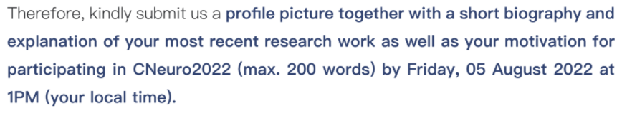

I am Aohua Cheng, a 4th-year undergraduate from Tsinghua University.

My most recent work is about the fast-convergence mechanism of natural gradient descent (NGD) in Machine learning. I am working on such a kindly irrelevant project with neuroscience because I hope to learn some theoretical methods and coding skills for research. Different from artificially tuning parameters from the traditional CS perspective, I am trying to relate the training dynamics of NGD to loss landscape with mean-field theory and levy process. So far, I found such a second-order optimizer shows a different dynamic path to achieve a much smoother learning process than classic stochastic gradient Descent. This leads me to have a more thorough understanding of learning theory.

For CNeuro 2022, I have several reasons. Firstly, I have watched some videos of CNeuro 2021 on youtube. These inspiring lectures make me believe that CNeuro is worth coming to. Secondly, another summer school, AI and Brain Computation organized by Prof. Si Wu and Jun Zhang last year provided me with lots of basic knowledge of learning, memory, and decision making. Also, it deeply influenced my research direction. Thus I hope to join CNeuro 2022 to blow me up again.