**DTrust: Decentralized Trusts**

David N Brunk

[zweckenllc@gmail.com](mailto:zweckenllc@gmail.com)

[www.dtrust.io](http://www.dtrust.io)

**Abstract.** Ethereum is a jurisdiction and code is law. A decentralized trust agreement (dtrust) would offer certain advantages over traditional common law trusts, including lower fees, lack of funding minimums, decentralization, court-independence, financial institution independence, and a more peer-to-peer trustee-settlor relationship. A Dapp running on the Ethereum Virtual Machine (EVM) could produce highly secure customized decentralized trust agreements that would execute payments to beneficiaries while managing various rights with private keys. Input questions on the Dapp web interface would produce a huge number of potential dtrust permutations to satisfy the diverse field of use cases across jurisdictions. Trustees and settlors would design dtrusts specifically to satisfy or avoid certain local rules for asset protection, tax treatment, forced inheritance circumvention, or other goals. The Dapp would include a mint function for Promote tokens (Pr) that would receive a fee from any new dtrusts associated with that Pr token. After the creation of the dtrust, ongoing fees would go to governance tokens for the Dapp.

1. **Introduction**

The law of trusts is an outgrowth of contract law with similar structure, purpose, and rules. In many fields of law, translating traditional contract into EVM smart contract offers certain strategic advantages. A smart trust agreement running on the EVM, a “decentralized trust” or “dtrust”, would likewise offer significant advantages over traditional trust agreements across a variety of legal systems and use cases. Further, a dtrust would be cheaper to operate and would not face minimum contribution limits imposed by traditional trustees. dtrusts could make the advantages of traditional trusts more widely available. The efficiency advantages of the EVM over traditional financial and legal infrastructure could make the structured financial lives of trust funds available to people who would not have access to traditional services. dtrusts would also allow individuals to craft their own trust rules to circumvent whatever local trust rules, such as forced heirship, might require. In this whitepaper I will use capitalized DTrust to refer to the EVM Dapp and dtrust to refer to specific smart trust agreement permutations used by settlors and trustees.

1. **Architecture**

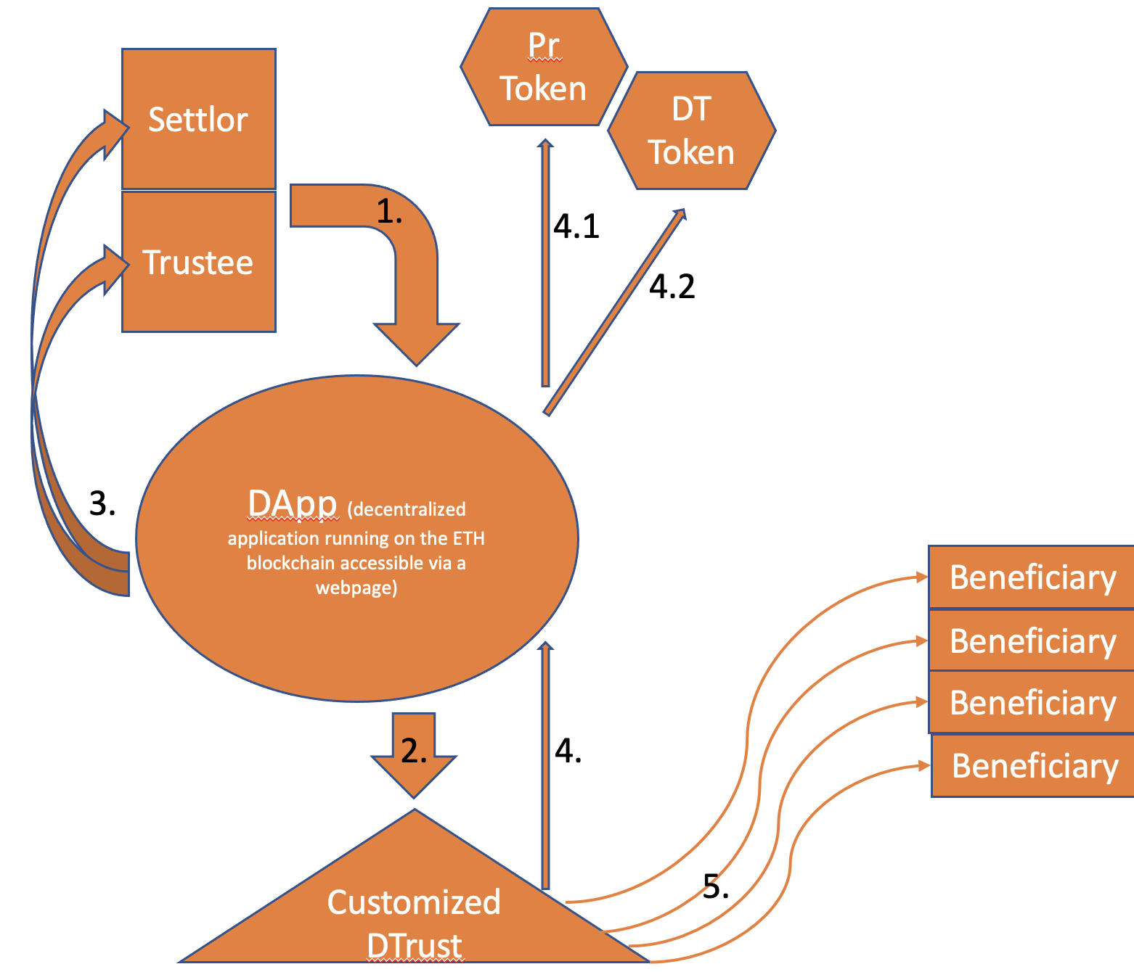

1. The settlor and trustee define the dtrusts that they want to form and enter the information into the Dapp web interface.
2. The Dapp generates a dtrust as specified.
3. The Dapp gives the settlor and the trustee keys to enable the specific rights initially decided upon.
4. An daily fee at an annual rate of (0%-1%) comes out of the assets held in the dtrust.
   1. The first year annual fee goes to a Promote (Pr) token associated with the promoter who brought the settlor and trustee to the Dapp. If there was no promoter, then the fee goes to the dtrust (DT governance tokens.
   2. Subsequent annual fees go to the dtrust (DT) governance tokens.
5. As initially specified or later decided, the smart contract pays assets out to the beneficiary wallets.
6. **Contract Permutations**

The settlor, trustee, and/or promoter would use the Dapp web interface to define the specific characteristics of their dtrust. The Dapp would then generate the desired smart contract. The input information would include the following:

**1. Wallets**

1.1. Who is funding the dtrust (settlor)?

Answer: settlor’s wallet address(es)

1.2. Who are the beneficiaries?

Answer: Beneficiary(s) wallet address(es)

1.3. Is there a trustee and if so, who is the trustee?

Answer: Trustee wallet address(es)

1.4. May the settlor change the beneficiary wallets?

Answer: Yes/No

Note: If a settlor has a power to revoke the dtrust, she may also choose to forfeit that power.

1.5. May the trustee change the beneficiary wallets?

Answer: Yes/No

**2. Schedules**

2.1. What will be be deposited and when? (maybe unnecessary)

Answer: A schedule of deposits of amounts of assets

2.2. What will be distributed and when?

Answer: A schedule of distributions of amounts/percentages of assets

2.3. May the settlor change the distribution schedule?

Answer: Yes/No

Note: If a settlor has a power to revoke the dtrust, she may also choose to forfeit that power.

2.4. May the trustee change the distribution schedule?

Answer: Yes/No

**3. Revocation**

3.1. May the settlor revoke the dtrust, and if so, what happens?

Answer: Assets would be split among the beneficiaries and settlor.

Note: If a settlor has a power to revoke the dtrust, she may also choose to forfeit that power.

3.3. May the trustee revoke the dtrust and if so, what happens?

Answer: Assets would be split somehow among the beneficiaries and settlor.

**4. Asset Swap**

4.1. May the settlor swap the assets in the trust for assets of equivalent value?

Answer: Yes/No

**5. Asset Management**

5.1. May the trustee transact with the assets?

Answer: Yes/No

**6. Trustee Fee**

6.1 Does the trustee receive a fee, and if so what amount?

Answer: 0%-2% annual rate paid to the trustee wallet daily

If either a settlor or trustee receives a right to do anything with respect to the dtrust, then the Dapp would distribute keys to the settlor and trustee upon creating the dtrust. For example, if the settlor is meant to have a revocation right, then the settlor would receive a key that would allow the settlor to interact with the dtrust to revoke it. If the trustee is meant to have a right to change the beneficiary wallets, then the trustee would receive a key that would allow the trustee to change the beneficiary wallets. The parties would then be able to engage with the dtrust either directly or through the Dapp web interface to exercise their rights with respect to the dtrust.

1. **Uses**

The law of trusts around the world are as varied as wealth, family, life, and death. There is no end to the variety of rules, circumstances, and strategies to managed economic value across human lives. The dtrust would provide a variable tool that could serve a variety of purposes to a variety of users. The dtrust could function simply to allow parties to seamlessly arrange traditional trust structures, but it could also enable novel strategies and new solutions.

1. Typical Trust Functions

Established trustees or settlors who would otherwise seek to form a traditional trust might prefer a dtrust for several reasons. A dtrust would not use traditional banking systems. It could pre-program payments in a way that is easier for the trustee. It would create more direct relationships between the trustee, settlor, and beneficiaries. A dtrust would more seamlessly manage digital assets. The traditional advantages of trusts include: (1) asset protection, (2) avoid probate time and fees, (3) privacy, (4) prevent estate and inheritance taxes, (5) specify the timeliness and use of assets, (6) plan for disability, illness, and death.

1. Asset Protection

Three features of trusts can typically provide asset protection: irrevocability, spendthrift provisions, and offshore jurisdictions. The most complicated trust structures might implement each of these typical trust strategies in addition to dtrusts, or some other combinations.

Irrevocability. In the United States, settlor creditors may only access a irrevocable trust assets to the amount of assets that are available to the settlor as a beneficiary. If a settlor places assets in an irrevocable trust and the settlor is not a beneficiary, then creditors cannot reach the trust assets. A dtrust could strengthen this protection, by enabling a settlor to make a trust irrevocable upon some adverse event. When a creditor lawsuit begins, the settlor could trigger a revocable dtrust to become an irrevocable dtrust by destroying a revocability key. This would not be a fraudulent conveyance, because the dtrust was already created and funded, so the triggering would not be a conveyance. It would not be a voidable transaction, because smart contracts on the EVM are not voidable. 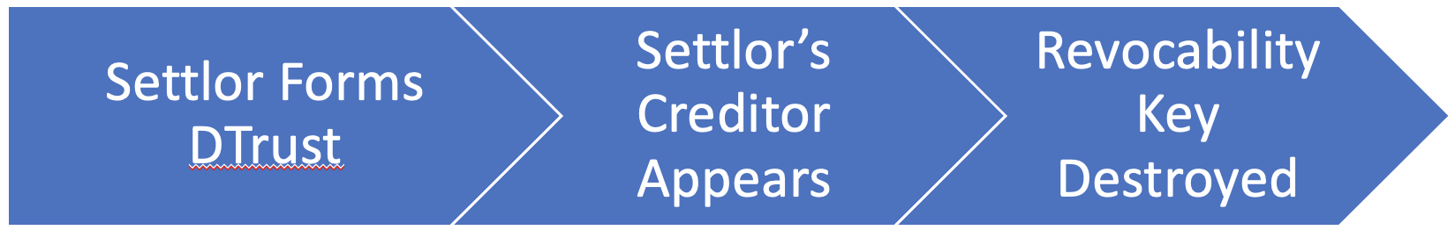

Spendthrift Provisions. Spendthrift provisions limit the beneficiary ability to alienate rights with respect to a trust. It is something like, “Beneficiary X may not voluntarily or involuntarily alienate rights with respect to this trust.” The effect is that a beneficiary’s creditors cannot reach the trust distributions. Spendthrift provisions would need to be built into a legal trust agreement associated with a dtrust, but the dtrust itself could add another layer to the spendthrift protections. If spendthrift provisions fail or cannot be implemented, then a trustee or settlor could change the beneficiary wallet addresses or change the distribution schedule to prevent beneficiary creditors from getting access to beneficiary distributions. In combination with a legal domestic or offshore, this ability could add a layer of protection to spendthrift provisions. A trustee to a traditional legal trust could not implement the wallet-changing strategy, but the pseudonymous nature of the EVM enable this novel strategy to strengthen spendthrift provisions. 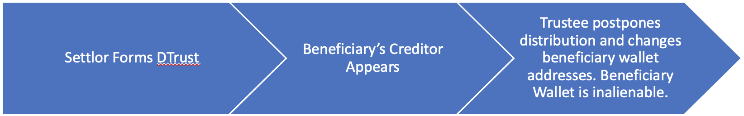

Offshore Jurisdictions. Offshore trust structures are often combined with domestic trusts to shield assets from lawsuits or creditors, but these offshore trusts are expensive and inconvenient. A dtrust could provide many of the same benefits as an offshore trust, but a dtrust would be cheaper and more convenient. By using a dtrust within a traditional domestic trust, settlors and trustees could build in an added layer of asset protection. An “offshore” character could be effectuated with a dtrust as long as the trustee is in another jurisdiction. A person with trustee control keys in an unknown foreign location provides a stronger offshore character to a dtrust than even the most secure Cook Island legal trusts.

1. Forced Heirship and Other Legal Solutions

Different countries have different rules around the administration of estates. For example, in South American countries forced heirship rules reserve a portion of a decedent’s estate for descendants, ascendants, and surviving spouses. Muslim countries apply different interpretations of Quranic inheritance rules. In China the rules direct a decedents estate more towards parents rather than children. Other regions have different rules. dtrusts would enable users in any jurisdiction to administer an estate as desired. Local lawyers may need to define the treatment of the dtrust, but the result itself would be built into the EVM.

1. Low Income Trusts

Unlike traditional trusts, which require extensive attention from a competent trustee, dtrusts would be much easier to administer. They would be simpler, more seamless, and more easily pre-designed. Trustees typically take a fee worth between 1% and 3% of the value of traditional trusts each year. DTrust fees would be just 0.5% of the assets held in the dtrust annually and could be much lower if necessary to encourage adoption. Additionally, there would be transaction costs on the EVM, but these costs are likely to fall in the future. More importantly, trustees typically require a settlor to provide some minimum amount into the trust to make it worth the time to administer. A dtrust would not impose the minimum amount. The result would be that middle- or low-income individuals could benefit from the structured financial system of trusts, which has been historically reserved for the wealthiest.

1. Decentralized Trustee

Although this white paper has contemplated that a human trustee would use a dtrust to administer a settlor’s trust, a dtrust could also be implemented without human trustee. It would be an “automated distribution machine”. This structure may or may not create a legal trust, depending on the jurisdiction, but the structure could still allow many of the benefits of a traditional trust. For example, under the Uniform Trust Act in the United States, a dtrust would not be a legal Trust, because a legal trust requires a trustee. A wealthy individual could still set a distribution schedule with other specifications for children. Depending on the situation, this could be a useful tax planning tool. It could also be useful to settlors who want to work around local forced heirship rules.

1. **Promotion**

The benefits of dtrusts resemble the benefits of life insurance policies because both enable individuals to make an initial decision to shape future financial circumstances, both can be used in tax strategies, and both deal with planning for death. Life insurance policies are often sold by commission only sales agents who often engage in a combination of sales and new agent hiring activities. Each agent manages other agents, and commissions are shared among the hierarchy. This structure enables high sales agent turnover, which enables sales activities to occur within friend, family, and social groups. In other words, a new agent is brought on, the new agent sells financial products to friends and family, and then often the new agent does not continue sales activity. This business development structure is highly effective for insurance sales, and it could also be effective for dtrusts as well.

Rather than hire sales agents, the DTrust Dapp could include a mint function to generate private keys for sales agents to enter at the time a new dtrust is formed. For example, Juan could go to the DTrust webpage, enter some information, and receive a private promoter token and key. The DTrust webpage would include some KYC input information for these promoters. Juan could then encourage friends, family, and associates to form a dtrust. Maybe Juan is already a trustee under traditional legal relationships, and he already engages in these activities. If a trustee and settlor submit Juan’s key when they enter the information into the Dapp to form the dtrust, then Juan’s Promote token (Pr) would receive the first year’s annual fee upon the funding of the contract.

The DTrust web interface would have two creation channels: (1) Promoter— “I am a Promoter.” (2) No Promoter—"I am a trustee or settlor.” The Promoter channel would allow the Promoter to enter her information in order to mint her Promoter (Pr) token and input the information collected from trustees and settlors. The promoter page would also include links to help the Promoter collect the information from trustees and settlors. A dtrust created in his Promoter channel would pay the first-year annual fee to the promoter’s Pr token. The No Promoter channel would allow a trustee or settlor to input the creation information directly. The first-year fee in this case would go to the DT fee tokens for the Dapp.