**Code for styles.css**

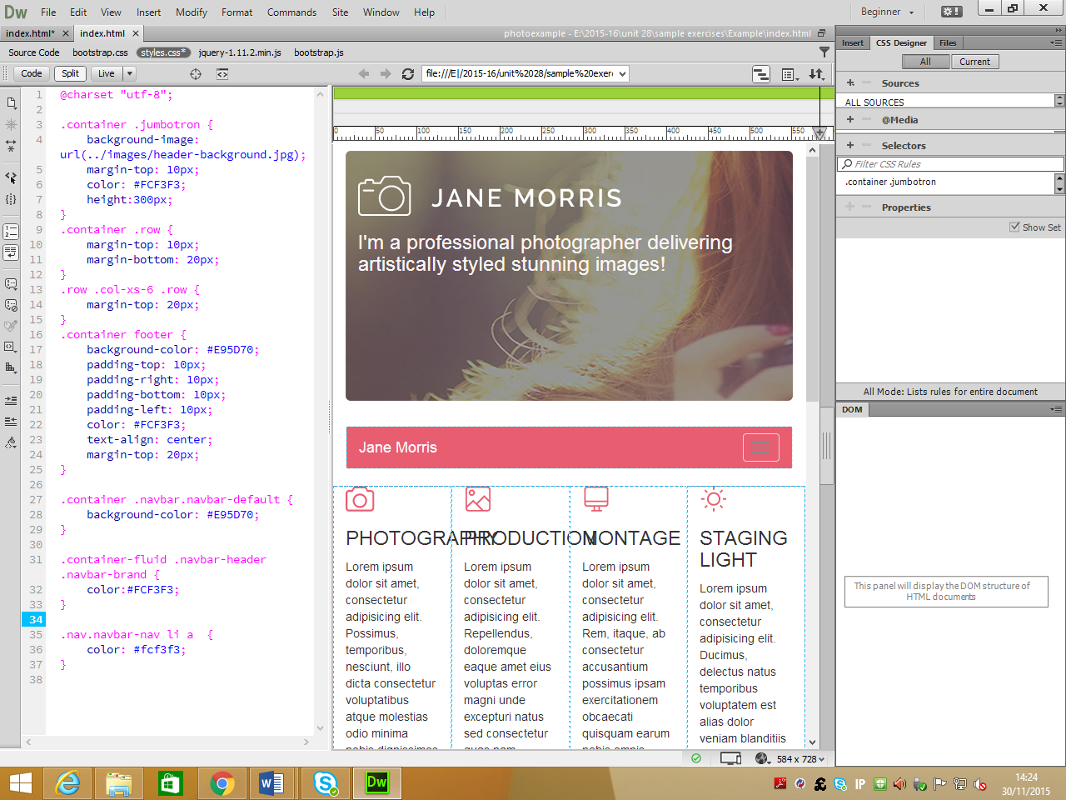

Sets the colour of the navigation links

Sets the background colour of navigation bar

Sets the background colour of the active link

This is the code to put some spaces around the text and align it to the centre

This is the code to put some margins and help the layout

This is the code to put a background image, put margins and specify a height for the jumbotron