# Interactive Web Media CA2

Aoife Sayers

T00170881

## Research

Possible games I considered when researching to make/recreate for my Interactive Web Media CA2.

* Mario Bros Style Game
  + Arrows keypad using left, right up and down
  + Mario game sprite
  + Koopa & Goomba enemy sprites
  + Mushroom 1 up
  + Different screens & progression in hardness as it goes on

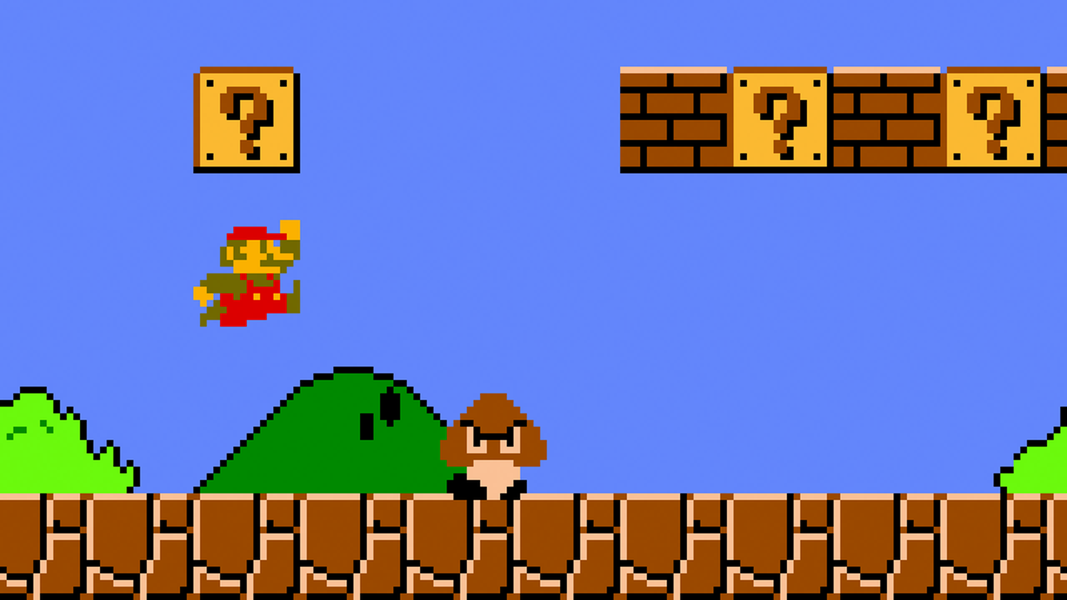

* Snake game
  + Researching this I discovered it more difficult than initially expected as it would have to be implemented on a grid layout and using arrays

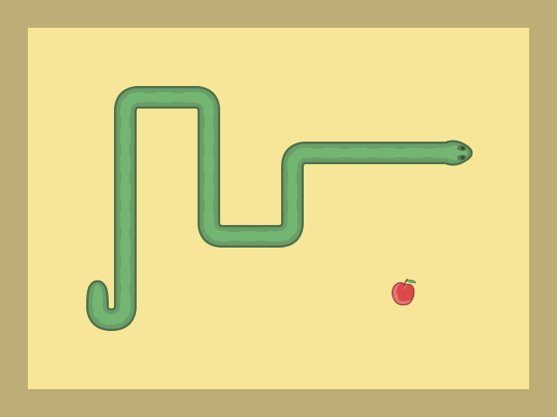

## Research

* Racing /dodge game
  + This was my second choice after Mario Bros’ Game as it’s easy to create
  + Requires no changing screen and the opponents cars just move y position at each frame
  + I decided against this game as I felt it might be too basic and I wanted to push my self

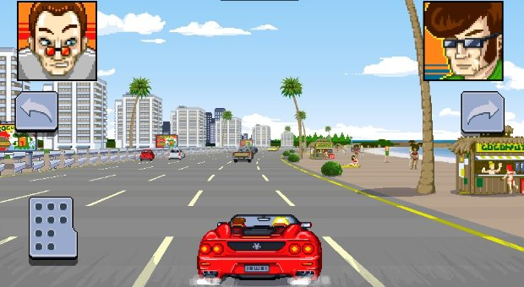

* Tetris
  + Difficult to create random shapes & have them fit other shapes
  + Decided against developing this as I researches & found out that I will need arrays to generate random shapes & difficult to match

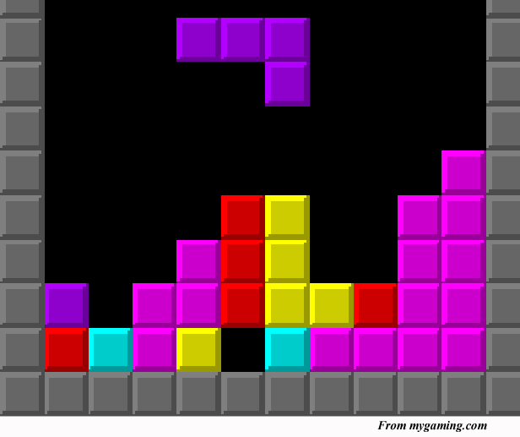

## Research

* Dinosaur jump game like on chrome
  + Constant scrolling background , obstacles appear and the use is supposed to use up arrows to avoid
  + Initially, thought this idea would be too simple and wouldn’t suit the requirements for this project

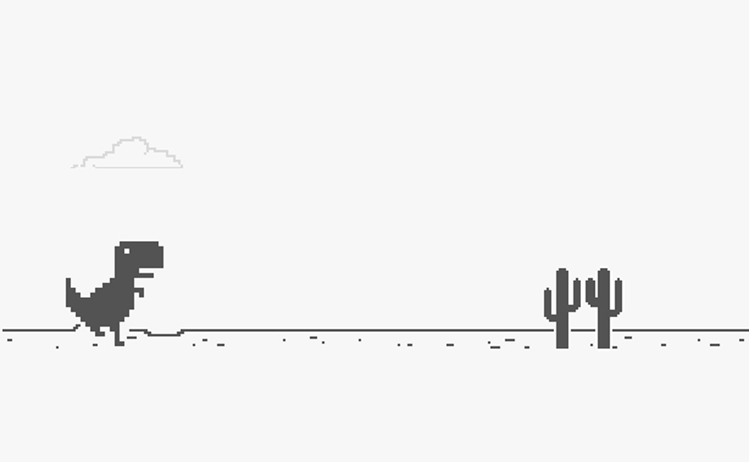

## Plan/Design

* My final idea was to go with the Mario Game. I felt this was the best idea that would fit the requirements of this project & the most complex way for showing off my HTML5 Canvas & JavaScript abilities

**User Interaction:**

* The user interacts with the game by using up, down, left & right arrows. Also the mouse click & for starting/pausing the game
* Involves a Mario sprite that is able to move left, right and jump using the left, right and up down arrows.
* Mario falls back down to the ground 1000ms after he jumps
* 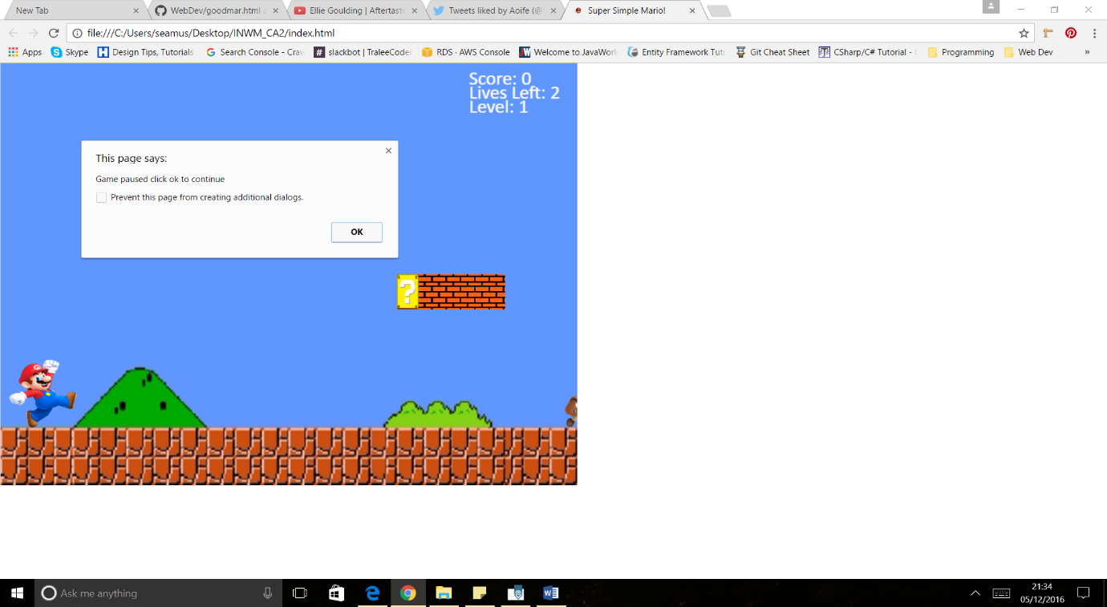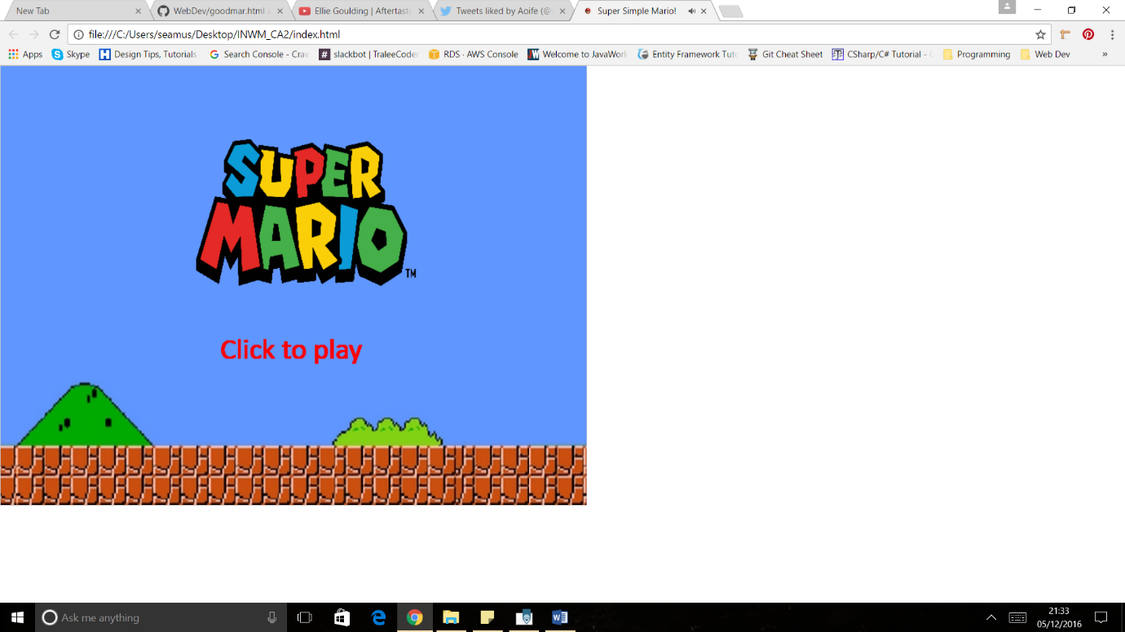Mouse Click & spacebar – to start or pause the game during gameplay
* Left, Right & Up arrow keys to move Mario sprite
  + Mario image redrawn each time he turns left or right

Right arrow used Up arrow for a jump

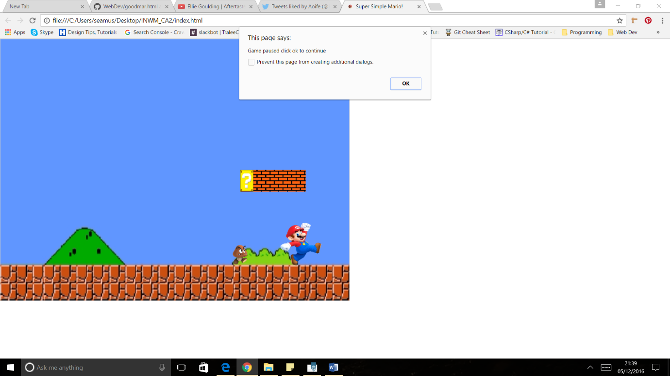

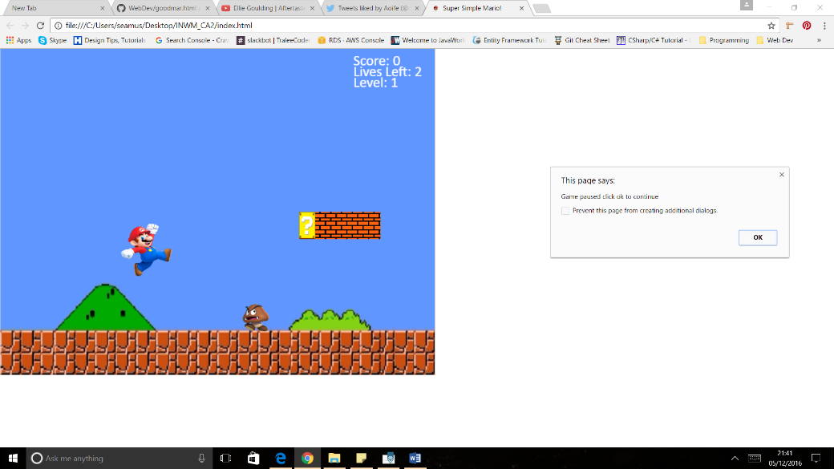

## Plan/Design

**Enemy Sprites**

* The enemy opponents are the Koopa(Turtle) and Goomba

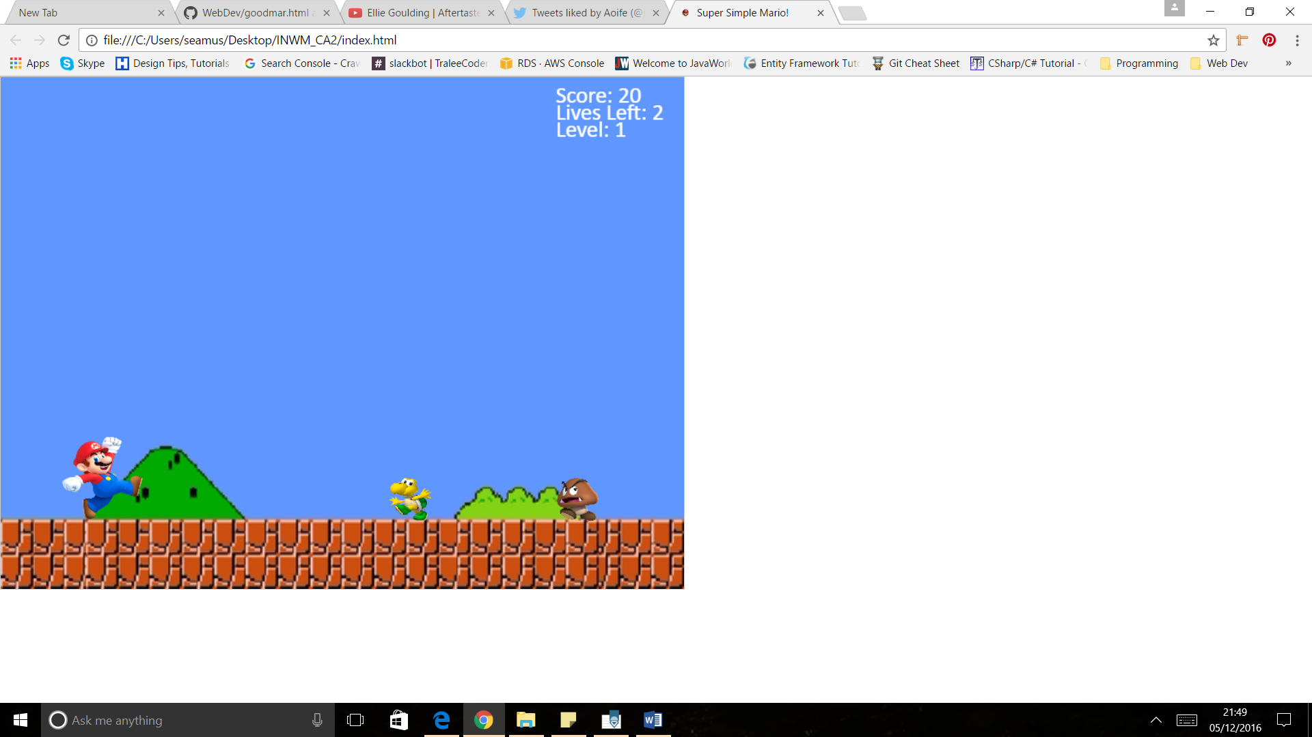

* Koopa moves slower than a goomba making him harder to jump over
* Mario must avoid the enemy opponents by jumping over them and avoiding them, if Mario hits off the side of the enemy opponents, Mario loses a life and his Y height decreases by 50, making him smaller
* If the sprite hits an obstacle Goomba/Koopa– health / size is decremented
  + Hit twice = dead

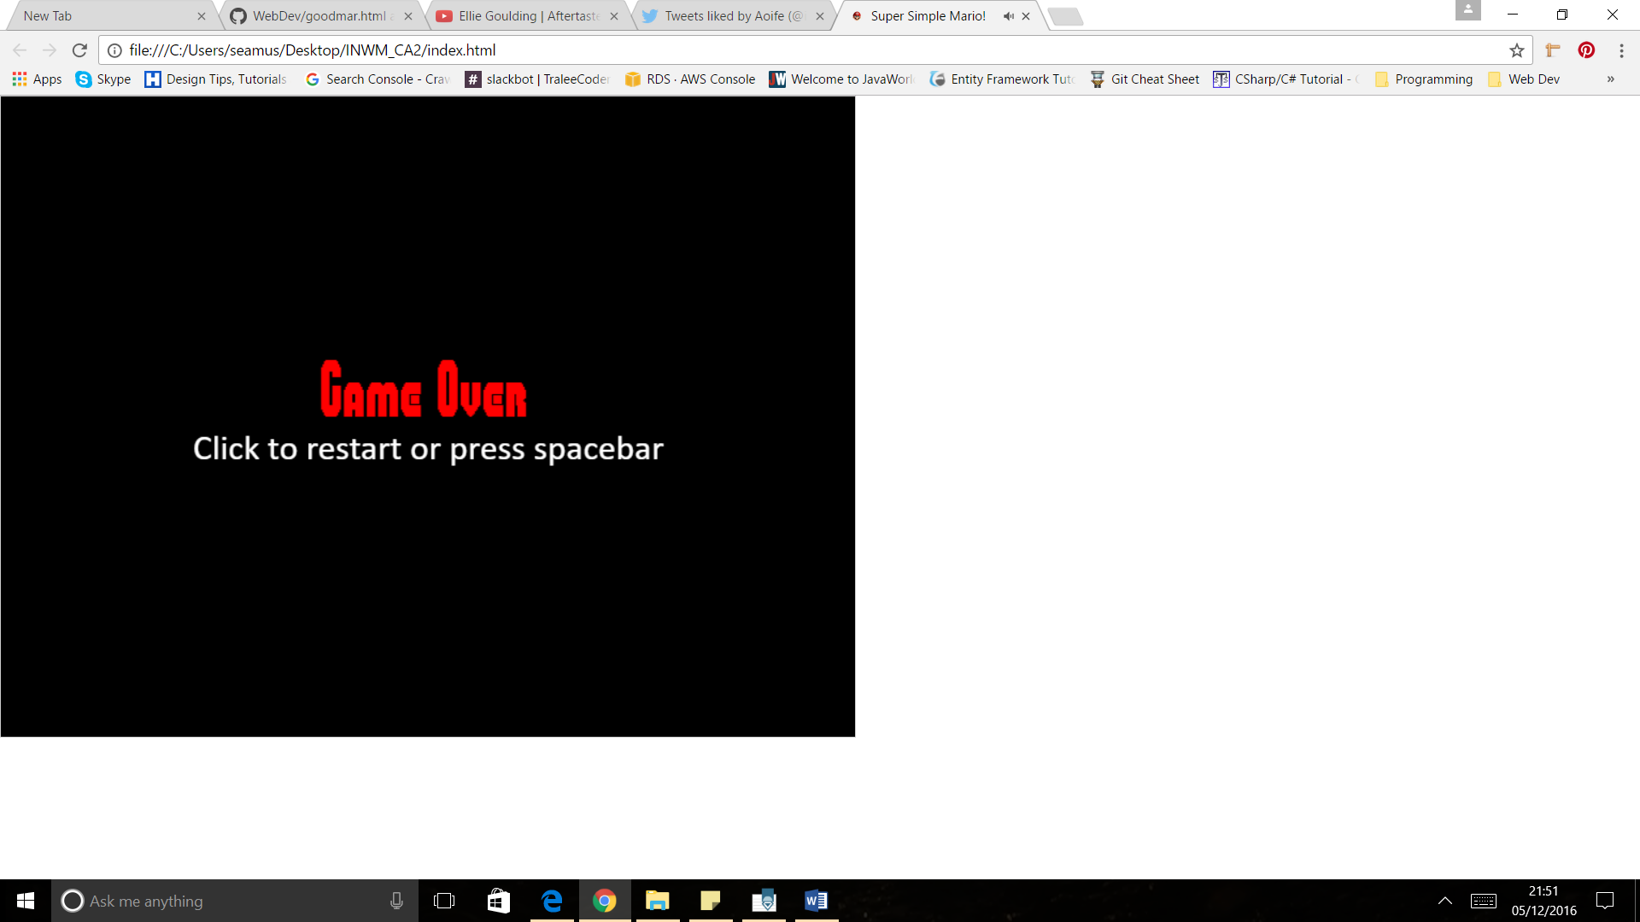

* If the enemy opponents hit off Mario, but don’t kill Mario, they turn in the opposite direction they were facing

## Plan/Design

**Levels & Progression**

* Incrementing score as Mario progresses through each screen
* As level goes on – sprite obstacles gets faster & Mario cannot jump for as long as he can
* Gets to right y axis of canvas & new enemies appear at faster speeds
* Mushrooms to increase Mario life & make Mario Y height bigger
* Mario wins when he reaches pole at end of the level
* Implemented 2 levels. Tried to add a second player to the 2nd level but it wouldn’t appear

**AI(Artificial Intelligence)**

* Mario hurt – Goomba turns back in opposite direction
* As level goes on – sprite obstacles gets faster & Mario cannot jump for as long as he can

**Audio & Images**

* Audio
  + Start screen music
  + Mario hurt music
  + Music Haha when Mario gets a mushroom / 1up
* Images

I decided to use images instead of custom drawing via canvas. Images look more realistic. Unfortunately, with time constraints, I did not have time to do sprite sheets but I would have liked to use better animated images

* + Background Image
  + Mario Left Image, Mario Right Image
  + Koopa Left Image, Koopa Right Image
  + Goomba Left Image, Goomba right image
  + Castle Image
  + Flag Pole Image
  + Bricks & ? Box Images
  + Mushroom Image

***Please see References.txt attached for references for the above material used***

**Start Screen & End Screen**

* Use CSS Animation for a scrolling background
* Tried to implement in the gameplay using jQuery but it wouldn’t work as the background had to be re-drawn each fps.

## Plan/Design & Development

|  |  |  |
| --- | --- | --- |
| **Plans** | **Finish for** | **Success** |
| Set up canvas & draw method | 10th November | Yes |
| Add main sprite | 15th November | Yes |
| Add opponents & move methods | 18th November | Yes.. need to fix mario’s jump  & fix goomba collision detection  Completely finished on 23rd November |
| Add Text | 20th November | Yes 15th November |
| Add Event Handling | 25th November | Yes 25th November |
| Add CSS Transitions | 30th November | No… 1st December |
| Add Images & Audio | 30th November | Yes 13th November |
| Add Start & Finish Screen | 5th November | Yes 10th November |

To conclude, I was happy with how my game turned out. I achieved everything I had planned to achieve and met all the requirements required for this CA. However, I feel I set out to achieve something too complex.

Some problems I encountered were:

* I could not implement collision detection straight above the enemy opponents
* Mario’s jump gets interrupted by the setInterval() method
* Canvas is very powerful but wish you could use CSS animation with the different elements

For future goals with this game:

* I would like to research JavaScript Frameworks/libraries to add more animation & more realistic graphics:
* Make the code more efficient

## References

Please see References.txt for the media references used in the game

References

canvas, make. "Make A Character Jump Inside Canvas". Stackoverflow.com. N.p., 2016. Web. 5 Dec. 2016.

"INIFINTE SCROLLING BACKGROUND". CodePen. N.p., 2016. Web. 5 Dec. 2016.

Malone, William. "Create A Sprite Animation With HTML5 Canvas And Javascript". Williammalone.com. N.p., 2016. Web. 5 Dec. 2016.

"Modifying The Canvas With CSS". Developer.apple.com. N.p., 2016. Web. 5 Dec. 2016.

"Reminder Of How To Make A Character Jump". Khan Academy. N.p., 2016. Web. 5 Dec. 2016.