# Audio (HTML5)

We saw that HTML5 supported audio earlier in this course, but we were just using it to play songs. How would we use it to programmatically/dynamically play sounds?

## Audio using Javascript

Create a HTML5 file  
Add <script> tags

Download the audio file from blackboard  
Within the script tags add these lines

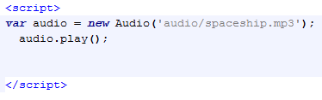

Open in a browser and see does it work.

## Audio in Games

Now using our previous game (Tennis) – you can download a working version of it no Blackboard

Download the computer wins audio file from Blackboard  
Now when the computer beats the human player play that audio.  
Test it and see if it works.

Playing the audio when something happens is easy but actually making it work properly is more difficult.

Try to "fix" all the issues. There is no "right" approach to do this as for each audio piece dynamically played there might be no need to change anything.

Now read the docs and see what elements we can control (volume of individuals sounds?) - <http://www.w3schools.com/tags/ref_av_dom.asp>