<?php

$x = 5 ;      // $x is an integer

$y = "Puja"; // $y is a string

echo $x;

echo "\n";

echo $y;

?>

output:

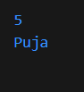

<?php

$x = 5 ;      // $x is an integer

$y = "Puja"; // $y is a string

var_dump($y);

?>

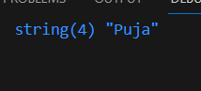

<?php

$x = 5; // global scope

function myTest() {

    $x = 5; //local

  // using x inside this function will generate an error

  echo "<p>Variable x inside function is: $x</p>";

}

myTest();

echo "<p>Variable x outside function is: $x</p>";

?>

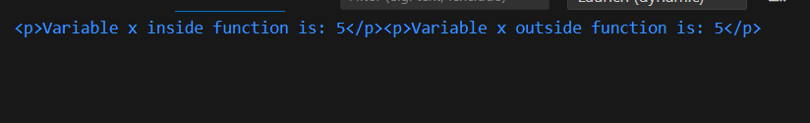

<?php

$x = 5;

$y = 10;

function myTest() {

  $GLOBALS['y'] = $GLOBALS['x'] + $GLOBALS['y'];

}

myTest();

echo $y; // outputs 15

?>

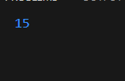

<?php

function myTest() {

    static $x = 0;

    echo $x;

    $x++;

  }

  myTest();

  myTest();

  myTest();

?>

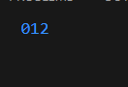

<?php

$txt1 = "Puja";

$x = 5;

$y = 4;

echo "<h2>" . $txt1 . "</h2>";

echo $x + $y;

?>

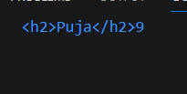

$cars = array("Volvo","BMW","Toyota");

var_dump($cars);

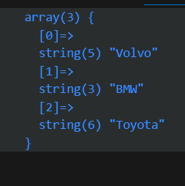

<?php

$x = "Hello World!";

echo strtoupper($x);

?>



<?php

$t = 14;

if ($t < 20) {

  echo "Have a good day!";

}

?>



<?php

$t = date("H");

if ($t < "10") {

  echo "Have a good morning!";

} elseif ($t < "20") {

  echo "Have a good day!";

} else {

  echo "Have a good night!";

}

?>

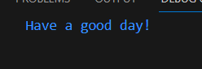

<?php

$i = 1;

while ($i < 6) {

  echo $i;

  $i++;

}

?>

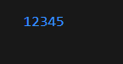

<?php

$i = 1;

do {

  echo $i;

  $i++;

} while ($i < 6);

?>



<?php

for ($x = 0; $x <= 10; $x++) {

    echo "The number is: $x ";

  }

?>

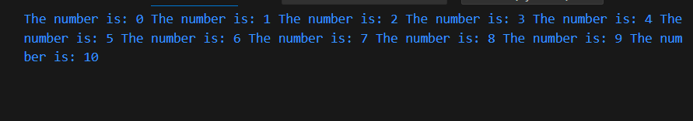

<?php

$colors = array("red", "green", "blue", "yellow");

foreach ($colors as $x) {

  echo "$x <br>";

}

?>

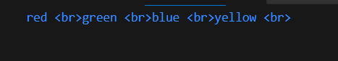

$cars = array("Volvo", "BMW", "Toyota");

echo $cars[2];

